
EPISODE 16
9 June 2026

KEY LEARNING
Students will view a range of BTN stories and use comprehension skills to respond to a series of focus questions.

CURRICULUM
English – Year 4
Use comprehension strategies such as visualising, predicting, connecting, summarising, monitoring and questioning to build literal and inferred meaning, to expand topic knowledge and ideas, and evaluate texts.
English – Year 5
Use comprehension strategies such as visualising, predicting, connecting, summarising, monitoring and questioning to build literal and inferred meaning to evaluate information and ideas.

English – Year 6
Use comprehension strategies such as visualising, predicting, connecting, summarising, monitoring and questioning to build literal and inferred meaning, and to connect and compare content from a variety of sources.

  - Teacher Resource

Focus Questions
As a class, discuss the stories featured in the episode of BTN Classroom and record the main points of the discussion. Students will then respond to the following focus questions.

Two-Party System
- What is the two-party system?
- What year was the first federal election held in Australia?
- What year was the Liberal Party created?
- What are the major political parties that make up Australia’s government?
- The One Nation Party is a minor political party. True or false?

FIFA World Cup
- Who is hosting the 2026 FIFA World Cup?
  - United States
  - Canada
  - Mexico
  - All of the above
- Why did FIFA start the World Cup?
- How often is the FIFA World Cup held?
- What year did Australia first qualify for a spot in the World Cup?
- What is the name of the Australian men’s national soccer team?

Moon Base
- Where will NASA build its Moon Base?
  - Lunar South Pole
  - Lunar North Pole
- What will astronauts need to live on the Moon Base?
- What does phase 3 of the Moon Base program involve?
- What countries other than the US are building Moon bases?
- What did you learn watching this story?

Check out the teacher resource on the Archives page.

Mount Everest
- What countries border Mount Everest? Find on a world map.
- What is the name of the mountain range where Mount Everest is located?
  - Alps
  - Andes
  - Himalayas
- Mount Everest is the highest mountain in the world. True or false?
- Who were the first people to successfully climb Mount Everest?
- Who are the Sherpa people?

Check out the teacher resource on the Archives page.

Ice Skater
- What medal did Hana win at the junior world championships for figure skating in Estonia?
  - Bronze
  - Silver
  - Gold
- What difficult move did Hana land that only a few figure skaters in the world can do?
- What inspired Hana to start figure skating?
- Who does Hana look up to for inspiration?
- How does Hana feel when she is on the ice performing?

EPISODE 16
9 June 2026

KEY LEARNING
Students will explore the challenges of living and working on the Moon. Students will think like engineers to design and build a model of a moon base.

CURRICULUM
Science – Year 5
Scientific understandings, discoveries and inventions are used to solve problems that directly affect peoples’ lives.

The Earth is part of a system of planets orbiting around a star (the sun).

Science – Years 5 & 6
Scientific knowledge is used to solve problems and inform personal and community decisions.
Science – Year 6
Describe the movement of Earth and other planets relative to the sun and model how Earth’s tilt, rotation on its axis and revolution around the sun relate to cyclic observable phenomena, including variable day and night length.

Science – Year 7
Model cyclic changes in the relative positions of the Earth, sun and Moon and explain how these cycles cause eclipses and influence predictable phenomena on Earth, including seasons and tides.

  - Teacher Resource

Moon Base

Focus Questions
Discuss the BTN story as a class and record the main points of the discussion. Students will then respond to the following:
- Where will NASA build its Moon Base?
  - Lunar South Pole
  - Lunar North Pole
- What will astronauts need to live on the Moon Base?
- What does phase 3 of the Moon Base program involve?
- What countries other than the US are building Moon bases?
- What did you learn watching this story?

Activity: Curious about the Moon?
Are you curious about the Moon and the possibility of astronauts living on the Moon? Students will make a list of questions they have about the BTN story. As a class, students will brainstorm as many questions as they can and organise them under these headings…
- Living on the Moon
- Staying safe
- Building the Moon Base
- Science and exploration
- Daily life

Students will become space researchers and investigate their own question in more detail. Students will locate, collect and evaluate information from digital sources. Below are some example questions...


- What will the Moon Base look like?
- How many astronauts will live there at one time?
What questions do you have?
- How will astronauts sleep on the Moon?
- What happens if there is an emergency on the Moon Base?
- Could plants be grown on the Moon?
- Is there water on the Moon?

Activity: Create a Moon Base
In this activity, students will explore the challenges of living and working on the Moon. Students will then think like engineers to design and build a model of a moon base. Students can design and build their moon base individually or in small groups.

Class discussion
Before starting this activity ask your students to imagine they are one of the first humans sent to live on the Moon. What would you need to survive on the Moon? Discuss the following:
- There is no breathable air
- Extreme temperatures
- Limited resources
- Need food, water, power and transportation.

Research phase
Before designing their moon base, students will consider and research the following structures to be included in their model. If working in small groups each student will choose one structure to research and design.

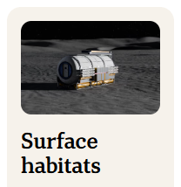  What living quarters will astronauts need to sleep, eat and conduct experiments? Astronauts will need shelter from radiation, extreme temperatures and small meteoroids. | 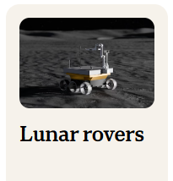  How will astronauts explore the Moon’s surface? The Moon’s surface is particularly rugged in the South Polar region. | 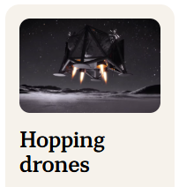  How will astronauts explore the difficult terrain including deep craters? A hopping drone moves by hopping across the Moon’s surface.
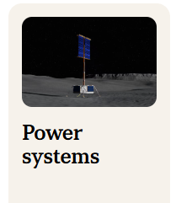  How will astronauts get power? Parts of the lunar South Pole receive near-continuous sunlight. | 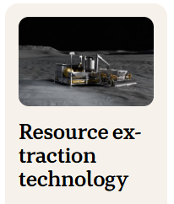  How could astronauts mine water ice that is trapped in craters on the Moon? Ice can be turned into drinking supplies.

Planning phase
Things to for students to think about before building their model:
- What do the different structures on your moon base look like? Explore the NASA website to learn more about the parts of a moon base.
- Sketch a diagram of your moon base and label important features.
- What will the size and scale of your model be?
- What materials or found objects will you use to make your moon base? Find recycled objects to construct your model.
- What tools will you need to build your moon base? Make a list.

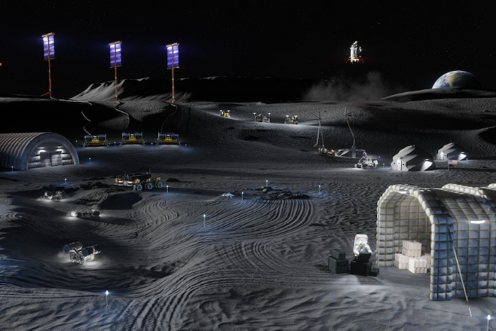
Building phase
Students will create a model of their moon base using the materials they have collected and display them in the classroom. Alternatively, students may want to create their moon base using Minecraft.

Further challenge
- Where on the Moon will your base go? Explore NASA’s interactive map of landing sites for possible locations to put your moon base. Find the lunar North and South Pole. What is the best spot to build your permanent moon base? Why is it a good location? Give 2-3 reasons.
Source: NASA
- What will you name your rovers and landers? What do you notice about the names of NASA’s rovers and landers (they’re all inspirational). Find an inspiring name.

Activity: Launch with TEDEd

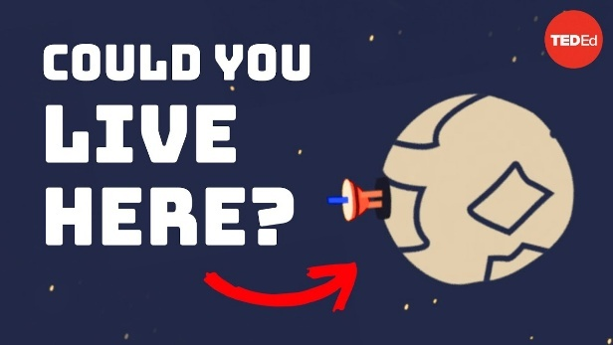 |  | 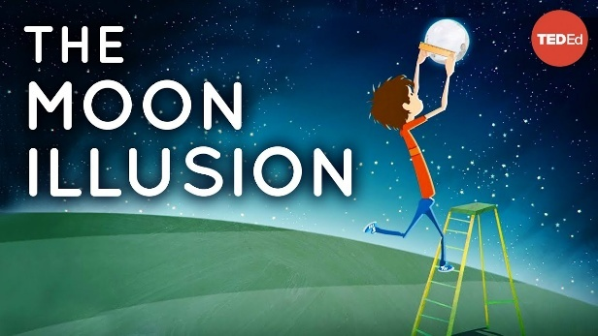

What would it be like to live on the moon?
Watch this TEDEd video to learn more!
The moon illusion
Watch this TEDEd video to learn more!

BTN Space Science collection
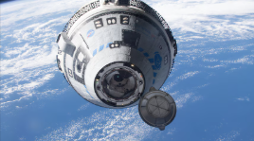
Visit BTN’s collection of stories which focus on Space Science. Look for BTN stories with the pencil icon to find supporting teacher resources all linked to the Australian Curriculum. BTN – Space Science Collection

Useful Websites
- Artemis 2 Launch – BTN
- Design your own Mission to the Moon! (teacher’s guide) – Australian Space Agency
- NASA has revealed its plan to live on the Moon. Here's how it would work – ABC News
- Moon Base – NASA
- Artemis III – NASA

EPISODE 16
9 June 2026

KEY LEARNING
Students will use maths skills to explore real-world information about Mount Everest.

CURRICULUM
Mathematics – Year 7
Compare, order and solve problems involving addition and subtraction of integers.

Mathematics – Year 5
Recognise that 100% represents the complete whole and use percentages to describe, represent and compare relative size; connect familiar percentages to their decimal and fraction equivalents.

Geography – Year 6
The geographical diversity of the Asia region and the location of its major countries in relation to Australia.

Geography – Year 8
Different types of landscapes and their distinctive landform features.

Geography – Year 7 & 8
Develop geographically significant questions and plan an inquiry, using appropriate geographical methodologies and concepts.

Science – Year 6
Sudden geological changes and extreme weather events can affect Earth’s surface.
  - Teacher Resource

Mount Everest

Focus Questions
Discuss the BTN story as a class and record the main points of the discussion. Students will then respond to the following:
- What countries border Mount Everest? Find on a world map.
- What is the name of the mountain range where Mount Everest is located?
  - Alps
  - Andes
  - Himalayas
- Mount Everest is the highest mountain in the world. True or false?
- Who were the first people to successfully climb Mount Everest?
- Who are the Sherpa people?

Activity: Comprehension
After watching the BTN Mount Everest story students can answer one or more of the following comprehension questions, for example:
- What are some keywords from the BTN story?
- What did you learn from the story? Write a summary.
- What is the purpose of this news story? To entertain, persuade, inform, explain or describe?


What questions do you have?
What surprised you about this story?

Activity: Vocabulary
Students will brainstorm a list of key words that relate to the BTN Mount Everest story. Here are some words to get them started.

MOUNT EVEREST | TALLEST PEAK | HIMALAYAS
SEA LEVEL | SHERPA | SUMMIT

Ask students to write what they think is the meaning of each word (including unfamiliar words). They will swap definitions with a partner and ask them to add to or change the definition. Check these against the dictionary definition.

Further activities for students:
- Students will add to their glossary by downloading the transcript for the BTN Mount Everest story and highlight all the words that relate to the topic.
- Where does the word Everest come from? Explore the history of the naming of Mount Everest.
- What is the official Nepali name for Everest? What does it translate to?
- What is the official Tibetan name for Everest? What does it translate to?

Activity: Fantastic Facts
Mount Everest is the tallest mountain on Earth measuring at 8,849 metres above sea level. There is a lot of mathematics involved in understanding mountains, from height and distance to temperature, climbing times and geographical measurements. In this activity, students will ask mathematical questions, choose one to investigate and use maths skills to explore real-world information about Mount Everest.

What’s your maths question?
Ask your students to think of 2-3 maths questions they have about Mount Everest. Invite students to share one of their questions with the class. Some possible questions are:
- How much taller is Mount Everest than other famous mountains?
- How many steps does it take to walk up Mount Everest? What is the best way to estimate this?
- How many school buildings stacked on top of each other would equal the height of Mount Everest?
- What is the temperature difference between base camp and the summit of Mount Everest?
- Which month has the highest number of successful climbs?

Investigation
Students will choose one question they would like to investigate in more detail and use the guide below to support their investigation.
- What is your maths question? Write it down.
- Identify what information you need.
- Gather the data you need from trusted sources online. Record the sources that you use.
- Use mathematical calculations, diagrams, tables, graphs or models to investigate your question.
- Record your working and write a conclusion. What did you discover?
Further challenge
Students will respond to one or more of the following questions:
- What maths skills did you use during your investigation?
- What was surprising about your findings? Write 2-3 sentences.
- Complete this sentence “The most interesting maths fact I discovered about Mount Everest was…”
- What new question would you like to explore next?

Activity: TEDEd
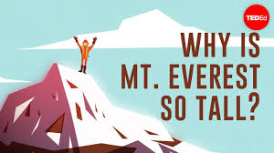
Students will watch this TEDEd video to learn more about Mount Everest and find out why it is so tall.

Students will use the facts they have discovered about Mount Everest to create a quiz and then test their classmates. Students will include a range of quiz styles, for example:
- Multiple choice
- True or false
Why is Mt. Everest so tall? (Source: TEDEd)
- Fill in the blank
- Use photos or pictures

- When an answer is revealed, provide extra information to explain the answer.

Students can make their quizzes in Kahoot or Quizizz. Make it fun, engaging, and educational!

Useful Websites
- Measuring Everest – BTN
- Why is Mount Everest so tall? – TEDEd
- Mount Everest – National Geographic Kids

  - Teacher Resource

BTN Transcript: Episode 16- 9/6/2026

Hey, I’m Amelia Moseley and you’re watching BTN. Thanks for hanging out with us again. Let’s see what’s coming up in today’s show. We get ready for the World Cup, find out about plans to live on the Moon and meet one of Australia’s best ice-skaters.

Two-Party System

Reporter: Saskia Mortarotti

INTRO: We’ll get to all that soon. But first today, to an opinion poll that made headlines. For the first time, One Nation was ranked higher in the poll than the two major parties, and it had some wondering if this minor party could become a major threat to our two main political players. Here’s Sas.

SAS: You might know them as the party associated with the colour red. They’re led by Anthony Albanese, Australia’s current Prime Minister. On the centre-left, it’s the Labor Party! And coming in, donning blue, they’re in a coalition with the Nationals and are led by Angus Taylor. On the centre-right, it’s the Liberal Party! It’s going to be a classic two-party battle.

SASKIA MORTAROTTI, BTN REPORTER: When it comes to politics here in Australia, it’s a fight between two major teams. And while the people representing those teams change, it’s always one of them leading the country.

It's what's known in politics as a two-party system. It's been that way for a really long time. Our first election was held back in 1901, just after we became a federation. This is a ballot paper from our very first election. As you can see, there’s lots of names there. I crossed out all the ones I didn’t want. There weren't really any formal political parties. Although there were loose groups of people with similar views - like the Protectionists, who wanted to protect Australian industries with tariffs. Free trade advocates, who wanted, well, the opposite of that. And various Labour parties which represented workers.

For the first few years, there were quite a few minority governments, where prime ministers had to struggle to get everyone to agree if they wanted to keep being Prime Minister. But it wasn't long before just a few major parties came to dominate Australian politics. The Liberal Party, as we know today, was created in 1944 and entered into a partnership with the Country Party - or the Nationals, as we know them now. And since then, every Prime Minister has either been a Liberal or a Labor.

Of course, they're not the only political parties. We've got dozens of minor parties - from the big minor ones you've probably heard of to the really minor ones. And while they've won seats before, they've never really threatened the two-party system. But that could be changing. Last week, an opinion poll came out showing that more people would be prepared to vote for One Nation than either of the major parties. And while it's just one opinion poll, it's got a lot of people talking.

LARISSA WATERS, SENATOR: Look, it does worry me that people who are so clearly angry with the two major parties - and are right to be - are thinking that One Nation is their option.

CHRIS MINNS, PREMIER OF NSW: There's a lot of drama around Pauline Hanson. There's a lot of similarities to Maga-style Trump politics.

One Nation is a minor party that's led by Pauline Hanson. It's been around since 1997, but it's only ever had 6 seats in federal parliament. Although recently it won four in South Australia, just one less than the Liberal Party. It's also caused a fair bit of controversy over the years.

One Nation says more people are turning towards their party because the major parties aren't doing enough to address problems like the cost of living.

PAULINE HANSON, SENATOR: People keep saying to us, “One Nation is the last hope.”

BARNABY JOYCE, AUSTRALIAN POLITICIAN: It's not One Nation that's changed, it's the Australian public that's changed.

Some reckon it could be part of a bigger global trend, where voters are turning towards minor parties with more extreme policies. For now, our government and our opposition say they're focusing on their jobs.

MARK BUTLER, HEALTH MINISTER: We're determined to keep on the path that we're on.

And we'll just have to wait and see whether or not our two-party system is set for a shake-up.

News Quiz

A deadly 7.8 magnitude earthquake has hit the southern Philippines's Mindanao region damaging and even destroying buildings and causing power outages. What is magnitude actually a measure of? The amount of shaking, the energy released by a quake or how many people it impacts? Magnitude is a measure of the energy released by an earthquake and helps us understand how powerful it is.

What's the population of Australia? Is it 18 million people, 28 million people or 38 million people? It's 28 million people. A new population milestone as of last week, actually.

Consumer watchdog Choice has launched a super complaint to the Australian Competition and Consumer Commission over what type of products being sold online? Is it toys, dog food or kitchenware? It's toys. Choice says some online retailers are selling things that are banned in Australia for being unsafe for kids.

And what type of exotic creature was seized from a breeder in Victoria last week? Was it rodents, cockroaches or lizards? It was 100,000 cockroaches. Yep. The creepy-crawlies, worth $200,000, included these massive Dubai and Madagascan hissing cockroaches, which can spread disease and harm our native wildlife and agriculture. And they're kind of gross, if you ask me.

FIFA World Cup

Reporter: Sharne Wakefield

INTRO: Now, if you're a soccer fan, you'll know the FIFA World Cup is about to kick off this week in Mexico, followed by Canada and the US as co-hosts. It's the biggest sporting tournament in the whole world, so Sharne found out why it always gets a lot of people talking. Take a look.

SHARNE WAKEFIELD, REPORTER: It's a sporting event that's watched more than any other... whether it's in a stadium, on the streets or even in space.

ISAAC: It's the biggest sporting event in history.

OLIVER: I want Ronaldo to win his first World Cup.

SAMAREEN: Lots of soccer fans are really excited for it.

Yeah, there are a lot of emotions. The Fifa World Cup is an international soccer tournament - or football to the fans - where teams from around the world come together to battle it out for this cup. The World Cup was created by Fifa. They wanted a chance for national teams to compete outside of the Olympics. So, in 1930, 13 nations hit the pitch for the first tournament in Uruguay. Since then, the World Cup has been held every four years. Well, except for a 12-year break caused by the Second World War and its aftermath. Countries don't automatically get a spot in the World Cup. They have to qualify. Australia didn't get there until 1974. We did it again in 2006... and have been in every Cup since. Each World Cup is held in a different country, and hosting is pretty competitive, too, because it means lots of tourists and lots of attention. And even some killer tracks. But it's also produced some controversies over the years.

RICHARD WEBER, HEAD OF IRS CRIMINAL INVESTIGATION: And today we are issuing Fifa a red card.

In the past, Fifa officials have been accused of taking bribes for hosting and broadcasting rights, and there's been controversy over the choice of hosting countries like Qatar, which was seen by some as inappropriate because of its weather and human-rights record. This year, there are actually three hosts - the US, Canada and Mexico. The matches will be held across all three in 16 different stadiums, which could mean some fans will be travelling to see multiple games. Fifa has also been criticised for the price of tickets.

PERSON 1: The prices exceeded what we were willing to pay. It's too expensive.
PERSON 2: I have to pay so much already for the gas to get here, and now even more for tickets.

The war in Iran has also complicated things by increasing the price of fuel. Despite the problems, a lot of people are excited. Australia will be taking one of its youngest squads in history. 17 out of 26 will be making their World Cup debut, including 18-year-old Lucas Herrington, who is seen as one of Australia's best up-and-coming defenders.

LUCAS HERRINGTON, SOCCEROO: It's a dream come true to, you know, make the final squad and, hopefully, I can get some minutes. But, you know, I've loved every minute of camp. You know, all the boys have worked hard. So it's a great group to be a part of.

OLIVER: I'm very excited to watch Socceroos 'cause I want them to come top in the group. I want them to beat every team, especially America.

SAGE: I think the Socceroos are going to do well.

ISAAC: My favourite team is the Aussies because I'm from Australia.

ALL: Go, Socceroos!

Quiz

Which of these countries has never won a FIFA men's World Cup? Is it Portugal, Spain or Uruguay? It's Portugal. Only eight countries have ever won the cup; Brazil, Germany, Italy, Argentina, France, Uruguay, England, and Spain.
Moon Base

Reporter: Tatenda Chibika

INTRO: Now, how would you like to live on the moon - at least for a little while? Well, for some astronauts, that could become a reality because NASA's just unveiled its plans for a permanent moon base by 2032. Tatenda can tell us more about it.

REAL ESTATE AGENT: Welcome to Extreme Properties. How can I help you today?

TATENDA: Well, I'm looking to buy a home.

REAL ESTATE AGENT: OK. Tell me what you're after.

TATENDA: Well, I'd want somewhere that's quiet, I think. Scenic would be really lovely. And I don't mind the cold.

REAL ESTATE AGENT: Oh! I think I've got just the place for you!

TATENDA: The moon?

REAL ESTATE AGENT: Breathtaking views, no traffic, no rain - in fact, the sky is always clear.

TATENDA: Right…

While it might seem like a far-fetched idea, humans living on the moon could soon be a reality.

HARRISON SCHMITT: # I was strolling on the moon one day... #

It's been more than fifty years since we last went there and we didn't stay for long.

GENE CERNAN: We leave as we came, and God willing, as we shall return.

And that's exactly what NASA wants to do.

JARED ISAACMAN: It means people are looking up again, believing in big things again, and paying attention as America returns to the moon again, and this time to stay.

NASA says setting up a moon base where humans can spend long periods of time would give them the opportunity to do a whole bunch of experiments, and potentially set us up for longer missions to other planets. But of course, it won't be us regular-degular humans who'll go.

TATENDA: Hang on - that says, "Astronauts only."

REAL ESTATE AGENT: Oh, does it?

TATENDA: Yeah.

LORI GLAZE, NASA: With Moon Base, Artemis astronauts will stay longer, explore farther, and conduct the kinds of science that advances exploration itself.

So, what does it take to live on the moon? Well, the first thing you need is air and water. And that's why NASA, along with its partners from other space agencies and private companies, are planning to set up near the moon's south pole.

REAL ESTATE AGENT: It's prime real estate.

TATENDA: Huh?

Yeah. The South Pole actually has layers of frozen water, which can be unfrozen to drink, create oxygen and even rocket fuel. They'll also need power, so they're planning to set up solar panels and nuclear plants. Plus, they'll need to build safe habitats where people can live. But of course, it all won't happen at once. NASA says they'll gradually work in phases. Phase one, which has already started, involves sending out rovers and drones to scope out the area. Then, they'll set up infrastructure, like power, communication and navigation systems. And in phase three, they'll start building permanent habitats. And they're hoping it'll be finished and ready to host humans by 2032.

CARLOS GARCÍA-GALÁ, NASA: Then, we'll be able to say, “Hey, we're permanently here, and we're not giving it up.”

NASA aren't the only ones with big moon plans. China and Russia are teaming up to build their own moon base in the 2030s. And they'll also be setting up shop near the South Pole. Of course, none of this will be cheap. NASA is expecting their moon base to cost around USD $20 billion. And while some would rather see that money spent here on Earth, others say it's worth it for an out-of-this-world ambition.

JARED ISAACMAN: And we go for the technology we will pioneer to get there, the science and all that we will learn that will make life better here on Earth, to advance humankind on this great adventure, to inspire the next generation to do it better than we can.

TATENDA: Mmm...I'll think about it.

Mount Everest

Reporter: Tatenda Chibika

INTRO: Now to another extreme place - not quite the moon, but the highest peak on Earth, Mount Everest. It's seen a record number of climbers this season, but not everyone thinks that's a good thing. Here's Tatenda again.
TATENDA CHIBIKA, BTN REPORTER: Here, at the border of Nepal and Tibet, is a mountain that has fascinated people for thousands of years.

It's the roof of the world, the tallest peak on Earth. Mount Everest is the highest point of the Himalayas, a mountain range that stretches across five countries. To Nepalis, the mountain is known as Sagarmatha, which means 'forehead of the sky'. And to Tibetans, it's Qomolangma, which means “Goddess Mother of the World.” The name 'Everest' comes from the British geographer Sir George Everest, who helped map the Indian subcontinent, although it's believed an Indian mathematician, named Radhanath Sikdar, first calculated its height. He was pretty close.

Today, its height is calculated at 8,849m above sea level. To put that into perspective, Australia's tallest mountain is only 2,228m. The first attempt to climb the mountain that we know of was made in the 1920s. George Mallory and Andrew Irvine got close to the summit, and may have even made it, but they never came back. It wasn't until 1953 that New Zealand mountaineer Edmund Hillary and Nepali Sherpa Tenzing Norgay proved that reaching the summit and coming back down again was possible.

Since then, thousands of people have followed in Norgay and Hillary's footsteps, and thousands more have tried. Most climbers pay tens of thousands of dollars to attempt the summit with local guides, many of them Sherpas. Sherpa is the name of an Indigenous group in the Himalayas, known for being skilled mountaineers and having a deep knowledge of the mountains and peaks they call home. This spring season, more than 1,000 people have successfully climbed Mount Everest, the most since expeditions began. 274 of them did it in a single day, which is another Everest record. But not everyone thinks that's a good thing.

Climbing Everest is dangerous. You need to be able to climb on steep ice and navigate crevasses. There's also extreme cold and wind. And the higher up you get, the less oxygen there is in the air. At around 8,000m is something called the Death Zone, where the amount of oxygen is only about one third of what it is at sea level. Even the most experienced climbers can only stay here for a short time. It's why lines like these are a huge problem. When a lot of people try to climb at once, it means people spend longer in dangerous areas. More than 300 people have died on the slopes of Everest, including five this year. Many reckon there are too many people climbing without really understanding the risks.

RYAN: I regret going to Everest with the lack of experience that I had in the technical realm of mountaineering.

The Nepali government does have some rules to address safety and pollution on the mountain. You now have to be 16 to climb from their side, and the climbers have to pay a cleaning fee. They're also looking at a law that would ban inexperienced people from climbing to the summit. But Everest is also an important source of income for Nepal and the Sherpa people. And some say people should be allowed to make their own decisions. And there will always be people who want to reach the roof of the world and see a one-of-a-kind view.

Did You Know?

Did you know, while Mount Everest is the highest peak above sea level, it's not the tallest mountain overall. Hawaii's Mauna Kea measures more than 10,000m from its base on the ocean floor. And because of the shape of the Earth, which bulges at the equator, Mount Chimborazo in Ecuador is the closest point on land to space.

Sport

Alexander Zverev has defeated Flavio Cobolli in the French Open final. It was a neck-and-neck battle, but five sets, four hours and 16 minutes later, Zverev lifted the cup. Also snagging a trophy this year, 19-year-old Mirra Andreeva stole the show after defeating qualifier Maja Chwalinska. It makes her the youngest woman to win the title since 1992.
MIRRA ANDREEVA, TENNIS PLAYER: I honestly cannot believe that I'm holding this trophy right now.
Staying in France, and Australia is on top of the Sevens world, having taken out the World Championship title in Bordeaux. Star player Maddison Levi scored two tries, helping the Aussies to down their great rivals New Zealand, 26-19.

COMMENTATOR: Australia, the champions in Bordeaux.

Finally, to the 'G, where some faces you may recognise hit the slide for the annual Big Freeze. The event takes place every year at the King's birthday match between Collingwood and Melbourne, to raise awareness and funds for research into motor neurone disease. It was all started by Neale Daniher, who was honoured at this year's event, following his death two weeks ago.

SPEAKER: The way that his message is just magnified today is, um...is really, really special.

Ice Skater

Reporter: Sharne Wakefield

INTRO: Last up today, let's meet one of Australia's best figure skaters. Hana is 16 years old and recently won a medal at the Junior World Championships. Sharne had a chat to her about her success on the ice - check it out.

HANA BATH, AUSTRALIAN FIGURE SKATER: I'm Hana Bath, and I'm a 16-year-old figure skater.

SHARNE WAKEFIELD, REPORTER: Hana Bath isn't just a figure skater - she's one of Australia's best figure skaters. And she's been making Australian history on the ice.

COMMENTATOR: It's probably the highest-scoring triple axel-triple toe that we've ever seen done by a woman.

COMMENTATOR 2: What will it be? It's a season best. 38.44. Wow! History is made. Your leader, Hana Bath.

SHARNE WAKEFIELD: She took home the silver medal at the Junior World Championships in Estonia, earlier this year, the first Aussie to ever score an individual medal at the event.

HANA: I was really shocked and surprised. I was also really happy that I won it. If I was told that I was going to medal before going into the event, I probably wouldn't have believed it.

SHARNE WAKEFIELD: She's also the first woman in Australia to land this move, known as the triple axel-toe loop combination, something only a handful of female figure skaters in the world can do.

HANA: I started training the triple axel at around ten or 11, roughly working on it every single day, and I started putting it in the program before I could actually do it, which I thought was really important because it gave me the experience of doing it when it mattered, at, like, competitions.

SHARNE WAKEFIELD: How did you even get into figure skating?

HANA: When I was younger, like, some of my friends were doing it. So, then, we booked into lessons, and from there, I just kept skating. It might have been the Olympics or something. After the performance, they got the toys, and I was like, “Oh, I really want to do that to get the toys and wear the dress.” At the last Junior Worlds, someone made a head thing. It's meant to go in your head, but someone handmade this to match the colour of my dress. So, I got it thrown to me, and it's...I really like it.

SHARNE WAKEFIELD: While Hana competes for Australia, she now lives in Japan, where she's been able to learn from some of the best figure skaters in the world.

HANA: At my rink, we have Ami Nakai, and she's the Olympic bronze medallist this year. So, every time I skate with her, I always watch her, and I can always learn a lot from her.

SHARNE WAKEFIELD: Did you have an idol growing up in figure skating? Is there someone that you really looked up to?

HANA: When I first started, it was Keilani Crane. She went to the Olympics in 2018 and 2022. Every time I watched her, she kind of motivated me 'cause I...And, you know, she was really an inspiration for me because I really wanted to become like her. Right now, I'm training six days a week. It's from in the early afternoon until the night, and on Sundays we have the morning.

SHARNE WAKEFIELD: She is hoping her success on the ice will inspire young skaters, especially here in Australia, where the sport isn't as popular as it is overseas.

HANA: When I'm on the ice performing, I feel like it's an opportunity to show everyone that's watching what I've been working on and what I love doing. I feel like I'm being myself. I'm really proud to represent Australia 'cause it's where I was born, and it's...It's, like, my home. So, I feel really happy when I get to go out on the world stage and represent my country.

Closer

Oh, amazing work. Thanks, Hana. Well, that's it for today, but don't you worry, we'll fill you in on all the news again next week. And don't forget, you can check out Newsbreak, right here in the studio, every weeknight. Have a good one, and I'll see you really soon. Bye.

