KEY LEARNING
Students will view a range of BTN stories and use comprehension skills to respond to a series of focus questions.

CURRICULUM
English – Year 4
Use comprehension strategies to build literal and inferred meaning to expand content knowledge, integrating and linking ideas and analysing and evaluating texts.

English – Year 5
Use comprehension strategies to analyse information, integrating and linking ideas from a variety of print and digital sources.

English – Year 6
Use comprehension strategies to interpret and analyse information and ideas, comparing content from a variety of textual sources including media and digital texts.

English – Year 7
Use comprehension strategies to interpret, analyse and synthesise ideas and information, critiquing ideas and issues from a variety of textual sources.

  - Teacher Resource

Focus Questions

Understanding Climate Change
- Before you watch the BTN story, record what you know about climate change.
- How does David Karoly explain what climate change is?
- David is the Chief Research Scientist for which organisation?
- What is the key greenhouse gas that is increasing in our atmosphere?
  - Carbon Dioxide
  - Water Vapour
  - Ozone
- Give examples of human activity that are causing the increase in carbon dioxide in the atmosphere.
- In Australia, the temperature has warmed up 50% more than the global average. True or false?
- What impact can an increase of a few degrees make?
- What is being done to cut carbon emissions?
- Scientists say that we need to find ways to live with a changing climate. Give an example of something we will need to adapt to.
- What do you understand more clearly since watching the BTN story?

Zero Emissions
- What did the Zero Emissions story explain?
- What year do many countries want to reach net-zero carbon emissions by?
- What are fossil fuels? Give one example.
- What is it called when the sun’s heat gets trapped in the Earth’s atmosphere?
- What does it mean to be net zero or carbon neutral?
- What is a greener alternative to petrol cars?
- What gas do trees absorb?
- Name one country that has committed to net zero carbon emissions by 2050.
- Why has Australia been criticised by other countries about its commitment to becoming carbon neutral?
- What did you learn watching this story?

Coal Explainer
- How does coal form?
- Which greenhouse gas is produced when coal is burnt?
- Where in Australia was coal first discovered? Find on a map.
- At the recent COP26 climate summit, countries agreed to
  - Phase up coal
  - Phase down coal
  - Phase out coal
- What does Prime Minister Scott Morrison say is the future of coal in Australia?

Pacific Islands Climate Change
- Where are the Pacific Islands? Find on a map of the world.
- How have rising sea levels affected the island of Nuatambu?
- How much have sea levels risen in the past 30 years?
  - 3 centimetres
  - 30 centimetres
  - 3 metres
- Kids in the Pacific are 10 times more likely to experience extreme ___________ events than their parents.
- How do the kids in the BTN story feel?

KEY LEARNING
Students will learn more about the greenhouse effect and investigate ways to take action on climate change.

CURRICULUM
HASS – Year 4
Reflect on learning to propose actions in response to an issue or challenge and consider possible effects of proposed actions.

HASS – Years 5 & 6
Work in groups to generate responses to issues and challenges.

HASS – Year 7
Reflect on learning to propose personal and/or collective action in response to an issue or challenge, taking into account different perspectives, and describe the expected effects.

Science – Years 5 & 6
Scientific knowledge is used to solve problems and inform personal and community decisions.

Science – Year 7
Scientific knowledge has changed peoples’ understanding of the world and is refined as new evidence becomes available.

  - Teacher Resource

Activity: Quick Climate Change Quiz
Begin this part of the activity with a quick climate change quiz. Circle the correct answer.

- The Earth’s atmosphere is made up mostly of oxygen. | True False
- CO2 is the chemical symbol for Carbon Dioxide. | True False
- The warming effect caused by gases that absorb the sun’s radiation is the hothouse effect. | True False
- Carbon dioxide, water vapour and methane are all greenhouse gases. | True False
- The name of the layer in the atmosphere that absorbs most of the ultraviolet radiation from the sun is the hydrogen layer. | True False

Answers: 1. False, it’s nitrogen, 2. True. 3. False, it’s the greenhouse effect, 4. True, 5. False, it’s the ozone layer

Activity: Climate Change Glossary
Students will brainstorm a list of words that relate to the BTN Understanding Climate Change story and then add to the glossary as they learn more about the topic. Below are some words to get you started.

GREENHOUSE EFFECT | EMISSIONS | GLOBAL WARMING
CARBON DIOXIDE | FOSSIL FUELS | RENEWABLE ENERGY

Activity: What is the Greenhouse Effect?
Working in pairs or small groups, ask students to discuss their understanding of the greenhouse effect. Use the following questions to guide discussion.
- What is the greenhouse effect?
- Why is it called the greenhouse effect?
- How is the earth a greenhouse? What are the similarities between earth’s atmosphere and a greenhouse that you would find in a garden?

In their pairs or groups, students will create a diagram/illustration to explain the greenhouse effect, including the following elements in their image: sun, earth, atmosphere, ozone layer and greenhouse gases.

What are the Consequences?
Ask the class to consider a range of consequences for not reducing greenhouse gas emissions. Rate the consequences on a scale of 1 to 10, where 1 is a low impact and 10 is severe impact.

Have students give their opinion on the likelihood of each consequence. Below are some suggested consequences:
- Rising temperatures
- Ice will melt
- Sea levels will rise
- Plants and animals at risk
- Ecosystems will be affected (e.g., the Great Barrier Reef ecosystem)
- Health will be affected
- Extreme weather (heat waves, flooding, bushfires, drought)

Activity: Choose your Climate Future
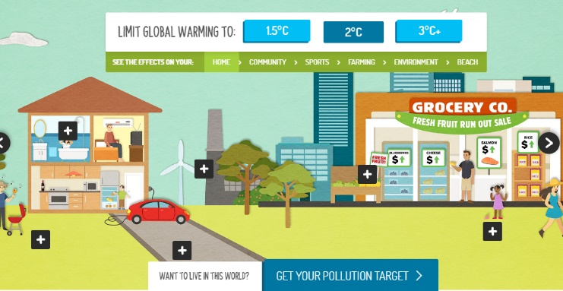
Students investigate how their world could change as global temperatures rise through the WWF’s interactive. They will see the effects on their home, community, sports, farming, environment and beach.

Summarise what you noticed when global warming increased by:
- 1.5°C
- 2°C
- 3°C+

Activity: Taking Action on Climate Change
Students will investigate ways that they can be part of the solution to reduce the effects of climate change. Discuss with the class ways to reduce the effects of climate change. What can be done on a global, national and local level? What changes can be made in our homes and schools to reduce emissions?

Reducing greenhouse gas emissions is the key to reducing the impact of climate change. This means getting most of our energy from a range of renewable energy sources instead of burning fossil fuels. Students can choose to research a clean energy technology in more detail and explain how it works and whether the technology is being used in Australia.

Ask your students ‘What can we do and why is it important to get involved in tackling pollution?’. Record students’ responses on a mind map. Ask students to think about ways their school and home can reduce energy demand, become more energy efficient and incorporate renewable energy sources.

Students can undertake one or more of the following activities:
- School energy audit – track your school’s energy usage and calculate your carbon emissions. How can your school reduce its carbon emissions? For example, turn of lights when not in use, turn off computers at the end of the day, find alternatives to driving to school, buy locally sourced seasonal food and reduce your waste. Share your results with the school community.
- Does your school have solar panels? If not, conduct a study and present it to your school.
Research the benefits of using solar energy at your school. Does your school have a plan to reduce its carbon footprint? If so, find out what your school’s targets are in reducing its carbon emissions. Would installing solar panels reduce your schools carbon emissions? Explain.
- Write letters to local or federal politicians expressing your school’s views on greenhouse gas emissions and its impact on communities, plants and animals in your local area.
- Contribute a class article to the school newsletter sharing your research.
- Invite a scientist to visit your school to talk about the effects of global emissions.
- Contact your local council and/or schools in your area to share ideas on how your community can reduce their greenhouse gas emissions.

Young People Taking Action
Watch the BTN Climate Change Court Battle story to find out how a group of teenagers challenged the Federal Environment Minster over the expansion of a coal mine in New South Wales – saying she has a duty to protect kids from the future impacts of climate change. Below are some questions about the story students can respond to. Students can also find out whether there are any updates or resolutions to the court case.
- Why have a group of teenagers taken the Federal government to court?
- They are hoping the court action will restrict the environment minister from approving an extension to the ____________mine.
- What does the government say are the benefits of the coal mine?
- Why don’t Izzy and Tom want the extension of the coal mine to go ahead?
- What is a class action law suit?
- Who are the group of teenagers representing?
- Taking a government to court has become more common. True or false?
- Why do Tom and Izzy say it’s important for young people to take action?

Useful Websites
- Climate Change Court Battle – BTN
- Greenhouse Gases – BTN
- Greenhouse Effect – Bureau of Meteorology
- Greenhouse Effect – Climate Kids: NASA

KEY LEARNING
Students will investigate ways to reduce carbon emissions at home, school and in the community.

CURRICULUM
Geography – Year 4
The use and management of natural resources and waste, and the different views on how to do this sustainably.

HASS – Year 4
Reflect on learning to propose actions in response to an issue or challenge and consider possible effects of proposed actions.

HASS – Year 5 & 6
Reflect on learning to propose personal and/or collective action in response to an issue or challenge and predict the probable effects.

HASS – Year 7
Reflect on learning to propose personal and/or collective action in response to an issue or challenge, taking into account different perspectives, and describe the expected effects.

Science – Year 4
Science knowledge helps people to understand the effect of their actions.

Science – Years 5 & 6
Scientific knowledge is used to solve problems and inform personal and community decisions.

  - Teacher Resource

Zero Emissions

Activity: Class Discussion
After watching the BTN Zero Emissions story students will reflect on the story and then respond to the following:
- What do you THINK about what you saw in the BTN story?
Positives Challenges
- What does it mean to have net zero emissions?
- What are some ways that we can achieve net zero carbon emissions by 2050?
- Think of three questions you have about the BTN story.
- What are the positives and challenges of trying to reach zero emissions? Create a T-chart.

Activity: Vocabulary
Students will brainstorm a list of keywords that relate to the BTN Zero Emissions story. Here are some words to get them started. Students will create their own class glossary of keywords and terms. Students can use illustrations and diagrams to help explain each keyword.
CARBON EMISSIONS | FOSSIL FUELS | RENEWABLE ENERGY
ATMOSPHERE | CLIMATE CHANGE | FOOTPRINT
GLOBAL WARMING | SUSTAINABILITY | GREENHOUSE GAS

Further investigation: Tricky Words
Students will choose additional keywords and terms to add to their class glossary that are tricky. For example, carbon offsetting, CFCs, emission trading scheme, Kyoto Protocol or greenhouse effect. Students will find a definition and explain to their classmates what the keywords mean.

Activity: Six Hat Thinking
As a class, use Edward De Bono’s Six Hat Thinking to explore the issues raised in the BTN Zero Emissions story. Make your own coloured hat cut-outs and place on the floor. Students will take it in turns answering questions in relation to what they already know about the issue, what they have learned from the story and what they want to learn further about the topic.

Reflection
After this activity, ask students to reflect on what they have learnt. Students can include details about how their thinking on this issue has changed.

How did the Zero Emissions story make you feel?

What do you know about the topic?
What have you learnt from the story?
Were there any positives from the story? If so, what were they?
What are some of the negatives or challenges that you learnt from the story?
Why is it important to find out more about the topic?
What questions were raised during this activity?
What do you want to learn further about this topic?

Activity: KWLH
Hold a class discussion about the information raised in the BTN Zero Emissions story. What questions were raised in the discussion and what are the gaps in their knowledge? The following KWLH organiser provides students with a framework to explore their knowledge on this topic and consider what they would like to know and learn.

What do I know? | What do I want to know? | What have I learnt? | How will I find out?

Research questions for Inquiry
Students will start to think like a scientist and develop their own question/s for inquiry, collecting and recording information from a wide variety of sources. Students may develop their own question for inquiry or select one or more of the questions below.

- What is carbon offsetting? Find a real life example of a company that is carbon offsetting and explain what they have committed to, to reduce their carbon footprint.
- What is the difference between weather and climate? Use meteorological terms in your explanation.
- What is currently being done to reduce our carbon footprint? Think about how your family, school, businesses and the government are trying to reduce their carbon footprint. Give examples.
- What is the difference between the Kyoto Protocol, the Paris Agreement and the Geneva Convention? How is Australia committing to these agreements?
- How can a city reach net zero carbon emissions? Design a sustainable community (think about transport, renewable energies, being water smart, recycling programs, growing food locally, changing habits) to represent your findings.
- What does climate change look like? Use images to show the impact of climate change in Australia. For example, bleaching of coral reefs in the Great Barrier Reef, dry lightning storms in Tasmanian World Heritage Forests or rising sea levels flooding mangroves.

Activity: Take action
Ask your students ‘What can we do and why is it important to get involved in tackling climate change?’ Facilitate a brainstorming session and record students’ responses on a mind map. Individually or in pairs, students will explore ways their school and home can reduce their carbon emissions and become more environmentally sustainable.

Students can undertake one or more of the following activities:
- School energy audit – track your school’s energy usage and calculate your carbon emissions. How can your school reduce its carbon emissions? For example, turn of lights when not in use, turn off computers at the end of the day, find alternatives to driving to school, buy locally sourced seasonal food and reduce your waste. Share your results with the school community.
- Does your school have solar panels? If not, conduct a study and present it to your school.
Research the benefits of using solar energy at your school. Does your school have a plan to reduce its carbon footprint? If so, find out what your school’s targets are in reducing its carbon emissions. Would installing solar panels reduce your schools carbon emissions? Explain.
- Write letters to local or federal politicians expressing your school’s views on greenhouse gas emissions and its impact on communities, plants and animals in your local area.
- Contribute a class article to the school newsletter sharing your research.
- Invite a scientist to visit your school to talk about the difference between weather and climate.
- Contact your local council and/or other schools in the area to find out how they are reducing their carbon footprint. Share ideas on how your community can reduce their greenhouse gas emissions.
- Design a special lesson to teach other kids at your school about why it’s important for people to take action against global emissions.
- Propose some goals (short-term and long-term) that your school could set to try and reduce their carbon footprint. Include a pact or plan of action in your proposal.

Activity: What is the Greenhouse Effect?
Working in pairs or small groups, ask students to discuss their understanding of the greenhouse effect. Use the following questions to guide discussion.
- What is the greenhouse effect?
- Why is it called the greenhouse effect?
- How is the earth a greenhouse? What are the similarities between earth’s atmosphere and a greenhouse that you would find in a garden?

In their pairs or groups, students will create a diagram/illustration to explain the greenhouse effect, including the following elements in their image: sun, earth, atmosphere, ozone layer and greenhouse gases.

What are the Consequences?
Ask the class to consider a range of consequences for not reducing greenhouse gas emissions. Rate the consequences on a scale of 1 to 10, where 1 is a low impact and 10 is severe impact.

Have students give their opinion on the likelihood of each consequence. Below are some suggested consequences:
- Rising temperatures
- Ice will melt
- Sea levels will rise
- Plants and animals at risk
- How are our natural ecosystems affected by climate change? (e.g., the Great Barrier Reef ecosystem)
- Health will be affected
- Extreme weather (heat waves, flooding, bushfires, drought)

Activity: What is climate change?
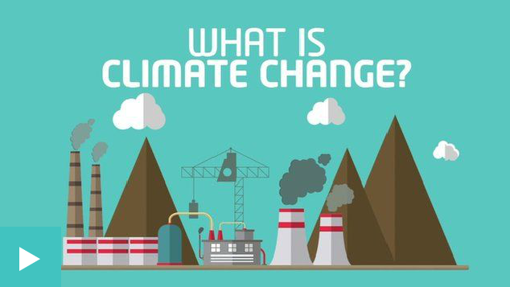
The following video explains what climate change is and the impact rising temperatures could have. Watch the Newsround video and answer the following questions:
- Pollution that causes climate change comes from what?
- Why is 2 degrees an important number?
- What are some of the effects of climate change?
- What can be done to reduce the impact of climate change?

Activity: BTN stories
Watch one of the following BTN stories to learn about hands-on projects that kids around Australia are working on at home, in the classroom and in the community to help the environment and reduce their carbon footprint. After watching any one of the BTN videos ask students to respond to the discussion questions (to find the teacher resources go to the related BTN Classroom Episode and download the Episode Package).

Climate Change Court Battle | 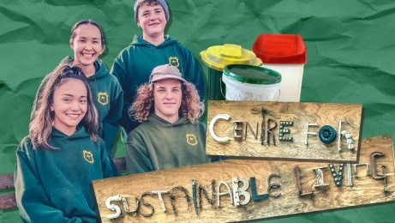  School Recycling Campaign | 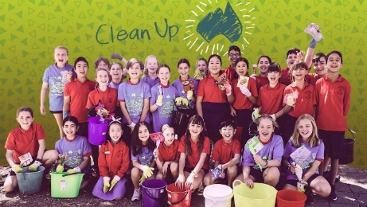  Clean Up Australia
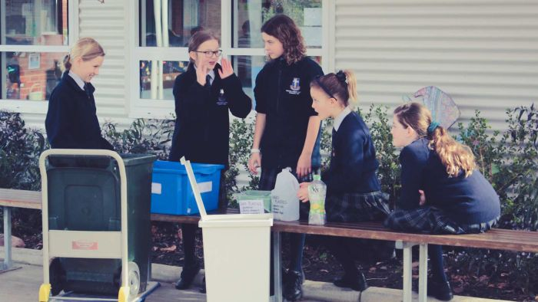  Recycling Solution | 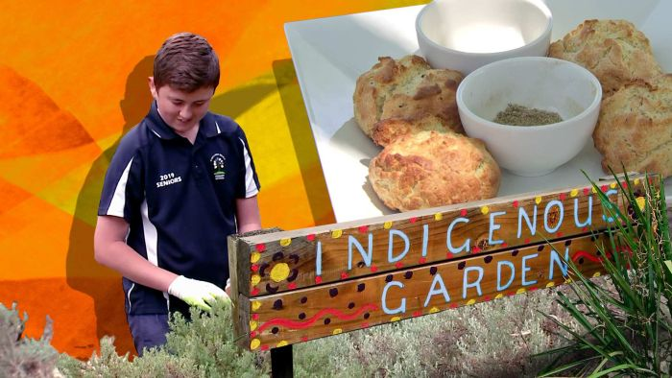  Bush Tucker Garden | 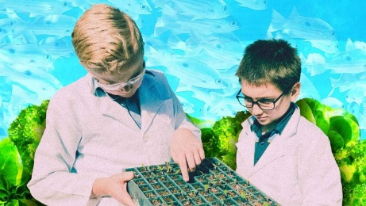  Aquaponics School
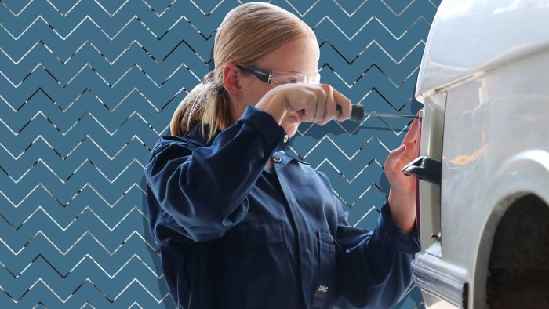  Electric Car Class | 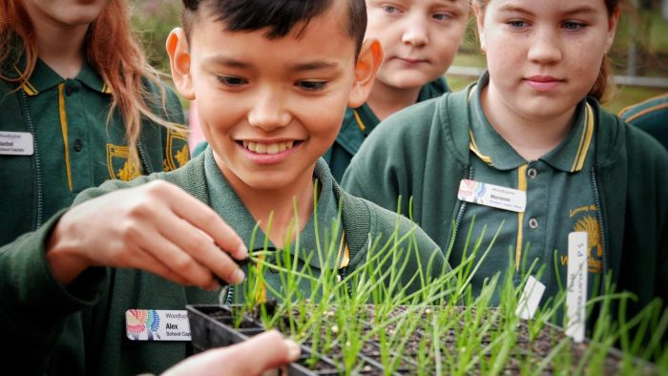  Endangered Seeds | 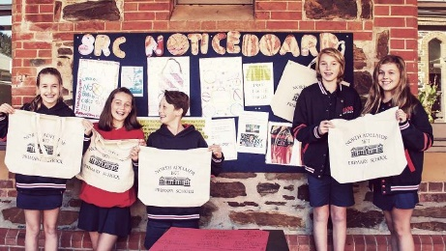  War on Waste School

Activity: Quiz
- What is the international treaty on climate change?  A. Paris Agreement  B. Kyoto Protocol  C. Geneva Convention  - Which of these is a greenhouse gas?  A. Carbon dioxide  B. Methane  C. Nitrous oxide  D. All of the above  - What is the chemical formula for carbon dioxide?  A. CO2  B. C2O  C. O2  - The Earth’s atmosphere is made up mostly of oxygen.  A. True  B. False  - What is NOT a fossil fuel?  A. Coal  B. Natural gas  C. Wood | - What does CFC stand for?  A. Carbon fluoro compound  B. Chloro fluoro carbon  C. Carbon fuel cycle  - What produces the MOST greenhouse gas emissions?  A. Electricity  B. Manufacturing  C. Transportation  - What is it called when there is a balance between emitting carbon and absorbing carbon from the atmosphere?  A. Global warming  B. Greenhouse effect  C. Net zero emissions  - What gas do trees absorb?  A. Methane  B. Carbon dioxide  C. Oxygen  - Which country has NOT yet committed to net-zero emissions by 2050?  A. Australia  B. Sweden  C. United Kingdom
Quiz Answers: 1A, 2D, 3A, 4B, 5C, 6B, 7A, 8C, 9B, 10A.

Useful Websites
- Understanding Climate Change – BTN
- Climate change: What is it and why is everyone talking about it? – Newsround
- Choose your climate future – WWF
- Net Zero Coalition – United Nations
- ‘No blank cheque’ on net zero carbon emissions target, PM says, as global ‘code red’ issued – ABC News
- Climate – WWF

KEY LEARNING
Students will develop a deeper knowledge of what coal is, how it forms, how it is used and how it impacts people and the environment.

CURRICULUM
Science – Year 4
Science knowledge helps people to understand the effect of their actions.

With guidance, identify questions in familiar contexts that can be investigated scientifically and make predictions based on prior knowledge.

Science – Year 5 and 6
Scientific knowledge is used to solve problems and inform personal and community decisions.

With guidance, pose clarifying questions and make predictions about scientific investigations.

Science – Year 7
Some of Earth’s resources are renewable, including water that cycles through the environment, but others are non-renewable.

Identify questions and problems that can be investigated scientifically and make predictions based on scientific knowledge.
  - Teacher Resource

Coal Explainer

Activity: Note taking
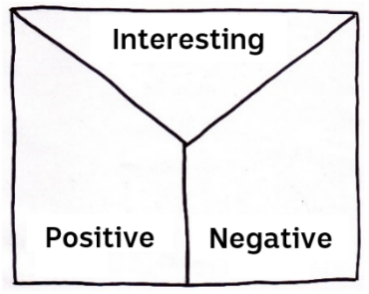
Students will practise their note-taking skills while watching the BTN Coal Explainer story. After watching the story, ask students to reflect on and organise the information into three categories. What information in the story was...?
- Positive
- Negative or
- Interesting

Activity: Class discussion
Discuss the information raised in the BTN Coal Explainer story. Ask students to record what they know about coal on a mind map. What questions do students have? Use the following questions to guide the discussion:
- What is coal made of and where is it found?
- How does coal generate electricity?
- Why is coal such a big issue?
- What impact does the burning of coal have on the environment?
- Do you think it is important that we phase out coal? Give reasons.

Activity: KWLH
Hold a class discussion about the information raised in the BTN Coal Explainer story. What questions were raised in the discussion and what are the gaps in their knowledge? The following KWLH organiser provides students with a framework to explore their knowledge on this topic and consider what they would like to know and learn.
What questions do you have about coal?

What do I know? | What do I want to know? | What have I learnt? | How will I find out?

Research questions for Inquiry
Students will start to think like a scientist and develop their own question/s for inquiry, collecting and recording information from a wide variety of sources. Students may develop their own question for inquiry or select one or more of the questions below.

- What is coal and how does it form? Include as many of the following terms in your explanation: sedimentary, carbon, fossil fuel, Carboniferous period, pressure, carbonisation, coal seam.
- When and where was coal first discovered in Australia? Investigate the history of coal and record your findings on a timeline.
- How do living things turn into fossil fuels?
- What is the carbon cycle? How long does it take for fossil fuels to form?
- How much of the world’s electricity comes from coal? Look at other sources of electricity and compare and contrast to coal.
- What are fossil fuels and what are the issues with continuing fossil fuel use?
- Will we ever run out of coal? What is the difference between renewable and non-renewable energy? Record your responses on a Venn diagram.
- Do you think we should continue burning coal for power? Why or why not?

Activity: Persuasive text
Students will develop a persuasive text for or against one of the following statements (alternatively, students can develop their own statement):

“Coal power should be banned”
“100% renewable energy can power the world”
“The Australian government should support phasing out coal”
“Coal mining should be allowed in Australia”
“We can live without fossil fuels”

Students will explore one or more of the following questions as part of their research:
- How does burning coal affect the environment?
- How will banning coal power affect the economy?
- What are some alternatives to coal power?
- How can the government promote and support the use of renewable energies?
- Who and what will be at risk if we continue to burn fossil fuels?
- Why do you think some people don’t want to ban coal power?

Terminology
Students will create their own class glossary of keywords and terms. Students can use illustrations and diagrams to help explain each keyword. Encourage students to use as many of the following key words and terms in their persuasive text as they can.

COAL MINING | SUSTAINABLE | FOSSIL FUELS
AIR POLLUTION | GREENHOUSE GAS EMISSIONS | CARBON DIOXIDE
NATURAL RESOURCE | ENERGY | ECONOMY

Persuasive text Structure
Encourage students to use a range of sources. Provide students with the following structure to follow when completing this activity.

Introduction
- What is the point you are trying to argue? Construct an introductory paragraph which states the issue or topic.
- Introduce the arguments that will be developed in the body of the text.

Body
- Construct arguments that support your point of view.
- Each paragraph starts with a topic sentence which introduces each point.
- The rest of the paragraph gives more reasons.
- Arguments can be ordered from strongest to weakest.

Conclusion
- Restate your position on the argument.
- Construct a concluding paragraph that provides a summary of your arguments and a call to action.
Tips
- Who is your audience? For example, are you directing your argument at kids, teachers or politicians?
- Explore how language choices can have a big impact on persuading your audience.
- Which language devices give the report credibility and authority?
- Which are designed to create an emotional response in the listener?
- Provide facts and evidence to support your argument.
- Write in the present tense.
- Check your spelling and punctuation.
- Use this Read Write Think persuasion map to organise your information.

Activity: Quiz
- Coal is a naturally occurring rock.  A. True  B. False  - What is coal made of?  A. Charcoal  B. Inorganic matter  C. The remains of living things  - What type of rock is coal?  A. Igneous  B. Metamorphic  C. Sedimentary  - Coal is a renewable resource.  A. True  B. False  - When was coal first used to generate electricity for homes and factories?  A. 1780s  B. 1880s  C. 1980s | - What happens when coal is burnt?  A. It makes heat and light energy  B. It turns into charcoal  C. It reverts into a living thing  - What type of gas is released when coal is burnt?  A. Carbon Dioxide  B. Hydrogen  C. Krypton  - What is NOT a fossil fuel?  A. Coal  B. Natural gas  C. Bio-diesel  - What is the biggest contributor to climate change?  A. Burning coal  B. Cutting down forests  C. Increased livestock farming  - At the COP26 climate summit countries agreed to…  A. Phase up coal  B. Phase down coal  C. Phase out coal

Quiz Answers: 1A, 2C, 3C, 4B, 5B, 6A, 7A, 8C, 9A, 10C.

Useful Websites
- Adani Coal Mine – BTN
- Clean Coal – BTN
- Zero Emissions – BTN
- Coal – National Geographic
- Coal – Geoscience Australia
- Why is coal such a big issue in climate change talks? – Newsround

