EPISODE 10
30th April 2024

KEY LEARNING
Students will view a range of BTN stories and use comprehension skills to respond to a series of focus questions.

CURRICULUM
English – Year 4
Use comprehension strategies to build literal and inferred meaning to expand content knowledge, integrating and linking ideas and analysing and evaluating texts.

English – Year 5
Use comprehension strategies to analyse information, integrating and linking ideas from a variety of print and digital sources.

English – Year 6
Use comprehension strategies to interpret and analyse information and ideas, comparing content from a variety of textual sources including media and digital texts.

English – Year 7
Use comprehension strategies to interpret, analyse and synthesise ideas and information, critiquing ideas and issues from a variety of textual sources.
  - Teacher Resource

Focus Questions
As a class, discuss the stories featured in the episode of BTN Classroom and record the main points of the discussion. Students will then respond to the following focus questions.

Kokoda Track
- Why was Prime Minister Anthony Albanese visiting Papua New Guinea recently?
- During which war was the Kokoda campaign?
- Why were Australian soldiers sent to New Guinea?
- Describe the conditions on the Kokoda Track.
- Why is the Kokoda campaign an important symbol to many Australians today?

Check out the teacher resource on the Archives page.

China Athlete Doping Claims
- What was the main point of the BTN story?
- When the first modern games began, the International Olympic Committee weren't too concerned with Olympians using drugs to give them an advantage. True or false?
- In which decade did the International Olympic Committee ban athletes from using performance enhancing drugs?
  - 1890s
  - 1960s
  - 1990s
- What did a recent documentary reveal about 23 Chinese swimmers that competed at the 2020 Tokyo Olympics?
- What do you understand more clearly since watching the BTN story?

Homework Ban
- Briefly summarise the BTN Homework Ban story.
- Fill in the missing words. In Poland, homework is now __________________for students in years 1 to 3 and for students in years 4 to 8, it’s _________________.
- What are the pros and cons of doing homework? Create a T Chart.
- How much homework do you do each night? What would happen if you didn’t do any homework?
- Do you think a homework ban for primary school students is a good idea? Give reasons for your answer.

Astronaut Training
- Which space agency did Katherine Bennell-Pegg complete her astronaut training with?
  - NASA
  - European Space Agency
  - Australian Space Agency
- What did Katherine say was a highlight of the training?
- Give some examples of the training astronauts do.
- What skills do you think you need to become an astronaut?
- What questions would you like to ask an astronaut?

Check out the teacher resource on the Archives page.

Helping the Homeless
- How old is Ashton?
- Which organisation does Ashton raise money for?
  - Early Morning Centre
  - The Salvation Army
  - St Vincent de Paul
- Describe the work they do.
- What are in the emergency packs that Ashton helps put together?
- How did the BTN story make you feel?

EPISODE 10
30th April 2024

KEY LEARNING
Students will explore in more detail Australia’s involvement in the Kokoda campaign and the impact the campaign had on those involved.

CURRICULUM
HASS – Years 5 & 6
Develop questions to investigate people, events, developments, places and systems.

Locate, collect and organise information and data from primary and secondary sources in a range of formats.

History – Year 7
Develop historical questions about the past to inform historical inquiry.

Locate and identify primary and secondary sources to use in historical inquiry.
Identify the origin, content, context and purpose of primary and secondary sources.
  - Teacher Resource

Kokoda Track

Focus Questions
Discuss the BTN story as a class and record the main points of the discussion. Students will then respond to the following:
- Why was Prime Minister Anthony Albanese visiting Papua New Guinea recently?
- During which war was the Kokoda campaign?
- Why were Australian soldiers sent to New Guinea?
- Describe the conditions on the Kokoda Track.
- Why is the Kokoda campaign an important symbol to many Australians today?

Activity: See, Think and Wonder
After watching the BTN Kokoda Track story, students will respond to the following questions:
- What did you SEE in this video?
- What did you LEARN from this story?
- What do you WONDER about this story?
- What QUESTIONS do you have about this story?

Activity: Class Discussion
After watching the BTN Kokoda Track story, hold a class discussion using the following discussion starters:
- Where is the Kokoda Track? Locate on a map.
- When did the Kokoda campaign begin and end?
- Who was involved?
- What images/words come to mind when you think of the Kokoda campaign?
- Why do you think the Kokoda campaign remains an important symbol to many Australians today?

Activity: Word Cloud
Students will brainstorm a list of key words that relate to the BTN Kokoda Track story and create a word cloud. A word cloud is a visual made up of important/key words relating to a topic. Ask students to think of words they associate with the Kokoda campaign. Create a word cloud using a free online word cloud creator such as MonkeyLearn or Word It Out. Working in pairs, students can clarify the meanings of the words included in their word clouds.
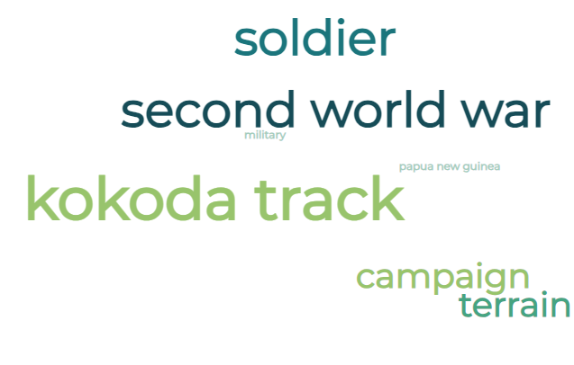

Activity: Kokoda Campaign Research
Discuss the information raised in the BTN Kokoda Track story. What questions were raised in the discussion and what are the gaps in students’ knowledge? Students will develop their own question/s to research or choose one or more of the questions below.

- What was Australia’s involvement in World War II?
- Why were Australian troops sent to Kokoda?
- Why was the Kokoda campaign important in World War II?
- What were the experiences of the Australian soldiers that fought in the Kokoda campaign? include 2-3 primary sources to support your explanation.
- What were the conditions on the Kokoda Track like? Think about the terrain, weather and vegetation. What impacts did the conditions have on the soldiers?
- During the Kokoda campaign, more Australian soldiers died from sickness than in battle. Find out more about diseases or infections that affected soldiers including information about what the symptoms were and how the soldiers were affected. What treatment was available to the soldiers?
- Investigate the psychological factors that impacted Australian soldiers during the Kokoda campaign.
- How were Papuans impacted by the Kokoda campaign?
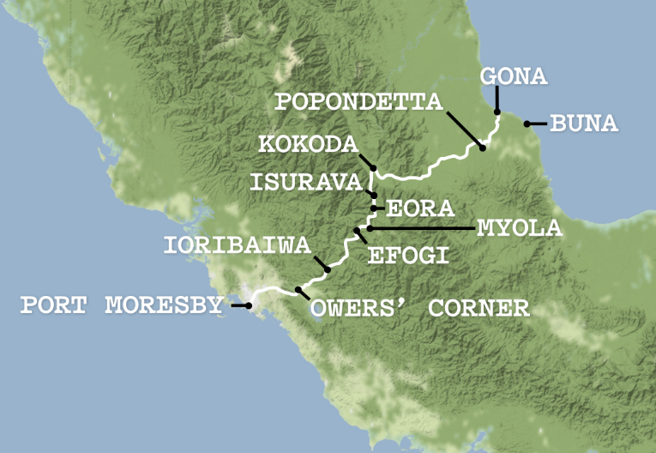
- How did the Kokoda campaign impact Australia’s relationship with Papua New Guinea?
- What is the significance of Kokoda today?
- Using the map of Kokoda, highlight key locations explaining why they were important in the context of the Kokoda campaign.

Activity: Conditions on the Kokoda Track
Below are photographs depicting conditions on the track during the Kokoda campaign. Students will look at the images and then respond to the following questions:
- What is happening in the image?
- What does the photo tell you about the conditions on the Kokoda track?
- How do you think the people in the image might be feeling?
- What question/s would you like to ask the people in the photo?
- Create a caption for each image.

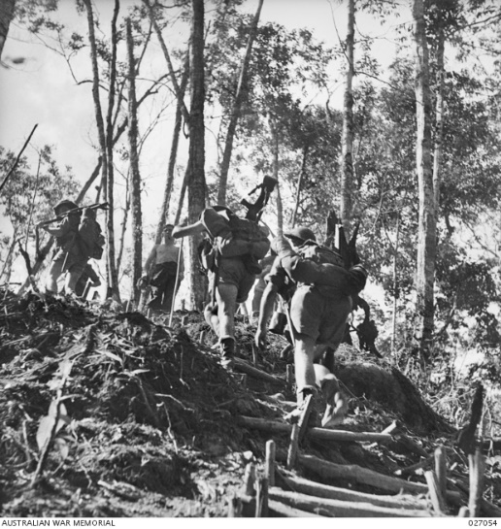
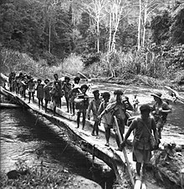
Image Source Image Source

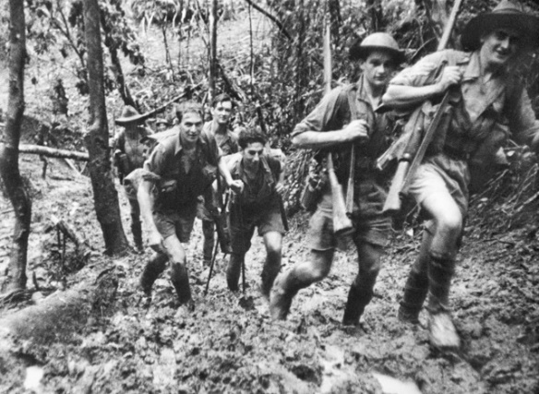
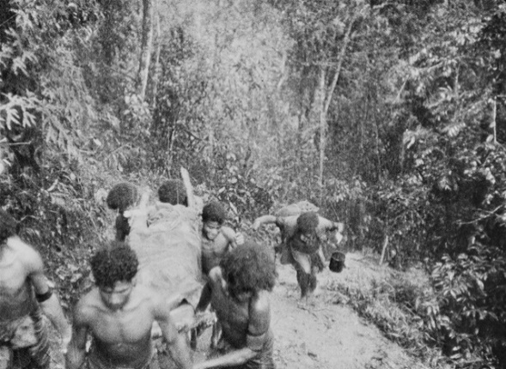
Image Source Image Source

Activity: Primary and Secondary Sources
Begin by clarifying students’ understanding of primary and secondary sources. Ask them to give some examples.

Through using primary sources, a document like a diary, painting or a physical object, that was written or created at a particular time, we can gain an understanding of what might have happened at a place in time. Example of a primary source – Photographs of Japanese bombing raids on Port Moresby

Secondary sources are documents written after an event has occurred, providing ‘second-hand’ accounts of that event, person, or topic. Unlike primary sources, which provide first-hand accounts, secondary sources offer different perspectives, analysis, and conclusions of those accounts. Example of a secondary source – The Age, May 20, 1942 49 Planes in Attack

Analysing Sources
Students will analyse primary and secondary sources from the Kokoda campaign. Look at each image/clip and respond to the questions provided. Click on each link to see the source in more detail.

Source A  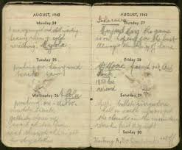  Source | - Is source A, a primary or secondary source?  - Who wrote the diary?  - When was it written?  - What information is included in the source?  - Why was the source created?  - Who was the intended audience?  - What does the source tell us about the Kokoda track?  - Do you think it’s a reliable source? Explain.
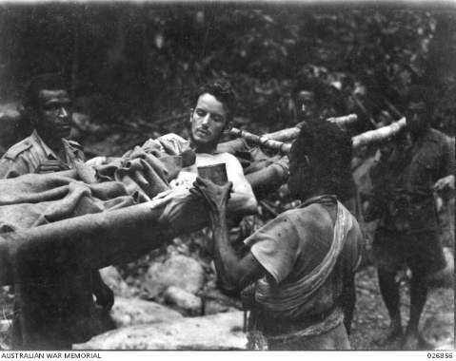  Source B  Source | - Is source B a primary or secondary source?  - Who took the photograph?  - When was it taken?  - What is happening in the image?  - Why was the source created?  - Who was the intended audience?  - What do you think the Papuans in the image might be thinking or how might they be feeling?  - Do you think it’s a reliable source? Explain.
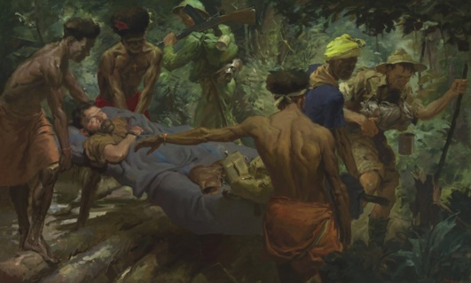  Source C  Source | - Is source C a primary or secondary source?  - Who created the painting?  - When was it created?  - What is happening in the painting?  - Why was the source created?  - Who was the intended audience?  - Do you think it’s a reliable source? Explain.
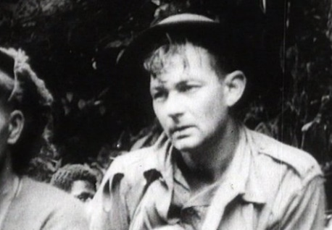  Source D  Source | Watch the clip from the Kokoda Front Line and respond to the following questions:  - Is source D a primary or secondary source?  - Who created the film?  - When was it created?  - What does the film tell you?  - Why was the film created?  - Who was the intended audience?  - What language, images and tone are used in the film?  - Do you think it’s a reliable source? Explain.

Useful Websites
- Anthony Albanese and PNG PM James Marape walk Kokoda Track ahead of Anzac Day – ABC News
- Kokoda 80th Anniversary – BTN
- Kokoda 75th Anniversary – BTN
- Kokoda Trail Campaign – Australian War Memorial
- Kokoda Trail – National Museum Australia

EPISODE 10
30th April 2024

KEY LEARNING
Students will explore what training is involved in becoming an astronaut.

CURRICULUM
Science – Year 5
The Earth is part of a system of planets orbiting around a star (the sun).

Scientific knowledge is used to solve problems and inform personal and community decisions.

Science – Years 5 & 6
With guidance, pose clarifying questions and make predictions about scientific investigations.

Science involves testing predictions by gathering data and using evidence to develop explanations of events and phenomena and reflects historical and cultural contributions.

Science – Year 7
Scientific knowledge has changed peoples’ understanding of the world and is refined as new evidence becomes available.

  - Teacher Resource

Astronaut Training

Focus Questions
Discuss the BTN story as a class and record the main points of the discussion. Students will then respond to the following:
- Which space agency did Katherine Bennell-Pegg complete her astronaut training with?
  - NASA
  - European Space Agency
  - Australian Space Agency
- What did Katherine say was a highlight of the training?
- Give some examples of the training astronauts do.
- What skills do you think you need to become an astronaut?
- What questions would you like to ask an astronaut?

Activity: Are you Curious about space?
Are your students curious about space? Students will make a list of questions they have about the BTN Astronaut Training story. For example:
- How do you become an astronaut?
- What sort of training do astronauts do?
- What is it like being in zero-gravity?
- How long do astronauts stay in space?
- How do astronauts sleep in the International Space Station?
- What happens to your body in space?

Ask your students how they will find answers to their questions. Students will find answers to their questions and share their findings with the class.
How do astronauts train to stay mentally strong?
What training do astronauts do?

Activity: Vocabulary
Students will brainstorm a list of key words that relate to the BTN Astronaut Training story. Here are some words to get them started.

ASTRONAUT | ZERO G | MICROGRAVITY
SPACE MISSION | ROBOTICS | SPACECRAFT

Ask students to write what they think is the meaning of each word (including unfamiliar words). They will swap definitions with a partner and ask them to add to or change the definition. Check these against the dictionary definition.

Further activities for students:
- Astronaut is a compound word derived from two Ancient Greek words. What is the Greek meaning of astronaut?
- Expand on your glossary and create your own glossary of astronaut jargon. Include terms like abort, command module, airlock, cosmonaut, G-force, No Go, zero gravity and uplink.
- Who explores the universe? Learn more about the jobs involved with space exploration. Choose one job and investigate what the job involves and what you need to study to become one.

Activity: Prepare for Take-off
Students will imagine they have completed their astronaut training and have been assigned a mission into to space on board the International Space Station. Students will take on the role of an astronaut and plan what they will take into space.

Background
Astronauts bring a Personal Preference Kit (PPK) into space with them. This Kit is used to carry their chosen personal belongings. These Kits have size and weight restrictions (astronauts are limited to 0.680 kg per astronaut). Explore an astronaut’s Kit from the Apollo 11 mission in 1969 - National Air and Space Museum
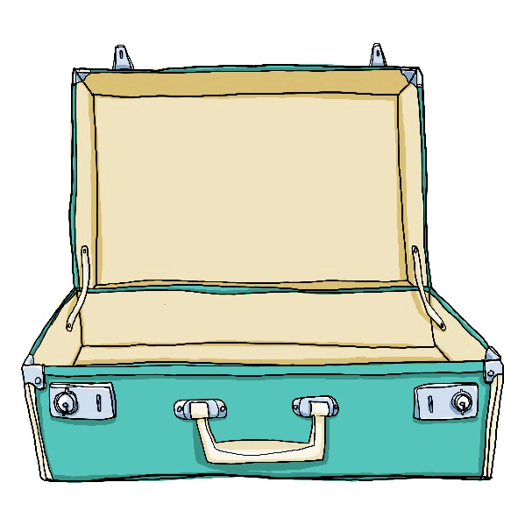
What is in your kit?
You've been invited on a 1-month trip to the International Space Station. Think about the following questions and then plan what you would take in your Personal Preference Kit.
- What would you bring for entertainment? Think about your favourite hobbies, books, or music.
- Would you bring something to remind you of your family or your culture or religion?
- If you could bring a favourite food or drink, what would you bring?

Look at everything you have chosen - do you have more than five things? This is where it gets tricky - you can't bring any more than five things, and everything has to fit in a bag that is 12.82 centimetres × 20.51 centimetres × 5.13 centimetres.

- List the 5 items you would pack in your Kit.
- Find or make a box which has the dimensions of a PPK. Would your chosen items fit?
- What is the total weight of your items?
- Why did you choose these items to take in your Kit? Give reasons.

Measurements – Items in your Kit

Item | Weight in grams | Length in centimetres | Width in centimetres | Height in centimetres | Total Volume
Item #1
Item #2
Item #3
Item #4
Item #5

Activity: Design a Rocket
Take part in the Australian Space Discovery Centre’s S.C.R.A.P Challenge!
The S.C.R.A.P Challenge is a paper rocket design challenge which invites students to set their own success criteria for their creations, then follow an iterative process to optimise their designs.

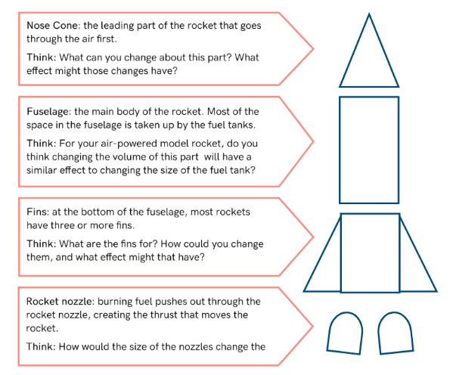

Activity – Choose a Project
Individually or in small groups, students will choose one of the following projects to work on and then present their findings to the class.

DIY Sundial
Make your own sundial with NASA’s template and step-by-step instructions.
Tour the ISS
Have you ever wondered how astronauts go to the toilet in space? Watch this tour of the ISS to learn more. What did you learn?
Nano-Rover
Explore the job of a rover! What do they do, and what have they discovered? Make your own NASA nano-rover.
Space Lander
Make your own space lander. Visit NASA and take on the challenge!

Useful Websites
- New Aussie Astronaut – BTN Newsbreak
- Aussie Astronaut – BTN
- Aussie Astronauts – BTN
- Astronaut Training – BTN
- Life of an Astronaut – TEDEd
- Astronaut – Australian Space Agency
- Pathways for a Career in Space – Australian Space Agency
- Tour of International Space Station – NASA

  - Teacher Resource

BTN Transcript: Episode 10 - 30/4/2024

Hey, I'm Amelia Moseley and you're watching BTN. Hope you had the best holidays, aww it’s great to be back – let’s jump into term two and see what's coming up on today’s show. We learn about the great homework debate, find out what it takes to be an astronaut and meet a primary schooler helping the homeless.

Kokoda Track

Reporter: Saskia Mortarotti

INTRO: All that soon, but first up let's find out more about a journey the Prime Minister, Anthony Albanese made last week when he became the first sitting Aussie PM to walk part of the Kokoda Track. Sas found out why it's such a significant site for Australians.
SASKIA MORTAROTTI, BTN REPORTER: It's a journey many Australians have made before. To a place that is special to a lot of people. On Tuesday last week, Prime Minister Anthony Albanese was given a leaders welcome as he arrived in Kokoda Village, to hike a section of the Kokoda trail with Papua New Guinea’s Prime Minister James Marape.
ANTHONY ALBANESE, PRIME MINISTER: It's such a humbling experience to walk in the footsteps of giants with the PNG Prime Minister.
SASKIA MORTAROTTI, BTN REPORTER: The Kokoda trail is 96-kilometre walking trail that winds through the Owen Stanley Range in Papua New Guinea, from Owers’ Corner to the village of Kokoda in the North. It was first used by European gold miners in the 1890s. But it was in 1942 that the Kokoda trail became a big part of Australia's military history.

At the time the Second World War had been raging for two years. Japan, which was fighting with the Axis powers, had invaded a number of countries in South-East Asia and was getting closer to Australia. In February, Japanese forces bombed Darwin and launched an attack to try to capture the capital of Papua, Port Moresby. At the time, Papua and New Guinea were territories of Australia and defending them was vital to Australia's safety. The trouble was, Australian troops were already fighting overseas. So, reserves were sent in instead. They didn't have a lot of training, or modern equipment and many were very young. Some were volunteers, and others were conscripted.

They arrived by boat in Port Moresby then headed to Kokoda to head off Japanese soldiers who'd landed in Buna. The journey along the Kokoda trail is hard work, uphill, in dense jungle. The narrow tracks turned into rivers of mud in the humid environment, and the nights were freezing cold. Diseases like malaria spread among the soldiers. The Australians had help from Papuan people, who scouted locations, carried supplies, and helped the wounded. Reinforcements were sent to help the reservists and eventually Japan began to withdraw from the track.

On the second of November Australia recaptured Kokoda. 625 Australians died alongside 150 Papuans in battles during the Kokoda campaign while another 4000 Australians died from disease. In the years after the war, the Kokoda trail became a pilgrimage for many Australians who would make the 4 to 12 day journey to honour the soldiers who fought and died here. But this is the first time a sitting Prime Minister has ever hiked a section of the trail. On the first day Anthony Albanese and James Marape walked 9 kilometres from Kokoda to Hoi Village, where they were greeted by locals and camped under the stars. On the Wednesday they continued the uphill trek with just a minor stumble. Before arriving at Isurava, the site of a long and deadly battle during the Kokoda campaign.
ANTHONY ALBANESE, PRIME MINISTER: What we have done over the past couple of days is get just a small insight of the courage and resilience.
SASKIA MORTAROTTI, BTN REPORTER: On Anzac Day, the leaders attended a dawn service together where they paid respect to the people who died in the Kokoda Campaign and in every battle before and since.
ANTHONY ALBANESE, PRIME MINISTER: We hold to the solemn promise that our countries made to the fallen all those years ago, we will remember them.
News Quiz
Former US President and presidential hopeful Donald Trump is being tried in a New York court. Do you know what charges he’s facing? Is it, falsifying business records, obstructing official proceedings or holding classified documents? In this case it’s falsifying business records. The prosecution says in the leadup to the 2016 election Mr Trump paid to cover up stories that would make him look bad and then hid those payments. He’s the first US president to ever face criminal charges and he’s got three more criminal court cases to come.

Can you name this world leader? It’s Narendra Modi, the Prime Minister of India, a position he’s hoping to hold onto as his country goes to the polls. Over the next few months more than 970 million people will vote for the 543 members of the Lok Saba, or House of the People, making this the biggest election ever held.

What big change did Australia Post bring in over the holidays? Drone deliveries, fewer standard mail deliveries or fewer parcel deliveries? It was fewer standard mail deliveries. To save costs and free up time for parcel deliveries Aus Post is now only delivering standard letters to homes once every two days.

A comet named 12P Pons-brooks has appeared in the sky for the first time in 71 years. What’s the comet’s nickname? The Ghost Comet, The Devil Comet or The Demon Comet? It’s the devil comet, because in some older photos it kinda looked like it had horns. Now, to us, at least, it looks like a fuzzy green ball, with a tail.

And while we’re in space lets head to Mars where this interplanetary helicopter has beamed its last signal back to Earth. Do you know its name? Ingenuity, Curiosity or Perseverance. It’s Ingenuity. NASA made the helicopter to test out how hard it would be to fly in Mars’ difficult conditions. It crash landed in January this year but while it can’t fly anymore it will keep on taking pictures which we may get to see if we ever land on Mars.

China Sports Doping Claims

Reporter: Jack Evans

INTRO: With the countdown on to the Paris Olympic games, a lot of people are talking about doping. That's because of recent reports that 23 Chinese swimmers tested positive to a banned drug before the last Olympics but were allowed to compete anyway. So, what's going on? Let's find out.

JUSTINA: Snap.
SAS: Snap.
JUSTINA: Wait, what are you doing?
SAS: I'm helping Jack
JACK: Yeah.
JUSTINA: You can't do that, that's cheating.
JACK: Oh, cheating is such a strong word, think of them as more enhancing my performance.
JUSTINA: What?
When it comes to sport, or I guess this game of snap, you'd like to think everyone was playing fair. But as long as people have been competing, they've been finding ways to get the winning edge.
SAS: Snap. You know, you're not very good at this.
JUSTINA: Well, maybe I would be, if I had someone helping me.
Thousands of years ago during the ancient Olympic games it was quite common for athletes to experiment by eating or drinking different things to see what effect they may have when competing. When the first modern games began in 1896, the International Olympic Committee weren't too concerned with Olympians using drugs to give them an advantage.
But as the years went on performance enhancing drugs became more effective and it started to be clear how unfair it was for the athletes who weren't using them. Plus, some drugs were seriously dangerous, and some athletes died after taking them. In the 1960s the IOC banned athletes from using performance enhancing drugs, regular testing became a thing and eventually the World Anti-Doping Agency or WADA was established as a way to stop illegal doping, although it didn't go away.
Over the years there have been some famous doping scandals. For example, Canadian sprinter Ben Johnson tested positive to banned drugs two days after breaking the world record in the men's 100 metres at the 1988 Olympics in Seoul. In 2007 American track and field athlete Marion Jones admitted to doping while competing at the 2000 Sydney Olympics. At the 2016 Olympics in Rio many Russian sporting stars were disqualified from competing after failing drug tests. And just last week we found out that 23 Chinese swimmers had tested positive to small amounts of a drug called trimetazidine during the 2020 Tokyo Olympics.
NEWS REPORT: It's been revealed that 23 members of the Chinese squad tested...
NEWS REPORT: …tested positive to the banned substance trimetazidine.
It's a drug that's used to treat heart disease, but it also helps with endurance, and it's banned. The Chinese Anti-Doping Agency says the athletes didn't mean to take it and that it had somehow found its way into food at the hotel they were staying at, and WADA accepted the explanation.
WITOLD BANKA, WADA PRESIDENT: We had no evidence of wrong doing at present and no credible way to disprove the contamination theory that was accepted by CHINADA and a position that was also accepted by World Aquatics.
But now, 3 years later many countries say that China and WADA should have been open about the positive testing and that the athletes shouldn't have been allowed to compete, even if it was an accident.
TRAVIS TYGART, CEO USADA: The whole situation is a tragedy for clean athletes around the world. The fact that, you know, the rules weren't followed.
WADA has stood by its decision.
WADA PRESIDENT: If we had to do it over again now, we would do exactly the same thing.
But with the Paris Olympic Games less than 100 days away, many will be looking closely at the issue of doping to make sure the games are as fair as possible.
TRAVIS TYGART, CEO USADA: Athletes are calling for a review and investigation and we have to get to the bottom of how this possibly happened.
Homework Ban

Reporter: Justina Ward

INTRO: Now to Poland where some kids are celebrating after the government decided to ban homework for lower primary kids that is. The idea is to give kids more time to be kids. Justina found out more about the debate around homework.
NAT: Hey, Nat here, let’s see what’s making news. Poland has just banned homework. Yes, that's right no homework ever. For lower primary students anyway. Here’s Wren.
DAKOTA: Are you thinking what I'm thinking?
JACK: Yeah. Let's move to Poland.
DAKOTA: No, let's make a mind control device so we can make the Prime Minister ban homework in Australia.
JACK: Okay.
Yep, over here in Poland, kids are here living the dream. Homework is now banned for students in years 1 to 3 and for students in years 4 to 8, it's optional and won't count towards grades.
OLA: I am happy because this homework, I did not like it too much and it didn't really make much sense because most people in my class, in the morning would copy it from someone who has done the homework.
JUILAN: It's a little bit uncool that there is no more homework. But when there is no homework, that's also rather cool.
The Polish government decided to make the big move. After a moment that went viral at a campaign rally in the lead up to the parliamentary elections were a 14-year-old decided to make a stand for all Polish kids.
MACIEK, PRIMARY SCHOOL STUDENT: This is a general problem of Polish schools that children's rights are being violated. For example, the right to take some rest. There is homework to be done during weekends, tests on Mondays, and so much homework is given us that we find no time for rest.
A lot of people agreed with Maciek. Before the ban, Polish kids spent around 1.7 hours per day on homework, which is more than a lot of other countries, and some experts questioned whether or not it was doing any good.
BARBARA NOWACKA, POLISH EDUCATION MINISTER: When I read research regarding the mental health of children, their overload with learning, the reasons of depression, of tensions, stress, or loss of interest in learning, one of the factors, the one that could be removed fastest, was the burden of homework.
Some studies have shown that while homework can be handy for high school students in primary school it doesn't necessarily help you learn and it takes up time that could be better spent doing things like hanging out with friends, playing sport, or doing other creative stuff.
STUDENT: I don’t mind it but I still feel like it’s a waste of time.
STUDENT: Because you could do everything else? Like you could do exercise? You could, like, play games.
On the flipside, fans of homework say, it can be a good way of making sure all the stuff you've learnt at school sticks in your head, and getting your parents involved in your learning. It can also teach you how to work independently, and to help you get ready for high school and university.
STUDENT: You can research more, and you have more time to catch up.
STUDENT: My grades have gone up a lot because of doing homework.

Some parents and teachers in Poland aren't on board with the ban, which they say happened too quickly and without enough consultation. So, could something like this happen here? Well, right now it's not on the cards and it's up to schools to decide their own homework policies. Unless of course...

DAKOTA: Three, two, one.
JACK: Did it work?
DAKOTA: Probably not.
Did you know?

While we don't know exactly who invented homework, some people credit famous Ancient Roman scholar Pliny the Younger. He would ask followers to practice their public speaking at home. Homework may have even saved Pliny's life when Mt Vesuvius erupted, he decided not to go and see it with his uncle because he wanted to finish some written work.
Astronaut Training

Reporter: Jack Evans

INTRO: Aussie Kathrine Bennell-Pegg has finished training with the European Space Agency in Germany to become a real life Astronaut. She's the first woman to do that under the Australian flag.
Jack found out what Katherine's been up to and what it takes to go to space.
It's a career many dream of having and one that's not for the faint hearted. Taking months, sometimes years of training just to be qualified for the…
JACK: Wait! Months of training? I haven't had any training. They just gave me this flimsy space suit and said for me to walk in slow motion. I didn't know you had to have training to be an Astronaut, did you know about the training?
While I might not be completely qualified to be an Astronaut, someone who is now, is Australia's own Katherine Bennell-Pegg.
KATHERINE BENNELL-PEGG, AUSTRALIAN ASTRONAUT: I've got the astronaut wings on and the Australian flag on my shoulder, it's, it's absolutely incredible to graduate as an astronaut, especially an Australian astronaut is a dream come true.
You might remember Katherine, Michelle chatted with her last year…

KATHERINE BENNELL-PEGG, AUSTRALIAN ASTRONAUT: Welcome to the Australian Space Discovery Centre.

…when it was announced that she’d been chosen out of more than 22,000 applicants to be the first Australian to train as an astronaut in Germany, as part of a partnership between the Australian Space Agency and the European Space Agency.
KATHERINE BENNELL-PEGG, AUSTRALIAN ASTRONAUT: I didn't believe I'd ever have the chance to do this as an Australian. And now here we are. And you know, while I might be the first to represent Australia, I certainly am determined to not be the last.
That's right, many hope that Katherine's success will lead to other Aussies being invited to train with different space agencies. So now, like me, you're probably thinking.
JACK: What exactly does it take to be an astronaut?
KATHERINE BENNELL-PEGG, AUSTRALIAN ASTRONAUT: Yeah, this here's been 13 months of intense training and many different topics.
JACK: Oh, intense training and many different topics.
KATHERINE BENNELL-PEGG, AUSTRALIAN ASTRONAUT: A major highlight was last week, when I went on a zero G plane. So that's when you go up in a special plane. And in bursts of 22 seconds experience, close to zero G. And we did that to learn how to manoeuvre in space and avoid colliding too much and to do actual exercises.
Zero G means Zero Gravity, it feels like you're floating because gravity isn't pulling you down anymore.
JACK: Which sounds absolutely incredible.
KATHERINE BENNELL-PEGG, AUSTRALIAN ASTRONAUT: it's absolutely incredible.
JACK: Oh, there you go.
If you can't get your hands on a Zero G plane, how about a spacewalk underwater?
JACK: I don't think that pool is big enough.
Well there are plenty of other things that you'll need to learn like how to speak Russian.
JACK: Borscht, is that it? Bosh? Borscht.
That's because both Russian and English are spoken on the ISS. Speaking of which, you'll also need to know how to operate and maintain the international space station.
JACK: I don't know about that.
Of course you'll have to have an understanding of robotics.
JACK: What are you?
And how to conduct experiments in space.
JACK: I'm sure it'll work in space.
Oh, and the most important part.
JACK: What am I going to wear?
KATHERINE BENNELL-PEGG, AUSTRALIAN ASTRONAUT: I got to try on the new suit for humans going back to the moon. So that was a special day. And they're looking at making them far more for diverse body types and more comfortable than before. So, more people can go to space and do good work up there.
While Katherine isn't signed up for a mission to space just yet, her new qualification means she could one day head to the International Space Station and become the first Aussie woman in space. But in the meantime, she wants to inspire the astronauts of the future to shoot for the stars.
KATHERINE BENNELL-PEGG, AUSTRALIAN ASTRONAUT: Well, I would say go for it. Being an astronaut is as fun as you can imagine, work hard, work hard at school, work hard at your job and dream big because it can happen.

JACK: Ohhhhhhh, so that’s what ISS stands for, ha.

MAN: (ON ASTRONAUT INTERCOM): Abort Mission. I repeat, abort mission.

Quiz

The Zero G plane that astronauts train on has an interesting nickname. Do you know what it is? The spew ship, vomit comet or the retching rocket? It's the vomit comet. Gross.

Sport

24th birthdays don't come much better than this.

COMMENTATOR: A superb champions league semi-final.

Ellie Carpenter and her Lyon team are heading to the Women's Champions League final. After they beat fellow French side PSG 2 to 1 in the second leg of their semi-final run. The team will now take on Barcelona for the title not before a quick happy birthday though.
Now to LIV golf, which took place in Adelaide over the weekend. And, for the third time, American pro Brendan Steele took the win by just one shot.

BRENDAN STEELE: I really can't say enough great things about the golf course and the fans and the whole country here. It's just been fantastic.

Meanwhile the Aussies took the win in the teams category thanks to some nifty work from Cameron Smith.
COMMENTATOR: True Aussie grit!
And finally, to the Olympic torch, which has just set sail on a 128-year-old French ship, on route to France.

WOMAN: Watching the Belem leaving with the flame on it, it was really amazing and exceptional.

The flame will arrive in Marseille next week, kicking off a torch relay around the country that will end at the Olympic opening ceremony in Paris.

Helping the Homeless
Rookie Reporter: Ashton

INTRO: Finally, today let's meet Ashton also known as Mr Ten. He's been taking action to help support people experiencing homelessness in Canberra. Check it out.

ASHTON: Hi, my name is Mr. 10 and I've been raising money for the homeless. It was very sad for me to see people on the street. I just felt really sad for them, and I felt like everyone should have the same opportunities as me. So, my mum and dad introduced me to the Early Morning Centre, and I started raising money through them. They make breakfast, and lunch for people who are in need, and they also have like, hospitals, vets, and people like that come over, they have free Wi-Fi and laundry. Cherie was really nice about it, and she said some stuff about the Early Morning Centre and what they do and how I can help them and their emergency packs which I started doing. People in need are allowed to get them one time a week. They consist of tuna, noodles, baked beans, cereal, and gum. I decided to raise money and make 10 a week, which is $100 dollars a week. My target was to raise $5000 which was 500 packs, which was hard at first, but then I had like these fundraising things at my school fate and those sorts of things.
CHERIE STYLES, EARLY MORNING CENTRE: He's supplied us with a months' worth of emergency food packs to give to our guests. That is amazing for anyone to give, let alone for a ten-year-old to do.
ASHTON: Kind of excited, surprised that I made it this far and, like, happy.
Closer

Awesome work Mr Ten. Well, that's all we have for today, but we'll be back with more next week and in the meantime, you can keep up with us online and check out Newsbreak every weeknight. Have the best week and I’ll see you soon. Bye!

