Episode 28
13th October 2020

COVID-19 Update
- Discuss the BTN story with another student and record the main points of your discussion.
- What has the latest easing of restrictions meant for students in Melbourne?
- Complete the following sentence. Melbourne is now in step _______ of its COVID recovery plan.
- What has happened with Melbourne’s nighttime curfew?
- What has the easing of restrictions meant for people in regional Victoria?
- Why are people happy about the borders opening up between most states?
- People from which country will be able to visit New South Wales soon?
- What is it still important to do, to stop the spread of COVID-19?
- What are the kids in the BTN story looking forward to as restrictions ease?
- How did this story make you feel?

Federal Budget 2020
- What did the BTN story explain?
- Why has this year been difficult for Australia’s economy?
- What impact has COVID-19 had on people’s spending?
- How have businesses been affected?
- Complete the following sentence. A recession means the economy is going _______________.
- What did the government bring in to keep the economy going?
- The federal budget outlines how the government plans to spend money on things like…
- What does it mean when the budget is in deficit?
- Why are some people not happy with the budget?
- What do you understand more clearly since watching this story?

La Niña Explained
- Briefly summarise the BTN story.
- What does La Niña mean in Spanish?
- Describe the weather when La Niña is about.
- When was the last time Australia had a La Niña weather event?
  - 2008 - 2010
  - 2010 - 2012
  - 2012 - 2014
- What causes the changing weather patterns in Australia during La Niña?
- What is there an increased risk of during La Niña?
- What does La Niña mean for farmers?
- What is the opposite of La Niña?
- Describe the weather during an El Niño phase.
- What did you learn watching the La Niña story?

Check out the La Niña Explained resource on the Teachers page.

Mainland Tassie Devils
- About how long has it been since Tasmanian devils lived in the wild on the mainland of Australia?
  - 300 years
  - 3,000 years
  - 30,000 years
- Which celebrity is involved in the Tassie devil rewilding program?
- Where in Australia is the rewilding program?
- Why did Tassie devils die out on the mainland?
- Which introduced species impacted on the Tassie devils?
- What disease has reduced the devil’s population by 90%?
- What does rewilding mean?
- Tassie devils are the world’s biggest meat-eating marsupials. True or false?
- Finish the following sentence: Tasmanian devils could help to control introduced species like…
- What was surprising about this story?

Check out the Mainland Tassie Devils resource on the Teachers page.

COVID Creativity
- What is the name of the app Siddak created during lockdown?
- Explain the concept of the app.
- Why did Siddak create it?
- What has he enjoyed about building the app?
- Explain the idea that Noah and Jai had during lockdown.
- How do you play Cupow?
- What did Diya create during lockdown?
- Who have Diya and her dad been cooking for?
- What has she learnt doing her cooking show?
- What did you like about the BTN story?

Teacher Resource
Episode 28
13th October 2020

La Niña Explained
Students will investigate what a La Nina weather event is and how it could affect Australia’s weather.

Science – Year 6
Sudden geological changes and extreme weather events can affect Earth’s surface.

Science involves testing predictions by gathering data and using evidence to develop explanations of events and phenomena and reflects historical and cultural contributions.

Scientific knowledge is used to solve problems and inform personal and community decisions.
Geography – Year 7
Causes, impacts and responses to an atmospheric or hydrological hazard.

- Briefly summarise the BTN story.
- What does La Niña mean in Spanish?
- Describe the weather when La Niña is about.
- When was the last time Australia had a La Niña weather event?
  - 2008 - 2010
  - 2010 - 2012
  - 2012 - 2014
- What causes the changing weather patterns in Australia during La Niña?
- What is there an increased risk of during La Niña?
- What does La Niña mean for farmers?
- What is the opposite of La Niña?
- Describe the weather during an El Niño phase.
- What did you learn watching the La Niña story?

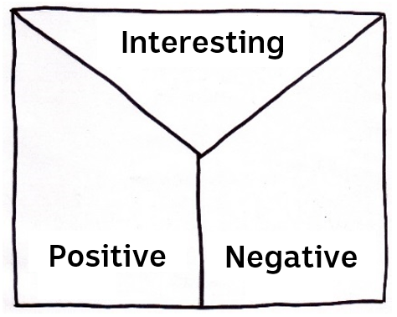Note taking
Students will practise their note-taking skills while watching the BTN La Niña Explained story. After watching the story ask students to reflect on and organise the information into three categories. What information in the story was...?
- Positive
- Negative or
- Interesting

Class Discussion
As a class discuss the BTN La Niña Explained story, using the following questions as a guide. Record the main points of the discussion.
- What is La Niña? Come up with a class definition.
- How could La Niña affect Australia’s weather this spring and summer?
- What causes the changing weather patterns in Australia during La Niña?
- What is the opposite of La Niña?
Key Words
Students will brainstorm a list of key words that relate to the BTN La Niña Explained story. Here are some words to get you started. Students may want to use pictures and diagrams to illustrate the meaning and create their own glossary. Here are some words to get you started.

Climate | La Niña | El Niño
Weather | Trade winds | Pacific Ocean

La Niña Research
Hold a class discussion after watching the BTN La Niña Explained story. What questions were raised in the discussion (what are the gaps in their knowledge)? The following KWLH organiser provides students with a framework to explore their knowledge on this topic and consider what they would like to know and learn.

What do I know? | What do I want to know? | What have I learnt? | How will I find out?

Students will develop their own question/s to research, collecting and recording information from a wide variety of sources. Students may develop their own question for inquiry or select one or more of the questions below.

- What is the difference between weather and climate?
- What happens to create a La Niña event and what are the consequences of this event on people living in Eastern Australia?
- What are the effects of La Niña and El Niño in Australia? What type of climate pattern do we see with La Niña and El Niño?
- What weather effects does La Niña have on the area where you live?
- What does La Niña mean for farmers?
- What does La Niña mean for the cyclone season?
- Why are the weather events called La Niña and El Niño?
- What role do oceans play in Earth’s weather?

Possible ways to present their research include:
- A ‘Did You Know’ Facts sheet
- Oral Presentation
- Prezi presentation
- Create an infographic using Canva
La Niña Conditions
The two images below show the differences between La Niña conditions and normal conditions in the Pacific Ocean. The interactive version of this diagram is available here. Ask students to examine the two diagrams and respond to the following questions:

- What happens to the Trade winds in the Pacific Ocean during La Niña?
- Warm water moves _______ during La Niña.
- As the warm water moves during La Niña, so do the clouds. What can that mean for the weather in Eastern Australia?
- La Niña causes water in the Eastern Pacific Ocean to be ____________than usual.

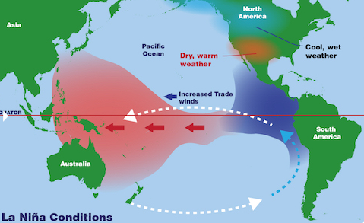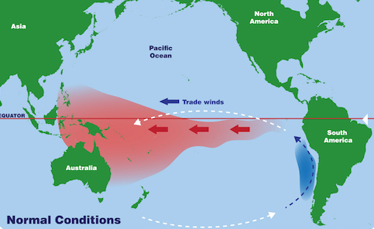
Source: NASA

BTN Stories
Watch the BTN El Niño story to learn more about the weather event.
- 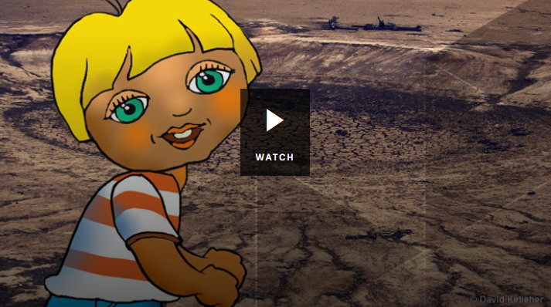What are the two major weather patterns in the Pacific Ocean?
- What do La Niña and El Niño mean in Spanish?
- Describe the weather when La Niña is about.
- How will El Niño change the weather patterns in Australia?
- El Niño doesn’t mean we definitely will experience drought. True or false?
- What did you learn watching the El Niño story?

The BTN Weather Science story explains the important job weather forecasters do.
- 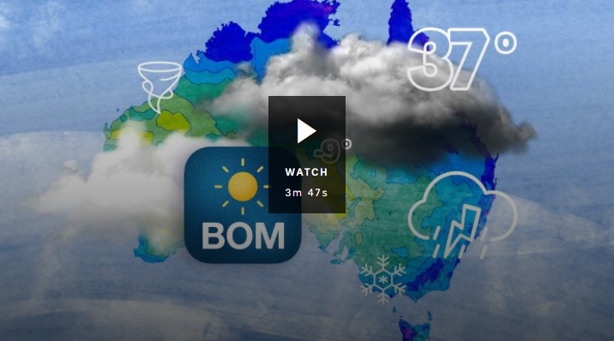Where does meteorologist Phil work?
- What is a meteorologist?
- What aspects of the weather do meteorologists study?
- Where can you find weather stations and instruments? Give one example.
- How is climate different to weather?
- How far in advance can meteorologists predict the weather?
- Why is the job of a meteorologist an important one?
BTN Ask a Reporter – La Niña
Do your students have questions about La Niña? BTN’s Ask A Reporter provides students with a chance to ask BTN reporters’ questions. Students can submit their questions here Check the BTN website for all the details.

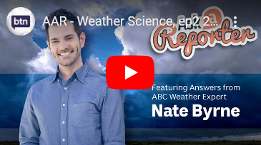Ask a Reporter – Weather Science
Watch a previous Ask a Reporter Weather Science and find out more about the job weather forecasters do. Features answers from an ABC weather expert.

What is La Niña? - NASA Space Place
https://spaceplace.nasa.gov/la-nina/en/

How the La Niña weather event could affect Australia for the rest of 2020- ABC News
https://www.abc.net.au/news/rural/2020-09-30/how-la-nina-will-impact-australia/12716500

BOM declares a La Niña, signalling wet spring and summer likely for northern, eastern Australia – ABC News
https://www.abc.net.au/news/2020-09-29/bom-declares-la-nina-wet-conditions-likely-for-eastern-australia/12617528

What are La Niña and El Niño events? – Bureau of Meteorology
http://www.bom.gov.au/climate/enso/history/ln-2010-12/ENSO-what.shtml

La Niña – BTN
https://www.abc.net.au/btn/classroom/la-ni241a/10532864

El Niño - BTN
https://www.abc.net.au/btn/classroom/el-ni241o/10526536

Weather Science – BTN
https://www.abc.net.au/btn/classroom/weather-science/11933890

Teacher Resource
Episode 28
13th October 2020

Mainland Tassie Devils
Students will develop a deeper understanding of the issues facing Tasmanian devil populations in Australia. Students will learn about solutions that scientists are finding to help protect Australian animals.

Science – Year 4
Living things have life cycles.

Living things depend on each other and the environment to survive.

Science – Year 5
Living things have structural features and adaptations that help them to survive in their environment.

Science – Year 6
The growth and survival of living things are affected by physical conditions of their environment.

Science – Year 7
Classification helps organise the diverse group of organisms.

- About how long has it been since Tasmanian devils lived in the wild on the mainland of Australia?
  - 300 years
  - 3,000 years
  - 30,000 years
- Which celebrity is involved in the Tassie devil rewilding program?
- Where in Australia is the rewilding program?
- Why did Tassie devils die out on the mainland?
- Which introduced species impacted on the Tassie devils?
- What disease has reduced the devil’s population by 90%?
- What does rewilding mean?
- Tassie devils are the world’s biggest meat-eating marsupials. True or false?
- Finish the following sentence: Tasmanian devils could help to control introduced species like…
- What was surprising about this story?

Discussion
Before watching the BTN Mainland Tassie Devils story students will respond to the following...
- What do you already know about Tasmanian devils?
- Where can Tasmanian devils be found?
- What do you want to learn about Tasmanian devils?

What do you see, think and wonder?
After watching the BTN story, students will respond to the following questions:
- What did you SEE in this video?
- What do you THINK about what you saw in this video?
- What did you LEARN from this story?
- What was SURPRISING about this story?

Students will then:
- Think of a question they would like to ask the researchers featured in the story.
- Leave a message in the comments section on the BTN Mainland Tassie Devils story page.
- Finish one or more of the following sentences:
  - Reintroducing Tassie Devils onto mainland Australia is important because…
  - We can help keep animal’s habitats safe by…

Glossary
Students will brainstorm a list of key words that relate to the BTN Mainland Tassie Devils story. Students will then use the words to write their own sentences about the topic. Students may want to use pictures and diagrams to illustrate the meaning and create their own glossary. Here are some words to get you started.

Ecosystem | Habitat | Native
Species | Conservation | Population
Behaviour | Threat | Introduced Species

Inquiry Questions
After watching and discussing the BTN Mainland Tassie Devils story, what questions do students have and what are the gaps in their knowledge? The following KWLH organiser provides students with a framework to explore their knowledge on this topic and consider what they would like to know and learn.

What do I know? | What do I want to know? | What have I learnt? | How will I find out?

Students will develop their own question/s for inquiry, collecting and recording information from a wide variety of sources. Students may develop their own question for inquiry or select one of the questions below.

- What is causing species loss of the Tasmanian devil? Explore issues such as habitat loss, introduced species, pollution and disease. Which of these factors are caused by humans?
- When did Tasmanian devils live on the mainland? Look at the history of Tasmanian devils and compare Tasmanian devil populations in Australia over time. Create a timeline showing your findings.
- How will the introduction of Tasmanian devils in Barrington Tops National Park help the species? How will the reintroduction of Tasmanian devils help the ecosystem?
- Where are Tasmanian devils in the food chain? Draw a diagram showing what animal feeds on what. Use illustrations or photos to demonstrate this food chain. On your diagram use words like predator, consumer, producer, decomposer, carnivore, herbivore, transfer of energy.
- What might happen if we don’t look after Tasmanian devils? What would the Tasmanian devil populations look like in 30 years’ time? Make some predictions. Imagine that Tasmanian devils have tragically become extinct and then write a news article telling people why they have become extinct.

Animal profile
Students will investigate the Tasmanian devil or choose another native animal that is a threatened or endangered species and create a profile of them. Ask students what they know about threatened species. Can they name any? What is the difference between a threatened or endangered species?

Using the Australian Government’s list of threatened fauna students choose a threatened Australian species to research. They record their information on the Research Project: Threatened Species template.
Students will research the following and then share their research findings with the class or create a display in the classroom.

- Name (including scientific name)
- Classification (class, family, genus)
- Description
- Habitat
- Conservation status
- Threats
- What is being done to protect and save the species?

Improve the biodiversity in your local environment
Students will work together to help and introduce a native animal species into their school yard. Ask them to consider the following:

- What kind of animals could you reintroduce into your school yard? E.g. bees, butterflies, birds. Research the animals native to your local area. Contact a ranger at park near your school or the local council to learn more about the local animal species.
- Do you have the right type of habitat in your school yard for them to survive? Describe the climate and identify the plants in your school yard.
- What are some threats to the species that are caused by humans? How can you reduce these threats in your school yard?
- What materials and tools will you need to build the habitat? Consider writing a guide or procedure manual explaining how to build the new habitat.
- 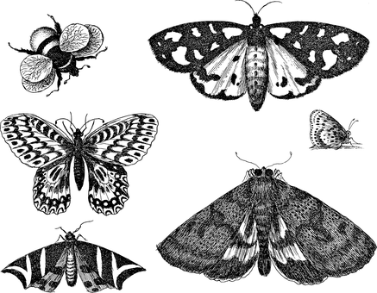Build the habitat as a class and present the habitat to your school community. Teach students in other classes about the new habitat and involve them in caring for the new habitat.
- Prepare a map of the habitat which highlights key features. Include information labels in the habitat (for example, QR codes next to plants) for other students to learn more about the habitat and the biodiversity of your school yard. Include scientific information about the species. Include botanical names of any plants which are part of the habitat, when it was planted and some basic information.

Choose a project
Individually or in small groups, students will choose one of the following projects to work on and then present their findings to the class.
Haiku poetry
Write a haiku poem focusing on one or more of the themes explored in the BTN Mainland Tassie Devils story. Use this graphic organiser to help brainstorm a list of words about the topic.

Reporter for a day
Investigate the issues highlighted in the BTN Mainland Tassie Devils story and write a newspaper article or online news report for kids.

Myths and Facts
Find some interesting facts about Tasmanian devils. Create your own myths and facts quiz to test the knowledge of students in your class.
Campaign
Design a public education campaign to raise awareness about Tasmanian devils. Think about your campaign’s aim, your target audience, and the value of raising awareness. Create a poster using Canva.

Tassie Devils in Trouble – BTN
https://www.abc.net.au/btn/classroom/tassie-devils-in-trouble/10488650

Devil Island – BTN
https://www.abc.net.au/btn/classroom/devil-island/10531576

Tassie Devils – BTN
https://www.abc.net.au/btn/classroom/tassie-devils/10534130

Tasmanian Devil – National Geographic
https://www.nationalgeographic.com/animals/mammals/t/tasmanian-devil/

Thor releases Tasmanian devils – BTN Newsbreak
https://www.abc.net.au/btn/newsbreak/btn-newsbreak-20201006/12736816

BTN Transcript: Episode 28 – 13/10/20

Hey, Amelia Moseley here, hope you've had a great holiday. Welcome back to another term of BTN. Here's what's coming up today. We find out why Aussies could be in for a soggy summer, learn why Tassie devils are roaming the bush in New South Wales and meet some kids who've been getting creative during lockdown.

COVID-19 Update

Reporter: Amelia Moseley

INTRO: But first, let’s have a bit of a look at how Australia's going when it comes to COVID-19 restrictions. While we're still a fair way from normal, there has been some good news over the holidays. Some borders have opened, restrictions have eased and a whole bunch of students in Victoria are back at school. Let's find out more.
Going back to school for term 4 isn't usually such a big deal, but this week some teachers in Melbourne were literally rolling out the red carpet to welcome students back to the classroom for the first time in ages.
MIA, MELBOURNE: So excited. Yeah, I really miss everyone at school, so I get to see them all now and come back.
SHIYUAN, MELBOURNE: I'm so excited to see some real people and so many real friends.
GEORGIA, MELBOURNE: I'm looking forward to seeing my teachers again. I really miss them.
BEN, MELBOURNE: I get to do PE and that's gonna be pretty good because I feel like I haven't been doing a lot of exercise at home.
While not all year levels are back at school 8,9 and 10 are still learning from home for now, some say it's a step in the right direction. In fact, it's step two in Melbourne's COVID recovery plan, which also meant some other changes like no more nighttime curfew.
BEN, MELBOURNE: Well now I'm excited because we get out past 8pm, we get to see our friends but we still need to make sure we follow the rules and not go to places where there are lots of people.
Some Melbournians were hoping for bigger changes, but the premier says they might have to wait a little bit longer for the next big step towards reopening. Meanwhile in regional Victoria, some towns have been allowed to open up their pubs and restaurants for outdoor dining and kids’ community sport is back on.
MADDIE, ALBURY: Personally, I think it's great. Because it just brings some normality back into our lives, but I just want to ease into it, take it slow and steady because I don't want another outbreak to happen and we want to get back to living normally.
In other states like South Australia and New South Wales, restrictions have also started to ease a bit making get-togethers a little easier. And speaking of getting together; friends and family have finally been reuniting or planning reunions as many states and territories work on opening up their borders, hopefully in time for Christmas.
QANTAS FLIGHT ATTENDANT: Today is a very special day because it marks the very first time Qantas has operated between Sydney and Adelaide since July.
MAN AT AIRPORT: This is Molly, my granddaughter.
WOMAN AT AIRPORT: Molly is 4 months old and she gets to meet my family for the first time today.
TOM, SYDNEY: I feel very happy that they’re opening up again because we'll be able to see all of our friends in Queensland.
ALICE, SYDNEY: I think that the borders opening up is good. Because it means that COVID is under control in Australia and also personally it means I can see family like my nanna in Brisbane again.
Travel's not just on the cards within Australia. Kiwis will be allowed into New South Wales and the NT soon, but unfortunately Aussies won't be allowed into New Zealand just yet. While a lot of people are really happy about getting some of their freedoms back, authorities say it's still super important that we stay focused on socially distancing and washing our hands regularly so that the last few months of 2020 can be way better than the rest of the year.
BEN, MELBOURNE: I'm excited to go get ice cream, go hang out with my friends that further than a five kilometre radius.
MADDIE, ALBURY: There's lots of small things that kind of make your day like seeing my favourite hairdresser and catching up with some old friends.
ALICE, SYDNEY: I'm looking forward to celebrating a normal year 6 formal cause I'm in year 6 so fingers crossed that can happen.
News Quiz

The really big news from the US has been the President, Donald Trump, contracting COVID-19. Who else connected to the President tested positive? The President’s wife, Melania Trump, President Trump’s Daughter, Ivanka Trump or the Vice President, Mike Pence? It was the president’s wife, Melania. She was one of a whole bunch of people connected to the White House that tested positive. As for the President, he says he’s now COVID free.

Can you name of this famous US Supreme Court judge who died recently? It’s Ruth Bader Ginsberg, sometimes known as the Notorious RBG by her fans. She’s well known for her work fighting for women’s’ rights.

Which one of these organisations has won this year’s Nobel Peace Prize? The World Health Organisation, the World Food Program or the World Bank? It was the World Food Program. It’s a branch of the United Nations that provides food to people in emergencies and works to make food sources more secure.
How much do you reckon someone just paid for this T Rex Skeleton, known as Stan? 43 thousand dollars, 4.3 million dollars or 43 million dollars? Stan sold at auction for just over 43 million dollars making it the most expensive dinosaur ever. Some palaeontologists weren’t happy about it though because they reckon fossil hunting should be about science not profit, and that stan should always be on public display.

Federal Budget 2020

Reporter: Nat Kelly

INTRO: The big news in Australia last week was the budget. It's the government's plan for how it's going to spend taxpayer’s money over the next year and this one is more important than most. Let's find out why.
NAT: Treasurer.
KID 1: What's wrong now?
NAT: Why do you always think there's something wrong when I come in here?
KID 1: Because there is, isn't there?
NAT: Yeah. Look the economy is in a bad way.
KID 2: Treasurer. The economy is in a bad way.
NAT: That's what I just said.
KID 1: Oh dear. Well there's only one thing do now.
KID 2: Who you gonna call?
KID 2: Oh, it's recess.
KID 2: Oh, it's a recession.
KID 1: Recession?
NAT: That's not good. A recession basically means the economy is going backwards.
You see, because of COVID-19, people haven't been spending as much money. Businesses have been making less money, which means people have been losing their jobs. Which means, they've been spending less money. It really is a vicious cycle. So, the government's been doing its best to keep the economy going.
KID 1: The Jobseeker’s running out. We need to try something else.
NAT: Ahh. Get the budget.
Let me bring you up to speed. If you didn't already know, the budget is a long, and let's be honest, usually pretty boring document outlining all of the money the federal government plans to spend over the next year; on things like education, hospitals, the defence force, welfare and so on.
NAT: And that's been particularly important now, due to...
KID 1 & 2: COVID-19.
NAT: You get the picture.
In this year's budget, the government's trying to fight the recession by encouraging people to spend more money and it's doing that with:
KID 2: Tax cuts.
Tax cuts for taxpayers, or people who work, which the government hopes will give them more money to spend.
KID 1: Business stimulus.
In other words, a bunch of tax write offs for businesses so that they can spend their money on other things too, and hopefully hire more people.
NAT: The budget also announced some new programs to help businesses employ and train young workers.
KID 2: Is it going to work?
Well, the government, and the rest of us, are certainly hoping so. But it's going to come at a cost. You see, all of this spending means Australia is recording record levels of debt. And that's something the government really didn't want to do.
JOSH FRYDENBERG, FEDERAL TREASURER: COVID-19 will see our deficit reach 213.7 billion dollars this year. This is a heavy burden, but a necessary one to responsibly deal with the greatest challenge of our time.
Plus, the government's plans come with some big expectations. The budget assumes that there'll be a vaccine for the coronavirus in 2021, and by this time next year, things need to be pretty much back to normal. Not everyone is happy with the budget. Some people think the government hasn't done enough for refugees, climate change, or people who don't make a lot of money. But when it comes to the budget, it's pretty rare that everyone's happy. And with so much on the line, a lot of people are hoping that this budget will work.
KID 1: Thank you Budget Busters.
KID 2: When you need us again, you know who to call.

La Niña Explained

Reporter: Cale Matthews

INTRO: Now let’s talk about the weather which, lately, has been pretty cold and wet in a lot of places.
And there's a very good reason for that. It's called La Niña and Cale's going to tell you all about it.

From long days splashing at the beach, to the ongoing race between the sun and your ice cream. Yeah, it's fair to say us Aussies love summer.
CALE, BTN REPORTER: Wouldn't it be weird if there was some Pacific Ocean weather pattern came along and there were was like colder temperatures and heaps more rain this summer.
Yeah, about that.
DR ANDREW WATKINS, BUREAU MANAGER OF CLIMATE OPERATIONS: We've moved into an active La Niña phase out in the tropical Pacific.
Yep, La Niña is back folks and it's here to rain on your summer parade. As you might have spotted, if you habla espanol, La Niña is Spanish for the little girl, while El Niño means the boy.

CALE, BTN REPORTER: They're opposite ends of a weather pattern known as ENSO or El Niño Southern Oscillation, and it's all got to do with what happens out in the Pacific and how it affects weather here.
In a normal year, the trade winds blow steadily across the tropical Pacific and by Christmas there's usually a buildup of warm water over our neck of the woods. Warm water evaporates and brings rain and it's why the north gets its wet season. A La Niña year is when those trade winds have gone into overdrive and there's much more warm water over here which means yeah, lots of rain.
DR ANDREW WATKINS, BUREAU MANAGER OF CLIMATE OPERATIONS: Typically La Niña brings more rainfall particularly across northern Australia and into Eastern Australia as well and as that wets up the soils it does increase the risk of flooding whenever we get a big rainfall event.
The last time we were in La Niña, back in 2010 to 2012, it was the wettest 2 year period in Australia's history, and it brought with it some pretty hectic storms, cyclones and flooding. But every La Niña is different, and the weather experts say this one could be a little milder.
While floods are always a possibility, some are hoping this La Niña will mean less bushfire risk over summer and for farmers, the rain is a sight for sore and rather dry eyes.

LOCKY, NSW FARMER: We may get an above average rainfall which will grow lots of grass and fill all the dams and make it an easier season for us next year.

As you probably already know, Australia has been going through one of its worst droughts on record, and some of it has to do with La Niña's hot and dry counterpart El Niño. El Niño happens when the trade winds over the Pacific get really weak or even reverse, which means Australia doesn't get its usual share of warm water or rain. Most of our driest and hottest years have coincided with an El Niño.
La Niña and El Niño are a natural part of the weather, but while they usually come every 2 to 7 years, we're never really sure when one is around the corner. But experts say we are locked into this drizzly old phase until at least next Autumn, so for summer loving, beach going Aussies like myself. It might be worth packing an extra brolly for your next trip down the coast.
Ask a Reporter

If you want to learn more about La Niña, you can ask me live on Friday for Ask a Reporter. Just head to our website for the details.

Mainland Tassie Devils

Reporter: Amelia Moseley

INTRO: Now if there's one thing we all know about Tasmanian devils it's that they live in Tasmania, right? But what if that wasn't the case anymore? You're about to meet some Tassie devils who are roaming the bush on the mainland. Take a look.

Buried deep in this forest is a very strange sight. Is that Thor?
CHRIS HEMSWORTH, AUSTRALIAN ACTOR: Yup.
Hmm, no, even seeing Aussie actor Chris Hemsworth isn't as unusual as spotting a Tasmanian devil out here in the wild. Why? Because this, my friends, is New South Wales.
TIM FAULKNER, AUSSIE ARK: Today marks the first time in 3000 years or thereabouts that the Tasmanian devil has roamed mainland forests.
You see, Tasmanian devils used to not just be Tasmanian, but experts reckon they died out on the mainland a long time ago because of people hunting them and the introduction of dingoes which competed with them for food. Yep, fun fact, dingoes aren't actually native. While dingoes never made it to Tassie; these little guys just couldn't catch a break. A nasty facial tumour disease has since killed off about 90 per cent of the population.
For decades, wildlife experts have been working on ways to help them, like breeding programs all across the country and even giving healthy ones their own island off Tassie. Seriously. But this is a first. 26 Tasmanian devils have been rewilded here in Barrington Tops Sanctuary in New South Wales, with the help of this famous wildlife hero, ah, ambassador.
CHRIS HEMSWORTH, AUSTRALIAN ACTOR: We've laid some traps to catch the devils and then we're going to release them out into the wild.
TIM FAULKNER, AUSSIE ARK: Correct.
As you might've figured, re-wilding is when people put native animal populations back where they used to be. It's something that's being tried all over the world from beavers in the UK to bison in the US. Of course, putting an animal into an environment that's got used to being without it comes with some risks and not everyone thinks it's the best idea. But others say it's a natural way of helping the ecosystem. For instance, Tassie devils are the world's biggest meat-eating marsupials and they could help to control introduced species like feral foxes and cats.
TIM FAULKNER, AUSSIE ARK: We've got the feral fox and feral cat wreaking havoc on our natives and a control measure like a devil back in the environment could be the only natural solution we have to protecting our natives.
Over the next few years, 40 more devils will join this crew and some other rewilded creatures too like quolls, bettongs, and bandicoots. In the meantime, the devils will be watched closely to see how they're doing and if they have any little devil babies. And, who knows, maybe one day we'll all be spotting these feisty little critters across the mainland again.
Did You Know?

Did you know relative to its size, the Tasmanian devil has the most powerful bite in the world. It can chomp down as hard as a dog three times its weight.

Sport

The LA Lakers are this year's NBA champs. They defeated the Miami Heat 106 to 93 to win the best of 7 final series 4 games to 2. Lebron James walked away with his 4th NBA title and the Finals MVP.
Dylan Alcott's living up to his rep as an all-time Aussie great with his second French Open win and 11th quad singles Grand Slam triumph. He beat his old rival and doubles partner Andy Lapthorne 6-2 6-2.
Meanwhile, Rafael Nadal smashed world number one, Novak Djokovic 6-love, 6-2, 7-5. It's his 13th triumph at the French Open and 20th overall, meaning he's now tied with Roger Federer for the most men's singles majors won.
West Coast Fever are heading to the Super Netball grand final next week after securing a convincing win over the Sunshine Coast Lightning. They'll face off against the Vixens for the decider on Sunday.
While international rugby has been virtually non-existent this year thanks to COVID, there's finally something to celebrate. The Wallabies went head to head against the All Blacks in Wellington for the Bledisloe Cup Opener and came away with an epic 16-16 draw.

COVID Creativity

Rookie Reporters

INTRO: Finally, today a lot of you have had extra time on your hands recently, particularly you guys in Victoria and many of you have been using it to get creative. You're about to meet three kids who've been working on some really cool projects while they were in lockdown. Check it out.

SIDDAK, APP DEVELOPER: Hi BTN my name is Siddak and I live in Melbourne in Victoria and during the COVID-19 lockdowns I've been working on my app KidKoin.
So KidKoin is, as I like to call it, is life at home gamified. The concept of KidKoin is basically just a currency for kids at home, that they can earn, lose, and even spend. I came up with the idea to build an app during lockdown, since I desperately needed something to save me from boredom. So, I began learning about building mobile apps with a few Google searches. My dad suggested that I should draw the rest of the screens and the UI on paper first. After finalizing the designs, I bought them to life with the magic of code. Okay, maybe it's more science than magic, but you get the point.
My suggestion for anybody still stuck and locked down would be to start a project, any project about anything that you're passionate about, and take advantage of being born in the 21st century, there's an internet, usually there'll be a lot of help available online.
NOAH: Hey BTN my name is Noah.
JAI: And I’m Jai and we’re from Point Lonsdale Victoria.

NOAH: Let's jump into this.
JAI: We're two best mates and known each other since kinder.

NOAH: And we started Lonny Team Ninja during COVID-19 homeschool. Lonny Team Ninja’s is about kids having fun.
JAI: And finding their new ninja skills.

NOAH: We wanted to do something fun, during homeschool, and we did some challenges at home.

JAI: So, we decided to challenge some other kids and we made our Cupow. Let’s go and show them how to play Cupow.
NOAH: Yes, that's a great idea. This is how you play Cupow. You have to work together as a team.

JAI: To get three balls in the cup before the time runs out.
NOAH: And if you get the ball into the cup you have to yell out Cupow.
JAI: Next week we're gonna be doing a surfing challenge.

NOAH: Chicken says yay.
DIYA: Hi BTN my name is Diya, I'm 8 years old and I'm from Melbourne. During my time in lockdown, I've started my own cooking show with my dad.

So, when I had finished all of my learning, I asked dad what should we do next. So, we had a brainstorm. And we came up with this great idea of doing a cooking show for YouTube. We have also been cooking lots and lots of food to give to the international students and homeless people around Melbourne. Since March we are cooking almost 500 meals every week from our home. I am learning so much by doing my cooking show, like different ways of cooking, like boiling, baking, roasting, frying but most of all it makes me think how I can make people happy.
Closer

Great work guys. Thanks for sharing that with us. Well that's it for today but we'll be back with more news and quizzes and all the rest of it next week. In the meantime, don't forget you can jump on our website or, if you're 13 or over, you can check out our YouTube Channel and BTN Newsbreak is here every weeknight to keep you up to speed. I’ll see you soon. Bye.

