Episode 31
3rd November 2020

US Election Candidates
- Briefly summarise the BTN US Election Candidates story?
- What are the two main political parties in the US?
- What political party does Donald Trump represent?
- How long has Donald Trump been the US president?
- What did Donald Trump study at university?
- Donald Trump was a reality TV star. True or false?
- What political party does Joe Biden represent?
- Complete the following sentence. Joe Biden was ______ ____________ to Barack Obama from 2009 to 2017.
- Why are some people saying the 2020 US Election is so important?
- What do you understand more clearly since watching the BTN story?

Kidfluencers
- Before you watch the BTN story, discuss what you already know about YouTube influencers.
- Discuss the BTN Kidfluencers story as a class and record the main points of the discussion.
- How do many YouTubers make money from their videos?
- What impact can YouTube videos promoting unhealthy foods have on kids?
- What is unboxing?
- What is the rule for advertising during kids’ TV programs?
  - The products have to be kid friendly
  - They can't promote an unhealthy lifestyle
  - They can't use popular characters or celebrities to sell stuff.
  - All of the above
- How are the rules for advertising on YouTube and TV different?
- The parents of Ryan’s World say they always follow social media and advertising guidelines. True or false?
- What do you think about the rules for influencers that advertise products on YouTube?
- What did you learn watching this story?

Moon Water Discovery
- Retell the BTN Moon Water Discovery story using your own words.
- What are the two building blocks of water?
  - Hydrogen and Oxygen
  - Helium and Oxygen
  - Hydrogen and Krypton
- Complete the following sentence. Water has been found in frozen __________ on the Moon.
- Water has only been found on the north pole of the Moon. True or false?
- What is the name of the flying telescope that helped scientists find water on the Moon?
- How much water did scientists find on the Moon?
- What does NASA want to achieve as part of its Artemis program?
- How can water be used to make rocket fuel?
- Name three facts you learnt while watching the BTN story.
- What questions do you have about this story?

Check out the Moon Water Discovery resource on the Teachers page.

Phar Lap
- Discuss the BTN Phar Lap story with another student.
- At which racecourse is the Melbourne Cup held?
  - Flemington
  - Randwick
  - Caulfield
- How long ago did Phar Lap win the Melbourne Cup?
- Where does the name Phar Lap come from?
- Describe the special bond that stable hand Tommy and Phar Lap had.
- What was the Great Depression?
- Why did Phar Lap become an Aussie icon?
- After his success in Australia, where did Phar Lap go to compete?
- What did scientists discover about Phar Lap after his death?
- How did you feel watching the BTN Phar Lap story?

Dangerous Animals
- Before watching the BTN story list as many Australian dangerous animals as you can.
- How many species of snakes are there in Australia?
- What is an interesting fact about the red belled black snake?
- What do tiger snakes look like?
- Complete the following sentence. Tiger snakes are considered the fourth most ____________ snake in the world.
- How can kids stay safe around wildlife this summer? Give one tip.
- What is the treatment for someone that has been bitten by a snake?
- What should you do if you find a snake in your house or backyard?
- Where in Australia can box jellyfish be found?
- What are the two types of crocodiles that can be found in Australia?

Check out the Dangerous Animals resource on the Teachers page.

Teacher Resource
Episode 31
3rd November 2020

Moon Water Discovery
Students will investigate the discovery of water on the Moon and what it means for the possibility of living on the Moon.

Science – Year 5
Scientific understandings, discoveries and inventions are used to solve problems that directly affect peoples' lives.

The Earth is part of a system of planets orbiting around a star (the sun).

Science – Years 5 & 6
Scientific knowledge is used to solve problems and inform personal and community decisions.

Science – Year 6
The growth and survival of living things are affected by the physical conditions of their environment.

Science – Year 7
Predictable phenomena on Earth, including seasons and eclipses, are caused by the relative positions of the sun, Earth and the moon.

Scientific knowledge has changed peoples’ understanding of the world and is refined as new evidence becomes available.

- Retell the BTN Moon Water Discovery story using your own words.
- What are the two building blocks of water?
  - Hydrogen and Oxygen
  - Helium and Oxygen
  - Hydrogen and Krypton
- Complete the following sentence. Water has been found in frozen __________ on the Moon.
- Water has only been found on the north pole of the Moon. True or false?
- What is the name of the flying telescope that helped scientists find water on the Moon?
- How much water did scientists find on the Moon?
- What does NASA want to achieve as part of its Artemis program?
- How can water be used to make rocket fuel?
- Name three facts you learnt while watching the BTN story.
- What questions do you have about this story?

Before students watch the BTN Moon Water Discovery story, ask them to record what they know about the Moon and record on a mind map.

Class Discussion
Discuss the BTN Moon Water Discovery story as a class. Continue to add to the mind map during the discussion. What questions do they have about the Moon? Use the following questions to help guide discussion:

- What are the conditions like on the Moon?
- Why do you think the recent discovery of water on the Moon is significant?
- Brainstorm a list of things humans need to survive. Do these things exist on the Moon?
- 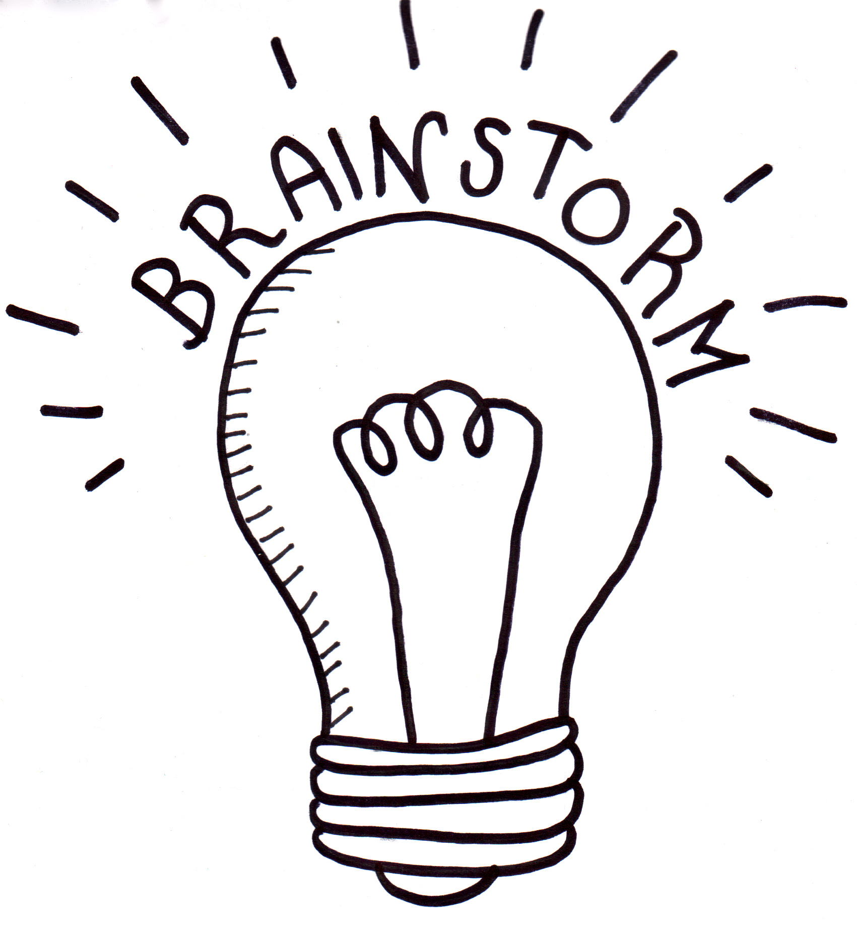What do you think it would be like to live on the Moon?

Key Words
Students will brainstorm a list of key words that relate to the BTN Moon Water Discovery story. Here are some words to get you started.
Moon | Crater | Solar System
Lunar | Telescope | SOFIA
True or False
Students will read the following statements about the Moon and tick true or false next to them.
Statement | True | False
The Sun and the Moon are the same size.
The Moon is 4.5 billion years old.
Humans can breathe easily on the Moon because the atmosphere is similar to that on Earth.
There are high levels of solar radiation on the Moon.
The temperature on the Moon is similar to
temperatures on Earth.
From Earth, we always see the same side of the Moon.
The gravity on the Moon is the same as Earth’s gravity.
The Moon has earthquakes call moonquakes.
Answers: F, T, F, T, F, T, F, T

Compare the Earth and the Moon
Working in pairs, students will create a Venn diagram to compare and contrast the Earth and the Moon. Begin by brainstorming the characteristics of both the Earth and the Moon. Record similarities in the overlapping areas.
Earth
Moon

Research the Moon
Students will explore the Moon in more detail. After watching and discussing the BTN Moon Water Discovery story, what questions do students have and what are the gaps in their knowledge? Here are some possible questions for students to research:

- Investigate why the discovery of water on the Moon is significant. Apart from drinking, how can it be used?
- Research and prepare a profile on Earth’s Moon. Include the following information: distance from Earth, how long it takes to orbit Earth, the minimum/maximum temperatures of the Moon and geographical features of the Moon. Include any other interesting facts you find.
- What are the relationships between Earth, the Moon and the Sun? Draw a diagram showing the relative sizes and movement of Earth, the Moon and the Sun. In your description include words like orbit, revolution and axis.
- How does gravity affect the Moon? Investigate Earth’s gravitational pull on the Moon and explain why we only ever see one side of the Moon.
- How can we see the Moon? Explain why we can sometimes see the Moon during the day.
- What would humans need if they were going to survive on the Moon for a long period of time. Make a list.

Creating a colony on the Moon
Students discuss in pairs what the recent discovery of water on the Moon means for the possibility of one day living on the Moon. Students will think about the different ways in which water could be used to help people to stay on the Moon for longer periods of time (these were mentioned in the BTN story). Watch The Living on the Moon video and the BTN Moon Living video to learn more.

Students will then need to research conditions on the Moon so they can plan and design a settlement on the Moon that will sustain human life. Things they will need to consider include:

- 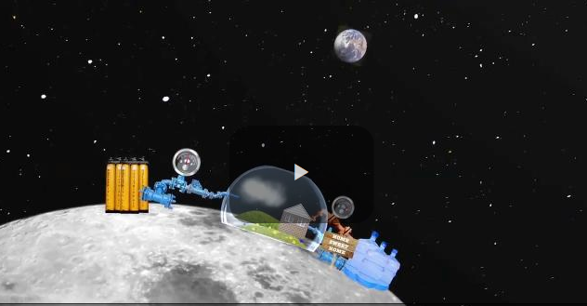What are the three basic things we need to survive?
- What are the conditions like on the Moon?
- What needs to be considered when planning a colony on the Moon? For example:
  - Water supply
  - Atmosphere
  - Temperature
  - Solar radiation
  - Food Production
  - Waste Management
  - Gravity
- What materials could be used to build a space settlement? Investigate the idea of using Moon dust and Sulphur to make bricks.
- What do you think it would be like to live on the Moon?
- What are the benefits of having a space settlement on the Moon?
- What are the challenges?

Students can create either a model or a labelled diagram of their ‘Moon settlement’. Make sure that it has all the support systems to enable humans to survive. Display students’ work in a public space in the school.

Further Investigation
Create an advertisement for your Moon settlement persuading people to live there.

BTN Moon Stories
These BTN stories are all about the Moon. After watching any one of the BTN videos ask students to respond to the discussion questions (to find the teacher resources go to the related BTN Classroom Episode and download the Episode Package).

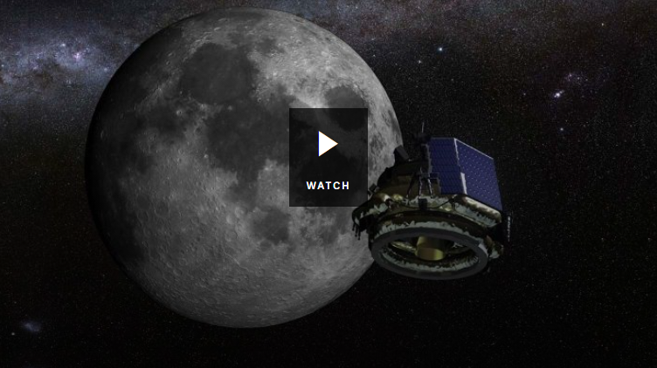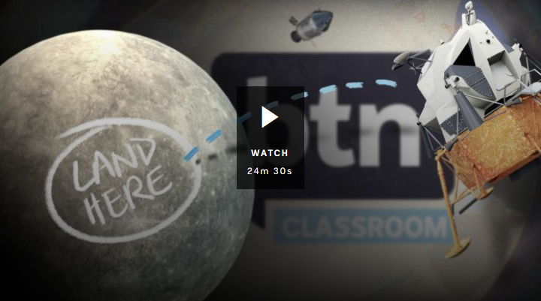

50th Anniversary of the Moon Landing Moon Exploration

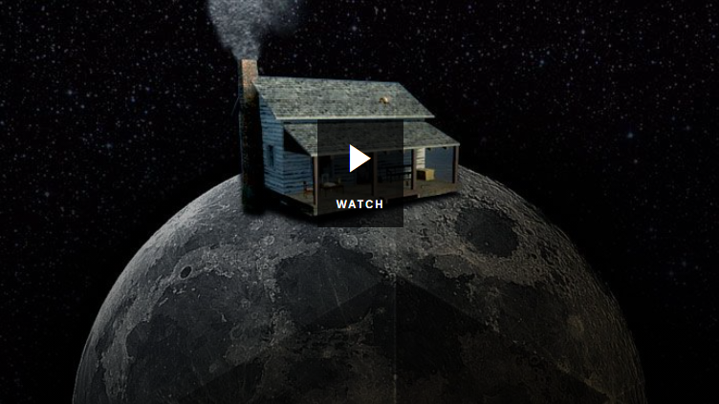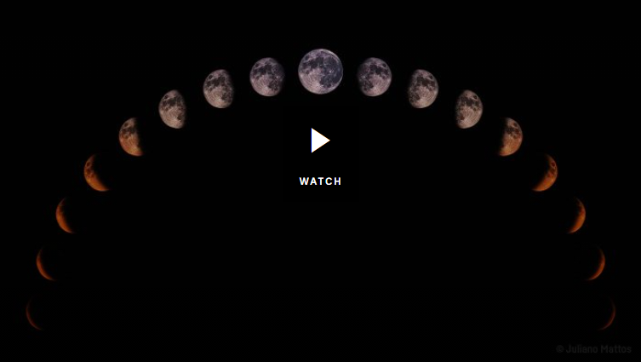

Super Blue Blood Moon Moon Living

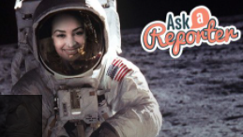
50th Anniversary of the Moon Landing
Watch Ask a Reporter Moon Landing and find out more about the Apollo 11 mission and more!

NASA finds liquid water on the Moon, raising hopes for exploration and habitation – ABC News
https://www.abc.net.au/news/science/2020-10-27/water-molecules-discovered-on-moon-using-nasa-flying-telescope/12806148

There’s more water on the moon than originally thought and it could be drinkable – Newsround
https://www.bbc.co.uk/newsround/54658717

NASA’s SOFIA Discovers Water on Sunlit Surface of Moon – NASA
https://www.nasa.gov/press-release/nasa-s-sofia-discovers-water-on-sunlit-surface-of-moon/

Moon Living – BTN
https://www.abc.net.au/btn/classroom/moon-living/10527786

Living on the moon! – ABC Education
https://education.abc.net.au/home#!/media/1902269/living-on-the-moon

50th Anniversary of the Moon Landing – BTN
https://www.abc.net.au/btn/classroom/20190723-ep19-btn/11313570

Teacher Resource
Episode 31
3rd November 2020

Dangerous Animals
Students will learn more about
Australia’s dangerous animals. Students will explore safety tips for encounters with Australian wildlife.

Science – Year 4
Living things have life cycles.

Living things depend on each other and the environment to survive.

Science – Year 5
Living things have structural features and adaptations that help them to survive in their environment.

Science – Year 6
The growth and survival of living things are affected by physical conditions of their environment.

Science – Year 7
Classification helps organise the diverse group of organisms.
- Before watching the BTN story list as many Australian dangerous animals as you can.
- How many species of snakes are there in Australia?
- What is an interesting fact about the red belled black snake?
- What do tiger snakes look like?
- Complete the following sentence. Tiger snakes are considered the fourth most ____________ snake in the world.
- How can kids stay safe around wildlife this summer? Give one tip.
- What is the treatment for someone that has been bitten by a snake?
- What should you do if you find a snake in your house or backyard?
- Where in Australia can box jellyfish be found?
- What are the two types of crocodiles that can be found in Australia?

Pre-viewing questions
Before watching the BTN Dangerous Animals story students, as a class, will respond to the following...
- What dangerous animals can be found in Australia? Make a list.
- Which animal is the deadliest?
- 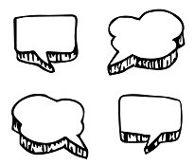Have you ever encountered a dangerous animal? Where did you see it and what did it look like?
- What first aid do you know if someone is attacked by a dangerous animal?
- What do you want to learn about dangerous animals?

Glossary
Students will brainstorm a list of key words that relate to Australian animals. The glossary will help inform students while working through the activities in this resource. Students can use the words to write their own sentences about the topic. Students may want to use pictures and diagrams to illustrate the meaning and create their own glossary. Here are some words to get you started.

Classification | Habitat | Behaviour
Species | Taxonomy | Native
Inquiry Questions
After watching and discussing the BTN Dangerous Animals story, what questions do students have and what are the gaps in their knowledge? The following KWLH organiser provides students with a framework to explore their knowledge on this topic and consider what they would like to know and learn.

What do I know? | What do I want to know? | What have I learnt? | How will I find out?

Students will develop their own question/s for inquiry, collecting and recording information from a wide variety of sources. Students may develop their own question for inquiry or select one of the questions below.

- Why do so many dangerous animals live in Australia?
- What do you think is the deadliest animal in Australia? Make a list of the top 10 deadly animals in Australia and rate them from the deadliest to the least deadly.
- Choose a dangerous Australian animal to explore in more detail. Where are they in the food chain? Draw a diagram showing what animal feeds on what. Use illustrations or photos to demonstrate this food chain. On your diagram use words like predator, consumer, producer, decomposer, carnivore, herbivore, transfer of energy.
- What is the difference between a bee and wasp? What is the difference between an Eastern brown snake and a Western brown snake? Explore the taxonomy of two animals, and categorise the information you find using the classification system.

Animal factsheets
Students will learn more about Australia’s dangerous animals, how to stay safe and what the first aid treatment is if you are attacked by the animal. Students will choose a species to research in more detail and create a factsheet of them. Students can use the following headings to help guide their research:
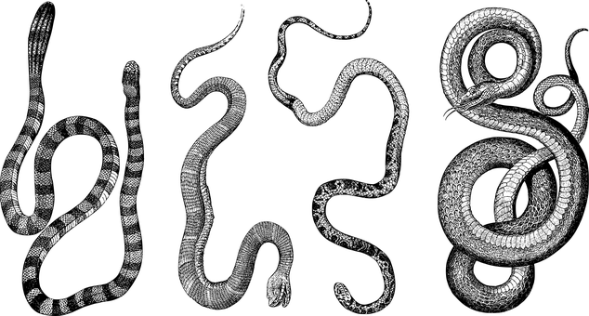
- Illustration or photo
- Common name
- Scientific name
- Classification (class, family, genus)
- Appearance
- Where can it be found?
- How deadly is the animal (rating & description)?
- How can you stay safe and avoid the animal?
- Symptoms if someone has been attacked
- First aid treatment

Geography
As a class, draw a map of Australia and use it to plot where Australia’s dangerous animals can be found.

Who Am I!
Play this who am I guessing game with your students to get them thinking about Australian animals and their classification properties. This game can be played with 2-6 players. To make the game write down the names of dangerous Australian animals on individual pieces of card (about the size of playing cards). You will need pieces of elastic to make head bands for each player to put around the top of their head.
How to play the game:
- Place the cards face down on a table.
- Each player will choose 1 card and tuck it into their headband (No peeking. However, the other players can see yours).
- Take it in turns to guess what animal is written on your card. You can only ask ‘yes’ or ‘no’ questions. When asking questions players can use the classification properties or more specific properties, for example its colour, size, where it lives and how it moves, to help identify the animal.
- When you have enough specific information, you may try to guess the animal’s identity.
- The first player to guess their animal wins.

Saltwater Crocodile

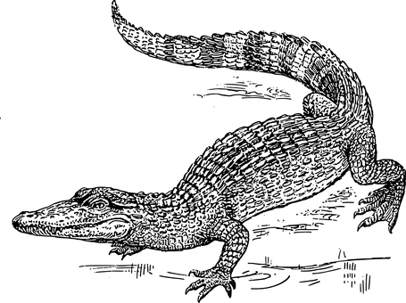
Brown Snake

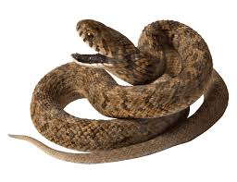
Box jelly fish

Taxonomy
Students will explore the classification system used to identify animals. Teachers will explain that every animal can be identified using the classification system. As a class, look at the seven levels which make up the classification system. Look at each level and an example animal (one of the animals featured in the BTN Dangerous Animals story).

- Kingdom
- Phylum
- Class
- Order
- Family
- Genus
- Species

Students will then explore the taxonomy of two or more animals and classify them into categories. Students will use a chart to categorise the taxonomic information they find.

Name | Phylum | Class | Order | Family | Genus | Species
Once completing their taxonomic research, students will respond to the following:
- Analyse the different names used to classify the animal. Do you notice anything interesting?
- How are the animals similar or different?
- Do you notice any patterns in the information?
- Compare your findings with your classmates.

Challenge – Create a new dangerous animal
Students will imagine they are biologists and create a new species! Students will draw the animal and classify it according to the principles of classification.
- Name the species
- Draw what it looks like (you may want to draw a scientific illustration or draw the animal in its natural habitat). Label important features.
- List the animal’s classification
- What are its characteristics?
- What makes it dangerous? How does it help the animal to survive?

Biological Illustration
Students will create their own biological illustration of a dangerous Australian animal. This activity encourages students to develop their observation skills and reinforce their understanding of biological concepts.

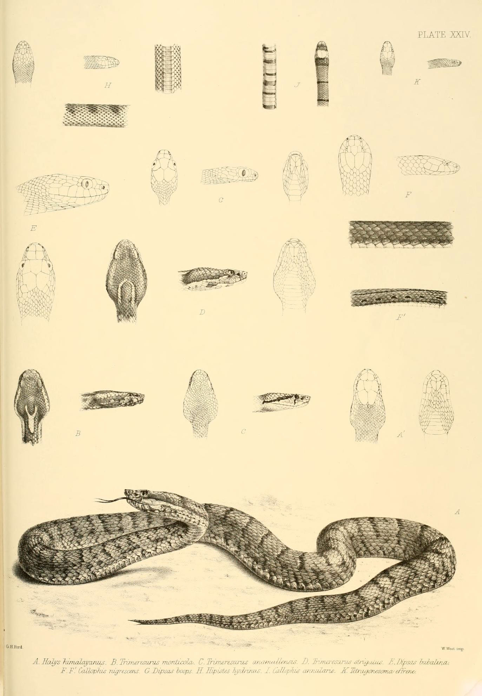Explain to students that in their illustration they need to draw what they see (using photographs/videos they find in books and on the internet). Students will need to think about size, shape, texture and patterns; and include as much detail as possible.

Teachers may want to show examples of scientific drawings or begin this exercise by asking their students to collect a plant specimen (for example, a leaf or flower) from the school yard to practise scientific drawing.

Students can use the following as a guide as they create their scientific drawing:
- Find photographs and/or videos of the animal to observe. What key structures and anatomy will you focus on in your drawings?
- Draw the animal to scale (include a ratio on the drawing).
- Include its scientific and common name.
- Add labels – to show size, color and texture.

For more information about scientific drawing in the classroom, visit this website Sketching for observation. Consider sending your students’ drawings into your local museum to display as an exhibition.

Dangerous Animals – Australian Museum
https://australian.museum/learn/animals/dangerous-animals/

Wildlife Encounters – NSW National Parks & Wildlife
https://www.nationalparks.nsw.gov.au/safety/wildlife-encounters#watch-your-step

What are QLD’s most dangerous creatures? – QLD Health
https://www.health.qld.gov.au/news-events/news/dangerous-creatures-animals-queensland-treatment-attack-prevention-spiders-snakes-sharks-bite-sting-poison

Staying Safe around Wildlife – Dept Environment and Science
https://environment.des.qld.gov.au/wildlife/animals/living-with/staying-safe

Bites and Stings First – BetterHealth
https://www.betterhealth.vic.gov.au/health/healthyliving/bites-and-stings-first-aid

Be Crocwise – Northern Territory Government
https://becrocwise.nt.gov.au/about-crocodiles/saltwater-crocodiles

BTN Transcript: Episode 31 – 3/11/20

Yaama I’m Jack, you're watching BTN. Here's what's coming up. NASA's big discovery on the Moon, the story of Australia's most famous racehorse and Liv gets hands on with some slippery reptiles.

US Election Candidates

Reporter: Olivia Mason

INTRO: But first we're heading to America because it's election time. People are coming out in record numbers to help decide who the next leader of their country will be. Let's find out who's in the running for the top job.

OLIVIA, REPORTER: Ahh the United States, the autumn leaves are falling, the jack-o-lanterns are probably starting to go bad and after many months of campaigning and debating and all that weird stuff about Kanye West running for president too, it's finally election time.
So, who are the contenders? Well, the main parties in the US are the Democrats and the Republicans. In the red corner from the Republican Party is this guy.
DONALD TRUMP, US PRESIDENT: Thank you.
OLIVIA: Donald Trump has been US President since 2016.
DONALD TRUMP, US PRESIDENT: We are going to win four more great years in the White House.
But his journey started way back in 1946. Donald John Trump was born into a very rich family. He studied economics in college before his dad gave him a huge amount of money to kick-start his career in property development. Since then, he's built casinos, offices, hotels and golf courses around the world, and became a reality TV star.
DONALD TRUMP, US PRESIDENT: Stacey, you’re fired. Out.
His presidency has had its fair share of controversies, including his handling of this whole COVID thing.
DONALD TRUMP, US PRESIDENT: When you do testing to that extent you're gonna find more people you're gonna find more cases so I said to my people slow the testing down please.
While some people are aren't happy about how he's been running the country, he's got a lot of supporters.
PERSON 1: My life has improved in the last 4 years. I feel like everyone's has with the tax cuts it's been great for the economy.
If he gets elected for a second term in office, Donald Trump says he'll cut taxes, expand fossil fuel projects in oil and gas and invest in a COVID-19 vaccine. So, who's he up against? In the blue corner from the Democratic Party, Joe Biden. Joseph Robinette Biden Junior was born in Pennsylvania in 1942. He studied arts and law and worked as a lawyer for a while. At 30, he became one of America's youngest Senators in history, so he's been in the politics game for a long time. In fact, he was Vice President to Barack Obama from 2009 until 2017. Joe Biden says he plans to take action on climate change, improve the health care system and will stop the spread of COVID-19.
JOE BIDEN, CANDIDATE FOR US PRESIDENT: I will put in place a plan to deal with this pandemic responsibly.
So, what's special about this election? Well, it's been a pretty full-on year for the US. They've had more reported cases of COVID-19 than any other country. There's been huge political disagreements on things like lockdowns and wearing masks. And we've also seen lots of protests and the rise of the Black Lives Matter movement. Some reckon the US is more divided than ever right now.
PERSON 2: I think it's a really divisive election.
PERSON 3: Democrats have lost their mind. They're insane.
PERSON 4: I don't care for not only Trump's politics but Trump as a human being.
It's why a lot of people are saying this election is so important and why record-breaking numbers of people have already put in an early vote. Many say, whoever wins, they want to see the United States, united.
PERSON 5: It's really important this election, a lot is at stake.
PERSON 6: We need a change; we definitely need to change.
PERSON 7: I think that we're doing really well right now, jobs are good, the economy's strong. I think people feel that way.
PERSON 8: More people have an opinion; more people are actually trying to vote so I think it'll be a more representative outcome than it was last time.
Ask a Reporter

If you want to know more about the US election, you can ask me live on Ask a Reporter. Just head to our website for all the details.
News Quiz

Which party has won the 2020 Queensland election? Labor, Liberal National Party or the Greens? It's Labor. Premier Annastacia Palaszczuk has been re-elected for a third term.
Who is this? It's actor, Sean Connery. He's died at the age of 90. The Scottish film star was the original 007 and suited up as James Bond 7 times.
What unusual thing has this cow got in its mouth? It's a snake. Cows don't normally munch on snakes. They're herbivores, but apparently this cow, snapped by the roadside in the NT is making a sand python sized exception.
Kidfluencers

Reporter: Jack Evans

INTRO: A new study has found many of YouTube's ‘Kidfluencers’ are being paid to promote junk food and sugary drinks. Researchers say the line between ad and fun video is often blurred and there need to be clearer rules around it especially when it comes to kids. We take a closer look and find out what you think.
JACJAC: Hey guys it's JacJac. Today we're going to be unboxing some boxes. We've got some really cool boxes for you today from boxes'n'boxes.
REPORTER: You might not always pick up on it but youtubers like this guy, well legit youtubers with a lot of followers anyway, they can get a lot of money from businesses just to feature their products in their videos.
JACJAC: And guess what, guys there's another box. Boxes'n'boxes what are you doing?
JACK: Boxes.? Actually, I could use a box to organise all these little boxes. What was the brand of box again?
JACJAC: Boxes'n'boxes.
While sometimes it's pretty clear what's being sold to us, other times it's not as obvious. That's something a team of researchers has been looking at in the United Sates. They studied videos of the 5 most popular kidfluencers on YouTube and found they were full of endorsements and product placement. Out of the more than 400 videos they looked at, almost a third featured foods and drinks and researchers considered most of them to be unhealthy. They say that can be a real problem, especially for young kids. Because they can't always tell the difference between an ad and just a fun video and when they're exposed to those kinds of ads it can encourage unhealthy eating habits, which can lead to things like obesity and diabetes.

You see YouTube doesn't let ads like this one play before or during videos that are made for kids. But the rules around showing products in videos are a little different. And that's why youtubers or kidfluencers like these guys are able to make money from companies to unbox, play with and even eat their products in their videos. The parents of Ryan's World, which was one of the YouTube videos the study looked at, say they always follow social media and advertising guidelines. But others reckon the rules should be clearer and tougher.

Here in Australia there are a bunch of rules when it comes to advertising during kids’ programs on TV. For starters the products have to be kid friendly, they can't promote an unhealthy lifestyle, like eating too much junk food and they can't use popular characters or celebrities to sell stuff. Some people reckon similar rules should apply to YouTube and that creators need to be more transparent when it comes to the content of their content. So, what do you think?
MARETTA: I think the person that's promoting it should step up and tell them that they are selling something. But if they don't, YouTube does need to step in and put like an includes paid promotion sticker on there.
ZOE: Some YouTubers, they like create a section just for that product. Whereas some YouTubers, they just secretly hide it in the corner of the video or something.
JADE: It's someone they look up to and they'd want to be just like them, so they want to buy these products and use them.

ANJALI: If they're being paid to advertise it, they're obviously going to give it better reviews and what they might genuinely feel towards it. So, they should disclose that to the audience, because it's not an honest review if they're being paid to do it.

Did You Know?

Did you know Baby Shark is the most watched video on YouTube Kids? That probably shouldn't come as a surprise. It has nearly 7 billion views and if you include all of YouTube it's the second most watched video of all time.

Moon Water Discovery

Reporter: Cale Matthews

INTRO: NASA's made a big new announcement about the Moon, and no, it's not that it's made out of cheese. New studies have found there's more water up there than we previously thought which could be huge if us humans actually want to live there.

CALE: C'mon. We're almost there.
NAT: This better be good.
CALE: There it is...
NAT: You're kidding.
Yeah finding water on Earth is not that big of a deal. But stumbling upon it more than 300,000 kays away on a surface that looks like this, well that's a different story.
SCIENTIST: Finding water ice on the Moon could be one of the most important discoveries of the space age because it’s basically transforming the Moon from a desert to an oasis.
Thirst quenching ability aside, water can be a precious and extremely useful resource in space and it’s why scientists have spent decades looking for it. We've got exciting results from a textbook mission. Over the years, Hydrogen and Oxygen, the building blocks of water, have been found in frozen craters on the north and south pole of the Moon. But we've never been sure if its usable or actually water for that matter. And even if it was, tucked away in these cold dark craters, it’s very hard to access. It's why this is such a big deal.
ALAN DUFFY, CHIEF SCIENTIST ROYAL INSTITUTE OF AUSTRALIA: What they have found is real water, liquid water glinting back at us, essentially from the surface of the Moon.
Yeah, for the first time ever we've found liquid water, real water, in the sunlit easier to get to parts of the Moon. It's partly thanks to this souped up 747 known as SOFIA. Inside this plane is a massive infrared telescope which scientists use to explore the solar system, and now the Moon. Now we're not exactly talking celestial swimming pools or lunar lakes, it’s actually tiny amounts trapped in lunar glass or soil.

CALE, REPORTER: Imagine this fish tank was the entire Clavius Crater, where the discovery was made, this is how much water they actually found. It may not seem like a lot, but it could be really useful.
PROF. FRANS VON DER DUNK, SPACE LAW EXPERT: Water is crucial for life. If we ever want to have people living in outer space for longer periods of time, we need water.
NASA wants to get astronauts permanently living and working on the Moon by the end of the decade as part of its Artemis program, but to do all of this they need a massive supply of water. Water to drink, help grow their food and also for something else. See water is made up of two parts hydrogen and one-part oxygen. When you split them apart, recombine them and ignite them, well, that can make rocket fuel.
This means the Moon can be used a bit like an interplanetary petrol station. Rockets can be refueled and then go further into the galaxy, or even put a human on Mars. So, who knows, in a few years we might be clinking our glasses with a nice refreshing drop of Moon water.

Phar Lap

Reporter: Charlotte Batty

INTRO: It's Melbourne Cup Day. So, we thought we'd take a look back at one of the legends of the race. 90 years ago, today, champion horse Phar Lap took out the competition and went on to become a household name all over the world.
It's the race that stops the nation. With hundreds of thousands of people flocking to Flemington Racecourse each year. Dressed to impress, donning some, well, pretty darn ridiculous hats to be honest, to cheer on some pretty darn majestic horses. But it's one horse whose name you might've heard of once or twice that changed the name of the game for good.
This is Phar Lap and 90 years ago he won the Melbourne Cup and became the most famous horse in the whole world. While it's a bit of a funny name Phar Lap actually comes from the Thai word for lightning which definitely suits his speedy talents. Although he was often called the Red Terror, Bobby or simply just Australia's wonder horse. Ha original.

After growing up in New Zealand Phar Lap was bought by a trainer from Sydney, Harry Telford back in 1928 for just 160 guineas. That's about $14,000 in today's money. And considering racehorses can go for hundreds of thousands of dollars these days it was a real bargain. And he wasn't actually an obvious choice. But Harry and stable hand Tommy Woodcock saw his potential. In fact, Phar Lap and Tommy developed a pretty special bond. They travelled everywhere together and even slept and ate their meals together. Aww best buds.
While Phar Lap lost his first few races, it wasn't long before he started to rack up the wins. Over his career he won, phwoar, are you ready for this? The Rosehill Guineas, the AJC Derby, the VRC Derby, the SAJC Kings Cup, the Chelmsford Stakes, the King's Plate, the Melbourne Stakes, the Spring Stakes and, well the list goes on and on. In fact, he won 37 of his 51 races. But it was his Melbourne Cup win in 1930 that made his popularity skyrocket. Phar Lap smashed the competition and won by three full lengths.
Jim Pike, Jockey: He's a great horse, in fact he's the best horse Australia's ever seen and I doubt we'll ever see his equal.
Phar Lap almost instantaneously became an Aussie icon in a time when things weren't so great for the average person. You see, at the time people all over the world were battling through something called the Great Depression. It was an economic crisis that started after the US stock market crashed in 1929 and it meant a lot of people lost their jobs and were doing it tough. But Phar Lap's winning streak gave Aussie's new hope and a sense of pride to see them through the difficult times. He was so good his owners shipped him to North America to race. But it was here he'd run for the last time.

In 1932 about a month after winning the Agua Caliente Handicap in record time which was the highest ever paying race in the continent by the way, Phar Lap mysteriously died. Many suspected he'd been poisoned perhaps by gangsters or rival horse-owners or perhaps by accident. His death sent shock waves across the world and people were really upset and angry.

But it was what they discovered after his death that scientists say could've been the key to his success and maybe look away for this bit if you're squeamish. You see Phar lap's heart weighed in at 6.35 kilos. That's more than one and a half times bigger than a normal thoroughbred's heart. And to this day you'll sometimes hear people say, woah he's got a heart as big as Phar Lap’s. So, people all over the world will never forget the wonder from down under.
Sport

It wasn't the weekend the Wallabies were hoping for. It's been almost 20 years since the Aussies have won the Bledisloe Cup against archrivals the All Blacks and it looks like it's going to be at least one more year before the drought is broken. By half time the All Blacks were already a whopping 26 points ahead and it didn't get much better in the second half as New Zealand ended up thrashing Australia 43-5.
The Tour Down Under is the latest sports event to be cancelled because of COVID-19. Organisers say that the normal January event won't go ahead because international border closures means that many riders won't be able to compete.
In Formula 1 Aussie Daniel Ricciardo has scored his second podium finish of the season in Italy. To celebrate he and race winner Lewis Hamilton shared a special moment by doing a shoey, which is about as gross as it looks.
Dangerous Animals

Reporter: Olivia Mason

INTRO: It's no secret that Australia's home to some of the world's most dangerous animals. So, with summer approaching. We sent Liv to get a very, very close look at a few of the big ones you might encounter and don't worry, no reporters were harmed in the making of this story.

From these guys, to these, and even these. Australia's home to some really special but also really dangerous creatures.

OLIVIA, REPORTER: Today we're going to come face-to-face with some of those animals and find out what to do if you come across them. Let's go.

First up, snakes. From some pretty harmless ones to some of the most venomous ones on the planet, Australia has around 140 species of snakes. Dean here is a snake catcher.
OLIVIA: So, Dean, what have we got here?
DEAN CLARKE, SNAKE CATCHER: We have a red-bellied black snake, these guys are found near water. They are absolutely great swimmers. And they can hold their breath for about 10 to 15 minutes or so.
Next, Dean introduced me to his tiger snake and it's doppelganger.
DEAN: Quite a few people have mistakenly gone to pick up a blue tongue lizard and found one of these guys at the end of their fingers.
OLIVIA: And is that a problem? Are these ones quite dangerous?
DEAN: Yes, they are considered the fourth most venomous snake in the world.
OLIVIA: Oh, my goodness. So definitely not somewhere you want to be putting your fingers close to.
DEAN: Definitely not.

OLIVIA: So, what are your top for kids to stay safe this summer.

DEAN: It's definitely a good idea to stick to your paths and stay away from long grass. Also avoid going and picking up or turning over rocks and big logs and things like that, because that's where the snakes like to hide out during the day.

Dean says it's a good idea to carry a compression bandage. If you're with someone who gets bitten by a snake, call an ambulance immediately, work your way up the bitten limb with a bandage and keep them nice and still until medical help arrives. That'll help slow down the spread of venom in the body. But, what if a snake turns up in your house or backyard?
DEAN: If you do find one of these guys, probably best just to call a snake catcher and have them come and catch it and relocate it for you.
My next stop, the beach. No, we're not looking for sharks. Surf lifesaver Chris says you're much more likely to have a run in with jellyfish.
CHRIS PARSONS, SURF LIFESAVER: There's a variety of jellyfish around that are from nearly harmless to potentially fatal.
Yep, from the ones that usually just cause a bit of a sting, like blue bottles, to the most venomous animal in the world, the box jellyfish, getting stung by one of these guys is something to avoid.
CHRIS: So the really dangerous ones are in the northern parts of the country. So, the tropical waters of Queensland and Northern Territory and Western Australia. The best bet is just to take all precautions, speak to the lifesavers or if they're not available, seek medical assistance because jellyfish stings in those regions can be very, very dangerous.
OLIVIA: So Alex, what sort of crocodiles do we have here in Australia?

My final stop is the Nature Education Centre where I'm going to meet a crocodile.
ALEX CARR, EDUCATION OFFICER: We've got two species of crocodile here in Australia, the smaller freshwater crocodile, and then the largest saltwater crocodile like this skull that we've got here.
OLIVIA: Yeah, he's got some massive teeth on him hey.
Crocs are found in the northern parts of Australia. It's important to be careful of them all year round but during the wet season from about November to April, they can move around a lot more than usual.
ALEX: Would you like to meet a crocodile today?
OLIVIA: Oh, I'm pretty scared of crocodiles.
He's a bit friendlier than this one would have been.
OLIVIA: Wow okay so he's not a huge one.
ALEX: No. This is Smiley. He's about a 6-month year old freshwater crocodile.
OLIVIA: And what's that little sound he's making?
ALEX: So that little noise he's making would actually be him calling for his mum in the wild. Crocodiles are actually quite good parents. They do protect their young and he'd be calling out for mum to come protect him.
OLIVIA: He's quite cute.
Alex says freshwater crocs generally won't bother you if you keep away from them, but their saltwater cousins can be very dangerous.
ALEX: Anywhere where there's crocodile warning signs or no signage, you should never swim, just in case there is a crocodile hanging around.
OLIVIA: So, stay safe out there this summer and remember to respect the weird and wonderful creatures we're sharing it with.
Closer

Well that's it for today, but before you go, it's time for this year's BTN Happiness Survey. We want to find out how you're doing, when you're at your happiest, when you're not and the things that matter most to you. Head to our website to find out more, and we’ll see you next time.

