Jason Clare addressing Parliament:

Quotes directly from speech to Parliament by Jason Clare Commonwealth Minister for Education | Discussion Points and research
A lot of the challenges we face in education have got worse over the last 10 years. | Fair point – we must also consider the rise of the ‘everyone is an education expert’ with many centimetres of newspaper columns and lots of TV and radio time spent in denigrating teachers.  Teachers once enjoyed the support and respect of the community and the 5th estate.  In 1989 things changed, possibly forever in Queensland – the abandonment of the Inspectorate who regularly visited, assessed and provided feedback to schools on their progress; the mainstreaming of many special education centres into their companion schools meaning that many special needs students were suddenly in primary and secondary class rooms [with teachers with little or no special education training] and often requiring of greater time and support than was possible given existing loads; and the nation-wide abandonment of the binary system by which teacher preparation, previously provided by the State Education Departments by highly successful and experienced teachers over a 3 year, 5 days/week, 42 weeks/year, College based program plus extensive practice teaching, was replaced by universities offering much shorter less practical programs with greatly reduced practice teaching opportunities.  Last National School Reform Goals:  The National School Reform Agreement  The National School Reform Agreement (NSRA) is a joint agreement between the Commonwealth, States and Territories to lift student outcomes across Australian Schools (DESE 2018). It commenced on 1 January, 2019 and will expire on 31 December, 2023. The NSRA sets a target of 90% Year 12 (or equivalent) or Certificate III attainment or above for young people aged 20–24 by 2020. The attainment rate increased overall between 2008 and 2020, from 83% to 89% (ABS 2020), landing close to the NSRA target.  The target to halve the gap for Aboriginal and Torres Strait Islander people aged 20–24 in Year 12 or equivalent attainment is on track to be met by 2020 (PM&C 2019). See Indigenous education and skills for more on this target.  In 2020, of people aged 20–24:  - Women (92%) were more likely than men (87%) to have completed Year 12 or a Certificate III or above, consistent with previous years  - People living in Major cities (92%) were more likely than those living in other remoteness areas to have completed Year 12 or a Certificate III or above (Figure 1).
Teacher shortages – 12% drop in the number of young people becoming teachers. | - Almost half of Australian teachers are considering leave the job in the next year, according to the report released earlier this year from the Black Dog Institute. The report ﻿surveyed more than 4000 teachers, who said 60 per cent of teacher absences in a single month were due to a mental health or emotional problem. Black Dog 2 June 2023  - Professor Robyn Brandenburg of Federation University, Ballarat, along with researchers from University of Southern Queensland, University of Melbourne, and the University of Sydney, analysed feedback from 255 former teachers from across Australia in an attempt to answer the elusive question — why did they leave?  Professor Brandenburg said workload, a general lack of respect, and the absence of a "living wage" were among the main reasons teachers gave when leaving the job. The majority of leavers, about 70 per cent, were in the secondary school system, with one in 10 respondents leaving the education industry completely. ABC 25 Apr 2023  - The ratio fell to 13.4 students to every teacher in 2021, down from 14.2 in 2006, according to data in the National Report on Schooling in Australia released on Monday. In 2021, there were 303,539 full-time teaching staff in schools across Australia, a rise of 2.4 per cent on the previous year, according to the report. Australian Financial Review20 Feb 2023  - Research, media reports, and anecdotal evidence report teachers' intentions to leave the profession within their first five years of teaching at a rate of up to 50% of the workforce, leaving Australian schools with further critical workforce shortages. Australian Association for Research in Education 13 Apr 2023  - The research, produced in collaboration with the Brain and Mind Centre's Mental Wealth Initiative, found in recent years there had been a continuation of the 30-year decline in teachers' salaries compared to the average of all professionals, with male teachers earning only 83.3 percent of the average professional. 2 Feb 2023 – University of Sydney
School attendance rates have got worse – 93% ten years ago to 87% last year. | - The attendance rate is the average number of students at school on any day. This has been declining steadily from 90% in 2014 to 86% in 2022. The further the school is from a major city, the more marked the decline is … Parents and schools are certainly reporting increasing concerns about school refusal or avoidance (when a child regularly fails to attend class) since COVID. The Senate is conducting an inquiry into the issue, with a report due in March.  - But if it was only a COVID response we would expect Victoria with the longest lockdowns would fare worst. However, this isn't the case: Victoria is the only state where government school attendance level is above 50%. Nigel Howard and Andrew Bills, The Conversation 27 Feb 2023  - Another way to look at this issue is to look at how education policy has changed over the same period. Over the last decade, with the advent of NAPLAN, testing has become much more important in Australian schools. This cannot help but narrow what schools concentrate on and what kind of student they value, if they want to be seen as a "successful" school.  - These standardized measures leave little room for principals and schools to cater for the needs of different communities and individual students, who will all have different strengths, weaknesses and interests. Nigel Howard and Andrew Bills, The Conversation 27 Feb 2023  - Are there still ‘truancy officers’ in Australia?  Your school will work with you if your child has more than 5 days of unapproved or unexplained days off in a school year. If this does not work, your school might refer your child to a school attendance officer. The school attendance officer will monitor and investigate your child's attendance.  - Many states provide for the appointment of local truancy officers who have the authority to arrest habitually truant youths and bring them to their parents or to the school they are supposed to attend. Many states also have the power to revoke a student's driver's license or permit. 22 Dec 2021 / Australia State Education Departments  - Families and carers of chronically truant school students could face fines of up to $5000 – ten times the previous penalty – after the State Government passed new legislation handing out tougher penalties for school absences. S.A. Education Department: July 2020  - The truancy problem in Queensland has recently attracted national attention in that a controversial federal intervention designed to reduce truancy is presently under trial in that state: the Improving School Enrolment and Attendance through Welfare Reform Measure (SEAM). SEAM authorises the quarantining of welfare payments to parents who fail to send their children to school. Queensland state laws allow for the prosecution of parents who fail to ensure that their children attend school. These state laws are, however, rarely implemented. Dickson and Hutchinson; QUT, 2010
The gap in reading skills between poor families and wealthy families has got worse – 15 years ago the gap between children from poor and wealthy families was about 1 year of learning and now it’s 2. The fact is, most of those children never catch up. In fact the reverse happens, the gap gets bigger and bigger. | - Last year, a Literacy Alliance Group report estimated 74% of businesses were affected in some way by low levels of literacy and numeracy. Independent economist Saul Eslake, who is also a member of the 100% Literacy Alliance, said literacy rates were slowing economic growth and keeping the unemployment rate higher in Tasmania.  - “This is having a severe impact on the profitability and productivity of what we do. If you run a cafe, can you be confident staff can provide the right change? If you’re on a farm, are you confident someone can determine the right dose of medicine for a sheep or a cow?” Literacy Alliance: 13 Apr 2023  - Literacy involves ‘students listening to, reading, viewing, speaking, writing and creating oral, print, visual and digital texts, and using and modifying language for different purposes in a range of contexts.’ ACARA 2019
In the last 6 years, we’ve seen a drop in the number of young Australians finishing high school – particularly poor kids and particularly in public schools. In 2017, 83% of children in public schools finished year 12, last year that was 76%. All this happening at a time when 9 out of 10 new jobs require you to finish school and then go on to university, at a time when we need more people to finish school not less. | - High school retention rates have started to decline in Australia with one in four kids from a poor family likely to drop out of school before the end of Year 12. Over the past five years, national school retention rates have fallen to 80.5 per cent from 84.8 per cent. Australian Financial Reveiw4 May 2023  - Retention rates were actually improving in Australia up until Covid .  Attainment of Year 12 or equivalent  This rate increased from 70% in 2010 to a peak of 79% in 2018, before declining to 72% in 2019. In 2020, around 8 in 10 (79%) people aged 15–64 had attained Year 12 or equivalent or a non-school qualification at Certificate III level or above (ABS 2020).31 May 2022: Australian Institute of Health and Welfare  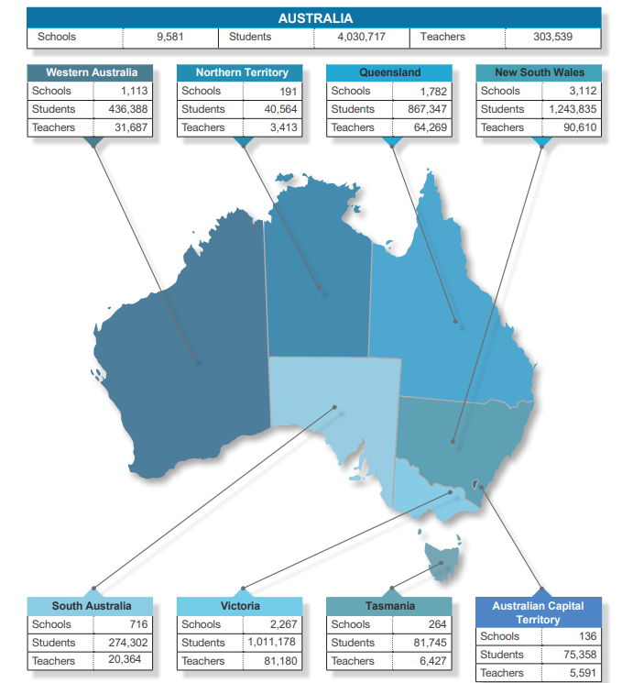
In 2 week’s time (NOW ONLY ONE), Education Ministers will meet to discuss major reform in the way we train our teachers. – literacy and numeracy and classroom management and better prepare them for the classroom. | 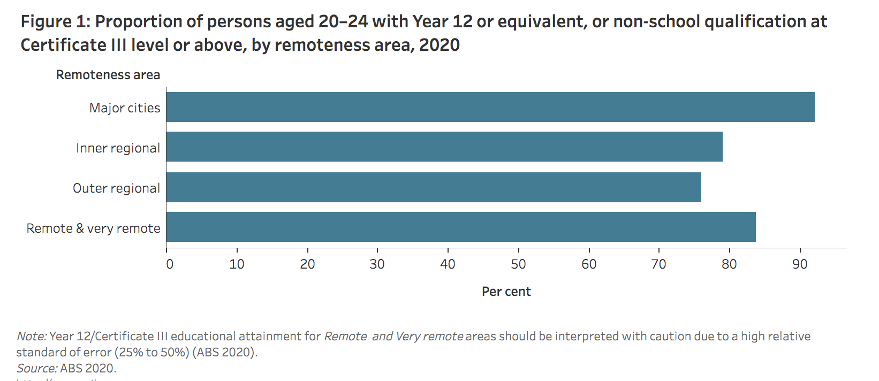  Australian Institute of Health and Welfare : Australian Government – 16 September, 2021
A few months ago we made major changes to NAPLAN – to raise the bar, to lift the minimum standard that students are required to meet and more clearly identify the children that need additional support. The next step is to provide them with that additional support. | On 10 February 2023 Education ministers agreed to change the way NAPLAN results are reported to parents and carers. The 10-band structure previously used in Individual Student Reports will be replaced with new proficiency standards, which will report on 4 levels of achievement. Queensland Curriculum and Assessment Authority (QCAA)  Education ministers have agreed to change the way NAPLAN results are reported to parents and carers, now that all students are taking the tests online, and with the move to an earlier NAPLAN in March.  New proficiency standards with 4 levels of achievement for each year level will replace the previous 10-band structure that covered all 4 levels tested and the old national minimum standard set in 2008 when tests were on paper.  The new proficiency standards include a baseline benchmark to identify students who are likely to need additional support. “These important changes mark a reset for NAPLAN that makes use of the online adaptive tests to deliver better information for parents, carers and teachers,” said ACARA CEO, David de Carvalho.  “The standard for proficiency is set at a challenging but reasonable level. If your child is in the Strong or Exceeding category, it means they have demonstrated proficiency and that their literacy or numeracy skills are where they should be at this stage of their schooling (my emphasis).  “If your child has not yet achieved proficiency, then they will either be in the Developing category or the Needs additional support category”.  “This is powerful information in the hands of parents/carers and teachers, and will enable much more meaningful conversations between them about how our children and young people are developing the foundational skills they need,” Mr de Carvalho said. “The proficiency standards represent a reasonable expectation of student achievement at the time of testing, with questions in NAPLAN tests based mostly on the literacy and numeracy skills students have learnt from previous years of schooling. The standard will support higher expectations for student achievement and ensure students are gaining the important literacy and numeracy skills they will need throughout their lives. “One of the issues with the previous national minimum standard was that parents and carers could think that if their child was at that level, then ‘everything is OK’. But it wasn’t. If your child is below 2 OFFICIAL the proficiency standard, then being informed that their skills are still developing towards proficiency is important. And it’s also important to know if your child needs additional support.” Australian Curriculum and Assessment Reporting Authority : 10 February, 2023 https://www.acara.edu.au/docs/default-source/media-releases/naplan-proficiency-standards-media-release-2023-02-10.pdf
We’re committed to work with States and Territories to make sure all schools are put on a path to full and fair funding. | National School Reform Agreement announced March 29, 2023 by the Australian Government’s Department of Education - The agreement is a joint agreement between the Commonwealth, states, and territories, to lift student outcomes across Australian schools. The Australian Government is committed to working with State and Territory Governments to get every school to 100 percent of its fair funding level.  The Review will focus on driving real and measurable improvements for students, with a particular focus on students most at risk of falling behind. This includes students from low socio-economic backgrounds, regional, rural, and remote Australia, students with disability, First Nations students and students from a language background other than English.  The Panel’s Terms of Reference  The Terms of Reference identifies the priority areas of focus for the Review, these include:  - Targets and reform areas to drive measurable improvements for all students, particularly those most at risk of falling behind  - Improving student mental health and wellbeing  - Attracting and retaining teachers  - Using data collection to best inform improvements to student outcomes  - Ensuring transparency and accountability of public funding.  The Expert Panel will consult with State and Territory Governments, teachers, principals and other education experts to present recommendations to Education Ministers. Consultations will also take place with Aboriginal and Torres Strait Islander communities, organisations from regional, rural and remote Australia, people with disability, and young Australians experiencing disadvantage.  The Expert Panel will advise Education Ministers on what reform priorities should be included in the next agreement by 31 October 2023.  The Review will be undertaken by an Expert Panel consisting of the following members (the blue information has been added from such sites as LinkedIn and others):  - Dr Lisa O’Brien AM (Chair) – Board Member of the Australian Education Research Organisation and former CEO of The Smith Family  - Ms Lisa Paul AO PSM (Deputy Chair) - Lisa Paul AO PSM is a Company Director of listed and private companies, an Enterprise Professor at the University of Melbourne, a Councillor of Bond University, a Director of several non-profit companies, a member of the Government’s Naval Shipbuilding Advisory Committee and consults as a Co-Founder of Paul and Webb P/L.  - Ms Dyonne Anderson - Experienced school principal and senior management roles including curriculum consultant at a regional and state level. Experienced Chief Operations Officer with a demonstrated history of working in the education management industry with a focus and priority on First Nations success. Ms Anderson is proud Githabal woman from the Far North Coast of NSW.  - Dr Jordana Hunter - Jordana Hunter is the Education Program Director at Grattan Institute.  - Professor Stephen Lamb - Professor Stephen Lamb is an Emeritus Professor in the Centre for International Research on Education Systems (CIRES) – University of Victoria.  - Professor Pasi Sahlberg – The Gonski Institute - Pasi Sahlberg is a Finnish educator, scholar, thought-leader and author. He has worked as a mathematics and science teacher, teacher-educator, researcher, and policy-maker in Finland, and studied education systems and advised education system reforms around the world. He is based at the University of Melbourne.
Funding is important but so is what it’s spent on, what it’s invested in., what it does, the difference it makes. We have to fix the funding gap and the education gap. | Education funding in Australia:  The Australian Government (the Commonwealth) provides recurrent funding for every student enrolled at a school. In 2023, recurrent funding for schools is estimated to total $27.3 billion. This includes $10.6 billion to government schools, $9.3 billion to Catholic schools and $7.4 billion to independent schools. C’wealth Dept of Ed’n: 10 May 2023
The next National School Reform Agreement will set targets and provide funding for children who fall behind and ensure more children finish school. | Work to be concluded by October 31st, 2023
  - Teacher nominees from each State and Territory  - Student representatives from each State and Territory  - Dianne Giblin AM – CEO, Australian Council of State School Organisations  - Jenny Branch-Allen – President, Australian Parents Council  - Andrea Obeyesekere – Catholic School Parents Australia  - Alana Moller – Federal President, Isolated Children’s Parents’ Association  - Andrew Pierpoint – President, Australian Secondary Principals Council  - Sally Ruston AM – Acting President, Australian Primary Principals Association  - Matthew Johnson – National President, Australian Special Education Principals’ Association  - Anne Keary – President, Australian Council of TESOL Associations  - Correna Haythorpe – President, Australian Education Union  - Kevin Bates – Secretary, Australian Education Union  - Meredith Peace – Deputy President, Australian Education Union  - Brad Hayes – Federal Secretary, Independent Education Union  - The Hon Jacinta Collins – Executive Director, National Catholic Education Commission  - Graham Catt – CEO, Independent Schools Australia  - Doug Taylor – CEO, The Smith Family  - Travers McLeod – Executive Director, Brotherhood of St. Laurence  - Professor Linda Graham – Director, QUT Centre for Inclusive Education  - David Bromhead – Wellbeing EDvantage  - Professor Maree Teesson AC – Centre Director, The Matilda Centre – University of Sydney | - Dr Rory Gallagher/Professor David Halpern CBE – Behavioural Insights  - Skye Kakoschke-Moore – CEO, Children and Young People with Disability Australia  - Hayley McQuire – CEO, National Indigenous Youth Education Coalition  - Christopher Wardlaw PSM OLY – Deputy Chair, Non-Executive Director AITSL  - Natalie Howson – Chair, ACT Teacher Quality Institute  - Professor Alan Reid – Professor Emeritus at the University of South Australia, and Chair of the Public Education Advisory Committee  - Adjunct Professor Susan Pascoe AM – Adjunct Professor at the University of Western Australia and Chair of the Australian Council for International Development  - Robyn Evans – President, NSW Primary Principals Association  - Valerie Gould – Former Executive Director, Association of Independent Schools of Western Australia  - Professor Ruth Wallace – Dean of College of Indigenous Futures, Arts and Society, and Director of the Northern Institute, Charles Darwin University  - Dr Regan Neumann - Director, Evaluation Office, Office of the Chief Executive OfficeDirector, Evaluation Office, Office of the Chief Executive Office  Queensland Curriculum and Assessment Authority (QCAA) · Part-time  - Dr Sally Milbourne – Former President of Tasmanian Principals Association  - Derek Scott – Chair, Australian Curriculum, Assessment and Reporting Authority  - Mark Grant PSM – CEO, Australian Institute for Teaching and School Leadership  - The Hon Fiona Nash – Regional Education Commissioner  - Associate Professor Jae Jung – Director, GERRIC – University of New South Wales  - Karen Batt – Federal Secretary, CPSU State Public Service Federation

