Episode 29

20th October 2020



**US Election 2020**

1. Discuss the BTN story with another student and record the main points of your discussion.
2. Where does BTN Rookie Reporter Zo live? Find on a map.
3. Who are the two presidential candidates?
4. Joe Biden was Vice President for which US President?
5. It is compulsory to vote in the US. True or false?
6. How often is the presidential election held in the US?
7. What is the Electoral College?
8. How many states are there in the US?
9. How many 4-year terms can a US president serve?
10. What factors are impacting the US 2020 Election?

**World Food Program**

1. What did the BTN *World Food Program* story explain?
2. Which organisation started the World Food Program?
3. What year was the World Food Program started?
4. Complete the following sentence. The program has helped people through some of the world's worst wars, natural disasters and ___________.
5. Which country is Gemma working in to help Rohingya refugees?
6. What other countries is the World Food Program helping? Name one.
7. What is the role of the World Wood Program?
8. How does the World Food Program deliver food in places where there is emergency or conflict?
9. Where does the World Food Program get its money from?
10. What do you understand more clearly since watching this story?

**World Statistics Day**

1. Discuss the BTN *World Statistics Day* story as a class and record the main points of the discussion.
2. Working in pairs, write down all the words you associate with statistics.
3. Statistics is a branch of mathematics that involves…
   1. Collecting data
   2. Analysing data
   3. Making sense of data
   4. All of the above
4. The smaller the sample size you have the better. True or false?
5. What is sampling bias? Describe using your own words
6. What are the horizontal and vertical sides of a graph called?
7. Explain an example that Cale used in the BTN story showing a misleading graph.
8. Why is it important that statistics are accurate and reliable?
9. What did you learn watching the BTN *World Statistics Day* story?
10. What questions do you have about statistics?

Check out the [Statistics resource](https://www.abc.net.au/btn/teachers/) on the Teachers page.

**Fire Ants**

1. What was the main point of the BTN *Fire Ants* story?
2. How are fire ants affecting farmers?
3. Fire ants can kill small animals. True or false?
4. Where do fire ants originally come from? Find on a map.
5. How were the first fire ants introduced to Australia?
6. When were fire ants first introduced to Australia?
7. Describe fire ants using 5 words.
8. Why are fire ants called ‘super pests’?
9. Why has it been difficult to eradicate fire ants from Australia?
10. What was surprising about this story?

Check out the [Fire Ants resource](http://www.abc.net.au/btn/teachers.htm) on the Teachers page.

**Online Musical**

1. Discuss the BTN story with another student.
2. Why are theatre companies all around the world performing online musicals?
3. What are Oliver’s responsibilities on the musical as the producer?
4. How do the performers in the musical rehearse?
5. What is the name of the character that Edgar plays?
6. Describe the character that Edgar plays.
7. How did COVID restrictions affect how Edgar made his costume?
8. What is one of the biggest differences between performing live or online?
9. What does Ben miss about live theatre?
10. What did you like about the BTN story?

Teacher Resource

Episode 29

20th October 2020

**World Statistics Day**



Students will develop statistical skills and thinking. Students will conduct their own statistical data investigation.



**Mathematics – Year 4**

Construct suitable data displays, with and without the use of digital technologies, from given or collected data. Include tables, column graphs and picture graphs where one picture can represent many data values.

Evaluate the effectiveness of different displays in illustrating data features including variability.

**Mathematics – Year 5**  
Pose questions and collect categorical or numerical data by observation or survey.

Describe and interpret different data sets in context.

**Mathematics – Year 6**

Interpret secondary data presented in digital media and elsewhere.

**Mathematics – Year 7**

Identify and investigate issues involving numerical data collected from primary and secondary sources.

Calculate mean, median, mode and range for sets of data. Interpret these statistics in the context of data.



1. Discuss the BTN *World Statistics Day* story as a class and record the main points of the discussion.
2. Working in pairs, write down all the words you associate with statistics.
3. Statistics is a branch of mathematics that involves…
   1. Collecting data
   2. Analysing data
   3. Making sense of data
   4. All of the above
4. The smaller the sample size you have the better. True or false?
5. What is sampling bias? Describe using your own words
6. What are the horizontal and vertical sides of a graph called?
7. Explain an example that Cale used in the BTN story showing a misleading graph.
8. Why is it important that statistics are accurate and reliable?
9. What did you learn watching the BTN *World Statistics Day* story?
10. What questions do you have about statistics?



**Class Discussion**

Discuss the BTN *World Statistics Day* story as a class. Record what students know about statistics on a mind map. What questions do they have about statistics? Use the following questions to help guide the discussion.

* What are statistics? Describe using your own words.



* Think of as many words as you can that relate to statistics.
* Where can you see statistics in your daily life? Give examples.
* Do you think it’s important to have statistics?
* What can statistics tell us?



**Glossary**

Students will brainstorm a list of key words that relate to the BTN *World Statistics Day* story. Students will then use the words to write their own sentences about the topic. Students may want to use pictures and diagrams to illustrate the meaning and create their own glossary. Here are some words to get you started.

|  |  |  |
| --- | --- | --- |
| **Data** | **Survey** | **Statistics** |
| **Trends** | **Percentages** | **Numerical data** |
| **Categorical data** | **Sample size** | **Graphs** |



**Warmup game**

As a class, play this warmup game “The Truth About Me” to get your students thinking about statistics. Refer to these [directions](https://dbp.theatredance.utexas.edu/content/truth-about-me-0) to get started – you just need an open space and room for a circle.



**The truth about me is that I like spiders**

**The truth about me is that I speak at least two languages**

**The truth about me is that I have brown eyes**

Explain to your students that the aim of the game is to learn more about statistics. Use the directions provided to play the game and then use the reflection questions below to spark a discussion:

* What did you notice?
* Which statements made a lot of people move? Why do you think that is?
* What did you learn about your classmates?
* What did you learn about your class as a whole?

Play the game again, but this time nominate someone (it could be a student or the teacher) who can record the information that is shared by the class, collecting as much data as they can throughout the game.

* Which of the data is numerical?
* Which of the data is categorical?
* What was your sample size?
* How might changing the sample size effect your results?
* What are some different ways that the data could be displayed?
* What is the best way to represent the data you collected? Why?
* What assumptions or conclusions can you make about the data?
* Are your assumptions different to your classmates? Compare.
* Use the statistics taken from the game to tell a story about your class.



**Inquiry Questions**

After watching and discussing the BTN *World Statistics Day* story, what questions do students have and what are the gaps in their knowledge? The following KWLH organiser provides students with a framework to explore their knowledge on this topic and consider what they would like to know and learn.

|  |  |  |  |
| --- | --- | --- | --- |
| ***What do I know?*** | ***What do I want to know?*** | ***What have I learnt?*** | ***How will I find out?*** |
|  |  |  |  |

Students will develop their own question/s for inquiry, collecting and recording information from a wide variety of sources. Students may develop their own question for inquiry or select one of the questions below.

* Why do we need statistics? Think of 10 reasons why statistics are important. Write an acrostic poem using the word ‘Statistics’ to teach others about the importance of statistics.
* The theme for World Statistics Day 2020 is “Connecting the world with data we can trust”. What does this mean?
* How can you spot a misleading graph? Watch this [TEDex video](https://www.youtube.com/watch?v=E91bGT9BjYk) to learn more and then explain ways that you can spot misleading statistics using your own words.



**Statistical data investigation**

Students will become statisticians and hold a census in their classroom. As a class discuss what you want to learn about the population of your class. Develop questions to investigate student’s experiences, opinions and interests. In small groups, students will design a survey, collect data, sort the information, analyse the data and then communicate their findings. Students can use the following framework to help guide them through the activity.

|  |  |
| --- | --- |
| **Research** | What do you want to find out about your class? Make a list of questions that you want to ask. Think about the type of data that you can get. See below for some ideas:   * Do you eat breakfast every day? * How do you get to school? (e.g. walk, ride, drive). * What is your favourite sport? * How many hours per week do you use the internet?   Which of the questions are numerical or categorical?  What is your sample size?  How will you collect the data? Design a form or simple table to record the information.  How will you respect privacy and protect confidentiality? For example, do not include your names on the census.  What is the purpose of your investigation? Write a sentence explaining why the data is being collected and how it will be used. |
| **Survey** | Survey the students in your class using the questions you have formulated. If you are collaborating assign different roles and responsibilities to each student. |
| **Sort** | Sort and enter the information you have gathered into an excel spreadsheet. Use mathematical equations like sum, percentage and averages in your spreadsheet. |
| **Representation** | What is the best way to represent the data you have collected? Summarise the information you have gathered and create a graph (e.g. column graph, pie graph, line chart) using excel. Consider drawing a diagram or creating an infographic to highlight the survey results. |
| **Analyse** | Analyse your results.   * What do the statistics tell you about your classroom? * Write a short paragraph explaining the results. * If you conducted another survey using a different class do you think the results would differ from your class data? Explain. * Did you have a big enough sample size? If you surveyed the whole school how would this effect the results? |
| **Reflection** | * What interesting things did the data tell you about your class? * How could the results collected from this data help your school make better informed decisions? |

**Further activity**

Make a time capsule which includes the data gathered from your classroom census. Future generations at your school, will be able to learn about the population of your class and then compare to their own.



ABC Education – Statistics

<https://education.abc.net.au/home#!/topic/1566429/statistics>

World Statistics Day – United Nations

<https://www.un.org/en/observances/statistics-day>

How to spot a misleading graph – Ted Ed

<https://www.youtube.com/watch?v=E91bGT9BjYk>

Census Stats – BTN

<https://www.abc.net.au/btn/classroom/census-stats/10524354>

Teacher Resource

Episode 29

20th October 2020

**Fire Ants**



Students will learn more about fire ants and the impact they have on people and the environment. Students will investigate other introduced species and methods used to manage or eradicate them.

S**cience – Years 5 & 6**



Scientific knowledge is used to solve problems and inform personal and community decisions.

**Science – Year 5**

Living things have structural features and adaptations that help them to survive in their environment.

**Science – Year 6**

The growth and survival of living things are affected by physical conditions of their environment.

**Science – Year 7**

Interactions between organisms, including the effects of human activities can be represented by food chains and food webs.

**Science – Year 7**

Scientific knowledge has changed peoples’ understanding of the world and is refined as new [evidence](http://www.australiancurriculum.edu.au/glossary/popup?a=S&t=evidence) becomes available.



1. What was the main point of the BTN *Fire Ants* story?
2. How are fire ants affecting farmers?
3. Fire ants can kill small animals. True or false?
4. Where do fire ants originally come from? Find on a map.
5. How were the first fire ants introduced to Australia?
6. When were fire ants first introduced to Australia?
7. Describe fire ants using 5 words.
8. Why are fire ants called ‘super pests’?
9. Why has it been difficult to eradicate fire ants from Australia?
10. What was surprising about this story?



**Class Discussion**

As a class discuss the BTN *Fire Ants* story, using the following questions as a guide. Record the main points of the discussion.

* When were fire ants introduced to Australia?

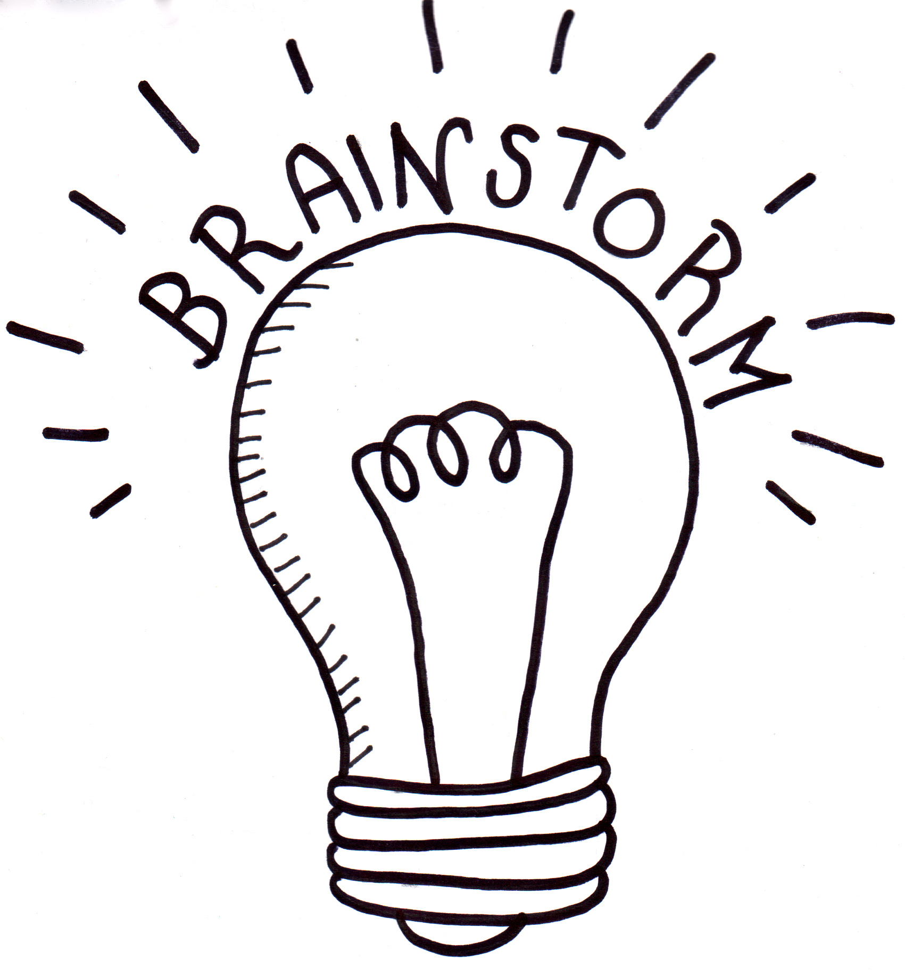

* How did they come here?
* What impact do fire ants have on the environment and people?
* How are fire ants different to native Australian ants?
* What other introduced animal species are there in Australia?
* What impact do introduced species have on ecosystems?



What is biosecurity? How does biosecurity help to keep Australian ecosystems healthy?

* How do we try to stop the spread of diseases and pest species (animals and plants) in Australia? (For example: not being allowed to take some food items across state borders, having bags checked at the airport, vaccinations for animals).
* Are introduced species always a bad thing? What makes an animal a ‘pest’?



**Key Words**

Students will brainstorm a list of key words that relate to the BTN *Fire Ants* story. Here are some words to get you started.

|  |  |  |
| --- | --- | --- |
| **Introduced species** | **Native** | **Eradicate** |
| **Invasive** | **Pest** | **Biosecurity** |



**Fire Ants Information report**

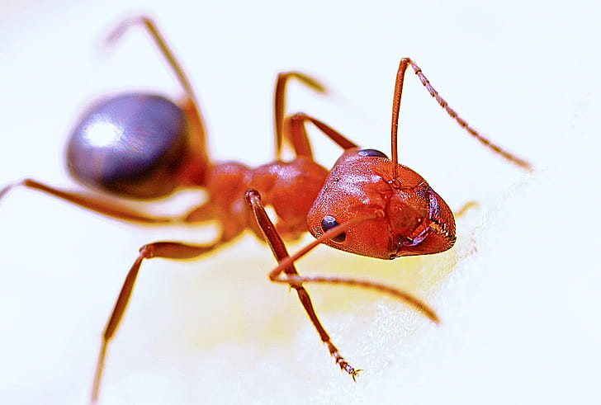

Students will create an information report about fire ants**.** The following may help guide students’ research:

* How did fire ants get to Australia?
* What do they look like?
* Where do they live?
* What impact do fire ants have on the environment and people?
* What is being done to eradicate fire ants?

**Structure and features of an information report**

Information reports are factual texts written to inform and provide detailed facts about a topic. Discuss with students what they already know about the purpose, structure and features of an information report. Use the following as a guide to use with students.

* **Purpose –** an information report provides information to the reader by stating facts.
* **Structure –** see table below.
* **Language features –** write in the present tense, use technical or scientific words and write in the third person.

Students can then use the following plan to help write their report.

|  |  |
| --- | --- |
| **Information report – structure** | |
| Title | States a topic |
| Introduction | The opening statement explains the subject of the report and includes a definition or short description. |
| Body | Facts grouped into paragraphs. Starts with a topic sentence. Include subject specific language. Text features such as sub-headings, labelled diagrams, charts and captioned photographs may be included. |
| Conclusion | A summary of what the topic is about and end with an interesting fact. |



**Introduced species – Research Task**

Students will then investigate the impact introduced species have on the environment and choose one to research. Include the following information:

|  |  |
| --- | --- |
| **Introduced species** | **Research** |
| Describe the animal |  |
| Which country did the animal come from? |  |
| When was animal introduced to Australia? |  |
| Why was the animal introduced to Australia? |  |
| Where does the animal live in Australia? (show on a map). |  |
| What impact does the animal have on native animals and the environment? |  |
| What methods have been used to control or eradicate the animal? How successful has it been? |  |

Below are stories about introduced species on the BTN website to help students with their research.

|  |  |
| --- | --- |
| [Rabbit Scan](https://www.abc.net.au/btn/classroom/rabbit-scan/10539160) | [Controlling Carp](https://www.abc.net.au/btn/classroom/controlling-carp/10525346) |
| [Toad Training](https://www.abc.net.au/btn/classroom/toad-training/10528504) | [Dirk Harthog Island](https://www.abc.net.au/btn/classroom/dirk-hartog-island/10611866) |



Students choose one of the following projects to work on and then present the information to their class.



**Campaign**

Design a public education campaign to raise awareness about an introduced species in Australia. Think about your campaign’s aim, your target audience, and the value of raising awareness.

**Anatomy of a Fire Ant**

Draw a labelled diagram showing the structural features of a fire ant. How are they different to native Australian ants?



**Most Unwanted Poster**

Create a poster of Australia’s 10 most unwanted invasive species. Describe each species and the impact the species has on the environment.

**Create a Quiz**

Create a quiz about fire ants or another invasive species using [*Kahoot!*](https://getkahoot.com/)Then test your classmates!



Australia claims small world-first victory against fire ants, but not everyone is convinced of the strategy – ABC News

<https://www.abc.net.au/news/2020-10-10/fire-ant-victory-in-se-qld/12740836>

Red Imported Fire Ant – Department of Agriculture, Water and the Environment

<https://www.environment.gov.au/biodiversity/invasive-species/insects-and-other-invertebrates/tramp-ants/red-imported-fire>

Invasive species in Australia – Department of Agriculture, Water and the Environment

<https://www.environment.gov.au/system/files/resources/2bf26cd3-1462-4b9a-a0cc-e72842815b99/files/invasive.pdf>

**BTN Transcript: Episode 29 – 20/10/20**

Hey, I’m Amelia Moseley and you’re watching BTN. Check out what’s coming up. We'll find out more about the Nobel Prize winning work of the World Food Programme, learn how to question numbers in the news on World Statistics Day and meet some young performers who are making sure the show goes on in 2020.

US Election 2020

Rookie Reporter: Zo

*INTRO: But first today to a story that I bet you've heard a fair bit about lately and that's the US Election. In just a few weeks Americans will get to choose their President and with so much going on in the world right now - this election is super important. So this week I've asked by cousin Zo to send us a special report from New York City filling us in on what's going on over there. Check it out.*

Hey BTN, I’m Zo. I'm 11 years old and I live in Brooklyn New York with my mum my dad and my little brother. Right now, all everybody’s talking about is the election next month. I asked my friends about it.  
  
MAX: I have been hearing about the election from parents, school and TV and I'm excited to hear what's going on.  
  
ZARA: I’d like to know what the future's going to look like because at this point whoever is elected to be president is really like shaping how the world is going to look like for us in the future.  
  
So I wanted to fill you in about them. Let's start with the presidential candidates. You probably know about Donald Trump already he's the current US President. And you might recognise Joe Biden too. He was the Vice President for 8 years when our last President Barack Obama was in office.  
  
ZO: Elections work a bit differently than they do in Australia.  
  
For starters, you don't have to vote here. People choose to vote or not. And the election is always held on the same date every four years, the Tuesday after the first Monday in November. And no, we don't have democracy sausages. Although they do look pretty tasty. We don't only vote for the party we like. We vote directly for the candidate we want to be our President and the person each candidate has chosen as their Vice President.   
  
ZO: But the winner isn’t based on who gets the most votes in the country. Instead, we have something called the Electoral College.  
  
It's made up of 538 people known as electors. They represent all 50 US states and Washington DC. To be elected the President and Vice President have to get at least 270 votes in the Electoral College. It's kinda complicated but basically, whoever wins the most states wins the election. US presidents can also only serve two terms of four years each. President Trump has already served one and if he wins it'll be his second term as President.  
  
ZO: Lots of people say this is a really important election because of all the big things that are happening in America right now.   
  
There's the coronavirus, which has had a big impact on us. In fact, even President Trump tested positive for coronavirus this month which was big news. And you might remember those big protests across America against racism and police shootings.  
  
MAX: I think the Black Lives Matter protests will have an impact in the election because people are starting to see that black lives matter and that people should be treated equal and I also think that coronavirus will have an impact on the election because Trump messed up and over 200 thousand people died.  
ZARA: I definitely don’t think that Joe Biden and Kamala Harris are the best option to be president, but at the moment this is our best shot.  
  
But not everyone feels that way. A lot of people really like President Trump and think he's been doing a good job and should keep doing it for four more years.  
  
ZO: The election will happen on November 3rd and I'm going to go with Mom and Dad when they go to vote. And when I'm old enough, I'm going to vote because I want to make a difference in this country’s future.  
  
ZO: I hope that’s helped you understand a little bit more about what's happening in America right now. Bye, BTN.

Ask a Reporter

If you want to know more about the election you can ask one of our reporters live on Friday. Check out our website for all the details.

News Quiz

Jacinda Ardern has been voted in for a second term as New Zealand’s Prime Minister. Do you know what political party she belongs to? Is it the Labour Party, the National Party or the Green Party? Jacinda belongs to the Labour party which won easily on Saturday.

Can you name this Australian politician? I’ll give you hint, she’s the Premier of New South Wales. It’s Gladys Berejiklian. Right now, she’s facing a bit of controversy, over her close personal relationship with a former MP who’s being investigated for some dodgy dealings.

This week is a big one for NASA’ Osiris-REX mission. What’s it trying to do? Land on Neptune, land on the Moon or land on an asteroid? It’s trying to land on an asteroid called Bennu. If everything goes to plan it’ll be the first spacecraft to take a sample of an asteroid back to Earth which could teach us a lot about the birth of our solar system.

A song from the 70s has rocketed up the music charts recently because of this Tik Tok video which sparked a viral challenge. The song’s called Dreams but can you name the band that first recorded it? Is it Fleetwood Mac, the Fleet Foxes or Little Feet? It’s Fleetwood Mac. In fact, one of the band’s founders, Mick Fleetwood, was amongst the many people who’ve done their own version of what’s been called the Dreams Challenge.

World Food Programme

Reporter: Nat Kelly

*INTRO: As you might have heard the Nobel Prizes were announced recently. They're really famous awards that recognise the work of the world's top scientists and doctors and writers and economists. There's also the Nobel Peace Prize, which this year went to the World Food Programme. Nat found out more about what that is and why it was given such a prestigious award.*

Welcome to the Nobel Peace Prize hall of fame. Not the real one. The list of world leaders, passionate campaigners and famous institutions that have worked hard to make the world a better place. And now there's a new member of this prestigious group.  
  
BERIT REISS-ANDERSEN, NORWEGIAN NOBEL COMMITTEE: The Norwegian Nobel Committee has decided to award the Nobel Peace Prize for 2020 to the World Food Programme.   
  
The World food programme is actually a branch of the United Nations which is devoted to making sure people have enough to eat.  
  
GEMMA SNOWDON, WORLD FOOD PROGRAMME: So the World Food Program was started in 1961, when the US president at the time, wanted to test what it would be like providing food aid in humanitarian emergencies.   
  
The test was a success, the world food programme saved lives, and since then it's helped people through some of the world's worst wars, natural disasters, and famines. Cut to today, and they're just as important as ever.  
  
GEMMA SNOWDON: Hunger, globally, is growing, unfortunately. And when we talk about hunger, we mean that people aren't able to put food on the table.  
  
Gemma works in Bangladesh, where the world food programme is helping more than 800,000 Rohingya refugees. They've had to leave everything they had because of violence in their home country. And now, COVID 19 is making things even harder.  
  
GEMMA SNOWDON: Our main role here is to ensure that people have food to eat, and they have dinner on the table every single night.  
  
But Gemma says her team has a little bit of help.  
  
GEMMA SNOWDON: Let me introduce Foxtrot, who is our WFP mascot, who we found on the beach here in Cox's Bazar.  
  
GEMMA SNOWDON: He has a very special list of roles and responsibilities at WFP. His number one role is actually to improve staff morale. It can be extremely stressful working in an emergency, there are long hours, lots of challenges to overcome.   
  
Gemma says sometimes workers have to get food into some pretty remote, and dangerous places.  
  
GEMMA SNOWDON: There are so many ways the WFP delivers food to people and it really depends on the situation that we're delivering to. Sometimes in a major emergency or conflict, then we'll have to use things like helicopters or planes and even do food drops, where we do a flyover, and we drop food. Otherwise, we will also use trucks, we use boats, we use any methods necessary, really.  
  
But it's not just about emergency relief, the WFP works with farmers and governments to try and prevent hunger.  
  
All of this work is expensive. The WFP gets all of its money from voluntary donations, made by governments around the world, including Australia's, businesses, and ordinary people. Many are hoping that the Nobel Prize win will encourage more people to donate. But for the people who work for the World food Programme, it was a surprising, but much appreciated moment of recognition.  
  
DAVID BEASLEY, EXECUTIVE DIRECTOR, WORLD FOOD PROGRAMME: This is unbelievable. Talk about the most exciting point in your life, the Nobel Peace Prize, it is because of the WFP family.   
  
GEMMA SNOWDON: It's humbling to be recognized with the Nobel Peace Prize this year, definitely. But I also think it's incredible. Not because WFP won, but because this is an opportunity to put hunger on the global agenda again.  
  
As for Foxtrot, well, he's not letting it go to his head, but I'm sure deep down he's pretty pleased with himself.

Quiz

What is the world's most commonly eaten staple food? Is it rice, potatoes or corn? It's corn. Maize corn makes up for more than 19 percent of humankind's energy intake. Rice is the next most common, followed by wheat.

World Statistics Day

Reporter: Cale Matthews

*INTRO: And that was an example of a statistic, which is very relevant because Tuesday, the 20th of October, is World Statistics Day. It was started by the UN to celebrate the really important things that statistics do for us. But experts say we need to be careful about believing every statistic that we hear. Here's Cale.*

POLICEMAN: So, I've got a few questions about our prime suspect.   
  
NUMBER 1: Oh 7, yeah he’s a bit of an odd fella, isn’t he?  
  
CALE: Numbers can be pretty useful tools, giving us vital bits of information.  
  
NUMBER 1: I was sitting in maths class.   
  
CALE: And help us piece together a story.  
  
NUMBER 1: And I looked over and saw it. 7 8 9.  
  
CALE: It's why, if you watch or read the news, you'll often see stuff like this. All of these graphs and percentages and numbers are examples of statistics. That's a branch of maths that involves collecting, analysing and making sense of data. You can think of it as facts supported by numbers, and we use it all the time.  
  
A lot of the statistics we see use smaller groups of people or numbers or data to make a prediction about bigger groups. So, say you wanted to know what Australia’s favourite sport was, you could ask a thousand random Aussies, and with the power of statistics, get a pretty good idea what the rest of us think.

JANE WATSON, STATISTICIAN: The larger the sample that you have, the more confidence you have in the conclusion that you reach.   
  
POLICE: Stop roamin numeral and sit down.  
  
CALE: But you have to be careful about believing everything the numbers say.  
  
POLICEMAN: Now I've been going over the maths and something doesn't add up.  
  
CALE: Imagine instead of asking 1000 people about their favourite sport, I only asked 10, that's not going to give me a very good idea about what the whole population thinks. Now imagine if those 10 were my basketball team chances are I would get a result that looks a bit like this. This is called sampling bias and it’s something you may have come across in the news.

CASEY BRIGGS, ABC DATA ANALYST: If you see, you know, survey results and statistics in the media is, ask yourself how is that number being calculated? If it’s a survey, who has been asked their opinion? If you're wanting to know how people are voting, but only young people are being asked their opinion, well, you're not getting a representative sample.

CALE: Casey is a data analyst at the ABC so he deals with a lot of statistics and he says it’s important to look closely at where data is coming from, whether its reliable and whether we are getting the full story.  
  
NUMBER ONE: What are you looking at.  
  
CALE: Take a squiz at this graph of global temperatures. If you look between 2015 and 2018 you might think things are getting colder. But zoom out a little and add a few more years and the picture starts to become a lot clearer. It's also important to look at the numbers on the sides of graphs, or the axes, to see what they're actually telling us. Say it’s a graph comparing the heights of me and Matt. Gee, I look pretty tall. But have a gander at the numbers on the side and you'll see we're only looking at a few centimetres. Stretch all of these numbers out to zero and we're really not that different.  
  
Casey says understanding how statistics work has been particularly important in 2020.  
  
CASEY BRIGGS: We have the biggest global pandemic in 100 years, the only way to understand the way that this virus is spreading is through numbers and the numbers are really complicated.   
  
CALE: Complications aside, you could say statistics are more important than ever, so long as we know how to understand them and when we can trust the numbers.  
  
POLICE: Right we've done some digging, checked your axis and your sample size and you seem like a rational number.  
  
NUMBER ONE: Great. So can I go?   
  
POLICE: Yeah, yeah you're free to go. Just let me jot down your number in case we need you again.  
  
NUMBER ONE: Yeah sure. One.

Fire Ants

Reporter: Nat Kelly

*INTRO: Now to a tiny little creature that's been causing havoc in Australia for the past 19 years - the fire ant. Since they sneaked into the country on a ship in 2001 authorities have been trying to wipe them out. Now they say they're having some success. Here's Nat.*

What do you get when you combine fire with ants? Fire ants. It's all in the name. A bite and sting that makes you feel like you're on fire, packaged in the stealthy size of a tiny ant. And it's not just the pain of being stung yourself, these ants have caused a lot of trouble for farmers across the country, by munching through crops, and even killing small animals. The red imported fire ant, as the name suggests, doesn't originally come from Australia. They come from the Pantanal region in South America, and in the 1930's, they spread to the US, which is where we got them from.  
  
DR ROSS WYLIE, SCIENTIST: We believe there were two separate introductions. One was with ceramic pots from Texas and the other was in a container at the port of Brisbane and they came from Florida.  
  
That was way back in 2001, and since then, they've spread like wildfire ants.  
  
DR ROSS WYLIE: This thing, it affects everything. It affects the environment, it affects human health, it affects lifestyle. So, it's a super pest.  
  
Ross is part of a national effort to eradicate fire ants. The program was designed to last 10 years, and this year is its 4th year in business. But getting rid of something so small, fast and stealthy is kind of hard. In the last century, they've managed to spread their wings and set up camp in parts of the world they'd never been seen before. And yes, when I say spread their wings, I mean wings. Queen fire ants are like the transformers of the insect world. They can fly, hitchhike, or even swim. Yep. Swim. See that there? That's not mud, that's a floating pile of fire ants.

DR ROSS WYLIE: And then they all link their little claws together and they make a raft, and they trap all oxygen in that raft. And off they can sail and they can sail around for two weeks if they have to.

So yeah, they're pretty O.P. And that's why the red ant eradication team has a big job ahead. To take them out, the team will have to cover all sides, land, air, suburbia and farmland, leaving no stone or dirt pile unturned. Here's a map of the area in Queensland they're focusing on. And this is a how far they reckon fire ants could have spread by now if it weren't for eradication. That's quite a difference.  
  
DR ROSS WYLIE: We're the ones who are taking up the fight, but we do it on behalf of the rest of Australia.  
  
Some people in Australia aren't sure how well our eradication program is actually going to work. And they say even more needs to be done. But officials are hopeful. And with 6 more years to go, only time and hard work will tell if these guys can extinguish Australia's fire ant.

Did You Know?

Did you know fire ants are attracted to electrical currents and have been known to chew through wires and even cause fires.

Sport

He's the Lions' King. Lachie Neale's been crowned the 2020 Brownlow medalist. The midfielder was a clear frontrunner with 31 votes but said it was a bittersweet win after his team's loss to Geelong over the weekend. Geelong and Richmond will go head to head for the premiership on Saturday.  
  
Victoria's not just delivering in the AFL. In Super Netball, the Melbourne Vixens won their first premiership since 2014. It was a tight game between the Vixens and West Coast with just 2 points between the teams at the buzzer.  
Holden driver Shane van Gisbergen has won his first Bathurst 1000. It was extra special for Holden because it was the teams last race after 52 years.

Online Musical

Rookie Reporters

*INTRO: Finally, today, if you're fan of musical theatre this year hasn't exactly been great. Heaps of shows have been cancelled, which is sad for audiences and for performers. But you're about to meet some kids who have found a way to make sure the show goes on - online that is. Check it out.*

OLLIE: Hi my name's Ollie and I'm here to talk to you about the musical adventures of Flat Stanley, online edition. At the moment it's pretty hard to get people all bunched together in a theatre, so instead lots of theatre companies all over Australia and even around the world are bringing you all the wonders and joy of a musical, from the comfort of your couch. My role in the musical is to play Arthur, Stanley’s brother, and I'm also the producer. As a producer I set up all the zoom rehearsals and I help the rest of the team make the whole show happen. I've enjoyed being able to continue performing during the middle of a pandemic, and I've learned that we need to be able to adapt to the new world we live in.   
  
EDGAR: Hi everyone, my name's Edgar Stirling and I play Stanley Lambchop. Stanley Lambchop is a young ordinary nerd who’s really into Harry Potter and Star Wars, he's at a slumber party with his friends when a bulletin board hanging above his bed comes crashing down leaving him flat as a tack. Normally we would travel all around Melbourne to Bunnings and $2 stores to try and find things for the costume, but because of stage 4 restrictions in Melbourne, I couldn’t go more than 5km of my home, and there are no Bunnings within 5km of my home, so I was in real strife. And other productions I've had dressers to fuss over my costume for me, but in this one me and mum fuss over the costume.   
  
Well for Victorians it feels impossible certainly to be back in theatres anytime soon, but for the rest of Australia small theatres are starting to open so, if we can tame the virus, then the theatres will start to open. I'm just saying.  
  
BEN: I think the biggest difference between performing online to live theatre is because you don't get the audience’s motivation. You don't know if they're enjoying the show, if they're not enjoying the show, and sometimes the audience gives you this great cheer and you're like yeah let’s do this show, but when you're doing it online you just don't know how their feeling. You'll never know. I miss performing in front of people, I just really hope I get to do it again soon.

Closer

Looks great guys, break a leg. Well that's it for today but we'll be back before you know it and, in the meantime, you can jump online to check out more stories and quizzes and specials. There's also Newsbreak every weeknight and if you're 13 or over you can subscribe to our YouTube channel, so you don't miss a thing. We’ll see you next time. Bye!