EPISODE 24
24th August 2021

KEY LEARNING
Students will view a range of BTN stories and use comprehension skills to respond to a series of focus questions.

CURRICULUM
English – Year 4
Use comprehension strategies to build literal and inferred meaning to expand content knowledge, integrating and linking ideas and analysing and evaluating texts.

English – Year 5
Use comprehension strategies to analyse information, integrating and linking ideas from a variety of print and digital sources.

English – Year 6
Use comprehension strategies to interpret and analyse information and ideas, comparing content from a variety of textual sources including media and digital texts.

English – Year 7
Use comprehension strategies to interpret, analyse and synthesise ideas and information, critiquing ideas and issues from a variety of textual sources.
  - Teacher Resource

Focus Questions

Afghanistan Crisis
- In pairs, discuss the Afghanistan Crisis story. Record the main points of your discussion.
- Maheen’s dad came to Australia from Afghanistan as a ____________.
- How did the Taliban affect people in Afghanistan?
- Why was life especially hard for women and girls?
- What attack happened on the 11th of September 2001?
- Who is Osama Bin Laden?
- How did life change in Afghanistan when the US and its allies invaded the country?
- What happened when the US and its allies withdrew troops from Afghanistan?
- How have people reacted to the Taliban taking over Kabul?
- What questions do you have about the story?

Wearing Face Masks
- What did the BTN Wearing Face Masks story explain?
- Since the beginning of the pandemic, scientists have been working out how the virus spreads and now it looks like a big culprit is…
- What are respiratory particles?
- Studies show that wearing a mask can reduce the transmission of the virus from an infected person by about…
  - 20-40%
  - 30-50%
  - 50-70%
- What have studies shown about uninfected people wearing masks?
- Give an example of where masks are mandatory.
- In South Australia, students in _________ school have to wear masks.
- Kids under 12 are exempt from mask rules. True or false?
- What are the rules about wearing masks where you live?
- What did you learn watching this story?

Fast Fashion
- Discuss the BTN Fast Fashion story as a class. Record the main points of your discussion.
- What is fast fashion?
- How has the way clothes are made changed over the years?
- What innovations meant that clothes could be made more quickly and cheaply?
- Clothes that are made in developing countries are cheaper because…
- Where are most of our clothes made?
- What impact does clothing waste have on the environment?
- Where does a lot of discarded clothing end up?
- Why can clothes that have been donated to charities cause problems?
- What is being done to solve the problem of fast fashion?

Check out the Fast Fashion resource on the Teachers page.

Young Marine Scientist
- What was the main point of the Young Marine Scientist story?
- Rehan is one of the youngest people in Australia to become an author of a scientific paper. True or false?
- What did Rehan observe when he was snorkelling?
- Scientists use something called a scientific _____________to test their observations?
- What question did Rehan investigate?
- What does it mean to form a hypothesis?
- How did Rehan test his hypothesis and gather evidence?
- What conclusion did he come to?
- What is the peer review process?
- Where was Rehan’s research published?

Check out the Young Marine Scientist resource on the Teachers page.

Tiwi Island Teen
- Where are the Tiwi Islands? Find on a map.
- What does Maletta mean when she says she’s lived on two islands all of her life?
- What was life like for Maletta in primary school?
- How did she get into boxing?
- What type of art does Maletta create?
- What does she want to do when she finishes school?
- How did this story make you feel?

  - Teacher Resource
EPISODE 24
24th August 2021

KEY LEARNING
Students will learn more about the impacts of fast fashion.

CURRICULUM
Geography – Year 4
The use and management of natural resources and waste, and the different views on how to do this sustainably.

Science – Year 4
Science knowledge helps people to understand the effect of their actions.

Science – Years 5 & 6
Scientific knowledge is used to solve problems and inform personal and community decisions.

Design and Technologies – Years 3 & 4
Evaluate design ideas, processes and solutions based on criteria for success developed with guidance and including car for the environment.

Design and Technologies – Years 5 & 6
Examine how people in design and technologies occupations address competing considerations, including sustainability in the design of products, services, and environments for current and future use.

Fast Fashion

Focus Questions
- Discuss the BTN Fast Fashion story as a class. Record the main points of your discussion.
- What is fast fashion?
- How has the way clothes are made changed over the years?
- What innovations meant that clothes could be made more quickly and cheaply?
- Clothes that are made in developing countries are cheaper because…
- Where are most of our clothes made?
- What impact does clothing waste have on the environment?
- Where does a lot of discarded clothing end up?
- Why can clothes that have been donated to charities cause problems?
- What is being done to solve the problem of fast fashion?

Activity: Class Discussion
Hold a class discussion about the information in the BTN Fast Fashion story. Use the following questions to guide discussion:
- What is fast fashion? Come up with a class definition.
- Do you know where your clothes come from?
- Why have clothes become relatively cheap?
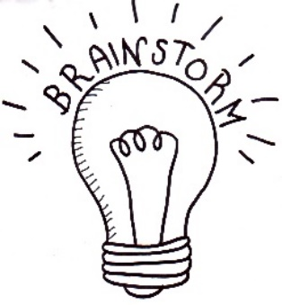
- Where can you buy fast fashion?
- What are the advantages and disadvantages of fast fashion?
- How can we reduce clothing waste? Make a list.
- What do you do with your unwanted clothing?

Activity: Match these terms to their definitions

Term | Definition
Sustainable | Cheap usually poor quality clothing that’s made in bulk.
Landfill | Materials or substances occurring in nature, like farm land and water.
Fast fashion | A site for the disposal of waste materials.
Natural resources | Interacting with the environment in a way that ensures there will be enough resources left for future generations.

Activity: Research
After watching and discussing the BTN Fast Fashion story, what questions do students have? The following KWLH organiser provides students with a framework to explore their knowledge on this topic and consider what they would like to know and learn.
What do I know? | What do I want to know? | What have I learnt? | How will I find out?

Students will develop their own question/s to research or select one or more of the questions below.
- What are the human, geographic and environmental impacts of fast fashion?
- Why is addressing fast fashion challenging?
- Investigate what happens to your clothes when you no longer wear them.
- How do you balance affordability, style, and ethics when it comes to buying clothing?
- Whose responsibility is sustainable fashion – the fashion industry or the consumer?
- Investigate a clothing company and research their ethical trading policy.
- Why is it important to know where our clothes are made and what happens to them once we no longer need or want them?
- Investigate the life cycle of a piece of clothing. Watch this Ted-Ed video about the life cycle of a t-shirt to learn more.

Activity: The story behind your t-shirt
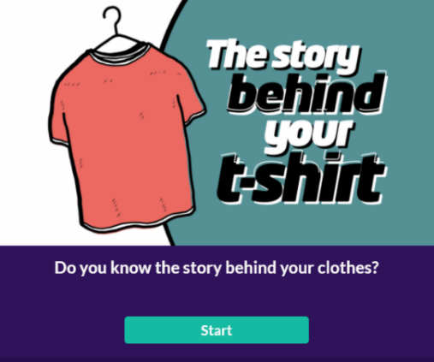
Do you know the story behind your clothes? Check out this interactive story to discover more about:
- What is your t-shirt made of?
- Where does it come from?
- Who made it?
- What happens to my clothes that are no longer wanted?
- What can you do about reducing the impact of fast fashion?

Activity: Upcycling
Clarify students’ understanding of what upcycling is and what the benefits are:
- What is upcycling?
- Do you know about the three R’s (reduce, reuse, and recycle)? Explain the difference.
- What do you recycle and upcycle at home and at school?
- What are the benefits of upcycling? Here are some suggestions:
  - reduces the amount of waste and therefore landfill.
  - reduces the need for production using new or raw materials (therefore reduces air pollution, water pollution, greenhouse gas emissions).
  - unique, one of a kind products.
  - Save money – for example you could upcycle your clothes into new designs
  - use your creativity.

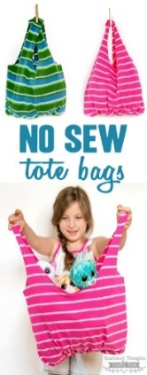
The BTN Upcycling and Green Art stories explain the benefits of upcycling unwanted items.

Have unwanted t-shirts? Make these no-sew bags - they make great book bags! Follow the step-by-step instructions or watch this short video.
A fantastic class project! Make a t-shirt rug for the classroom or another room in the school. Here are the instructions.
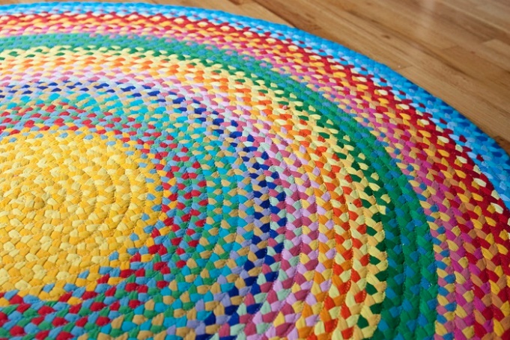
No sure what do to with your old pairs of jeans? Check out these 30 denim upcycling ideas for some inspiration!

The Pinterest upcycling and repurposing page has lots of ideas for reusing unwanted items. Get creative!

BTN Fast Fashion Stories

Watch these BTN stories to learn more about fashion waste and the way fast fashion is produced.

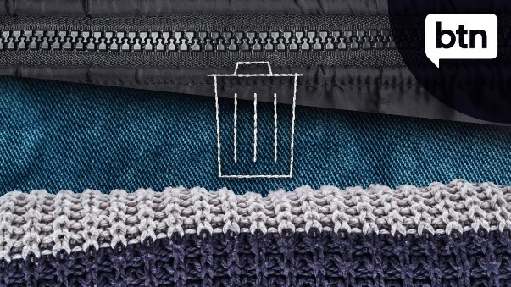  Fashion Waste | 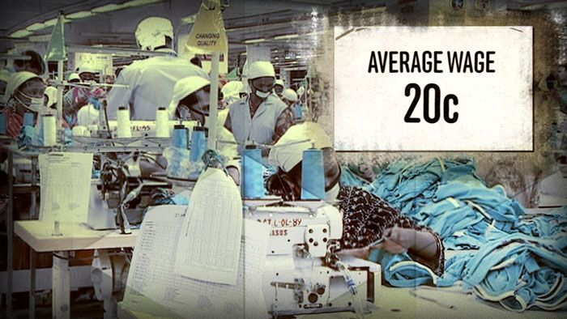  Fashion Factories

Activity – Choose a project
Individually or in small groups, students will choose one of the following projects to work on and then present their findings to the class.
Kahoot Quiz
Create a Kahoot quiz using the facts from the BTN Fast Fashion story.
Reporter for a day
Investigate the impacts of fast fashion and write an online news report or create a short video for kids.

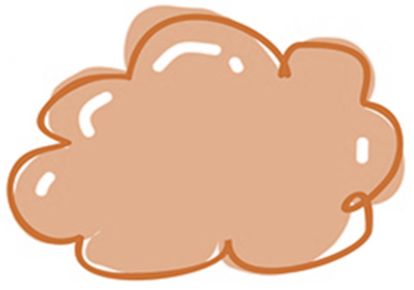
Campaign
Design a public education campaign to raise awareness about fast fashion. Think about your campaign’s aim, your target audience, and the value of raising awareness. Create a poster using Canva.

Where are your school uniforms made?
Investigate where your school uniforms are manufactured. Take your concerns to school leadership or SRC.

Useful Websites
- Fashion Waste – BTN
- Fashion Factories – BTN
- Fast Fashion – Foreign Correspondent
- Fast Fashion story map – ESRI
EPISODE 24
24th August 2021

KEY LEARNING
Students will use the scientific method to answer science related questions.

CURRICULUM
Science – Year 4
Living things depend on each other and the environment to survive.

Science knowledge helps people to understand the effect of their actions.

Science – Year 5
Living things have structural features and adaptations that help them to survive in their environment.

Science – Year 5 & 6
Scientific knowledge is used to solve problems and inform personal and community decisions.

Science – Year 6
The growth and survival of living things are affected by physical conditions of their environment.

Science – Year 7
Classification helps organise the diverse group of organisms.

Scientific knowledge has changed peoples’ understanding of the world and is refined as new evidence becomes available.

Interactions between organisms, including the effects of human activities can be represented by food chains and food webs.

  - Teacher Resource

Young Marine Scientist

Focus Questions
Discuss the BTN story as a class and record the main points of the discussion. Students will then respond to the following:
- What was the main point of the Young Marine Scientist story?
- Rehan is one of the youngest people in Australia to become an author of a scientific paper. True or false?
- What did Rehan observe when he was snorkelling?
- Scientists use something called a scientific _____________to test their observations?
- What question did Rehan investigate?
- What does it mean to form a hypothesis?
- How did Rehan test his hypothesis and gather evidence?
- What conclusion did he come to?
- What is the peer review process?
- Where was Rehan’s research published?

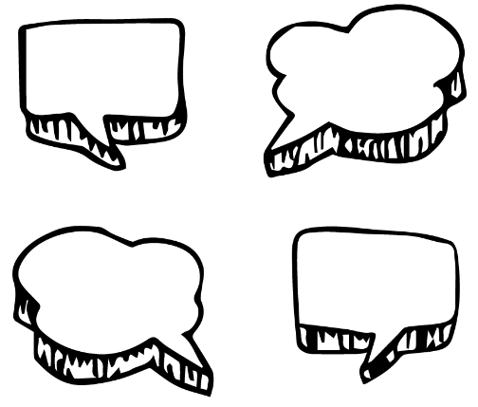
Activity: What do you see, think & wonder?
After watching the BTN Young Marine Scientist story hold a class discussion, using the following as discussion starters:
- What do you THINK about what you saw in the story?
- What does this video make you WONDER?
- What did you LEARN from the BTN story?
- Think of three QUESTIONS you have about the story.

Questions and Answers
All scientific discoveries start with a question! As a class, come up with some questions you think scientists ask and solve. Organise the questions into common themes. As a class, make a list of questions that you would like to ask a scientist. Use the internet to find answers to your class questions.

Activity: Glossary
Students will brainstorm a list of keywords that relate to the BTN Young Marine Scientist story. Here are some words to get them started. Students will create their own class glossary of keywords and terms. Students can use illustrations and diagrams to help explain each keyword.

CEPHALOPOD | BEHAVIOURAL ADAPTATIONS | HYPOTHESIS
INVERTEBRATE | SCIENTIFIC OBSERVATIONS | MARINE SCIENCE
SCIENTIFIC METHOD | NUCLEAR-FOLLOWER BEHAVIOUR | CONCLUSIONS

Activity: Inquiry based-learning
After watching and discussing the BTN Young Marine Scientist story, what questions do students have? The following KWLH organiser provides students with a framework to explore their knowledge on this topic and consider what they would like to know and learn.

What do I know? | What do I want to know? | What have I learnt? | How will I find out?

Questions for inquiry
Students will develop their own question/s for inquiry. Students will collect and record information from a wide variety of sources. Students may develop their own question for inquiry or select one of the questions below.

- What does an octopus’ habitat look like? Study the habitat of one type of octopus species and create a diorama of its habitat.
- Research some specific adaptations that octopuses have made to survive in particular habitats, for example, body shape, colour. Give an oral presentation explaining the adaptations.
- Why are octopuses an important part of the marine ecosystem?
- What is the role of a marine biologist? What are the different parts to the job of a marine biologist and what skills do they need to have? Present your information in a creative way.
- Where are octopuses in the food chain? Draw a diagram showing what animal feeds on what. Use illustrations or photos to demonstrate this food chain.
- Why do octopuses have 8 legs, 3 hearts and 9 brains? Explore the physical adaptations that help octopuses survive.
- Why do people explore underwater? What are the benefits? Explore one area of underwater research (E.g., marine life, ecosystems, ocean health, biodiversity).

Activity: Scientific Method
What is a scientific method?
Before starting this activity, explain to students what the scientific method is and why we use it. As a class look at a diagram which illustrates the scientific method and explain the meaning of each step in the process. The method consists of a range of steps, however the order of the steps in the process can vary. The scientific method is a tool which helps us to solve problems and answer questions.

Ask a question
Research
Hypothesis
Analyse data
Conclusion
Experiment

Framework
Provide students with the opportunity to think and behave like scientists. In pairs or small groups, students will conduct a scientific investigation using the scientific method to guide their investigation. Students will design and conduct their own scientific investigation in pairs or small groups. Students will use the framework below before, during and after their investigation.

Possible areas for investigation include understanding climate change, invasive species, the role that bees play in the ecosystem, plastic pollution, the impact of technology on health or if you are already focusing on a science topic in class use this as a basis for your investigation. Visit BTN’s Subjects page to explore stories with a focus on science.
ASK A QUESTION | - Before you ask a question, plan a visit to a local nature reserve or your own school yard to explore and observe the world around you. Take notes about what you see, hear and touch and record what you are drawn to.  - Use speech bubbles to document your thoughts and graph paper to document what you see. Ask why or how something is happening.  - Brainstorm some ideas for your science investigation based on what you have observed.  - Identify a question that can be tested or researched. For example, “What happens when…?” or “What is the effect of…?”  - Describe what you are going to research using your own words.
RESEARCH | - Research the topic to learn as much as you can.  - Research using secondary sources of information to help you understand the observations you have made.
HYPOTHESIS | - What do you already know about this scientific topic?  - Formulate your hypothesis.  - What do you predict to be true about the answer to your question?
EXPERIMENT | - Design and conduct an experiment to test your predictions.  - How will you test your hypothesis?  - What steps do you need to follow to investigate your prediction?  - What equipment and materials will you need to conduct your investigation?  - How will you gather evidence?  - Plan how you will record and organise your data.  - Perform your experiment, by repeating trials of tests, taking measurements, making observations, and recording data.
ANALYSE DATA | - What does the data mean? Write a paragraph that summarises what happened.  - Make calculations using the data you have collected.  - Can you see any patterns in the data you have collected?  - Draw a labelled diagram of your results to show what happened.
CONCLUSION | - Review your findings in relation to your hypothesis.  - How effective was your investigation in testing your hypothesis?  - Think of a creative way to explain/answer your science discovery (using multimedia, models, video, or animation).  - Create your own mini science lesson about what you have learnt and teach students in another class.
REFLECTION | - Was this what I expected? Explain.  - What problems did I experience when I was doing the investigation? How could I fix these problems?

Activity: Species profile
Students will imagine they are marine biologists and study one species from the cephalopod family. Students will create a profile about the species, see below for some examples:
- Blue-lined Octopus
- Striped pyjama squid
- Mourning Cuttlefish
- Common Sydney Octopus
- Nautilus
- Cone shell

Students will research the following and then share their research findings with the class or create a display in the classroom.
- Name (common and scientific name)
- Biological illustration or photo
- Classification (class, family, genus)
- Description (size, colour, physical features)
- Habitat
- Diet
- Behaviours
- Adaptations
- Conservation status
- Threats

Students will then choose one of the following activities to complete:
- Model – Create a 3D model of an octopus or another type of cephalopod using recycled materials. Display your model in the classroom.
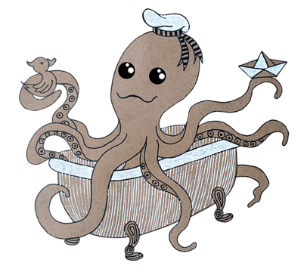
- Haiku – Write a haiku poem about octopuses or another type of cephalopod.
- Children’s book or comic – Write and illustrate either a children’s book or comic which tells the story of an octopus.
- True or false? – Find out as much as you can about octopuses. Create a true or false quiz and test your classmates. Alternatively, create a word find or crossword about octopuses.
- Celebrate – On October 8th, World Octopus Day celebrates one of the oldest animals on earth. Think of a creative way to celebrate the day in your class.

Activity: New species
Create a new species of cephalopod
Students will imagine they are biologists and create a new species of cephalopod! Students will draw the animal and classify it according to the principles of classification.
- Name the species
- Draw what it looks like (you may want to draw a scientific illustration or draw the animal in its natural habitat). Label important features.
- List the animal’s classification
- What are its characteristics?
- What adaptations help the animal to survive?

Activity: Quiz

- How many brains does an octopus have?  A. 3 brains  B. 8 brains  C. 9 brains  - What colour is an octopus’ blood?  A. Red  B. Blue  C. Purple  - What class is the octopus from?  A. Mammalia  B. Chondrichthyes  C. Cephalopoda  - Octopuses have beaks.  A. True  B. False  - How many hearts does an octopus have?  A. 1 heart  B. 3 hearts  C. 8 hearts | - Octopuses are invertebrates.  A. True  B. False  - What adaptation does an octopus have to escape predators?  A. Camouflaging themselves  B. Expelling ink  C. Squeezing into tiny spaces  D. All of the above  - Octopuses are herbivores.  A. True  B. False  - How many species of octopus are there?  A. 100  B. 200  C. 300  - Octopuses have excellent eyesight.  A. True  B. False

Quiz Answers: 1C, 2B, 3C, 4A, 5B, 6A, 7D, 8B, 9C, 10A.

Useful Websites
- Perth boy Rehan Somaweera has become one of Australia’s youngest authors of a scientific paper – ABC News
- Science Lessons – BTN
- Science Week 2021 – BTN
- Molluscs – Australian Museum
- Did you know that octopuses dream? – Newsround
- Octopus – BBC Earth

  - Teacher Resource

BTN Transcript: Episode 24 - 24/8/2021

Hey, I’m Amelia Moseley and you're watching BTN. Here’s what’s coming up. We check out this season's biggest fashion trend. Yeah, it's masks. We also find out about the dark side of fast fashion and meet one of Australia's youngest published scientists.

Afghanistan Crisis

Reporter: Amal Wehbe

INTRO: All that soon. But first to Afghanistan. Over the past week we've seen some pretty upsetting images coming from the country after it was taken over by a militant group called the Taliban. Amal found out what's happened and why it's got so many people worried.

For many of us it's hard to imagine what life has been like for people in Afghanistan. We've seen images of chaos on the streets and at airports, as people desperately try to leave the country. For some Aussie families, it's particularly sad to watch.
MAHEEN AMANI: I'm like sorry for them, it's just sad.
AHMAD: I have cousins, I have extended family, my maternal uncles, they are living in total fear, in total desperation.
Maheen and her brother were born in Australia, but their parents are from Afghanistan.
MAHEEN: My dad left Afghanistan in 2000 while the Taliban were in power. Then in early 2001 he came to Australia as a refugee.
The Taliban is an extremist religious group that took over Afghanistan in the 90s. They believe in their own strict interpretation of Islamic law. And controlled many aspects of people's lives. Banning many things like television, non-religious music and even flying kites. And they gave harsh punishments to people who disobeyed them.
MAHEEN: The Taliban they would be killing innocent people and abusing people and hurting them. Not letting girls go to school and covering them up.
For women and girls, life was especially hard. Girls weren't allowed to go to school after the age of 8 or get a job, couldn't leave the house without a man and all women had to wear burkas, which is a one-piece veil that covers the face and body. It was in 2001 that the Taliban really came to the world's attention. On the 11th of September 2001, an Islamic extremist group called Al-Qaeda carried out the biggest terrorist attack in history against the US. Al-Qaeda’s leader Osama Bin Laden wasn't from Afghanistan, but he trained there, and the Taliban was protecting him and other terrorists.
FORMER US PRESIDENT, GEORGE BUSH: On my orders, the United States military has begun strikes against Al-Qaeda terrorist training camps and military installations of the Taliban regime in Afghanistan.
The US, along with its allies including Australia invaded Afghanistan and ended the rule of the Taliban. But the group didn't disappear all together. They fled to remote parts of the country and continued to fight against the US, its allies and the Afghan army. Over the next 2 decades, trillions of dollars were spent, and thousands of lives were lost as the US and its allies fought the Taliban, while training the Afghan army, rebuilding parts of the country and trying to establish democracy. Afghanistan set up a free media and had an election. Girls could go to school, get a job, and be what they wanted to be. But earlier this year the US announced it was going to leave.
JOE BIDEN, US PRESIDENT: I concluded that it's time to end America's longest war.
Many worried that without US support, the Taliban would take control again. And that's exactly what happened, way faster than anyone expected. The Taliban swept across Afghanistan, with not much resistance from the Afghan army. Then they entered the capital Kabul and took over the presidential palace, as elected leaders fled the country.
The Taliban have established a new government, and they say they want to work with Afghan people and the rest of the world. They've promised to respect women's rights and not punish people who've helped foreign armies. But many don't believe them.
AFGHAN GIRL 1: As an Afghan woman I wouldn't trust them because they don't have a very clear track record of keeping their promises, or something like that.
The US and other countries, including Australia, have been evacuating their citizens from Afghanistan along with Afghans who helped them during the war.
PRIME MINISTER, SCOTT MORRISON: Devastated, absolutely devastated about it. It's a terrible, it's a terrible situation.
Many Afghan people say they're shocked and angry.
AFGHAN GIRL 2: What did they do? They just came back, left Afghanistan in the same situation as it was in 2001.
But the US President has stood by his decision to leave.
US PRESIDENT, JOE BIDEN: American troops cannot and should not be fighting in a war and dying in a war that Afghan forces are not willing to fight for themselves.
For people in Afghanistan and for people watching around the world it's a sad and a scary time.
TANWEER: I don't want to start wars with each other because wars are bad for killing people and no shooting people.
MAHEEN: I hope that there’s no more war, there’s no bombing, there’s no shooting, there’s no killing, there’s no anything there. It’s just going to the shops and just getting whatever you need and just coming home safe.

Upsetting News

Now if you're feeling worried or upset about that story or anything else you see in the news, make sure you talk to someone about it. We've also put together some resources on our website with tips on how to deal with upsetting news so make sure you check that out. Now it’s time for a news quiz.

News Quiz

Can you name this Caribbean country that’s been hit by a devastating earthquake? It’s Haiti. The magnitude 7.2 quake destroyed homes, businesses and churches and has killed more than 2,000 people. To make things worse, it was hit by a tropical storm that brought heavy rains making it hard for rescue workers and survivors.

Can you name this Aussie leader? Michael Gunner is the NT Chief Minister. And last week he was in the news when he put the Territory into a short, sharp lockdown. While Territorians and Queenslanders are now out and about, New South Wales, the ACT and Victoria are still stuck at home.

The Paralympic Games are getting started this week. Which two of these sports will make their debut at the games? Badminton, taekwondo, lawn bowls, gymnastics. It’s badminton and taekwondo. They’ll replace sailing and seven-a-side soccer.

Wearing Face Masks

Reporter: Jack Evans
INTRO: Now to a little accessory that most of us never really thought would become such a big part of our lives, masks. With the COVID Delta variant spreading around the world, experts say we're probably going to be wearing them for a while now. Jack found out how they're helping to keep us safe. Check it out.

JACK: Ooh the latest edition of Vague is out. Let's see what fashion trends are in this season. Masks, again. Ground breaking.
Yeah, while it might feel like a bit of a fashion repeat from last year, it's no surprise that masks are the must have staple for yet another season. And what's not to love about them?
JACK: You can disguise your bad breath.
AMAL: I can still smell it.
JACK: You can match them to your outfit. You can stick googly eyes on your chin and make a little face, and no one will ever know. Oh yeah, and then there's the fact that they're now scientifically proven to help evade pesky viruses.
Since the pandemic began face masks have been a pretty debated topic and at first there were a lot of mixed messages.

JACK: That's because, well, we hadn't really been in a pandemic like this before. So, we didn't really know how effective they were at stopping the spread of viruses.

For the last year and a half, scientists have been trying to work out how exactly the virus spreads and now it's looking like a big culprit is respiratory particles. You know, little droplets that we release when we speak or cough or sneeze or sing or even just breathe. Some of those droplets can be really tiny and linger in the air for a long time. That's led to experts recommending changes for things like ventilation in buildings, social distancing, and yep, masks.
Thanks to a whole bunch of studies, we now know that wearing a mask can reduce the transmission of the virus from an infected person by about 50 to 70 percent. Studies have also found that if you're uninfected and wearing a mask it can also reduce the chances of becoming infected. While the rules around when to wear a mask are different depending on where you live, there are some places where masks are now mandatory. Like catching a plane or places where social distancing is difficult. Oh, and of course areas that are in lockdowns. Meanwhile in SA where there aren't any current community cases people are still required to wear a mask in certain places, including all high school students who have to wear them at school.
KID 1: We have to wear them in class and when we're going around, however during break 1 and break 2 we don't need to.
KID 2: I find it very difficult to hear some people talk and it does get really hot and stuffy if you keep them on for long durations of time as well.
KID 3: Sometimes it also goes with my outfit and helps with fashion as well.
KID 4: I like how we get to go back to school and see our friends because socialising is a big part of like going to school so I like how that allows us to do that.
Kids under 12 are exempt from mask rules, but health experts say they can be helpful for anyone over 2. And whether you love them or hate them experts reckon we'll have to get use to them. Of course, there are some people who have really good reasons why they can't wear one, which is OK. And there are still some people who haven't quite worked out how to wear one properly, which is not OK. It goes over the nose people.

Then there's the debate over what sort of mask is best. While these fabric ones look fancy. Unless they're made properly, they're not as effective as these ones. Although there are concerns now that disposable masks are just adding to the pollution problems we already have. Either way, whatever your style, it looks like face masks will be "on trend" for the foreseeable future. Which means I'll have to get over my phobia of a fashion repeat.
JACK: But I wore this mask last week, what are people going to think of me?
AMAL: That you're being protective of yourself and others?
JACK: Oh well. That’s true I suppose.

Fast Fashion

Reporter: Leela Varghese

INTRO: OK, we're going to stick with the fashion theme now, but this time we're talking about something that isn't keeping our planet safe, and that's fast fashion. Leela found out how the clothes we buy and throw away are hurting the planet. Take a look.

It's the stuff of nightmares, wreaking havoc on our world. A monster made of clothes. Like most horror stories, you might not see this one coming. Fashion is something a lot of us enjoy. And shopping for a new outfit can be a lot of fun. But experts say there's a dark side to our love of clothes especially when it comes to fast fashion.

Fast fashion is basically cheap, usually poorly made clothing that's made in bulk. It exists so we can afford to buy new clothes regularly that keep up with trends. But it wasn't always this way. Back in the old days clothes were made at home or by small local businesses and they cost a lot. So, most people only had a few different outfits which they would often mend or restyle. But innovations like the sewing machine and synthetic material meant clothing could be made a lot more quickly and cheaply. So, it was a lot easier to be all trendy and the monster of fast fashion was born, with the help of international trade.
LEELA: Now, I'm sure you've looked at a tag on a piece of clothing before and seen that it isn't made here in Australia.
Companies can cut costs by having clothes made in developing countries, where people are often paid lower wages. That's helped grow the economies of those countries and give a lot of people jobs. But it's also led to some problems like poor working conditions and pollution. Making clothes takes a lot of natural resources, like farmland and water, as well as a lot of chemicals and energy. The industry is one of biggest polluters in the world. Accounting for about 10 percent of global carbon emissions, and nearly 20 percent of global water pollution. And then there's the clothes we throw out, which often end up in landfill, even when we donate to charity, they can end up in landfill overseas.

The ABC's Foreign Correspondent tracked down one of the places that ends up with a lot of our trash-ion. This mountain of rubbish in Ghana in West Africa is estimated to be 40 percent unwanted clothing. 15 million used garments are shipped here every week to be sold and reused but a lot of them just aren't worth holding onto. And locals say that’s the result of poor quality fast fashion. So, at this point you and I are wondering.
LEELA: How can we stop this ever growing fast fashion monster?
Well, some companies are trying to find more environmentally friendly ways of making clothing or recycling old clothes. Kind of like how we recycle plastic. And many governments and organisations are trying to build better working conditions and environmental regulations. But defeating this monster also comes down to you and me. Thinking about what we buy, buying less and holding on to our clothes for longer to slow down this fast growing problem.
Ask a Reporter

If you want to know more about fast fashion you can join me live on Friday. Check the website for more details.

Young Marine Scientist

Reporter: Leela Varghese

INTRO: Alright, now for some science. You're about to meet a 10-year-old who’s just become one of Australia's youngest published scientists and, if you're a scientist like Rehan, you'll know getting published is a big deal. Leela found out how he used the scientific method to make a very important discovery.
Here at BTN, we seem to be pretending to be scientists an awful lot, but we’ve got nothing on Rehan here. At just ten, he's one of the youngest people in Australia to become an author of a scientific paper. So how do you go from wannabes, to legit? Well, it all started with his love for exploring the ocean.
REHAN: The ocean is like a whole different world itself.
While he was snorkelling, he observed something interesting going on with an octopus.
REHAN: When I looked really close, I could notice that there was a fish next to it. I thought it could be by coincidence, but it wasn't, it was actually following it. I told my dad, and he didn't believe me at first.
But as a researcher of animal behaviour himself, Rehan's dad Ru challenged him to test his observations. See that's how science works. Big discoveries don't come from just one observation.
LEELA: Was this water always blue?
Scientists used something called the scientific method.
LEELA: I know all about that because I'm definitely a real scientist and not just pretending to a scientist.
Basically, the scientific method involves observing something, asking a question about it. In this case, does the brown-spotted wrasse fish always follow around the WA common octopus? The next step is forming a hypothesis. Which is a theory or an idea about how something might work. Like, I think this fish is following this octopus. Then you have to test your hypothesis and gather evidence. For a year Rehan did this snorkelling at four different beaches in Perth to find octopuses and see if wrasse fish were hanging nearby.
REHAN: We saw it a couple more times.
Which meant they could go to the next step recording their results and drawing a conclusion. The fish was following the octopus. Leading to a new hypothesis that the fish was taking advantage of food that was disturbed by the octopus when it moved its arms around. It’s something called nuclear-follower behaviour. And while it's been seen with other animals, thanks to Rehan, it's the first time this budding friendship has been noticed.

RU: I've spent so much time in the ocean and it's not something I've ever seen.
REHAN: We wrote a scientific article.
But there's another important step in the scientific method that Rehan and his dad had to go through. The peer review process.
LEELA: That's when you share your findings with other real scientists to see if they agree with your conclusions. Ahh Cale, here's my findings about the blue water.
CALE: Leela you know we're not real scientists. Oh, I’ll take a look anyway.
In Rehan's case his discovery was reviewed and has now been published in a CSIRO journal. Having the research published is a really impressive achievement. So, the obvious question: does Rehan want to be a scientist when he's older?
REHAN: Of course, I do. Because science is kind of my thing.
That makes one of us, Rehan.
Sport

The biggest sports news of the week is happening over in Tokyo, where the 2020 Paralympics are kicking off. More than 4 and a half thousand athletes from 163 nations will be competing across 22 sports. And the Aussie team reckon they’re in with a chance of bringing home a decent haul of medals.

And it's been a wild final round of the AFL. First off, Port kicked the last 3 goals to win a Friday night thriller against the Bulldogs. Then the Hawks and the Tigers drew. Then Geelong and Melbourne came down to the very last kick. This goal from captain Max Gawn gave Melbourne their first minor premiership since 1964, putting them in prime position for next week’s AFL finals.
Tiwi Island Teen

Reporter: Jack Evans

INTRO: Finally, today, we're going to the Tiwi Islands to meet a young artist called Maletta. She's a winner of the ABC's Heywire competition which asks young people from regional Australia to tell their stories, and telling stories is something that Maletta's pretty passionate about. Check it out.

MALETTA: I've lived on two islands all my life. I live at Tiwi College Monday to Friday before returning home on the weekends and school holidays. Our classroom is surrounded by bush and animals. After school has finished, we sometimes head down to the creek where I muck around with my friends. For fun, we paint ourselves with clay and have a bit of a laugh. We tell stories together, creating fun and happy memories.
But there was one time when things weren’t so great for me. At primary school, I used to get bullied for my art. Everyone was into sport, and I wasn't good at it. Other kids would say, I hate art, art is for losers. When my dad found out I was getting bullied, he said I had to stand up for myself. He taught me how to box. Now I train with my uncle. I've gotten tougher. And my art has gotten better too.
I'm a digital artist now, self-taught. I'm the first and only person in my family to do digital art. After school, I want to go to an art school and study animation so I can make my own Tiwi anime inspired by dreamtime stories. In many ways, this has been a magical place to grow up. I want to use these happy memories and turn them into animations.
Closer

Wow, you’re amazing Maletta, nice work. Well, that's if for another week. We'll be back before you know it and, in the meantime, you can check out our website and you can keep up to date with Newsbreak every weeknight. Plus, if you're 13 or over, you can subscribe to our YouTube channel where there's even more content. Have a great week. Stay safe everyone and I’ll see you soon.

