
KEY LEARNING
Students will view a range of BTN stories and use comprehension skills to respond to a series of focus questions.

CURRICULUM
English – Year 4
Use comprehension strategies to build literal and inferred meaning to expand content knowledge, integrating and linking ideas and analysing and evaluating texts.

English – Year 5
Use comprehension strategies to analyse information, integrating and linking ideas from a variety of print and digital sources.

English – Year 6
Use comprehension strategies to interpret and analyse information and ideas, comparing content from a variety of textual sources including media and digital texts.

English – Year 7
Use comprehension strategies to interpret, analyse and synthesise ideas and information, critiquing ideas and issues from a variety of textual sources.

  - Teacher Resource

Passion Projects Special
As a class, discuss the stories featured in the BTN Special and record the main points of the discussion. Students will then respond to the following focus questions.

Pencil Pals
- Summarise the BTN Pencil Pal story in three sentences.
- What are the benefits of having a pen pal?
- Do you think letter writing is important? Give reasons for your answer.
- What do the students in the BTN story like about having pencil pals?
- Have you ever written or received a letter? How did it make you feel?

Mypolonga School Shop
- What do the students sell at the Mypolonga school shop?
- Who are their customers?
- What do the students spend their profits on?
- What skills have the students learned?
- How does running the school shop make the students feel?

Human Powered Vehicles
- What is used to power human powered vehicles?
  - Pedal power
  - Electric power
  - Solar power
- How do students steer an HPV?
- What skills have the students learned being involved in the HPV program?
- How do the students prepare for Pedal Prix?
- Design and sketch your own human powered vehicle.

Hans Heysen
- What kinds of paintings is Hans Heysen best known for?
  - Landscape
  - Abstract
  - Portrait
- What landmarks in Australia are named after Hans Heysen? Name one.
- Where was Hans Heysen born and where did he grow up?
- What did you learn about Hans Heysen?
- What did you like about this BTN story?

KEY LEARNING
Students will learn about letter writing and examine the difference between formal and informal letters.

CURRICULUM
English – Year 4
Plan, create, edit and publish written and multimodal imaginative, informative and persuasive texts, using visual features, relevant linked ideas, complex sentences, appropriate tense, synonyms and antonyms, correct spelling of multisyllabic words and simple punctuation.

English – Year 5
Plan, create, edit and publish written and multimodal texts whose purposes may be imaginative, informative and persuasive, developing ideas using visual features, text structure appropriate to the topic and purpose, text connectives, expanded noun groups, specialist and technical vocabulary, and punctuation including dialogue punctuation.

  - Teacher Resource

Pencil Pals

Activity: See, think & wonder?
After watching the BTN Pencil Pals story hold a class discussion, using the following as discussion starters:
- What do you THINK about what you saw in the story?
- What does this video make you WONDER?
- What did you LEARN from the BTN story?
- Think of three QUESTIONS you have about the story.

Activity: Class Discussion
After watching the BTN Pencil Pals story hold a class discussion, using the following questions to start the discussion:

- What is the purpose of a letter? Why do people write letters instead of sending emails or texts?
- What are some examples of different types of letters.
- Who do we send letters to?
- What makes a letter interesting to read?
- Have you ever written a letter? Have you ever received one? How did it feel?

Activity: Letter Writing Research
Students will choose one of the questions below to explore in more detail or they can develop their own questions to research.

- What are the different parts or features of a letter? For example, date, postal address, greeting, signature.
- What type of language would you use in an informal letter to a friend or relative? Compare the language used in an informal letter to the language used in a formal letter. Give examples.
- Investigate the history of letter writing. When and why did people start writing letters?
- Why are letters useful primary sources? Investigate how letters can tell us about the writer’s opinions and personality and tell us more about the past. Choose an important letter in history to research.
- How has technology changed the way we communicate? What impact has technology had on letter writing?

When you're writing formal or informal letters or emails, what should you include in it? Watch the following Everyday English videos to learn more.
Formal letters
Watch the video and respond to the following questions:
- Give 3 examples of people you would send a formal letter or email to.
- When might you need to write a formal letter or email?
- Write a short formal letter or email using the tips that Sarah and Jack talk about in the video.

Informal letters
Watch the video and respond to the following questions:
- Give 3 examples of people you would send an informal letter or email to.
- What sort of language do you use when you’re writing an informal letter or email?
- Write a short informal letter or email using the tips that Sarah and Jack talk about in the video.

Activity: Practising Letter Writing
Students will practise the art of letter writing. Below are some letter writing activities.
- Connect with a class from another school - they may be in the same city or in a different state or country and ask if they would like to become pen pals with your class. Students consider the following when planning their letters to a pen pal.
  - What do you want them to know about you? What information would you like to share? Think about possible topics to write about (hobbies, family, pets, school).
  - What questions would you like to ask them? What interesting information would you add to your letter?
  - How do you keep a pen pal conversation going over time?
- Design and create your own letter head or writing paper and write a letter to someone using their paper.
- Make a time capsule which includes a collection of letters handwritten by students. Students can write to future students at the school telling them what school is like for them and then make a prediction about what school will be like in the future.
- Write a letter to your future self. Include personal highlights or challenges from the past year, what you’re currently interested in and any goals or ambitions you have for the future.
- Interview a friend or relative about letter writing. Has letter writing changed during their life? Do they send and/or receive letters? Do they think letter writing is important? Why or why not?

Useful Websites
- Letter Writing Class - BTN
- Future of Letter Writing – BTN
- World Letter Writing Day

KEY LEARNING
Students will learn more about Australian artist Hans Heysen and respond to his artwork.

CURRICULUM
Visual Arts – Years 3 and 4
Explore where, why and how visual arts are created and/or presented across cultures, times, places and/or other contexts.

Use visual conventions, visual arts processes and materials to create artworks that communicate ideas, perspectives and/or meaning.

Share and/or display artworks and/or visual arts practice in informal settings.
Visual Arts – Years 5 and 6
Explore ways that visual conventions, visual arts processes and materials are combined to communicated ideas, perspectives and/or meaning in visual arts across cultures, times, places and/or other contexts.

Use visual conventions, visual arts processes and materials to plan and create artworks that communicate ideas, perspectives and/or meaning.

Select and present documentation of visual arts practice, and display artworks in informal and/or formal settings.

  - Teacher Resource

Hans Heysen

Activity: Class Discussion
Discuss the BTN Hans Heysen story as a class using the following questions to guide discussion:
- Before watching the BTN story, had you heard of Hans Heysen? What did you know about him?
- Where is Hans Heysen from and where did he grow up?
- How would you describe Hans Heysen’s art?

- What are the subjects of his art?
- What themes does Hans Heysen explore in his work?
- What are some interesting facts about Hans Heysen?
- What questions do you have about Hans Heysen?


What questions do you have?
Discuss the story as a class

Activity: Connection to Environment
In this activity students will explore the symbolism, importance and features of the eucalyptus tree in Hans Heysen’s paintings. Students will look at Heysen’s key artworks to understand how he communicates place, identity and connection to the environment.

Responding to art
Show 2-3 key pieces of Hans Heysen’s artworks to your class that feature the iconic eucalyptus landscapes. You may want to print out copies for your students or display them using your class whiteboard. Below are some examples.

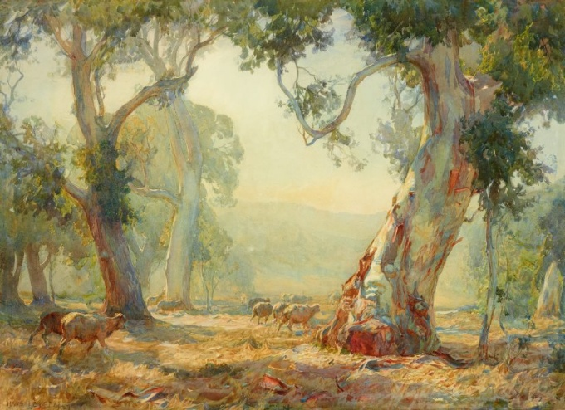  Art Gallery NSW  Hans Heysen, Summer | 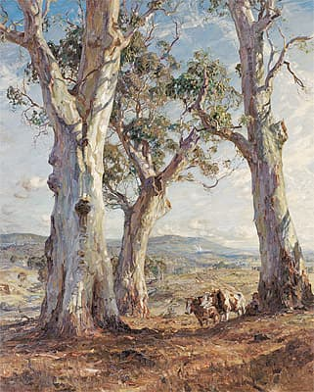  National Gallery of Australia  Hans Heysen, The three gums
Discuss why the eucalyptus tree is symbolic of the Australian landscape. Ask your students the following questions as they look at the artworks.
- What do you first notice in this painting?
- How does Hans Heysen use light and shade to make the trees feel peaceful?
- How do these images represent Australia?

Students will then work individually or in pairs to analyse one Hans Heysen artwork in more detail, responding to the following:
- What colours stand out?
- What mood does the painting create?
- What message or story do you think the artist is trying to convey?

Observing your natural environment
Move your class outside to observe the natural environment. It may be the environment of your school grounds or a park nearby. Students will take a pen and piece of paper with them to record their observations, responding to the following:
- Find a place in the environment to sit. Observe the shapes, shadows, textures and colours of the natural elements around you.
- Notice the light where you are, where is it brightest and where are there shadows.
- Write down what you see. Sketch 1-2 studies of a tree, leaf pattern or the shape of the landscape.
- How does being where you are, make you feel?
Create an artwork
Students will create an artwork inspired by their outdoor sketches. Students can base their artwork on one of the following:
- a tree that has meaning to them
- a small landscape scene of the school yard
- a symbolic drawing showing how they feel in nature.

Curate an art exhibition
Students will curate an art exhibition of their landscape artworks. As a class use the following questions to help plan your class exhibition:
- Where will it be? You could hold it at school and invite other classes to attend or consider another location in the local community.
- What are the dates of your exhibition?
- How will you label your artworks? Include the following information: a title, artist name, date and a description. Here is some more information about Exhibition labelling.
- Who will you invite to the exhibition opening?
- How will you let people know about your exhibition?
- How long will the exhibition run for?
- Are the artworks for sale?

Activity: Timeline Poster
Students will research the life and achievements of artist Hans Heysen and create a timeline poster and prepare an oral presentation summarising key events in Hans Heysen’s life. Alternatively, students can choose a different Australian landscape artist to investigate, for example, Albert Namatjira, Mary Tonkin, Tom Roberts, Frederick McCubbin, Arthur Streeton or Sidney Nolan.

Timeline Poster
Your students’ task is to create a timeline poster, responding to the following areas of research.

Research
- Early Life - Information about your significant person’s parents. When/where was your significant person born? What type of education did your significant person receive?
- Family - Personal information; Was your significant person married? Did they have children?
- Legacy - What event and/or action led to them becoming a significant person in Australia’s History? What did they do that had an impact on the lives of others?
- ‘Where are they now?’ If your significant person has died, you can outline where they are buried. If they are still alive you can outline what their life looks like now.
- 2 x ‘Interesting Facts’ and 2 x ‘Did You Know?’
- A minimum of 6 and a maximum of 10 photos with captions.
- Include a bibliography on the back of your poster.

Oral Presentation
Students will prepare a short oral presentation, speaking in ‘first person’. They will speak about their life, their family, character, the decisions they made and why, and their impact and influence on society.

Further Research
Students will choose one of the activities to further investigate their significant person.

Interview
- Imagine you could sit down and talk to the person.
- What questions would you ask about their life and achievements?
- Find answers to your questions.

5 w’s
- What are some of the key events in their life?
- Write a summary for one key event, which answers the 5 W’s – Who, What, Where, When and Why?


ABC iView
In this fun ABC series, one smart kid and one adequate adult embark on a fact-finding mission through all things “art”. Who will be declared the Know It All in the quiz: the kid or the adult?

ABC iView - Know It Alls: Visual Art


BTN The Arts collection
Visit BTN’s collection of stories which focus on the arts. After watching any one of the BTN videos ask students to respond to the discussion questions.

BTN - The Arts collection

Useful Websites
- Hans Heysen – Heysen the Cedars
- Hans Heysen – National Gallery of Australia
- Sir Hans Heysen – SA History Club
- Hans Heysen – Australian Dictionary of Biography
- Sewing (The Artist’s Wife) by Hans Heysen – National Museum Australia
- Hans and Nora Heysen: Two Generations of Australian Art – NGV

