Episode 33
19th November 2019



Bushfire Kids Visit
- Discuss the Bushfire Kids Visit story as a class and record the main points of the discussion.
- Where is Port Macquarie? Find using Google Maps.
- How did Abbey prepare for the bushfires?
- How did the bushfires affect visibility in the area?
- Where did a lot of the locals go after they left their homes?
- How did people keep their pets safe during the bushfires?
- How did kids in Port Macquarie cheer up the firefighters?
- What questions do you have after watching the BTN story?
- What do you understand more clearly about the impact bushfires have?
- Write a message of support to the people affected by the bushfires and post it in the comments section on the story page.

Kids Talk - Sleep
- Before watching the story, discuss as a class how much sleep you get each night.
- What did the BTN Kids Talk - Sleep story explain?
- In the BTN Kids Talk survey how many kids feel tired all the time?
  - 1 in 2
  - 1 in 6
  - 1 in 10
- What does your brain do while you’re asleep?
- What is the recommended time kids should sleep each night?
- Complete the following sentence. The blue light from screens changes the release of a hormone called ____________.
- Describe a good bedtime routine.
- Why is sleep good for you?
- If you don’t get enough sleep how do you feel?
- What was surprising about the BTN story?

Check out the Kids Talk - Sleep resource on the Teachers page.

World Television Day
- Discuss the BTN World Television Day story with another student.
- In what decade was the television first invented?
- Who invented the television?
- When did Australia first get its own television stations?
- Describe how TV has changed over the years.
- Why did the United Nations start World Television Day?
- What important world events have people watched on TV? Give two examples.
- In the BTN Kids Talk survey kids said TV is the number one place they get their news from. True or false?
- Do you think television is important? Discuss in pairs.
- What did you learn watching the BTN story?
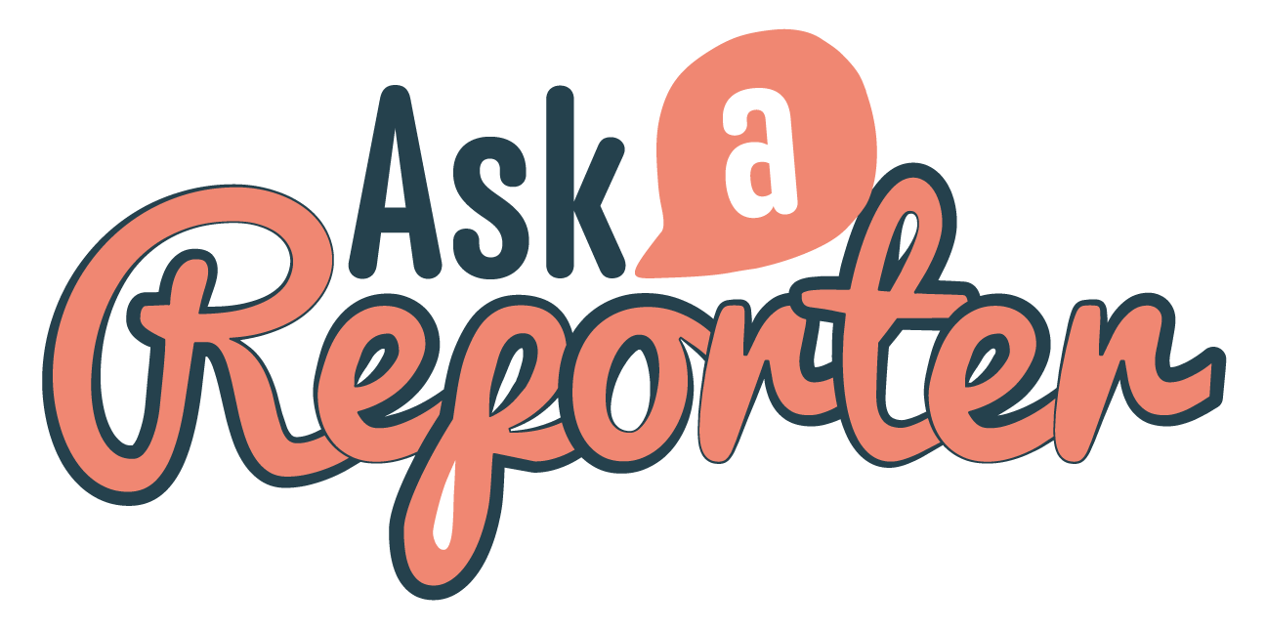
Check out the World Television Day resource on the Teachers page. Get your class involved in BTN’s Ask A Reporter. This week’s topic is World Television Day.

Songwriting with Paul Kelly
- Retell the BTN Songwriting with Paul Kelly story using your own words.
- How old is Jasmin?
- How old was Jasmin when she first started playing the guitar?
- Where did Jasmin get the inspiration to write her first song?
- How old was Paul Kelly when he first started writing songs?
- How did Paul Kelly feel when he heard his song on the radio for the first time?
- Where does Paul Kelly get his ideas for songs from?
- Who is Paul Kelly’s favourite writer?
- Which of these isn’t a Paul Kelly Song?
  - From Little Things Big Things Grow
  - How to Make Gravy
  - My Happiness
- What did you like about the BTN story?

Teacher Resource
Episode 33
19th November 2019

Kids Talk - Sleep


Students will keep a sleep diary to monitor their sleep habits and use of devices before bedtime.


Health and Physical Education – Years 3 & 4
Identify and practise strategies to promote health, safety and wellbeing.

Discuss and interpret health information and messages in the media and internet.

Health and Physical Education – Years 5 & 6
Plan and practise strategies to promote health, safety and wellbeing.

- Before watching the story, discuss as a class how much sleep you get each night.
- What did the BTN Kids Talk - Sleep story explain?
- In the BTN Kids Talk survey how many kids feel tired all the time?
  - 1 in 2
  - 1 in 6
  - 1 in 10
- What does your brain do while you’re asleep?
- What is the recommended time kids should sleep each night?
- Complete the following sentence. The blue light from screens changes the release of a hormone called ____________.
- Describe a good bedtime routine.
- Why is sleep good for you?
- If you don’t get enough sleep how do you feel?
- What was surprising about the BTN story?


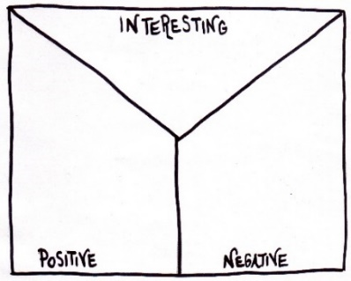
Note taking
Students will practice their note-taking while watching the BTN Kids Talk – Sleep story. After watching the story, ask students to reflect on and organise the information into three categories.
What information in the story was...?
- Positive
- Negative or
- Interesting


Class Discussion
As a class discuss the BTN Kids Talk - Sleep story using the following questions as a guide. Record the main points of the discussion on a mind map with sleep at the centre. Use the following questions to guide the discussion:
Why do we need sleep?
How much sleep do you think you need?
What are the things that stop you getting enough sleep?
How does lack of sleep make you feel?
Do you think you get enough sleep?
How can you improve your sleep?
Weekly Sleep Diary
Students will keep a sleep diary over the period of a week to monitor their sleep habits and their use of devices before bedtime. They will record data every day using the following table.

 | Time spent on devices before bedtime | Time I went to sleep | Time I woke up | Number of hours asleep | How I felt when I woke up
Monday
Tuesday
Wednesday
Thursday
Friday
Saturday
Sunday

Students will calculate the average time they spend asleep each night (using the data collected over the one-week period) and compare it to the time spent on devices before bedtime. Ask students to graph their results. They can then compare their results with other students in the class and the recommended sleep required for kids their age.

Reflection
The journal provides the opportunity for students to reflect on their own learning. Provide regular opportunities for students to write individual journal entries to reflect on the following questions:

- What does the information collected tell you about your sleep patterns when using devices before bedtime?
- Do you think you sleep better when you don’t use devices before bedtime?
- What did you learn?
- What else could you have done?
- What would you do differently next time?


Sleep Inquiry
Students will be exploring sleep in more detail. They can develop their own key questions to investigate or respond to one or more of the questions below. Students can complete the following KWLH organiser to explore their knowledge and consider what they would like to know and learn.

What do I know? | What do I want to know? | What have I learnt? | How will I find out?
Discuss the story as a class and ask students to pose questions about sleep. Students will develop an appropriate question to guide an inquiry about sleep (below are some example key questions).

- What does our body continue to do while we are asleep?
- What health problems can a lack of sleep cause?
- To what extent can technology affect a person’s sleep?
- How does melatonin work?
- What are the stages of sleep? What happens in each stage?
- What is circadian rhythm? What impact does going to sleep at different times every night have?

Students can present the information in one of the followng ways:
- Prezi presentation
- An infographic using Canva
- An oral presentation

Students watch this BTN Investigates - Why do we sleep? then answer the following questions:

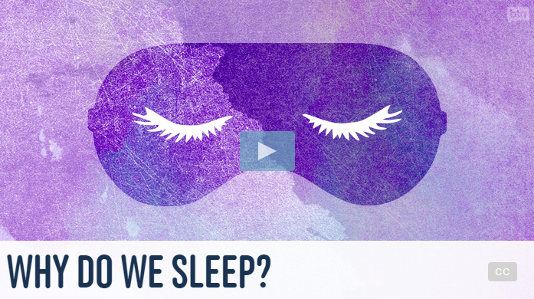
- Why do we need sleep?
- What do studies show about animals that are sleep deprived?
- Why are sleeping animals at risk?
- What happens to a dolphin’s brain when they sleep?
- What does the prefrontal cortex do?
- How can a lack of sleep affect a person’s learning?
- Finish the following sentence: Research shows that while we sleep, our brains are…
- How do you feel when you get a bad night’s sleep?

Sleep Quiz

- On average, about how much time does a person spend sleeping in their lives?
- One third
- One quarter
- Three quarters

- How much sleep do 6-13-year-olds need each night?
- 6 – 8 hours
- 9-11 hours
- 11-14 hours

- Which hormone is released by the brain to get us to sleep?
- Melanin
- Melatonin
- Adrenaline
- Insomnia is the sleep disorder where a person finds it difficult to fall or stay asleep.
- True
- False

- Using devices in bed is not recommended because the light suppresses the hormone melatonin, which helps us get to sleep.
- True
- False

Answers: 1a, 2b, 3b, 4a, 5a


Sleep Problems – BTN
https://www.abc.net.au/btn/classroom/sleep-problems/10522312

Why do we sleep? – BTN
https://www.abc.net.au/btn/classroom/why-do-we-sleep/10523318

Kids Sleep – BTN
https://www.abc.net.au/btn/classroom/kids-sleep/10530126

Curious Kids: What happens to our body when we sleep? – The Conversation
https://theconversation.com/curious-kids-what-happens-in-our-bodies-when-we-sleep-94301

Teacher Resource
Episode 33
19th November 2019

World Television Day
Students will explore the history of the television. Students will investigate how television has impacted on society and culture.

Media Arts – Year 5 & 6
Plan, produce and present media artworks for specific audiences and purposes using responsible media practice.

Explain how the elements of media arts and story principles communicate meaning by comparing media artworks from different social, cultural and historical contexts, including Aboriginal and Torres Strait Islander media artworks.

Media Arts – Year 7 & 8
Develop media representations to show familiar or shared social and cultural values and beliefs, including those of Aboriginal and Torres Strait Islander Peoples.

Identify specific features and purposes of media artworks from contemporary and past times to explore viewpoints and enrich their media arts making, starting with Australian media artworks including of Aboriginal and Torres Strait Islander media artworks.

- Discuss the BTN World Television Day story with another student.
- In what decade was the television first invented?
- Who invented the television?
- When did Australia first get its own television stations?
- Describe how TV has changed over the years.
- Why did the United Nations start World Television Day?
- What important world events have people watched on TV? Give two examples.
- In the BTN Kids Talk survey kids said TV is the number one place they get their news from. True or false?
- Do you think television is important? Discuss in pairs.
- What did you learn watching the BTN story?

Pre-viewing questions

Before watching the BTN World Television Day story, hold a class discussion asking the following questions:
- When do you think the television was invented?
- When were TVs first introduced in Australia?
- What’s your favourite TV show? Why?
- How much TV do you watch each day?

KWLH
What questions were raised in the discussion and what are the gaps in their knowledge. The following KWLH organiser provides students with a framework to explore their knowledge on this topic and consider what they would like to know and learn.

What do I know? | What do I want to know? | What have I learnt? | How will I find out?
Question for inquiry
Students will develop their own question/s for inquiry, collecting and recording information from a wide variety of sources. Students may develop their own question for inquiry or select one or more of the questions below.

- Who invented the television? Write a biography about the inventor of the television.
- How is the internet changing the way we watch TV? Conduct a survey in your class to find out how much television people watch compared to watching videos on the internet. Analyse your results and share with the class.
- What impact has TV had on society and culture?
- Make a prediction about how our television viewing habits will change in the future.

Timeline of main events
Students will create a timeline to sequence the history of television including the invention of the first electronic television, the introduction of colour television and the switch from analogue to digital TV transmitters.

Early 1970s
Introduction of colour TV in Australia
1927
First electronic television invented.

2013
Australia switches off last remaining analogue TV transmitters.





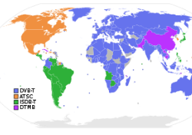
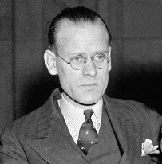

Students will work in small groups and work through the following questions to build on their understanding of the history of the television (including the invention of the television, when the television was introduced to Australia, how television has changed the world and how technology has changed the television). Students will find and collect images, photographs, illustrations and video as part of their research.

- When was the electronic television invented?
- When was television introduced to Australia?
- When was the ABC’s first television broadcast?
- What was the first Australian TV show?
- When was colour television invented?
- When did digital television start?


What do you see, think and wonder?
As a class watch the 1956 opening night broadcast of ABC television and ask students to respond to the following:

- What are your FIRST IMPRESSIONS of the broadcast?
- What did you SEE in this video?
- What do you THINK about what you saw in this video?
- What did you LEARN from this video?
- What was SURPRISING about the video?

Interview
Students will interview someone who remembers the introduction of television in Australia and ask them to share their memories about the event. Students will prepare a list of questions, conduct the interview and then share their interview findings with the class. Below are some example questions.

- How old were you when television was introduced to Australia?
- Where did you watch television?
- How much television did you watch?
- What did you watch on television?
- How did you feel when you first watched television?
- How was life different before television?

Behind the scenes at Behind the News
The team at Behind the News take you behind the scenes to see how their weekly news program is produced. As a class, watch this behind the scenes video and then students will respond to the following:

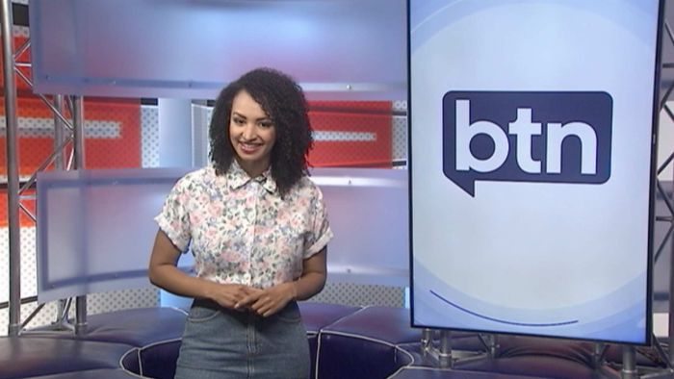
- Summarise the BTN Behind the Scenes story, using your own words.
- When putting together a show, BTN looks for stories that are:
  - True
  - Interesting
  - Important
  - All of the above
- Who decides what stories will go on BTN?
- What does the archive team do?
- What might happen on a BTN filming day? Give one example.
- Why do you think BTN stories involve a lot of dressing up?
- Complete this sentence. Animations on BTN are made by the __________ team.
- What is the role of an editor on BTN?
- What is the name of BTN’s daily news program?
- Illustrate an aspect of the Behind the Scenes story.
World Television Day – UN
https://www.un.org/en/events/televisionday/

ABC national TV service: opening night, 1956 – ABC Education
https://education.abc.net.au/home#!/media/153386/abc-national-tv-service-opening-night-1956

BTN Transcript: Episode 33 – 19/11/19

Hey, I'm Amelia Moseley and you're watching BTN. Here's what's coming up on today's show. We find out how you can get more sleep, take a close look at the history of television and a young songwriter meets an Aussie music legend.

Bushfire Kids Visit
Reporter: Amelia Moseley

INTRO: All that soon, but first up today. Things have got a bit easier for firefighters in New South Wales and Queensland thanks to cooler temperatures and even some rain over the weekend. But the situation is still really serious, there are bushfires burning in both states, more than 500 houses have been destroyed and people are still being forced to leave their homes. I headed to the Mid North coast of New South Wales to speak to some kids about how the bushfires have been affecting them.
Imagine seeing this practically on your doorstep.
TAHLIA: We had to leave our house because the fire got really close, it was a couple of kilometres away.
ABBEY: When we were coming across Bains Bridge they had a huge pump station ready and they were pumping, which was a real reminder of how close it was gonna get.
Tahlia and Abbey are some of the many kids that live in this area here near Port Macquarie along the Mid North coast of New South Wales who have been watching and waiting as bushfires burned out of control in or near their towns.
ROXY: We sort of thought that it wouldn't really come near us, but it just started picking up so we were like, we'll pack everything and we'll just get out. Better to be safe than sorry, really.
AMELIA, REPORTER: The fires have burned thousands and thousands of hectares around the area of Port Macquarie and beyond and as you can see, they've also created a thick layer of smoke that's blanketed the region and at one point the sky actually turned this really red colour during the afternoon, which locals say was pretty scary to see.
ADAM: We were at the pool at Wauchope and it was all orange. The sky was orange.
AMELIA, REPORTER: That's so crazy. How did that make you feel?
ADAM: I dunno, I was just amazed.
ABBEY: Yesterday morning you couldn't see like ten metres in front of you and, it was scary cause you couldn't see and all you could hear were fire trucks.
More than 400 locals, including lots of kids, left their homes and relocated here to the Wauchope Showgrounds.
AMELIA, REPORTER: This has been the safest place for a lot of those people to stay, and animals, because of the approaching bushfires. Heaps of people have been staying in tents and in campervans and even sleeping in their horse floats.
TAHLIA: I've been here at the Wauchope Showgrounds with my horse Nibbles and my sister for about three days now. We've been living in our horse float and our swag cause our parents are still out, so I'm old enough to look after me and my sister and my horses.
And it's not just people and horses looking for safety.
ROXY: Ahh, my two dogs are here and my cat.
TILLY: We've got two hens and four chicks as well as two hermit crabs and my dog Duffer.
TAHLIA: Nibbles hasn't been very happy. He doesn't like being stuck in a spot, he likes to be out in a paddock, he, but he's safe here so that’s good.
And these guys say they won't be going home or back to school until it's safe there too.
ADAM: Yeah, well the firies came in and did a meeting and stuff and they said in about seven days, maybe less hopefully.
TILLY: It's my fifth day off today since I've been to school, so yeah you kinda want to go and see your mates again.
Meanwhile, firefighters (many of them volunteers) have been working really hard to protect people and properties. Some haven't had a day off in a whole week. So, before they left for another long day on the job, a group of kids in Port Macquarie decided to cheer them up with cards and drawings.
BOY 1: I made this little card: "To firies, you have done a great job, you have saved heaps of homes. Great job from Joe."
AMELIA, REPORTER: Why'd you decide to come out?
GIRL 1: I think they just really deserve something like this to lift some spirits and let them know they're appreciated.
GIRL 2: They also protected my school and it got quite close to my school that we had to evacuate and I haven’t been at school for about a week now and if they hadn't of it might've caught fire.
AMELIA, REPORTER: You reckon you guys would ever wanna be firefighters?
KIDS: Umm maybe. You never know. You never know.

FIREFIGHTER 2: To come all the way from Victoria to help and to see this from everyone. The pictures and the smiles on the kids’ faces. It's good yeah, it's very appreciated.
FIREFIGHTER 1: It gives you goosebumps, seeing all the families and the kids around, all the photos and stuff. It gives you goosebumps. It's very emotional, yeah.
KIDS: Thanks, firies. High five.
This Week in News

Severe thunderstorms have hit South East Queensland bringing damaging winds, lightning. Oh yeah and hail the size of cricket balls. They smashed homes, cars and businesses. So much fell in some areas that it looked more like a blanket of snow. While a weather change helped with the fire-fight it brought some trouble to Brisbane. This is what the city's been like for the past week or so. Winds have pushed the bushfire smoke over the city and it's really affected the air quality. It's especially bad for people with asthma like Nicholas.
Nicholas: My throat and my lungs have been really tight, and it's been hard to breathe and when I'm outside I've been coughing a lot.
The Bureau of Meteorology says it'll hopefully clear up soon, but people should avoid going outdoors if they're badly affected.

Venice, Italy's floating city, is struggling to stay afloat. People there are going through some of the worst flooding in decades. It's triggered by record high tides, fierce winds and torrential rain. St Mark's Square was closed along with other shops and tourist attractions. While flooding happens almost every year and the city has a few ways to cope, this time around, they reached a height of 1.87metres, the worst in 53 years. The city's mayor says damages from the flooding could reach at least 1.6 billion dollars.

Some amazing footage has captured of this blue whale dropping more than 100 litres of poo straight into the ocean. I guess when you eat 4000 kilograms of krill every day, it's gotta go somewhere. But who would have thought whale poo was bright yellow?

Kids Talk - Sleep
Reporter: Leela Varghese

INTRO: Our Kids Talk survey has told us a lot about the big issues affecting you and one of them is sleep. Some of you aren't getting anywhere near enough and one in four of you say you feel tired most of the time. So Leela took a trip to Snoozeville to find out more.
LEELA VARGHESE, REPORTER: Who Wants to Be a Million Times Better at Understanding Sleep.
LEELA: On average about how much time does a person spend sleeping in their lifetime. A, B or C?
KID: Oh, tough one. Lock-in, A, One Third.
LEELA: I'm afraid, you're correct.
Yep, we all get a lot of sleep in our lifetimes and we need it. Without sleep your day can be a struggle. It's harder to remember information, socialise and it's even tough on our bodies. But you told us in our Kids Talk survey that one in six of you feel tired all the time, while one in four said you feel tired most of the time. So, it seems like some of you need more sleep. While you sleep your brain has a chance to rest and store all the new information you have learnt that day. It's also when the human growth hormone is released from our brain. Which helps our bodies to grow, repair damage and build muscle.
LEELA: The Sleep Health Foundation recommends kids between 6 and 13 years should get between, A, B or F (just kidding) C, amount of sleep?
KID: Lock in B, 9 to 11 hours.
LEELA: He’s done it again, He’s correct.
The good news is most of you are sleeping the recommended amount. You see you need an awful lot of sleep when you're young because every day you're taking in the world and learning new things. So why are some of you so sleepy? Well, while the stats showed most of you said you go to sleep between 8 and 10 pm and get out of bed between 6 and 8 am, around eight per cent of you go to bed after 11 o'clock at night. So, to be able to get to school on time you're not going to have enough sleep.
So, what could be keeping you up? Well, technology could be the culprit. Sixty-two per cent of you said you look at a screen when you're in bed.

LEELA: OK Bryce, what can help us sleep better A, B or C?
KID: I might phone a friend. My parents friend Raymond he’s a sleep expert.
RAYMOND: Hello.
KID: Hey Raymond I'm on Who Wants to Be a Million Times Better at Understanding Sleep. What can help us sleep better?
RAYMOND: Well a bedtime routine is a really good way to help you fall asleep a little bit easier. I'd say spend about half an hour of relaxation time in the evening and that will help you fall asleep as soon as the lights turn out. And avoid bright light in the evening, that will make it a bit harder to fall asleep. Try and limit the screen time with mobile phones and tablets. Lastly, bright light in the morning can be really useful, so get outside and get some exercise. Get a nice dose of bright.
KID: Why do you think sleep is so important?
RAYMOND: Well sleep is good for a lot of reasons. Physically it's going to help you be stronger, and it's going to help you grow and it's going to help you fight off infections. You're also going to be smarter because when you're asleep your brain does lots of things to consolidate the memories that you've had during the day. That means the next day you can focus more, you can recall information better. Also, you're going to be the best person that you can be, you'll be happier, you'll be calmer, and you can make strong choices throughout the day.
KID: Okay let's lock in C.
LEELA: Correct bring out the confetti. There’s no confetti. Okay, Bryce time to wake up bud.
KID: What?
KID: What a weird dream and a terrible name for a show.

Quiz
Which of these animals sleeps the least?
Giraffes
Bats or
Walruses
The answer is giraffes. They actually only get a couple of hours of sleep a day, and often for less than five minutes at a time.
World Television Day
Reporter: Jack Evans

INTRO: This week, the United Nations is celebrating something that's been a big part of many people's lives since it was invented. I'm talking about TV. The 21st of November is World Television Day, so Jack's looked into it.

JACK: TV studio? Has the ABC always had a TV studio? Maybe there's someone in there that could tell me about television? Whoa what's going on?
GEORGÉ GEORGE: Cool your jets Jacky boy, welcome to the magic of television.
JACK: Who are you?
GEORGÉ GEORGE: I'm Georgé George from the tonight show with Georgé George.
JACK: Who?
GEORGÉ GEORGE: So, you want to know what's the dealio with telly?
JACK: How did you know that?
GEORGÉ GEORGE: I work in television, It's my job. Try the 1920s.
As that very stylish and sophisticated Georgé George pointed out, the first time a moving image was transmitted onto a television was in the 1920s. While there were a number of scientists who'd been experimenting with this sort of technology. Most people credit the American inventor Philo Fransworth as the OG Telly guy. In 1927 he successfully transmitted this. It might just look like a bunch of wiggly lines, which it is, but at the time it was a technological breakthrough and pretty soon this new technology saw TV stations popping up in the UK and the US. Like the BBC and CBS, which are both still around today.
It wasn't until 1956 that Australia got its own TV stations, including TCN - 9 AKA the Nine Network and the ABC AKA - oh it's still the ABC. Over the years TV's changed quite a bit. These days, thanks to the internet, we can consume TV just about anywhere and on anything.
JACK: But the one thing that hasn't changed is its purpose and that's to provide entertainment, communicate important information.
GEORGÉ GEORGE: And connect us to the world around us.
JACK: Hey, that's my line.
GEORGÉ GEORGE: Don't blame me Jacky boy, I'm just reading a script.
JACK: Yeah so am I.
The UN started World Television Day to celebrate the impact TV has had on the world. Whether it's bringing together hundreds of millions of people to watch incredible accomplishments, more attention to conflicts or providing a platform to influence social and political change. TV's had a huge effect on our world and the UN says it's not going anywhere. In fact, more people are buying TV's than ever. In our kids talk survey, you told us it's the number 1 place you get your news from by a pretty big margin. I wonder if that's because you're watching BTN on a TV.
JACK: Gee thanks for your help Georgé George, but I better get back to the real world.
GEORGÉ GEORGE: Any time Jacky boy and remember, television is - oh he's gone. Jas, get me a latte and for the hundredth time this is not my news scarf, it's my cruise scarf. does it look like I'm going on a cruise?

Ask a Reporter

Do you want to know more about World Television Day? Well, we'll be around to answer live on Ask a Reporter this Friday. Just head to our website for all the details.

Quiz

What's the longest running program on Australian TV? Is it?
Play School
Four Corners or
Neighbours
It's Four Corners. The current affairs program has been running since 1961. Play School's not far behind, first airing in 1966. But in third place, it's actually us Behind the News. This year, we're celebrating 51 years on air. Yay.

Sport
Red Bull's Max Verstappen has won the Brazilian Grand Prix in a race with a few twists and turns. Ferrari's Sebastian Vettel and Charles Leclerc collided with each other ending both their races. Meanwhile six-time world champion Lewis Hamilton caused Alex Albon to spin and drop out and was penalised five seconds dropping him from third to seventh place. Ouch. Meanwhile, Aussie, Daniel Ricciardo finished sixth.

To tennis, 21-year-old Stefanos Tsitspias has taken out the ATP Finals defeating Dominic Thiem 6-7 6-2 7-6. The Greek player is the youngest to win the season ending tournament since Lleyton Hewitt in 2001, as well as the youngest person to debut and win the trophy since John McEnroe, smashing records everywhere.

The 2019 Esports Awards have been handed out. Like most things esports related, the award ceremony was streamed by thousands of people around the world. The winner of this year’s Fortnite World Cup, Bugha, took out two of the top awards, PC Rookie of the year and PC Player of the year and he was pretty happy with the result.
BHUGA: Wow. I definitely didn't expect to win this I'm gonna be honest but it's an absolute honour to be in the same category as so many of these talented individuals.
And over in Russia's capital, skaters from far and wide have taken part in the 2019 Moscow Skateboarding Open. Russian skateboarder Semen Kutuzov won the men's comp, while Natalia Bystrova was the women's champ. The comp gave spectators a taste of what to expect when skateboarding debuts at the 2020 Tokyo Olympics.

And check out these awesome tricks at the World Street Style Championships in Miami. Competitors have to juggle the ball in the coolest way they can using any body part. Melody Donchet won the women's event for her third street style title, even though she was warned not to compete. She didn't listen and that paid off, apparently.

Songwriting with Paul Kelly
Reporter: Jack Evans

INTRO: And finally, today, it's Ausmusic Month, which is dedicated to celebrating Australian talent and supporting the next generation of artists. So, we asked an up-and-coming musician to sit down with one of the country's most acclaimed singer-songwriters, Paul Kelly. Check it out.

JASMIN: My name's Jasmin, I'm 15 years old and I love music. It's really my life because, you know, I love playing and I love listening to it and I don't think I could live without it. I first started playing guitar when I was 7 and I first started singing when I was 9. I wrote my first song when I was 11 and it was about being yourself because everyone else was already taken and I got it from a quote from the Lonely Planet book.
One day I'd like to write songs that people could reflect on afterwards, that have an impact on them and music that would have really deep and meaningful lyrics. To get some tips on how to do that I'm going to talk to one of Australia's most well-known songwriters. Paul Kelly's an artist that like all Australian’s know, like a household name in Australia, a legend. I'm really excited to meet him. It's going to be so cool.
JASMIN: How old were you when you started song writing?
PAUL: 21, which is much later than you. when did you start?
JASMIN: I was 11.
PAUL: 11. I didn't really start playing guitar until I was about 18 but I wanted to be a writer, so I was writing like prose poems, but they weren't songs and one day when I was 21 I wrote a song and I thought, I can do this.
JASMIN: What do you write first? Do you write your words, or do you write your music first?
PAUL: I used to always write the music first and that's probably the main way I write songs. It's more just fooling around with chords on a guitar or the piano and then singing gibberish is basically what I do. Sort of singing sounds then getting words to fit it.
JASMIN: What's it like hearing your song on the radio for the first time? How did you feel?
PAUL: Very excited. I still remember listening to "Before Too Long" on the radio. I was driving with the band and it just came on the radio and we just went nuts started singing along really loud.
JASMIN: Where do you get your ideas for your song writing and your lyric writing?
PAUL: Well a lot of them from other songs or from things I read or from poems or things people say. I think song writing is just a matter of keeping your ears open and you know, if I think of a line for a song I try to write it down straight away because otherwise I forget it.
JASMIN: Who's your favourite writer?
PAUL: If I said my favourite writer it'd have to be Shakespeare, William Shakespeare who I first discovered at school.
JASMIN: Is there any songs you're really proud of and want to talk to us about?
PAUL: Well I guess, the songs that I still play that I never get sick of playing - how to make gravy. It's an unusual song so I like it. I have no idea how it sort of happened and It sort of breaks some rules, formula rules of song writing but it still works. I like that one.
JASMIN: Do you want to have a little play together?
PAUL: I've never done a harmony to that one before so that's good, thank you.
JASMIN: Thank you.
Closer

Well that's it for now but we'll have more great stories for you next week. In the meantime, you can check out our website for the latest news and more of our Kids Talk results. I’ll see you soon.

