Episode 35
1st December 2020

Remembering the Pandemic
- Discuss the BTN Remembering the Pandemic story as a class.
- Where were the first cases of COVID-19? Find on a map.
- What month and year were the first cases of COVID-19 found?
- When did the World Health Organisation declare COVID-19 as a world pandemic?
- What is a lockdown?
- What supermarket product were people fighting over?
- What 3 important steps should you take to help reduce the spread of COVID-19?
- What restrictions were put in place to slow the spread of COVID-19? Name one.
- Complete the following sentence. Australia's economy went into ___________ for the first time.
- What country has had more than 12 million cases of COVID-19?

Check out the Year in Review resource on the Teachers page.

Bushfire Crisis and World News
- Discuss the BTN story as a class and record the main points of the discussion.
- How many hectares of land were burned in the 2020 Australian bushfires?
- How did the bushfires affect people?
- How did the bushfires affect Australia’s wildlife?
- In different parts of the world people faced other natural and unnatural disasters. Name one.
- What is Black Lives Matter?
- Which country voted in a new president in 2020?
  - China
  - Lebanon
  - The United States of America
- Complete the following sentence. The United Kingdom exited the European __________.
- What did scientists recently find on the Moon?
- What questions do you have about the story?

Kids Remember 2020
- Discuss the BTN Kids Remember 2020 in pairs. Share your thoughts with the class.
- What have the kids in the BTN story found difficult this year?
- What were the best moments of 2020 for them?
- What helped them cope during COVID?
- What have you found challenging this year?
- What have been some positive moments for you?
- Name at least three things that helped you during COVID.
- What are you looking forward to these holidays?
- What do are you looking forward to in 2021?
- What message do you have to kids in Australia?

BTN Bloopers
- What do you think was the funniest moment on BTN this year?
- Choose your top 5 stories from BTN this year. Briefly explain why you chose the stories.
- What topics or issues would you like to see reported on BTN next year?
- What changes would you make to BTN?
- Choose your favourite story on BTN this year and write a brief summary of what the story was about.

Teacher Resource
Episode 35
1st December 2020
Year in Review 2020
Students will choose their favourite stories from BTN in 2020. They will reflect on a range of events that occurred during 2020.

English – Year 6
Use comprehension strategies to interpret and analyse information and ideas, comparing content from a variety of textual sources including media and digital texts.

Compare texts including media texts that represent ideas and events in different ways, explaining the effects of the different approaches.

English – Year 7
Use a range of software, including word processing programs, to confidently create, edit and publish written and multimodal texts.

Media Arts – Year 5 & 6
Plan, produce and present media artworks for specific audiences and purposes using responsible media practice.

- What do you think was the most interesting Aussie news event this year? Give reasons for your answer.
- Which world news story would you like to know more about? Why?
- Which world news story had the biggest impact on you this year? Why?
- Which story about kids did you like the most? Why?
- What topics or issues would you like to see reported on BTN next year?
- What do you think was the funniest moment on BTN this year?
- What changes would you make to BTN?

Favourite BTN stories
Ask students to choose their top five BTN stories from 2020. They can choose stories from a range of topics, for example:

- Global
- Science
- Health
- Environment
- Human interest

Students will explain to another student why they chose these five stories. Students will then choose their favourite and respond to the following questions:

- 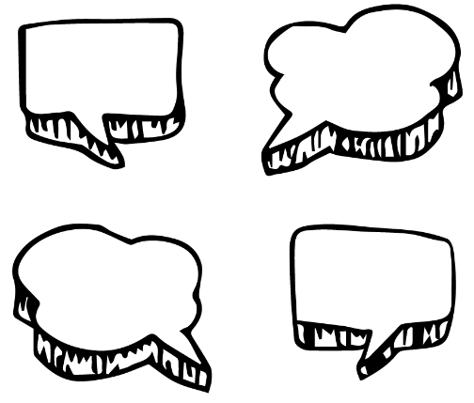Why did you choose this story?
- What was the main issue/message in the story?
- Where and when did it happen?
- Who is affected by the issue?
- Why do you think kids would be interested in this story?
- Why do you think BTN ran this story?
- Are there any updates on the story? Describe using your own words.

Kids on BTN
BTN featured kids doing amazing things in 2020. Choose one of your favourite stories below or visit BTN’s website to see all the Rookie Reporters for 2020. Students will then respond to the following questions:
- What is the story about?
- Why did you choose this story?
- Why do you think BTN chose to feature this kid’s story?
- Describe the main issue/message in the story.
- What makes this story interesting?
- What questions do you have about the story?

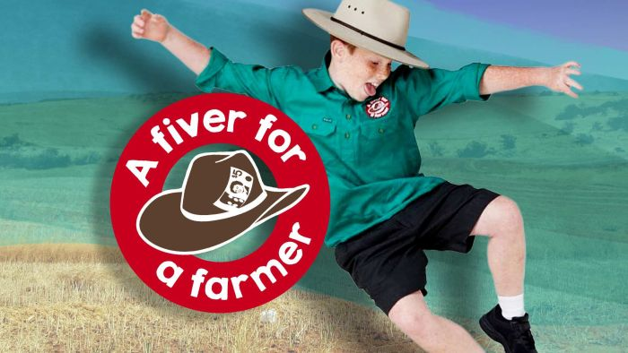  Fiver for a Farmer | 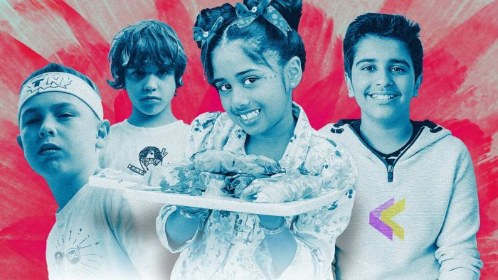  COVID Creativity
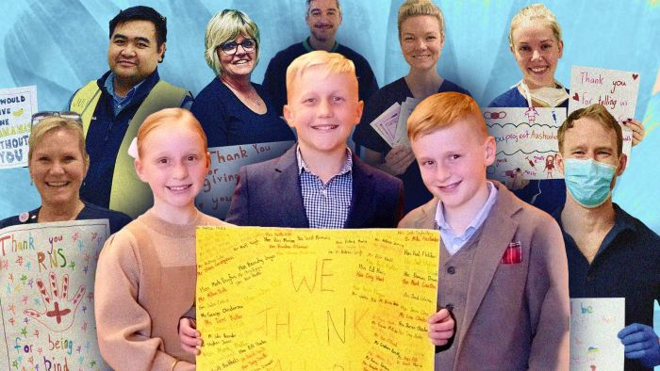  Thank You Project | 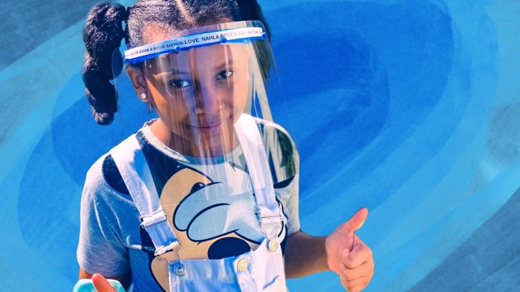  Protective Mask Maker
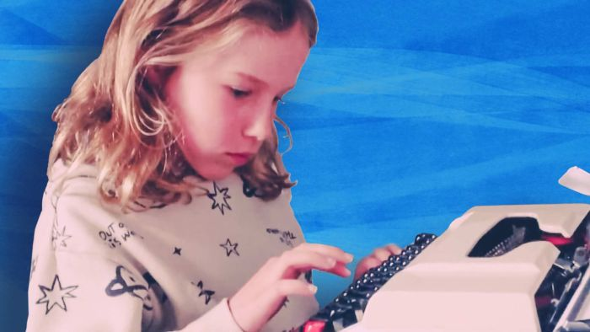  COVID Catch-Up Newspaper | 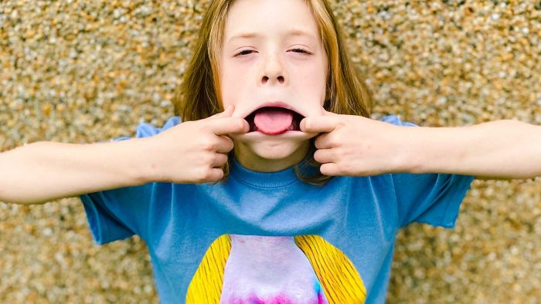  Punk Magazine Kid

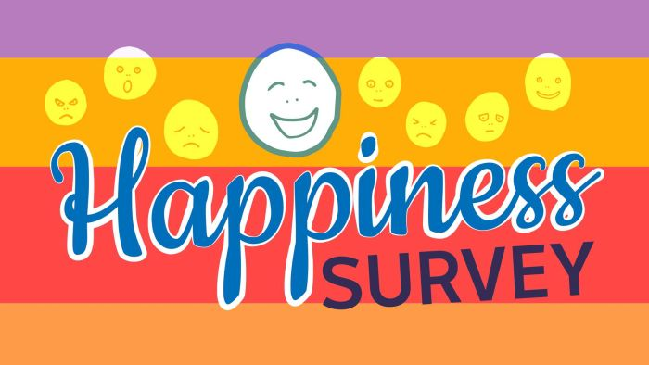BTN Happiness Survey 2020
It's time for the BTN Happiness Survey. We want to find out how kids are doing, when they’re at their happiest, when they’re not and the things that matter to them.

The survey is still OPEN. Get your students to take part in the survey now! Survey closes 18th December 2020.

Watch BTN’s Happiness Survey Results story to get an update on some of the results that have come in so far.

BTN Features 2020
There were several special anniversaries in 2020. Check out BTN’s Features on the BTN website. Each Special includes in depth teacher resources linked to the Australian Curriculum.

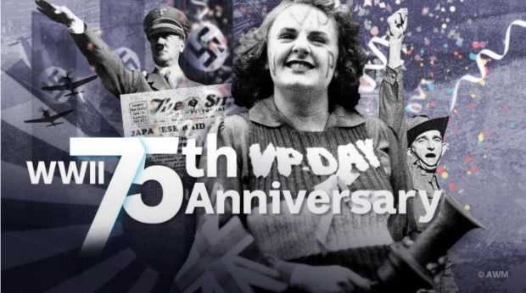WWII VP Day Anniversary Special
A special episode to commemorate the 75th anniversary of the end of the Second World War. We look at the events that led up to World War II and give a brief history of one of the deadliest conflicts that the world has ever seen, find out more about Australia's role in the war, the bombing of Darwin by Japanese forces, share the memories of people who were alive during WWII and finally, the impact WWII had on the world. Video | Teacher Resource

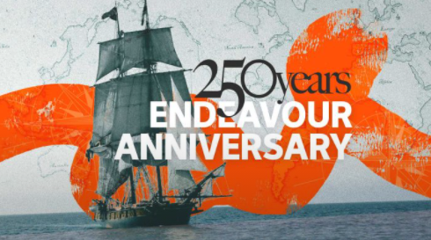HMB Endeavour 250th Anniversary
A special episode commemorating the 250th anniversary of the Endeavour’s voyage to Australia. BTN finds out more about Captain James Cook and his famous voyage on board the Endeavour. The National Maritime Museum gives Amelia a tour of the HM Bark Endeavour Replica. We explore the lasting impact of the Endeavour’s arrival on Australia’s First Peoples. We take a look at how Australia has changed in the 250 years since Cook’s arrival.
Video | Teacher Resource

Anniversaries
Make a list of all the anniversaries that are important to you and your class. BTN covered some significant days and weeks in 2020. Make a list of the ones you enjoyed learning more about. For example:
Bridge Walk Anniversary
World Alopecia Day
NAIDOC Week – Charlie Perkins
Qantas History
Food Safety Week
History of the UN
World Statistics Day
Stamp Collecting Month
BTN – Behind the Scenes
The BTN Behind the Scenes video gives a snapshot into the making of a BTN episode. Students can watch the video then answer the following questions.

- When putting together a show, BTN looks for stories that are…
- Who decides what stories will go on BTN?
- What might happen on a BTN filming day? Give one example.
- Why do you think BTN stories involve a lot of dressing up?
- Complete this sentence. Animations on BTN are made by the __________ team.
- What is the role of an editor on BTN?
- What surprised you about the BTN Behind the Scenes video?

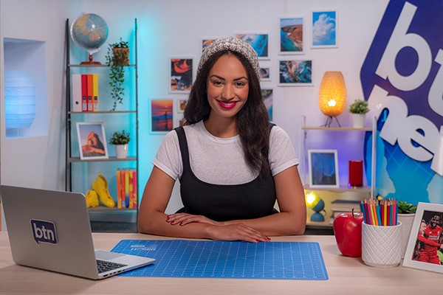BTN Newsbreak
Watch BTN every day! Newsbreak is a great way to kick off the morning routine. You can watch Newsbreak anytime on our website or by subscribing to our YouTube channel. Head to the BTN website for all the details.

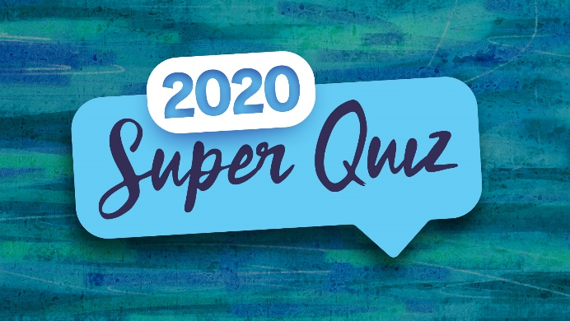Create your own Super Quiz
After completing the BTN 2020 Super Quiz, students will create their own news quiz. Students can use the following as a guide.

- Make a list of news stories from 2020 that were important to you.
- Write a structure for your quiz. Include a quiz title, target audience, time frame in which quiz needs to be completed and news themes.
- Write and design your quiz. Consider including multiple choice, true or false and picture quiz. It is important that your questions are based on news stories from 2020. Make it fun, engaging and educational.
- Give your quiz to a classmate to complete. Provide your classmate with a score and correct answers.

Stories – BTN
https://www.abc.net.au/btn/stories/

Happiness Survey – BTN
https://www.abc.net.au/btn/features/happiness-survey-2020/12795914

Super Quiz Questions

These quiz questions are to be used in conjunction with viewing BTN’s Year in Review 2020 program. Pause the video after each question to allow time for students to answer.
Questions | Your Answer
- What city were the 2020 Olympics supposed to take place in?
  - New York
  - Tokyo
  - Beijing
- Which of these world leaders was the first to be diagnosed with COVID-19?
  - US President Donald Trump
  - UK Prime Minister Boris Johnson
  - Brazilian President Jair Bolsonaro
- Can you name this iconic Aussie car brand which we said goodbye to this year?
- What did Prince Harry and Meghan Markle announce on Instagram in January?
- They were getting married
- They were having a baby
- They were stepping down from their royal positions
- The UK is formally stepping down from its place in the European Union. What’s the nickname given to that decision?
- Can you name this former British colony where there have been big protests over Chinese national security laws?
- Shanghai
- Hong Kong
- Taipei
- What social media platform was banned in India this year?
- Facebook
- TikTok
- Instagram
- An invasion of locusts has caused huge problems in which African country?
- Kenya
- Mali
- Nigeria
- What team did Kobe Bryant play for?
- LA Lakers
- Charlotte Hornets
- Miami Heat
- What country does Black Panther lead?
- Asgard
- Genosha
- Wakanda
- Where was the film Parasite made?
- China
- Korea
- Japan
- Which American artist won the Grammy for Album of the Year?
- Ariane Grande
- Lizzo
- Billie Eilish
- What’s the name of this song?

Total score
Answers

- Tokyo
- UK Prime Minister Boris Johnson
- Holden
- They were stepping down from their royal positions
- Brexit
- Hong Kong
- TikTok
- Kenya
- LA Lakers
- Wakanda
- Korea
- Billie Eilish
- Dreams

BTN Transcript: Episode 35 – 1/12/20

Hey everyone, Amelia Moseley here bringing you the final episode of BTN for 2020 and yes I am presenting it from home, because, let's face it, that's where we've done most things this year. Let's see what’s coming up. Today we're going to have a look back at this very unusual year, we'll find out how you guys have been coping and what you're looking forward to in 2021 and of course, we'll test your knowledge with our annual BTN Mega Quiz.
Remembering the Pandemic

Reporter: Jack Evans

INTRO: But first let’s take a look at how we all ended up in the middle of one of the biggest world events in generations. Yes I’m talking about the COVID-19 pandemic. Jack's taken a trip back in time to find out how events unfolded here in Australia and around the world. Check it out.
2019 JACK: Hello.? Who's there?
2020 JACK: Ahh, it worked. hello.
2019 JACK: Oh no. One of my clones escaped again.
2020 JACK: I'm not a clone.
2019 JACK: Well who are you?
2020 JACK: I'm you, from the future.
2019 JACK: Ooooh.
2020 JACK: I have something very important to tell you. Have you heard of something called COVID-19.
2019 JACK: Co... vid... 19?
2020 JACK: Oh yes that's right it doesn't have a name yet. What about a coronavirus?
2019 JACK: Oh yeah, that virus overseas. I don't need to worry about that.
2020 JACK: I wouldn't say that if I were you, which I am.
Yep go back a year and it'd be fair to say we were all blissfully unaware of what was in store for 2020 - AKA the year of COVID-19. The first COVID-19 cases were in Wuhan in China back in December 2019.
ELI: There are some precautions being taken like having to wear masks and temperatures being checked.
We got our first glimpse at a city in lockdown and the ways people coped with isolation. By the end of January COVID-19 cases started popping up in other countries and in March the World Health Organisation declared the COVID-19 problem a pandemic.
ZACH: Since the 9th of March, the whole country of Italy has been in lock down, which means almost everything is shut and we have to stay home as much as possible.
Back in Australia we started to wonder if the same was in store for us.
2020 JACK: Quick question, how are you doing for toilet paper?
2019 JACK: Toilet paper?
Yep, things got a little weird as people decided toilet paper was the must have product of the season and authorities had to tell us to stop fighting over TP. We started learning about things like socially distancing, wearing masks and washing our hands.
2019 JACK: Alright distance, wear masks, wash hands. Yeah, I can do all of that just as long as I get to go on my overseas holiday. No? What?
Remember overseas travel it's been a while hasn't it. In fact, just travelling around Australia got a lot more difficult as borders started to close and Governments put in restrictions to slow the spread. Yep we all got pretty good at working/learning/living from home and we also got pretty good at making video calls, well most of us anyway. And it wasn't just in Australia. All around the world people found a new way of doing, well, everything really. And many things we were looking forward to were put on hold.
2019 JACK: Do you have any good news?
2020 JACK: Um, oh yes. look at this video of penguins wondering around an empty aquarium, so cute.
2019 JACK: No about the restrictions
2020 JACK: Oh well no, but don't worry they only last for 6 weeks or so. Oh except for Melbourne.
2019 JACK: What happens to Melbourne?
2020 JACK: Oh yeah, they go back into lock down. But don't worry it gets better.
All in all, things haven't been as bad as they could have been here in Australia. Overseas it's way worse, the US has had more cases of COVID 19 than anywhere else in the world and the UK and most of Europe are still in lockdowns. Meanwhile during this whole thing there have been millions of essential workers helping to keep us safe, as well as scientists working tirelessly to find a vaccine. Which hopefully we're pretty close to getting.
2020 JACK: Well this has been fun, but I better get back to 2020.
2019 JACK: But what will I do?
2020 JACK: I don't know, learn to make sourdough or something.
2019 JACK: Sourdough?
2020 JACK: Anyway, how did this time machine work again? Oh, no I got it. Don’t worry. I better go. I’ll see you later. I miss you already!
Mega Quiz 1

This year was meant to be an Olympic year but of course COVID-19 meant that had to be cancelled. What city were the 2020 Olympics supposed to take place in? New York, Tokyo or Beijing. They were supposed to be in Tokyo. Hopefully they’ll go ahead there next year instead.

Which of these world leaders was the first to be diagnosed with COVID-19? Was it US President Donald Trump, UK Prime Minister Boris Johnson or Brazilian President Jair Bolsonaro? Well they all had it but it was Boris Johnson who was first diagnosed. He was also the most seriously affected and spent days in intensive care.

Can you name this iconic Aussie car brand which we said goodbye to this year? It’s Holden. In February, its American owners General Motors announced they were retiring the brand which has featured on cars in Australia since the 1940s.

Bushfire Crisis and World News

Reporter: Amelia Moseley

INTRO: With something as big as COVID-19 going on around us, it can be kinda easy to forget that lots of other stuff happened in 2020 too. Like the Black Summer bushfires which are still affecting the lives of millions of Aussies. Let’s look at that and some other big world events that happened this year.
As 2020 began, Australia was already in the middle of one of the worst bushfire seasons we've ever seen. Fires were burning across the country, especially along the east coast, creating thick smoke and turning the sky orange.
KID 1: Very scary. It was so smoky. The sky was red one minute then completely black the next minute.
Many people had to evacuate from their homes and towns.
KID 2: We sort of thought that it wouldn't really come near us, but then it just started picking up, so we were like, we'll pack everything and just get out. Better to be safe than sorry.
But sadly, not everyone was able to escape the fires, and as more than 18 million hectares of land was burnt, thousands of homes, businesses and farms were damaged or destroyed.
KID 3: My home burnt down, and we think one of our cats Millie is in there.
KID 4: Half of the island basically got burnt. It got 85% of the farm ended up getting and that was really scary.
Australia's wildlife took a serious hit too.
SAM, KANGAROO ISLAND WILDLIFE PARK: Unfortunately, we estimate that we’ve lost about 80% of those koalas.
SCIENTIST: We're probably looking at about a billion mammals, birds and reptiles that are affected by the fires.

But, as news of the fires spread, people in Australia and beyond reached out to help.
SAM, KANGAROO ISLAND WILDLIFE PARK: We have anywhere from 10 to 15 army personnel here every day and we even have army vets.
VOLUNTEER: In two days we collected crazy amounts of food and we're here to give it to people who need it.
CELESTE BARBER, COMEDIAN: Remember that time that you guys raised 16.5 million dollars in a day and a half, I do, I'm bumping it up, I'm gonna bump it up to 20 million.
KID 5: I just think they just really need something like this to lift their spirits and just let them know they're appreciated.
In different parts of the world, people faced other natural and unnatural disasters. There was more political unrest and protesting in Hong Kong. While over in the United States, the death of a black American man at the hands of police officers sparked huge protests.
US PROTESTER: The way they treated George Floyd on the streets, man, is the most brutal, most inhumane things seen on this planet.
It led to more protests around the world and a global movement against racism.
AUSTRALIAN PROTESTERS: Black Lives Matter. Black Lives Matter.
INDIGENOUS AUSTRALIAN PROTESTER: We have since colonisation been fighting for our rights to be recognised in our own country and today, it's wonderful to see you fellas here today to say enough is enough.
In some countries, people even tore down statues of controversial historical figures and demanded change. And speaking of change; the dancing stopped for this US President as the majority of Americans voted in a new president. And, the first female person of colour as vice president.

Fans celebrated some big sporting moments, and the world looked to the stars as epic journeys and discoveries opened up new possibilities for the future of humanity.
SCIENTIST: Finding water ice on the Moon could be one of the most important discoveries of the space age.

Mega Quiz 2

What did Prince Harry and Meghan Markle announce on Instagram in January? They were getting married, they were having a baby, or they were stepping down from their royal positions. They announced their decision to formally step down as senior royals.

Meanwhile, the UK was formally stepping down from its place in the European Union. What’s the nickname given to that decision? It’s Brexit, short for the British exit. The UK voted to do it back in 2016, but this year it became official.

Can you name this former British colony where there have been big protests over Chinese national security laws? Shanghai, Hong Kong or Taipei? It’s Hong Kong. While it’s technically part of China, it has its own laws and government, and some are worried it’s losing its independence.

What social media platform was banned in India this year? Facebook, TikTok or Instagram? It was TikTok. It was one of several Chinese owned apps which India banned after fighting on the Chinese-Indian border.

An invasion of locusts has caused huge problems in which African country? Kenya, Mali or Nigeria? It’s in Kenya.

Kids Remember 2020

Reporter: Olivia Mason

INTRO: This year we've been hearing a lot from you guys, the kids of Australia. You've sent us videos from all over the place helping to fill us in on what's been happening in your world. So, this week we thought we'd check in with some of our regular BTN contributors, to find out how 2020's been for them, and what they’re hoping for in 2021.
BEN: Well 2020 has been quite crazy. There's been lockdowns, there's been protests. Online learning. So, it's pretty much been like a rollercoaster if you know what I mean.
ALICE: Well, it's been hard, pretty much all of it. I'm not seeing my family and friends, like new ways of learning.
RAEMI: This year it's been pretty crazy and very unpredictable well with all the fires and the COVID.
EDGAR: It's been a shocker year 2020. Everything that I was looking forward to has been cancelled and rescheduled. So, it's been horrible.
CARA: The worst things about this year are that I haven't been able to see my friends and do sport.
ROSE: COVID-19 I mean that's obvious, having my house burn down and losing the forest.
EDGAR: Absolutely. The loneliness has been the worst part of this year.
DIYA: The best part was that I got to see my friends on Microsoft Teams. Making cooking videos, having fun and being happy.
RAEMI: Because we were staying home all the time, we got to spend more time with the family.

BEN: Having a bit more time on the PlayStation and screen time than usual. Mm. And doing online musicals like Flat Stanley.
SIDDAK: I learned to code apps and build my very own called KidKoin. I started a video series on YouTube for kids who wanted to learn to code and build mobile apps.
MADDIE: The main thing that's helped me cope with COVID is trying to stay connected with all my friends.
NADIA: Music, music, music, music, music.
ALICE: I've ignored all the bad news about COVID. And what's been happening around the world, and I've focused on the good.
BEN: Well BTN has helped me get through it for giving me something to focus on. Binge watching pretty much everything on Netflix, or Stan, you name it. I've seen it.
DIYA: Looking forward for next year is that the coronavirus never ever comes back.
NADIA: I hope to perform in front of a live audience instead of a screen.
BEN: Well, I hope next year that will actually find the vaccine for the cure. And then we can just go around freely with our lives and the arts. Hope the arts will return.
SIDDAK: My hopes for next year are that we don't need to learn remotely, and I can enjoy extracurricular activities like cricket and swimming.
ALICE: To the kids and families in Melbourne. Thank you so much for keeping the virus contained. Happy holidays.
BEN: Well to everyone here in Australia had the holly jolly Christmas. But I want to see those double doughnuts worldwide.
CARA: You're all champions just hang in there you'll be fine. You'll get through it in the end.
EDGAR: Enjoy the easing restrictions, but don't abuse them. Because I know that nobody in Australia wants to go through what we went through over the past year again. And for kids around the world. I have to say, in Australia during winter, we went through a really tough second wave. We had days where we had over 700 cases. But for the last three weeks, we in my state Victoria we've had zero cases for three weeks. And so, if we can do it, you can do it too.
BEN: Hopefully see you next year. See you later.

Mega Quiz 3

In January the sporting world mourned the death of basketball legend Kobe Bryant. Which team did he win five championships with? The LA Lakers, Charlotte Hornets or Miami Heat. It was LA Lakers who in a fitting tribute went on to win the championship this year.

We said goodbye to actor Chadwick Boseman, who died of cancer in August. He was probably best known for playing Black Panther or King T’Challa, the superhero leader of which fictional country? Asgard, Genosha or Wakanda. It’s Wakanda.

The film Parasite made history when it won Best Picture at this year’s Oscars. Where was it made? China, Korea or Japan? It was made in Korea. It’s the first non-English film to win Hollywood’s top award, and it was pretty exciting for the filmmakers and the cast.

Which American artist won the Grammy for album of the year? Was it Ariane Grande, Lizzo or Billie Eilish. It was Billie Eilish. The 18-year-old singer won five of her six nominations, including Song of the Year, Best Pop Vocal Album, Album of the Year, Record of the Year and the Best New Artist.

A much older band, Fleetwood Mac, made it back into the charts thanks to a TikTok video that went viral. What’s the name of the song? It’s Dreams.

BTN Bloopers

Reporter: Olivia Mason

INTRO: If 2020 has taught us anything it's that things don't always go according to plan and filming BTN is no exception. But I like to think we've learned a lot along the way. So, before we go, check out the BTN guide to surviving 2020.
OLIVIA: In 2020, we've learnt to brush up on our hygiene. No more of this. That's more like it. Remember to wear a mask and stay active.
Social distancing is important.

And toilet paper is more valuable than you think.
Yep, things can get scary at times.

But dancing always helps.
And when things don't go right, keep calm and carry on.
And don't forget to have fun.

Closer

Well that's it for BTN in 2020. Thank you so much for watching and for being a part of it. Don't worry, we'll be back next year with more news for you, but in the meantime, if you miss us, you can always head to our website to check out new videos, or if you're 13 or over you can subscribe to our YouTube Channel. And don’t forget it’s not too late to have your say in the BTN Happiness Survey. Have a fantastic break, take care of each other, wash those hands and I will see you in 2021. Bye. Happy holidays everyone.

