Episode 2
11th February 2020



Coronavirus Explained
- Discuss the BTN Coronavirus Explained story as a class and record the main points of the discussion.
- Where was the coronavirus first found? Find using Google Maps.
- What type of market do they think the virus started?
- What does the Latin word ‘corona’ mean?
- What are the symptoms of coronavirus?
- Coronavirus can be transmitted from animals to humans. True or false?
- What is China doing to stop the spread of coronavirus?
- Which organisation has declared a global health emergency?
- How many people in Australia have been confirmed with coronavirus?
- How did the BTN story make you feel? Discuss with another student.

Weather Science
- What was the main point of the BTN Weather Science story?
- Where does meteorologist Phil work?
- What is a meteorologist?
- What aspects of the weather do meteorologists study?
- Where can you find weather stations and instruments? Give one example.
- How is climate different to weather?
- Complete this sentence. With a warming world, we're seeing a lot more _______ in the atmosphere.
- How far in advance can meteorologists predict the weather?
- Why is the job of a meteorologist an important one?
- What questions do you have after watching the BTN story?

Locust Plague
- What did the BTN Locust Plague story explain?
- Where is Kenya? Find using Google Maps.
- How are locust plagues in Kenya affecting farmers?
- What insect is a locust similar to?
- Locusts are normally shy and gentle. True or false?
- What causes a locust plague to occur?
- What causes locusts to change colour and grow bigger?
- How much do locusts eat each day?
- How are authorities trying to keep the locusts under control?
- What are three facts you learnt from the Locust Plague story?

Charles Darwin Day
- Briefly summarise the BTN Charles Darwin Day story.
- What year did Charles Darwin join the crew of the HMS Beagle?
  - 1731
  - 1831
  - 1931
- What type of bird did Charles Darwin study while travelling around the Galapagos and Cocos Islands?
- Where are the Galapagos and Cocos Islands? Find using Google Maps.
- What did Charles Darwin notice about their beaks?
- What is the theory of natural selection? Explain using your own words.
- What is the name of Charles Darwin’s most famous book?
- Why is Charles Darwin considered an important scientist?
- What did you learn while watching the BTN story?
- Illustrate an aspect of the story.

Check out the Charles Darwin Day resource on the Teachers page.

Special Effects
- Discuss the BTN Special Effects story with another student.
- Rising Sun Pictures has worked on the visual effects for serval Hollywood films. Name one.
- What is the difference between a practical and a computer-generated visual effect? Give examples.
- What historical event was recreated in the film Ford v Ferrari?
- What research did the Rising Sun Pictures team do to make the scene accurate?
- What is a green screen?
- How were the cockpit interior shots filmed?
- What visual effects were added to the cockpit interior shots?
- How long does it take for 80 people to create 8 minutes of visual effects?
- What was surprising about this story?

Check out the Special Effects resource on the Teachers page.

Teacher Resource
Episode 2
11th February 2020

Charles Darwin Day

Students will learn more about the life and work of Charles Darwin.


Science – Year 5
Living things have structural features and adaptations that help them to survive in their environment

Science – Year 6
The growth and survival of living things are affected by the physical conditions of their environment


- Briefly summarise the BTN Charles Darwin Day story.
- What year did Charles Darwin join the crew of the HMS Beagle?
  - 1731
  - 1831
  - 1931
- What type of bird did Charles Darwin study while travelling around the Galapagos and Cocos Islands?
- Where are the Galapagos and Cocos Islands? Find using Google Maps.
- What did Charles Darwin notice about their beaks?
- What is the theory of natural selection? Explain using your own words.
- What is the name of Charles Darwin’s most famous book?
- Why is Charles Darwin considered an important scientist?
- What did you learn while watching the BTN story?
- Illustrate an aspect of the story.


What do you see, think and wonder?
After watching the BTN Charles Darwin Day story, students will respond to the following questions:

- What did you SEE in this video?
- What do you THINK about what you saw in this video?
- What did you LEARN from this story?
- What was SURPRISING about this story?
- What QUESTIONS do you have about this story?

Class Discussion
As a class discuss the BTN Charles Darwin Day story, using the following questions as a guide. Record the main points of the discussion.

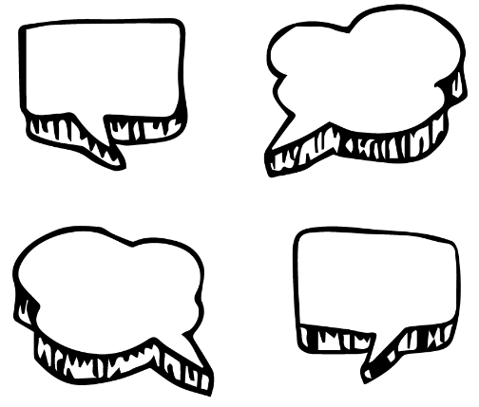
- What do you know about Charles Darwin?
- What do you know about evolution?
- What has surprised you most about Charles Darwin?
- Why do you think his ideas are still relevant today?

Glossary
Students will brainstorm a list of key words that relate to the BTN Charles Darwin Day story. Here are some words to get them started.

Evolution | Adaptation | Species
Natural selection | Variation | Survival

Charles Darwin Research
Students will be exploring the work of Charles Darwin in more detail. They can develop their own key questions to investigate or respond to one or more of the questions below. Students can complete the following KWLH organiser to explore their knowledge and consider what they would like to know and learn.
What do I know? | What do I want to know? | What have I learnt? | How will I find out?
Here are some possible questions for students to research:
- What did Charles Darwin see and do on his five-year journey on the HMS Beagle?
- What did Darwin discover about finches on the Galapagos Islands? How did it confirm his idea of natural selection?
- Charles Darwin visited Australia in 1836. Where in Australia did Darwin visit? Show the Beagle’s Australian route on a map. What observations did he make?
- How did people react to Darwin’s ideas, and how did they change the way people thought about the origins of the world?
- Why was Charles Darwin reluctant to publish his theory of evolution?
- What is Darwin’s most important contribution to science? Give reasons for you answer.

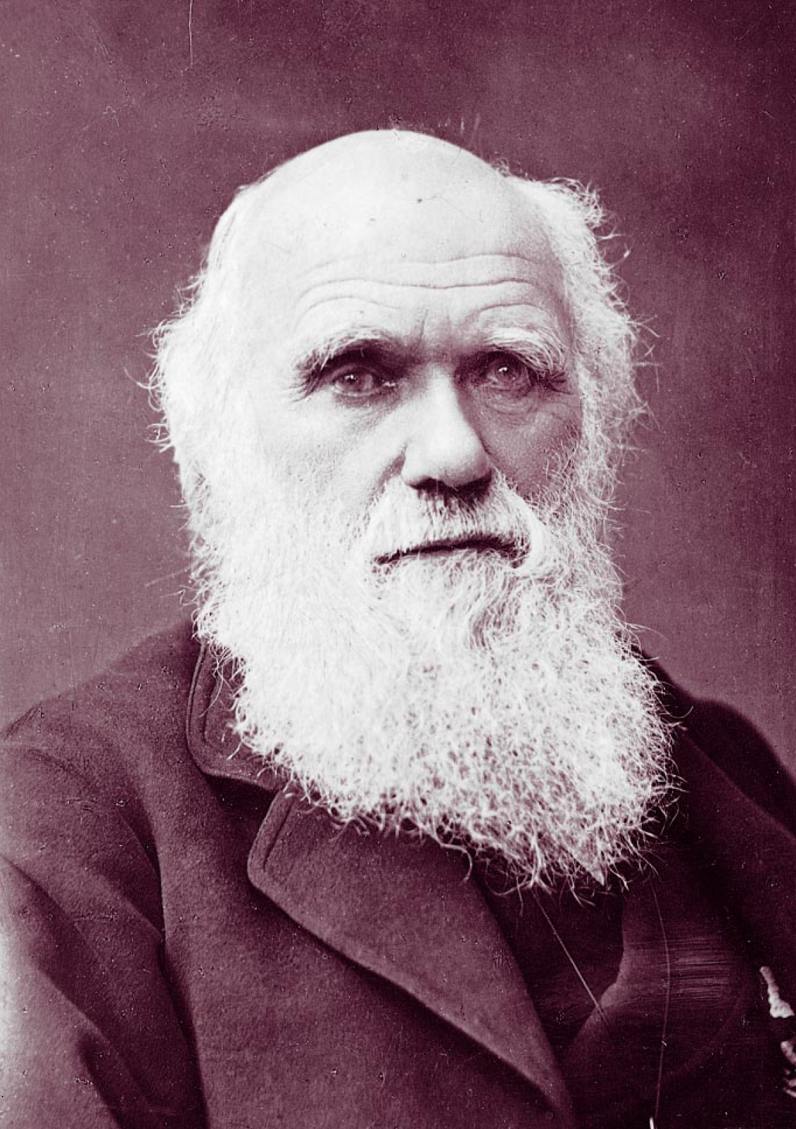
Who was Charles Darwin?
Before students begin to construct their biographies, hold a class discussion to find out what they already know about biographical writing. Below are some discussion starters:

- What does a biography tell us about a person?
- Where can you look to find information for your biographical writing? It could include the internet, newspaper articles, magazine articles and interviews, other biographies, historical books or television interviews. Why is it important to use more than one source of information?
- What makes a biography interesting? For example, key information and facts, a timeline of events, photographs, illustrations and quotes.

Using the biography worksheet at the end of this activity, students will find and record information about Charles Darwin. This Charles Darwin timeline will help students with their research. Some possible areas to include are:
- Where was Charles Darwin from? Locate using Google Maps.
- When was he born? Describe his family life growing up.
- What were some of Charles Darwin’s achievements? Choose one to explore in more detail.
- What were some challenges Darwin faced?
- How has Charles Darwin made an impact on people’s lives?
Further investigation
- Imagine you could sit down and talk to Charles Darwin. What questions would you ask about his life and achievements?

Experiment - Does saltwater kill seeds?
Before starting this activity, reading the following excerpt as a class.
I have begun making some few experiments on the effects of immersion in sea-water on the germinating powers of seeds, in the hope of being able to throw a very little light on the distribution of plants, more especially in regard to the same species being found in many cases in far outlying islands and on the mainland. Charles Darwin, Gardeners’ Chronicle and Agricultural Gazette

To explore the question `How did plants become distributed over the Earth’s surface?’ Darwin tested how plant seeds would survive in seawater. Students will conduct a similar experiment as explained here. Before students conduct the experiment, ask them to make some predictions.

Students can then discuss the results of their experiment reflecting on:
- How many seeds germinated?
- Why did certain seeds germinate more than others?
- Why did Charles Darwin conduct this experiment?

Watch the BTN Human Evolution story then answer the following questions:

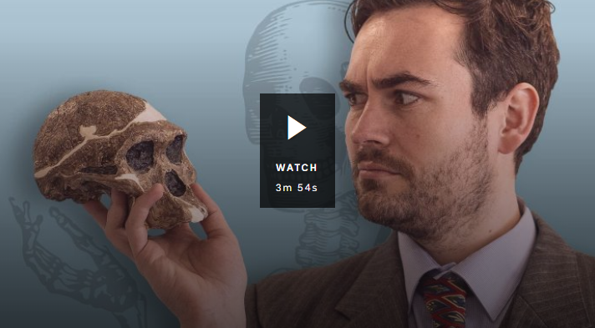
- What part of the human body is helping us learn about human evolution?
- What is the scientific name for modern humans?
- Approximately how far back in time do modern humans date?
- Where did Homo sapiens originate?
- What did our earliest ancestors look like? Describe.
- How are Homo habilis different to Homo sapiens?
- The most famous Australopithecus afarensis was discovered by scientists in which country?


Human Evolution – BTN
https://www.abc.net.au/btn/classroom/human-evolution/11481954

What is evolution? - BBC Bitesize
https://www.bbc.co.uk/bitesize/topics/zvhhvcw/articles/z9qs4qt

Charles Darwin Timeline – The Darwin Project
https://www.darwinproject.ac.uk/learning-resources/timeline#/




Family
Full name

Portrait of Charles
Important contributions Charles Darwin made to science…

Born
Interesting things about Charles Darwin…
Biography – Charles Darwin

Charles Darwin’s achievements

Teacher Resource
Episode 2
11th February 2020

Special Effects
Students will explore visual effects techniques used in film.

Media Arts – Years 3 & 4
Use media technologies to create time and space through the manipulation of images, sounds and text to tell stories.

Plan, create and present media artworks for specific purposes with awareness of responsible media practice.

Media Arts – Years 5 & 6
Develop skills with media technologies to shape space, time, movement and lighting within images, sounds and text.

Plan, produce and present media artworks for specific audiences and purposes using responsible media practice.
- Discuss the BTN Special Effects story with another student.
- Rising Sun Pictures has worked on the visual effects for serval Hollywood films. Name one.
- What is the difference between a practical and a computer-generated visual effect? Give examples.
- What historical event was recreated in the film Ford v Ferrari?
- What research did the Rising Sun Pictures team do to make the scene accurate?
- What is a green screen?
- How were the cockpit interior shots filmed?
- What visual effects were added to the cockpit interior shots?
- How long does it take for 80 people to create 8 minutes of visual effects?
- What was surprising about this story?

Vocabulary
Students will develop a glossary of words and terms that relate to film making and visual effects. Below are some words to get them started. Students will add words and meanings to their glossary as they come across unfamiliar words throughout their research.

Green screen | Computer-generated imagery | Scene
Visual effects | Shot | Animation

Further investigation
Students will consider using pictures and diagrams to illustrate meanings of the words in the glossary.

KWLH
Watch the BTN Special Effects story and discuss as a class. What questions were raised in the discussion and what are the gaps in their knowledge. The following KWLH organiser provides students with a framework to explore their knowledge on this topic and consider what they would like to know and learn.

What do I know? | What do I want to know? | What have I learnt? | How will I find out?

Students will develop their own question/s for inquiry, collecting and recording information from a wide variety of sources. Students may develop their own question for inquiry or select one or more of the questions below.

- What are visual effects? Explore 3 different types of visual effects techniques used in film. Find examples of these techniques in films.
- What was the one of first films to use visual effects? Explore the history of visual effects in film from early animation to computer generated images used today.
- How is technology changing visual effects techniques?
- Why do filmmakers use storyboards? Choose a scene from your favourite film and make a storyboard of that scene.
- Who is involved in the making of a film? Watch the closing credits of a film to see who is involved in the film making process. Make a list of the different roles and their responsibilities. Choose one role to research in more detail.
- Explore the history of the Australian film industry and create a timeline to highlight your findings. Compare and contrast the film industry in Australian to that of other countries, for example, the Bollywood film industry in India.

Visual effects
In small groups students will choose one visual effects technique from the list below to research in more detail and then demonstrate in a short 2-minute video.

Green screen / Chroma key | Green screen is also known as ‘chroma key’. It is a technique used in film that can replace a real background (usually a green background) with a digital background. Watch these BTN stories to watch kids using green screen.  Screen It Competition  Gaming FX
Jump cut | A jump cut is a technique used in film to show a time jump or a change of location during a film. A jump cut can also create the illusion that an actor or an object has disappeared. Visit ACMI’s website to learn more about jump cuts.
Stop motion animation | Stop-motion is a technique used in animation to make still objects appear to come to life on screen. This is done by taking lots of still photos of the object in slightly different poses. When all the photos are played in order it shows movement.  You can make your own short 3D clay animation film using stop-motion animation. Watch this BTN story to see kids making their own stop-motion animation.
History of the Oscars
Watch this BTN story to learn about the history of the Oscars. BTN finds out why they’re such a big deal, why they’re called the Oscars, and why they’re sometimes controversial. Students will then respond to the following focus questions:

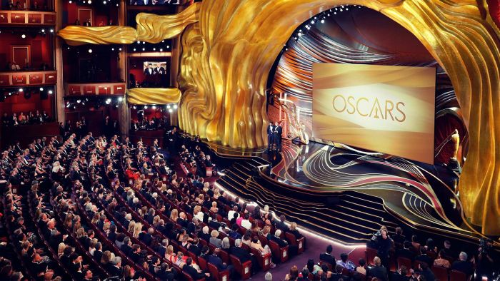
- Name some of the categories awarded at the Oscars.
- What is the name of the production company that Louis B. Mayer co-founded?
- What year was the first Academy Awards held?
- Why is the gold award called an ‘Oscar’?
- In what year were the Academy Awards first televised?
- Give an example of when things have gone wrong at the Academy Awards.
- In what year was an African American man first named best actor?
- Who is the only woman to have won best director?

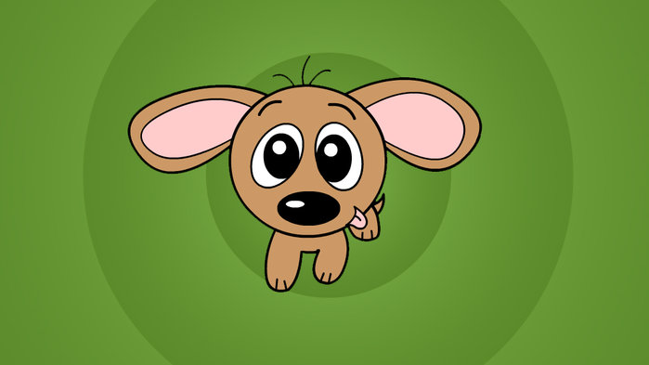
Animation game
In this ABC Education game students will build animated characters for a new cartoon show. Students will choose each character's walking movements to suit their personality, mood, actions and relationship to other characters.

ABC Education: Character Maker

History of the Oscars BTN
https://www.abc.net.au/btn/classroom/history-of-the-oscars/10834166

Oscar Props - BTN
https://www.abc.net.au/btn/classroom/oscar-props/10531032

BTN – Screen It Competition
https://www.abc.net.au/btn/classroom/screen-it-competition/10523034

BTN – Movie Magic
https://www.abc.net.au/btn/classroom/movie-magic/10534812

BTN Transcript: Episode 2 – 11/2/20

Hey. I'm Amelia Moseley and you're watching BTN. Here's what's coming up today. We'll find out more about the science of predicting the weather, learn about the life of the world's most famous biologist and meet the people putting the magic into movies. Ooh I’m excited for that story.

Coronavirus Explained
Reporter: Leela Varghese

INTRO: But first today to something you've probably heard a bit about over the past few weeks - coronavirus. There's been a lot of talk about the new strain of virus which started in China and has now spread to other countries. Let’s find out what's been happening.

You'd have to really be trying to avoid the news to have missed people talking about coronavirus.

LEELA VARGHESE, REPORTER: What’s that?

VO: Well Leela, or me. I’m glad you asked.

It was late last year that we started to hear reports about a new virus that had infected some people in the Chinese city of Wuhan. They reckon it might have started in this market where there was a lot of raw meat and animals. Pretty quickly it started to spread, some people died and the news reports about coronavirus got more serious and regular.
What a lot of people might not realise is coronaviruses are actually a whole big family of viruses. Interesting fact, the name corona comes from the Latin word for crown, because they kind of look like little crowns. These viruses usually cause symptoms like a fever, a dry cough, and aching muscles, a bit like the flu. And just like the flu, they generally spread via respiratory droplets generated by sneezing and coughing. They can also be transmitted from animals to humans which is how this particular strain of coronavirus got going.
So why are people so worried? Well, any new disease is something experts watch really closely. Especially when they're potentially fatal. Although most people who've caught this coronavirus have recovered. The real concern is how fast this one is spreading.
There have now been more than 40,000 confirmed cases. Most of those have been in China. But the virus has now been found in at least 25 countries and some are worried about it spreading even further. To try and stop that from happening the World Health Organisation has declared a global health emergency. Which is basically a way of encouraging governments around the world to take this seriously and do what they can to stop it.
That's certainly happening. China has taken some extraordinary steps like quarantining 55 million people in the city of Wuhan and the surrounding Hubei province. And building a brand-new hospital there. People in other parts of the country are also feeling the effects, like Eli and Tyson who live in Kunming city.
TYSON: We are pretty far from Wuhan, the centre of the virus except if it spreads too fast, we might be seriously affected.

ELI: There are some precautions being taken like having to wear masks and temperatures being checked.
Back here in Australia there's only been around a dozen cases of coronavirus but it's still having a big effect on a lot of people. Aussies who were stuck in Wuhan have been sent to Christmas Island for two weeks so authorities can check they're not sick.
The government has also banned Chinese people who aren't citizens or permanent residents from coming into the country. That's hurting a lot of businesses that rely on Chinese visitors. It's also hard for international students who are missing class time and families who are being kept apart. But the government says it's about keeping people safe.
SCOTT MORRISON, PRIME MINISTER OF AUSTRALIA: I want to assure Australians that we are doing everything that we can, and through these actions to protect Australia from what is an escalating threat and a constantly changing situation.
It all sounds pretty intense, right? But don't worry too much. Experts say there's no need to panic. Your chances of getting coronavirus are really low and like we said most people who get it get better. The best way to protect yourself is to do things you should do anyway like covering your mouth when you cough and washing your hands regularly. Meanwhile, scientists are working hard to develop a vaccine and hopefully, it won't be too long before coronavirus isn't in the news so much.
News Quiz

Okay let’s see how closely you guys have been following the news lately with our very first weekly news quiz.

This week the Australian Greens got a new leader. What is his or her name? Is it Adam Bandt, Bob Brown or Larissa Waters? It's Adam Bandt. He got the top job after the old leader, Richard Di Natale, decided to step down to spend more time with his family.
Meanwhile, US President Donald Trump has hung onto his job this week. Some politicians tried to vote him out in a process called what? Impairment, impeachment or implosion? The answer is impeachment. He was accused of abusing his power as President by pressuring a foreign leader to dig up dirt on a political rival. But the all-important vote went his way.
Who's this famous world leader? Yep, the hair gave it away. It's UK PM Boris Johnson. He's happy this week because he finally pushed through his Brexit Deal, taking Britain out of the European Union. Some people were so happy they held parties.
LOCALS: We're glad that we got our country back.
Speaking of British exits, this famous red head has stepped down from his official role in the Royal Family to spend time with his wife and child. Prince Harry is going to split his time living between the UK and which other country? Yep, it's Canada. And he says he's also going to drop the title Prince. Fair enough Harry, Duke of Sussex.

Weather Science
Reporter: Amelia Moseley

INTRO: Well now to another topic that's been big in the news here in Australia recently, and that’s the weather. We've certainly seen some extreme conditions. There was a cyclone in WA, floods in New South Wales and Queensland and, of course, the bushfires. And through all of it weather forecasters have been working hard to keep people informed so they can stay safe. Let's find out more about their important job.
Who do you go to to predict the future? Fortune tellers? Astrologers? Or New Zealanders, because they're at least half an hour ahead of us? Hmm, how useful any of those things are is up for debate. But there's one group of people whose job it is to predict what's going to happen in an hour or a day or more. The Bureau of Meteorology. This is where magic happens. And by magic, I mean science.

AMELIA MOSELEY, REPORTER: Hey Phil.

PHIL PERKINS, BUREAU OF METEOROLOGY: Hey Amelia. Welcome to the Bureau of Meteorology.
AMELIA MOSELEY: Thanks for having me.

Phil is a meteorologist. That means he studies weather.

AMELIA: So Phil, do your friends always ask you what the weather's going to be tomorrow?
PHIL PERKINS: Yes, people are always asking me and usually blaming me as well if the weather's not to their tasting.
AMELIA: That's unfair.
Meteorologists don't just pull their forecasts out of a crystal ball. Every day, they measure things like rain, temperature, and how much water is evaporating as well as wind speed, direction and air pressure. All that info comes from weather stations and instruments all over the place. Like buoys at sea, weather balloons, satellites in space and even that plane you might've flown in. Oh, and also people like you and me.
PHIL PERKINS: People who go out to their farm, maybe go to their school, their post office, maybe even a police officer who goes down to the beach and tells us exactly what the weather is doing right there and right then. We make sure they've got sort of industry standard equipment rather than just what does my thermometer in my car say right now or how cold is it outside today or throwing grass in the air; we've kinda have to make sure that it's pretty legit.
With all of that information and some serious computers to help crunch the data, meteorologists can track changes in the weather over time and find patterns which they use to figure out what it'll do next. And that's important because weather forecasting isn't just about knowing what to wear tomorrow. These guys can literally save lives. They provide info to pilots, so they know if it's safe to fly, and during emergencies like fires and floods their work is super important.
PHIL PERKINS: What we also do is provide briefings to government to make sure that people know the latest information about where the hazardous areas are, where fires are going to go ultimately to keep people safe.
Really big fires, like the ones we saw recently, can actually create their own weather systems and their own storms, so understanding how they work is really important. And then there are the effects of climate change. Climate isn't the same as weather. It's measured over a much longer time period, but it is having an impact on the day-to-day business of predicting the weather.
PHIL PERKINS: So with a warming world, we're seeing a lot more energy in the atmosphere and when there's more energy in the atmosphere it means the weather can be more extreme.
AMELIA MOSELEY: So, how far in advance can you predict the weather?
PHIL PERKINS: We've got some fairly reasonable skill in terms of whether you need to pack a raincoat or an umbrella or put on extra sunscreen maybe for an extra seven to ten days from now. Our research is getting better and better, and more and more time and money is getting put into our computer modelling so that means that in the future we're going to have a better understanding about how the weather is going to impact us moving forward.
For now, though, the weather is a tricky thing and, unfortunately, even the cleverest forecaster can't tell you if, say, it's going to rain on your birthday next year. For that, you're going to need this crystal ball. Oh wait. No that's just an old weather instrument. Sorry.
Ask a Reporter

If you've got questions about weather forecasting, then you can ask me live next week on Ask a Reporter. Check out our website for all the details.
Locust Plague
Reporter: Jack Evans
INTRO: Now to a different type of natural extreme that's happening in Kenya right now. The country is dealing with a locust plague. The little insects are devastating local farms, and many are worried they'll cause a food crisis. Let's find out more.
Kenya is home to some pretty amazing and dangerous creatures. And right now, one of them is causing huge problems as it rampages across the landscape destroying everything in its path. But it's not what you might think. They might not look that scary, but for local farmers these locusts are horrific. Kenya's going through one of the worst locust plagues in decades, as millions of the critters munch through people's crops, putting livelihoods at risk.
ESTHER KITHUKA, FARMER: We depend a lot on this season and we worry that the locusts will destroy our harvest and we will end up remaining hungry throughout the rest of the year.
So how can such a little insect cause so much grief? Locust plagues happen all around the world. We've seen quite a few of them here in Australia and they've been happening for a long time. There is even talk about them in the Bible. But for quite some time we didn't know that much about them. Except that they come in swarms, eat everything in sight and then disappear leaving behind their path of destruction. In the 1920s scientists discovered something interesting and weird.
It turns out that locusts are actually certain types of grasshoppers which undergo a hulk-like transformation. Normally these guys are gentle and shy and tend to hang out alone. But when something like a drought happens and there isn't much vegetation available, they have to leave their life of solitude and crowd together and that's when the transformation begins.

The sound of all those long legs rubbing together causes their bodies to release a chemical that changes their colour, makes them bigger and turns these once harmless creatures into mini beasts that can eat their own body weight in food every day. Multiply that by a million and you have one hungry, hungry swarm ready to cause a lot of damage.
It's not just Kenya that's in trouble. Other countries in Africa and Asia have been hit with the swarms. While locust plagues would be bad anywhere it's especially bad in countries where a lot of people were already struggling to have enough to eat. Authorities have been trying to get them under control. Insect spray or pesticide is being used to take them out. But as you can see there are a lot of locusts and it's going to cost a lot of money to get rid of them
MARCUS DUNN, FARMLAND AVIATION: We just don't know how big this problem is going to be and we just can't quantify that.
The United Nations Food and Agricultural Organisation has asked other countries to help. But for now, nobody's sure when the swarms will stop.

Charles Darwin Day
Reporter: Jack Evans

INTRO: Now for something a bit different. Did you know February 12th is Darwin Day? And, no, it's got nothing to do with the Northern Territory. It marks the birthday of the famous biologist Charles Darwin. He came up with the theory of natural selection which changed our understanding of the natural world. Jack found out more about him and, um scored an interview.
JACK: Thank you so much for joining me today Mr Darwin, for your only interview of 2020.
DARWIN: Yes, hello.
JACK: Now, I hear today is your 211th birthday. Happy birthday and might I just say you don't look a day over 200.
DARWIN: Oh thank you, although I have been dead for the past 138 years so.
JACK: Now, tell me about the Beagle.
DARWIN: Ah yes. A scent hound bred primarily for hunting hare.
JACK: No, I meant the ship.
DARWIN: Ah yes. A ship that was charting the waters of the south Americas and I joined the crew in 1831 as a naturalist, naturally. I spent five years travelling the world searching for new specimens to study. During my trip around the Galapagos and Cocos Islands I spent a lot of time studying finches. Actually, they were probably Passeriformes of the Thraupidae family. But everyone calls them Darwin's finches. Anyway, I noticed something very interesting. These birds all had distinctly different beaks. Some with strong beaks that ate mostly nuts. Others with narrow beaks that ate mostly insects. It's as if nature had selected the exact right beak for the birds preferred food source.
JACK: Ah yes. Your famous theory of natural selection. Tell me, what's that all about?
DARWIN: Let’s take this cage of finches for example.
JACK: Ahh. Where did you get a cage of finches?
DARWIN: Each of these finches is unique. They have slight natural variations. And some of those differences make finches better at surviving. Now take Ethel here, hello Ethel. Imagine Ethel had a slightly stronger beak. That might make her better at cracking hard seeds or nuts. So, she'd get more food, which means she's more likely to survive and have babies. And she might pass on her strong beak to some of them. Or say Charlie here has a slightly narrower beak which would make him just a little bit better at catching insects in little holes. So, he might be more likely to survive and have narrow beaked babies. Over enough time you might see two different types of finches appear some with narrow beaks some with strong beaks.
JACK: So what you're saying is that natural selection is the process by which organisms that are best suited to survive their environment are more likely to reproduce and through that process different species have evolved from a common ancestor.
DARWIN: Precisely.
JACK: And that's why we're all monkeys?
DARWIN: No no no, I never said that. I merely pointed out the obvious similarities between humans and apes. It follows that they evolved from a common ancestor.
JACK: Now, you've written several books including your best seller, On the Origin of Species, which is still regarded as one of the most important works of science. Was it an instant hit?
DARWIN: Well there were mixed reactions. You have to understand that people in my part of the world were fairly religious and didn't take too well to the idea of things evolving. In fact, it took me quite a while to get my head around it at first. But the science world went ape for it and why wouldn't they? My theories explained everything. Why birds have wings, why turtles have shells, why a beaver looks like this, why a duck looks like that and why a platypus looks like, well, everything. And do you know what? Ever since then scientists have only added to my theories. Now it forms the very back bone of biology.
JACK: Well, thank you Mr Darwin. It has certainly been enlightening.
DARWIN: Well thank you for having me and would you like a finch I’ve got plenty of them.
Did You Know?

Did you know that Charles Darwin invented the office chair? Yep. It turns out he wanted to work a lot quicker, so he put some wheels on the bottom of his chair and zoomed around his office. Nice one.

Sport

The Sydney Sixers have won the Big Bash League. They took on the Melbourne Stars in the final in a match which many people thought might not actually go ahead because of Sydney's crazy weather. In a rain shortened game, Josh Philippe led the Sixers to 5 for 116 from 12 overs which was enough to see the Sixers claim their second BBL title.

The Aussie Opals have qualified for the Olympics with a win over Brazil. Liz Cambage starred for the team with 29 points and qualifying clearly meant a lot to her and the team.

Penalty shootouts are the nerve-wracking way to decide soccer finals that end in a tie and it usually comes down to whoever misses first. But what happens when everyone's having a bad day? In the Japanese Super Cup final shootout there were a whopping 9 misses in a row. Eventually Vissel Kobe scored so all of the fans and players could finally go home.
Special Effects
Reporter: Leela Varghese

INTRO: Finally, to some movie magic. As you probably know the Academy Awards have just been handed out in Hollywood and it got us thinking about an aspect of movie making that you might not think too much about and that's visual effects. Leela went to meet some Aussies who put the effects in one of this year's Oscar-nominated films.
Jack: Ah what are we doing this for again?
Leela: I told you Jack. We're making a film. I'm going to call it Star Trek. I just can't figure out how they make it look real like in all the movies?
Jack: It's called visual effects, and you might want to google the name Star Trek.
Yep, so I Googled it. Turns out Star Trek is already a thing. And it looks pretty good.
Leela: Their spaceship looks way better than mine. Maybe I should look into this whole visual effects thing.
Welcome to Rising Sun Pictures. They've done visual effects on some huge Hollywood films. Ever heard of Captain Marvel or Harry Potter?
Leela: So Malte, for those of us trying to figure out visual effects, can you explain exactly what they are?
Malte Sarnes, VFX supervisor, Rising Sun Pictures: A visual effect is any kind of effect that supports the story of the movie. It can be either shot practically. Like smoke or explosions or it can be done completely on a computer.
Back in the days before computers, filmmakers would use some pretty clever tricks to make that movie magic happen. Check out this sneaky camera trick in this Charlie Chaplin film. The second half of the shot isn't even there. It's just a picture. Now those tricks can be done digitally, and it's made things possible that early filmmakers could never have dreamed of. But visual effects aren't always about superheroes and magic powers.
You might have a hard time spotting the work Rising Sun Pictures did on Ford v Ferrari. The film's based on a true story that's set in 1966 and obviously, without a time machine, it's not that easy to make a film look like it's 1966. And that's where Rising Sun Pictures came in. They studied photos and archival footage to digitally recreate details which were added after the shoot was finished.
Malte: The cockpit interior shots they shot on a stage. Meaning there was just a green screen and then we had to replace the green screen, which you can see here, with the racetrack.

Leela: Sneaky, sneaky Christian Bale making it look like he's amazing at driving cars but he's just in a studio being like, zoom, zoom.
Even the crowds were added digitally which according to Malte is pretty tricky.
Malte: People, humans, everyone knows how they walk, how they act, how they cheer so as soon as you get this wrong it just looks wrong.
It's all a lot of hard work. Creating about eight minutes of visual effects took around 80 people two weeks and unlike most people in showbiz, these guys are hoping you don't notice what they did.
Malte: On this movie that's the main task to do something people buy, believe but you can't really tell what's real and what's not.
So, the next time you watch a film or a TV show you might want to ask yourself, "Is what I'm seeing really there? Or is it just the magic of visual effects?". Ha, ha ha, we fooled you all. Now to go finish Stark Trek. Oh, I can't call it that now. What am I gonna call it? I've got it. Star Wars.
Closer

I can't wait to see it Leela. Well that's it for this week. I hope you've enjoyed the show. We'll be back with more next week but in the meantime, you can catch up with the news every weeknight with Newsbreak. There’s also our website and, if you're 13 or over, you can subscribe to our YouTube channel, so you don't miss a thing. I’ll see you soon. Bye.

