
KEY LEARNING
Students will view a range of BTN stories and use comprehension skills to respond to a series of focus questions.

CURRICULUM
English – Year 4
Use comprehension strategies to build literal and inferred meaning to expand content knowledge, integrating and linking ideas and analysing and evaluating texts.

English – Year 5
Use comprehension strategies to analyse information, integrating and linking ideas from a variety of print and digital sources.

English – Year 6
Use comprehension strategies to interpret and analyse information and ideas, comparing content from a variety of textual sources including media and digital texts.

English – Year 7
Use comprehension strategies to interpret, analyse and synthesise ideas and information, critiquing ideas and issues from a variety of textual sources.
  - Teacher Resource

International Women’s Day Special
As a class, discuss the stories featured in the BTN special and record the main points of the discussion. Students will then respond to the following focus questions.

Elizabeth Kenny
- What started Elizabeth Kenny’s interest in the human body?
- How did Elizabeth treat patients with polio?
- In which country did the `Kenny method’ take off and voted her the most admired woman?
- Why do you think Elizabeth Kenny is an important Australian?
- What did you like about the BTN story?

Cathy Freeman
- Where was Cathy Freeman born? Find on a map.
- What year did Cathy Freeman become the first Indigenous Commonwealth gold medallist?
- Which Olympic Games did Cathy Freeman win the 400 m gold?
  - Atlanta 1996
  - Sydney 2000
  - Athens 2004
- What flags did Cathy Freeman carry on her victory lap?
- Why do you think Cathy Freeman is an important Australian?

Dame Mary Gilmore
- What were some significant achievements in Dame Mary Gilmore’s life?
- What sparked her interest in politics and social change?
- Which banknote does Dame Mary Gilmore feature on?
- Why is she an important Australian?
- If you could ask Dame Mary Gilmore one question, what would it be?

Dr Lowitja O’Donoghue
- What were some significant achievements in Lowitja O'Donoghue’s life?
- What was Lowitja O’Donoghue’s first job?
- How did Lowitja help Indigenous people?
- Which award did Lowitja receive?
  - Australian of the Year
  - The Order of Australia
  - Order of the British Empire
  - All of the above
- Why is she an important Australian?

KEY LEARNING
Students will recognise and celebrate Australian women who have made significant positive changes in society.

CURRICULUM
HASS – Year 3 and 4
Pose questions to investigate people, events, places and issues.

Locate and collect information and data from different sources, including observations.

HASS – Year 5 and 6
Develop appropriate questions to guide an inquiry about people, events, developments, places, systems and challenges.

Locate and collect relevant information and data from primary sources and secondary sources.

History – Year 6
The contribution of individuals and groups to the development of Australian society since Federation.

HASS – Year 7
Construct significant questions and propositions to guide investigations about people, events, developments, places, systems and challenges.

  - Teacher Resource

Elizabeth Kenny

Activity: Personal Response
Respond to the BTN Elizabeth Kenny story as a class. Students will complete one or more of the following incomplete sentences:

- Elizabeth Kenny was an important Australian because…
- It was interesting to learn…
- These are five words that I would use to describe Elizabeth Kenny…
- This story made me feel…
- It is important to remember Elizabeth Kenny because…

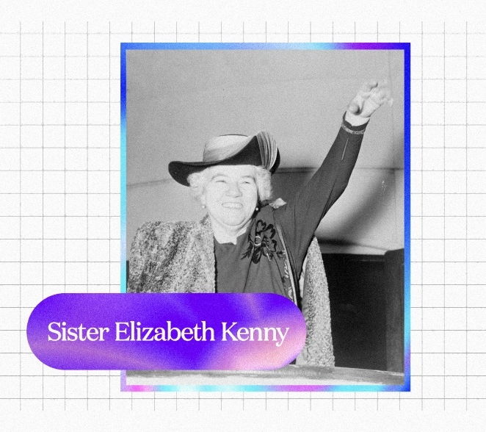

Activity: Step back in time…
Students will explore the life of Elizabeth Kenny to not only get an insight into her life, but to also gain a better understanding of what the times were like - including details about particular social, cultural, and historical perspectives.

Students will step back in time and imagine what life was like for Elizabeth Kenny. Students will find out as much as they can about Elizabeth, including her childhood, major events in her life, and learn more about her achievements and challenges.

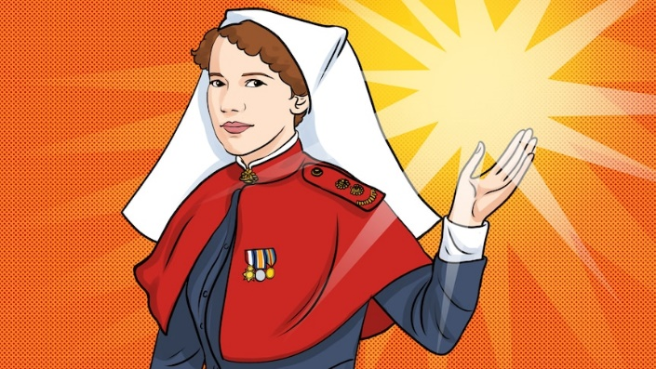
Listening
Start this activity by listening to the ABC Fierce Girls podcast about Elizabeth Kenny as a class. After listening to the podcast discuss what your student’s reactions are to the story and how it made them feel.
- What is your initial response to Elizabeth Kenny’s story?
- How did the stories about her life make you feel?
- What method did Elizabeth Kenny use to treat polio?
ABC Fierce Girls podcast – Elizabeth Kenny
- What opposition did she face from the medical profession?

Writing
Students will then choose a point in time in Elzabeth Kenny’s life, focussing on a particular event or moment in time. Students will then complete one of the following activities:
- Imagine you are Elizabeth Kenny. Write a letter from her perspective to either a friend or family member explaining how she feels and what she is going through.
- Imagine you are a patient with polio and being treated by Elizabeth Kenny. Write a letter to Elizabeth Kenny expressing your thanks for the treatment you received.
- One of Elizabeth Kenny’s significant quotes was “It is better to be a lion for a day, than a sheep all your life”. What do you think she meant by this? Think of a time when Elizabeth Kenny symbolised this and explain using your own words.

Further Investigation
Students will choose one of the following activities to complete individually or in pairs:
- Identify aspects of Elizabeth Kenny’s everyday life (from the past) that are similar and/or different from yours. How can you show that the present is different from or similar to the past?
- Find historical sources of information, for example, personal journals/diaries/memoirs, letters, newspaper and magazine articles, movies, music, photographs, artefacts. Examine each piece of information and identify if it is a primary or secondary source of information. Create a virtual excursion about Elizabeth Kenny using the historical information you find.

Activity: Who inspires you?
Class Discussion
Start the lesson by asking students which women past or present inspire them. It could be women they know in their family, the wider community or someone well-known.

- Which woman in your life do you look up to? Why?
- Which woman in your life inspires you?
- Think about a time a woman in your life helped you solve a problem. What was the problem, and how did she help you solve it?
- Think of a list of women trailblazers.
- What have people that are trailblazers got in common? Think of a list of traits.

Confident
Adventurous
Changemakers
Innovative
Strong
Powerful
Bold
Brave

Activity: Research Project
In this activity students will recognise and celebrate Australian women who have made significant positive changes in society and understand the importance of their contributions. Ask students to brainstorm and list the names of individuals they know or have heard of who have made significant positive changes in society. Encourage them to think about different areas such as civil rights, environmental conservation, science, and more.

Start a class discussion using the following questions:
- Can you think of women, past or present, who have made a positive change in society? Think of people that inspire you or are your role models.
- What qualities make this person special?
- How did their actions make a difference?
- What are some common characteristics and actions of people that are changemakers?
- Who inspires you? Why?

Direct your students to the BTN website to find stories of trailblazing Australian women who’ve made an extraordinary contribution to society, including:
- Nancy Bird Walton – Aviation pioneer
- Dorothy Hill – Scientist
- Edith Cowan – Social reformer and politician
- Faith Bandler – Civil rights activist
- Evonne Goolagong Cawley – Tennis legend

Or visit the ABC Fierce Girls website to learn more about Australian women who dare to do things differently. From athletes to aviators, scientists to spies. From the deep blue sea to the dark, black skies.
Students will choose one trailblazing Australian woman they find inspiring and research and record information about the person. Some possible areas of research include:
- When and where were they born? Describe their family life growing up.
- What are some of their achievements? Choose one to explore in more detail.
- What inspired or motivated them?
- What are some of their values?
- What were some challenges they faced?
- How did they make an impact on people’s lives?
- What do you admire about them?

Students will use a range of primary and secondary sources during their research including biographies, articles, letters, speeches, artworks, photographs, and news stories. To extend learning in this activity students will choose one of the following projects to complete.

Biography
Create a biography about the person, which includes a timeline of important events in their life.

What are some of the key events in their life? Write a summary for one key event, which answers the 5 W’s – Who, What, Where, When and Why?
Creative Writing
Who inspires you?

Write an original story (approx. 500-800 words) about an Australian girl, boy, woman or man you admire most.

They could be someone famous already, or someone you think the world should know more about!

Do you have questions?

Portrait
Plan and create a portrait of the person or group. Think about the expressions, symbolism, and colours that reflect the person, their values, and their impact. Explore and experiment with different techniques and mediums to produce a portrait.

Present your portrait to the class, introducing who the person is, the impact they had and then explain your portrait and what each of the elements in the portrait mean. Organise a class exhibition of your artworks to share with the school and local community.

Podcast
Write stories about people doing inspirational things in your community. Create a podcast using PodOmatic, Buzzsprout to share your stories with the school community.


Activity: International Women’s Day
International Women's Day is a global day celebrating the economic, political, and social achievements of women past, present and future. How does your school honour and celebrate the achievements of women all around the world? Go to the UN International Women’s Day website for more information.

Useful Websites
- Women’s History Month 2024 – BTN Newsbreak
- Women in History Special 2020 – BTN
- NAIDOC Indigenous Women – BTN
- Women’s History Month 2020 – BTN
- Australian Women in Politics – BTN
- Women’s History Month – Royal Australian Historical Society
- Fierce Girls – ABC
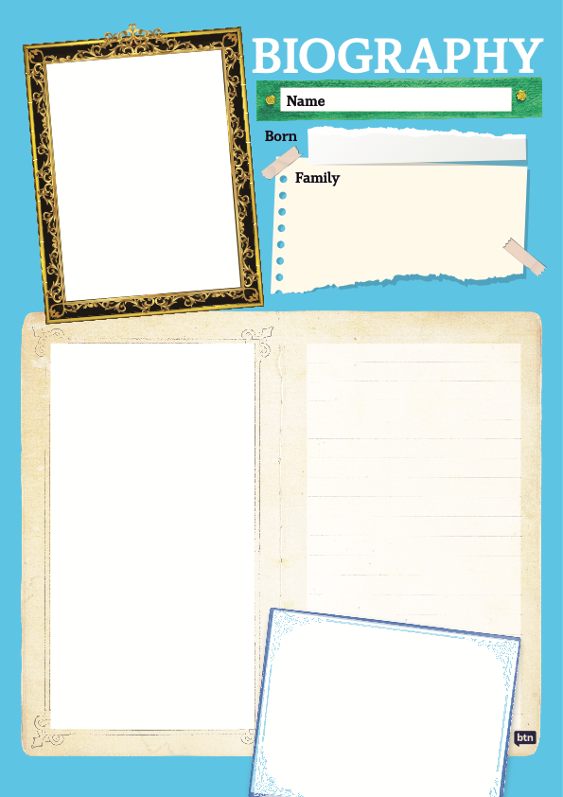

KEY LEARNING
Students will recognise and celebrate Australian women who have made significant positive changes in society.

CURRICULUM
HASS – Year 3 and 4
Pose questions to investigate people, events, places and issues.

Locate and collect information and data from different sources, including observations.

HASS – Year 5 and 6
Develop appropriate questions to guide an inquiry about people, events, developments, places, systems and challenges.

Locate and collect relevant information and data from primary sources and secondary sources.

History – Year 6
The contribution of individuals and groups to the development of Australian society since Federation.

HASS – Year 7
Construct significant questions and propositions to guide investigations about people, events, developments, places, systems and challenges.

  - Teacher Resource

Cathy Freeman

Activity: Personal Response
Respond to the BTN Cathy Freeman story as a class. Students will complete one or more of the following incomplete sentences:

- Cathy Freeman is an important Australian because…
- It was interesting to learn…
- These are five words that I would use to describe Cathy Freeman …
- This story made me feel…
- It is important to celebrate Cathy Freeman because…

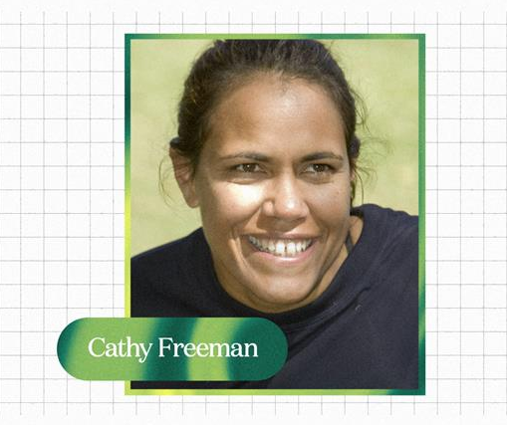

Activity: Visual Literacy
In this activity students will examine, analyse and query a range of images featuring Cathy Freeman during the 2000 Olympic Games. Encourage students to provide detailed and thoughtful responses based on their analysis of the photos. Students will gain an understanding of the significance of Cathy Freeman's gold medal win as a symbol of national unity and reconciliation in Australia.

Students will choose one of the photographs below (alternatively, students can find an image themselves to analyse). Students will then respond to the following:

- What do you see in this image?
- What significant moment or event does the image relate to?
- When and where was the photo taken?
- What do you think is happening?
- If there are people in the image, who do you think they are?
- How do you think they might be feeling?
- How does the image make you feel?
- What question/s would you like to ask the people in the image?
- Create a caption for each image.

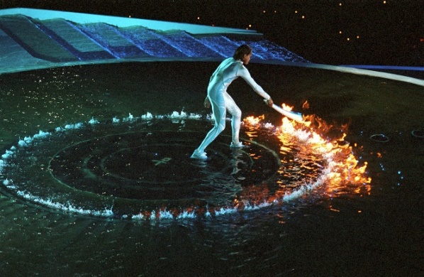  Image Source (IOC) | 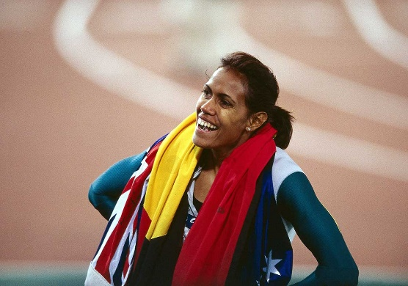  Image source (NMA)
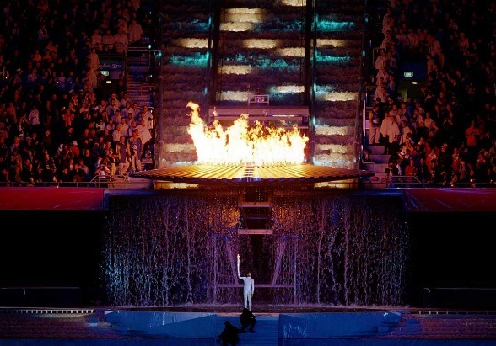  Image source (NMA) | 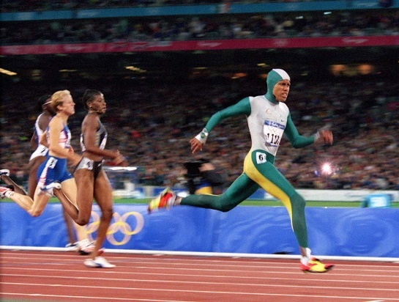  Image source (NMA)

Activity: Symbol of Reconciliation
Students will analyse how Cathy Freeman's victory became a symbol of hope, unity, and reconciliation for the nation. Choose one or more of the following activities to complete individually, in small groups or as a whole class.
- Discuss as a class, the symbolism of Cathy Freeman’s win.
- Students will analyse the images (in the Visual Literacy activity above) and identify symbols that represent hope, unity, and reconciliation. For example, Cathy Freeman lighting the Olympic cauldron at the opening ceremony, carrying both flags for her victory lap, wearing a green and gold bodysuit, and red, yellow, and black shoes.
- Why was Cathy Freeman chosen to light the Olympic flame?
- What impact did Cathy Freeman have on Australian society?
- Can you think of other examples where sports have played a role in promoting unity and reconciliation? Explain using your own words.
- In 2000 the Olympic torch was carried by 13,400 torchbearers. After Olympic champion Herb Elliott carried the torch into the stadium, the last six torchbearers were famous Australian women Olympians. Cathy Freeman was the final torchbearer and had the honour of lighting the Olympic cauldron. Analyse the importance of the torchbearers at the Sydney Olympics.
- Students will create an artwork that symbolises unity and reconciliation inspired by Cathy Freeman’s win.

Activity: Watch the Race
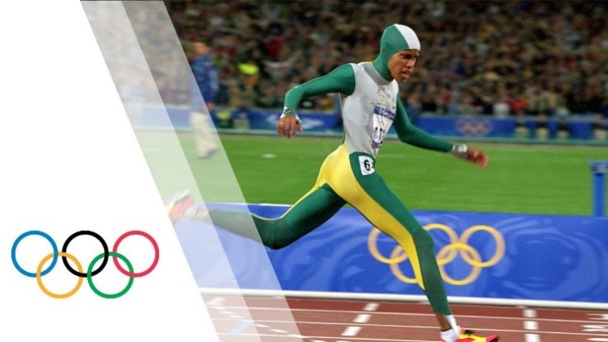
As a class watch Cathy Freeman as she wins the women’s 400 metre race at the 2000 Sydney Olympic Games.

Watch the Race
Video – without commentary
Video – with commentary (scroll down)

Class discussion
Use the following questions to start a class discussion.

Olympics - Cathy Freeman Wins 400 m Gold Sydney 2000 Olympics - YouTube video (IOC)
- What do you see?
- What do you hear?
- What is happening in the video?
- How did the video make you feel?

Add your own commentary
Individually or in pairs, students will try and have a go at commentating Cathy Freeman’s race using their own words. Students will write a script and then read it whilst watching the race. In this activity students will need to demonstrate good communication skills, knowledge of sports terminology, and the ability to engage and captivate an audience.

Activity: First Nations Sportswomen
In this activity students will learn more about significant First Nations sportswomen, their accomplishments, and their impact on sport in Australia. Students will choose one sportswoman they find inspiring and would like to learn more about. Students may want to explore the ABC’s Fierce Girls, a podcast that tells the stories of some of Australia's most extraordinary women, including many significant sportswomen.

ABC Fierce Girls
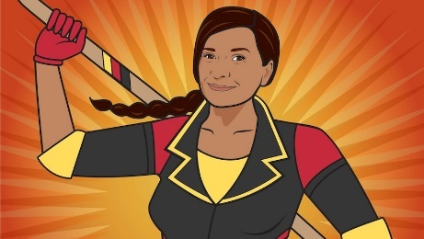  Nova Peris (ABC) | 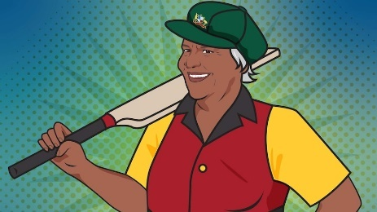  Faith Thomas (ABC) | 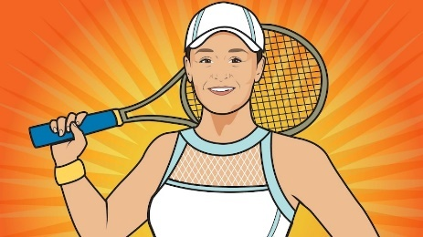  Ash Barty (ABC)
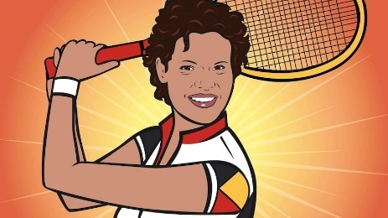  Evonne Goolagong Cawley (ABC) | 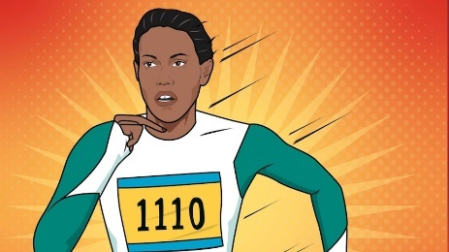  Cathy Freeman (ABC) |   Allirra Jennings (ABC)
Further Investigation
- Create a timeline of important events in her life.
- What are some of the key events in her life? Write a summary for one key event, which answers the 5 W’s – Who, What, Where, When and Why?
- How do primary sources (for example photos, letters, diaries, and official documents) help us understand what might have happened at a place in time? Find 1 or 2 primary sources that help you learn more about the person’s life.
- Make a Did You Know for other students.
- Plan and create a portrait of the person. Think about the expressions, symbolism, and colours that reflect the person, their values, and their impact. Explore and experiment with different techniques and mediums to produce a portrait. Present your portrait to the class, introducing who the person is, the impact they have had and then explain your portrait and what each of the elements in the portrait mean.

Activity: International Women’s Day

International Women's Day is a global day celebrating the economic, political, and social achievements of women past, present and future. How does your school honour and celebrate the achievements of women all around the world? Go to the UN International Women’s Day website for more information.
(UN)

Activity: Choose a project
Students choose one of the following projects to work on and then present their work to a partner, small group, or the class.

Athletics
Do you enjoy running? Practise running a 50 metre, 100 metre or 400 metre run. Organise a race with your classmates.

Quiz
Create a quiz about Cathy Freeman! Use a range of question types (true or false, multiple choice, fill in the blank, matching the pair). Test your classmates’ knowledge.
Celebrate IWD
As a class celebrate the achievements of sports women in Australia. Go to the UN International Women’s Day website for more information.

.
Letter writing
What significant Australian sportswoman inspires you? Write a letter thanking her for her achievements and the impact she has had on Australia and sport.

Useful Websites
- Cathy Freeman — the girl who ran fast – ABC Fierce Girls
- Cathy Freeman: Digital Classroom – National Museum Australia
- Fierce Girls: Cathy Freeman (with animation) – ABC Education
- Cathy Freeman’s Golden Run – ABC News

KEY LEARNING
Students will recognise and celebrate Australian women who have made significant positive changes in society.

CURRICULUM
HASS – Year 3 and 4
Pose questions to investigate people, events, places and issues.

Locate and collect information and data from different sources, including observations.

HASS – Year 5 and 6
Develop appropriate questions to guide an inquiry about people, events, developments, places, systems and challenges.

Locate and collect relevant information and data from primary sources and secondary sources.

History – Year 6
The contribution of individuals and groups to the development of Australian society since Federation.

HASS – Year 7
Construct significant questions and propositions to guide investigations about people, events, developments, places, systems and challenges.

  - Teacher Resource

Dame Mary Gilmore

Activity: Personal Response
Respond to the BTN Dame Mary Gilmore story as a class. Students will complete one or more of the following incomplete sentences:
- Dame Mary Gilmore is an important Australian because…
- It was interesting to learn…
- These are five words that I would use to describe Dame Mary Gilmore…
- This story made me feel…
- It is important to celebrate Dame Mary Gilmore because…

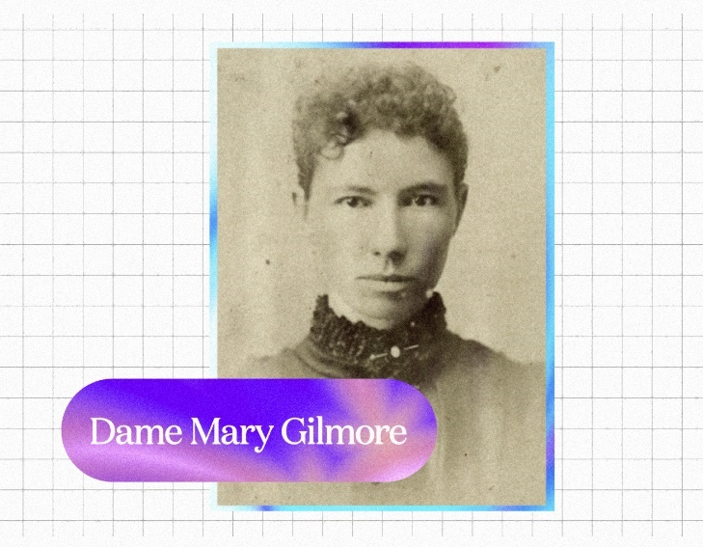

Activity: Explore our Banknotes
Begin this activity by asking your students if they know who is on the Australian $10 banknote. Provide your students with a magnifying glass and a physical $10 banknote. Students will take it in turns to observe and study the $10 banknote. Students can also view a specimen of the $10 banknote up close on the RBA website.

Investigation
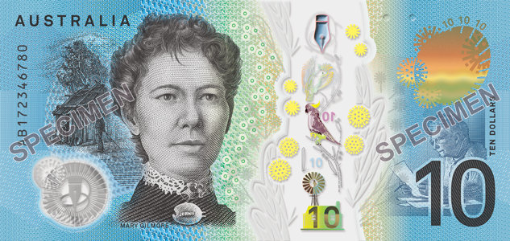
Students will get up close with the $10 banknote, examine it in detail and respond to the following questions:
- What do you see? Write down as much as you can about what you see. Use a magnifying glass to see as much detail as possible.
- Can you find any icons, images, writing or clues about Dame Mary Gilmore on the banknote? Record your discoveries.
Australian $10 Banknote (RBA)
- Why do you think Dame Mary Gilmore is on the $10 banknote?
- What questions do you have about what you see on the banknote?
- Share your findings with the class.

Interactive App
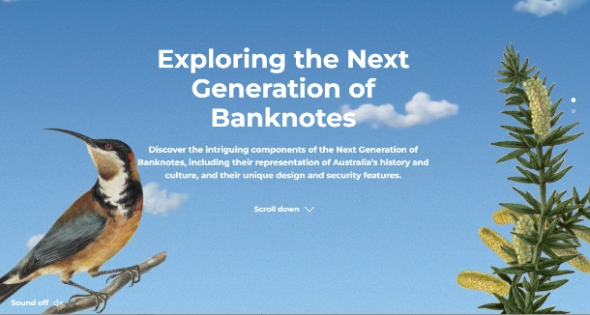
As a class visit the RBA’s Interactive App to discover the components of Australia’s banknotes including their representation of Australia’s history and culture, and their unique design and security features.

Focus on the $10 banknote and find out as much as you can about Dame Mary Gilmore. Students will try to find answers to the questions they wrote during their investigation.
Interactive App (RBA)

Did You Know?
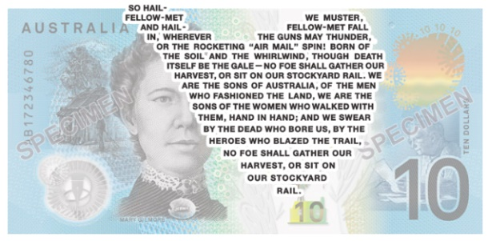
Did you know Australia’s banknotes have areas of text unreadable to most human vision? The text is approximately 0.25mm in height and can only be read with the help of a magnifying glass! Learn more about the RBA’s Microprinting process.

As a class, listen to the microprint excerpt from Dame Gilmore’s No Foe Shall Gather Our Harvest, a poem that united the Australian people against the growing fear of Japanese invasion.
Microprinting (RBA)

Activity: Biography
Before students begin to construct their biographies, hold a class discussion to find out what they already know about biographical writing. Discuss what type of information is included in a biography and what they tell us about a person.

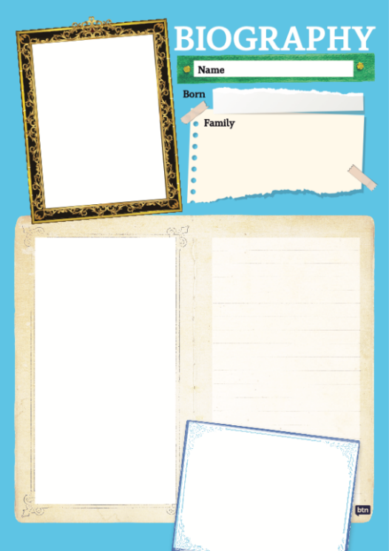
Class Discussion
Use the questions below to get a class discussion started with your students about biographical writing.

- What does a biography tell us about a person?
- Where can you look to find information for your biographical writing? It could include the internet, newspaper articles, magazine articles and interviews, other biographies, historical books or television interviews. Why is it important to use more than one source of information?
- What makes a biography interesting? For example, key information and facts, a timeline of events, photographs, illustrations and quotes.

Create your Biography
Using the biography worksheet at the end of this activity, students will research and record information about Dame Mary Gilmore. Some possible areas of research include:
- When and where was Dame Mary Gilmore born? Describe her family life growing up.
- What were some of her achievements? Choose one to explore in more detail.
- What inspired or motivated her?
- What were some challenges that she faced?
- How did she make an impact on people’s lives?
- What do you admire about her?

Interview
- Imagine you could sit down and talk to Dame Mary Gilmore.
- What questions would you ask about her life and achievements?
- Find answers to your questions.
Portrait
- Plan and create a portrait of Dame Mry Gilmore.
- Explore and experiment with different techniques and mediums to produce a portrait.
- Organise a class exhibition of your artworks.
Timeline
- Create a timeline of important events in Dame Mary Gilmore’s life.
- What are some of the key events in her life? Write a summary for one key event, which answers the 5 W’s – Who, What, Where, When and Why?

Useful Websites
- Dame Mary Jean Gilmore (1865–1962) – Australian Dictionary of Biography
- Dame Mary Gilmore (1865–1962) – Reserve Bank Australia
- Dame Mary Gilmore – National Portrait Gallery

KEY LEARNING
Students will recognise and celebrate Australian women who have made significant positive changes in society.

CURRICULUM
HASS – Year 3 and 4
Pose questions to investigate people, events, places and issues.

Locate and collect information and data from different sources, including observations.

HASS – Year 5 and 6
Develop appropriate questions to guide an inquiry about people, events, developments, places, systems and challenges.

Locate and collect relevant information and data from primary sources and secondary sources.

History – Year 6
The contribution of individuals and groups to the development of Australian society since Federation.

HASS – Year 7
Construct significant questions and propositions to guide investigations about people, events, developments, places, systems and challenges.

This document contains the names and images of Aboriginal and Torres Strait Islander people now deceased. It also contains links to sites that may use images of Aboriginal and Torres Strait Islander people now deceased.

  - Teacher Resource

Lowitja O’Donoghue

Activity: Personal Response
Respond to the BTN Lowitja O’Donoghue story as a class. Students will complete one or more of the following incomplete sentences:
- Lowitja O’Donoghue is an important Australian because…
- It was interesting to learn…
- These are five words that I would use to describe Lowitja O’Donoghue …
- This story made me feel…
- It is important to celebrate Lowitja O’Donoghue because…

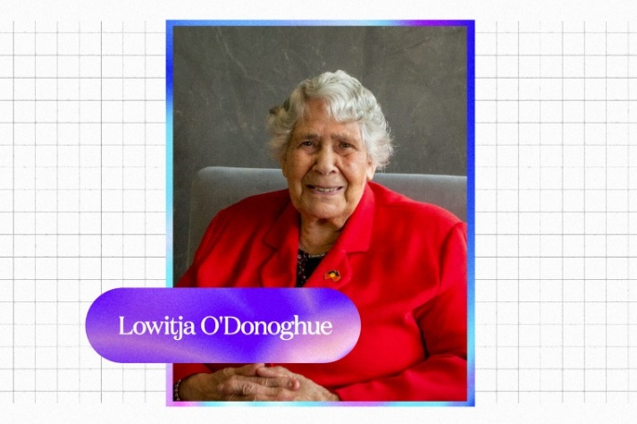

Activity: Vocabulary
Students will brainstorm a list of key words that relate to the BTN Lowitja O’Donoghue story. Below are some words to get them started. As a class discuss the meaning of each word/terminology and how it relates to Lowitja O’Donoghue and her story.

Advocacy
Trailblazer
Indigenous Rights
Equality
First Nations peoples
Stolen Generations
Activist
Elders

Further Investigation
- What is advocacy? Ask students to give an example of when Lowitja O’Donoghue was an advocate on Indigenous issues.
- Lowitja O'Donoghue was one of many Indigenous children separated from their families. Take the time to learn what your students know about the Stolen Generations. As a class, find out more about Lowitja O'Donoghue’s story.

Activity: Research and Document
5 W’s
Students will choose one key event in Lowitja O’Donoghue’s life and research as much as they can about it. They will write a summary on the key event which answers the 5 W’s – Who, What, Where, When and Why?


When
Asks about a time
Why
Asks about a reason
Who
Asks about people
What
Asks about an action
Where
Asks about a place

KWLH
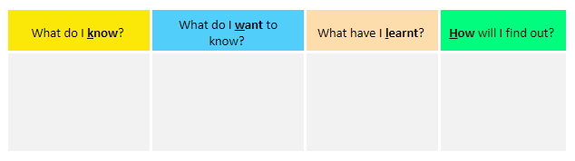
The following KWLH organiser provides students with a framework to explore their knowledge on Lowitja O’Donoghue and her advocacy for Indigenous rights. After watching the BTN Lowitja O’Donoghue story, students will develop their own question to research in more detail.

Timeline
Students will research and document the story of Lowitja O’Donoghue, to teach future generations about her life, her achievements, and her challenges. They will use a timeline to document their findings. Below is a timeline highlighting Lowitja O’Donoghue’s trailblazing achievements. Visit the Lowitja O’Donoghue Foundation website to read and learn more about her biography and achievements.

1954  Lowitja O’Donoghue became the first Aboriginal person to train as a nurse at the Royal Adelaide Hospital.  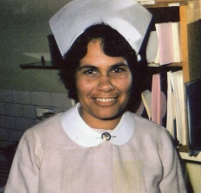  ABC News | 1973  Lowitja O’Donoghue was appointed as regional director of the Department of Aboriginal Affairs in SA, the first woman to hold a position like this in a federal government dept.  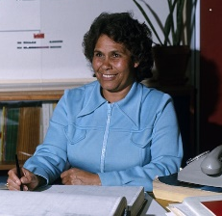  ABC News | 1976  Lowitja O’Donoghue was the first Aboriginal woman inducted into the Order of Australia. | 1992  Lowitja O’Donoghue was the ﬁrst Aboriginal person to address the United Nations General Assembly, in Geneva.  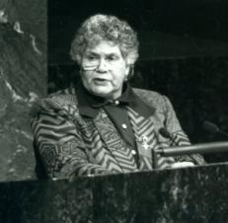  ABC News | 2000  Lowitja O’Donoghue was the first Indigenous person to give the annual national address as part of Australia Day celebrations.

Activity: BTN Stories
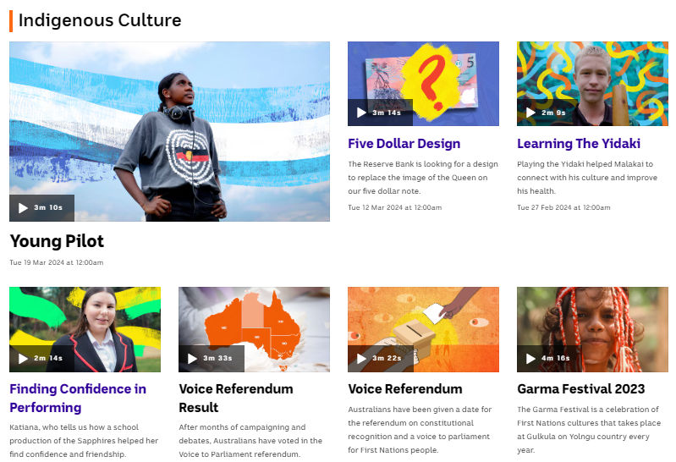
Visit BTN’s collection of stories which focus on Aboriginal and Torres Strait Islander peoples’ culture and issues.

After watching any one of the BTN videos ask students to respond to the discussion questions (to find the discussion questions and teacher resources go to the related BTN Classroom Episode and download the Episode Package).

Collection of BTN stories about Indigenous culture

Activity: Portrait
In this activity students will identity and understand the importance of individuals who have used their voice to make a positive change in society. As a class discuss the importance of individuals or groups who have used their voice to make a positive change in society and brainstorm a list of people that have made a significant impact. Below are examples of Australians who have fought for the right to voice, such as civil rights activists, suffragettes, or advocates for free speech.

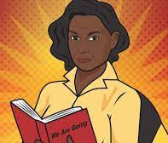  ABC Fierce Girls – Oodgeroo Noonuccal | 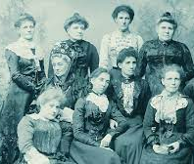  BTN – Australian Women in Politics | 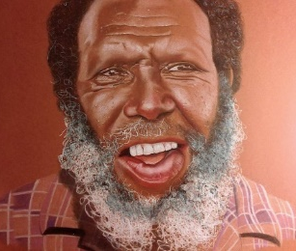  BTN – Mabo Day | 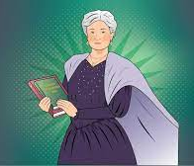  ABC Fierce Girls – Edith Cowan
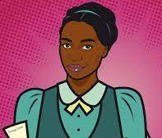  ABC Fierce Girls – Fanny Finch | 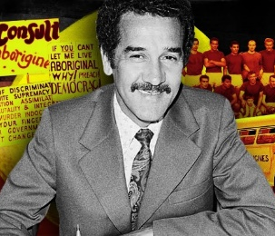  BTN – Charlie Perkins | 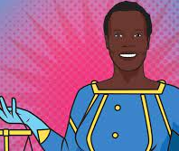  ABC Fierce Girls – Nyadol Nyuon | 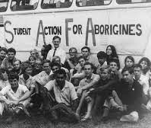  BTN – Freedom Ride

Students will then choose one of these people or groups that they find inspiring. Alternatively, they can choose someone in their community who has used their voice to make a positive change in society. Students will use the following as a guide:
- Research the individual and record their achievements, their values, and the impact they have had on society.
- Use a range of primary and secondary sources during your research including biographies, articles, letters, speeches, artworks, photographs, and news stories.
- Plan and create a portrait of the person or group. Think about the expressions, symbolism, and colours that reflect the person, their values, and their impact.
- Explore and experiment with different techniques and mediums to produce a portrait.
- Present your portrait to the class, introducing who the person is, the impact they had and then explain your portrait and what each of the elements in the portrait mean.
- Organise a class exhibition of your artworks to share with the school and local community.

Useful Websites
- Dr Lowitja O’Donoghue – Lowitja O’Donoghue Foundation
- How Lowitja O'Donoghue changed the way Australia looked at Aboriginal affairs – ABC News
- Dr Lowitja O’Donoghue AC CBE DSG: biography and achievements timeline – Lowitja O’Donoghue Foundation
- Classroom resources to help schools promote a broader understanding of the Stolen Generations – ABC Education

