KEY LEARNING
Students will view a range of BTN stories and use comprehension skills to respond to a series of focus questions.

CURRICULUM
English – Year 4
Use comprehension strategies to build literal and inferred meaning to expand content knowledge, integrating and linking ideas and analysing and evaluating texts.

English – Year 5
Use comprehension strategies to analyse information, integrating and linking ideas from a variety of print and digital sources.

English – Year 6
Use comprehension strategies to interpret and analyse information and ideas, comparing content from a variety of textual sources including media and digital texts.

English – Year 7
Use comprehension strategies to interpret, analyse and synthesise ideas and information, critiquing ideas and issues from a variety of textual sources.
  - Teacher Resource

Focus Questions
As a class, discuss the stories featured in the episode of BTN Classroom and record the main points of the discussion. Students will then respond to the following focus questions.

Egyptian Mummy Recipe
- Where is Cairo, Egypt? Find on a world map.
- Why were pharaohs mummified in ancient Egypt?
- What is natron and how was it used in the mummification process?
- What parts of the body were placed in jars during the mummification process?
- What ingredients did scientists discover were used during mummification? Give 1 or 2 examples.

King Tut Anniversary
- How old was Tutankhamun when he became king?
- Who discovered the tomb of King Tut?
- In ancient Egypt, why were important people mummified, placed in a sarcophagus and then put into a tomb with treasures?
- Why was the discovery of King Tut’s tomb a big deal?
- Name three things you learnt watching the King Tut story.

Ancient Egyptian Discovery
- Briefly summarise the Ancient Egyptian Discovery story.
- What did archaeologists discover recently?
- What is the Egyptian queen’s name?
- How long ago did she die?
- Complete the following sentence. Her husband was the first ____________of Egypt’s 6th dynasty.
- Why did ancient Egyptians build elaborate monuments for their dead royals and fill them with treasure?
- What is mummification?
- How did embalmers preserve the bodies?
- Describe the papyrus scroll that was discovered.
- What was surprising about this story?
KEY LEARNING
Students will explore the process of mummification and learn why it was important in ancient Egypt.

CURRICULUM
HASS – Year 3-4
Pose questions to investigate people, events, places and issues.

HASS – Year 5-6
Develop appropriate questions to guide an inquiry about people, events, developments, places, systems and challenges.

HASS – Year 7
The methods and sources used to investigate at least ONE historical controversy or mystery that has challenged historians or archaeologists, such as in the analysis of unidentified human remains.

The significant beliefs, values and practices of ancient Greece, Egypt or Rome, with a particular emphasis on ONE of the following areas: everyday life, warfare, or death and funerary customs.

Key features of ancient societies (farming, trade, social classes, religion, rule of law).

The evidence for the emergence and establishment of ancient societies (including art, iconography, writing tools and pottery).

The role of a significant individual in ancient Egyptian, Greek or Roman history.
  - Teacher Resource

Egyptian Mummy Recipe

Activity: Class Discussion
Discuss the BTN Egyptian Mummy Recipe story as a class. Ask students what they learnt about mummification and ancient Egypt, recording their responses on a mind map. In small groups, ask students to brainstorm responses to the following questions:
- What did you learn?
- What was surprising about the story?
- What do you wonder?
- What questions do you have about the BTN story?

Activity: Questions and Answers
All scientific discoveries start with a question! As a class, come up with some questions you think scientists ask and solve in relation to the ancient past and how people lived. As a class, make a list of questions that you would like to ask an Egyptologist. Organise the questions into common themes. Use the internet to find answers to your class questions.
What questions do you have?

Activity: Glossary
Students will brainstorm a list of key words that relate to the BTN Egyptian Mummy Recipe story. Here are some words to get them started.

PHAROAH | AFTERLIFE | MUMMIFICATION
EGYPTOLOGIST | SARCOPHAGUS | TOMB

Ask students to write what they think is the meaning of each word (including unfamiliar words). They will swap definitions with a partner and ask them to add to or change the definition. Check these against the dictionary definition.

Further activities for students:
- Visit the Australian Museum for a glossary on ancient Egyptian terms. Choose some words to add to and enhance your classroom glossary on ancient Egypt.
- Learn more about the process of mummification including embalming, wrapping and burial of the body here. What were the following items used for in the embalming and wrapping process: palm wine, natron, linen, canopic jars, amulet, and papyrus scroll.
- Find out if your local museum has an ancient Egyptian collection and plan a visit to learn more about mummification and the afterlife. Alternatively, find a virtual museum like this 360 museum tour, to visit and explore ancient Egypt from your classroom.

Activity: Explore a mystery
After watching the BTN Egyptian Mummy Recipe story ask students to think about what they found interesting, or what they are curious about. In pairs, students will work together to try and uncover more about the mystery of mummification in ancient Egypt.

Students can use the steps below to guide them as they uncover the mystery of mummification. Alternatively, students can choose another mystery of ancient Egypt that interests them.
- What are you curious about? Write down all the questions you have about the mystery.
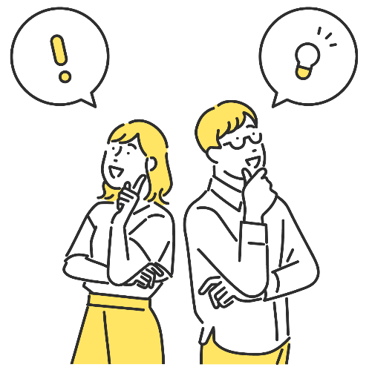
- Do as much research as you can to help answer some of your questions. ‘Visit’ a range of different places during your research phase, collecting as many clues as you can along the way. Possible places for research could include the library, a museum (real or virtual), or the internet.
- Choose 1 or 2 significant pieces of evidence that you have collected during your research. Try and choose one primary source and one secondary source of information. Write a summary about each piece of information which answers the 5 W’s – Who, What, Where, When and Why?
- Consider interviewing an expert to learn more and take your research further.

Activity: Further Investigation
Individually or in small groups, students will choose one of the following projects to work on and then present their findings to the class.

Experiment
Experiment with the process of mummification in your classroom by mummifying an orange. Use these step-by-step instructions. Predict what you think will happen.

True or False?
Create a true or false quiz about mummification in ancient Egypt and test your classmates. Alternatively, create a word find or crossword.

Instructions
Explore the process of mummification in ancient Egypt. Write your own instructions which include the embalming, wrapping and burial process. Include as many words as you can from this glossary of ancient Egyptian terms.
Design
Explore the amulets found in the tombs of ancient Egyptian pharaohs. What did they mean? Design and make your own amulet. What does the shape and colour of your amulet symbolise?

Activity: Pharoah profile
Students will research and write a profile about an ancient Egyptian pharaoh. Students can use the biography worksheet at the end of this activity to record their findings. Encourage students to use a range of sources to find their information.

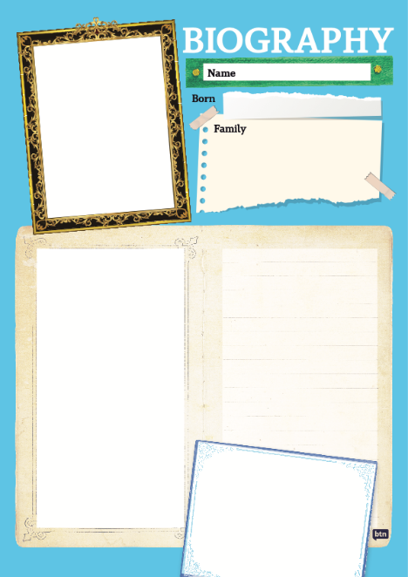
Students will choose an ancient Egyptian pharaoh to research and create a biography.
- Pharaoh’s name
- How is the pharaoh depicted in Egyptian art? Include an illustration.
- When were they born and when did they die?
- When did they reign?
- What were some of their achievements?
- Where is their tomb (if it has been found)? What was found in their tomb? Describe.
- Interesting facts

Useful Websites
- Ancient Egypt Special – BTN
- Ancient Egypt: Ingredients used to embalm mummies identified – Newsround
- Ancient Egyptian Discovery – BTN
- Investigating Ancient Egypt – ABC Education
- How were ancient Egyptians mummified? – Australian Museum
- Investigating Ancient Egypt – ABC Education

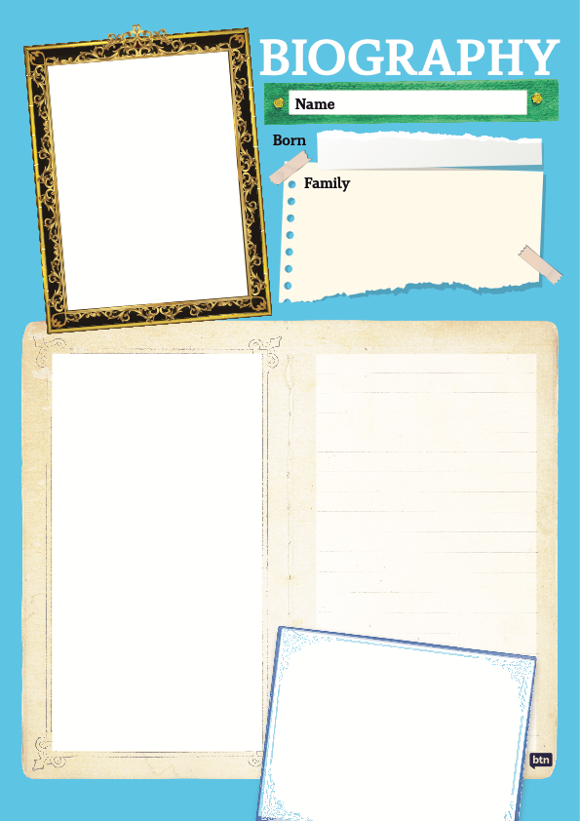

KEY LEARNING
Students will identify a range of questions about the past to inform a historical inquiry on King Tutankhamun. Students will develop their historical knowledge and understanding of ancient Egypt.

CURRICULUM
HASS – Year 3-4
Pose questions to investigate people, events, places and issues.

HASS – Year 5-6
Develop appropriate questions to guide an inquiry about people, events, developments, places, systems and challenges.

HASS – Year 7
The role of a significant individual in ancient Egyptian, Greek or Roman history.

The physical features of ancient Greece, Egypt or Rome and how they influenced the civilisation that developed there.

The methods and sources used to investigate at least ONE historical controversy or mystery that has challenged historians or archaeologists, such as in the analysis of unidentified human remains.

Key features of ancient societies (farming, trade, social classes, religion, rule of law).

The evidence for the emergence and establishment of ancient societies (including art, iconography, writing tools and pottery).
  - Teacher Resource

King Tut Anniversary

Activity: Class Discussion
Before watching
Before watching the BTN King Tut Anniversary story students will discuss in small groups what they already know about the Pharoah and Ancient Egypt.
What do you know about King Tut?
- What do you already know about Ancient Egypt and King Tutankhamun? Record your ideas on a mind map.
- What do you wonder about King Tutankhamun?

After watching
Students will respond to one or more of the following questions after watching the BTN story:
- What did you learn from the BTN story?
- What do you THINK about what you saw in the story?
- Think of three questions you have about the story.
- What more do you want to learn about King Tutankhamun?

Activity: Glossary
Students will watch the BTN King Tut Anniversary story and summarise the story in their own words. Students will watch the story again and listen carefully, circling each of the following words as they hear them and recording any unfamiliar words.

SARCOPHAGUS | MUMMY | ANCIENT EGYPT
HIEROGLYPHICS | PHAROAH | ARCHAEOLOGIST
TOMB | VALLEY OF KINGS | EGYPTOLOGIST
Ask students to write what they think is the meaning of each word (including unfamiliar words). They will swap definitions with a partner and ask them to add to or change the definition. Check these against the dictionary definition.

Further activities for students:
- Write your own sentences using the key words.
- Investigate this interactive map of the Valley of Kings. Can you find King Tutankhamun’s tomb?
- Use the following words to write a summary about King Tutankhamun: Pharoah, tomb, mummy.
- Find out if your local museum has an ancient Egyptian collection and plan a visit to learn more about Ancient Egypt. Alternatively, visit the Australian Museum’s online collection including objects documented in 3D.

Activity: Inquiry Research
Discuss the information raised in the BTN King Tut Anniversary story. What questions were raised in the discussion and what are the gaps in students’ knowledge? The following KWLH organiser provides students with a framework to explore their knowledge on this topic.

What do I know? | What do I want to know? | What have I learnt? | How will I find out?

Students will develop their own question/s to research or choose one or more of the questions below. Encourage students to collect and record information from a wide variety of sources and present the information they find in an interesting way.

- Why is King Tutankhamun so well known today?
- Who found King Tutankhamun’s tomb? Describe some of the objects that the archaeologists could see in the tomb.
- Why was the discovery of King Tutankhamun’s tomb so important?
- Where is King Tut’s mummy now?
- Why were ancient Egyptian royalty buried in tombs? How many tombs have been found in the Valley of the Kings.

Activity: Act Like an Historian
Provide your students with the opportunity to think and act as historians. Students will investigate in more depth some questions they have about King Tutankhamun. Students can take notes as they watch the BTN King Tut Anniversary story or download the transcript after watching the story to guide them through the activity. Students will use the following as a guide or students can write their own inquiry question.
- Write a summary about King Tutankhamun, which answers the 5 W’s – Who, What, Where, When and Why?
- Create a timeline highlighting key events in King Tutankhamun’s life. Include a title, date, and description for each event.
- Find one primary source and one secondary source which helps you understand more about King Tutankhamun. Respond to the questions below for each source you find. Share and compare your findings with your classmates.

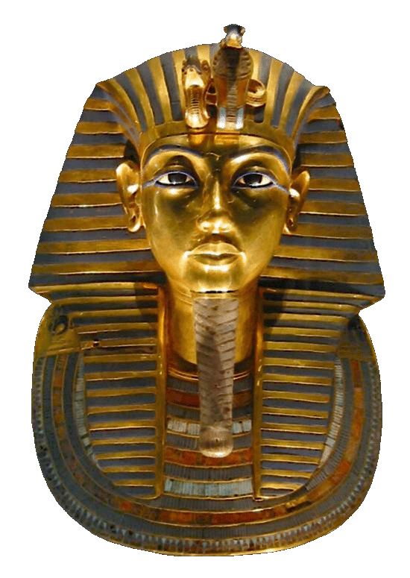
- What is it?
- Who wrote it or made it?
- When was it written or made?
- Where was it written or made?
- How was it written or made?
- Why was it written or made?
- What evidence does this source contribute to my research?

Activity: A snapshot in the life of…
Students will choose one aspect of Ancient Egypt to explore in more detail and then use a timeline to organise the information they find in a chronological sequence. This activity will help students understand growth, change, recurring events, cause and effect, and key events of historical and social significance.

Students will construct a timeline of…
- The evolution Ancient Egypt. When and how did Ancient Egypt start and end? Plot your findings on your timeline.
- Technology of the Ancient Egyptians. What are five technological inventions of the Egyptians? Plot your findings on your timeline. Choose one to explore in more detail.
- The life of Pharaohs. Investigate some of Ancient Egypt’s most famous pharaohs. Plot your findings on your timeline. Choose one Egyptian pharaoh and create a biography on their life and achievements.

Activity – Choose a project
Individually or in small groups, students will choose one of the following projects to work on and then present their findings to the class.

Minecraft creation
Create King Tut’s tomb using Minecraft. Make it as historically as accurate as you can. Alternatively, create an Egyptian pyramid or map of ancient Egypt using Minecraft.
Design a Shabti
Design and create your own Shabti. What will it be made from? What will you name it?
Children’s Book
Write and illustrate a children’s book or comic which tells the story of King Tutankhamun. Alternatively, write a blurb for a book which is a dramatisation of the life of King Tut.
True or False?
Create a true or false quiz about King Tut and test your classmates. Alternatively, create a word find or crossword.

Useful Websites
- Ancient Egyptian Discovery – BTN
- Ancient Egyptian Timeline – Australian Museum
- Egypt Exploration – BTN
- How were ancient Egyptians mummified? – Australian Museum
- Ancient Egypt Special – BTN
- Ancient Egyptian Collection – Australian Museum
- Mummy Mystery: King Tut – National Geographic Kids
- Glossary of Ancient Egyptian terms – Australian Museum

KEY LEARNING
Students will develop their historical knowledge and understanding of ancient Egypt. Students will identify a range of questions about the past to inform a historical inquiry on ancient Egypt.

CURRICULUM
History – Year 7
How historians and archaeologists investigate history, including excavation and archival research.
Significant beliefs, values and practices of the ancient Egyptians, with a particular emphasis on ONE of the following areas: everyday life, warfare, or death and funerary customs.
The importance of conserving the remains of the ancient past, including the heritage of Aboriginal and Torres Strait Islander Peoples.

  - Teacher Resource

Ancient Egyptian Discovery

Activity: Class Discussion
Discuss the BTN Ancient Egyptian Discovery story in small groups or as a class. Ask students to record what they know about ancient Egypt. What questions do they have? Use the following questions to help guide discussion:
- What words do you associate with ancient Egypt? Make a list.
- What was discovered in Egypt recently?
- Archaeologists and historians are saying it will ‘rewrite history’. What do you think that means?
Using the Ancient Egyptian Timeline, ask students to identify the 6th dynasty when Queen Neit and her husband King Teti lived.

Glossary
Students will brainstorm a list of key words that relate to the BTN Ancient Egyptian Discovery story. Here are some words to get them started.

SARCOPHAGUS | ARCHAEOLOGIST | ANCIENT
ARTEFACTS | PHARAOH | FUNERARY

Activity: Investigating the Ancient Past
Finding out about the ancient past can be difficult. Some ancient peoples and civilisations have left behind evidence of the past which help us learn about how they lived. Working in pairs or small groups, ask students to consider the following questions:
- Why do you think people investigate the ancient past?
- How do we know about the ancient past? For example, archaeologists make discoveries, looking at artefacts in museums.
- What are some examples of evidence or places which help us understand the ancient past? For example, Aboriginal rock art in Australia, Mungo Man at Lake Mungo, Stonehenge in England.
- Why is it important to conserve the remains of the ancient past?
- What are some characteristics of Egypt’s ancient societies?
- What can the recent discoveries of mummies, wooden coffins and the temple of Queen Neit tell us?
Students will explore the work done by archaeologists to discover and preserve ancient artefacts. Ask students to record what they know about the work archaeologists do.

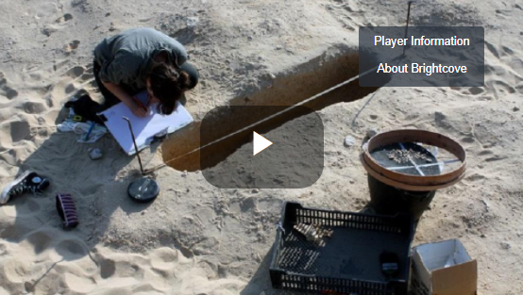
Go to chapter 5 - Archaeology in Egypt in the Investigating ancient Egypt digibook. Watch the video to learn more about what it’s like to be an archaeologist working on a dig in Egypt. Students can then respond to the following questions:
- How do archaeologists record their findings?
- What is photogrammetry and how is it used to document findings?
- What did you learn about the work of an archaeologist in this video?

Further investigation
Students will create a flow chart that shows the process an archaeologist undergoes from finding the artefact, preserving it and using it to interpret the past.

Activity: Funerary Customs & Mummification
Go to chapter 1 - Beliefs and funerary customs in the Investigating ancient Egypt digibook. Watch the video to learn more about funerary customs and mummification.

- Why is our understanding of ancient Egyptian religion, funerary customs and beliefs mostly based on the burials of the elite (wealthy people)?
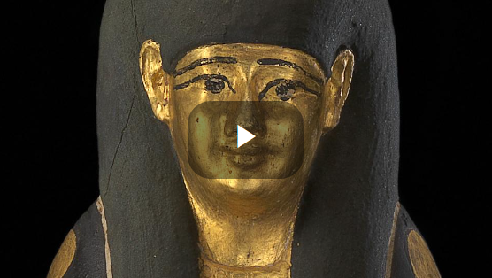
- What did ancient Egyptians believe about death and the afterlife?
- Why did ancient Egyptians place objects in the tomb? Give examples of these objects. (Canopic jars, lucky amulets, food and papyrus scrolls)
- What information in this video was surprising?

The Australian Museum has more information about funerals in Ancient Egypt.

The preservation of the body was an essential part of ancient Egyptian funerary belief and practice. In order to have a life after death, the Egyptians believed their bodies had to be preserved. The mummification process involved removing the internal organs, drying out the body and wrapping it in bandages. Students will research the significance of the afterlife to ancient Egyptians by investigating mummification. Here are some questions to help guide students’ research:
- Who was mummified in ancient Egypt?
- Why were they mummified?
Did You Know animals were also mummified in ancient Egypt? Animal mummies were created in recognition of the animal’s religious importance

- Why was the mummification process important?
- How were ancient Egyptians mummified?
- Why were mummies and sarcophagi’s important to ancient Egyptians?

Resources to help students with their research:
Egyptian Cat Mummies - BTN
Mummification explains the embalming of the body and then the wrapping and burial of the body.
Click on the coffin, the mummy and the objects to learn more about them.
How were ancient Egyptians mummified? – Australian Museum

Activity: Egyptian Papyrus
Papyrus was used for everyday writing in ancient Egypt but also for documents that were put into the tomb with the dead. Archaeologists and historians use clues from papyrus to help them interpret the past. To learn more about papyrus, students will respond to the following:

- What is papyrus and how was it used in ancient Egypt?
- What is the Book of the Dead? How was it used as part of funerary customs?
- What are hieroglyphs and where would you see them in ancient Egypt?

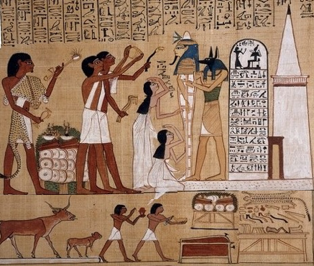
Students look at the scene from the Book of the Dead of Hunefer showing a funeral, and then identify the following:

- The mummy
- The tomb
- Hieroglyphics
- The mourners
- The priests
- Ceremonial objects on a table
Scene from the Book of the Dead of Hunefer

Activity: Investigate Ancient Egypt
Individually or in small groups, students will choose one of the following projects to work on and then present their findings to the class.

Investigate an important person such as Tutankhamen or Nefertiti in ancient Egypt.

What was the role of sacred animals in ancient Egypt? Which animals were associated with which gods and goddesses? What were the connections between the role of a deity and their associated animal?

What were the roles of key people in ancient Egyptian society, such as the nobility, bureaucracy, women, and slaves?

Why were the pyramids built? Consider the significant beliefs, values, and practices of the ancient Egyptians.

BTN Ancient Egypt stories

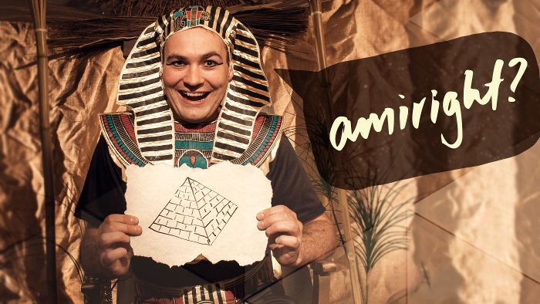Egypt Exploration | 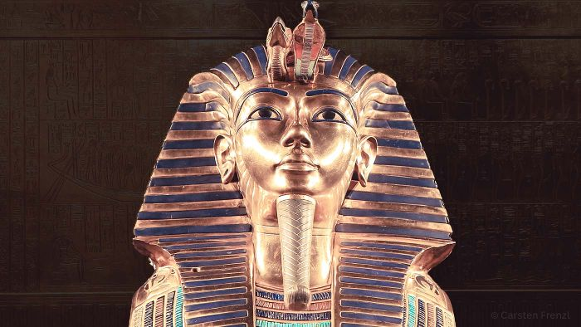Tutankhamun Exhibition
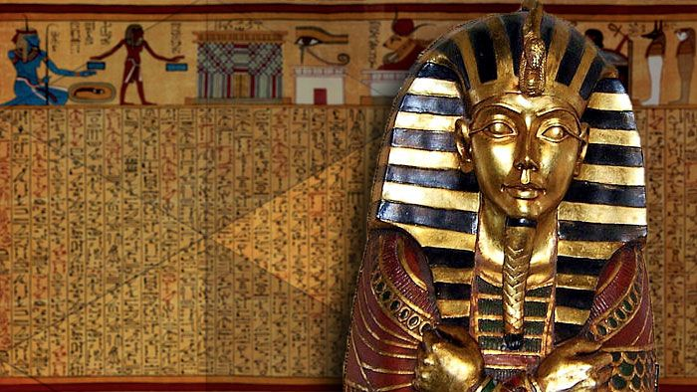Mummies | 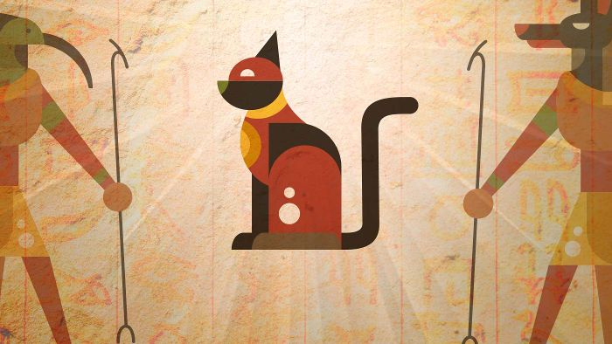Egyptian Cat Mummies

Useful Websites
- Investigating Ancient Egypt – ABC Education
- How were ancient Egyptians mummified? – Australian Museum
- Egypt: Discoveries will ‘rewrite history’ - Newsround
- Egypt unveils 3,000-year old coffins in latest discovery at Saqqara necropolis south of Cairo – ABC News
- Ancient Egyptian Timeline – Australian Museum

