KEY LEARNING
Students will view a range of BTN stories and use comprehension skills to respond to a series of focus questions.

CURRICULUM
English – Year 4
Use comprehension strategies to build literal and inferred meaning to expand content knowledge, integrating and linking ideas and analysing and evaluating texts.

English – Year 5
Use comprehension strategies to analyse information, integrating and linking ideas from a variety of print and digital sources.

English – Year 6
Use comprehension strategies to interpret and analyse information and ideas, comparing content from a variety of textual sources including media and digital texts.

English – Year 7
Use comprehension strategies to interpret, analyse and synthesise ideas and information, critiquing ideas and issues from a variety of textual sources.
  - Teacher Resource

Dinosaurs Special
As a class, discuss the stories featured in the episode of BTN Classroom and record the main points of the discussion. Students will then respond to the following focus questions.

Megafauna Extinction
- Before watching the BTN story, record what you know about megafauna.
- What is megafauna?
- About how many years ago did megafauna exist in Australia?
  - 4,000
  - 40,000
  - 400,000
- Complete the following sentence. A Diprotodon was a giant _________________.
- What did palaeontologist Dr Scott Hocknull and his team discover?
- Where did they make the discovery?
- What did they use to create images of what the megafauna might have looked like?
- Give some examples of the megafauna species they discovered.
- What might have caused megafauna to become extinct?
- What did you learn watching the BTN story?

Dinosaur Extinction
- How long ago did dinosaurs live?
- What caused the Chicxulub crater?
- Where is the Chicxulub crater? Find on a map.
- How did dust contribute to the extinction of the dinosaurs?
- What percentage of life went extinct when the dinosaurs died?

Giant Aussie Dinosaur
- What was the main point of the Giant Aussie Dinosaur story?
- What nickname is Australotitan cooperensis known by?
- What does Australotitan cooperensis mean?
- Cooper is a new species of ______________.
- Who discovered Australotitan cooperensis?
- When was it discovered?
- Where was it discovered? Locate using Google Maps.
- Cooper was about the size of…
  - 1400 red kangaroos
  - A basketball court
  - Two buses
  - All of the above
- Someone that studies dinosaurs is called a ______________________.
- What did you like about this story?

KEY LEARNING
Students will learn more about Australian megafauna and investigate why they became extinct.

CURRICULUM
Science – Year 6
The growth and survival of living things are affected by physical conditions of their environment.
Science – Year 7
Scientific knowledge has changed peoples’ understanding of the world and is refined as new evidence becomes available.
Interactions between organisms, including the effects of human activities can be represented by food chains and food webs.
  - Teacher Resource

Megafauna Extinction

Activity: What do you know about megafauna?
As a class discuss the BTN Megafauna Extinction story and ask students to record what they learnt watching the story. Record any questions they have. Here are some questions they can use to help guide their discussion.
- What does the term megafauna mean?
- When did megafauna exist?
- How do we know they existed?
- Why did megafauna grow so big?
- What might have caused Australia’s megafauna to die out?

Activity: Glossary
Students will brainstorm a list of key words and terms that relate to the BTN Megafauna Extinction story. Here are some words to get your students started.

MEGAFAUNA | ADAPTATIONS | FOSSIL
EXTINCTION | SPECIES | PALAEONTOLOGIST

Activity: Meet the Megafauna
Students will learn more about the species of megafauna discovered by palaeontologists. Students will choose a species of megafauna to research and create a profile of them. Use the following headings to help guide research:
- Common and scientific names
- What type of animal is it? (mammal, reptile, bird)
- Description – size, appearance, special features.
- When did it die out? What caused the extinction?
- Where did it live? Describe the habitat.
- What was its diet?
- What existing species is it similar to?
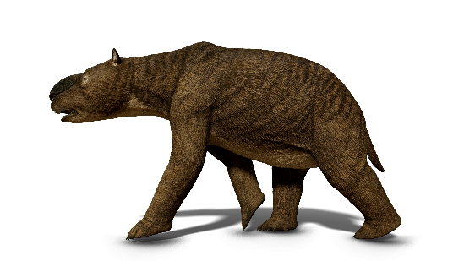
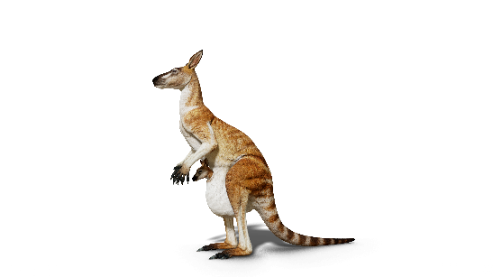

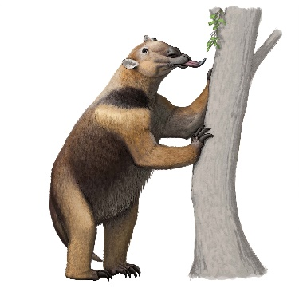
Diprotodon Macropus

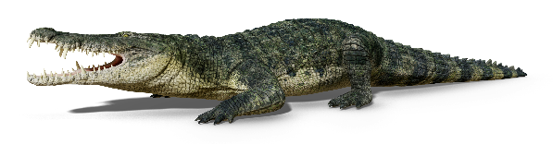

Pallimnarchus Palorchestes
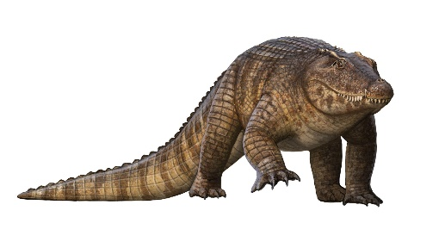
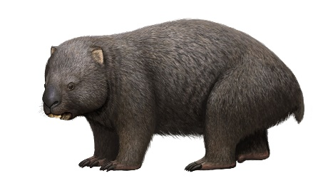

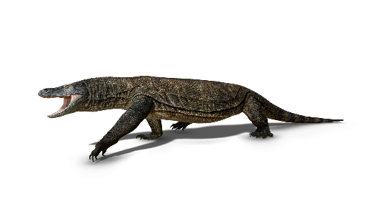
Phascolonus Quinkana
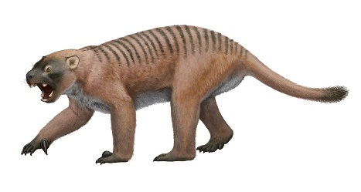

Thylacaleo Megalania
Images: Queensland Museum

Activity: Research
Students will explore megafauna in more detail. After watching and discussing the BTN Megafauna Extinction story, what questions do students have and what are the gaps in their knowledge? Students can complete the following KWLH organiser to explore their knowledge and consider what they would like to know and learn.

What do I know? | What do I want to know? | What have I learnt? | How will I find out?

Students will develop their own question/s to research or choose one or more of the questions below.

- Why is it important to research megafauna?
- What theories do we have for the extinction of Australia’s megafauna? Investigate possible causes.
- Did people live during the age of Australian megafauna? What evidence do we have of this?
- What is the connection between Australian Indigenous peoples and megafauna?

Activity: Megafauna at a billabong
Students will analyse the image and then respond to the following:
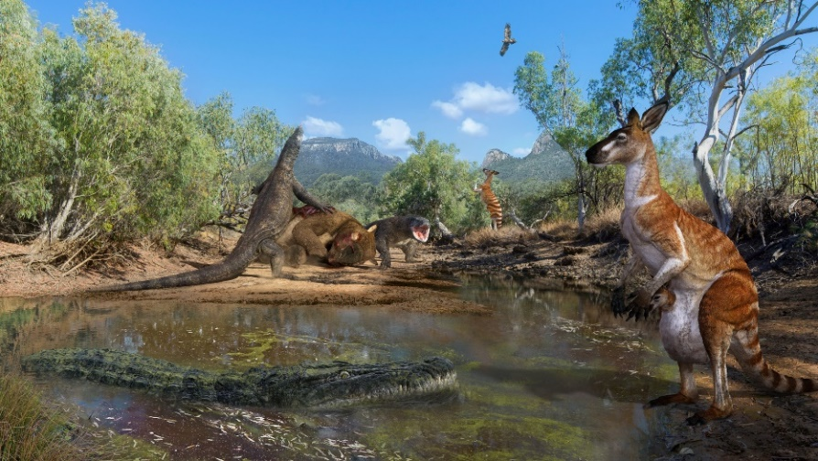
- Write a short paragraph describing what you see in the image.
- What does the image tell you about megafauna?
- Create a caption for the image.
- What question/s would you like to ask about the image?
- Choose a species of megafauna in the image and write a fictional story about it or write about a day in the life of…
Image courtesy of Queensland Museum
- Create your own artwork featuring megafauna.

Further investigation
Students will design their own species of megafauna. Students will draw a picture of their animal and include information about where it lives, what the animal eats and any adaptations.

Activity: Megafauna Quiz

- The term megafauna means…  A. Scary animal  B. Large animal  C. Extinct animal  - About how many years ago did megafauna exists in Australia?  A. 4,000  B. 40,000  C. 400,000  - Megafauna include…  A. Mammals  B. Mammals and birds  C. Mammals, birds and reptiles | - What is the biggest megafauna animal?  A. Diprotodon  B. Thylacoleo  C. Wonambi  - Which megafauna is named after an Aboriginal word for the Rainbow Serpent?  A. Wonambi  B. Macropus  C. Quinkana

Quiz Answers: 1B, 2B, 3C, 4A, 5A

Useful Websites
- Megafauna – Queensland Museum
- Megafauna – Australian Museum
- Megafauna Exhibition - BTN
- Megafauna Fossil Footprints - BTN
- Death of the Megafauna – ABC Science
- Megafauna murder mystery – ABC Education

KEY LEARNING
Students will learn more about the causes of dinosaur extinction.

CURRICULUM
Science - Year 4
Earth’s surface changes over time as a result of natural processes and human activity.
Science - Year 5
Living things have structural features and adaptations that help them to survive in their environment.
Science - Years 5 & 6
Science involves testing predictions by gathering data and using evidence to develop explanations of events and phenomena and reflects historical and cultural contributions.
Scientific knowledge is used to solve problems and inform personal and community decisions.
Science - Year 6
Sudden geological changes and extreme weather events can affect Earth’s surface.
Science - Year 7
Classification helps organise the diverse group of organisms.
Scientific knowledge has changed peoples’ understanding of the world and is refined as new evidence becomes available.

  - Teacher Resource

Dinosaur Extinction

Activity: Class Discussion
Discuss the BTN Dinosaur Extinction story as a class and record the main points on a mind map with DINOSAURS in the centre.

Students will respond to the following:
- What do you know about what caused the extinction of dinosaurs?
- When did the extinction happen?
- What did you learn from this story?
- What does this story make you wonder?
- Think of three questions you would like to ask about the story.
- Make a list of words related to this story. Use this list of words to help form a class glossary.

Activity: Q&A
Are you curious about dinosaurs? Students will make a list of questions they have about the BTN story and the extinction of dinosaurs. Students will use the internet to find answers to their questions and share their findings with the class.
Why do we study dinosaurs?
How did dinosaurs become extinct?

Activity: Glossary
Students will brainstorm a list of key words that relate to the BTN Dinosaur Extinction story. Here are some words to get them started.
PALAEONTOLOGIST | FOSSIL | PREHISTORIC
CRETACEOUS PERIOD | EXTINCTION | DINOSAUR

Ask students to write what they think is the meaning of each word (including unfamiliar words). They will swap definitions with a partner and ask them to add to or change the definition. Check these against the dictionary definition.

Further activities for students:
- Students will add to their glossary by downloading the transcript for the BTN Dinosaur Extinction story and highlight all the words that relate to the topic.

Activity: KWLH
Discuss the information raised in the BTN Dinosaur Extinction story. What questions were raised in the discussion and what are the gaps in students’ knowledge? The following KWLH organiser provides students with a framework to explore their knowledge on this topic.

What do I know? | What do I want to know? | What have I learnt? | How will I find out?

Students will develop their own question/s to research or choose one or more of the questions below. Encourage students to collect and record information from a wide variety of sources and present the information they find in an interesting way.

- When did dinosaurs live? Choose one dinosaur from each of the following geological periods: Triassic, Jurassic, Cretaceous and Cenozoic. Record your findings on a timeline.
- How does finding fossils help scientists learn about the past?
- What evidence have scientists found to help understand how dinosaurs became extinct?
- What is the role of a palaeontologist? What are the different parts to the job of a palaeontologist and what skills do they need to have? Present your information in a creative way.

Activity: Dinosaur Profile
Students will imagine they are palaeontologists and study a type of dinosaur in as much detail as possible. Students will investigate the dinosaur using the following questions to guide their research and then present their findings in an interesting way. Students can use the animal profile worksheet at the end of this activity to record their findings. Encourage students to use a range of sources to find their information.

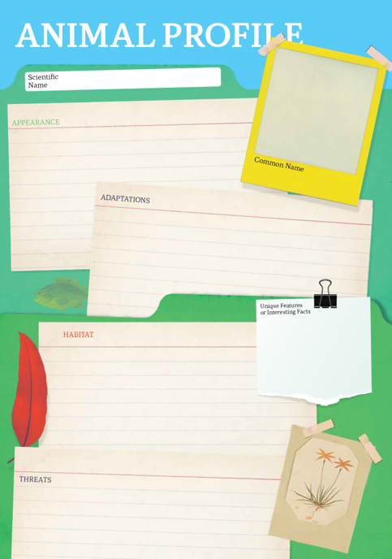
Research
Students will research and create a profile of a dinosaur. Students can use the Animal Profile at the end of this activity to record their findings.
- What is its scientific name? What does its name mean?
- Is it known by any other names?
- What did it look like? Describe.
- How big was it? Length, height, and weight.
- What did it eat?
- Where did it live? Where have its fossils been found?
- How long ago did it live?
- When did it become extinct?
- What was the cause/s of its extinction?

Further Investigation
Students will respond to one or more of the following questions.

- How long did dinosaurs live on Earth? Investigate when the Tyrannosaurus rex lived compared to when the Stegosaurus lived. In what geological periods did they live?
- Modern birds are a kind of dinosaur. True or false? Explain your answer.
- How did dinosaurs get their names? Use these words in your answer: genus, scientific name, the specific epithet, Greek or Latin.
- Are we drinking the same water as the dinosaurs? Explain your answer.
- Where have the most dinosaur fossils been found? Highlight these places on a map.
- How often are palaeontologists uncovering new dinosaurs? Find a news report with the latest discovery.

Activity: How do Dinosaurs get their names?
During this activity students will become palaeontologists and create a new dinosaur species! Students will imagine they have discovered a new species of dinosaur which has never been discovered before and give it a scientific name.

Class Discussion
Find a range of pictures of dinosaurs and ask your students if they can name any of them and write some examples of dinosaur names on the whiteboard.

Introduce the concept of scientific naming, which is used to name all living organisms. Dinosaur names are often made up of combinations of Greek or Latin words that describe the dinosaur’s appearance, characteristics, or behaviours of the animal. For example, "Tyrannosaurus" means "tyrant lizard" and "Triceratops" means "three-horned face". Some dinosaurs are named after the people who discovered them, and others are named after the place where they were discovered. Explain that the Genus name (the first word) is capitalised, and the species name (the second word) is in lowercase.

Below are some Greek and Latin words which have been used in dinosaur names.

Word (Greek or Latin) | Meaning
tyranno  rex  raptor  tri  stego  compso  bronto | tyrant  king  robber  three  roof  pretty  thunder

Group Activity
In small groups students will use their imagination and come up with a list of scientific names for new dinosaurs. Students will follow the structure (Genus species) and consider the dinosaur's appearance or behaviour. Student will share their scientific names and explains their meanings.

Individual Activity
Students will choose one name from their list and then respond to the following questions:
- What have you named your dinosaur? Explain the origins of the name. Is it named after a person or a place? Is the name something that describes its characteristics or behaviour?
- What did your dinosaur look like? Describe any interesting or unusual features.
- How big was it? What was its height and length?
- What did it eat?
- Where did it live?
- When did it live? When did it become extinct?

Further Activities
- Draw a picture of the new dinosaur species using only a black felt-tip pen on a piece of A4 art paper – include as much detail as you can. You may want to draw a scientific illustration or draw the animal in its natural habitat. Label important features.
- Create a 3D model of your new species using upcycled materials.
- How possible do you think it is that your new species exists? Explain your answer.
- Present your dinosaur to the class. Present using Prezi or Canva.
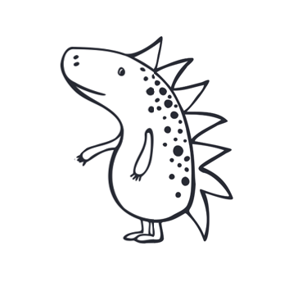
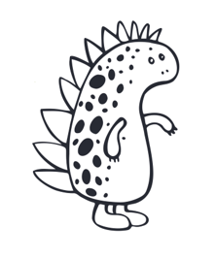
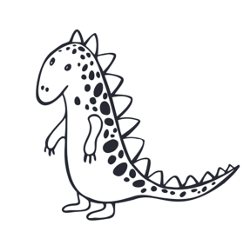

Useful Websites
- Giant Aussie Dinosaur – BTN
- Dinosaur-killing asteroid in Yucatan Peninsula unleashed 2,000 gigatonnes of dust into the atmosphere, new research suggests – ABC News
- Extinction – National Geographic Education
- Mass Extinctions – National Geographic Education
- The Dino Directory – Natural History museum
- Dinosaurs – BTN
- What are fossils? – Australia Museum
- Dinosaurs: Collection – National Geographic Education
- Fossil – National Geographic Education

