Episode 23

18th August 2020



**Coping during COVID-19**

1. Before watching the BTN story what one word would you use to describe COVID?
2. Discuss the BTN *Coping During COVID-19* story as a class and record the main points of the discussion.
3. What is Kids Helpline?
4. Kids Helpline have had a big rise of young people reaching out to them. True or false?
5. What is the fight, flight or freeze response?
6. The government has increased their support for mental health services. Name one of the services.
7. How do the kids in the BTN story feel?
8. What do the kids in the story do to help themselves feel calm?
9. Who do you talk to when you are feeling stressed or anxious?
10. What words of support would you send to kids in Victoria?

**Mauritius Oil Spill**

1. What did the BTN *Mauritius Oil Spill* story explain?
2. Where is Mauritius? Find using Google Maps.
3. What did the cargo ship hit before becoming stuck?
   1. A shipwreck
   2. A coral reef
   3. An iceberg
4. How has the oil spill affected marine animals?
5. Why is the oil spill in this area so devastating?
6. Complete the following sentence. Mauritius is a _____________ hotspot.
7. How are they trying to clean up the oil spill? Illustrate.
8. What unusual object is being used to soak up the oil?
9. How did this story make you feel?
10. How can these sorts of environmental disasters be prevented? Make some suggestions.

**Underwater Explorer**

1. Discuss the *Underwater Explorer* story with another student.
2. What did underwater explorer Jacques Cousteau invent in the 1940s?
3. We know more about our oceans than we do about deep space. True or false?
4. What does the Proteus look like? Describe.
5. Who will live on the Proteus?
6. Who designed the Proteus?
7. How many underwater habitats have been invented around the world?
8. How is the Proteus different to the Aquarius?
9. What did you learn watching the BTN story?
10. Sketch a design of your own underwater habitat.

Check out the [Underwater Explorer resource](http://www.abc.net.au/btn/teachers.htm) on the Teachers page.

**Dark Sky Sanctuary**

1. Retell the BTN *Dark Sky Sanctuary* story to another student.
2. What can you see when you look up at the night sky where you live? Discuss in pairs.
3. Where is Australia's first ever dark sky reserve? Find using Google Maps.
4. Why was this area chosen to become a dark sky reserve?
5. What is light pollution?
6. Why do astronomers call light pollution ‘wasted light’?
7. Complete the following sentence. One third of the world can’t see the __________ ______.
8. How does light pollution affect people’s health?
9. How does light pollution affect wildlife?
10. What did you learn watching the BTN story?

Check out the [Dark Sky Sanctuary resource](http://www.abc.net.au/btn/teachers.htm) on the Teachers page.

**Stamp Collecting**

1. Briefly summarise the BTN *Stamp Collecting* story.
2. What are stamps used for?
3. Grace and Tyson have stamps from all around the world. Name one country.
4. Where and when did the first stamp come out?
5. What was the name of the world’s first postage stamp?
   1. Penny black
   2. Dollar blue
   3. Queen green
6. Before the introduction of stamps, it was the recipient of mail, not the sender, who paid the cost of postage. True or false?
7. What does the stamp called the ‘Inverted Jenny’ look like? Describe.
8. What is the most valuable stamp in the world?
9. What is this year’s theme for stamp collecting?
10. Design and sketch your own postage stamp.

Teacher Resource

Episode 23

18th August 2020

**Underwater Explorer**



Students will explore Australia’s marine parks; its habitats and the plants and animals that live within these habitats. Students will design and create a 3D model of an underwater human habitat.



**Science – Year 5**

Living things have structural features and adaptations that help them to survive in their environment.

Scientific knowledge is used to solve problems and inform personal and community decisions.

**Science – Year 6**

The growth and survival of living things are affected by physical conditions of their environment.

Scientific knowledge is used to solve problems and inform personal and community decisions.

**Science – Year 7**

Classification helps organise the diverse group of organisms.

Scientific knowledge has changed peoples’ understanding of the world and is refined as new evidence becomes available.



1. Discuss the *Underwater Explorer* story with another student.
2. What did underwater explorer Jacques Cousteau invent in the 1940s?
3. We know more about our oceans than we do about deep space. True or false?
4. What does the Proteus look like? Describe.
5. Who will live on the Proteus?
6. Who designed the Proteus?
7. How many underwater habitats have been invented around the world?
8. How is the Proteus different to the Aquarius?
9. What did you learn watching the BTN story?
10. Sketch a design of your own underwater habitat.



**What do you see, think and wonder?**

After watching the BTN *Underwater Explorer* story, students will respond to the following questions:

* What did you SEE in this video?
* What do you THINK about what you saw in this video?
* What did you LEARN from this story?
* What was SURPRISING about this story?
* What QUESTIONS do you have about this story?

Students will respond to the following questions. Students can then leave a comment on the BTN *Underwater Explorer* story page.



**What questions do you have about the story?**



**What did you learn from the story?**



**Personal response**



**Glossary**

Students will brainstorm a list of key words that relate to the BTN *Underwater Explorer* story. Students will then use the words to write their own sentences about the topic. Students may want to use pictures and diagrams to illustrate the meaning and create their own glossary. Here are some words to get you started.

|  |  |  |
| --- | --- | --- |
| **Marine** | **Habitat** | **Seafloor** |
| **Species** | **Conservation** | **Marine Park** |



**Inquiry Questions**

After watching and discussing the BTN *Underwater Explorer* story, what questions do students have and what are the gaps in their knowledge? The following KWLH organiser provides students with a framework to explore their knowledge on this topic and consider what they would like to know and learn.

|  |  |  |  |
| --- | --- | --- | --- |
| ***What do I know?*** | ***What do I want to know?*** | ***What have I learnt?*** | ***How will I find out?*** |
|  |  |  |  |

Students will develop their own question/s for inquiry, collecting and recording information from a wide variety of sources. Students may develop their own question for inquiry or select one of the questions below.

* Why do people explore underwater? What are the benefits? Explore one area of underwater research (E.g. marine life, ecosystems, ocean health, biodiversity).
* What is the deepest part of the ocean? Explore the marine life in this area. What are the challenges of exploring the deepest place on Earth?
* What does the ocean floor look like? Study the oceans seafloor and create a diorama.
* What is an oceanographer? Explore an underwater discovery in more detail. For example, the discovery of an [ancient Aboriginal underwater archaeological site](https://www.abc.net.au/news/2020-07-02/aboriginal-underwater-site-discovered-off-burrup-peninsula/12391858) or the discovery of new [underwater volcanoes in the Coral Sea](https://www.abc.net.au/news/2019-09-03/csiro-investigator-underwater-volcano-coral-sea-depths/11474246). Why was the discovery important?
* What is the future of underwater exploration? Make some predictions and design your own futuristic underwater habitat.
* What is the history of underwater exploration? Use a timeline to record your findings.

|  |  |  |
| --- | --- | --- |
| Cousteau’s vision of underwater living | Aquarius Reef Base | Proteus |



**Create an underwater habitat**

Students will imagine they are architects and they have been challenged to design and create an underwater human habitat. Students will brainstorm ideas in pairs and then share their ideas as a class. Encourage creativity during this activity and give students the time to explore their thinking. During the design process students will consider the following:

* Where will your underwater habitat go? Find the location using [Google Maps](https://earth.google.com/web/@1.88301833,-46.61902289,-1114.05573183a,46340242.7790928d,35y,0h,0t,0r/data=Ci4SLBIgNjZlNzQ1NjM3OGMwMTFlOGJmMTZhMTM2MjYyMmZhYjAiCG92ZXJ2aWV3).

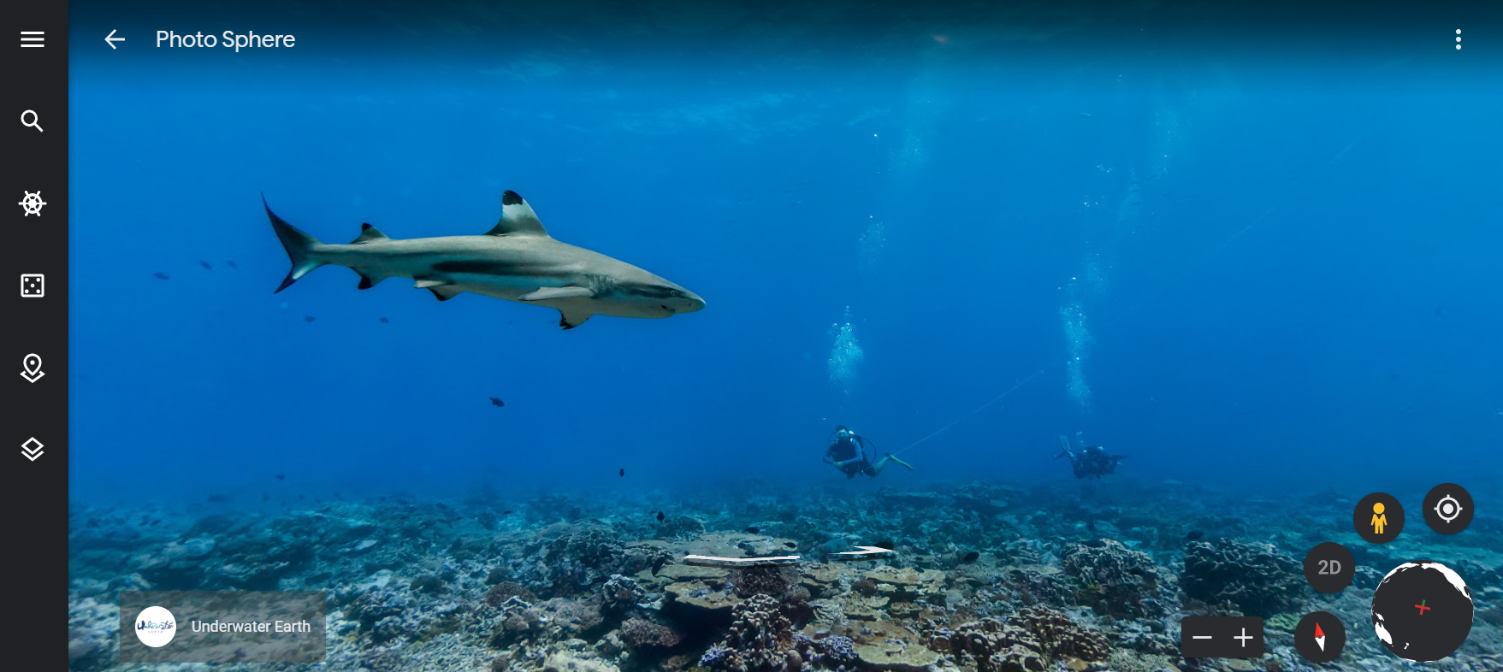

* How deep will it go?
* What will be explored in the area? Think about the living and non-living things in the area.
* How will you keep the aquanauts that visit the habitat safe?
* What design features will you include? For example, living stations, laboratories, emergency features.

[Google Maps - The World’s Ocean](https://earth.google.com/web/@1.88301833,-46.61902289,-1114.05573183a,46340242.7790928d,35y,0h,0t,0r/data=Ci4SLBIgNjZlNzQ1NjM3OGMwMTFlOGJmMTZhMTM2MjYyMmZhYjAiCG92ZXJ2aWV3)

* What other design considerations will you need to think about? Make a list.
* What is innovative about your design?

Students will then design and create their own underwater habitat.

* Sketch a rough design of your habitat.
* Include notes which explain specific design features.
* What materials will you use to make your 3D model?
* Display your models in the classroom.



**Literacy activity – Marine habitats**

This literacy activity demonstrates students active listening and interpreting skills. Students will listen to a description of a marine animal’s habitat and create a simple black and white artwork illustrating its habitat. Teachers will use the following as a guide for this activity.

* Find a description of a marine animal’s habitat to read aloud to your students. Teachers may want to choose an animal that is an endangered species which lives in Australian waters. Some examples include the [dugong](https://www.environment.gov.au/marine/marine-species/dugongs) or the [green turtle](http://www.gbrmpa.gov.au/the-reef/animals/marine-turtles/green-turtle). Use [Google Maps](https://earth.google.com/web/@1.88301833,-46.61902289,-1114.05573183a,46340242.7790928d,35y,0h,0t,0r/data=CiQSIhIgNjZlNzQ1NjM3OGMwMTFlOGJmMTZhMTM2MjYyMmZhYjA) to delve underwater and find marine animals from around the world.
* Read the description of the animal’s habitat aloud to your class as a whole, reading the description 2 or 3 times.
* Students will take notes and write down key words as they listen.
* Students will illustrate the marine animal’s habitat using only a black felt—tip pen (0.4 or 0.6) on a piece of A4 art paper. Students will include as much detail as they can.
* Display the student’s artwork in a school exhibition.
* We would love to see your student’s artwork! Send your artwork to us at [btn@abc.net.au](mailto:btn@abc.net.au)
* Challenge students by asking them to recreate the habitat as a diorama or a virtual reality experience using Minecraft.



**Virtual diving**

Students will go on a virtual diving expedition using [Google Maps](https://earth.google.com/web/@1.88301833,-46.61902289,-1114.05573183a,46340242.7790928d,35y,0h,0t,0r/data=CiQSIhIgNjZlNzQ1NjM3OGMwMTFlOGJmMTZhMTM2MjYyMmZhYjA) to explore the world’s oceans. Students will explore a range of areas including Australia’s [Great Barrier Reef](https://earth.google.com/web/@-28.61198571,153.6291305,2.61123004a,0d,60y,12h,119t,0r/data=Ci8SLRIgNjZlNzQ1NjM3OGMwMTFlOGJmMTZhMTM2MjYyMmZhYjAiCWJ5cm9uLWJheSIwCixBRjFRaXBPUHdET0szdHB1S3l5NlFaRUpLRktwYXJ4b0gxdXB1bzRkYTBmYRAFKAI) and the [Galapagos Islands](https://earth.google.com/web/@-1.21646583,-90.4221496,-0.00195193a,0d,60y,332.02h,97.74t,0r/data=CjcSNRIgNjZlNzQ1NjM3OGMwMTFlOGJmMTZhMTM2MjYyMmZhYjAiEWdhbGFwYWdvcy1pc2xhbmRzIjAKLEFGMVFpcE1YMFJEYWFBaTQxdkVjbE5rcHU0SG5CUGxlUDRHc2tEenR3eVd4EAUoAg). Students will then focus their underwater exploration around Australia and choose one location to explore in more detail. Students may want to explore Australia’s marine parks using this [interactive map](https://parksaustralia.gov.au/marine/parks/). See below for a list of possible areas of exploration:

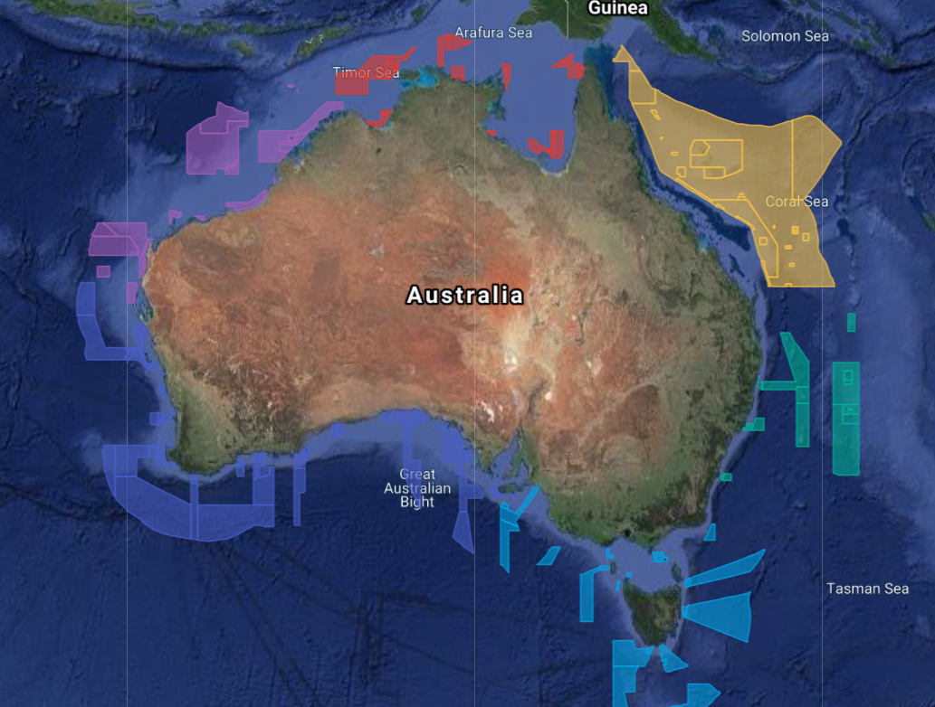

* The Great Barrier Reef
* The Perth Canyon
* Lord Howe Marine Park
* Arnhem Marine Park

Once students have chosen an area to explore, they will respond to (one or more) the following:

* Describe the region and include a detailed map.
* What is the depth range and/or average depth of the area?
* What type of habitats can be found in this region? Describe.
* What are some of the unique features of this region? For example, coral reefs, seagrasses or mangroves.

[Australia’s Marine Parks - interactive map](https://parksaustralia.gov.au/marine/parks/)

* What species live in and rely on the habitats in this region?
* Choose one species in the region to investigate in more detail and create a creature feature about the species.
* Have any exciting marine discoveries been made in the area? Explain.
* Create a did you know using your research.
* Create a diorama of the region.



**Virtual Reef Diver**

The [Virtual Reef Diver](https://www.virtualreef.org.au/) project allows students to become citizen scientists, classifying underwater images of coral. The data collected is then used by researchers to make better decisions about protecting the Great Barrier Reef. Virtual Reef Diver also allows students to explore 360-degree images of the Great Barrier Reef (through the Google Play store).

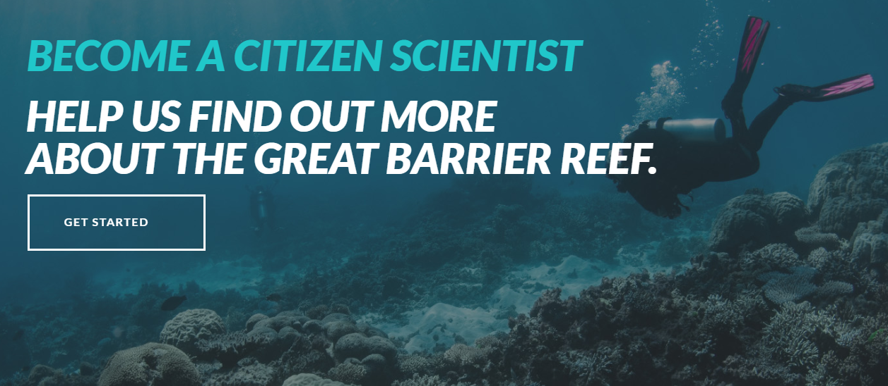

|  |  |
| --- | --- |
| Quiz Questions | Your Answer |
| 1. What percent of the Earth’s surface is covered by ocean?    1. 17%    2. 57%    3. 71% |  |
| 1. What percent of the Earth’s oceans have been explored?    1. 5%    2. 15%    3. 50% |  |
| 1. What is the biggest coral reef in the world?    1. Florida Keys, United States    2. Great Barrier Reef, Australia    3. Red Sea Coral Reef, Red Sea |  |
| 1. The majority of life on Earth is aquatic?    1. True    2. False |  |
| 1. What is the largest ocean?    1. The Indian Ocean    2. The Pacific Ocean    3. The Atlantic Ocean |  |
| 1. The sea sponge is a living sea animal.    1. True    2. False |  |
| 1. How many kilometres is the deepest part of the ocean?    1. 1 kms    2. 11 kms    3. 100 kms |  |
| 1. What is the largest living animal in the world?    1. Whale shark    2. African elephant    3. Blue whale |  |
| 1. Starfish have eyes.    1. True    2. False |  |
| 1. What is the name of the first inhabited underwater habitat?    1. Proteus    2. International Space Station    3. Continental Shelf Station |  |

Answers: 1c, 2a, 3b, 4a, 5b, 6a, 7b, 8c, 9a, 10c



Underwater Research – BTN

<https://www.abc.net.au/btn/classroom/underwater-research/11143338>

Deep Sea Exploration – BTN

<https://www.abc.net.au/btn/classroom/deep-sea-exploration/10524130>

Proteus

<https://www.fabiencousteauolc.org/proteus>

David Attenborough’s Great Barrier Reef – An Interactive Journey

<https://attenboroughsreef.com/>

Australian Marine Parks

<https://parksaustralia.gov.au/marine/>

Ocean Rubbish Clean-Up – BTN

<https://www.abc.net.au/btn/classroom/ocean-rubbish-clean-up/10448624>

Teacher Resource

Episode 23

18th August 2020

**Dark Sky Sanctuary**



Students will develop a deeper understanding of what light pollution is and its impact on stargazing. They will also explore, identify and investigate stars, planets and constellations.



**Science – Year 5**

The Earth is part of a system of planets orbiting around a star (the sun).

Scientific knowledge is used to solve problems and inform personal and community decisions.

**Science – Years 5 & 6**

Scientific understandings, discoveries and inventions are used to solve problems that directly affect peoples' lives.

**Science – Year 7**

Predictable phenomena on Earth, including seasons and eclipses, are caused by the relative positions of the sun, Earth and the moon.



1. Retell the BTN *Dark Sky Sanctuary* story to another student.
2. What can you see when you look up at the night sky where you live? Discuss in pairs.
3. Where is Australia's first ever dark sky reserve? Find using Google Maps.
4. Why was this area chosen to become a dark sky reserve?
5. What is light pollution?
6. Why do astronomers call light pollution ‘wasted light’?
7. Complete the following sentence. One third of the world can’t see the __________ ______.
8. How does light pollution affect people’s health?
9. How does light pollution affect wildlife?
10. What did you learn watching the BTN story?



**Note t****aking**Students will practise their note-taking skills while watching the BTN *Dark Sky Sanctuary* story. After watching the story, ask students to reflect on and organise the information into three categories. What information in the story was...?

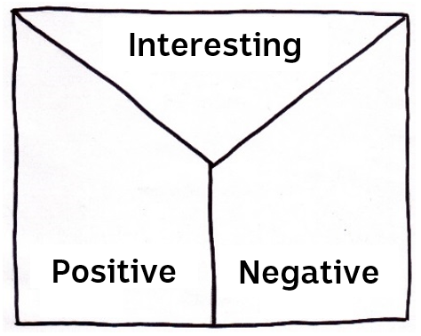

* Positive
* Negative or
* Interesting



**Class Discussion**

Hold a class discussion about the information raised in the BTN story. Use the following questions to help guide discussion:

* Why might the view of the night sky be different in urban versus rural areas?
* Why was the Swan Reach Reserve chosen as a Dark Sky Reserve?
* Before watching the BTN story, had you heard of light pollution?
* What is light pollution?
* What causes light pollution?
* Who or what is affected by light pollution?
* What are some problems with light pollution?



**Glossary**

Students will brainstorm a list of key words that relate to the BTN *Dark Sky Sanctuary* story. Students may want to use pictures and diagrams to illustrate the meaning and create their own glossary. Here are some words to get you started.

|  |  |  |
| --- | --- | --- |
| **Constellation** | **Light Pollution** | **Astronomy** |
| **Star** | **Observatory** | **Glare** |



**Research**

Students will develop their own inquiry questions about astronomy and light pollution. The following KWLH organiser provides students with a framework to explore their knowledge on this topic and consider what they would like to know and learn.

|  |  |  |  |
| --- | --- | --- | --- |
| ***What do I know?*** | ***What do I want to know?*** | ***What have I learnt?*** | ***How will I find out?*** |
|  |  |  |  |

Students can investigate the following questions or develop their own.

* Does everyone see the same sky at night? Explain your answer.
* Why do we see different constellations at different times of the day?
* Why are Aboriginal people called the first astronomers and how did they use the sky as a calendar?
* How did the stars help Aboriginal people understand their universe?
* What are some solutions to light pollution? What can be done to reduce it?



**Light Pollution**

How does light pollution affect the visibility of stars? How does the visibility of stars differ in urban to rural areas? Discuss as a class.

* Create a planetarium in your room [using these simple instructions](http://lifestyle.howstuffworks.com/crafts/other-arts-crafts/science-projects-for-kids-the-incredible-universe1.htm). Explore and create a range of constellations seen in the Southern Hemisphere.

What does Earth look like at night? Students will brainstorm what they think Earth would look like at night looking down from space. Using the internet students will find images of Earth at night. [View these images](https://www.nasa.gov/mission_pages/NPP/news/earth-at-night.html) taken by a NASA satellite. Students will then respond to the following questions.

* What do you see?
* What do these images tell you about our energy usage at night?
* What surprised you about these images?
* Imagine if these photos were taken 100 years ago. Do you think they would look the same or different? Why?



**Become an Amatuer Astronomer**



Students will become familiar with finding constellations in the night sky. Explain to students that the stars move across the sky as one. Stars rise in the east and set in the west, just like the sun and moon do. The [following animation](http://www.abc.net.au/science/articles/2009/08/11/2647703.htm) shows stars moving through the night sky over a 24 hour period. The area of sky we see at night is determined by how far north or south of the equator we are.

**Stargazing tips**

* Check local weather conditions on the Bureau of Meteorology website
* Choose a location away from streetlights
* Take 10-15 minutes to let your eyes adjust to the dark
* Use a red light to preserve your vision (make one by covering a torch with red cellophane)

Ask students to brainstorm a list of constellations that they know. Do they know how to find them?



**Stargazing Activities**

Students will learn how to find their way around the night sky, spotting stars, planet and galaxies. The [ABC Science Sky Tour](http://www.abc.net.au/science/starhunt/tour/outdoor/) has winter and summer tours or take a virtual tour.

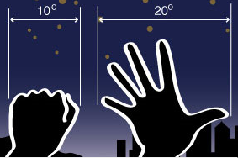

Students will learn how to [Measure the sky with their hands](http://www.abc.net.au/science/articles/2009/07/27/3169109.htm). Astronomers measure distances in the sky in degrees. Students follow the step-by-step instructions to learn how to use their hands to measure the sky in degrees.

Students will explore the night sky using interactive software. The [Stellarium](http://www.stellarium.org/) is a free planetarium for your computer. It shows a realistic sky in 3D. Students can explore the effect of light pollution on visibility.

[Google Sky](http://www.google.com/sky/) allows students to explore planets. Turn the `Sky’ button on in Google Earth to change to sky view.

Bring the stars to your students by using an online application to discover and explore stars, planets and constellations in the classroom. Before starting this activity download a free app like [SkyView](https://itunes.apple.com/au/app/skyview-lite/id413936865?mt=8) onto your classroom hand held devices.

* Dim the lights in the classroom to create the feeling that it is nighttime. Students will sit on the ground with SkyView open on their hand-held device.
* Students will point their device at the sky to locate and identify planets, stars and constellations. There is the option to turn on night mode. Students can learn more about what they find by selecting a celestial body and tapping on it. Give students time to explore the night sky.
* Hold a class discussion. What did your students find?
* Students will choose one constellation that they want to learn more about. Students may want to consider choosing the zodiac constellation in which they were born. Students will develop their own question/s for inquiry, collecting and recording information from a wide variety of sources.



**BTN Stories**

Students can watch this [BTN story](https://www.abc.net.au/btn/classroom/light-pollution/10526576) and answer the following questions to learn more about light pollution.

1. What is light pollution?

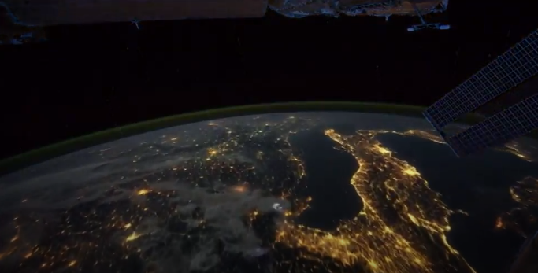

1. How does light pollution affect the environment?
2. How can streetlights be changed to reduce light pollution?
3. What impact can artificial light have on the human body?
4. Describe the affect lights can have on some sea animals.
5. Give some examples of how light pollution can be reduced.
6. By reducing light pollution, we will have a better view of the____________.
7. What was surprising about this story?

Students watch the [BTN Amateur Astronomer](https://www.abc.net.au/btn/classroom/amateur-astronomer/10526998) story and answer the questions.

1. At what age did Jonah get his first telescope?

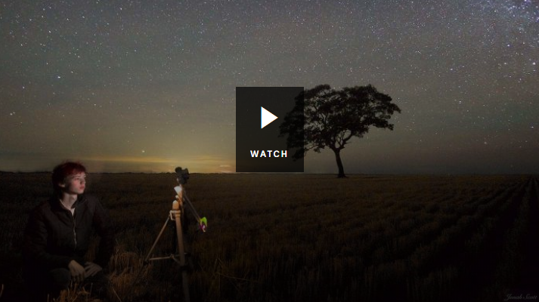

1. Explain and illustrate how a telescope works.
2. What did Jonah experiment with to help him take photos high above the atmosphere?
3. Illustrate Jonah’s experiment.
4. What happened to the balloon when it reached the stratosphere?
5. What galaxy does Jonah plan to photograph when he sends another balloon up into the air in a couple of months?
6. What did you learn from this story?



South Australia’s River Murray Designated First International Dark Sky Reserve in Australia – International Dark Sky Association

<https://www.darksky.org/south-australias-river-murray-designated-first-international-dark-sky-reserve-in-australia/>

SA’s River Murray Dark Sky Reserve to become home of space traffic management facility – ABC News

<https://www.abc.net.au/news/2020-06-23/swan-reach-soon-to-be-home-of-international-space-observatory/12379546>

Astronomical Society of South Australia – Light Pollution

<https://www.assa.org.au/lightpollution>

Amateur Astronomer - BTN

<https://www.abc.net.au/btn/classroom/amateur-astronomer/10526998>

Light Pollution – BTN

<https://www.abc.net.au/btn/classroom/light-pollution/10526576>

History of Stargazing - BTN

<https://www.abc.net.au/btn/classroom/history-of-stargazing/10489030>

Aboriginal Astronomy – BTN

<https://www.abc.net.au/btn/classroom/aboriginal-astronomy/10523908>

**BTN Transcript: Episode 23 – 18/8/20**

Hey, I'm Amelia Moseley and you're watching BTN. Here's what's coming up. We find out what it's like to live in a dark sky reserve, meet a man who wants to help researchers live underwater and learn more about a very old hobby.

Coping with Covid-19

Reporter: Ella Germein

*INTRO: But first today, we're going to find out more about how people are coping during COVID-19. It's been pretty tough for all of us, especially you guys in Victoria and while the priority is stopping the virus, there are worries about how people's mental health is being affected by all this isolation and uncertainty. Here's Ella with more.*KID: If I had to sum up how I’m feeling about COVID in one word it would just probably be stressed.

KID: Sad.

KID: Angry.

KID: Cautious.

KID: Anxious.  
  
Yep, if you live in Melbourne or well anywhere at the moment that might describe how you're feeling. Whether it's because you're stuck at home and separated from your mates. Because your favourite events have been cancelled and homework has taken on a whole new meaning. Or just because the world is kind of weird right now.  
  
BROOKE, KIDS HELPLINE: What's been going on is actually causing quite a lot of people to have some really big emotions for example stressed or anxious or worry, or confused and what these emotions are is it’s helping us to try and make sense of what's going on.  
  
Brooke works at Kids Helpline, which takes calls from young people who are feeling anxious or sad or just need someone to talk to and she says lately they've been pretty busy.  
  
BROOKE: One thing we’ve noticed here at Kid's Helpline is we’ve have had a really big rise in young people reaching out to us.  
  
She says feeling stressed or anxious about what's happening now is actually totally normal. You see our brains are hard wired to respond to threats by either getting ready fight to run away or to freeze. It's called the fight, flight or freeze response and it evolved to help us safe from things that might hurt us like wild animals.  
  
BROOKE: In modern day society we don't have threats like big tigers trying to eat us but still our bodies are trained to have those responses.  
  
It's why we end up feeling anxious about less man eating situations like being stuck at home.  
  
KID: I'm feeling anxious because you don't have a teacher to teach you things you learn face to face.

KID: Things that I’m cautious about is staying away from other people, washing my hands regularly and wearing a mask when I go out of the house.

KID: I'm feeling stressed because I can't see my friends and that’s really weird for me and also online learning is just really tricky for everyone.   
  
Of course, it's not just kids being affected.  Adults in Australia and around the world are having a hard time because of COVID-19. And while the big focus now is on keeping people safe from the virus many experts say it is also really important to look after people's mental health. It's why federal and state governments have boosted their support for mental services like Lifeline, Headspace, Beyond Blue and the Kids Helpline. Brooke says they can be really helpful for anyone who's feeling down.  
  
BROOKE: We have a saying here, anytime, any reason. That means any time of the day or night we never close and any reason means no matter what’s going on for you, if you feel like you need or want someone to talk to, we can be that person for you.   
  
And she says there are things we can do at home to make us feel better.  
  
BROOKE: One thing we often find that really helps is doing things that help you feel calm, to calm those emotions, maybe it’s listening to music, or drawing, there's a lot of things that we could try.  
  
KID: When I feel worried I play with my stress toy or watch 'try not to laugh videos'.

KID: I talk to my mum and my dad and sometimes my dog.

KID: If I’m feeling stressed out, normally I will write something. I write down a lot of stuff or I’ll go on a walk.

KID: I’ll have a big cry and go downstairs on my bed then I get back up and keep going, be brave.

Whatever you do to stay happy, experts say it’s really important to look after ourselves, look after each other and remember things will get better.

BROOKE: It might be really tough but you are tougher, and what we really encourage is that how ever you're feeling that's okay, and the world might look really different now but it won't be this way forever.  
  
KID: Hang in there cause we're all going to get out of this together.

News Quiz

JACINDA ARDERN, NZ PRIME MINISTER: I know how deeply frustrating this current situation is for every single member of our team of five million.

What was New Zealand PM Jacinda Ardern talking about? The whole country going into lockdown, the city of Christchurch going into lockdown or Auckland going into lockdown? It was Auckland going back into lockdown after some new cases of COVID-19 were found there. Before that New Zealand had been COVID free for more than 100 days.

JACINDA ARDERN, NZ PRIME MINISTER: Once again we are reminded of how tricky this virus is and how easily it can spread.

Which country has just approved a COVID-19 vaccine? Was it the US, China or Russia? It was Russia.

VLADIMIR PUTIN, PRESIDENT OF RUSSIA: This morning the world’s first coronavirus vaccine was approved.

But before you start celebrating, some scientists have their doubts about it because they say it hasn’t been tested thoroughly enough.

Mount Sinabung started spewing plumes of smoke and ash into the sky above which Indonesian island: Bali, Sumatra or Java? Mt Sinabung is in Sumatra. It was dormant for 400 years before erupting in 2010. Since then there’ve been several big eruptions, some of them deadly. But so far no one’s been hurt this time.

Who is this? It’s Kamala Harris and she’ll be the next US Vice President if Joe Biden wins against Donald Trump in the upcoming election. Ms Harris is a Senator and she’s the first Black and Asian American woman to be in the running for US Vice President.

Mauritius Oil Spill

Reporter: Nat Kelly

*INTRO: Now to Mauritius where locals are dealing with an environmental disaster. A cargo ship has run aground on a nearby reef and it's leaking oil into the ocean. Nat found out why that's such bad news.*

Mauritius. An island nation in the Indian Ocean. Home to many natural wonders and creatures, including the Black River Gorges, skinks, and once upon a time, the Dodo. But now, it's in a big spot of trouble. You see, earlier this month, a big cargo ship called the MV Wakashio was travelling from China to Brazil, when it hit a coral reef near Mauritius and got stuck. At first, things didn't look so bad, but then disaster struck.  
  
DR VIKASH TATAYAH, MAURITIAN WILDLIFE FOUNDATION: Following that, 12 days later, there was an oil spill that happened from the ship. And it's now gone into the sea, and it's affected the lagoon of the south east of Mauritius.   
  
That's Dr Vikash Tatayah. He works for the Mauritian Wildlife Foundation.  
  
DR VIKASH TATAYAH, MAURITIAN WILDLIFE FOUNDATION: I've been in conservation for 25 years and Mauritius has never seen something like this before. It’s been declared a catastrophe. It has been declared an environmental catastrophe for very good reasons.   
  
Like most ships, the Wakashio was powered by a type of oil. It's black and sticky and contains chemicals that are toxic to plants and animals.   
  
DR VIKASH TATAYAH, MAURITIAN WILDLIFE FOUNDATION: We suspect there'll be long term effects on the corals and the fishes of the area. We're already seeing dead fish. We're seeing oil crabs. We started getting small numbers of birds that are oiled and we're expecting more. And all around the island that we manage, there's the constant smell of petroleum.   
  
While this isn't the biggest oil spill we've ever seen, what makes it so devastating is where it's happened, near protected marine parks and wetlands. Mauritius is a biodiversity hotspot, with unique plants and animals which could be threatened by the oil. It could also have a big impact on local fishermen and the many businesses that rely on tourism.   
  
Authorities, environmental organisations and ordinary locals are racing to save wildlife and clean up as much oil as possible. They're using these big floating booms which are made out of hay and sometimes even human hair. Yes, human hair. Apparently our hair is really good at soaking up and collecting oil, so people have been cutting off their locks to help out.  
  
Over the weekend, the ship broke in half, but authorities say they've been able to drain most of the oil that was still in it. The Japanese government has sent a disaster relief team, and the French military has sent in equipment to help with the clean-up. But some, like Dr Tatayah, say more has to be done to protect precious environments like this in the future.   
  
DR VIKASH TATAYAH, MAURITIAN WILDLIFE FOUNDATION: It just goes to show how quickly an oil spill can happen and threaten a whole pristine and natural area. So, we have to push for better protection of our environment, our shorelines against oil spills and we have to become more prepared. So that we can react very quickly and limit the damage that an oil spill can cause.

Underwater Explorer

Reporter: Ella Germein

*INTRO: Now to a good news story about the ocean. Ella's caught up with Fabien Cousteau, an aquanaut from a very famous family who's planning to build the world's biggest underwater research station. It'll be a place where scientists could live and work on the ocean floor. Check it out.*

It's a part of our planet that humans don't get to see too often. Full of other worldly landscapes and amazing creatures. So, imagine what it would be like to live here.  
  
Fabien Cousteau, AQUANAUT: It's paradise, living underwater is absolute paradise. It's an amazing fireworks display of life, it's something that is so alien and yet so enticing, it's pandoras box of amazing mysteries.  
  
This is Fabien Cousteau, and if anyone should feel at home in the water, it’s him. Back in the 40s his grandfather, Jacques Yves Cousteau, helped to invent the aqualung, an underwater breathing device. He went on to inspire generations of underwater explorers.  
  
FABIEN Cousteau: My upbringing was slightly different. My grandparents were in modern day ocean exploration, were the first to really explore the oceans and bring back those stories through multiples of documentaries, 134 to be exact, from 1944 through 1997.   
  
Ocean research has come a long way since then. We’ve been deeper than ever before, and thanks to new technologies we’ve seen more of the ocean floor and the weird things that live there. But there’s still a lot left to explore. In fact, experts say we know more about deep space than we do about our oceans, which is why Fabien is working on a new project, the Proteus.  
  
FABIEN Cousteau: The project Proteus and Proteus, specifically being the habitat you can see right behind me is an underwater habitat that is essentially a house underwater with your workspace or a laboratory.  
  
He says it’ll be a bit like the International Space Station underwater where researchers can live and work for weeks or even months at a time. It's not a completely new idea. There have been 18 underwater habitats around the world including the Aquarius which is about the size of a bus and sits on the sea floor off the coast of Florida. Fabien and his crew have spent time there doing research and running an education program.  
  
FABIEN Cousteau: We were able to do over three years’ worth of scientific research, reach 100,000 students live from the bottom of the sea through Skype in the classroom sessions.  
  
He says the Proteus will be 10 times bigger than the Aquarius and would allow scientists to stay underwater for much longer and he hopes it’ll help the next generation of aquanauts to learn more about our amazing oceans.  
  
FABIEN Cousteau: Proteus, as it's Greek legend insinuates, is and will be the shepherd of the sea and the keeper of knowledge and we’ll be able to share that knowledge with the world so that all of us can learn more about this amazing oceanic planet.

Did You Know?

Approximately what percentage of the Earth is covered with oceans? Is it 50%, 70% or 90%? It's approximately 70%. And those oceans contain 97% of the world's water.

Dark Sky Sanctuary

Reporter: Anita Ward

*INTRO: Now from the bottom of the ocean to the stars and a place where you get a pretty good view of them. Swan Reach in SA recently became part of Australia's first International Dark Sky Reserve. It's an area that'll be set aside for stargazing where light pollution will be kept to a minimum. Anita's been talking to some locals who think it’s pretty cool.*What do you see when you look up to the night sky? Maybe the moon and a few stars shimmering in the distance, if there are no clouds around. But for many of us, the sky isn't dark enough to see everything that's really up there and that's where these guys feel they're pretty lucky. They live in Australia's first ever dark sky reserve. It covers more than three thousand square kilometres around the Murray River in South Australia and includes the small town of Swan Reach.  
  
TIMOTHY: I heard that the dark night sky reserve here is actually one of the darkest night skies in the whole entire planet. So, our dark night sky here is really, really good.

CORA: It's really cool that you get to see how clear the stars are, and the moon.  
  
The sky in this area is special because it has barely any light pollution. That's that glow that you often see above cities and it comes from all of those streetlights and houselights and billboards and stadiums and the thousands of other things that light up the night. Astronomers call it 'wasted light' because it's light that spills away from where it's supposed to go. It wastes energy and doesn't actually improve the way things are lit up. What it does do is make it harder to see the stars.  
  
Studies have found that the artificial glow of cities is masking the night sky for around 80 per cent of the world's population, and one third of the world can't see their own galaxy; the Milky Way. Not only does that make things hard for astronomers, it can affect peoples' health making it harder to sleep. And it can have a big impact on wildlife and insects which use natural light to navigate.  
  
It's why the International Dark-Sky Association was created. It's a group that works to protect the night from light pollution, by showing people and organisations how to use light more efficiently, and by creating dedicated dark sky places around the world where local authorities agree to protect the darkness. The River Murray Dark Sky Reserve is the 16th in the world chosen because of its exceptionally dark skies.  
  
ELLA: They're at a 21 point 98 per cent darkness and the highest is 22. So, it means that it's pretty dark here, so it's pretty exciting.  
  
The town will also soon host a Space Observatory, where astronomers will keep an eye on objects in orbit. And many locals are hoping to see a boom in stargazing tourists.

ALISSANDRA: I definitely think that yeah, it's really important. Especially for like local small businesses.  
  
For these guys, it's a really exciting opportunity to learn more about the universe that they can see more clearly than most of us.  
  
TIMOTHY: It just helps to know so much more about a star. It's not just a bright light or a diamond in the sky, it's something truly extraordinary.

Did You Know?

Did you know Aboriginal people have been described as 'the world's first astronomers'. They were mapping constellations thousands of years before the first Greek astronomers and had Dreaming stories to explain many astronomical phenomena like the tides, the rising of the sun and moon and the changing positions of stars and planets.

Sport

It was a dramatic weekend at the Austrian MotoGP. The red flag came out early when Franco Morbidelli's Yamaha collided with Johann Zarco's Ducati sending their bikes cartwheeling through the air. Luckily the two riders came out unharmed, but they narrowly missed several others on the track including MotoGP legend Valentino Rossi who said he was lucky to be alive and warned racers they need to be more careful.  
Over in New Zealand the Winter Games Obsidian has taken shreddin' the gnar' to the extremes. The comp started last week, and competitors showed off some pretty impressive moves in the Big Air event  
and traversed some pretty epic slopes in the Freeride. At the moment Team Smoothy is topping the leader board but there's still plenty of time for things to change before the comp wraps up on Thursday.  
Imagine swimming for 10 hours and 40 minutes straight. Well, that's what Aussie, Chloe McCardel's just done by crossing the English Channel between England and northern France, oh and it's the 35th time she's done it. She's now taken over the men's record for the most crossings and has eight more swims to go to beat the women's record. Phwoar I'm tired just thinking about it.

Stamp Collecting

Reporter: Grace and Tyson

*INTRO: Finally, today did you know August is Stamp Collecting Month? It's all about celebrating a hobby that goes back a long way and has pretty interesting history. We've got some avid stamp collectors to tell you all about it. Take a look.*

Hi BTN. I'm Grace, and I'm Tyson, and we want to talk to you about these. Stamps.   
  
GRACE: You put stamps on letters and parcels when you want to post them.

TYSON: But we collect them.

GRACE: We've got stamps from all over the world, like Malaysia, Mongolia and Africa. People have been collecting stamps for a really long time.  
  
The very first stamp came out in the UK in 1840 and it looked like this. It was called the Penny Black because it's black and it cost a penny and it had Queen Victoria on it. Before it came out, sending mail was much more complicated. How much it cost depended on what you were sending and how far it had to go. But you didn't pay when you sent it, you had to pay when you got mail, which would have been pretty annoying.  
  
So, an English school principal called Rowland Hill had an idea; why not pay before you post by buying a stamp. He was knighted for his idea and it changed postage all around the world. People started sending heaps more letters and cards, and they started collecting stamps which came out in all sorts of pictures and designs.  
  
Some rare stamps have sold for a lot of money, like this one; it's called the Inverted Jenny and it's an American stamp. One sheet was accidentally printed upside down and now, each one is worth millions of dollars. But the most valuable stamp is this one. It's a one cent stamp from British Guiana, it's the only one that's ever been found and it's worth 13 million dollars. I wish I could find one of those. There's also some really valuable Australian stamps. Heaps of kids used to collect stamps in the olden days, our nanny did when she was a kid and that's how we got started.  
  
GRACE: Come and meet our nanny. Nanny, how many stamps do you have?  
  
NANNY: Way, way too many to count.  
  
I've been collecting stamps for at least 3 years. Me and my brother are the only two kids in the whole of South Australia competing in the stamp competitions.

GRACE: These are some of my trophies for stamps. This coin I won in an international competition in 2019.  
  
TYSON: I got this trophy by beating Grace.  
  
Stamp Collecting Month is a great opportunity for new kids and people to start collecting. This year's theme is wildlife recovery so there will be a lot of really cute and cool animals for you to see. I do hope more kids get involved in stamp collecting because it's a really nice little hobby and it's a great way to spend time with your family.  
  
TYSON: I hope more kids collect stamps because it's actually really, really fun.

Ask A Reporter

If you have any questions about that stamps or stamp collecting you can ask me live on Ask A Reporter. Head to our website for all the details.

Closer

Well that's it for this week but we'll be back before you know it and, in the meantime, there heaps to see and do on our website and if you're 13 or over you can check out our YouTube channel. And don't forget you can stay up to date with Newsbreak every weeknight. Have an awesome week and I’ll see you soon. Bye.