EPISODE 15
4th June 2024

KEY LEARNING
Students will view a range of BTN stories and use comprehension skills to respond to a series of focus questions.

CURRICULUM
English – Year 4
Use comprehension strategies to build literal and inferred meaning to expand content knowledge, integrating and linking ideas and analysing and evaluating texts.

English – Year 5
Use comprehension strategies to analyse information, integrating and linking ideas from a variety of print and digital sources.

English – Year 6
Use comprehension strategies to interpret and analyse information and ideas, comparing content from a variety of textual sources including media and digital texts.

English – Year 7
Use comprehension strategies to interpret, analyse and synthesise ideas and information, critiquing ideas and issues from a variety of textual sources.
  - Teacher Resource

Focus Questions
As a class, discuss the stories featured in the episode of BTN Classroom and record the main points of the discussion. Students will then respond to the following focus questions.

National Service
- What announcement has the British Prime Minister made about national service?
- How have British people reacted to the announcement?
- How many countries have some form of national service? Give 2 examples.
- How did the birthday ballot work in Australia?
- Do you think Australia should bring in some form of national service? Give reasons for your answer.

Native Title
- When is Mabo Day?
- What does Native Title recognise?
- Where is Eddie Mabo from? Find on a map.
- Why did Eddie Mabo take the government to court in the 1980s?
- What did you learn watching this story?

Generation Restoration
- What is the focus of World Environment Day this year?
- What is an example of restoring native environments?
- What do plants take out of the atmosphere?
  - Carbon dioxide
  - Hydrogen
  - Oxygen
- How will planting native trees help the natural environment?
- What is a native plant that can be found in your local area? Name one.

Check out the teacher resource on the Archives page.

Language App
- How many Indigenous languages are there in Australia?
- What is the Mamutjitji Story app based on?
- What is another name for Mamutjitji?
  - Antlion
  - Green ant
  - Termite
- Complete the following sentence. Mamutjitji Story is the first-ever app in the _________ language.
- Why is it important to preserve Indigenous languages?

Check out the teacher resource on the Archives page.

Young Breakdancer
- What age did Jeff start breakdancing?
- What breakdancing move is an air flare? Describe.
- Where did breakdancing originate?
- 2024 is the first time that breakdancing will be in the Olympic Games. True or false?
- What did you like about the BTN story?

EPISODE 15
4th June 2024

KEY LEARNING
Students will understand the importance of natural ecosystems, and the human impacts which place ecosystems at risk.

CURRICULUM
Science – Year 4
Living things depend on each other and the environment to survive.

Living things have life cycles.

Science – Year 5
Scientific knowledge is used to solve problems and inform personal and community decisions.

Science – Year 6
The growth and survival of living things are affected by physical conditions of their environment.
Scientific understandings, discoveries and inventions are used to solve problems that directly affect peoples' lives.

Geography – Year 4
The importance of environments, including vegetation and water sources, to people and animals in Australia and on another continent.

  - Teacher Resource

Generation Restoration

Focus Questions
Discuss the BTN story as a class and record the main points of the discussion. Students will then respond to the following:
- What is the focus of World Environment Day this year?
- What is an example of restoring native environments?
- What do plants take out of the atmosphere?
  - Carbon dioxide
  - Hydrogen
  - Oxygen
- How will planting native trees help the natural environment?
- What is a native plant that can be found in your local area? Name one.

Activity: Note taking
Students will practise their note-taking skills while watching the BTN Generation Restoration story. After watching the story, ask students to reflect on and organise the information into three categories. What information in the story was...?
- Positive
- Negative or
- Interesting

Activity: What did you See, Feel and Learn?
As a class ask students to discuss their thoughts and feelings about the BTN Generation Restoration story. Record responses on a mind map. Clarify students’ understanding of the following terms: Ecosystem, Vegetation, animals, urbanisation, conservation, and biodiversity. Use the following questions to guide discussion:
- What is an ecosystem? Give an example.
- Why do we need to look after natural ecosystems?
- What things are threatening our natural ecosystems?
- What is an example of restoring our natural enviuronement?
- Why is it important that we protect and conserve living things?

Activity: Glossary
Students will brainstorm a list of key words that relate to the BTN Generation Restoration story. Here are some words to get them started.

ECOSYSTEM | BIODIVERSITY | RESTORE
DEGRADED | RECOVERY | URBANISATION

Ask students to write what they think is the meaning of each word (including unfamiliar words). They will swap definitions with a partner and ask them to add to or change the definition. Check these against the dictionary definition.

Further activities for students:
- Students will add to their glossary by downloading the transcript for the BTN Generation Restoration story and highlight all the words that relate to the topic.

Activity: Restoring Ecosystems
Students will investigate eight major types of ecosystems that have been degraded. Look at the examples of what can be done to restore critical ecosystems by clicking on each image and looking at the Ecosystem Restoration Playbook to learn more about the challenges and opportunities for each ecosystem.

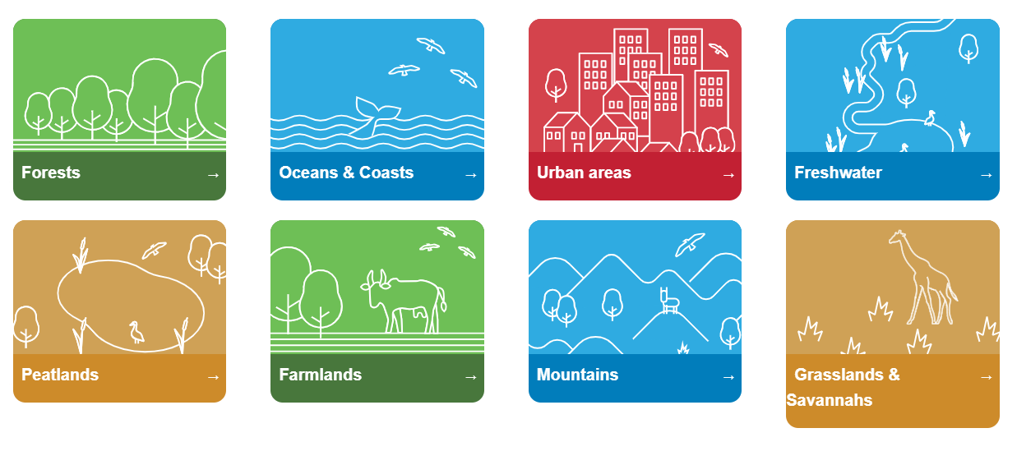

Activity: Plant Investigation
Get to know the plants in your area
Provide students with the opportunity to think and behave like ecologists (an ecologist studies the relationship between living things and their habitats). In this activity students will be given the mission to explore a natural ecosystem in their local area, identify a native plant and document what they find. Use the following as a guide. Students may work individually or in small groups.

Plan | Students will plan a visit to a local nature reserve or their own school yard to explore the natural ecosystem and identify native plants. Students will need to write a list of tools they may need for the investigation, for example: pen and paper for taking notes, camera and magnifying glass. Students will predict what plants they might see.
Explore | Students will carry out an exploration of the area. Students will choose a spot in the environment to investigate. Consider exploring the area from different angles, closeup or far away. Look and listen for evidence that animals live in the area.
Collect | Students will choose one native plant to explore in detail. Students will collect as much data as they can about that plant and record what they find. Students may write notes and sketch what they see to help in their investigation. Students may want to record what they see with a stills or video camera.
Share | Students will return to the classroom and share/compare their findings.
Analyse | Students will analyse their findings and write a short summary of their investigation. Students will respond to the following questions:  - Did you find any native plants during your investigation? If yes, identify and describe what you found. Did you find any evidence that insects or other animals live in the area?  - How could you help protect this habitat?
Research | Students will research and respond to the following:  - What does the plant look like? Describe its physical characteristics.  - What is its classification?  - What role does the plant play in the ecosystem?  - Why is this plant important?
Reflect | Students will reflect on the investigation by responding to one or more of the following questions:  - What did you enjoy about this investigation?  - What did you find surprising?  - What would you do differently next time?

Activity: Biodiversity
Restore the biodiversity in your local environment!
Students will work together to help introduce a native plant and/or animal species into their school yard. Ask them to consider the following:
- What kind of plants and animals could you help reintroduce into your school yard? Research the species native to your local area. Contact a ranger at a park near your school or the local council to learn more about the local species.
- Do you have the right type of ecosystem in your school yard for native animal species to survive? E.g., birds, bees, frogs, butterflies. Describe the climate and identify the plants in your school yard.
- What are some threats to the species that are caused by humans? How can you reduce these threats in your school yard?
- What materials and tools will you need to build the habitat or introduce new species to your area? Consider writing a guide or procedure manual.
- Build the habitat as a class and present the habitat to your school community. Teach students in other classes about the new habitat and involve them in caring for the new habitat.
- Prepare a map of the habitat which highlights key features. Include information labels in the habitat (for example, QR codes) for other students to learn more about the habitat and the biodiversity of your school yard. Include scientific information about the species.

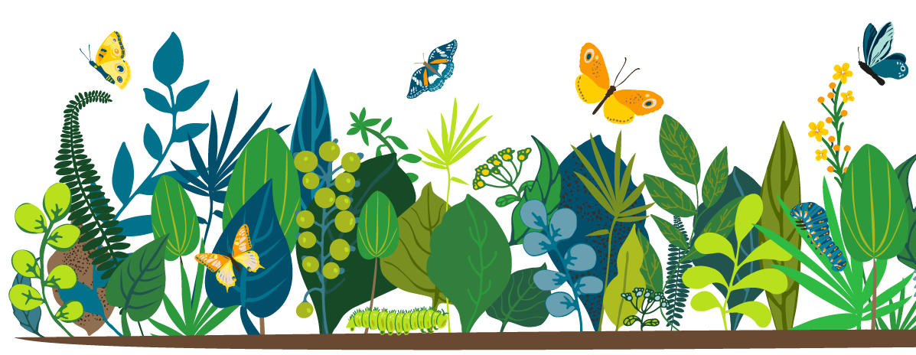

Useful Websites
- World Environment Day
- World Environment Day – United Nations
- BECOMING #GENERATIONRESTORATION: Ecosystem restoration for people, nature and climate – United Nations

EPISODE 15
4th June 2024

KEY LEARNING
Students will learn more about the local Indigenous languages where they live and the importance of maintaining them.

CURRICULUM
English – Year 5
Identify aspects of literacy texts that represent details or information about historical, social and cultural contexts in literature by First Nations Australian, and wide-ranging Australian and world authors.

HASS – Year 4
The diversity of First Nations Australians, their social organisation and their continuous connection to Country/Place.

  - Teacher Resource

Language App

Focus Questions
Discuss the BTN story as a class and record the main points of the discussion. Students will then respond to the following:
- How many Indigenous languages are there in Australia?
- What is the Mamutjitji Story app based on?
- What is another name for Mamutjitji?
  - Antlion
  - Green ant
  - Termite
- Complete the following sentence. Mamutjitji Story is the first-ever app in the _________ language.
- Why is it important to preserve Indigenous languages?

Activity: See, Think and Wonder
After watching the BTN Language App story, students will respond to the following questions:
- What did you SEE in this video?
- What did you LEARN from this story?
- What do you WONDER about this story?
- What QUESTIONS do you have about this story?

Activity: Class Discussion
Students will respond to one or more of the following questions after watching the BTN story:
- What do you know about Indigenous languages?
- What Indigenous language/s are spoken where you live?
- What has happened to many First Nations languages since European colonisation?
- Why do you think it’s important to protect Indigenous languages?
- Why is preserving Indigenous languages difficult?
- What are the benefits of learning an Indigenous language?
- Who are the traditional custodians of the land in your local area?

Activity: Local Indigenous Languages
Students will learn more about their local Indigenous languages by exploring the Gambay – First Languages Map. As a class or in small groups, students can investigate the following:
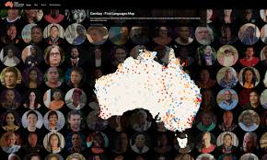
- On the Gambay map type in the area where your school is situated.
- What is the local Indigenous language in your area?
- Do your own research to learn more about the local language. Find out the local language words for hello and goodbye.
- Look for stories by Aboriginal and Torres Strait Islander peoples valuing their oral traditions. Can you find stories told through dance, song and other art forms as well as through text?

Many of the languages have videos or resources to support students to learn more about the language.
Here are the Teachers Notes to support teachers.

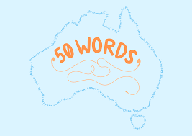
50 Words Project
Learn words in your local Indigenous language! The 50 Words Project provides words in Indigenous languages and includes audio provided by a language speaker. Use the map to search the local language and learn 50 words. Here are the Learning Materials to support teachers.

Further Learning
Invite an Indigenous language speaker to your school to learn more about the local languages.

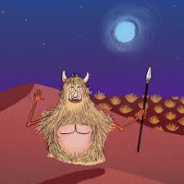
Mamutjitji Story
Mamutjitji Story is the first ever app in the Ngalia language. The resource tells the Mamutjitji Story, a Dreamtime story about the life cycle of a common desert insect, the antlion, to teach Aboriginal and Western Science concepts. Download the app for Apple and Android mobile devices from your usual app stores.

This Place
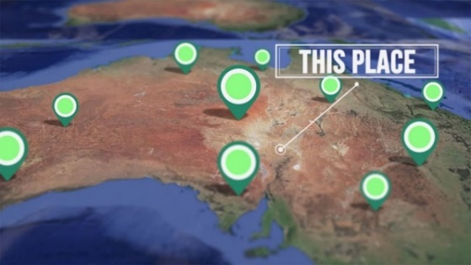
Around Australia, many places are known by their Aboriginal and Torres Strait Islander names. Indigenous communities share the stories behind place names of their country in the This Place digibook. Do you know the meaning of the place names where you live?

Included in the resource are questions for students to respond to.

Good Mornings
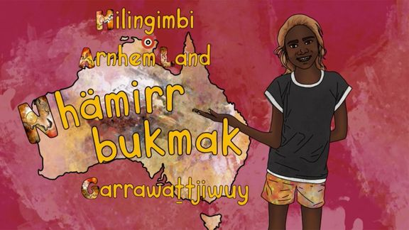
How would you greet someone in the language of the land on which you live? In these ABC Education videos, children from around Australia encourage you to join them as they share greetings in their Indigenous languages.

Meet Garrawattjiwuy and learn how to say hello in the local language in Arnhem Land.
Link to iView videos

Little J and Big Cuz
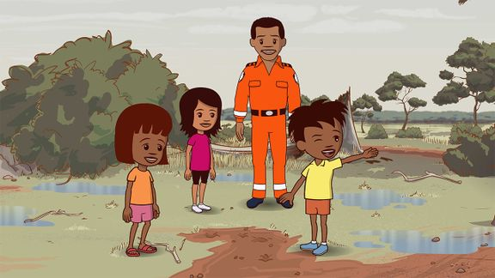
Watch an episode of the ABC’s Little J and Big Cuz which are spoken in the Indigenous languages of Gija, Noongar, Torres Strait Creole, Palawa Kani, Warlpiri and Djambarrpuyngu. Find an episode in an Indigenous language local to your area. Link to iView videos

Activity: Indigenous Perspectives
There are a range of children’s picture books which help us understand Aboriginal and Torres Strait Islander histories and cultures. Introduce your students to Aboriginal perspectives by reading one of the following picture books and then discuss the themes in the books.
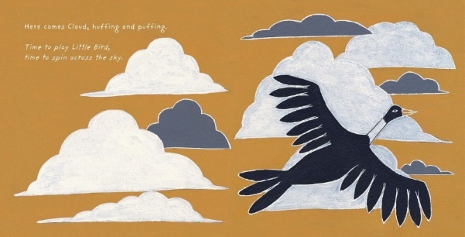
- Young Dark Emu by Bruce Pascoe
- Took the Children Away by Archie Roach
- Hello, Hello by Children from the Spinifex Writing Camp
- Freedom Day: Vincent Lingiari and the Story of the Wave Hill Walk-Off by Thomas Mayor and Rosie Smiler
Little Bird’s Day by Sally Morgan, illustrated by Johnny Warrkatja Malibirr

- Stolen Girl by Trina Saffioti
- Little Bird’s Day by Sally Morgan

Watch this video as a class to hear illustrator, Johnny Warrkatja Malibirr, read his Little Bird's Day book to 'Bapi' class at Gapuwiyak School. Watch this video to hear Johnny talk about his illustrations that he made for the Little Bird’s Day story.

After reading one of the books listed above, students will respond to the following:
- Who is the author and illustrator of the book?
- What traditional lands are they from?
- What is the theme of the book?
- What techniques does the author use to create suspense in the story? Think about the words and sounds that are used.
- What words or imagery are used in the book to convey feeling and emotion?
- What is the message of the book?
- Write down three things you would like to learn more about after having read the book.

BTN Indigenous Language Stories
Students can watch one or more of the BTN stories below to learn more about Indigenous languages.
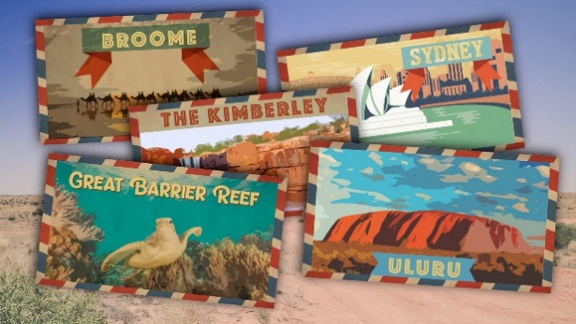  Indigenous Place Names | 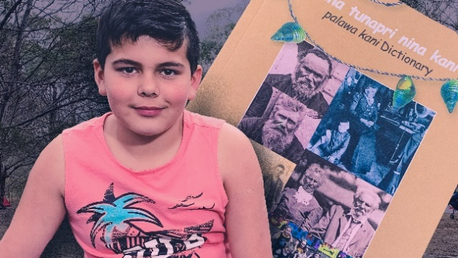  Palawa Kani
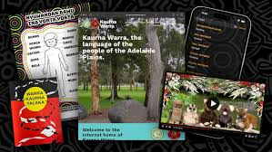  Reviving Indigenous Languages | 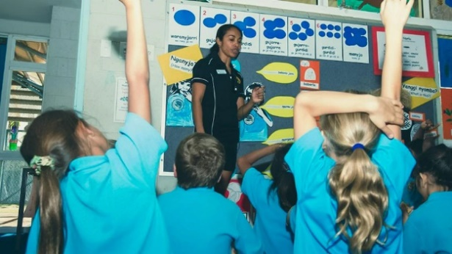  Indigenous Language Lessons

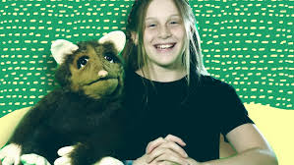  Kaurna with Tiyana | 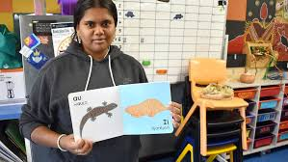  Pitjantjatjara Book

Useful Websites
- App designed by Indigenous people in WA’s northern Goldfields helps preserve language and culture – ABC News
- Reviving Indigenous Languages – BTN
- Indigenous Language Lessons – BTN
- Gambay First Languages Map – First Languages Australia
- Kaurna with Tiyana – BTN
- Palawa Kani – BTN
- Pitjantjatjara Book – BTN

  - Teacher Resource

BTN Transcript: Episode 15 - 4/6/2024

Yaama. I'm Jack and you're watching BTN. Here's what's coming up. We find out about Generation Restoration, meet kids keeping a language alive and get a lesson in breakdancing from a soon-to-be Olympian.

National Service

Reporter: Saskia Mortarotti

INTRO: But first up today, to national service. That's when young people have to spend time in the military or doing some other sort of service for their country. And it's been in the news since UK Prime Minister Rishi Sunak promised to bring it back. Here's Sas with more.
BIRTHDAY TEEN: Thank you.
SASKIA MORTAROTTI, BTN REPORTER: Imagine you've just turned 18, and along with your presents and cards, you get this.
BIRTHDAY TEEN: Thank you. This says I have to do national service? Umm, thanks?
Well, that’s what Britain’s Prime Minister Rishi Sunak has proposed for young Brits.
RISHI SUNAK, PRIME MINISTER OF THE UNITED KINGDOM: Britain today faces a future that is more dangerous and more divided. That is why we will introduce a bold new model of national service.
The Prime Minister said if he's elected in July, all British teens will have to spend a year serving their country. Either by spending one weekend a month volunteering in the community, helping the National Health Service, police and fire services or other services and charities or by spending a year full-time in the armed forces.
JAMES CLEVERLY, BRITAIN'S HOME SECRETARY: Some of it is about utility to the armed forces. That's part of it. But the bulk of this is about helping build a cohesive society where people mix outside their bubble.
Responses to the announcement have been, well, mixed.
VOX POP: I think it's so funny, it's ridiculous.
VOX POP: The kids that are having to go and do it don't even get to vote.
VOX POP: I think it’s a good thing because there isn't a lot for 18 year olds to do.
The UK has had a national service scheme before and if it brought it back it wouldn't be alone. In fact, 66 countries today have some form of a national service. Like Sweden, Denmark, Israel, Singapore, Brazil, Cyprus and South Korea. Yes, even some of your favourite K-Pop stars have done their national service. Australia’s had national service schemes too. Starting way back in the early 1900s when boys were trained at school as cadets and had to register with their local military when they turned 18. In the 50s all 18-year-old men had to spend around six months training with the military. Followed by another 5 years in the Reserves. Most spent that time was spent here in Australia where some were involved in atomic tests. That scheme ended in 1959, but the government decided to bring it back in 60s. Australia was involved in conflicts in Vietnam and in Borneo and needed soldiers. So, all men over the age of 21 were put into a so-called birthday ballot. If your birth date was drawn and you able to fight, you were forced to join military. But it was really controversial.
PROTESTORS: NO MORE CONSCRIPTIONS, NO MORE CONSCRIPTIONS…
PERSON: I think it's about time they started thinking about changing the national service laws.
PERSON: I missed out on a lot I would've liked to do as far as being a civilian goes.
Australia ended conscription in 1972, and never brought back national service.
COLONEL GARLAND: This is it, it's all over, this is the end of national service.
Although debate about it never went away.
RICHARD MORECROFT, NEWS PRESENTER: The RSL wants a national service training scheme introduced as a way of reducing unemployment.
JOHN HOWARD, FORMER PRIME MINISTER OF AUSTRALIA: We would always be willing to consider the introduction of national service.
Some still reckon it's a really good way to give young people new experiences and teach them new skills. And it helps the armed services, which can struggle to find new recruits. And while there are no plans to bring it back in Australia, some say it's not such a terrible idea.
JACQUI LAMBIE, JLN SENATOR: I don't want to scare you, I just want you to have some skill sets.
So what do you think?
STUDENT: I think having a national service might not be the best idea because it would put a lot of pressure on young adults.
STUDENT: I think it could be good if people had like a choice to do it.
STUDENT: If we introduced national service to Australia, I would be very scared when it was my turn.
STUDENT: If Australia brought back national service, I would not be very happy about it because I have plans for 18.
News Quiz
Donald Trump has been found guilty by a court in New York.

DONALD TRUMP: This was a rigged, disgraceful trial.

What crime was he convicted of? Withholding classified documents, falsifying business records or interfering with an election? He was convicted of 34 counts falsifying business records.

ALVIN BRAGG, NEW YORK DISTRICT ATTORNEY: We arrived at this trial by following the facts and the law.
It’s a crime that can be punished by up to 4 years in jail, but the judge hasn’t decided on a sentence yet. Mr Trump is the first ever former US president to be convicted of a crime and he’s still got a few court cases to go.

PERSON: It's about time he was held accountable for something.
PERSON: Even if Trump goes to jail, gets out or gets bail or whatever, we're all going to vote for Trump still.

What sort of farm product from Victoria has been banned by several countries including the US and Japan because of a disease outbreak? Is it, beef, eggs or cheese? It’s eggs. Several countries stopped importing Victorian eggs after bird flu was detected on a couple of farms.

GRAEME COOKE, VICTORIAN CHIEF VETERINARY OFFICER: For the poultry industry, it's very important that this disease is eradicated.

There are a few different strains of bird flu on the loose and scientists are particularly worried about one that’s killed a lot of birds in Antarctica although it hasn’t been found in Australia.

As many as 2 million Aussies may have had their personal information stolen in a cyber-attack on a business that sells what sort of product? Mobile phones, insurance or tickets? It’s tickets. A group of hackers known as ShinyHunters claims to have stolen the details of more than 500 million people around the world who have an account with Ticketmaster, which sells tickets online for gigs shows and sporting events.

Native Title

Reporter: Jack Evans

INTRO: This Monday was Mabo Day - which celebrates the historic 1992 Mabo Decision and the man it was named after Eddie Mabo. It was the court case that paved the way for Native Title. Let’s find out what that is and why it's important.

About 270 kilometres north-east of Alice Springs, you'll find Huckitta station.
Maria Ross, Native Title Holder: This country is for everyone, we can bring our young children into country, visit country. It's got lots of sacred sites.
It's home to the Amapete, Apwetyerlaneme, Atnweale and Warratharre people, who recently - on the banks of the Plenty River - heard something they've been waiting to hear for years.
Justice John Halley, Federal Court: The court is satisfied that native title exists over the land and waters of the Determination area.
The court’s decision has been described as the strongest native title claim ever and it means they will be able to take back full ownership of the land that their ancestors have been living on for thousands of years.
Lesley Turner, CEO Central Land Council: Congratulations to all the native title holders, and the long awaited recognition of your Native Title rights on Huckitta Station.
Maria Ross, Native Title holder: We’re so happy and proud. Many years we was waiting for this to happen, all our old people passed away the ones you know who was talking about this country all the time.
Raymond Webb, Native title holder: Wonderful, real good, too deadly.
Native title recognises Aboriginal and Torres Strait Islanders rights to their lands and waters, right around Australia. It means traditional owners can fish, hunt, practice ceremonies on their land and even make money from it.
And it came about partly thanks to this man, Eddie Koiki Mabo. Eddie was a Meriam man born on the Island of Mer or Murray Island. It's part of the Torres Strait and his ancestors have lived there for thousands of years. But when British settlers arrived they declared Mer Island, along with the rest of the country, Terra Nullius or empty land. Which meant it could be claimed by the British crown.
When Eddie learnt that his people didn't legally own their own land, he decided to do something about it. In the 1980s he and some fellow Mer Islanders, including his wife Bonita, took their case to the highest court in Australia. Over 10 years they presented evidence proving that Mer Island had never been Terra Nullius. On the 3rd of June 1992 the High Court made its decision.
Richard Morecroft, TV Newsreader: The High Court has recognised there were people here and they have rights.
George Mye, Commissioner, Aboriginal Spokesperson: Torres Strait Islanders Australia wide, particularly the Murray islanders are really thrilled with the outcome of the high court.
Sadly Eddie died before the decision was made.
Maleta West, Daughter of Eddie Mabo: He'd be excited. I can't see him talking, I can see him dancing.
The Mabo case led to the Native Title Act of 1993, which has seen thousands of claims around the country. Native title can only be claimed on land that isn't privately owned and isn't being used for other purposes, like government buildings. Traditional owners have to prove their use of and relationship to the land hasn't changed, and that's exactly what the owners of Huckitta station did. While this decision doesn't change their relationship to the land, it's a recognition that it always has been and always will be theirs.
Quiz
What court was the Mabo decision made in? The Federal Court, the Supreme Court or the High Court?
It was the High Court - which is the highest court in Australia.
Generation Restoration

Reporter: Michelle Wakim

INTRO: Now to Generation Restoration which is the theme of this year's World Environment Day. It's a call to people around the world, particularly young people, to be part of the generation that saves the planet by restoring ecosystems. Here's Michelle to explain.

At Coromandel Valley Primary School in South Australia, these guys are getting their hands dirty.
STUDENT: We are in the YELP Group, the Youth Environmental Leadership Group.
STUDENT: We're just trying to work on improving the growth of the area.
MICHELLE, BTN REPORTER: Have you planted some of the other plants around here?
STUDENT: Yeah, some of them. I called that one there Rosie, and this one up there is called Spider, and jelly and ice cream.
STUDENT: We’re calling this one Bob.
MICHELLE: Bob? Yeah, nice.
STUDENT: We were doing this because, when we made this path, we had to chop down all the trees and like break down all the bushes.
Yep, we humans have had a big impact on the planet. If you look around, it might be hard to imagine what our environments might have looked like before we started to change them. Over the last few centuries, we've seen massive changes to forests, grasslands, frozen tundra, deserts, lakes, rivers and oceans. All of the earth’s ecosystems.
DAVID KAROLY, CLIMATE SCIENTIST: An ecosystem is really the combination of all the plants, all the vegetation, but also all the animals, all the birds, all of the aspects of life within a natural system. Important natural ecosystems have been suffering from land clearing from agriculture, from cities from urbanization, building bigger cities.
This is David Karoly, and he's climate change expert, in case you couldn't tell by his t-shirt.
DAVID: It's essentially a metaphor of the damage that is due to global warming.
David says the earth is struggling to cope with all the changes we're making. It takes a year and a half to generate the resources that the human population uses in only a year, and the UN says that 75 per cent of the Earth's land surface and 66 percent of ocean areas have been seriously impacted by human actions and activities. And one million species of plants and animals are facing the threat of extinction, mainly because their habitats have been destroyed.
So, that's the bad news. But the good news is, the changes can go the other way too.
DAVID: The degradation of these ecosystems can be reversed. And that's the focus of World Environment Day this year.
UNITED NATIONS: Restore my land for future generations. Generation Restoration begins with you.
Scientists say that by restoring only 15 per cent of ecosystems, we could reduce animal and plant extinctions by 60 per cent, and there is good work happening all around world, where people are working to restore native environments, replanting forests, restoring reefs and repopulating animals. Restoration can also mean bringing in better farming practices and even creating greener cities and biodiverse backyards. David says nature is actually pretty good at recovering when it's given a chance.
DAVID: It's remarkable, even in COVID, when we stopped having as much traffic, there were many plants that essentially regrew again, around some city areas on some farms, and around some roads.
And he says restoring ecosystems is essential if we want to keep global warming below two degrees.
DAVID: There's only one proven 1000-year-old technology that removes carbon dioxide from the atmosphere, and it's trees and plants, that suck carbon dioxide out of the atmosphere. You can do that in schools or even in at home in your gardens by planting more trees and planting more plants. You can get more insects, more butterflies, more birds, and also more space for native animals.
STUDENT: So we want to plant more native plants to attract more native animals like koalas.
STUDENT: Rosellas…
STUDENT: and like all the different pollinators and, if we're lucky, even some blue-banded bees.
STUDENT: So that the native animals don't get extinct for the future generations.

Quiz

Which type of ecosystem cannot be found on mainland Australia? A savanna, a tundra or a desert?
It's a tundra which is a very cold region with no trees and little rainfall kinda like a frozen desert.
The only Australian Tundra is on islands in the subantarctic.

Language App
Reporter: Saskia Mortarotti

INTRO: Next up we're going to meet some kids in WA who are helping to preserve a very rare language. There are only three people in the world who speak and understand Ngalia, and they're passing it on to students through an app that tells the story of the Mamutjitji. Here's Sas.

SASKIA MORTAROTTI, BTN REPORTER: What these students are up to might not look that out of the ordinary but in fact they're doing something that no other kids in the world are doing. They've been chosen to test out an app called Mamutjitji Story.
KADO MUIR, APP CO-WRITER: So the app we've designed is based on a dream time story, which we've held and known about since I was a child, and it's been part of our language group for thousands of years.
The Mamutjitji story is about hairy creatures called Mamu and the kids who stood up to them. Which became little insects which we call Mamutjitji or ant lions.
KADO MUIR, APP CO-WRITER: The app is to bring this dream time story into our contemporary experience and understanding so that people now can actually experience what I have experienced as a child growing up in the bush.
It's a way to teach kids about science while connecting with their culture.
STUDENT: When there's been lots of rain, we go out bush and we um, look at what, some pathways.
DAISY WARD, NGAANYATJARRA ELDER AND EDUCATOR: It is important to go back because there’s lots of education in Ngaanyatjarra way, in western way, so we still need children to learn both ways, in our ways too.
But the app is also really important because it uses both English and Ngalia. An Indigenous language that only three people in the whole world still speak and understand. One of those speakers is the app creator, Kado Muir.
KADO MUIR, APP CO-WRITER: It's very important to me the work that my parents who've now passed on, I've done. My brothers and I are carrying on that tradition today.
There are more than 250 Indigenous languages in Australia. Including around 800 dialects that have been spoken for tens of thousands of years. There used to be even more languages but after colonisation many were lost. Government policies split up family groups and in many cases First Nations people were discouraged or even banned from speaking their language. Today around 90% of surviving Indigenous languages are considered critically endangered. Which means, not many people speak them and there's a danger of them disappearing. Which is why a lot of people around Australia are working to make sure that doesn't happen. And young people are playing a huge role in that.
TIYANNA: Welcome to Kaurna with Tiyana!

Online, at home and in classrooms. Just by learning, these kids are making sure that languages like Ngalia survive and can be taught to kids in the future.
DAISY WARD, NGAANYATJARRA ELDER AND EDUCATOR: We need that more in schools so kids could learn in both worlds - English and language. And language is important, too.

Sport

Madrid have won the Champions League title for a record-breaking 15th time.

COMMENTATOR: It's their trophy again!

After a 2-0 win against German side Borussia Dortmund, Spanish champs Real Madrid have once again won world football's biggest club competition, the European Champions League. Madrid now holds the title for, well, having the most titles. They have won the Champions League more than any other team, and, yeah, they're pretty stoked.

Speaking of Madrid and winners, Australia has won the Women's World Rugby Sevens Series and a crushing defeat of France in Madrid.

COMMENTATOR: Australia champions in Madrid.

All eyes were on Madison Levi, who scored a whopping 13 of Australia's 21 tries in the series, including three hat-tricks in five games.

COMMENTATOR: Simply superb.

And, finally, to the World Surf League in Hawaii, where Brazilian surfer Tatiana Weston-Webb has just made history as the first woman to achieve a perfect 10 at Teahupo'o.

COMMENTATOR: Deep one for Weston-Webb! She comes out.

For years, only men were allowed to surf at this beach in Tahiti because it was considered too dangerous for women. So, Tatiana's achievement is a pretty big deal.

Young Breakdancer
Rookie Reporter: Jeff Dunne

INTRO: Finally, today, we're going to meet a teenager who's going to be one of the first people ever to represent Australia in Olympic Breakdancing. The sport will make its debut in the Paris Games and Jeff Dunne will be there as part of Team Australia. Here he is to tell you more about how he got there and why he loves breaking.

JEFF DUNNE, BREAKDANCER: 50 per cent of breaking is mental. You’re meant to be the intimidator, not be intimidated. You don't want to look like you're thinking about what you're doing. So, once you like, get over that mental game and have that mental toughness, you'll be fine.
I am 16 years old, and I live in northern New South Wales. I was seven years old when I properly started breaking. It did feel extremely natural to me. I just found this odd sense of like, joy in this kind of dance.
So that is an airflare. I'm jumping from one hand and then reaching across to the other while spinning. This took me a year or so to do it.
Breaking has been around forever. It originated in the New York Bronx with a bunch of African Americans on the streets learning how to incorporate I think house dance and like ballet and gymnastics and all that. It got really big in the early 2000s, like you would have seen some breaking moves in movies like Step Up. I reckon after Olympics is going to blow up again.
Breaking is an extremely difficult, high level art form. You have so many movements that require so much strength, flexibility, mobility, and high intensity core work. But, at the same time, you have to make that look extremely cool, or artistic or beautiful.
Most people know breaking for all the power moves, so like all the head spins, and the spinning on your hands, and all the air tricks and all the flips. But breaking is really all about the originality of someone and the style and the presence.
It started getting pretty serious when the Olympics was announced.
OCEANIA OLYMPIC QUALIFIER ANNOUNCER: One Oceania representative will be in Paris 2024 for breaking. See you in Paris 2024.
This is the very first time that breaking will be in the Olympics. We have a great duty in order to make breaking look cool to the world. I feel like extremely honoured and proud to be not only representing breaking, but Australia and my family and my crew. I feel honoured to be able to show what breaking really is. I'm just going to keep on training and then hopefully, I'll get that gold.

Closer

Well that's it for today, but we'll be back before you know it and if you miss us in the meantime, you can jump online and check out more stories and specials and quizzes and resources for your teachers. BTN Newsbreak will also be here every weeknight to keep you up to date. See you next time. Bye-bye!

