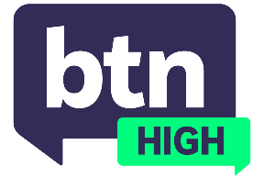
EPISODE 1
19th June 2024

KEY LEARNING
Students will discuss the use of AI (artificial intelligence) and explore how generative AI detection is being used by schools and universities.

CURRICULUM
Digital Technologies – Years 7 & 8 (v8.4)
Digital Technologies – Years 7 & 8 (v8.4)

Digital Technologies – Years 7 & 8 (v9.0)
Digital Technologies – Years 7 & 8 (v9.0)
Digital Technologies – Years 7 & 8 (v9.0)

  - Teacher Resource

AI Detection

Focus Questions
Discuss the BTN High story as a class and record the main points of discussion. Students will then respond to the following:
- Have you ever used an AI program like ChatGPT? If so, what did you find it useful for?
- What are the advantages of AI programs like ChatGPT?
- What are the disadvantages of these programs?
- Do you think students should be allowed to use AI programs? Explain your answer.
- Some schools and universities are using AI detection software to check students’ work. Do you think this is necessary? Explain your answer.
- How do you think generative AI detection will change in the future?

Activities
- Research the Australian Framework for Generative Artificial Intelligence (AI) in schools that was released by the Department of Education in 2023. Explain ways you can effectively use AI in the classroom within the framework. Present them as a slideshow, poster or feature article.
- Is AI use cheating? Write an essay about whether you agree or disagree with this statement. Explain your reasons and provide examples.

