EPISODE 16
11th June 2024

KEY LEARNING
Students will view a range of BTN stories and use comprehension skills to respond to a series of focus questions.

CURRICULUM
English – Year 4
Use comprehension strategies to build literal and inferred meaning to expand content knowledge, integrating and linking ideas and analysing and evaluating texts.

English – Year 5
Use comprehension strategies to analyse information, integrating and linking ideas from a variety of print and digital sources.

English – Year 6
Use comprehension strategies to interpret and analyse information and ideas, comparing content from a variety of textual sources including media and digital texts.

English – Year 7
Use comprehension strategies to interpret, analyse and synthesise ideas and information, critiquing ideas and issues from a variety of textual sources.
  - Teacher Resource

Focus Questions
As a class, discuss the stories featured in the episode of BTN Classroom and record the main points of the discussion. Students will then respond to the following focus questions.

Donald Trump Conviction
- Discuss the BTN story in pairs or small groups.
- What crime was Donald Trump found guilty of?
- How likely is it that Donald Trump will go to jail?
- Can Donald Trump still run for President, even if he goes to jail?
- What questions do you have about the story?

Bird Flu
- Briefly summarise the BTN Bird Flu story.
- Bird flu has been detected at poultry farms in which state?
- What impact is bird flu having on egg supply?
- When was bird flu first discovered?
  - 1878
  - 1978
  - 2024
- What did you learn watching this story?

Blood Donor Day
- What is the process of taking blood from one person and giving it to another called?
  - Transmission
  - Transfusion
  - Donation
- Name three facts you learnt about the history of blood donation.
- How many main types of blood are there?
- How many Australians will need donated blood at some stage?
  - One in three
  - One in ten
  - One in fifty
- How did this story make you feel?

Check out the teacher resource on the Archives page.
Creative AI
- What did Sony Pictures announce recently?
- How is AI already being used in the filmmaking process?
- How do you feel about watching movies that are made with entirely AI generated visuals?
- What creative jobs could be impacted by AI?
- Do you think AI can be as creative as humans? Why or why not?

Check out the teacher resource on the Archives page.

F1 Girl
- How old is Lana?
- Lana is one of six young women from around the world to get selected for what?
- What percentage of licensed motorsport drivers are women?
  - 1.5%
  - 15%
  - 50%
- Motorsport is one of the few sports where men and women can compete against each other. True or false?
- Why is motorsport male dominated?

EPISODE 16
11th June 2024

KEY LEARNING
Students will learn about the history of blood transfusions and the importance of donating blood.

CURRICULUM
Science – Year 4
Science knowledge helps people to understand the effect of their actions.

Science – Year 5 and 6
Scientific knowledge is used to solve problems and inform personal and community decisions.

Science – Year 7
People use science understanding and skills in their occupations, and these have influenced the development of practices in areas of human activity.

Scientific knowledge has changed peoples’ understanding of the world and is refined as new evidence becomes available.

  - Teacher Resource

Blood Donation History

Focus Questions
Discuss the BTN story as a class and record the main points of the discussion. Students will then respond to the following:
- What is the process of taking blood from one person and giving it to another called?
  - Transmission
  - Transfusion
  - Donation
- Name three facts you learnt about the history of blood donation.
- How many main types of blood are there?
- How many Australians will need donated blood at some stage?
  - One in three
  - One in ten
  - One in fifty
- How did this story make you feel?

Activity: Class Discussion
Discuss the information raised in the BTN Blood Donation History story. Ask students to record what they learnt about the history of blood and blood donation on a mind map. What questions do students have? Use the following to guide the discussion:
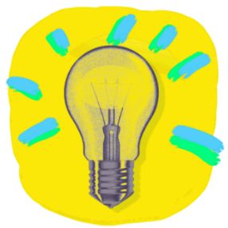
- Do you know anyone who has either donated blood or has received a blood donation?
- What did you learn about the history of blood?
- What does this story make you wonder?
- How do you feel about blood donation?
- It was interesting to learn that…
- Why do you think it is important to hear about stories like this?
- How has your thinking changed since watching this story?
- What questions do you have about this topic?

Activity: Glossary
Students will brainstorm a list of key words that relate to the BTN Blood Donation History story. Below are some words to get them started. Students will create their own class glossary of scientific keywords and terms. Consider using photos, illustrations and/or diagrams to help explain each keyword.

PLATELETS | PLASMA | BLOOD DONOR
BLOOD GROUPS | RED BLOOD CELLS | TRANSFUSION

Further investigation
Students will choose additional keywords and terms to add to their class glossary. For example, white blood cells, antigens, antibodies, haemoglobin, blood bank and circulatory system. Students will find a definition and explain to their classmates what the keywords mean.

Activity: Research project
Students will start to think like scientists and develop their own question/s for inquiry, collecting and recording information from a wide variety of sources.

What do I know? | What do I want to know? | What have I learnt? | How will I find out?

Students may develop their own question for inquiry or select one or more of the questions below.
- What is a blood transfusion? List some of the reasons why people need to have blood transfusions.
- How does blood travel around the body? Use as many of these terms in your description: circulatory system, oxygen, blood vessels, arteries, heart, circulation.
- What is blood made of? List the 4 main components of blood. Give a description of each and its function.
- Why is blood red?
- What is the function of blood?
- What are the most common and least common blood types in Australia? Create a graph to show percentages.
- What is the history of blood transfusions? Compare how technology has changed. Explore the history of blood transfusions in more detail and create a timeline of significant events.

Activity: Jigsaw learning activity
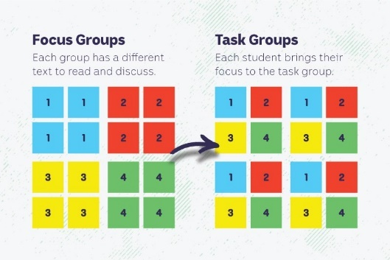
In this jigsaw learning activity students will work cooperatively to learn more about the biology of blood. Each group will become experts and then share what they have learnt with other students.

As a class watch this episode of Operation Ouch, What is blood made of? for a fun look at what blood is made of and where it is made (Operation Ouch, YouTube).

Form groups
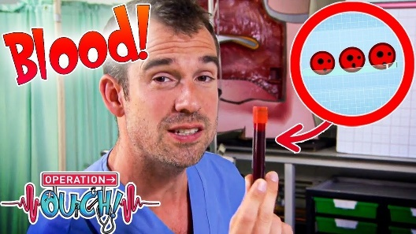
Divide the class into 5 x Focus Groups. Each Focus Group will be assigned a different area of research related to the science of blood to investigate and become experts.

Areas of research:
- What are the four main components of blood? (red blood cells/plasma/white blood cells/platelets)
YouTube video: What is blood made of? (Operation Ouch, YouTube)
- Where is blood made? (bone marrow)
- What transports blood around the body? (veins/arteries/circulatory system)
- What are the main blood types?
- What is a blood transfusion?

Each group will need to decide how they will collect and communicate the information they find during their research.

Research
Each Focus Group will work as a team to learn as much as they can about their topic. They will use the following as a guide for their research.
- Write 3 scientific questions to research and answer.
- Include diagrams.
- Include a glossary of key words.
- Interesting facts!

Share
Mix the Focus Groups to form Task Groups (Tasks Groups include one student from each of the Focus Groups) to share the information they have collected. Students will share the information they have collected and learn from one another.

Reflect
Students will reflect on the activity by responding to one or more of the following questions:
- What did you enjoy about this investigation?
- What did you find surprising?

Activity: Blood Quiz
1. Where is blood made?  A. Heart  B. Bones  C. Muscles  2. You have to be at least 18 years old to donate blood.  A. True  B. False  3. How many Australians will need donated blood at some stage?  A. 1 in 3  B. 1 in 10  C. 1 in 50  4. What system is blood part of?  A. Circulatory  B. Respiratory  C. Digestive  5. Approximately how much blood is in the human adult body?  A. 1 litre  B. 5 litres  C. 10 litres | 6. Which part of blood is most important for clotting?  A. White blood cells  B. Red blood cells  C. Platelets  7. What is the process of taking blood from one person and giving it to another called?  A. Transfusion  B. Transmission  C. Donation  8. Which part of blood helps fights infections?  A. White blood cells  B. Plasma  C. Platelets  9. What blood type is considered ‘universal’ (it can be given to anyone)?  A. A  B. AB  C. O negative  10. Which part of blood carries oxygen?  A. White blood cells  B. Red blood cells  C. Platelets

Quiz Answers: 1B, 2A, 3A, 4A, 5B, 6C, 7A, 8A, 9C, 10B

Activity – Choose a Project
Individually or in small groups, students will choose one of the following projects to work on and then present their findings to the class.

Pie Chart
What are the 4 main parts of blood? Find out the percentages for each and display your results in a pie chart.
Summary
Write a summary of the story. What was the story about? Why did BTN cover this story?

Quiz!
Create a quiz about the science of blood and test your classmates. Use Kahoot! to create your quiz.
Campaign
Design a public education campaign to raise awareness about blood donation. Think about your campaign’s aim, target audience, and the value of raising awareness in your community.

Useful Websites
- Blood Donation Day – BTN
- Blood Donation Crisis – BTN
- National Blood Donor Week – Australian Red Cross Lifeblood
- History of Blood Transfusion – American Red Cross
- How do blood transfusions work? – Ted
- Learn about blood donation – Australian Red Cross
- How bones make blood? – TEDEd
- How the heart actually pumps blood – TEDEd
- Blood Types – Healthdirect
- Why Donate Blood? – Red Cross
- World Blood Donor Day – World Health Organisation
- Know Your Blood Type Essentials – Red Cross

EPISODE 16
11th June 2024

KEY LEARNING
Students will explore the impact of artificial intelligence on creative industries and look at how creative AI can be.

CURRICULUM
Science – Year 5 & 6
Scientific knowledge is used to solve problems and inform personal and community decisions.
Design and Technologies – Years 5 & 6
Examine how people in design and technologies occupations address competing considerations, including sustainability in the design of products, services, and environments for current and future use.

.

  - Teacher Resource

Creative AI

Focus Questions
Discuss the BTN story as a class and record the main points of the discussion. Students will then respond to the following:
- What did Sony Pictures announce recently?
- How is AI already being used in the filmmaking process?
- How do you feel about watching movies that are made with entirely AI generated visuals?
- What creative jobs could be impacted by AI?
- Do you think AI can be as creative as humans? Why or why not?

Activity: Class Discussion
Before Watching
Before watching the BTN Creative AI story students will discuss in small groups what they already know about AI and what they think this BTN story will be about.
- What do you know about AI?
- What words do you associate with AI?
What questions do you have about AI?
- What impact might AI have on jobs?
- What do you wonder about AI?

After Watching
Students will respond to one or more of the following questions after watching the BTN story:
- What did you learn watching the BTN Creative AI story?
- Have your thoughts or feelings about AI changed since watching the BTN story? Discuss.
- What impact do you think AI could have on some creative jobs?
- Do you think that AI can be as creative as humans? Give reasons for your answer.

Activity: Glossary
Students will brainstorm a list of key words that relate to the BTN Creative AI story. Here are some words to get them started.

ARTIFICIAL INTELLIGENCE | CREATIVE | GENERATIVE AI
ALGORITHM | MACHINE LEARNING | CREATIVE INDUSTRIES

Ask students to write what they think is the meaning of each word (including unfamiliar words). They will swap definitions with a partner and ask them to add to or change the definition. Check these against the dictionary definition.

Further activities for students:
- Students will add to their glossary by downloading the transcript for the BTN Creative AI story and highlight all the words that relate to the topic.
- Create a word cloud using key words from the Creative AI story. Create a word cloud using a free online word cloud creator such as MonkeyLearn or Word It Out

Activity: AI Research
Discuss the information raised in the BTN Creative AI story. What questions were raised in the discussion and what are the gaps in students’ knowledge? Students will develop their own question/s to research or choose a question below.

- What are the advantages and disadvantages of artificial intelligence?
- How have jobs changed or been replaced by technology over time? Investigate and record your findings on a timeline. Include the following on your timeline: Industrial Revolution, digital revolution, and artificial intelligence.
- What creative jobs will artificial intelligence have an impact on in the future? Choose a job to research in depth explaining how AI will impact it.
- Are there any jobs that shouldn’t use AI? Why?
- Which jobs face the biggest risk of automation? Which face the lowest risk of automation?
- What do you think jobs will look like in 10 years or 50 years’ time? Make a prediction.
- How can artificial intelligence be used in creative jobs?
- How do artists use artificial intelligence as a tool to create art? Choose an artist to explore in detail.
- Can AI match humans for artistic creativity? Create an argument for or against.

Activity: AI or Human?
Can students tell if these artworks were created by artificial intelligence or a human? Take the quiz.
Students can respond to the following questions when they’ve completed the quiz:
- How difficult was it to tell whether the image was created by AI or a human?
- How can you tell if an image was created using AI? What are some things to look out for?
- What does AI mean for the future of art?
- Further investigation: How do AI image generators work?
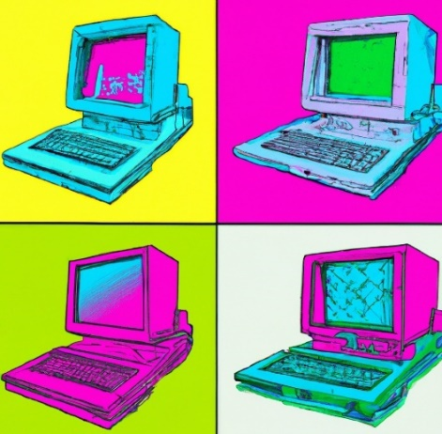
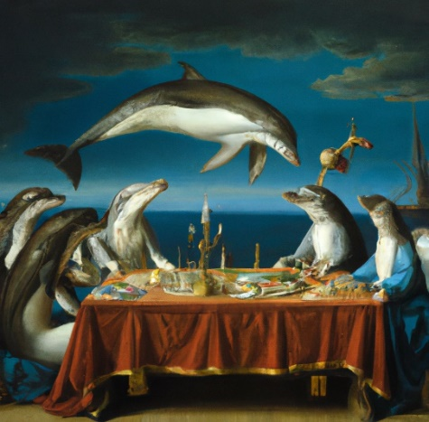

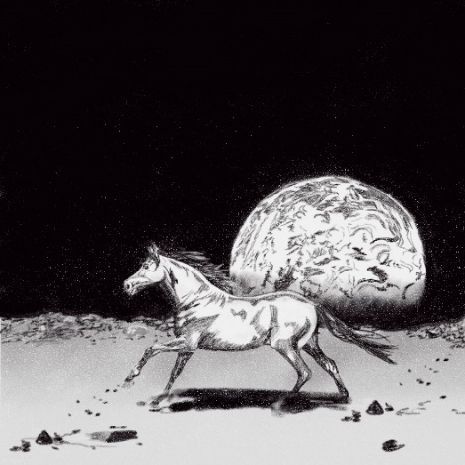
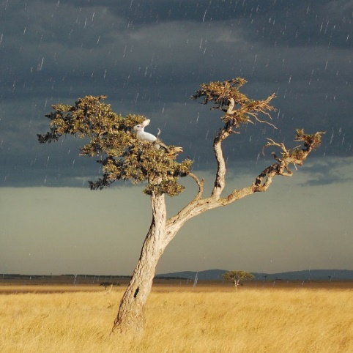

BTN AI Art story
The BTN AI Art story looks at the debate over an image created by artificial intelligence winning a prestigious photography prize. Students watch the story then respond to the following questions:
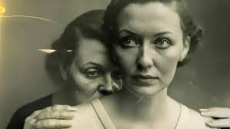
- What is AI art?
- Why did Boris Eldagsen refuse the photography award that he won?
- How do the AI programs create the art?
- What are the copyright issues with AI art?
- Do you think there is a place for AI in visual arts? Give reasons for your answer.

BTN AI Song Contest story
The BTN story looks at an online song contest where all of the songs were composed by computers and meets the programmers behind Australia’s entry. Students watch the story then respond to the following questions:
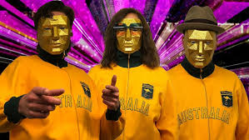
- Why was the AI Song Contest created?
- Explain how the song was created.
- Complete the following sentence. Computers find mathematical ________________ within music to create original songs.
- Who used computers to make music in 1961?
- What do you think the future of using AI in music is?

Useful Websites
- AI Art – BTN
- AI Jobs – BTN
- AI Videos – BTN
- Sentient AI - BTN
- AI Laws – BTN
- AI vs Human: The Creativity Experiment – ABC iview

  - Teacher Resource

BTN Transcript: Episode 16 - 11/6/2024

Hey. I'm Amelia Moseley and you're watching BTN. Thanks for hanging out with us again. Let’s see what’s coming up on today’s show. We find out about the race to keep Victoria's hens healthy, learn about the history of blood donations and ask whether machines can really make art. All that soon but first…

Donald Trump Conviction

Reporter: Michelle Wakim

INTRO: Let's head over to the United States, where Donald Trump has become the first US president to be convicted of a crime. Michelle found out what happened and what it means for the upcoming US election.
NEWSREADER: Ah, we are looking at count 1, guilty. Count 2, guilty. Count 3, guilty.
PERSON: I'm so pleased that there's finally some accountability for Donald Trump.
NEWSREADER: Count 10, guilty. Count 11, guilty.
PERSON: He's an innocent man. These people are too afraid to speak the truth.
NEWSREADER: Count 28, guilty.
MICHELLE WAKIM, REPORTER: Yep, Donald Trump made history and not in a good way.
NEWSREADER: Count 33 and 34, guilty.
Now you've probably all got some questions.
REPORTER: What’s this trial about?
Let's start with that one. You see, back in the lead up to the 2016 election Donald Trump gave money, through his lawyer, to a woman he'd had an affair with, while he was married to his wife Melania, and made her agree not to tell anyone. There's actually nothing illegal about that, but Mr. Trump lied on official documents about how the money was being used, and that's a crime.
REPORTER: Doesn't sound like a serious crime.
Well, some people say it wasn't. Mr. Trump says he was only prosecuted because some people don't want him to win the election.

DONALD TRUMP, FORMER US PRESIDENT: This was a rigged trial by a conflicted judge who was corrupt.

But others say a crime is a crime. The District Attorney who brought about the case said Mr. Trump was treated fairly, and the crime was serious because it was done…
ALVIN BRAGG, MANHATTAN DISTRICT ATTORNEY: To conceal a scheme to corrupt the 2016 election.
Okay, next question.
REPORTER: Will Trump go to jail?
The judge will decide his punishment on the 11th of July and the maximum sentence is four years in jail. But experts say it's not very likely Mr. Trump will get that because he didn't have a criminal record until now.
PROF. DAVID SHAPIRO, CRIMINAL JUSTICE EXPERT: Likely, Mr. Trump will receive a non-custodial term and possibly a fine.
There is a possibility that the judge could put restrictions on where Mr. Trump can travel, which could get in the way of his campaigning.
REPORTER: What. Campaigning? Is he still running?
REPORTER: Can he still be president?
Even if he ends up behind bars, Donald Trump could still run for president.
In fact, in 1920, a candidate named Eugene Debs ran for president from prison, and he got three percent of the vote.
REPORTER: Will this affect how people vote?
That is a very good question.

REPORTER: Hmm, Pretty Good.

Well, some people say a lot of Americans will be put off by the idea of voting for a criminal, and this isn't the last of Mr. Trump's legal problems. He's got three criminal court cases to come, all for more serious charges, which involve his handling of classified documents, and alleged role in trying to change the 2020 election result. But these probably won't go to court before the election in November, and in any case some people say this…
PERSON: Even if Trump goes to jail, gets out or gets bail or whatever, we're all going to vote for Trump still… how's it going to change my mind?
REPORTER: And what if he wins? Could he get rid of all of this?
Well, that's another great question that we don't really know the answer to yet. Some say Mr Trump could clear himself legally as president, but that's never happened before, and a lot of top legal experts are trying to figure out what the rules are. In the meantime, Mr. Trump is going to appeal this decision and says he's going to leave it to the public to decide whether he should have the top job.
News Quiz
Do you know who this is? It’s Narendra Modi, the Prime Minister of India, a job that he’s managed to hang on to after the country’s recent election, but not as easily as many were predicting.

Australia’s minimum wage has gone up. As of the first of July, how much will people over the age of 21 earn an hour? $16.10, $20.10 or $24.10? Australia’s new minimum wage is $24 and ten cents.

The world has marked the 80th anniversary of the Normandy Landings in World War Two, which was also known as what? D-Day, VE-Day or C-Day? It was D-Day. The D-Day landing was the biggest seaborne invasion in history. Around 160 thousand allied troops crossed the English Channel to invade German occupied France, helping to turn the tide of the war.

PRINCE WILLIAM: Today we remember the bravery of those that crossed the sea to liberate Europe.
VERTERAN: My thoughts today are with those that fell.

A Chinese spacecraft has just collected rocks from which hard-to-get-to place? Is it Mars, an asteroid or the far side of the moon? It’s the far side of the moon. Chang-e is the first spacecraft to collect rocks from the part of the moon that faces away from us.

And which of these paintings won this year’s Archibald prize? It was c. which is a portrait or Tim Winton by Laura Jones.

Bird Flu

Reporter: Thomas Midena

INTRO: Now over to Victoria, where the race is on to contain an outbreak of bird flu. It's having a big impact on chicken farmers and on people trying to buy eggs in supermarkets. Thomas found out more.

JOSH ON FARM: Let's go, my friends! Off to the grass.

JOSH MURRAY, JOSH'S RAINBOW EGGS: I love a lot of things about my farm. I love the green grass. I love people. I love the chickens.
THOMAS MIDENA, REPORTER: Josh here is a big fan of chickens.
JOSH: People are always surprised how chickens’ kind of want to be around you. Right? They have this this this dog like quality where they just kind of want to hang out.
THOMAS: In fact, he's been farming them since he was still at school and has managed to build up a successful business selling eggs from his flock of 40,000.
JOSH: So, I started Josh's Rainbow Eggs when I was nine, with the goal of making some pocket money; it was very simple. And over the last 14 years, the business has obviously grown a lot. And our goals have changed to reflect that. We want to provide nourishment for the community and do the right thing.
THOMAS: But right now, farms like Josh's are facing a big threat.
NEWS REPORT: An egg farm has been forced into quarantine.
NEWS REPORT: An outbreak was confirmed on a poultry farm.
NEWS REPORT: An outbreak of bird flu.
THOMAS: Two different strains of bird flu have been found on farms in Victoria, H7N3 and H7N9, both highly contagious and deadly for chickens.
You see, humans aren't the only ones who can get the flu. Ya right there lil’ buddy? Bird flu is a kind of influenza. Similar to the type that can make humans sick around this time of year. But unlike us, treating these guys isn't as simple as a trip to the doctor. In bad outbreaks like these, farmers can be forced to cull their animals, to make sure the flu doesn't spread any further.
JOSH: Bird flu is amongst the most serious threats our industry faces. There's a lot of really good people out there who have lost their livelihoods.
THOMAS: Luckily, Josh's farm hasn't been affected, but it’s already having a big impact on the industry and on customers. In fact, over the weekend, some supermarkets have brought in limits on how many eggs you can buy.
JOSH: I think that you're already seeing it right now. Next time you go to the grocery store, have a look at the shelf, and you'll see fair fewer eggs.
THOMAS: Bird flu isn't a new thing. We've known about it since 1878. For a long time, it was known as "fowl plague", but in 1955 it was discovered to be a type A influenza virus. It's spread by wild birds, and there are lots of different strains. At the moment a highly contagious strain called H5N1 is wreaking havoc in Asia, Europe and The Americas. And while it hasn't reached Australia, it is affecting birds in the world's most remote continent, Antarctica.
DR MEAGAN DEWAR, FEDERATION UNIVERSITY: We're sort of in uncharted territory, in a sense, of this... it's sort of the first time this has happened. But it was something that yeah, we predicted.
THOMAS: And it's not just birds. Bird flu can actually be transmitted to other animals. And occasionally, it can even be transmitted to humans.
H5N1 has been found in foxes, squirrels, and in the United States it’s recently been affecting cows. That's a worry because when viruses spread between different animals, they adapt, and could become more likely to affect humans. And although the World Health Organisation says the virus only poses a low risk to people, authorities are keeping a close eye on the situation. But some good news is you can't catch bird flu by eating chicken or eggs.
JOSH: It's very important to remember in every recorded case of human avian influenza, we've got prolonged exposure to sick birds.
THOMAS: And some more good news is that scientists are working on vaccines for the dangerous strains of bird flu. But for now, farmers like Josh are working to keep their chickens as safe as possible.
JOSH: You want to make sure nothing's getting out to the chickens in the paddock. So, that means all the vehicles are coming to the farm sanitised, they're parked in a separate spot, and they're kept separate away from anything that's going out to the field.
Blood Donor Day

Reporter: Michelle Wakim

INTRO: This Friday is World Blood Donor Day. It was created by the World Health Organisation 20 years ago, to recognise how important blood donors are to medicine. So, Michelle rolled up her sleeve and learnt all about the history of blood donations. Check it out.

MICHELLE WAKIM, REPORTER: Here, in Australia, donating blood is pretty common. In fact, a few BTN reporters have rolled up their sleeves over the years.
PAST REPORTER: And you don’t even know the needle’s gone in.
NURSE: A little squeezy for your hand.
PAST REPORTER: Thank you!

And today, it's my turn. And while the idea of using your blood to potentially save the life of someone you've never met might seem normal, it hasn't always been that way.
For a long time, blood was very misunderstood. We knew we needed it, and if you lost too much that was bad. But the idea of taking blood from one person and giving it to another, a process called transfusion, well, that took a while.
If we go way back to the 15th century, there are stories about people trying to transfuse blood by drinking it and, spoiler, it didn't end well for anyone involved, but no one really knew any better. It wasn't until 1628 in Europe that a man named William Harvey worked out how blood circulated, being pumped by the heart through arteries and veins. Not long after that, a French physician named Jean Baptist Denis, tried transferring blood from an animal to a human. That didn't end well either and the entire process was outlawed across Europe.
More than a century later, Dr William Halsted successfully completed the first emergency blood transfusion in the US. His sister had lost a lot of blood in childbirth, so he quickly inserted a needle into his arm, drawing out his own and transferring it to her, and after a few minutes she started to recover. But this was pretty lucky. It only worked because Dr Halsted and his sister happened to have to same blood type.
If you ever donate blood, you'll find out what your blood type is, because it's a crucial element of making blood transfusion work. There are eight main blood types, and they all have different kinds of antigens, which are part of our immune response when we get sick. If different types of blood are mixed together, they form clots because of these antigens, and that can kill people, but that wasn't discovered until 1900, by an Austrian physician named Karl Landsteiner. Although, there are stories of the Inca doing successful blood transfusions centuries before that, which may have been because there wasn't a lot of mixing between groups of people, and many in the region had the same blood type. Even after we discovered blood types, it was a long time before we worked out how to do this.
Until the early 20th century, transfusions could only happen directly from person to person. That’s because blood begins to clot almost immediately after coming into contact with air, which is actually a pretty handy if you're injured, but not so handy if you want to store blood. But in 1916, a pair of American scientists found a way to stop blood from clotting. The discovery came just in time for World War 1. Portable boxes were created to take blood that had been donated to wounded soldiers on the battle fields. After the war, these boxes became the inspiration for the modern-day blood bank.
Now, there are blood banks all around the world, so there's supply for when we need it - and one in three of us will over our lifetime. But to keep up with demands, just here in Australia, we need more than 29,000 blood donations every week, and that's why the World health Organisation created Blood Donor Day to recognise the importance of donors, and to celebrate the medical discoveries that have saved so many lives around the world.

Quiz

Which blood type is sometimes called the universal donor because it's the least likely to react if it mixes with another blood type? Is it A+, AB- or O-? It's O negative. In an emergency, O negative blood can be given to anyone if their matching blood type is in short supply.

Creative AI
Reporter: Wren Gillett

INTRO: Sony has just announced it's going to start using Artificial Intelligence to help make movies and TV shows. That's got a lot of filmmakers and other creative workers worried about the future of their jobs. But can AI really replace humans when it comes to making art? Wren investigates.

WREN GILLETT, REPORTER: And the Oscar goes to, Botrina67 for the Botbie movie.
BOTRINA67: Oh, my goodness. If I had tear ducts, I might just cry.
Okay, while the robot Oscars might seem farfetched, the idea of movies made by machines is not as whacky a concept as you might think.
TONY VINCIQUERRA, SONY CEO: We will be looking at ways to use AI to produce both film for theatres and television.
Yep, this is the CEO of one of the biggest film studios in the world, and they're going to start using AI, why? To save money.
TONY VINCIQUERRA, SONY CEO: The biggest problem with making films today is the expense.
While we don't exactly know how Sony will be using AI just yet, lots of companies are already using it in many stages of the movie-making process, from scriptwriting to video editing, to CGI generation. There's even a movie coming out at the end of the year, that has entirely AI-generated visuals.

VOICEOVER: Maybe you're the dark, mysterious kind of man who never shows his vulnerability.

This kind of thing is what a lot of people have been afraid of, both in Hollywood and other creative industries, from writers, to photographers, to painters, to musicians.
BOTRINA67: Thank Bipbop and Boop who wrote the beautiful soundtrack behind Botbie.
Yep, AI is quickly becoming pretty good at doing things we once thought only humans could do.
ANGHARAD YEO, JOURNALIST: So when you start talking about robots making art, it gets really, really interesting.
Rad is a journalist who made a whole show about whether AI could be as creative as people, and she reckons that, at the moment, we humans still have the upper hand.
ANGHARAD YEO, JOURNALIST: It's important to remember that AI doesn't actually have creativity. In fact, it can't actually think. AI literally at the moment, is basically just guessing, like the next word in the sentence, or the next pixel, that would be, you know, next to the other pixel.
You see, before AI can create anything, it has learn from us. Programs like these are trained on our words, videos and images and this has made a lot of artists angry.
PERSON 1: We need to talk about AI art.
PERSON 2: My work has been stolen.
PERSON 3: Someone trained an AI to copy and replicate my personal art style without my permission
But, some argue we humans learn in a pretty similar way. Every time we create something new, we're drawing from stuff we've already learned from reading books, watching movies, having conversations. So, is AI any different?
ANGHARAD YEO, JOURNALIST: I think there are some people that do think AI is being creative? And then a lot who don't? That's a really big philosophical question that I'm excited that we're talking about, because AI has come onto the scene.
So, what does that mean for people with creative jobs, like, hah, me. Well, while some are worried, we might be replaced by Botrina67s, others say AI will just change the way we do our jobs. Some even say it could give more people the tools they need to make really cool stuff or inspire us to use our human imaginations in new ways.
Whatever happens, we may have to get used to sharing the stage with machines.

BOTRINA67: And most of all I'd like to thank all you humans out there. Botbie was made by all of us.

Sport

The battle of the blues and the maroons is now well underway, with the first men's State of Origin game delivering a massive upset for the home ground heroes, New South Wales. The blues had some promising breakthroughs but couldn't keep up with the Maroon's charge, ending the match down 38 to 10.
Meanwhile in Newcastle, a record crowd braved wet weather to see the women's 2nd Game, and it was a thriller. Both teams were neck and neck until the dying minutes, when Queensland's Lauren Brown booted a 69th minute field goal…

COMMENTATOR: What a kick!!

… tipping the Maroons to an 11 to 10 victory. The win levels the series one-all, which means we get to see the first Game 3 in the history of the women's origin later this month.
Buckle up for the 2024 Finke Desert Race. It's known around the world as Australia's toughest off-road contest. And this year's winner was Beau Robinson clinching his first every victory with a time of 3 hours, 28 minutes and 45 seconds.
And if you add on another 40 minutes and 15 seconds, that's how long it took Carlos Alcaraz to defeat Alexander Zverev in five-sets at the men's singles French Open final. The win makes Alcaraz the youngest male player to win grand slam titles on the three surfaces.
And in the Women's comp, Iga Świątek claimed her third straight French Open crown defeating Jasmine Paolini and continuing her reign as the world's top women's singles player.

Formula One Girl
Reporter: Wren Gillett

INTRO: Now, if you’re 12, you probably don't know how to drive a car yet, but Lana from Brisbane is learning how to drive cars really, really fast. She's been selected to take part in a really prestigious training program for the future female champions of Formula One. Check it out.

WREN GILLETT, REPORTER: She's fast, she's fearless, and she's ready.
LANA, AUSTRALIAN MOTORSPORT TALENT: To be the first female Formula One champion.
At 12-years-old, Lana's become one of just six young women from around the world, handpicked to take part in a driver development program, called More than Equal. It was started by thirteen-time Grand Prix winner David Coulthard, Who wanted to find the world's very first female Formula One champion.

You see, while women have been part of motorsports for a long time, the last woman to actually race in Formula One was Lella Lombardi, way back in 1976. Today, most drivers are male. In fact, only about 1.5 per cent of licensed motor sport drivers are women, even though motorsport is actually one of the few sports where men and women can compete against each other. Experts say that's not because girls can't race as well, but because they aren't given the same opportunities, and they don't have as many female role models. Plus, these girls say they face a lot of discrimination.
SARAH MOORE, MORE THAN EQUAL DRIVER COACH: I think one of the biggest things you have to deal with as a girl, coming up through carting, and as you progress into cars, is the comments you receive around the paddock, on social media.
LANA: Some boys are supportive, other boys aren't most of them take me out and bully me.
That's something More than Equal, and this group of talented girls, want to change.
LANA: Most people are like oh yeah, it's not a girl's sport it's a boy sport but like, like they've got lots of girl programs to help girls get up to that stage.
IVONN SIMEONOVA, AUSTRIAN MOTORSPORT TALENT: I think we need more girls in Formula 1 and in motorsport cause we are all equal and I mean we should get the same chances.
LAURA BUBENOVA, SLOVAKIAN MOTORSPORT TALENT: I'm there because I'm talented, I'm good enough to do this, and I do it because I love it.
KATRINA THUNG, MALAYSIAN MOTORSPORT TALENT: We're all more than equal.
So, to support these girls and get them up to speed, the program is giving them world-class training, at camps like this. So, they too, can learn all the tricks.
SKYE PARKER, UK MOTORSPORT TALENT: We learnt how to drift as usually when I tried attempted drifting, I would just slide and spin, but this time I learned how to control it.
LANA: I just think, I've gotta be smooth, I've gotta like, hit my markers, I've gotta like, break at this point, I've gotta like, keep focused.
And, they've all got their sights set high.
IVONN: My ambitions are to be like famous in motor sports, the number one aim is formula one of course.
LAURA: My ambition, the top one, is to be an F1 world champion, but it's also to be a role model for the girls that are in the position that I am in now.
LANA: I wanna be the first female to win a championship.
Closer

Way to go Lana, we'll keep an eye out for you on the podium soon. That's it for us this week but we'll be back with more next Tuesday. In the meantime, you can check out our website, download our teacher resources, if you're a teacher. And Newsbreak will be here every weeknight to keep you up to date. Have a great week. See you soon. Bye!

