
KEY LEARNING
Students will view a range of BTN stories and use comprehension skills to respond to a series of focus questions.

CURRICULUM
English – Year 4
Use comprehension strategies to build literal and inferred meaning to expand content knowledge, integrating and linking ideas and analysing and evaluating texts.

English – Year 5
Use comprehension strategies to analyse information, integrating and linking ideas from a variety of print and digital sources.

English – Year 6
Use comprehension strategies to interpret and analyse information and ideas, comparing content from a variety of textual sources including media and digital texts.

English – Year 7
Use comprehension strategies to interpret, analyse and synthesise ideas and information, critiquing ideas and issues from a variety of textual sources.

  - Teacher Resource

Flag Special
As a class, discuss the stories featured in the BTN Special and record the main points of the discussion. Students will then respond to the following focus questions.

Torres Strait Islander Flag
- Where are the Torres Strait Islands? Find on a map.
- How many islands in the Torres Strait are inhabited?
- When was the Torres Strait Islander flag created? Tell the story of how it was created using your own words.
- What colours can be found on the Torres Strait Islander flag?
  - Green, blue, black, white
  - Red, yellow, black
  - Blue, white, red
- What do the colours of the Torres Strait Islander flag represent?

Aboriginal Flag Anniversary
- What do the colours on the Aboriginal flag represent?
- In 1972, the flag became a famous symbol at which protest site in Canberra?
- Which Australian athlete sparked controversy at the 1994 Commonwealth Games by carrying both the Aboriginal and Australian flags during her victory lap?
- When did the Aboriginal flag become an official flag of Australia?
- What does the Aboriginal flag mean to you?

Flag Day
- What year did Australia get its national flag?
- What are the main features on the Australian flag?
- What constellation is featured on the Australian flag?
- What flag is similar to Australia’s flag?
- Why do some people have mixed feelings about the Australian flag?
- Do you think the Australian flag should be redesigned? Give reasons for your answer.

KEY LEARNING
Students will identify elements, colours and symbols of the Torres Strait Islander flag and explain the meaning and significance of each element. Students will learn more about Torres Strait Islander people, their language, culture, and traditions.

CURRICULUM
HASS – Year 3
The ways First Nations Australians in different parts of Australia are interconnected with Country/Place.

HASS – Year 3
The importance of Country/Place to Aboriginal and/or Torres Strait Islander Peoples who belong to a local area.

HASS – Year 3 and 4
Pose questions to investigate people, events, places and issues.

HASS – Year 4
The diversity of First Nations Australians, their social organisation and their continuous connection to Country/Place.

HASS – Year 5 and 6
Develop appropriate questions to guide an inquiry about people, events, developments, places, systems and challenges.

HASS – Year 6
Changes in Australia's political system and to Australian citizenship after Federation and throughout the 20th century that impacted First Nations Australians, migrants, women and children.

  - Teacher Resource

Torres Strait Islander Flag
This document contains the names and images of Aboriginal and Torres Strait Islander people now deceased. It also contains links to sites that may use images of Aboriginal and Torres Strait Islander people now deceased.

Activity: Class Discussion
Before watching the BTN Torres Strait Islander Flag story students will discuss in small groups what they already know about the Torres Strait Islander Flag.

Facilitate a class discussion using these discussion starters:
- What does the Torres Strait Islander flag look like? Describe the shapes and colours on the flag.
- What do the different shapes and colours represent?
- List some places where you would see the Torres Strait Islander flag.

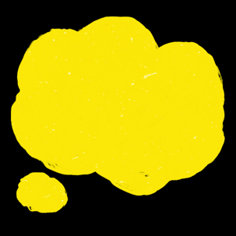
What questions do you have?
What surprised you about this story?

Activity: Inquiry Research
Discuss the information raised in the BTN Torres Strait Islander Flag story. What questions were raised in the discussion and what are the gaps in students’ knowledge? The following KWLH organiser provides students with a framework to explore their knowledge on this topic.

What do I know? | What do I want to know? | What have I learnt? | How will I find out?

Students will develop their own question/s to research or choose one of the questions below. Encourage students to collect and record information from a wide variety of sources and present the information they find in an interesting way.
- What is the history of the Torres Strait Islander flag? Who created it and when was it first flown?
- When was the Torres Strait Islander flag first recognised as a national flag? What are the official flags of Australia?
- What do the elements of the Torres Strait Islander flag represent? Explore the symbolism of the shapes and colours.

Activity: Understanding the Torres Strait Islander Flag
Students will identify elements, colours and symbols of the Torres Strait Islander flag and explain the meaning and significance of each element. Start this class activity by asking your students, “what do you think flags represent” and “why do communities and nations have flags?”.

Students will use the following questions to guide their research:
- What is the story of the Torres Strait Islander flag?
Describe using your own words.
- Who designed the flag?
- When was the flag designed?

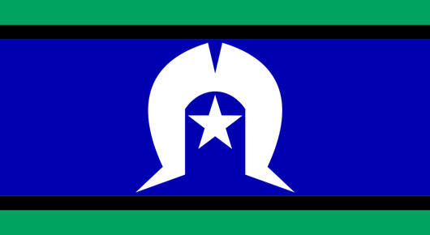
Research and answer these questions:
- The green stripes represent...
- The blue represents...
- The black stripes represent...
- What is the white symbol in the middle of the flag? It represents...
- What does the star symbolise?
- The colour white represents...
Torres Strait Islander Flag (Source: AIATSIS)
- The flag as a whole symbolises...

Activity: Language, Culture, and Traditions
After watching the BTN Torres Strait Islander Flag story students will learn more about Torres Strait Islander people, their language, culture, and traditions. Students will research and present on one of the following topics.

- Torres Strait Islander Languages – What are the traditional languages spoken in the Torres Strait? Learn more about the different dialects. Learn some everyday words for the two languages of the Torres Strait and Torres Strait Creole. Torres Strait Islander Word Lists (State Library QLD)

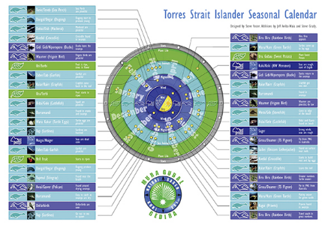
- Seasonal Calendar – What are some important animals in Torres Strait Islander culture? Learn more about the Torres Strait Islander seasonal calendar (QCAA), and the plants and animals that are important to Torres Strait Islander people.

- Geography – Where are the Torres Strait Islands? How many islands make up the Torres Strait? There are 5 geographically and cultural distinct main island groups. List the islands in each group and highlight on a map.

- Totems – In small groups students will explore animal totems which are important to Torres Strait Islanders. Watch this video about the Importance of Dugongs for Torres Strait Islanders (ABC Education). Why is this totem important to Torres Strait Islanders? How does this totem help you understand Torres Strait Islander people and culture?

- Important People – Who are some important Torres Strait Islander leaders, artists, and performers? Choose one to explore and learn about their life and achievements. Write a profile about them. Some important Torres Strait Islander people include Eddie Mabo, Chrstine Anu and Uncle Bernard Namok Snr.

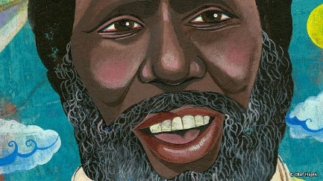
- Land Rights – Watch this BTN Mabo Day story to learn about the story of Eddie Mabo. Write 2-3 paragraphs about what you learned, using one or more of the following sentence starters.
  - Five words that I would use to describe Eddie Mabo are…
  - This story made me feel…
  - It is important to remember Eddie Mabo because…

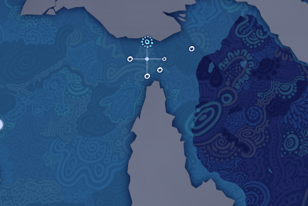
- Deep Time – Explore the ABC’s Deep Time website to learn more about Torres Strait Islander people and culture. Go to the Place map on the Deep Time website and select one of the stories from the Torres Strait Islands. What does the story tell you about Torres Strait Islanders connection to animals, the land, water or sky?

BTN First Nations collection

Visit BTN’s collection of stories which focus on First Nations. Look for BTN stories with the pencil icon to find supporting teacher resources all linked to the Australian Curriculum. BTN – First Nations Collection

Useful Websites
- Torres Strait Flag Anniversary – BTN Newsbreak
- Flag Day – BTN
- Torres Strait – BTN
- Aboriginal and Torres Strait Islander Flags – Australian Museum
- Flags – National Museum of Australia
- Aboriginal Flag History – BTN
- Aboriginal and Torres Strait Islander flags – Reconciliation Australia
- The Torres Strait Flag – Torres Strait Regional Authority
- Torres Strait Islander flag – AIATSIS

KEY LEARNING
Students will learn more about the history of the Aboriginal flag.

CURRICULUM
HASS – Year 3
Significant events, symbols and emblems that are important to Australia’s identity and diversity, and how they are celebrated, commemorated or recognised in Australia, including Australia Day, Anzac Day, NAIDOC Week, National Sorry Day, Easter, Christmas, and other religious and cultural festivals.

The ways First Nations Australians in different parts of Australia are interconnected with Country/Place.

HASS – Year 4
The diversity of First Nations Australians, their social organisation and their continuous connection to Country/Place.

HASS – Year 5 and 6
Develop appropriate questions to guide an inquiry about people, events, developments, places, systems and challenges.

Teacher Resource
Aboriginal Flag Anniversary

Aboriginal and Torres Strait Islander people should be aware that this document may contain images and names of deceased persons.

Activity: Comprehension
After watching the BTN Aboriginal Flag Anniversary story students can answer one or more of the following questions:
- What are some keywords from the BTN story?
- What did you learn from the story? Write a summary.
- Why do you think BTN covered the story?

Activity: Class Discussion
Hold a class discussion after watching the BTN story using the following questions as a guide. Record the main points of the discussion on a mind map with ABORIGINAL FLAG at the centre.
- Who designed the Aboriginal flag?
- When and where was the flag first flown?
- What do the colours - black, red and yellow on the flag represent?
- Where can you see the Aboriginal flag in your community?
- What is the significance of the Aboriginal flag to you and/or to your school and community?

Did you know? The black section must always be at the top when the flag is flown. Why do you think that is?

Activity: Key Words
Students will brainstorm a list of key words that relate to the BTN Aboriginal Flag Anniversary story. Here are some words to get them started.

UNITE | SYMBOL | CULTURE
LAND RIGHTS | ACTIVIST | PROTEST

Ask students to write what they think is the meaning of each word (including unfamiliar words). They will swap definitions with a partner and ask them to add to or change the definition. Check these against the dictionary definition.

Activity: Aboriginal flag timeline
Students place the following key moments in the correct chronological order from 1 to 6. Write the numbers next to the events. Choose one of the events from the list below to investigate further.
Students use their research to answer these questions:
- What happened during this event?
- Why was this moment so important for the Aboriginal flag?
- Create a poster, write a short paragraph, or draw a picture explaining your chosen event.

The Australian Government officially proclaims the flag under the Flags Act 1953.

Harold Thomas designs the Aboriginal flag.
The Aboriginal flag is flown at Victoria Square, Adelaide.

The Commonwealth secures the copyright, making the flag free for public use.

The flag achieves national prominence at the Aboriginal Tent Embassy in Canberra.

Olympic athlete Cathy Freeman wore both the Australian and Aboriginal flags during her victory lap at the Commonwealth Games.

Activity: Aboriginal Flag Research
Discuss the information raised in the BTN Aboriginal Flag Anniversary story. What questions were raised in the discussion and what are the gaps in students’ knowledge? Students will develop their own question/s to research or choose one or more of the questions below.
Research Questions
- In what ways is the Aboriginal flag a symbol of cultural identity?
- What protocols should be followed when flying the Aboriginal flag?
- How does the Aboriginal flag tell a story without using words?
- In 1995, the Australian government made the Aboriginal flag an official flag of Australia. Why do you think official recognition is important for the people a flag represents?
- How do other flags around the world use colour to represent their people and geography?

Useful Websites
- Aboriginal Flag History – BTN
- Free the Flag – BTN
- Aboriginal and Torres Strait Islander flags – Australian Museum
- Moments of the Aboriginal and Torres Strait Islander flags – Australian Government
- First Nations Stories – BTN

KEY LEARNING
Students will learn about the history of the Australian flag and conduct an opinion poll about whether the flag should be redesigned.

CURRICULUM
HASS – Year 3
Significant events, symbols and emblems that are important to Australia’s identity and diversity, and how they are celebrated, commemorated or recognised in Australia, including Australia Day, Anzac Day, NAIDOC Week, National Sorry Day, Easter, Christmas, and other religious and cultural festivals.

HASS – Year 5
Present descriptions and explanations, drawing ideas, findings and viewpoints from sources, and using relevant terms and conventions.

Teacher Resource
Flag Day

Activity: What do you see, think & wonder?
After watching the BTN Flag Day story hold a think, pair, share using the following as discussion starters:
- What do you THINK about what you saw in the story?
- What does this video make you WONDER?
- What did you LEARN from the BTN story?
- Think of three QUESTIONS you have about the story.

Activity: Class Discussion
After watching the BTN Flag Day story hold a class discussion, using the following questions to start the discussion:


- Describe the Australian national flag. What do the different elements of the flag represent?
- Why do we have a Australian national flag?
- What are the flags of Australia? What do they represent?
- When do you see the flags of Australia? Give some examples.
- Are flags important? Why or why not?

Activity: Glossary
Students will brainstorm a list of key words that relate to the BTN Flag Day story. Here are some words to get them started.
SYMBOLISE | FEDERATION | REPRESENT
ENSIGN | UNION JACK | SOUTHERN CROSS

Activity: Design a New Flag
In this activity students will design a new Australian flag that they think best represents Australians and Australia’s history. Use the following as a guide for this activity.
- Include three symbols in your new flag design and describe what each of the symbols represent.
- Design your flag. Be creative!
- Present your flag design to the class explaining what each of the symbols mean.
- Display your flag in the classroom. Hold a competition in your class for the best flag.
- How has this activity impacted on your thinking about the Australian flag?

Activity: Public Opinion
Students will interview a range of people to find out the different attitudes and feelings people have towards the Australian flag and whether it should be changed. Students will use the following as a guide during the interview process:
- Think about who you will interview, for example, family and/or friends.
- Prepare for your interview by writing some questions that you will ask your interviewee. Write open-ended questions. Open-ended questions have no right or wrong answer and can’t be answered with a ‘yes’ or ‘no’.
- Find out what the flag means to them.
- Ask if they think the Australian flag should be changed and ask them to explain their answer.
- Think about ways to record peoples’ responses – written, audio or video.

Activity: Opinion Poll

Hold a poll in your class. Students will conduct their own opinion poll on the issue of whether the Australian flag should be redesigned. Working in groups, students will need to decide who their sample group will be and how many people will be polled.
- Write a poll question. Poll questions should be clear, concise, and relevant to the topic. For example, Should the Australian flag be redesigned?
- What method will they use to conduct the poll? (Face to face interviews or written responses).
- Ask students to graph the opinion poll results and display in the classroom. Students can reflect on how reliable they think the results were. What would they do differently next time?
- Students may want to film their interviews and then create a movie to present to other students.

Activity: Choose a project
Students will choose one of the following activities to work on and then present their findings to the class.

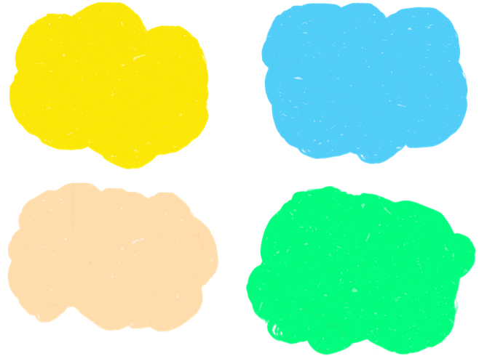
Aboriginal and Torres Strait Islander flags
What is the history of the Aboriginal flag and the Torres Strait Islander flag? Who created them, why and when were they first flown?

Summary
Summarise the BTN Flag Day story in three sentences. Share your summary with another student. How did your summaries differ?
State Flags
Each Australian state and territory has its own flag. Research the flag of the state or territory you live in. What do the symbols represent?
Did you know?
Using the information in the BTN story and your own research, create a Did You Know fact sheet about Australian flags. Publish using Canva.

Activity: Quiz
Students will use the facts they have discovered about flags to create a quiz and then test their classmates. Students will include a range of quiz styles, for example:

- Multiple choice
- True or false
- Fill in the blank
- Use photos or pictures
- When an answer is revealed, provide extra information to explain the answer.
Students can make their quizzes in Kahoot or Quizizz. Make it fun, engaging, and educational!

Useful Websites
- Australia’s Flag – BTN
- Aboriginal Flag History – BTN
- The Australian flag – National Archives of Australia
- Aboriginal and Torres Strait Islander Flags – Australian Museum
- Australian Flag Defined – National Museum of Australia
- Flags – National Museum of Australia
- The Australian National Flag – Department of the Prime Minister and Cabinet

