EPISODE 27
13th September 2022

KEY LEARNING
Students will reflect on the life and achievements of Queen Elizabeth II. Students will investigate the role of the British monarch and construct a biography.

CURRICULUM
HASS – Year 3 and 4
Pose questions to investigate people, events, places and issues.

HASS – Year 5
The influence of people on the environmental characteristics of places in Europe and North.

HASS – Year 5 and 6
Develop appropriate questions to guide an inquiry about people, events, developments, places, systems and challenges.

HASS – Year 7
Construct significant questions and propositions to guide investigations about people, events, developments, places, systems and challenges.

  - Teacher Resource

The Queen Special

Focus Questions
Discuss the BTN Queen Special as a class and record the main points of the discussion. Students will then respond to the following:

World Reacts to Queen’s Death
- How did the world react to the news of the Queen’s death?
- Queen Elizabeth II is Britain’s longest serving monarch. True or false?
- What words would you use to describe Queen Elizabeth II?
- What does it mean when flags are flown at half-mast?
- How did this story make you feel?

The Life of Queen Elizabeth II
- How did Elizabeth’s father become King?
- What did Queen Elizabeth train as during her time with the British Army?
  - Mechanic
  - Nurse
  - Soldier
- How old was Elizabeth when she became Queen?
- The Queen could make new laws and political decisions. True or false?
- What did you learn about Queen Elizabeth II? List two interesting facts.

The Queen in Australia
- How many times did Queen Elizabeth II visit Australia?
- Australia is a constitutional monarchy. True or false?
- When did Australia become a British colony?
- What is the role of Australia’s head of state?
- What did Queen Elizabeth II do during her visits to Australia? Give an example.

The Queen’s Death: What Happens Next?
- Where will the Queen’s funeral be held?
  - Westminster Abbey
  - Buckingham Palace
  - Balmoral Castle
- How will Australia’s coins and banknotes change?
- How will Britain’s national anthem change?
- Why is Australia having a public holiday on September 22nd?
- What questions do you have about this story?

King Charles III
- When was King Charles III born?
- King Charles III completed some of his schooling in Australia. True or false?
- Who was King Charles III’s first wife?
- What issues is King Charles III particularly passionate about?
- What else do you know about King Charles III? List two interesting facts.

Activity: Class discussion
As a class discuss the BTN Queen Special, using the following questions as a guide. Record the main points of the discussion.
- How did this story make you feel?
- What words would you use to describe the Queen?
- What do you wonder?
- What questions do you have after watching this story?

How would you describe the Queen?
What questions do you have?

Activity: Reflections on the Queen
Provide your students with the opportunity to reflect on the life and achievements of Queen Elizabeth II. After watching the BTN Queen story ask your class to brainstorm a list of words to describe Queen Elizabeth II. Record students’ responses on a mind map.
Students will then choose one of the following activities to work on as they reflect on the Queen:
- Use the internet to find a story, news article or video about the Queen. Analyse the text and respond to the following question: What did you learn about the Queen as a person and a leader?
- Write a letter to the Queen thanking her for her achievements.
- Make a poster which celebrates the life and achievements of the Queen.
- Design your own class memorial box which contains drawings, photos, and objects to celebrate the Queen.
- Write a journal entry in your diary which reflects on your feelings and thoughts about the Queen.
- What are your favourite memories of the Queen?
- Write a poem about the Queen.
- Research and learn more about the Queen’s love of animals, including her corgi’s, horses, and her humorous encounter with Paddington.

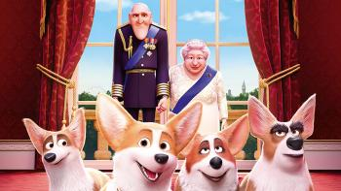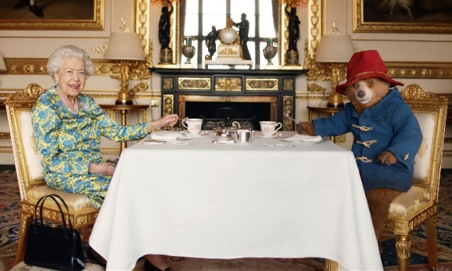
The Queen’s Corgi movie (PG)
Paddington Bear joins the Queen for afternoon tea at Buckingham palace. (Guardian News - YouTube) Link

Activity: Biography
Before students begin to construct their biographies, hold a class discussion to find out what they already know about biographical writing. Discuss what type of information is included in a biography and what they tell us about a person. The Civics and Citizenship website has some examples of biographies for students to look at.

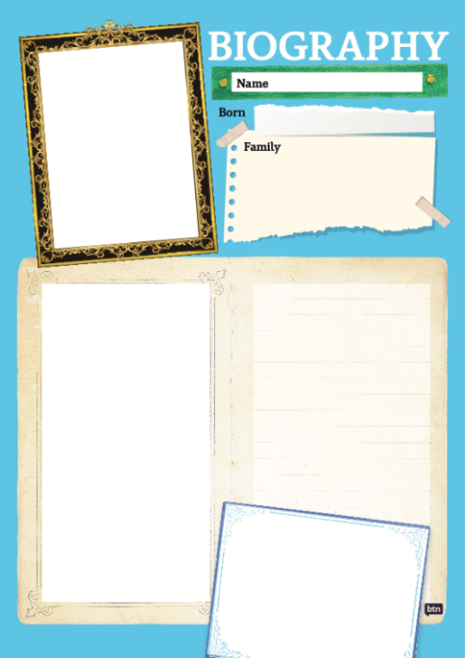
Class Discussion
Use the questions below to get a class discussion started with your students about biographical writing.

- What does a biography tell us about a person?
- Where can you look to find information for your biographical writing? It could include the internet, newspaper articles, magazine articles and interviews, other biographies, historical books or television interviews. Why is it important to use more than one source of information?
- What makes a biography interesting? For example, key information and facts, a timeline of events, photographs, illustrations and quotes.

Create your biography
Using the biography worksheet at the end of this activity, students will research and record information about Queen Elizabeth II. Some possible areas of research include:

- When and where was Queen Elizabeth II born? Describe her family life growing up.
- When did she become the Queen?
- What were some of her achievements? Choose one to explore in more detail.
- What inspired or motivated Queen Elizabeth II?
- What were some challenges that she faced?
- How did she make an impact on people’s lives?
- What do you admire about her?

Alternatively, students can research and create a profile on the new British Monarch, King Charles III.

Further Investigations
- Create a timeline of important events in Queens Elizabeth II’s life.
- What are some of the key events in her life? Write a summary for one key event, which answers the 5 W’s – Who, What, Where, When and Why?
- How do primary sources (for example photos, letters, diaries and official documents) help us understand what might have happened at a place in time? Find 1 or 2 primary sources that help you learn more about the person’s life.
- Create a portrait of the Queen. Explore and experiment with different techniques and media to produce a portrait. Around the sketch brainstorm and record important things that the Queen did in her life.
- Write a letter to Queen Elizabeth II thanking her for her achievements and how she has changed the world.
- Make a Did You Know for other students.

Activity: Glossary
Students will brainstorm a list of key words that relate to the BTN Queen Special. Students may want to use pictures and diagrams to illustrate the meaning and create their own glossary. Here are some words to get students started.

CONSTITUTIONAL  MONARCHY | BRITISH COLONY | COMMONWEALTH
MONARCH | REIGN | HEAD OF STATE

Activity: Research inquiry
The KWLH organiser provides students with a framework to explore their knowledge and consider what they would like to know and learn.

What do I know? | What do I want to know? | What have I learnt? | How will I find out?

Questions to research
Students will develop their own question/s to research. Students will collect and record information from a wide variety of sources. Students may develop their own question for inquiry or select one of the questions below.

- What are the key moments in the history of Queen Elizabeth II’s reign? Create a timeline of significant events in her life. How has the world changed over this time? Include key moments in history to include on your timeline. Learn more about Queen Elizabeth II’s life in 92 facts!
- Who will be the next Monarch of England? Investigate the rules of succession.
- What is the role of the Monarch?
- What happens to Australia’s money now the Queen has died? When will the portrait change on Australia’s coins and is the money still legal tender?
- What are some of the key events in Queen Elizabeth II’s life? Write a summary for one key event, which answers the 5 W’s – Who, What, Where, When and Why?
- How has the royal family changed over time? How have they adapted to the times?
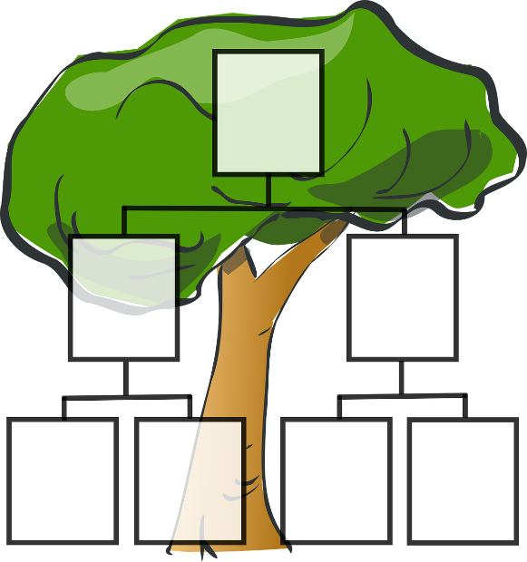
- How do primary sources (for example photos, letters, diaries and official documents) help us understand what might have happened at a place in time? Find 1 or 2 primary sources that help you learn more about Queen Elizabeth II’s life.
- Why did the Queen have two birthdays?
- Why does Australia have a Monarch as its Head of State? Find out what a constitutional monarchy is and explore the reasons why some people want Australia to become a republic.
- Who is in the Royal Family? Create a family tree. How does succession work in the royal family? Explore this interactive guide to find out who’s who in the royal family.

Activity: Quiz

- How old was Elizabeth when she became Queen?  A. 18  B. 25  C. 52  - What Australian banknote does Queen Elizabeth II feature on?  A. $5  B. $20  C. $50  - Who is the new British Monarch?  A. Prince Charles  B. Prince William  C. Prince Harry  Quiz Answers: 1B, 2A, 3A, 4B, 5A, 6A | - Which way does the Queen’s portrait face on Australia’s coins?  A. Left  B. Right  5. Queen Elizabeth II was the longest reigning British monarch.  A. True  B. False  - Australia is a constitutional monarchy.  A. True  B. False

Useful Websites
- Queen Elizabeth II 1926-2022 – The Royal Family
- Queen Elizabeth II has died, aged 96 – Newsround
- Queen Elizabeth II’s life in pictures – Newsround
- The life of Princess Elizabeth before she was Queen – Newsround
- The little girl who was never meant to rule became the longest-reigning monarch – ABC News
- Queen’s Platinum Jubilee – BTN
- What is the role of the Queen in Australia’s system of government? – Parliamentary Education Office
- Why are we a constitutional monarchy? – Parliamentary Education Office
- Australia – The Royal Family
- Queen Elizabeth II death: Charles is the new King – Newsround
- King Charles III pays tribute to Queen Elizabeth II in first statement as monarch – ABC News
- Queen Elizabeth II: Tributes to Her Majesty – Newsround

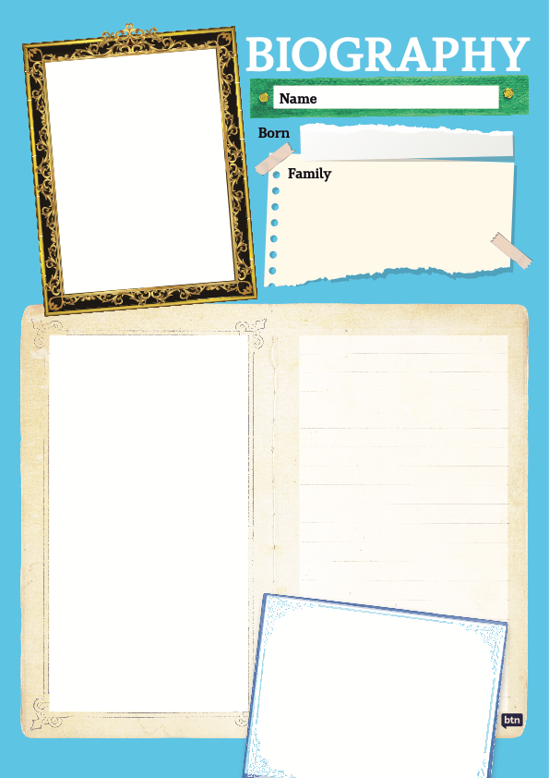

  - Teacher Resource

BTN Transcript: Episode 27- 13/9/2022

Hey everyone, we're bringing you a very special episode of BTN today to mark a huge moment for the UK, Australia and the world, and that's the death of Queen Elizabeth II. On today's show we're going to take a look back at the life of the Queen and what she meant to Australia, we'll find out what happens next and what will change here and overseas and learn more about King Charles III.

World Reacts to Queen’s Death

Reporter: Cale Matthews

INTRO: But first, let's find out how news of the Queen's death spread around the world and how people are remembering her.

People watched anxiously as streams of cars rushed to Balmoral Castle in Scotland. It was the Royal Family, gathering together to be with the Queen. Then came the announcement everyone was dreading.

NEWS REPORTER: This is BBC News from London. Buckingham Palace has announced the death of Her Majesty, Queen Elizabeth II.

Just after 6.30pm on the 8th of September, Buckingham Palace confirmed that Queen Elizabeth II had died. Crowds gathered outside Buckingham as tributes started flowing for Britain's longest serving monarch.
Queen Elizabeth II was working right up until the end. In fact, just a week ago she swore in the new British Minister Liz Truss.

LIZ TRUSS, UK PRIME MINISTER: Through thick and thin, Queen Elizabeth II provided us with the stability and the strength that we needed.

Right across the globe people took the time to remember the Queen. Sports matches were cancelled and there were moments of silence. Monuments were lit with British flags or were switched off, and world leaders paid their respects.
JACINDA ARDERN, NEW ZEALAND PRIME MINISTER: It's with great sadness that New Zealand wakes up to the news of the passing of Her Majesty, Queen Elizabeth II.
JUSTIN TRUDEAU, CANADIAN PRIME MINISTER: She was thoughtful, wise, curious, helpful, funny, and so much more.
LIZ TRUSS: Our country has grown and flourished under her reign. Britain is the great country it is today because of her.
Here in Australia flags flew at half-mast which is a symbol of mourning, as Aussies reflected on this historic and sad event.
ANTHONY ALBANESE: Queen Elizabeth II is the only reigning monarch most of us have known and the only one to ever visit Australia.

The Life of Queen Elizabeth II

Reporter: Amelia Moseley

INTRO: Queen Elizabeth II reigned for 70 years and 214 days making her the longest serving monarch in British history and over that time she played a part in some huge world events. Let's have a look back at her incredible life.
In 1926, Elizabeth Alexandra Mary Windsor was born. She was the newest arrival in a family, a royal family, with 160 servants and five palaces. And while her life might've seemed like a fairytale, she never expected to be a Queen. But in 1936, her uncle decided to abdicate, or give up the throne. So, Elizabeth's father became King and at ten years old she suddenly became first in line to the throne.

During World War Two, the 14 year old princess gave her first royal address. It was when London was under attack by bombing raids and many children were being evacuated from the city.
QUEEN ELIZABETH II: We know every one of us that in the end all will be well for God will care for us and give us victory and peace.
When Elizabeth turned 18, she insisted on joining the women's branch of the British army and trained as a mechanic. When the war finally came to an end, she and her sister slipped into the crowd to celebrate with everyone else, in what she described as one of the most memorable nights of her life. Not long after the war ended, she married Prince Philip. And had her first child, Prince Charles. On February the 6th, 1952, Elizabeth's dad King George the sixth died.
NEWS REPORTER: Tragic in sombre black, the ladies of his house follow, the Queen, the Queen mother together in their grief.
And at the age of 25 she became Queen. In 1954, she took a trip to Australia. She was the first British monarch to visit us. Back then the Queen was the official head of state of 32 Commonwealth countries, although that number went down over the years. Her role was ceremonial, so she didn't make laws and was expected to stay out of politics, although she would often meet with Prime Ministers. She also supported many charities and eventually became the UK's longest reigning monarch.

PRINCE CHARLES: Thank you from your family, the country, the Commonwealth, in fact, the whole world. On behalf of us all, I wanted to pay my own tribute to your lifetime of selfless service.
Of course there were plenty of ups and downs over the years. From famous family problems to huge historic events, and some scary moments. In the 80s, she woke up and found a stranger sitting on the end of her bed in Buckingham Palace.
NEWS REPORTER: The queen chatted with the intruder for a few minutes and then under the pretext of getting him a cigarette, went to the door and summoned help.
But even though she was always in the public eye, the Queen was a super private person who only gave a few little glimpses into her home life.

Queen Elizabeth II: Clothes-wise, does it look alright with the background? Yes, it does. Well, it'd be awful if you said no because I'd have to find something else.

We know she love, love, loved horses and horse racing and her dogs.
QUEEN ELIZABETH II: Really, you're not supposed to do that. Go away. I’m not here don't do that. I'm not here. Go do your stuff.
But most of all, she cared for her four kids, Charles, Anne, Andrew and Edward and her grandkids and great grandkids.
Through it all was her husband, Prince Philip, who died in 2021 at the age of 99.
QUEEN ELIZABETH II: He is someone who doesn't take easily to compliments, but he has quite simply been my strength and stay all these years.
The Queen kept working for longer than some expected and was happy to make a joke or two about that.
REPORTER: Are you well?
QUEEN ELIZABETH II: Thank you very much. I'm still alive.
She spoke about the importance of fighting climate change. And even embraced some new technology.
QUEEN ELIZABETH II: Good morning. Well good morning to me, I don't know what it is for you.
Over 70 years as Queen, she dedicated her life to serving her country and the Commonwealth, and while that job that will now pass to her eldest son King Charles III, Queen Elizabeth II will keep a big place in the history books.

QUEEN ELIZABETH II: It is a job for life.
The Queen in Australia

Reporter: Jack Evans

INTRO: As our official head of state for 70 years, Queen Elizabeth was pretty important to Australia. She even visited us 16 times over the decades. Let's find out more about the Queen's role in Australia and other Commonwealth countries.
Whether it's riding a beach buggy on Bondi or taking a drive through the outback, there are plenty of reasons to come to Australia, and while I'm sure Queen Elizabeth II enjoyed taking in our Aussie culture, she also had a bit of an obligation to visit us down under and that's because she was our monarch.
You see, Australia is a constitutional monarchy, which basically means the Queen or now King of England is the head of state. Why? I hear you ask. Well, when Captain Cook arrived here in 1770, he declared the country to be Terra Nullius or land belonging to no-one. That wasn't actually true, of course, Indigenous people had been here for tens of thousands of years - but he claimed the land for the British Crown and 18 years later the continent became a British colony, or a series of British colonies. Anyway, a couple of hundred years later when Australia became a federation, we got a prime minister but kept the King.
While it might be a bit odd having someone on the other side of the world as head of state it's actually pretty common. During her reign, Queen Elizabeth II was head of state to 33 countries. Although that doesn't mean she was involved with the day to day business of the Australian Government. Rather, the head of state plays an important ceremonial and symbolic role. So, what does that mean exactly? Well for starters there are the royal visits that involves a lot of waving and smiling to huge crowds. And in the 16 times the Queen had visited Australia, she did some pretty Aussie things.
Her first visit down under was in 1954 and it took 6 weeks to arrive here by boat. But once she was here and welcomed by a very enthusiastic crowd, she did a bit of formal duties and then the Queen took in some of the local culture, attending a surf lifesaving comp at Bondi. Another big part of the job as our monarch is to open things. Like in 1973 she opened the Sydney Opera House and in the 80's she also opened the newly built Parliament House. The last time the Queen came to Australia was in 2011. She attended a big Aussie BBQ in Perth and I do mean bit. It's estimated nearly 100,000 people turned up to Perth's foreshore. I hope they had enough sausages.
Some other parts of the job of being a monarch is that you get your face on money and that you get things named after you. Which is why we have places like, Queen Elizabeth Park in Concord NSW, Queen Elizabeth Lookout at Echo Point also in NSW. There's Elizabeth Town in Tassie, there's also the City of Elizabeth in South Australia and just this year Aspen Island in Canberra was renamed Queen Elizabeth Island in honour of the Queens's Platinum Jubilee. Oh, and what about the statues. Yep, there are also numerous statues of Queen Elizabeth II scattered around the country. And so, while we now have a new head of state, there's no doubt Queen Elizabeth II will be remembered.

The Queen’s Death: What Happens Next?

Reporter: Amal Wehbe

INTRO: The Queen's death is going to mean some big changes both in the UK and here in Australia. So, what's happening now and what can we expect in the days and weeks to come? Let’s find out.

For the past 70 years she's been a constant for many people in many countries around the world. On our TVs, on the world stage, in our oaths and anthems, and on our coins. And now her reign is over, many people are wondering what comes next.
PERSON 1: It's a new era for us. Like, we've only ever known the one Queen and now we're moving into a new monarch.
PERSON 2: Just can't really believe it to be honest because she's been Queen my whole life so, it's just what's going to happen now really.
Well there's actually a pretty detailed plan for what comes next. It's known as Operation London Bridge and was signed off by the Queen herself. After her death was officially announced, the Union Flag on top of Buckingham Palace was lowered to half-mast, beginning 10 days of national mourning across the United Kingdom.
GISELLE BASTIN, ROYAL EXPERT: There'll be enormous amounts of symbolism and ceremony, you know, really, that's been rehearsed down to the last minute.
British Parliament is paused. Official engagements and events are cancelled and flags on government building are lowered to half-mast until her funeral. At the moment, the Queen's coffin is in Edinburgh, where people are paying their respects.

KID 1: She’s done so much for everyone, so we, kind of, need to honour her.

KID 2: We think that it’s important for , to come down and lay flowers, because Queen Elizabeth was very important to us.

Then it will travel to London, where people can visit her at Westminster Hall. On the 19th of September the royal family will host the state funeral at Westminster Abbey. And leaders from around the world will attend including Prime Minister Anthony Albanese and Governor-General David Hurley. There’ll be 2 minutes of silence and finally the Queen will be laid to rest with her husband and other family members at Windsor Castle. When the Queen died, her eldest son Charles now known as King Charles III, automatically took the throne. So, he's now in charge of the Commonwealth but his actual coronation ceremony where he's given a crown might not be for a few months. But with a new head of state a lot will need to change.
Britain's royal anthem's already been changed replacing God save the Queen with God save the King.
Passports, stamps and portraits will need to be replaced, along with anything using the royal insignia.

GISELLE BASTIN. ROYAL EXPERT: All the signage on every post box on police uniforms anywhere you can imagine that the Royal Standard or the Royal Crest, or the figure of the monarch is in evidence, it has to all change over.
Changes will have to be made in Australia too. Next year, the Mint will start printing coins and notes with King Charles' head on them instead of the Queen. Don't worry though, you'll still be able to use the old currency. Meanwhile Australia's parliament’s been suspended for 15 days. And next Thursday's been declared a one off public holiday as a day of mourning.

While the changes won't all happen at once, there's no doubt that this is a huge moment in the history of the Commonwealth and the world.

King Charles III
Reporter: Jack Evans

INTRO: Finally today, to the Queen's eldest son who's taking his place on the British throne and on Australia's coins. Let's learn more about the new monarch, King Charles III.
King Charles III was born at Buckingham Palace on the 14th of November 1948. Unlike his mother, Charles grew up knowing that one day, he would be King. He became heir to the throne at the age of just 3 after his grandfather King George VI died and Queen Elizabeth II took the throne.
Even though he was destined to rule, Charles wanted to learn. He went to boarding school and spent a few years at Geelong Grammar here in Australia. He was also the first British heir to go to university where he obtained a second class history degree. In 1969 he was formally named the Prince of Wales.
KING CHARLES III: I, Charles, Prince of Wales, do become your liege man of life and limb, and of earthly worship.
It was a title that came with a lot of responsibilities. He learned to speak Welsh, took a seat in the House of Lords in British Parliament, visited Commonwealth countries and served in the British military. In 1977 Prince Charles met Lady Diana Spencer, who would eventually become his first wife.
KING CHARLES III: Difficult to find the right word really, just delighted, and happy, and I'm amazed that she's been brave enough to take me on.
Millions of people tuned in and lined the streets surrounding Buckingham Palace to watch the two wed. Prince Charles and Princess Diana had two sons, who you probably recognise, William and Henry AKA Harry. But the royal marriage didn't last.
JOHN MAJOR, FORMER UK PRIME MINISTER: It is announced from Buckingham Palace that with regret the Prince and Princess of Wales have decided to separate.
Two years later, on the 31st of August 1997, Diana died in a car crash in Paris.
NEWS REPORT: The world is in shock, Diana, Princess of Wales is dead and Britain is in mourning.
It was devastating for many people, but especially for William and Harry. Prince Charles continued to raise his two sons and in 2005 he married Camilla Parker Bowls who was eventually named as future Queen Consort. As Prince of Wales, Charles was a patron or president for more than 400 charitable organisations and was particularly passionate about the environment and fighting climate change.
KING CHARLES III: The point being, that this is our last chance saloon. Literally, because if we don't really take the decisions that are vital now, it's going to be almost impossible to catch up.
Earlier this year he stepped in to take on more of the Queen’s duties.
KING CHARLES III: My lords and members of the House of Commons. Her Majesty's government's priority is to grow and strengthen the economy and help ease the cost of living for families.
So what else do we know about our new King? Well, he once wrote a children's book. He drives a car that runs on bio fuel made from English wine, he has a frog named after him and the Masai in Tanzania gave him the official title "Keeper of the Cows". He's also the oldest person to take the British throne at 73 and in the next few years we'll get to know more about King Charles III as he takes on this huge job.
KING CHARLES III: I shall strive to follow the inspiring example I have been set in upholding constitutional government and to seek the peace, harmony, and prosperity of the peoples of these islands and of the Commonwealth realms and territories throughout the world.
Closer
That's it for this special episode of BTN. We'll be taking a break for the school holidays, just like you, but we'll be back after that to bring you all the latest news and Newsbreak will keep you up to date in the meantime. Take care of yourselves and I'll see you soon. Bye.

