EPISODE 23
16th August 2022

KEY LEARNING
Students will explore the topics in the BTN Science Week special including the history of glass, fibre optics, recycling glass and glass blowing. They will also learn more about glass inventions including reading glasses, the light bulb and telescopes.

CURRICULUM
Science – Year 4
Natural and processed materials have a range of physical properties that can influence their use.

Science - Year 5
Light from a source forms shadows and can be absorbed, reflected and refracted.

Solids, liquids and gases have different observable properties and behave in different ways.

The Earth is part of a system of planets orbiting around a star, the sun.

Science – Year 5 & 6
Scientific knowledge is used to solve problems and inform personal and community decisions.

Science – Year 7
Solutions to contemporary issues that are found using science and technology, may impact on other areas of society and may involve ethical considerations.

People use science understanding and skills in their occupations, and these have influenced the development of practices in areas of human activity.
  - Teacher Resource

Science Week

Focus Questions
As a class, discuss the stories featured in the episode of BTN Classroom. Students will then respond to the following focus questions.

History of Glass
- Make a list of all the things you can think of that are made from glass. Share your list with a partner.
- What is obsidian? When and how was it formed?
- What are the main ingredients in making glass?
- How did First Nations people use glass?
- What are three interesting facts you learnt from the BTN story?

Glass Recycling
- Recycling glass dates back to the _______________ Empire.
- In Australia, what percentage of all glass products come from recycled glass?
  - 20%
  - 50%
  - 70%
- What is the main ingredient of glass?
- Melting down recycled glass takes less energy than melting sand from scratch. True or false?
- What are the benefits of recycling glass?

Fibre Optics
- Fibre optics are thin strands of _____________.
- How do fibre optics transmit information?
- What are fibre optics used for?
- In which decade where fibre optics invented?
- What questions do you have about this story?

Glass Blowing
- At what temperature can glass be shaped, moulded, and blown into objects?
- What equipment is used to blow glass?
- What are some unique properties of glass?
- Why is it important to cool the glass slowly in the kiln overnight?
- What did you like about the BTN Glass Blowing story?

Activity: Inquiry Research
Discuss the information raised in the BTN Science Week Special. What questions were raised in the discussion and what are the gaps in students’ knowledge? The following KWLH organiser provides students with a framework to explore their knowledge on this topic.

What do I know? | What do I want to know? | What have I learnt? | How will I find out?

Students will develop their own question/s to research or choose one or more of the questions below. Encourage students to collect and record information from a wide variety of sources and present the information they find in an interesting way.

- Where can you find glass? Make a list of all the different places we use glass and choose one to investigate in more detail. For example: telescopes, solar panels, reading glasses, windows, mirrors, conservatory, TV screens and fibre optics.
- What is the history of glass? Plot your findings on a timeline.
- What is the difference between a reflector and a refractor telescope?
- Why is glass transparent?

Activity: History of Glass
Students will investigate the history of glass and present their research as a timeline, infographic or a presentation. Below are some key events in the history of glass.
20 million years ago
Obsidian, a naturally occurring volcanic glass.

13th Century
First eye glasses are invented in Northern Italy.

2500 BC
First humans to make glass.

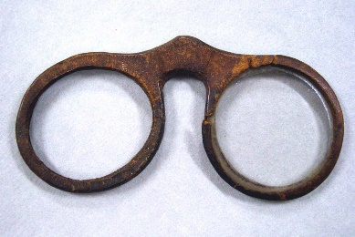
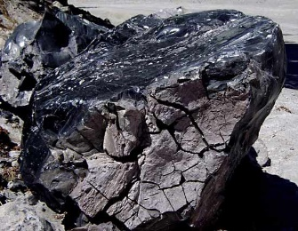

- 20 million years ago – Obsidian formed when molten rock from volcanos cooled rapidly.
- 2500 BC – Mesopotamia, first humans make glass.
- 1500 BC – Ancient Egyptians, the first to make something out of glass.
- 1st Century BC – Syrians develop the technique of glass blowing.
- 1st Century BC – Romans develop a pressing technique to create the first glass windows.
- 1100s – European cathedrals are decorated with stained glass windows.
- 13th Century – Northern Italy, the first glasses to enhance eye sight are developed.
- 16th Century – Venice, mirrors are developed.
- 17th Century – Telescopes are invented.
- 19th Century – Henry Bessemer develops a method for making a continuous ribbon of plate glass.

Activity: Fibre Optics
Students watch the BTN Fibre Optics story, then respond to the following questions:
- Fibre optics are thin strands of _____________.
- How do fibre optics transmit information?
- What are fibre optics used for?
- In which decade where fibre optics invented?
- What questions do you have about this story?

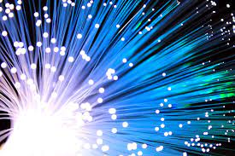
Students will create an information report about fibre optics. The following may help guide students’ research:
- What are fibre optics?
- How do fibre optics work?
- What are fibre optics used for?
- Impact of fibre optics.
- Interesting facts about fibre optics.

Structure and features of an information report
Information reports are factual texts written to inform and provide detailed facts about a topic. Discuss with students what they already know about the purpose, structure, and features of an information report. Use the following as a guide to use with students.
- Purpose – An information report provides information to the reader by stating facts.
- Structure – see table below.
- Language features – write in the present tense, use technical or scientific words, and write in the third person.

Students can then use the following structure to help write their report. They can present their reports using publishing software or as a brochure.

Title - States the topic.

Introduction - The opening statement explains the subject of the report and includes a definition or short description.

Body - Facts grouped into paragraphs. Starts with a topic sentence. Include subject specific language. Text features such as sub-headings, labelled diagrams, charts and captioned photographs may be included.

Conclusion - A summary of what the topic is about and end with an interesting fact.

Activity: Glass Recycling
Students watch the BTN Glass Recycling story and answer the following questions:
- Recycling glass dates back to the _______________ Empire.
- In Australia, what percentage of all glass products come recycled glass?
  - 20%
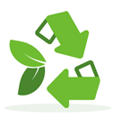
  - 50%
  - 70%
- What is the main ingredient of glass?
- Melting down recycled glass takes less energy than melting sand from scratch. True or false?
- What is cullet?
- What are the benefits of recycling glass?

Further investigation
- Can all glass be recycled? Explain your answer.
- Glass fines are the small glass particles that are broken during the recycling collection. Investigate how they are used to make different products.

Activity: Waste Hierarchy
The waste hierarchy is a guide to help minimise waste. Discuss with students the different elements of the waste hierarchy and what they mean. Brainstorm a list of actions or practices that can be done for each element to reduce the amount of rubbish going to landfill.
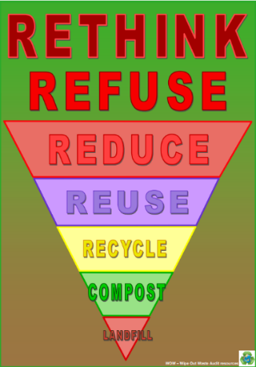
Rethink – think about what you are buying and consuming
Refuse – say no to unnecessary things (packaging etc.)
Reduce – the amount of material that will go to landfill
Reuse – many items can be reused or upcycled
Recycle – choose items that can be recycled
Compost – organic waste can be put into green waste bins or home compost bins
Landfill – send as little waste as possible to landfill
More information about the waste hierarchy can be found at the Wipe Out Waste website
Source: Wipe Out Waste

Activity – Choose a project
Individually or in small groups, students will choose one of the following projects to work on and then present their findings to the class.

Upcycling Glass
Glass can be reused and repurposed into useful and decorative items. Explore ways to reuse glass waste created at your school.
Take action
Do you live in an area that refunds 10 cents for cans and containers? Set up a bottles and cans collection at your school. Use this step by step guide to help with the process.
Recycling Glass
How is glass recycled? Create a poster, infographic or flow chart that shows the process.
Test your classmates
Brainstorm the different types of waste produced at your school. Do you know where they can be recycled? Create a quiz to test your classmate’s knowledge about recycling.

Activity: Glass Blowing
Class discussion
After watching the BTN Glass Making story hold a class discussion using the following questions to get the discussion started:
- What words would you use to describe the process of glass blowing?
- What is molten glass?
- What is molten glass compared to? Why?
- What can you do with glass when it is molten? (e.g., pour, stretch, mould, blow).
- What sort of tools do glass blowers use?

Have you ever seen an artist blow glass to make something? Discuss as a class. Find out if there is a glassmaking studio in your area and organise a class excursion. Watch one of the following videos to watch how glass can be blown and worked into different things.
- Glass Marbles – Magic of Making (YouTube)
- Making Doughnuts – JamFactory
- Robert Wynne glass blower in Sydney – Vimeo
- The Glass Artist Who Hides His Work All Around the World – Great Big Story (YouTube)
Experiment
Learn about the science of molten glass by doing this “Cold honey, hot honey” experiment which can be found in the National Science Week 2022 Resource p. 34-35. Students will use honey to learn about states of matter and transfer of heat.

Activity: Telescopes
Think like a scientist
Bring a telescope into class, or alternatively visit or take a virtual excursion to an observatory. As a class identify the different parts of the telescope, including the eye piece, optical tube, and lens. What questions do students have about telescopes?

Students will develop their own question/s for inquiry, collecting and recording information from a wide variety of sources. Students may develop their own question for inquiry or select one or more of the questions below.
- How do telescopes work?
- Why are telescopes important?
- What do they help us see?
- What can you find in nature that is like a telescope?

As a class watch these ABC Education explainers to learn about how telescopes work, the different types of telescopes, and solar telescopes.

Make a telescope
Students can follow these National Science Week 2022 step-by-step instructions on how to make a telescope (p.38-39), using paper towel tubes, scissors, sticky tape and 2 lenses (from a pair of old reading glasses). Ask students if they know what type of telescope they have created. Students can watch this ABC Education video to learn more about the different types of telescopes.

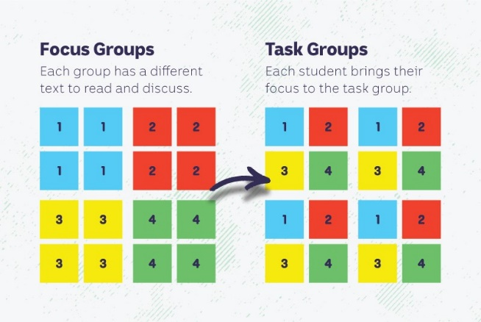
Jigsaw learning activity
In this activity students will work cooperatively to learn more about telescopes, the different types of telescopes and how they work. Each group will become experts and then share what they have learnt with other students.

Form groups | Divide the class into 4 x Focus Groups. Each Focus Group will be assigned a different telescope to investigate and become experts. Below is a list of famous telescopes:  - Galileo’s telescope  - Isaac Newton’s telescope  - Hubble Telescope  - James Webb Telescope  Each group will need to decide how they will collect and communicate the information they find during their research.
Research | Each Focus Group will respond to the following questions to become experts:  - Who invented it?  - When was it built?  - What type of telescope is it?  - What does the telescope look like? Describe and then draw a sketch.  - How big is it? What are its dimensions?  - How does it work?  - What important discoveries have scientists made with the telescope?  - Choose your favourite photos or illustrations to present to the class.
Share | Mix the Focus Groups to form Task Groups (Tasks Groups include one student from each of the Focus Groups) to share the information they have collected. Students will share the information they have collected and learn from one another.
Reflect | Students will reflect on the activity by responding to one or more of the following questions:  - What did you enjoy about this investigation?  - What did you find surprising?

Activity: Glass Invention - Eyeglasses
Watch the BTN Glass Inventions: Eyeglasses story and respond to the following questions:
- Most people agree that glasses were invented in Italy around 1268. True or false?
- When did glasses become more popular?
- What is refraction?
- When our eyes work perfectly, light hits the lens and _________ at the front and then focuses on the _______ at the back, which sends a nice clear image to our brain.
- How do glasses fix the mistakes in our lens and cornea?
- About what proportion of Aussies wear some form of glasses?

Watch these TED Ed videos to find out more about eyeglasses and how they work.

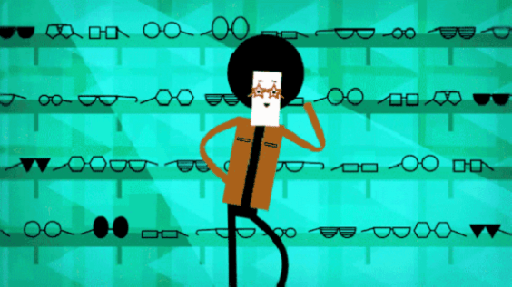  A Brief History of Eyeglasses – TED Ed | 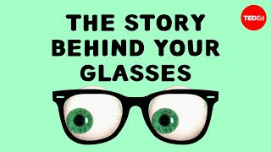  The Story Behind Your Glasses – TED Ed

How does the eye work?
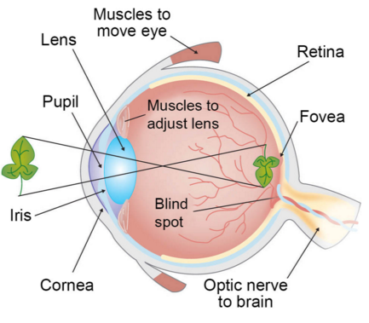
Students will investigate the parts of the human eye and what each part does. Students will use the following as a guide during their investigation.

- Draw a diagram of the human eye.
- Label the features of the eye including the cornea, pupil, lens, iris, retina and optic nerve.
- Create a glossary on each of the features of the eye.
- Create a model of the eye.
- Explain to another student how our eyes work.

Source of image

Activity: Glass Invention: Light Bulb
Watch the BTN Glass Inventions: Light Bulb story and respond to the following questions:
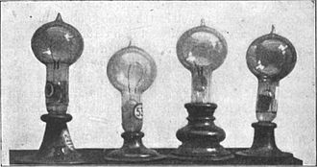
- What was used as a light source before light bulbs were invented?
- The basic idea of a light globe is that electricity is sent through a thin _____________which heats up and glows.
- Why is glass an important part of the light globe? What does it do?
- Who invented the light globe?
- How has the light bulb changed people’s lives?

Further Investigation
Watch this video which shows how the incandescent light bulb is made.

Activity: Who was Thomas Edison?
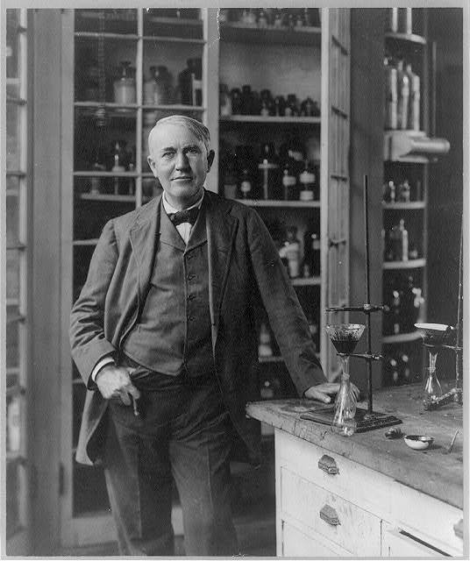
Students will develop a biography of Thomas Edison, the inventor of the light bulb. Begin by discussing with students what a biography is. What information is included in a biography and what does it tell us about a person? The biography organiser template at the end of this activity will help students to structure their biography. Students can use the following questions to guide their research.
- Where and when was Thomas Edison born?
- Describe his life growing up.
- What did Thomas Edison invent? (hint – it wasn’t just the light bulb)
- How has his inventions made an impact on others’ lives?
- Imagine you could sit down and talk to Thomas Edison. What questions would you ask him about his life and work?

Further Investigation
Sketch a portrait of Thomas Edison. Explore and experiment with different techniques and media to produce a portrait.

Useful Websites
- Glass: More Than Meets the Eye (Resource Book) – National Science Week 2022
- The Deadly Science Guide to Glass Teacher Resource – Australia Post
- Why is glass transparent? – TedEx
- Thomas Edison – Edison Innovation Foundation
- The origins of glassmaking – Corning Museum of Glass
- Timeline – History of Glass
- History of Fibre Optic Solutions - OSA
- Recycling Glass – WWF
- Bin Audit – BTN
- War on Waste: Can all glass really be recycled? – ABC News
- Making art with glass – ABC Open

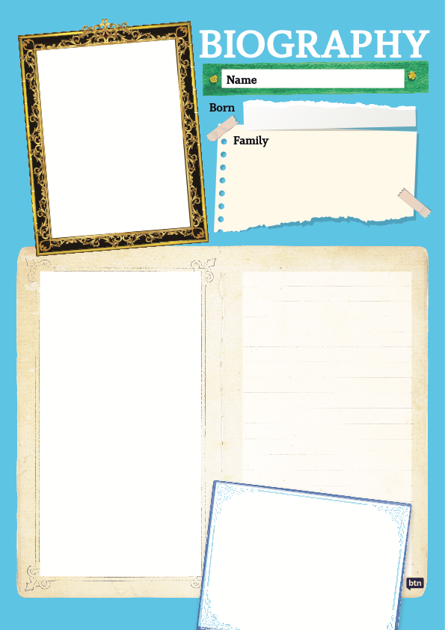

  - Teacher Resource

BTN Transcript: Episode 23 - 16/8/2022

Hey everyone, Amelia Moseley here bringing you this BTN Science Week special. Now, if you’re wondering what I’m doing standing in front of a glass house, well that’s because the theme of this year’s Science Week is glass and that’s what we’re going to explore on today’s show. We'll find out how glass has changed the world, learn about some amazing glass inventions, with the help of our Rookie Reporters, and even see some impressive glass art.

History of Glass

Reporter: Jack Evans

INTRO: But first today, let’s go back in time to find out how glass was first discovered and used and how it’s changed life as we know it. Here's Jack.

JACK, REPORTER: When it comes to drinking vessels, for me, nothing beats a glass. But have you ever wondered where does glass comes from? Why can I see through it? Is it just hot sand? And why can't I throw stones in glass houses? Well, I've asked a very dear friend of mine to help explain. Ahh. Oh gosh sorry, you're just so terrifying sometimes. Oh, those eyes.
While we clean up, let's take a look at the long, long history of glass and I do mean long.
JACK: Well, look what I found.
This is obsidian, it's a type of natural glass.
JACK: Yeah, yeah, I know. It appears to have been formed when the molten rock from this volcano cooled rapidly resulting in this sort of blackish/greenish thing. What do you think?
As the volcano would suggest, one of the main ingredients in making glass is heat. The other is typically, but not always, sand. There are a few other types of naturally occurring glass, like fulgurite which occurs when sand is hit by lightning and tektite which is the result of a meteorite impact. And from what experts can tell humans have been using these types of glass for hundreds of thousands of years. Including Australia's First Nations peoples who used it as cutting tools, as tips for spears and for ceremonial purposes. But the first human efforts to make glass, that we know of anyway, happened around 2500 BC, in the ancient region known as Mesopotamia. And some historians reckon it might have happened by accident.
JACK: Yeah, so, all I did was mix silica sand, lime, and soda. I thought I was making a drink. But instead, no, I was making this, a cup for my drink. Ha.
About 1000 years later the Ancient Egyptians also began creating things out of glass, in particular they were quite fond of making glass beads.
JACK: Oh, my necklace. Yeah, you noticed that did you. Yeah, it's glass beads. Yeah, yeah. All the rage down at the bazaar. I can get you some?
Over the next few hundred or so years glass making became popular across the Mediterranean, Europe and into parts of Asia. And around the first century BC the Syrians came up with the technique of glass blowing, which truly changed the game. Glass blowing was later taken by the Romans who used it, along with a sort of pressing technique, to create the first glass windows.
JACK: Manny, Manny, can you see me? I can see you.
Yep, there was a time when people didn't have glass windows. Instead, you might just have a hole in your wall with an animal hide curtain or a window made out of paper, fancy. By the 1100s many European cathedrals were being decorated with stained glass windows, coloured with powdered metals mixed into the molten glass.
JACK: Oh no. What have you done? All the glass is stained. Oh, I’m just kidding, no, no it looks great. Yeah, I love it, love what you've done.
As the years went on glass became more and more popular. In the 13th century in Northern Italy the first glasses to enhance eye sight came about.
JACK: Wow. Oh, I can see everything so much more clearly now. Wait a second, are you a mannequin?
Then in the 16th century in Venice we got our first look at ourselves thanks to mirrors.
JACK: Yeah, that's you. That's what you look like. Ah, not bad hey.
And in the 17th century we got telescopes.
JACK: Yoo hoo, Manny.
As for the big sheets of glass that are used in buildings pretty much everywhere. Well, most of that is thanks to this guy Henry Bessemer. He was the first to find a way of making glass perfectly flat. Nowadays we have all sorts of glass for all sorts of purposes, and it's opened up windows, so to speak, into a whole world of inventions and discoveries.
JACK: Well, thanks for helping me explain the origins of glass and sorry about throwing that water on you before. It's just that I got really, well, I guess we're even.
Quiz

Do you know the name of the type of glass that's formed by volcanoes? It's obsidian, and it's been used for thousands of years for all sorts of things.

Glass Inventions: Reading Glasses

Read by: Alba

Can you read this? What about now? Well, for millions and millions of people, these humble bits of glass have brought the world into focus and their story begins more than 800 years ago with this painting. Wait. Ah, there we go.
This is the earliest known painting of someone wearing glasses. His name is Hugh of Saint Cher and he lived in 13th century France. But many people agree that glasses were probably invented in Italy around 1268. Anyway, it wasn't until the printing press came along and people started reading a lot more books or trying to read them that glasses became super popular.
But how do they actually work? Well, it's all to do with something called refraction which is the way light bends as it passes through transparent surfaces. When our eye works perfectly light hits our lens and cornea at the front and then focusses onto our retina at the back which sends a nice clear image to our brain. But sometimes our cornea and lens have little imperfections that makes the light focus too close, too far away or not at all.

Glasses work by fixing these mistakes. By adding a bit of well, glass, to shift the light into exactly the right spot on our retina. About two thirds of Aussies wear some form of glasses in all sorts of different shapes, sizes and styles helping us see the world in all its perfectly refracted glory.

Glass Recycling

Reporter: Cale Matthews

INTRO: Now, one of the really cool things about glass is that it can be reused again and again and even transformed into something completely different. Let’s find out more about glass recycling and how it can help the environment.

GLADYS: Cale? You alright? You seem a bit stressed.
CALE: Yeah, sorry, I’m just trying to work out which bin to put my glass bottle in. I mean it seems like it should be recyclable, but I've just never really thought about if whether you can recycle glass.
GLADYS: Okay, that sounds like a bit of a ‘you’ problem. Probably something you can research yourself.

CALE: That was rude.
Gladys was right, it was a me problem and one that I could research. Turns out you can recycle glass.

CALE: In fact, it dates all the way back to Ancient Rome.

They produced glass on a massive scale and then broke it down and transported it across the Roman Empire, where it was re-melted, re-shaped and recycled into all sorts of glassware.

CALE: But what about in modern Australia, you know, right now, do we still recycle glass and if so, how do we do it? Let's find out.
CALE: G'day, g'day, how are you?
PHIL MARTIN, VICE PRESIDENT RECYCLING ASSOCIATION SA: I’m good, how are you?
CALE: Not too bad. Can you tell me, what you do here?
PHIL MARTIN, VICE PRESIDENT RECYCLING ASSOCIATION SA: Well, this is a recycling centre. This is one of 40 in metropolitan South Australia. We've got 120 of them across the state.
Phil Martin is the Vice President of the Recycling Association of South Australia and let's just say he can't get enough of glass bottles.
PHIL MARTIN, VICE PRESIDENT RECYCLING ASSOCATION SA: We can't get enough of glass bottles, whether it be beer bottles, wine bottles, glass is the best thing that can be recycled.
CALE: So I brought my glass bottle in, should we go see what happens to it?
PHIL MARTIN, VICE PRESIDENT RECYCLING ASSOCATION SA: Why not, let's do it.
CALE: Let’s do it.
Alright let me hit ya with some recycling facts. Around the globe around 20 percent of all glass products come from recycled glass. In Australia, that number is closer to 50 percent, and that's a good thing because right now the world is going through a bit of a sand shortage, the main ingredient of glass. See, you can't just use any sand, to make glass it needs to have a really high amount of the compound silicon dioxide and that's in high demand. Plus, melting down recycled glass takes far less energy than melting sand from scratch and that whole recycling process starts right here.
CALE: Nice and loud.
Glass gets brought in by the public to depots like this, where it’s sorted and then these massive containers are moved across town. That's to places like this one, where it’s processed into tiny glass pebbles known as cullet, which can then be melted down and re-made into new glass products.

PHIL MARTIN, VICE PRESIDENT RECYCLING ASSOCATION SA: You’re looking at around, about 14 and a half thousand cans in one of those blocks.

Phil says even though recycling cans, plastic and paper is great, these things deteriorate every time you reuse them, but glass doesn’t, and he says the best place to recycle glass is to take it directly to a depot like this.
CALE: Phil, thank you very much, I've learned a lot about recycling glass, clearly it’s the way to go.
PHIL MARTIN, VICE PRESIDENT RECYCLING ASSOCATION SA: For sure, it just keeps going round and round.

CALE: Absolutely, perfect. Well at least it will be recycled.
Quiz

What chemical compound is glass usually made from? Is it silicon dioxide, carbon dioxide, or calcium carbonate? It’s silicon dioxide.

Glass Inventions: Telescopes

Read by: Devon.
For thousands of years, people have stared up at the stars and imagined what was out there. But it wasn't until a few hundred years ago we started to get a glimpse of all the planets and galaxies that fill our universe, and it was all thanks to a few bits of glass.
The invention of the telescope is usually credited to Dutch eyeglass maker Hans Lippershey in 1608. Like others before him, he knew that you could make images seem bigger using curved glass and the power of refraction. He used one curved piece at the front of the telescope which then focussed the light down a long tube towards another smaller bit of glass which enlarges the image for our eye.
It was Galileo Galilei in 1609 who realised the telescopes full potential. He pointed it to the sky and for the first time saw mountains and craters on the Moon. The rings of Saturn and four of Jupiter's moons. His observations changed our view of the universe forever.

Today, most telescope use a combination of lenses and large mirrors to help us peer into the galaxy and beyond at exploding stars, far away planets and even billions of years into the past to the very beginning of our existence.

Fibre Optics

Reporter: Cale Matthews

INTRO: Glass has some really amazing properties that make it useful for all sorts of things, like growing plants or even transmitting information. Cale went along to meet a group of scientists who are using a special type of glass to help them explore the underwater world. Check it out.

NAT: Stop it, you.

CALE: Kelly.

NAT: Yes captain.

CALE: Status report.
NAT: Ah, status is good sir, I had a wonderful sleep, a splendid breakfast, but I must admit I’m missing my family and feeling quite lonely.
CALE: The ocean Kelly. What sort of data are we collecting? What’s, what’s out there?
NAT: Ah, okay. The data, yes. Now would be a good time to tell you we’re not actually collecting any data; these are just videos I'm playing from my laptop. But we’re having fun. Just me and you on a submarine.
CALE: Okay, give me an hour, I’m going to find an expert. Just, just give me an hour.
NAT: Cale, where are you going, we're underwater Cale?
Whether you're underwater in a submarine or just sitting at home on your computer, there's a piece of technology we've been using for years to send and receive information in the blink of an eye. These are optic fibres. They work by transmitting information in the form of light along ultra-thin strands of glass, yeah, that's glass. Most of our telecommunication, TV and internet signals are sent through optic fibre cables that stretch for hundreds and thousands of kilometres underground. In fact, you're probably using them to watch this.

CALE: Hey Shanae, how are you going?

SHANAE LAY, DEFENCE SCIENTIST: Hey, good how are you?

CALE: Not too bad.

I went down to the Defence Science Technology Group in Adelaide to learn a little bit more about how they work.
CALE: I've got a bit of optic fibre here and some light coming through it, which the camera can see, there you go. But even if I bend it and move it round the light still comes out the other side, so is that a kind of a good demonstration of how optic fibres work?
SHANAE LAY, DEFENCE SCIENTIST: Yeah, and the way it works is via a reflection process. So, the light is contained within the optical fibre because as it moves through, it just reflects from surface to surface through that glass core all the way until it reaches the other end.
Optical fibres have been around since the 60s. In fact, they were used in the cameras that recorded this. But they've come a long way since then and scientists like Shanae are still finding new uses for them.
SHANAE LAY, DEFENCE SCIENTIST: We use them to make something called a fiber optic hydrophone. So, that is a type of underwater microphone that we use to listen to different sounds in the ocean. When we put one of these sensors in the ocean and a sound wave comes along and hits the sensor, it will exert a pressure on the device which bends that fibre laser and when this happens it sends a signal to us to say, hey, something’s making some noise in this area, and then we can try to figure out what it is and where it’s coming from. Especially if you're deep in the ocean, it's quite dark, we can't see things. So, we use sound instead to navigate and figure out where we are and make sure we don't crash into some ocean trenches or sea cliffs or that sort of thing.
CALE: Right, sounds like I need some of them, alright, I'll be back.
NAT: Is it too late to add two garlic breads to that, and the sodas, could I get one orange?
CALE: Okay, sorry. Back.
NAT: How did you get into the, ah.
CALE: Don’t worry about that. So, turns out boats like ours use this really high-tech glass called fibre optics and it kinda like senses what’s around the boat and stuff like that.
NAT: Cool, well let’s get some in here. Stop dilly-dallying.
CALE: Mm, ah, that part sounded really complicated. So, no.

Quiz

What do you call it when light bends as it passes through glass? Reflection, refraction or retention? It's refraction.

Glass Blowing
Reporter: Gladys Serugga

INTRO: Something else glass has been used for, for thousands of years, is art. And that’s what this next story’s all about. Gladys went to meet a glass blower to find out how it can be moulded and shaped.

GLADYS, REPORTER: Here in this 1,200 degree furnace also known as a crucible, a transformation is taking place. This glowing syrupy gob is the early stages of a work of art. Emma is the glass artist behind these colourful and unusual creations which all started out as sand.
EMMA, GLASS ARTIST: We melt it at 1,000 degrees, at least. So, I think it's about 1,200 degrees at the Jam Factory our glass will melt at and that's when it changes from being sand to liquidy, molten, the closest thing it is to, it's really like honey.
While it's in that runny, sticky state glass can be poured, stretched and moulded into all sorts of shapes or even blown up like a balloon.

EMMA, GLASS ARTIST: Glassblowing is just magic in action. It's using glass in its soft, molten form and using metal equipment like blow pipes. So, like a straw basically made of metal, and because it’s hollow and there’s a hole inside, you can blow in one end and the glass on the other end can inflate.

Glass blowing is a technique that's been around for a really long time. It's thought that it was first discovered by Syrian craftsmen sometime in the first century BC. But the world's most famous glass blowers were from the island of Murano in Venice, where the technique was a closely guarded secret for centuries. Now, it’s something anyone can learn, including me.
EMMA, GLASS ARTIST: Alright Gladys. Blow, please.
This is all possible because of the unique scientific properties of glass.

EMMA, GLASS ARTIST: Stop, wonderful. You can see that really inflated, didn’t it?

Glass is something called an amorphous solid. Which means its atoms aren't arranged in a perfect pattern like most solids. Instead, they're a little bit random, kind of like a liquid. Amorphous solids don't have an exact melting point, where they snap from solid to liquid and back again. Which means you can keep them in this gooey, sticky, honey state and keep reworking the shape. Once she's finished shaping the glass, Emma has to leave it in a kiln overnight so it can cool down really slowly.
EMMA, GLASS ARTIST: So, the atoms of the glass are flying around when it's in a really hot state. And when it cools down, they connect together. And if that happens too quickly, they don't connect very well. And that's when there's stress in the glass, and it can crack and shatter and explode, so, we want to avoid that.
Emma says she's a big fan of the science behind glass art.
EMMA, GLASS ARTIST: So, what I actually loved in school was science. So, I think that it's very funny that I'm now a glass artist, because I find that art and glassblowing is a perfect mixture of psychology and science and chemistry. There's so many different techniques and different types of glass for different applications depending on what you want to make. So, glass as you find out during Science Week, it's not just one thing. It's this umbrella term for all these different aspects of what glass is and has been in can be. And glass for art is just one of those.

Glass Inventions: Light Bulb

Read by: Eamon.
I've got an idea. I want you to think of an invention that has brightened up our lives. Have you thought of it yet? Before electricity, the world was mostly lit by fire in candles or oil lamps or gas lanterns. But in the 1800s we discovered we could make light from electricity and scientists imagined a new way of lighting our world, the lightbulb. The basic idea is that electricity is sent through a thin material called a filament which heats up and glows. It’s all encased in a glass bulb which protects the filament and lets the light shine through.
Early inventions looked pretty similar to the way they look today, but they were either too dim, the filament didn't last long, or it cost too much money. All the while, an American inventor called Thomas Edison was working away, trying to come up with the perfect material. After thousands of different designs, he eventually settled on this one with a bamboo filament. These days it’s usually made out of tungsten, but the design of the bulb is pretty much the same and it’s changed our world letting people work, play and travel and discover in the dark all thanks to one bright idea.
Closer

Well, that's it for this BTN Science Week special. I hope you enjoyed it and learnt a lot more about glass. We'll be back next week with a regular episode, but you can stay up to date with the latest news on Newsbreak every weeknight. I’ll catch you next week, bye.

