
EPISODE 12
12 May 2026

KEY LEARNING
Students will develop a deeper understanding of platypuses and create a profile.

CURRICULUM
Science – Year 5
Examine how particular structural features and behaviours of living things enable their survival in specific habitats.

Science – Year 6
Investigate the physical conditions of a habitat and analyse how the growth and survival of living things is affected by changing physical conditions.

  - Teacher Resource

Platypus

Focus Questions
Discuss the BTN story as a class and record the main points of the discussion. Students will then respond to the following:
- What are some unique features of the platypus?
- Platypuses are monotremes. What does that mean?
- Scientists originally thought the platypus was a fake. True or false?
- What are some threats to platypuses?
- Why are some scientists in New South Wales trying to change the protection status of the platypus?

Activity: Note taking

Students will practise their note-taking skills while watching the BTN Platypus story. After watching the story, ask students to reflect on and organise the information into three categories. What information in the story was...?
- Positive
- Negative or
- Interesting

Activity: Class Discussion
Create a class mind map with PLATYPUS in the middle. Ask students to record what they know about the species. In small groups, ask students to brainstorm responses to the following questions:

- What do you know about platypuses?
- Why is it important to protect the species?
- What is the conservation status of platypuses? Is it the same in every state?
- What makes the platypus unique?
- What questions do you have about platypuses?

Activity: Key Words
Students will brainstorm a list of key words that relate to the BTN Platypus story. Here are some words to get them started.
THREATENED SPECIES | MAMMAL | MONOTREME
BURROW | VENOMOUS | ELECTRORECEPTORS

Ask students to write what they think is the meaning of each word (including unfamiliar words). They will swap definitions with a partner and ask them to add to or change the definition. Check these against the dictionary definition.

Activity: Platypus profile
Students will research and write a profile featuring the platypus. Encourage students to use a range of sources to find their information.
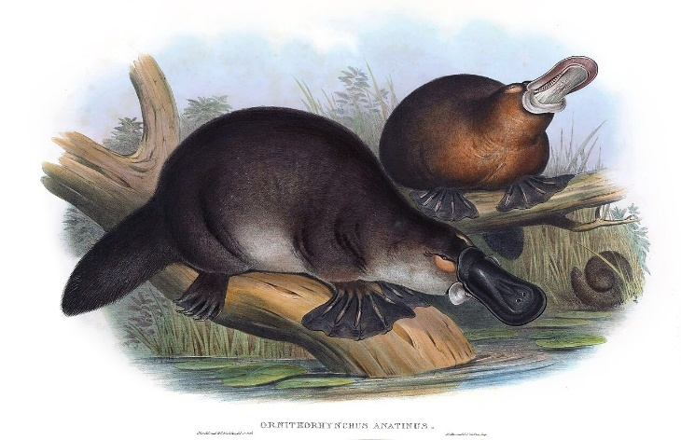
Research
Students will research the following and then share their research findings with the class or create a display in the classroom.
- Illustration or photo
- Name (common and scientific name)
- Conservation status – What is being done to protect the species?
- Appearance
- Adaptations
- Habitat
- Threats
- Unique features

Further Investigation
Students will respond to one or more of the following questions.
- How do platypuses use electroreceptors in their bills to detect prey? Why is it necessary for hunting?
- How does the platypus's venom work?
- Why do platypuses glow under UV light?
- Investigate why scientists originally thought the platypus was a fake.

Activity: Platypus Dreaming Story
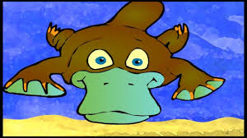
Students will explore Indigenous people’s connection to the platypus through Dreaming Stories. Listen to Biladurang - the Dreaming Story of how First Nations people believe the platypus got its features. Ask students to retell the story in their own words.

Useful Websites
- Platypus Protection – BTN
- Platypus Return – BTN
- Platypus – Australian Museum
- What is a monotreme? – Australian Museum
- The platypus: a unique and vulnerable Australian – Museums Victoria
- Our animals: Lives of platypuses – ABC Education

