EPISODE 26
12th September 2023

KEY LEARNING
Students will view a range of BTN stories and use comprehension skills to respond to a series of focus questions.

CURRICULUM
English – Year 4
Use comprehension strategies to build literal and inferred meaning to expand content knowledge, integrating and linking ideas and analysing and evaluating texts.

English – Year 5
Use comprehension strategies to analyse information, integrating and linking ideas from a variety of print and digital sources.

English – Year 6
Use comprehension strategies to interpret and analyse information and ideas, comparing content from a variety of textual sources including media and digital texts.

English – Year 7
Use comprehension strategies to interpret, analyse and synthesise ideas and information, critiquing ideas and issues from a variety of textual sources.
  - Teacher Resource

Focus Questions
As a class, discuss the stories featured in the episode of BTN Classroom and record the main points of the discussion. Students will then respond to the following focus questions.

Qantas Troubles
- Why has Qantas been in the news recently?
- Qantas is owned by the government. True or false?
- What impact did the pandemic have on the airline?
- Why were some customers unhappy with Qantas?
- If you were in charge of Qantas, what changes or improvements would you make?

Fire Season Warning
- Discuss the BTN story in pairs or small groups.
- What skills are the young people in the BTN story learning?
- What are experts saying about the chances of bushfires this summer?
- Why is there more fuel around?
- What are authorities urging people to do to reduce the risk of bushfires?

Check out the teacher resource on the Archives page.

Food Advertising
- What was the main point of the Food Advertising story?
- Why are some customers unhappy with Burger King?
- What tricks do advertisers and food stylists use to make food look more appealing?
- In Australia, what guidelines do advertisers need to follow when advertising food and drinks?
- What did you learn watching the BTN story?

Democracy Day
- What is a monarchy? Name three countries that are monarchies.
- What type of government do we have in Australia?
- Democracy comes from which two Greek words?
- What are some threats to democracy?
- What questions do you have about the Democracy Day story?

Check out the teacher resource on the Archives page.

Opera Kids
- Working in pairs, discuss the Opera Kids story.
- Which opera are Elliot and Tomas performing in?
  - The Magic Flute
  - Otello
  - Macbeth
- In which century did opera start?
- How is opera different from other performance art?
- What does Elliot like about performing in an opera?

EPISODE 26
12th September 2023

KEY LEARNING
Students will investigate the science of bushfires and the importance of preparing for bushfire season.

CURRICULUM
HASS – Year 5
The influence of people on the environmental characteristics of places in Europe and North America and the location of their major countries in relation to Australia.

The impact of bushfires or floods on environments and communities, and how people can respond.

HASS – Years 5 and 6
Work in groups to generate responses to issues and challenges.

Science – Year 5 & 6
Scientific knowledge is used to solve problems and inform personal and community decisions.

Science – Year 6
Scientific knowledge is used to solve problems and inform personal and community decisions.

Sudden geological changes and extreme weather events can affect Earth’s surface.

Science – Year 7
Scientific knowledge has changed peoples’ understanding of the world and is refined as new evidence becomes available.

  - Teacher Resource

Fire Season Warning

Focus Questions
Discuss the BTN story as a class and record the main points of the discussion. Students will then respond to the following:
- Discuss the BTN story in pairs or small groups.
- What skills are the young people in the BTN story learning?
- What are experts saying about the chances of bushfires this summer?
- Why is there more fuel around?
- What are authorities urging people to do to reduce the risk of bushfires?

Upsetting News
Talking about bushfires may be upsetting for some children and may cause some discomfort, distress and/or anxiety. Please refer to the following links for information on how to talk to children about bushfires and upsetting news.

- UNICEF has created a guide about how to talk to children about natural disasters.
- Kids Helpline has some information to help children cope with natural disasters.
- BTN has a short video about the Important Things to Remember about Upsetting News.

Activity: Note taking
Students will practise their note-taking skills while watching the BTN Fire Season Warning story. After watching the story, ask students to reflect on and organise the information into three categories. What information in the story was positive, negative, or interesting?

Activity: Research
Discuss the information raised in the BTN Fire Season Warning story. What questions were raised in the discussion and what are the gaps in students’ knowledge? The following KWLH organiser provides students with a framework to explore their knowledge on this topic.

What do I know? | What do I want to know? | What have I learnt? | How will I find out?

Students will develop their own question/s to research or choose one or more of the questions below. Encourage students to collect and record information from a wide variety of sources and present the information they find in an interesting way.

- How can people prepare for the bushfire season?
- How do bushfires start? (Think about fuel, weather and geographical conditions).
- What is the Fire Danger Rating system? Explain what it is and why we have it.
- What is a bushfire survival plan?
- What is bushfire fuel? List the different fuel types.
- Research the difference between low, medium, high and extreme bushfire risk situations. Think about temperature, wind conditions, how dry it is and when it last rained.

Activity: Understanding Bushfires
Watch these videos to help students understand more about bushfires. Visit BTN’s topics page for a range of stories looking at Natural Disasters to learn more about bushfires, and their impact on people and the environment.

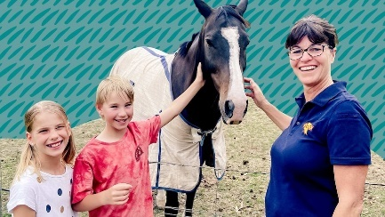  BTN Bushfire Survival Plan | 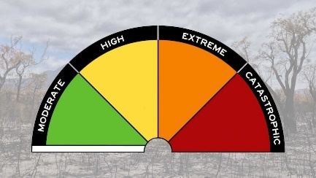  BTN Fire Rating Update | 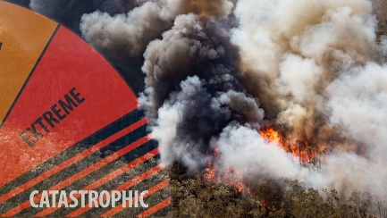  BTN Bushfire Season

Activity: Mt Resilience
Students will visit Mt Resilience – an augmented reality experience that allows students to explore a town that’s been designed around climate and disaster preparedness. The app works on both phones and tablets.

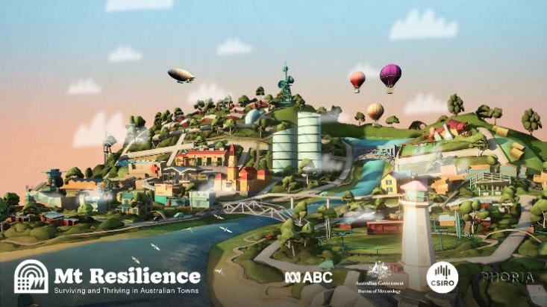
Explore the features of Mt Resilience
Working in pairs, students will look around and explore Mt Resilience. Students will play the Mt Resilience experience to see how the community has worked together to mitigate the impact of extreme weather.

Working in pairs, students will look around Mt Resilience and practise navigating their way around the town by zooming and rotating. Students will start by experiencing the Bushfire Scenario. There are several play arrows, two of which will take you to the Fire Resilient House and Cultural Burning videos. Students will play each of the videos and the respond to the questions below.

Fire Resilient House
Watch the Fire Resilient House video and respond to the following:
- How do Sam and Ayla prepare their property for bushfires?
- Explain their power set up.
- What is their bushfire evacuation plan?
- Explore the features of Sam and Ayla’s house by tapping on the information icons.

Research examples of bushfire resilient buildings (homes and schools) and gardens. Design a bushfire resilient house or garden. What are the features that make it bushfire resilient?

Cultural Burning
Watch the Cultural Burning video and respond to the following:
- What is cultural burning?
- What do rangers consider when they do a low intensity cultural burn?
- What do practices like cultural burning achieve?
- Record what you know about the importance of Country to Aboriginal and Torres Strait Islander people.
- Explore each information icon in the cultural burning area.

To learn more about cultural burning, go to the Firesticks website. This Traditional burning video explores bushfire management practices in more detail.

Activity – Bushfire Plan
Students will learn more about bushfire survival plans. Watch the short video and then hold a class discussion about making a bushfire survival plan.

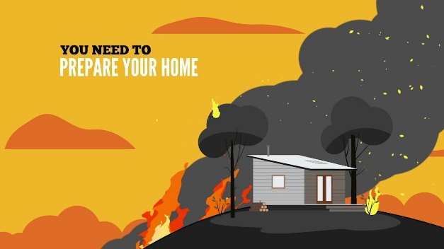
Ask students to respond to the following questions:
- What is a bushfire survival plan?
- Why is it important to have a bushfire plan?
- Who should have a bushfire plan?
- What sort of information should be in a bushfire plan?
- Why is it important for the whole family to be involved making the plan?

Students will research the four steps to get ready for a bushfire.
- Discuss what to do if a bushfire threatens your home.
- Prepare your home and get it ready for bushfire season.
- Know the bushfire alert levels.
- Keep all the bushfire information numbers, websites and the smartphone app.

The NSW Fire Service website has more information about what to do to be well prepared for a bushfire.

Activity – Choose a project
Individually or in small groups, students will choose one of the following projects to work on and then present their findings to the class.

Summary
Write a summary of the story. What was the story about? Why did BTN cover this story?
Quiz
Create a true or false quiz to test your classmate’s knowledge about the bushfire season.
Minecraft Challenge
Design and build a virtual bushfire resilient home using Minecraft Education.
Campaign
Design a campaign to educate kids around Australia about the Australian Fire Danger Rating System.

Useful Websites
- Junior program helping Glenlyon Rural Fire Brigade attract next generation of volunteers – ABC News
- Large parts of Australia put on high alert for significant bushfires in spring – ABC News
- Bushfire Survival Plan – BTN
- Fire Rating Update – BTN
- Bushfire Survival Plan – NSW Rural Fire Service
- Bushfire Prepare – Government of WA

EPISODE 26
12th September 2023

KEY LEARNING
Students will learn more about what democracy is and explore significant events in Australian democracy.

CURRICULUM
HASS – Year 5
The key values and features of Australia’s democracy, including elections, and the roles and responsibilities of elected representatives.

HASS – Year 6
The key institutions of Australia’s system of government, how it is based on the Westminster system, and the key values and beliefs of Western democracies.

  - Teacher Resource

Democracy Day

Focus Questions
Discuss the BTN story as a class and record the main points of the discussion. Students will then respond to the following:
- What is a monarchy? Name three countries that are monarchies.
- What type of government do we have in Australia?
- Democracy comes from which two Greek words?
- What are some threats to democracy?
- What questions do you have about the Democracy Day story?

Activity: See, Think and Wonder?
After watching the BTN Democracy Day story, students will respond to the following questions:
- What did you SEE in this video?
- What did you LEARN from this story?
What do you SEE, THINK and WONDER?
- What do you WONDER about this story?
- What QUESTIONS do you have about this story?

Activity: Class Discussion
After watching the BTN Democracy Day story, hold a class discussion, using the following questions as a guide. Record student responses on a mind map.
- What is democracy?
- Where did democracy come from?
- Australia is a democratic society. What does this mean?
- What is needed for a healthy democracy?
- What are some threats to democracy?

Glossary
Students will brainstorm a list of key words that relate to the BTN Democracy Day story. Here are some words to get them started.

DEMOCRACY | REPRESENTATIVE DEMOCRACY | MONARCHY
DECISIONS | CONSTITUTION | GOVERNMENT

Activity: Research Project
Discuss the information raised in the BTN Democracy Day story. What questions were raised in the discussion and what are the gaps in students’ knowledge? The following KWLH organiser provides students with a framework to explore their knowledge on this topic.

What do I know? | What do I want to know? | What have I learnt? | How will I find out?

Students will develop their own question/s to research about democracy. They will collect and record information from a wide variety of sources. Students may develop their own question for inquiry or select one of the questions below.

- Magna Carta has become a powerful symbol of our rights and freedoms. Why was Magna Carta originally created? What would life be like if Magna Carta didn’t exist? This British Library video explains more.
- Investigate the key values that underpin Australia’s democratic system of government: freedom, equality, fairness and justice. What does each value mean to you? Why are these values important?
- What are the benefits of democracy? Is everyone’s experience of democracy the same?
- What is the Voice to Parliament? Write a summary which answers the 5 W’s – Who, What, Where, When and Why? Include the following words in your explanation: Uluru Statement from the Heart, referendum, First Nations Voice and constitution.
- What is the Australian Constitution? When and why was it written?
- What are the steps to change the Australian Constitution? Explain the process of a referendum. How many votes does a referendum need to be successful?
- How many referendums have been held in Australia? Use a timeline to highlight important referendums in Australia.

Activity: Australian Democracy
Look at this infographic, The Story of Our Freedom, to get a picture of the origins of democracy and how it has influenced our rights and freedoms today.

Students can then create their own timeline highlighting the main events that led to democracy in Australia. Research the origins of democracy and what democracy looks like in Australia today. Include three significant facts about each event. Reflect on ways in which people in ancient societies were represented and compare to Australia today. Students can watch Ten Fast Facts about Australian Democracy to help them create their timelines.
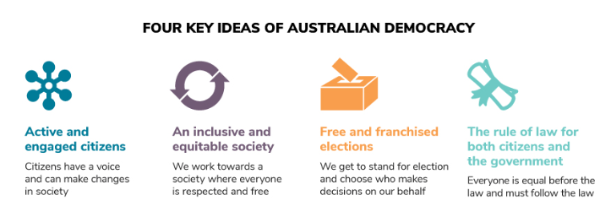

Source: Parliamentary Education Office

Activity: Representative Democracy
In Australia we have something called a representative democracy. That means that unlike in ancient Greece where everyone went to meet and vote on laws, we elect a representative to do that for us. They're our politicians and they represent us in parliament. It's their responsibility to keep in touch with their voters and make sure their voices are heard on a national level.
What makes a good representative?
Ask students to think about the following question: What do you think makes a good representative? Brainstorm and list what a good representative ‘is’, ‘does’, ‘does not’ and ‘says’. Record their ideas. Here are some examples:
- honest
- good at communicating
- confident
- has a positive attitude
- commitment
- creative
- inspiring

Who represents you in your electorate?
Find out which electorate your school is located in and who representatives you in your local area.
- Go to the Australian Electoral Commission website to find your electorate.
- Find more information on the electorate that your school is situated. On a map locate your school and draw the boundary of your electorate.
- Create a profile on your local Member of Parliament.
  - Who is the current member for this electorate?
  - What political party do they represent?
  - Is it a safe or marginal seat? Watch this BTN story to learn more about Safe and Marginal Seats.

Who represents you in your school community?
What makes your school a democratic community?
- Who makes decisions at your school? Give examples.
- What decisions do you make personally?
- Are many decisions made through representation?
- How do your school representatives know what you want?
- Who represents you on the School Representative Council (SRC)?
- How important is it for us to have good representatives that make decisions on our behalf?
- How can teachers, students and parents have a say in what happens in your school community?

Activity: Class poll
Should young people have a say in how our country is run? Students will conduct their own opinion poll on the issue of lowering the voting age. Working in groups, students will need to decide who their sample group will be and how many people will be polled.
- What method they will use to conduct the poll? (Face to face interviews or written responses).
- Ask students to graph the opinion poll results and display in the classroom. Students can reflect on how reliable they think the results were. What would they do differently next time?
- Students may want to film their interviews and then create a movie to present to other students.

Activity: BTN Democracy special
Watch this BTN Democracy special to learn more about the origins of democracy, Australia’s democratic journey and ask whether voting rights should be extended to younger Australians.

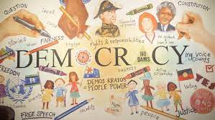

Activity: Democracy Quiz

- Who created the first form of democracy?  A. Ancient Greece  B. Ancient Rome  C. Ancient Egypt  - Which type of government gives citizens the power to decide the laws they live under?  A. Communism  B. Democracy  C. Monarchy  - Australia is a constitutional monarchy.  A. True  B. False  - The word democracy comes from the ancient Greek words `demos’ and `kratos’. What do these words mean?  A. The dictator, to rule  B. The king, to rule  C. The people, to rule  - Who does the Governor-General  represent in Australia?  A. Prime Minister  B. The people  C. The King | - Voting in Australia is compulsory.  A. True  B. False  - At what age is it compulsory  for an Australian citizen to vote?  A. 16 years old  B. 18 years old  C. 21 years old  - When is the Indigenous Voice to Parliament referendum going to be held?  A. 14 September  B. 14 October  C. 14 November

Quiz Answers: 1A, 2B, 3A, 4C, 5C, 6A, 7B, 8B

Useful Websites
- International Day of Democracy – UNESCO
- Defining Democracy – Museum of Australian Democracy
- Democracy - Parliamentary Education Office
- Ten Fast Facts about Australian Democracy – MOAD
- History of Democracy? – BTN
- History of Voting – BTN
- The story of our freedom – Human Rights Commission

  - Teacher Resource

BTN Transcript: Episode 26 – 12/9/2023

Yaama I'm Jack and you're watching BTN. Here’s what’s coming up. We find out how Aussies are preparing for fire season, learn why a group of American customers is suing over this burger and discover more about art of opera.

Qantas Troubles

Reporter: Michelle Wakim

INTRO: First up today to Qantas. As you might have heard, it's been facing a bit of criticism and last week it's former boss, Alan Joyce, retired early after 14 years on the job. Here's Michelle to find out more about what's going on.

Robert Menzies, Former Australian Prime Minister: I never have any hesitation myself in saying that Qantas is the greatest international airline in the world. There may be others that are bigger, but in my humble opinion there are none quite so good.
Michelle, WAKIM, REPORTER: For more than a 100 years, Qantas and its flying kangaroo has defined itself as Australia's airline. It was created in 1920, and originally called the Queensland and Northern Territory Aerial Services, shortened to how we know it now as Qantas. For a while, it was owned by the government, and it was known around the world for its safety.
Tom Cruise, Rain Man: Qantas?

Dustin Hoffman, Rain Man: Qantas never crashed.
Of course, a lot has changed over the years: it's now a private company and it also owns JetStar. And while it still calls itself the spirit of Australia, our oldest and largest airline, has hit some turbulence.

News Headline: Qantas has apologised to customers after being accused of selling tickets for flights that had already been cancelled.
News Headline: Qantas is now facing a class action lawsuit seeking millions of dollars in compensation and refunds for thousands of customers.
News Headline: Qantas has issued a statement, admitting its customer service standards has slipped and promising to do better. But it's just one of several challenges the airline is now facing.
MICHELLE: Over the past few weeks you might have heard a lot of people criticising Qantas. So, what's going on?

Well, for starters, there was a pandemic, which had a huge impact on airlines right around the world.

News Headline: Covid-19 and the Virgin Australia collapse are costing hundreds more jobs tonight.

News Headline: With billions of dollars in debt and most of its fleet grounded, the announcement surprised few.
To survive, Qantas said it needed to lay off thousands of staff and took billions of dollars of help from the government. Then when travel started up again, there were a few issues including lost luggage and cancelled flights. And people whose flights were cancelled, either during covid or after, were given flight credits, which is kind of like a gift voucher. As the months went on, things improved.
Alan Joyce, Former Qantas CEO: Qantas is now the most on time, and the lowest level of cancellations of any of the major carriers for 11 of the last 12 months.
And by the end of last month, Qantas announced an almost $2.5 billion profit.
MICHELLE: Good news ladies and gentlemen, it looks like clear skies ahead. Oh wait, what was that?
Despite the improvements for Qantas, trust in the airline plummeted and it became the most complained about company in Australia. It's now facing a couple of law suits, one from customers who say they should have been given refunds not flight credits and another from the ACCC, which looks after consumer rights, and says the airline had been booking passengers on flights it had already cancelled. Qantas has apologised and said it's going to turn things around and, just last week, a new boss took over.
Vanessa Hudson, Qantas CEO: We know that post-Covid we haven't always delivered to what our customers expect, but we are listening, and we hear what they are saying. Our job is to get the balance right, between looking after our customers, you our people, and the business itself.
So where does this leave the flying public? A bit up in the air, to be honest. But many are hoping that we land in a better, fairer place.

News Quiz
Who is this? It’s Chinese President Xi Jinping. Anthony Albanese’s set to become the first Australian Prime Minister to visit China in seven years after accepting an invitation to meet the country’s leader. Australia hasn’t had the best relationship with China in recent years after big disagreements over COVID19, trade and human rights issues.
Australia’s planning to send a rover to the moon for the first time. It’s working with NASA to design and build the rover which will be sent on a future Artemis mission with liftoff set for as soon as 2026. What will the rover be called? It’s a trick question because the rover doesn’t have a name yet. The Australian Space Agency’s launched a competition to let Aussies decide it instead. You’ve got until October 20 to submit your best idea.

The world’s most popular search engine, Google, has celebrated a milestone birthday. How long has Google been operating for? 10 years, 25 years or 40 years? It’s 25 years. It was founded on the 4th of September 1998 by these guys Sergey Brin and Larry Page, who built Google together in their Californian dorm room. 25 years on there are 8.5 billion searches on Google every single day… you don’t believe me go google it.

Fire Season Warning

Reporter: Joe Baronio

INTRO: The weather's starting to warm up in Australia and in some places, fire season has already started. Authorities are warning this summer could be a particularly dangerous one, so Joe found out what people are doing to stay safe.

Joe Baronio, Reporter: These kids from Glenlyon in rural Victoria are learning some important skills. They're training to be firefighters as part of the Country Fire Authority's junior fire brigade.
Katie: It's a good way to learn about the fire brigade and what it is like to be a firefighter, without actually going into the action yet.
Rural Aussie towns like Glenlyon rely on volunteers to help their fire services. But recently they've been struggling to find enough people, and this year it's looking like they'll need as much help as possible. See, according to the Bureau of Meteorology, we've had an unseasonably warm and dry winter, with the rainfall average down by about 8% and the average temperature up by about 1.5 degrees. Experts reckon these odd conditions will carry through spring and eventually summer. In fact, they've already announced that Aussies should be preparing for a summer of heatwaves, and the most significant bushfire season since the black summer fires of 2019-2020.
Robb Webb, Australasian Fire Authorities Council: It doesn't need to be a black summer to be dangerous, and it just makes common sense for people to be prepared. We don't need any reminders given what's happened in the northern hemisphere, whether it be Greece, whether it be Canada, and of course the tragic conditions in Hawaii recently.
Since 2020 we've had three pretty wet years, which has created a lot of fuel in the form of things like grass.
Comm. Rob Rogers, NSW Rural Fire Service: There's more than a metre tall grass, and we've had frost and dryness that's started to kill off that grass so it's all ready to burn.
These warnings are all coming without an El Niño weather event formally being declared in Australia. An El Niño event happens when ocean temperatures near South America are unusually warm, and waters in this part of the world is colder than usual. That means more rain over there and hotter and drier conditions over here, leading to increased risk of things like droughts and bushfires. Authorities from the United States and the United Nations have already declared El Niño, but Australia's Bureau of Meteorology says while it looks likely, they're not ready to make the call yet. Even without El Niño declaration, things aren't looking great for millions of Aussies across the country living in rural areas.

The Australasian Fire Authorities Council say the areas most at risk of fires include central Australia, Queensland, parts of New South Wales, Victoria, and South Australia, and authorities are urging people to clean up hazardous debris around their homes while also getting their bushfire plans ready early. Fire services like the CFA are calling for more volunteers and say they're supporting more fire brigades to start their own junior programs, like this one in Glenlyon. Although they won't be on the front-line fighting fires this season, these kids say they're keen to keep learning the ropes so they're ready to help protect their community.
Leni: I think it's important to be part of the fire brigade on a community level because we make lots of friends and it's fun to just talk to people, and it's a good thing to do, I guess.
Stanley: It's a good thing for the community and I live in the bush so if there's fires, I want to feel like I'm helping to put them out.
Russell Newton, Glenlyon Fire Brigade Captain: We're hoping that those kids will become our next level of leaders and take on the custodianship of the brigade for the future.
Democracy Day

Reporter: Joe Baronio

INTRO: This Friday is the International Day of Democracy which was created by the UN to celebrate the type of government that's of, for and by the people. Let's find out more about just what democracy is and why the UN says young people are the key to its future.

Shop Assistant: Ah, welcome to the build a government workshop, where dreams are made, and your future is in your hands.
KID: Woah. Where do I begin?
Shop Assistant: Well, let's start with a base. What type of government do you want?
KID: There's different types?
Shop Assistant: Of course. We have something for everyone. I'll run you through our best sellers. First off, we have the monarchy, which is when one family is in charge of making all the decisions, like a royal family with a king, queen, and so on. That's one of our oldest types of government and it's been available since ancient Egypt around 3000 B.C.
KID: Communism, dictatorship. What about that one?
Shop Assistant: Aha. that's our best seller, Democracy. Where people have the power to decide what laws they live under.
KID: Wow.
Shop Assistant: Yeah. This one has also been around for quite a while. It comes from the ancient Greek words 'Demos', the people, and 'Kratos', to rule, and since the Ancient Greeks, many countries have put their own spin on democracy. Take Australia for example: we're a representative democracy, which means the public elect a representative to make decisions on their behalf, and a constitutional democracy which means our government follows the rules of this really important document called, well, the constitution. Why is democracy so popular you might be asking?
KID: I didn't ask.
Shop Assistant: Well, let me tell you. The idea behind democracy is everybody is equal and respected. Everybody gets an equal say in how things are run, and if they're not happy they can do something about it. Let's hear from some satisfied customers.
VOXIE: A democracy allows people to get a choice.
VOXIE: It gives people a chance to say what they think and not just like one person voting on everything.
VOXIE: It's a fair system that will let the people have the choice.
Shop Assistant: While there are definitely exceptions, generally democracies tend to be wealthier, healthier, and more peaceful, which is why the UN is such a big fan of it. Except there's a problem. Recently, they say democracy has been declining.
KID: What does that mean?
Shop Assistant: Uh, well these things take a bit of work to look after. A healthy democracy depends on a few things. People have to know what their leaders are up to, which requires free and honest media, if they have a problem, they have to be able to talk about it, and the leaders need to be trustworthy. The UN says that conflicts, climate change, and financial problems are all threats to democracy, and so is the flood of fake news, which can undermine people's trust in their government. But the UN say the answer is, well, you. In fact, at this year's theme for their International Day of Democracy is "Empowering the Next Generation". So, what do you guys think about it?
VOXIE: Maybe giving younger people the option to vote.
VOXIE: Lowering the age so it makes more kids like us want to vote on what they want to, not just adults.
KID: Hmmmm, well I think I'll choose democracy.
Shop Assistant: Excellent choice. Come over here and let's build your democracy.
Quiz

The system of voting where people mark their choices in private on a uniform piece of paper is known as what? An Australian ballot, a French ballot or an English ballot? It's known as an Australian ballot.
Until it was introduced here in the 1850s, people made their choice in front of everyone, sometimes out loud. Secret ballots were thought to be safer and more fair which is why they soon spread overseas and became known as Australian ballots.
Fake Burger Ads

Reporter: Jack Evans

INTRO: Now to a story from the US about burgers. The fast food chain Burger King is being sued by a group of customers who say the Whoppers in its ads and bigger and more impressive than the real thing. Let’s find out more.

JACK EVANS, REPORTER: You are about to enter the courtroom of Judge Jackie. The wigs are real, the cases are made up and the rulings are questionable.
JUDGE JACKIE: Mr customer, I gather from your complaint that you weren’t happy with the size of your burger?
CUSTOMER: That is correct.
JUDGE JACKIE: Order, Order. What did you order?
CUSTOMER: I ordered: a double, triple stack overflow with extra cheese and this is what I got, clearly not what I ordered.
BURGER: Ugh, it's called good lighting.
CUSTOMER: Good lighting. Why I ought to...
JUDGE JACKIE: Order, Order. Not in my court room. Ok?
This seems a little odd, but right now over in the US there are some unhappy customers who are actually suing a burger or Burger King to be precise. They say that Burger King misled them with false advertisement of the size of their whopper and that the burgers in the ads are about 35% larger and contain more than double the meat than what they got. Now it's no secret that advertisers will try to make food look as appealing as possible in ads. Marcus here works in advertising which is why we’ve had to blur his face.
MARCUS MCKENZIE, FILMMAKER: Oh, you don't have to blur my face.
Oh, great.
MARCUS MCKENZIE, FILMMAKER: Yeah, so there's a lot of tricks that advertisers, and food stylists in particular, use to make food look more appealing. Like especially in drinks photography, you'll get fake ice cubes made of acrylic instead of using real ice because it's cloudy. Milk doesn't look great on camera, it usually looks much watery than what we expect. A lot of advertisers and stylists will do is use glue, so that the cereal will sit on top of it. I think that there's probably a level to which people understand what has been sort of manipulated by advertisers. Anyone that's gone through a drive thru at a fast food chain knows that they're not getting something that looks like what they saw on TV.
While most people typically accept that food in ads has been given a glow up, it's illegal for companies in the US to falsely advertise their products. So, the foods in the ads has to actually be a more glamorous version of what's actually on offer and in the case of Burger King, the customers say that the whoopers they got served are vastly different from the one in the ads.
This is certainly not the first time a fast food chain has been in trouble for not delivering on what they advertise. Just this year Taco Bell was also taken to court in the US for selling products that allegedly contained only half as much filling as what was advertised.
JUDGE JACKIE: Well they're crispy, they're hard shelled - which I like, so that's good.
CUSTOMER: This is nacho advertised.
JUDGE JACKIE: What?
CUSTOMER: This is not what you advertised. Nacho - not what you, I was trying to do a pun but yeah no, didn't quite work did it.
JUDGE JACKIE: No not quite. PUN OVER-RULED.
There are similar guidelines here in Australia for when it comes to advertising food and drinks. They include things like, making sure what is advertised is what you get, and that the information presented in ads is true. They also are there to make sure unhealthy foods aren't being targeted towards kids. For example last year this Guzman Y Gomez ad was found to be advertising an unhealthy product to kids and as a result the ads were removed.
As for burger king, representatives say it's all a whopper. No, literally they say this is a whopper. The patty in it is the exact one used in millions of burgers each day and that they don't have to deliver burgers that looks exactly like the picture. But a judge, not that judge, said that Burger King will have to go to court and argue their defence and as for our fictional Burger trail, well.
JUDGE JACKIE: I've reached my verdict. The burger. Where is the burger?
CUSTOMER: Oh, well I got a little peckish.
Sport

It's now 24 grand slam titles and counting for Novak Djokovic because he's just taken out his fourth US Open win in the men's comp in straight sets against Daniil Medvedev. Crowds went wild for Coco Gauff, too, who at age 19 beat world champ Aryna Sabalenka to become the youngest American US Open winner since her idol Serena Williams in 1999.
COCO GAUFF: Those who thought they were putting water on my fire you were really adding gas to it and now I am really burning so bright right now.
Now over to France where the Wallabies have taken down Georgia 35-15 in their first match of the Rugby World Cup. Fullback Ben Donaldson was a standout with a whopping 25 point haul earning him player of the match. The cup means there'll be non-stop rugby mayhem in France until the end of October with France, New Zealand and South Africa all expected to dominate.
Matildas stars Sam Kerr and Hayley Raso have been nominated for one of football's most prestigious awards, the Ballon d'Or which means the Golden Ball. And while it's nothing new for Sam Kerr who's been nominated every year since the awards started, it's Hayley Raso's first time and the first time two Aussies have made the list in the same year.
Opera Kids

Reporter: Michelle Wakim

INTRO: Now, how much do you know about opera? A lot of kids might say, not much, but you're about to meet a young South Australian who's learnt a lot more about it since he scored a role in an upcoming production of Verdi's Macbeth. Check it out.
MICHELLE WAKIM, REPORTER: Opera is big. Opera is bold. Opera is, well, I'll let these two explain it.
ElliotT Purdie, Performer: Hi BTN. My name is Elliot Purdie. And I'll be Fleance in Macbeth.
Tomas Dalton, Opera Singer: Hi BTN. My name is Tomas Dalton and I'm singing Malcolm in Macbeth.
Elliott and Tomas are starring in an opera based off William Shakespeare's play, Macbeth. The music for this production was written by Italian composer Giuseppe Verdi, way back in the 19th century. Opera has been around for a long time. It started in Italy in the 16th century and was originally just short musical scenes performed for aristocrats at parties. Over time, it turned into a full-length theatrical art form.
Tomas Dalton, Opera Singer: Opera is quite different from other forms of theatre because it is unamplified music, so we don't use microphones. We have to train to make our voices resonant so they can sing over 100-piece orchestra without amplification. There's definitely a lot of training because there's a kind of an athletic element involved in developing the muscles to be able to consistently have the stamina to sing over an orchestra. But anyone can kind of play around with it for sure, like when people sort of are silly, you know, singing in the shower, saying ‘Oh, I'm an opera singer’, like that's probably the first steps on the way to singing opera.
Are there any exercises that are your favourite, that are really to do?
Tomas Dalton, Opera Singer: Are you trying to get me to do one on camera?
Tomas: So, something like that and then gradually take it higher and higher to get the top of the voice flexible.
That was amazing. That was so good, that was awesome. Tomas has been a performer for many years now but, for Elliott, it's his first time in the opera scene.
Elliot Purdie, Performer: The thing I've enjoyed the most is definitely how different it is to normal theatre. Like for normal theatre, you've got acting, singing, dancing, whereas this, it's just based on singing and that's a whole another experience and I love it. So my role, since I'm not singing, it's definitely based on acting. I get to do a bit of combat and maybe punch somebody.
Opera has a long history, but what keeps it relevant?
Tomas Dalton, Opera Singer: So many of the issues that it deals with – love, loss – these kinds of things are timeless and universal. And the music is just so good. I think there's always something to enjoy in it. I think it's fantastic to get young people involved in opera, behind the curtain, on the stage, in the audience as early as possible. It's a lot more accessible than I think people realise, the stories are fantastic.
Elliot Purdie, Performer: In the future, I would definitely love to be in more opera. It's definitely a different sort of style, and definitely a fun thing to do.
Closer

Well, that's it for today but we'll be back with more BTN next week. In the meantime you can check out our website and catch Newsbreak every weeknight. Have a good one. Bye!

