EPISODE 17
15th June 2021

KEY LEARNING
Students will view a range of BTN stories and use comprehension skills to respond to a series of focus questions.

CURRICULUM
English – Year 4
Use comprehension strategies to build literal and inferred meaning to expand content knowledge, integrating and linking ideas and analysing and evaluating texts.

English – Year 5
Use comprehension strategies to analyse information, integrating and linking ideas from a variety of print and digital sources.

English – Year 6
Use comprehension strategies to interpret and analyse information and ideas, comparing content from a variety of textual sources including media and digital texts.

English – Year 7
Use comprehension strategies to interpret, analyse and synthesise ideas and information, critiquing ideas and issues from a variety of textual sources.
  - Teacher Resource

Focus Questions

COVID Variants
- Discuss the BTN COVID Variants story as a class.
- When was COVID first discovered?
- A virus can change and evolve as it spreads. What are these changes called?
- It’s common for a virus like COVID-19 to mutate. True or false?
- What is a `variant’?
- Some variants have been found to be more transmissible. What does that mean?
- In which countries have COVID variants been found?
- Which COVID variant was found in Melbourne recently?
- The COVID vaccines will/will not work against the new variants. Circle the correct answer.
- What do you understand more clearly since watching the BTN story?

Electric Cars Class
- Discuss the BTN story in pairs and record the main points of your discussion.
- What are the students in the BTN story doing?
- Finish the following sentence: Petrol and diesel cars produce…
- What does EV stand for?
- Electric vehicles make up less than _______per cent of cars sold in Australia last year.
- Why aren’t many people buying electric cars?
- What do we need more of in Australia for electric cars to get around?
- Which state or territory is now offering people discounts on buying and running electric vehicles?
- What do you think the future of electric cars is? Explain your answer.
- What questions do you have about the story?

NASA Venus Missions
- Retell the BTN story using your own words.
- Venus is the __________brightest object in our sky.
- How is Venus similar to Earth?
- What are some of the differences?
- Venus is the hottest planet in our solar system. True or false?
- The atmosphere of Venus is made up mainly of…
  - Carbon Dioxide
  - Hydrogen
  - Oxygen
- What is NASA’s VERITAS mission going to do?
- The aim of the DAVINCI+ mission is…
- What are some of the challenges of exploring Venus?
- Think of three unanswered questions you have about Venus. Share them with the class.
Check out the NASA Venus Missions resource on the Teachers page.

Giant Aussie Dinosaur
- What was the main point of the Giant Aussie Dinosaur story?
- What nickname is Australotitan cooperensis known by?
- What does Australotitan cooperensis mean?
- Cooper is a new species of ______________.
- Who discovered Australotitan cooperensis?
- When was it discovered?
- Where was it discovered? Locate using Google Maps.
- Cooper was about the size of…
  - 1400 red kangaroos
  - A basketball court
  - Two buses
  - All of the above
- Someone that studies dinosaurs is called a ______________________.
- What did you like about this story?

Blood Donation Day
- Briefly summarise the Blood Donation Day story.
- How many Australians will need donated blood at some stage?
  - One in three
  - One in ten
  - One in fifty
- Just half a litre of blood can save up to ____________lives.
- What are the components of blood?
- Which blood type can anyone receive?
- What sorts of things is donated blood used for?
- What happens to the blood once it’s been donated?
- Why does Eva need plasma infusions every week?
- What is Eva’s message to people that give blood?
- What did you learn watching this story?

Check out the Blood Donation Day resource on the Teachers page.

  - Teacher Resource
EPISODE 17
15th June 2021

KEY LEARNING
Students will learn more about Venus and the NASA missions planned.

CURRICULUM
Science – Year 5
The Earth is part of a system of planets orbiting around a star (the sun).

Scientific knowledge is used to solve problems and inform personal and community decisions.

Science – Years 5 & 6
With guidance, pose clarifying questions and make predictions about scientific investigations.

Science involves testing predictions by gathering data and using evidence to develop explanations of events and phenomena and reflects historical and cultural contributions.

NASA Venus Missions

Focus Questions
- Retell the BTN story using your own words.
- Venus is the __________brightest object in our sky.
- How is Venus similar to Earth?
- What are some of the differences?
- Venus is the hottest planet in our solar system. True or false?
- The atmosphere of Venus is made up mainly of…
  - Carbon Dioxide
  - Hydrogen
  - Oxygen
- What is NASA’s VERITAS mission going to do?
- The aim of the DAVINCI+ mission is…
- What are some of the challenges of exploring Venus?
- Think of three unanswered questions you have about Venus. Share them with the class.

Activity: Quick Venus Quiz
Begin the NASA Venus Missions activity with a quick true or false quiz. Circle the correct answer.
- Venus is the 2nd planet from the sun. | True False
- Venus is bigger than Earth. | True False
- Venus is the hottest planet in the solar system. | True False
- The atmosphere of Venus is made up mainly of hydrogen. | True False
- A day on Venus is longer than a year. | True False
- Venus doesn’t have any moons. | True False
- Venus is named after the Roman god of fire. | True False
Answers: 1 True, 2 False, Earth is slightly bigger than Venus, 3 True, 4 False, the atmosphere is made up mainly of carbon dioxide, 5 True, 6 True, 7 False, it is named after the Roman goddess of love and beauty.

Activity: Class Discussion
Discuss the BTN NASA Venus Missions story as a class. Ask students to record what they know about Venus. What questions do they have? Use the following questions to help guide discussion:

- Make a list of all the things you know about Venus.
- What does Venus look like?
- How similar are Venus and Earth?
- What are some differences between Venus and Earth?
- Describe the location of Venus in relation to Earth and the Sun.
- Can humans survive on Venus? Why or why not?
- Why do you think NASA wants to explore Venus?
- What might be some of the challenges of exploring it?
- Think of three unanswered questions you have about Venus. Share them with the class.

Activity: Profile of Venus
Create a profile of Venus using a range of sources of information. The following questions will help guide students’ research:

- Who discovered Venus and when was it discovered?
- How was it named?
- How big is Venus?
- Where is Venus in the solar system?
- Describe Venus’ atmosphere.
- What does Venus look like? Describe using words and pictures.
- List 10 interesting facts about Venus.

Use a Venn diagram to compare and contrast Venus with other planets in our solar system. Compare and contrast the size of the planets, the distance from the sun and its physical features.

Venus
Other planets in our solar system

Activity: NASA Venus Mission
Watch NASA’s new mission to Venus video to learn more about the DAVINCI+ mission. Students can then respond to the following questions:

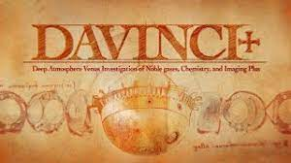
Why is the probe described as both a time capsule and time machine?
- The probe will act as chemistry lab and ______________.
- How long will the mission take?
- What is the purpose of the Veritas Mission?
- Do you think these missions are important? Explain your answer.

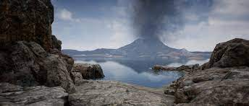
The Evolution of Venus animations shows the change in Venus’ landscape over time. Ask students to write a paragraph explaining how Venus’ landscape has evolved. They can then research why these changes have occurred. The Mysterious Planet video helps to explain why
Venus has changed over time.

Activity: BTN Transit of Venus
Students watch the BTN Transit of Venus story then answer the questions below.

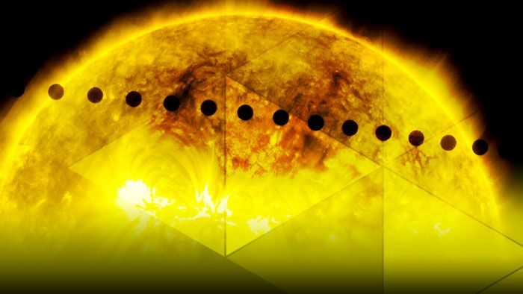
- Captain James Cook travelled to which place to witness the transit of Venus?
- In which century did he make the journey?
- What were scientists and astronomers hoping to learn from the mission?
- What was Captain Cook’s secret mission?
- Describe Wayne’s feelings about Cook’s trip to New Zealand.
- Why did students in New Zealand ask for plant seeds to be sent back from England?
- Where did Cook go to from New Zealand?
- Why was the transit of Venus significant to the European settlement of Australia?

Useful Websites
- NASA’s going to send new spacecraft to Venus. Here’s why – ABC News
- NASA plans two new missions to Venus, its first in decades – ABC News
- Venus: NASA to launch two new missions between 2029 and 2030 – Newsround
- Venue Overview – NASA Solar System Exploration
- Transit of Venus – BTN

EPISODE 17
15th June 2021

KEY LEARNING
Students will develop an understanding of the components of blood and ways to encourage people to donate blood.

CURRICULUM
Science – Year 5 and 6
Scientific knowledge is used to solve problems and inform personal and community decisions.

Science – Year 7
People use science understanding and skills in their occupations and these have influenced the development of practices in areas of human activity.

Scientific knowledge has changed peoples’ understanding of the world and is refined as new evidence becomes available.

  - Teacher Resource

Blood Donation Day

Focus Questions
Discuss the BTN story as a class and record the main points of the discussion. Students will then respond to the following:
- Briefly summarise the Blood Donation Day story.
- How many Australians will need donated blood at some stage?
  - One in three
  - One in ten
  - One in fifty
- Just half a litre of blood can save up to ____________lives.
- What are the components of blood?
- Which blood type can anyone receive?
- What sorts of things is donated blood used for?
- What happens to the blood once it’s been donated?
- Why does Eva need plasma infusions every week?
- What is Eva’s message to people that give blood?
- What did you learn watching this story?

Activity: Class Discussion
Discuss the information raised in the BTN Blood Donation Day story. Ask students to record what they learnt about blood donation on a mind map. What questions do students have? Use the following to guide the discussion:
- Do you know anyone who has either donated blood or has received a blood donation?
- What did you learn about blood donation?
- What does this story make you wonder?
- How do you feel about blood donation?
- It was interesting to learn that…
- Why do you think it is important to hear about stories like this?
- How has your thinking changed since watching this story?
- What questions do you have about this topic?

Activity: Glossary
Students will brainstorm a list of key words that relate to the BTN Blood Donation Day story. Below are some words to get them started. Students will create their own class glossary of scientific keywords and terms. Consider using photos, illustrations and/or diagrams to help explain each keyword.

PLATELETS | PLASMA | WHITE BLOOD CELLS
BLOOD GROUPS | RED BLOOD CELLS | BLOOD DONATION

Further investigation: Tricky words
Students will choose additional keywords and terms to add to their class glossary that are tricky. For example, antigens, antibodies, haemoglobin or cardiovascular system. Students will find a definition and explain to their classmates what the keywords mean.

Activity: Research project
Students will start to think like scientists and develop their own question/s for inquiry, collecting and recording information from a wide variety of sources. Students may develop their own question for inquiry or select one or more of the questions below.

- How does blood travel around the body? Use as many of these terms in your description: circulatory system, oxygen, blood vessels, arteries, heart, circulation.
- What is blood made of? Use objects to demonstrate the various parts of blood.
- Why is blood red?
- What is the function of blood?

Activity: Public education campaign
Students will design a public education campaign to raise awareness about blood donation. Students will think about their campaign’s aim, target audience, and the value of raising awareness at their school.

To create a school awareness campaign, students will need to identify the following:
- What is blood donation?
- What type of blood can be donated?
- Who can be a blood donor?
- Why is blood donation important?
- What is the process for blood donation?
- How can you teach other kids about the importance of blood donation? Think of creative ways you can teach kids your message about the topic.

Some questions to consider when designing your campaign:
- What is the campaign’s main aim?
- Do you have a slogan or message? What is it?
- Who is your target audience?
- What is the best way to communicate the message?

Discuss with students how they will get their message out there to help raise public awareness. Some possibilities include:
- Short film or animation
- Community service announcement (for print, television or radio).
- Press release (create posters to be put up around the school or pamphlets to give to all students).

Activity: Visual literacy
In this activity students will examine, analyse and query the images below, which show the different parts that make up blood. Students will respond to the following:

- Write a short paragraph describing what you see in this image. What colour is it? What shape is it? What size is it?
- Write a caption for each image.
- What is the scientific name for each component of blood?
- What is the function of each component?
- What questions do you have about what you see in the image?

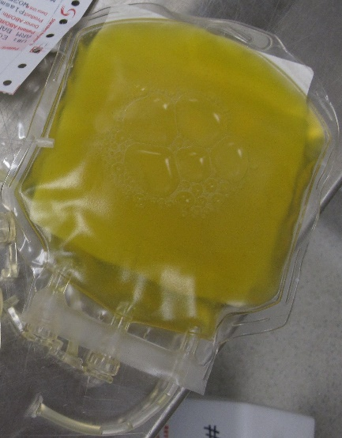 | 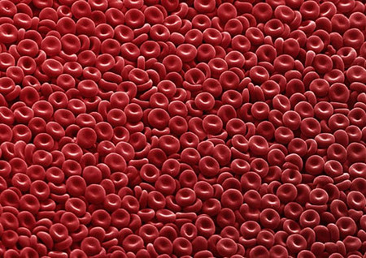
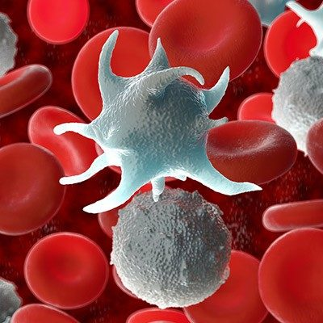 | 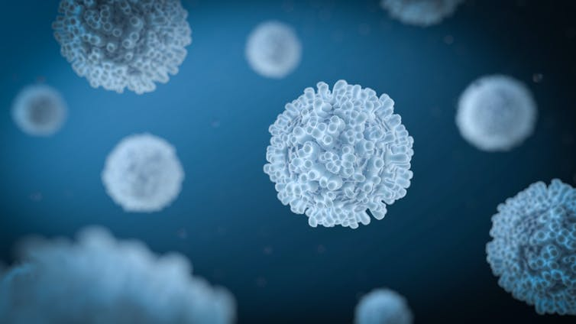

Useful Websites
- Learn about blood donation – Australian Red Cross
- How bones make blood? – TEDEd
- How the heart actually pumps blood – TEDEd

  - Teacher Resource

BTN Transcript: Episode 17 - 15/6/2021

Hey. I'm Amelia Moseley and you're watching BTN. Here's what's coming up. Why this class is building an electric car, the discovery of Australia's biggest ever dinosaur and Amal rolls up her sleeve for National Blood Donor Week.
COVID Variants

Reporter: Jack Evans

INTRO: All that soon, but first. Melbourne's now out of lockdown. But many people were predicting it would last much longer after the highly infectious Delta variant of COVID-19 was detected in Victoria for the first time. You've probably heard of COVID variants popping up around the world lately, so what are they? And where did they come from? Jack explains.
JACK: So, do you like my toy design?
FACTORY BOSS: Like it? I love it. I'm gonna claim it as my own and sell it to every kid in the country.
JACK: Oh.
FACTORY BOSS: I want a hundred, no, a hundred thousand of those googly eyed little things by the morning.
JACK: Oh gee, that's so many hundreds.
FACTORY BOSS: And don't you dare think about using the cloning machine to make them. Any who too-da-loo.
JACK: What's the point of having a cloning machine if you're not allowed to use it? I'm sure one or two wouldn't hurt. See, that was fine, I wonder what happens when I put two in? Four, well that makes sense. Although that one looks a little odd.
Don't you hate it when you're making sock puppets and they start to go, well, mutant on you. No? I guess that's not really a common thing anyone has probably ever experienced. But it is kinda what's been happening with the COVID-19 virus. Just minus the socks and the googly eyes.
You see since first discovering COVID back in 2019 we've noticed it sort of change and evolve as it's spread across the globe. These changes are called mutations and it's actually pretty common for a virus like COVID-19 to, well, mutate over time. Especially if it's being spread around a lot and no, it's not because of some cloning machine gone wrong.
If you look inside a virus, like COVID-19, you'll find a very specific string of thousands of molecules called nucleotides. Each time the virus infects someone and makes copies of itself those nucleotides are copied. Every now and then, as it's copied, there is a mistake in the string of nucleotides and the mistake gets copied as the virus spreads. Most of the time these tiny variations don't alter how the virus works and sometimes they can actually make the virus a little weaker and it eventually dies out. But sometimes the variation can make the virus stronger. Like better at transmitting or more resistant to the immune system and these strains tend to thrive.
JACK: I don't think this is going to end well.
When there are multiple viruses with the same mutation floating around, they become known as a variant. There have been a few variants of COVID that have popped up around the world. The Alpha UK variant, which was found last year in September and is believed to be 50 percent more transmissible. The Beta South African variant that shares similarities with the Alpha. There's the Brazilian variant, Gamma, which was responsible for a surge of cases in Brazil. And then there are the two Indian variants Kappa and Delta. That last one, Delta, actually found its way to Melbourne and was detected in someone last week.
The good news is that experts say that COVID vaccines are designed so that in most cases they will work against new variants. But experts also say it's still really important to practice all that stuff we've gotten so good at doing, washing hands, wearing masks, keeping socially distanced and staying home and away from others if you are feeling sick. I just wish I had a solution for this guy. They are just socks though, I mean how bad can they be?

News Quiz

World leaders from countries like the US, Australia, France and the UK have met in person for the first time since the COVID-19 pandemic began. But what are they meeting for? The G7, the G20 or the United Nations Climate Change conference? It's the G7 or Group of 7 summit where the leaders from the world's leading economic countries get together to talk, well, economy stuff. This year a few other countries who aren't normally a part of it including Australia have been invited to take part, too.
What do all these people have in common? They’re among 1,190 Australians on this year’s Queen’s Birthday Honours list. The list recognises the achievements of all kinds of people including health workers, sports stars, and of course a few Thor size celebrities.
An Australian city's just been named the third most liveable in the world. What an accomplishment. But which Australian city is it? Melbourne, Sydney or Adelaide. It's Adelaide. It came in behind Auckland in New Zealand and Osaka in Japan. All up, four Aussie cities made the top ten.
And, more than a dozen McDonald's outlets had to close in Indonesia last week because of scenes like this. But what were so many people trying to get their hands on? The answer is a new meal named after K Pop superstars BTS. Delivery drivers were lining up for hours to get a single order cramming into restaurants without proper social distancing so for safety, owners decided to shut up shop.
Electric Car Class

Reporter: Amelia Moseley
INTRO: Next up, did you think we'd all be driving around in electric cars by now? Well, despite being around for a while, the technology's still surprisingly rare on our roads. Now some states and territories are trying to change that. Let's find out why, starting with a class in Victoria that's creating their very own electric vehicle.

From an old gas guzzler to an electrified engine. These grease monkeys in Bendigo are creating a car fit for the future.
ABI: So, we're restoring an old car and we're turning it into an electric car.
DANIELLE: After we strip it down, we're gonna get I think we're going to get new parts and we're gonna put them all back together. We're just trying to move on into the future a bit more with cars and helping out the environment.
Like these students, you probably know that petrol and diesel cars produce air pollution because their engines burn fuel and that's why lots of experts reckon the way forward is this greener option.
FORD ADVERTISEMENT: It's the all new F1-50 lightning.
Some of the world's biggest car companies have started shifting their models to electric ones.
US REPORTER: Mr President.
JOE BIDEN, US PRESIDENT: This sucker's quick.
And some governments have been trying to encourage people to buy them. Not just by hooning about but by offering tax breaks or discounts.
JOE BIDEN, US PRESIDENT: The future of the auto industry is electric. There's no turning back.
But in Australia, things seem to be moving like my old 1988 Ford Laser with the air con on, quite slowly. Electric vehicles made up less than one per cent of cars sold here last year. That's nowhere near as many as in other wealthy countries. Some people say electric cars are just too expensive in Australia and there aren't that many models available.
But car manufacturers say that could change if more people were given more reasons to buy them. While the Federal Government says it doesn't plan to set any electric car targets or offer incentives right now; some states have put their foot on the accelerator. The ACT's now offering people discounts on buying and running EVs and some other states have similar plans.
ANDREW BARR, ACT CHIEF MINISTER: Let's have a race amongst the Australian states and territories as to who can have the best policies in this area.
But hit the brakes again, because there's another thing to consider on this road trip.
AUSTRALIAN DRIVER 1: I think more charging stations.
AUSTRALIAN DRIVER 2: Now there's not many places to charge the electric car.
Yup, we probably need more of these to help electric cars get around our rather large country. Plus, if people weren't stopping here anymore it could leave a big hole in Australia's budget. You see, the government charges fuel tax, which is often used to keep up our roads. That's why some states are planning to bring in a charge for electric car drivers, but some people say that could end up being another obstacle on the bumpy road to electricity. While the rest of the country works on, well, all of that stuff. These students say they'll be busy for the next year creating their own electric future.
TEESHA: I think the car's gonna go somewhere in town and they're going to let people rent it to have a go and a bit of use of electric vehicles.
BELLA: In Australia, we're fairly behind on those sorts of things, with the electric cars in a couple of other countries, so we're trying to catch up in a way and this is something we're doing to help.

Did You Know?

Did you know people in the UK won't be allowed to buy new petrol and diesel powered cars from 2030? The UK has banned selling them from that date because it's trying to cut its greenhouse gas emissions to net zero by 2050.

NASA Venus Mission

Reporter: Amelia Moseley

INTRO: Now let's head to space. NASAs announced two new missions to Venus later this decade. It's one of our closest neighbours, but there's still a lot we don't know about this red hot planet. Let's find out more.

If you could hop in a spaceship.
Amelia, Reporter: Yup, if you just can park over there.
And pick any planet in our solar system to be your new home.
ALIEN: *Unknown Alien Language*
Amelia: No, that's OK. It's a bit rocky.
It probably wouldn't be this one, to be honest.
AMELIA: Now this next planet is Venus. Lovely.
Yes, Venus.
ALIEN: *Unknown Alien Language*
AMELIA: Yeah, you're right it is actually very close to Earth. So, just 237 million kays away. So, just a hop, skip and a jump really.
You can even spot Venus from Earth because it's the third brightest object in our sky, after the sun and moon, of course.
AMELIA: Now, Venus is a lot like Earth.
ALIEN: *Unknown Alien Language*
Yeah it is similar in its geology, its size and its distance from the sun. But it's also a bit different.
AMELIA: I should warn you it does get a little balmy here. The surface gets to more than 470 degrees.
ALIEN: *Unknown Alien Language*
Yeah, Venus is the hottest planet in our solar system thanks to its super thick atmosphere that traps in heat and exerts a similar pressure to being about 800 metres underwater. Yikes. It's also made mostly of carbon dioxide, so we humans couldn't breathe here.
AMELIA: But I'm not sure what you breathe, so you might like it.
ALIEN: *Unknown Alien Language*
Scientists reckon it's covered with craters, mountains and possibly active volcanoes and big plains of red-hot lava. Lovely.
AMELIA: Oh, and did I mention that when it rains, it rains sulfuric acid?
AMELIA: No? Well, that too.
While this charming planet isn't the most homely one (at least for us humans), it is one we want to know more about and over the years we've tried. Unfortunately, thanks to Venus' atmosphere probes don't last all that long on the surface. The current world record is held by a Soviet spacecraft in 1982, which lasted just over two hours.
But now, NASAs giving it another shot for the first time in more than 30 years. It's announced two unmanned missions to Venus starting in 2028: DAVINCI+ and VERITAS. VERITAS will send an orbiter to map the planet in more detail than ever before, while DAVINCI+ will drop a probe through the planet's thick clouds to explore its atmosphere before landing on the surface. It'll measure the makeup of the planet to understand how it formed and work out if Venus ever had an ocean.
ALIEN: *Unknown Alien Language*
AMELIA: Oh no, sorry if it was there, it's not there anymore.
NASA says our earth-like neighbour will also teach us more about Earth.
NASA ADMINISTRATOR BILL NELSON: We hope these missions will further our understanding of how Earth evolved and why it's currently habitable when others in our solar system are not.
And there's another thing. The missions will help us find out if anything ever lived on Venus, or if it still does.
AMELIA: Now I have some reviews here. I know you like reviews. Now, NASA described it as 'hot, hellish and unforgiving'.
ALIEN: *Unknown Alien Language*
AMELIA: OK there's no need to use that kind of language.
ALIEN: *Unknown Alien Language*
AMELIA: We’ve talked about this. Earth is out of your price range. But if you want to go back around to Mars, we could take a second look or even Pluto. Pluto is very very affordable, cheap even. It’s very cold though. We’ll just see how we go. Difficult.

Ask a Reporter

Do you want to know more about the planet Venus? You can ask me live this Friday on Ask A Reporter. Just head to our website for all the details.
Giant Aussie Dinosaur

Reporter: Jack Evans

INTRO: A new species of dinosaur has been officially announced as the largest ever found in Australia. It stood taller than a giraffe and measured as long as a basketball court. Here's Jack to tell us more about this big news.
Move over Brontosaurus, take a hike Diplodocus, get out of here Brachiosaurus. Cause the Dinosaur kingdom just got a whole lot bigger. Introducing Australotitan cooperensis or Cooper to its friends. This new species of sauropod has just been officially announced as the largest dinosaur ever found here, in Australia.
DR SCOTT HOCKNULL, PALAEONTOLOGIST: Australotitan cooperensis is his name. Australotitan means Southern Titan, so basically the Southern Giant and cooperensis from Cooper country. Cause we're here in Cooper Country and that's where the dinosaurs were found.
Two cattle farmers discovered Cooper back in 2006, in Eromanga, Queensland.
ROBYN MACKENZIE, EROMANGA NATURAL HISTORY MUSEUM: It wouldn't have entered our mind that we were about to deal with an animal that was the largest in Australia and one of the largest in the world. So that was not even in our thinking.
KENN MANN, TOURIST: And here is the real McCoy here in dinosaurs and looking down on us from how high? Goodness knows what, it's fantastic.
ROBYN MACKENZIE, EROMANGA NATURAL HISTORY MUSEUM: From a tourism point of view, you can't get anything better, really, it's something that's going to help put Australia on the map, put Eromanga on the map.
It took 15 years and a lot of digging, but palaeontologists finally have enough info to say that Cooper is definitely a new species. One that was up to 6 and a half metres tall, 25 to 30 metres long and weighed between 50 and 70 tonnes. To put that into perspective.
DR SCOTT HOCKNULL: The size of two busses, a basketball court, a b-double, or fourteen hundred red kangaroos, you take your pick.
I think I'll pick the fourteen hundred red kangaroos. Ooh yeah, that is enormous. Anyway, Australotitan cooperensis was so big that experts reckon it's in the top 10-15 biggest dinosaurs in the world. Which is pretty exciting for Aussies, because unlike some other countries we haven't had as many Dino discoveries.
DR SCOTT HOCKNULL: Unlike North America and Canada or even in China or South America where you have these big mountain ranges or badlands where you can literally walk along and find a bone right next to, to eroding out of a creek bank. Out here in Western Queensland everything is coming up through the ground and this takes 10s of 1000s of years to occur and then they're all broken down into small fragments.
Well there you go. So far, the list of known Aussie dinosaurs is a fairly small one, but it is growing. And experts reckon there could be a whole bunch of bones, belonging to other dinosaurs, just waiting to be uncovered in our backyard that could be even bigger. I mean, bigger than fourteen hundred red kangaroos, I'd like to see that.
Sport

Euro 2020 is here and for soccer fans, it's big. Euro 2020 is basically like the World Cup, but just for Europe. Normally it happens every four years, but you know last year COVID happened. Everyone wants to know who's going to win, and this year a psychic dog even made headlines for making its prediction. There was a bit of a scary moment in Denmark’s game against Finland. Denmark midfielder Christian Eriksen collapsed during the game and had to be rushed to hospital. Tributes have flooded in from teams and fans everywhere. He's still in hospital at the moment but has sent his greetings to teammates.
Novak Djokovic has made history at the final of the French Open. The world number one claimed his nineteenth Grand Slam title and became the first man in 52 years to win all four majors twice and that wasn't the only history making moment. Barbora Krejcikova won her first ever Grand Slam defeating Anastasia Pavluyuchenkova in 3 sets then went on to win the doubles crown as well.
Queensland swimmer Kaylee McKeown has broken the 100 metre backstroke world record. It happened on day two of the Australian Olympic swimming trials, where the best swimmers race to find out who's going to the Olympics and, yes, Kaylee will be going.
Blood Donation Day

Reporter: Amal Wehbe

INTRO: It's National Blood Donor Week and the Red Cross is calling on more people who are healthy and 18 and over to donate. One in three of us will need to be given blood at some point in our lives but it's something only one in thirty Aussies actually do. So, Amal decided to get on board and become a donor. Check it out.

AMAL, REPORTER: OK, so I'm about to do something I've never done before. And that's donate blood. But I thought it was about time I change it, because it can help people who really need it. I'm a little bit nervous, but I'm ready to go. Let's see what happens.
One in three Aussies will need to be given blood at some point in their life and just half a litre can save up to three lives.
AMAL: So that's why they need people like me, healthy people, to donate. But first I need to answer a lot of questions and do some tests.
NURSE: That’s a little squeezy for your hand. Your veins are beautiful, absolutely beautiful for the donation process.

AMAL: Yay.
NURSE: So, you are eligible to donate blood today. Thanks so much for coming in.
AMAL: Thanks for having me.
AMAL: That's because they need to check that I'm fit and healthy. If I'm sick, I could pass that on to someone who takes my blood.
AMAL: OK it's about to go in. I'm a little bit nervous. But I'm just not going to look and hopefully it's all good. Wish me luck.
NURSE: I'm just going to pop the needle in. A small scratch now, just look away, you’re fine, just stop squeezing, all good and it's in.
AMAL: And we're all good. Wasn't that bad. Just don't look and that's the key.
AMAL: So, now I'm all hooked up and it's taking about 500 millilitres of blood. So, that has the red blood cells, the plasma and the platelets.
They're all really important. Most blood donations go to people who have cancer or other diseases. Then there's people having surgery, people with broken bones, and even mums and their newborn babies.
AMAL: So, 6 minutes later and I'm all done.
But that's not the end of it. The blood is then sent off to the processing centre. First up, it's needs to get labelled. All up, there's eight different blood types and the donor's blood type has to be the same as the recipient. Well except for the O group. It's a universal donor so anyone can receive O blood type.
JEN SALTER, RED CROSS: And once the blood is at our processing centre, it's tested and then it’s put into a special machine. And the machine spins really, really fast, and that actually separates the blood into those three parts. So, it separates the blood into red cells, into plasma and into platelets. And those things all do separate things to help people but it's all really important.
Every bag is scanned and put into a system. After that, it's sent out all across the country, to people who need it most.
JEN SALTER, RED CROSS: We do know that every blood donation travels on average about 370 kilometres. So, if you're donating blood in South Australia, for example, it might help somebody else in Adelaide. Or it might actually help somebody in Perth or Darwin. It’s amazing.
One of those people is Eva.
EVA: Well, I've got CVID, which is common variable immune deficiency, and it means when I get a virus my body can't fight it off.
Eva’s immune system doesn’t work the way it is supposed to. So, she can get really sick, really easily. She relies on plasma donations to stay healthy.
EVA: So, I need plasma infusions, because it means I can live a healthy life. And I can do all the things I want to do like photography, dancing, hanging out with my friends, going places, going shopping. Things that people take for granted, I cherish.
AMAL: So, if you could say something to the people that give blood donations, what would you say?
EVA: You're basically helping someone to live a normal life and helping someone, another person or more. You're just helping them out. And it's really big. It means a lot to the person receiving it.
Closer

Nice work. Well, that's it for now but we'll be back with more for you next week including the results of our Kids Talk survey. You won't want to miss it. Until then, you can check out our website for more stories, teacher resources and specials. Have an awesome week and I’ll catch you soon.

