Episode 4
5th March 2019



Phone Ban in Schools
- Do you take a mobile phone to school? Why or why not? Discuss in pairs before watching the BTN story.
- Briefly summarise the BTN Phone Ban in Schools story.
- Which Australian state has recently banned the use of mobile phones in primary schools?
- How can mobile phones be distracting in class?
- Who has spoken out against the ban?
  - Students
  - Parents
  - Principals
- How can mobile phones be useful in the classroom?
- What is a brick phone?
- In what country were students allowed brick phones instead of smartphones?
- Do you think kids should be allowed to use their mobile phones during school hours? Give reasons for or against a ban?
- How did this story make you feel? Discuss as a class.

Australian Women in Politics
- Before watching the BTN story, make a list of Australian women in politics.
- In pairs, discuss the Australian Women in Politics story and record the main points of the discussion.
- How many years ago did women not have the right to vote?
- The South Australian Government was the first in the world to give women the right to run for election. True or false?
- Who was Catherine Helen Spence?
- In what year were the first women elected to Federal Parliament?
  - 1902
  - 1943
  - 1980
- Who was Australia’s first female prime minister?
- Who was the first Indigenous woman to sit in parliament?
- What was surprising about this story?
- What did you learn watching the BTN story?

Check out the Australian Women in Politics resource on the Teachers page.

Palm Oil Ban
- What did the BTN Palm Oil Ban story explain?
- What tree does palm oil come from?
- What type of products contain palm oil?
- Complete this sentence. Palm oil can sometimes appear on food labels as ______________ oil.
- In which two countries are large areas of rainforest being cleared to make room for palm oil plantations? Find using Google Maps.
- The clearing of rainforests is destroying the habitat for which animals?
  - Tigers
  - Elephants
  - Orangutans
  - All of the above.
- How is the production of palm oil affecting Sumatran Orangutans?
- What did Zoos Victoria recently announce about products they sell?
- What did you learn watching the BTN story?
- Illustrate an aspect of the Palm Oil Ban story.

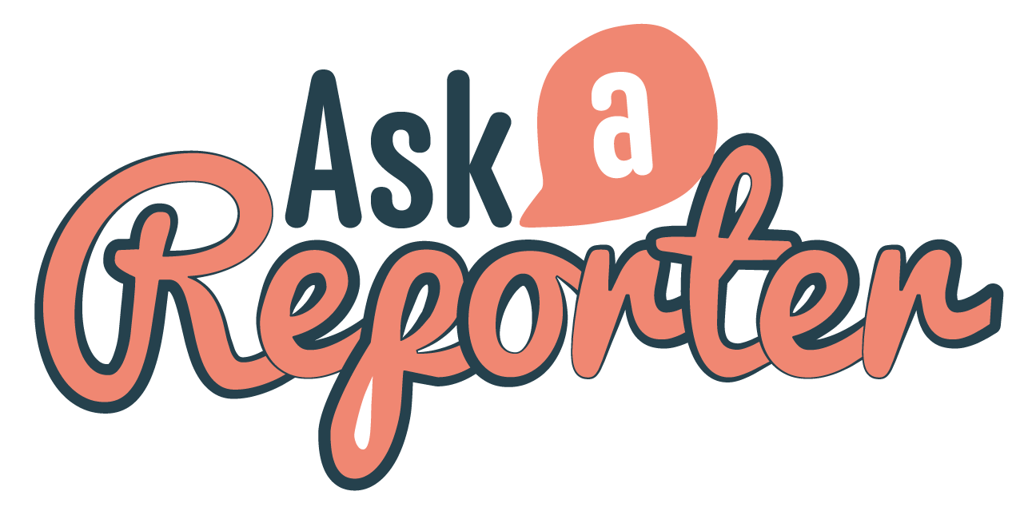
Check out the Palm Oil Ban resource on the Teachers page. Get your class involved in BTN’s Ask A Reporter! This week’s topic is Palm Oil Ban.

Rat Island
- Retell the BTN Rat Island story using your own words.
- Where is the island Reiono? Find using Google Maps.
- How far is Reiono from Tahiti?
- What lives on the island of Reiono?
- The Polynesian rat is a native species to Reiono. True or false?
- How did the Polynesian rat travel to islands across the Pacific?
- What makes the Polynesian rat a pest?
- How do warmer climates affect the population of rats?
- What are scientists doing to get rid of the rats on the island?
- Illustrate an aspect of the Rat Island story.

Breakdancing Olympic Sport
- Before watching the BTN story, think of 5 words you would use to describe breakdancing.
- What do the kids in the BTN story like about breakdancing?
- What is another name for breakdancing?
- In what decade did breakdancing become popular on the streets of New York?
- What type of movies did breakdancers first get their inspiration from?
- What country included breakdancing in the Youth Olympics?
- Which country won gold in breakdancing at the Youth Olympics?
  - Russia
  - Japan
  - Russia and Japan
- Which country is hosting the 2024 Olympic Games?
- Who will decide if breakdancing is included at the 2024 Olympic Games?
- What did you like about the BTN story?

Teacher Resource
Episode 4
5th March 2019

Palm Oil Ban

Students will explore the impact of palm oil production on the habitat of orangutans.


Science – Year 5
Living things have structural features and adaptations that help them to survive in their environment.

Science – Year 6
The growth and survival of living things are affected by physical conditions of their environment.

Science – Year 7
Interactions between organisms, including the effects of human activities can be represented by food chains and food webs.

HASS – Year 6
The obligations citizens may consider they have beyond their own national borders as active and informed global citizens.

- What did the BTN Palm Oil Ban story explain?
- What tree does palm oil come from?
- What type of products contain palm oil?
- Complete this sentence. Palm oil can sometimes appear on food labels as ______________ oil.
- In which two countries are large areas of rainforest being cleared to make room for palm oil plantations? Find using Google Maps.
- The clearing of rainforests is destroying the habitat for which animals?
  - Tigers
  - Elephants
  - Orangutans
  - All of the above.
- How is the production of palm oil affecting Sumatran Orangutans?
- What did Zoos Victoria recently announce about products they sell?
- What did you learn watching the BTN story?
- Illustrate an aspect of the Palm Oil Ban story.


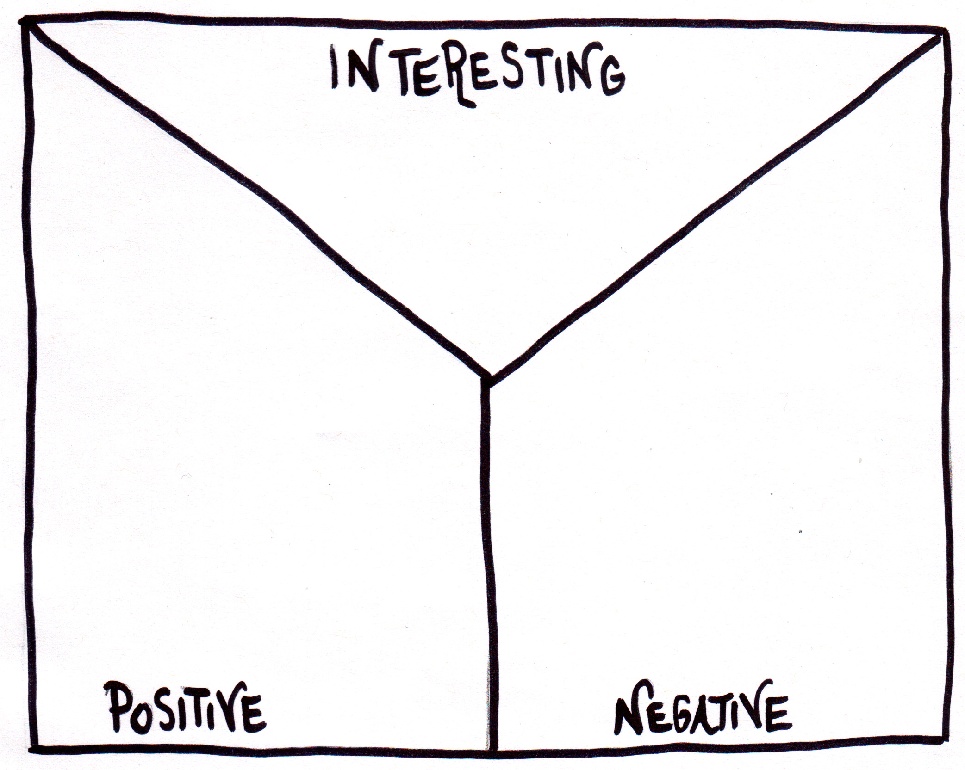
Note taking
Students take notes while watching the BTN Palm Oil Ban story. After watching the story, students reflect on and organise the information into three categories.
What information was...?
- Positive
- Negative or
- Interesting

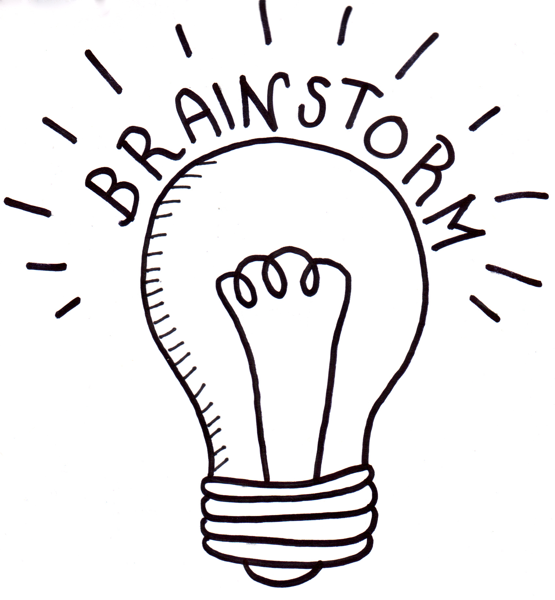
What do you think?
Students will respond to one or more of the following questions:
- What do you THINK about what you saw in the BTN Palm Oil Ban story?
- What does this story make you WONDER?
- Think of three questions you have about the story. Remember that good questions are open-ended (have no right or wrong answer and can’t be answered with a ‘yes’ or ‘no’).
- What did you learn from the BTN story? Leave your comment on the Palm Oil Ban story page. How to add comments to BTN stories
Glossary
Students will develop a glossary of words and terms that relate to palm oil and habitat loss in the context of the BTN Palm Oil Ban story. Below are some words to get them started. Students will add words and meanings to their glossary as they come across unfamiliar words throughout your research. Students will then write their own sentence using each of the terms.

 | Meaning | Sentence
Deforestation
Endangered
Global warming
Habitat loss
Palm oil
Plantation
Sustainable palm oil

KWLH
Discuss the BTN Palm Oil Ban story as a class. What questions were raised in the discussion and what are the gaps in their knowledge? The KWLH organiser provides students with a framework to explore their knowledge on this topic and consider what they would like to know and learn.
What do I know? | What do I want to know? | What have I learnt? | How will I find out?

Topics of inquiry
Students will develop their own question/s for inquiry, collecting and recording information from a wide variety of sources. Students may develop their own question for inquiry or select one or more of the questions below.
- Why is palm oil considered a problem?
- How is palm oil important to the economy of Indonesia and Malaysia?
- What species have been impacted by the production of palm oil? Research how one of these species has been impacted by the clearing of tropical rainforests to make way for palm oil plantations.
- What is sustainable palm oil? Look for products that contain sustainable palm oil and influence others in your community to make sustainable choices at the supermarket.
- What does it mean to shop sustainably? How can you make a difference as a consumer?
- Why should we protect orangutans and other endangered species affected by deforestation? Write a persuasive piece of writing explaining your reasons.
- Why are orangutans important? Think of creative ways to raise awareness about the issues raised in the BTN Palm Oil Ban story.

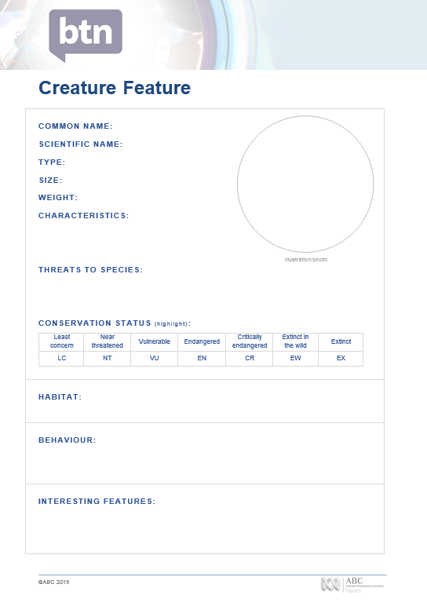
Creature Feature
Students will research and write a Creature Feature about orangutans or another endangered species affected by the production of palm oil. Students can use the Creature Feature worksheet at the end of this activity to record their findings. Encourage students to use a range of sources to find their information.

Students will research the following for their project:
- Common and scientific name
- Appearance - what are some of their physical characteristics?
- Habitat - where do orangutans live? Describe their habitat.
- Conservation status
- Threats - what are some of the threats to the survival of orangutans? What is being done to protect their habitat?
- Interesting features.

Haiku poetry
Write a haiku poem focusing on one or more of the themes explored in the BTN Palm Oil Ban story. Use Read Write Think’s Haiku Starter graphic organiser which allows students to brainstorm a list of words about their chosen theme.

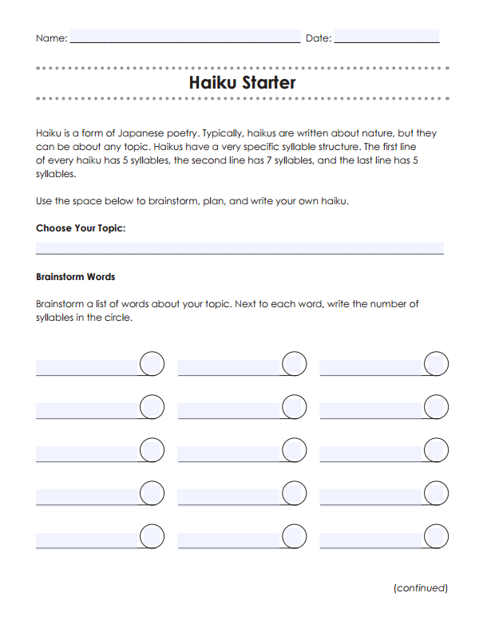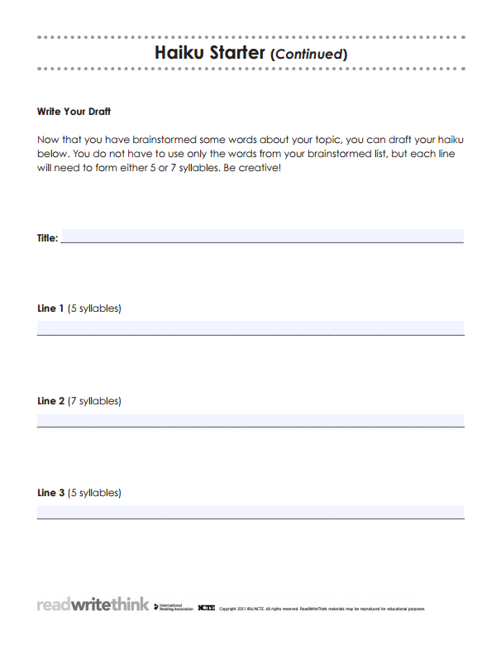

Source: Read Write Think

BTN – Palm Oil Problem
http://www.abc.net.au/btn/classroom/palm-oil-problem/10523458

BTN – Palm Oil
http://www.abc.net.au/btn/classroom/palm-oil/10528254

BTN – Saving Orangutans
http://www.abc.net.au/btn/classroom/saving-orangutans/10532904

WWF – Orangutan
https://www.wwf.org.au/what-we-do/species/orangutan#gs.speBM4O4

WWF – Palm Oil
https://www.wwf.org.au/what-we-do/food/palm-oil

CBBC Newsround – What is palm oil and why is thought to be bad?
https://www.bbc.co.uk/newsround/39492207

Creature Feature
COMMON NAME:
SCIENTIFIC NAME:
TYPE:
SIZE:
WEIGHT:
CHARACTERISTICS:

Illustration/photo
THREATS TO SPECIES:

CONSERVATION STATUS (highlight):
Least concern | Near threatened | Vulnerable | Endangered | Critically endangered | Extinct in the wild | Extinct
LC | NT | VU | EN | CR | EW | EX

HABITAT:
BEHAVIOUR:

INTERESTING FEATURES:

Teacher Resource
Episode 4
5th March 2019

Australian Women in Politics
Students will learn more about the suffrage movement in Australia
and significant political milestones for Australian women.

History – Year 3
Days and weeks celebrated or commemorated in Australia (including Australia Day, Anzac Day, and National Sorry Day) and the importance of symbols and emblems.

History – Year 6
Experiences of Australian democracy and citizenship, including the status and rights of Aboriginal and Torres Strait Islander Peoples, migrants, women and children.

- Before watching the BTN story, make a list of Australian women in politics.
- In pairs, discuss the Australian Women in Politics story and record the main points of the discussion.
- How many years ago did women not have the right to vote?
- The South Australian Government was the first in the world to give women the right to run for election. True or false?
- Who was Catherine Helen Spence?
- In what year were the first women elected to Federal Parliament?
  - 1902
  - 1943
  - 1980
- Who was Australia’s first female prime minister?
- Who was the first Indigenous woman to sit in parliament?
- What was surprising about this story?
- What did you learn watching the BTN story?

Class discussion
After watching the BTN Women in Politics story hold a class discussion. Here are some discussion starters:
- How did you feel after watching the story?
- What surprised you about the story?
- What did the video make you wonder?
- List some facts that you learnt from this story.
- Is it important to see female politicians in parliament? Why?
- Think of three questions you have about the BTN story.

Glossary
Students will develop a glossary of terms that relate to women in politics. Below are some key terms and concepts to get you started:

suffrage | suffragette | parliament
House of Representatives | Senate | equality
Suffragette movement
Students will develop an understanding of the suffragette movement and then present their findings in an interesting way.

- What does suffrage mean? Find a dictionary meaning.
- Describe the suffragette movement in Australia.
- Imagine you are a suffragette living in the late 1800s. Write a persuasive letter to your local government, write a newspaper article or start a petition explaining why women should be able to vote.

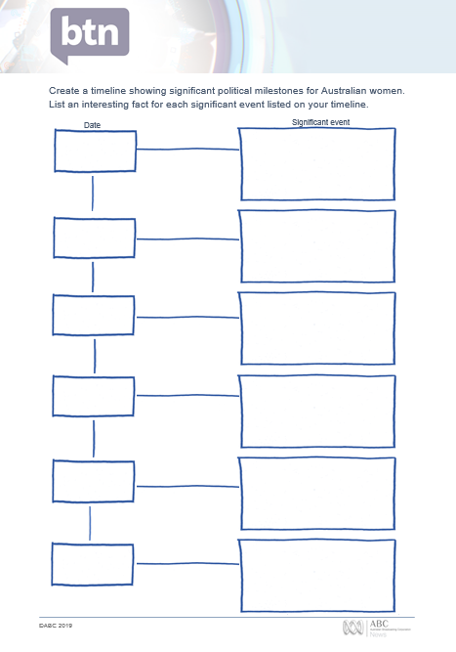
Women in Politics Timeline
Students create a timeline showing significant political milestones for Australian women. Use the timeline template at the end of this activity to record key dates and milestones. Students can use the following questions to guide their research:

- When did women get the right to vote in Australia?
- Which state first gave women the right to vote?
- When were women first given the right to stand for Federal Parliament in Australia?
- When were Australian Aboriginal women given the right to vote?
- Who was the first woman to be elected to the House of Representatives?
- Who was the first woman to be elected in the Senate?
- Who was Australia’s first female prime minister?

Class discussion: What is a biography?
Before students begin to write their biographies, hold a class discussion to find out what they already know about biographical writing. Record students’ responses. Below are some discussion starters:

- What does a biography tell us about a person?
- Where can you look to find information for your biographical writing? It could include the internet, newspaper articles, magazine articles and interviews, other biographies, historical books or television interviews. Why is it important to use more than one source of information?
- What makes a biography interesting? For example, key information and facts, a timeline of events, photographs, illustrations and quotes.

Women in Politics – Create a biography
Students will choose a woman in Australian politics (past or present) and write a biography about them. Using the Biography Organiser template at the end of this activity, students will find and record information about the female politician they have chosen. Some possible areas of research include:
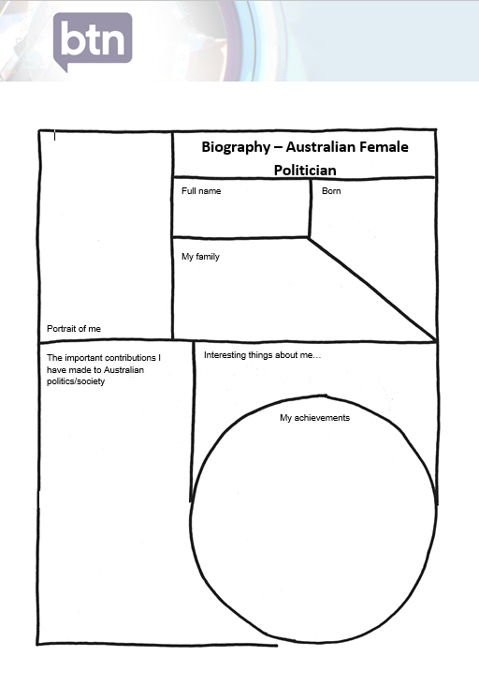
- Where and when were they born? Describe their family life growing up.
- What are some of their achievements? Choose one to explore in more detail.
- What inspired/motivated them to become a politician?
- What were their challenges?
- How do we recognise their achievements?
- How have they made an impact on people’s lives?
- How did they change our understanding of the world?
- What do you admire about them?
- Imagine you could sit down and talk to them. What questions would you ask about their life and work?

Present your findings in an interesting way.
- Give a presentation on their achievements
- Create a portrait
- Make a “Did you know?” for other students
- Write a letter thanking them for their achievements and how they have changed the world
- Create a timeline highlighting significant events

The following BTN story may help students with their research. They can also respond to the questions relating to each story.
BTN History of Voting
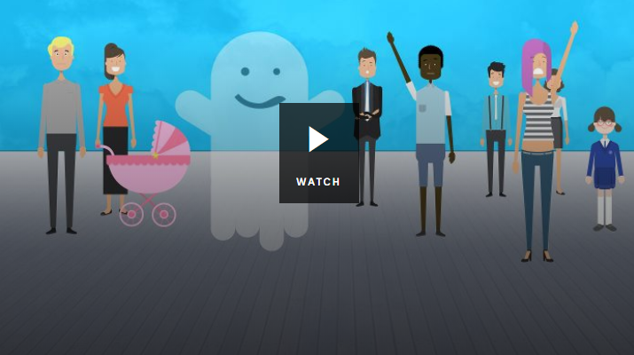
- Who was allowed to vote in Australia in the 1800s?
- What does suffrage mean?
- Who were the suffragettes?
- When did women get the right to vote in Australia?
- When did all Indigenous people get the right to vote in federal elections?
- In which year did the voting age change from 21 to 18 years of age?
- Do you think the right to vote is important? Explain your answer.

BTN Women at Work
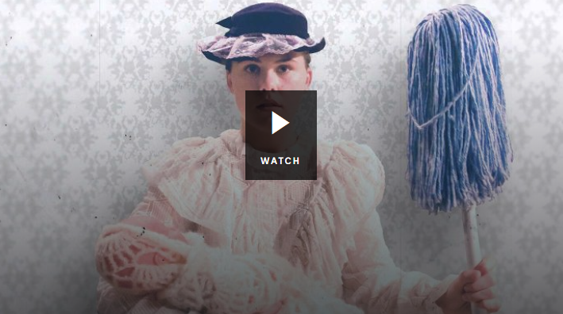
- What changes started to happen for women in the late 1800s?
- Which state was the first to give women the vote?
- How did the Second World War change the role of women?
- After the war, most women were forced to go back to _______________.
- Describe work for women in the 1950s.
- How did women fight for their rights in the 1960s and 1970s?
- How has your thinking changed since watching the Women at Work story?
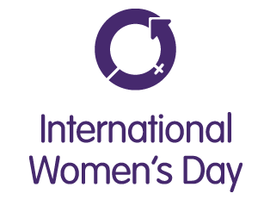
International Women’s Day
International Women's Day is a global day celebrating the economic, political and social achievements of women past, present and future. How does your school honour and celebrate the achievements of women all around the world? Go to the International Women’s Day website for more information.

National Museum Australia – First women in Parliament
https://www.nma.gov.au/defining-moments/resources/first-women-in-parliament
National Museum Australia – Women’s suffrage
https://www.nma.gov.au/defining-moments/resources/womens-suffrage
AEC – Electoral Milestones for Women
https://www.aec.gov.au/Elections/Australian_Electoral_History/milestone.htm
BTN – History of Voting
http://www.abc.net.au/btn/classroom/history-of-voting/10524754
BTN – Women at Work
http://www.abc.net.au/btn/classroom/women-at-work/10523414

Create a timeline showing significant political milestones for Australian women. List an interesting fact for each significant event listed on your timeline.

Date
Significant event




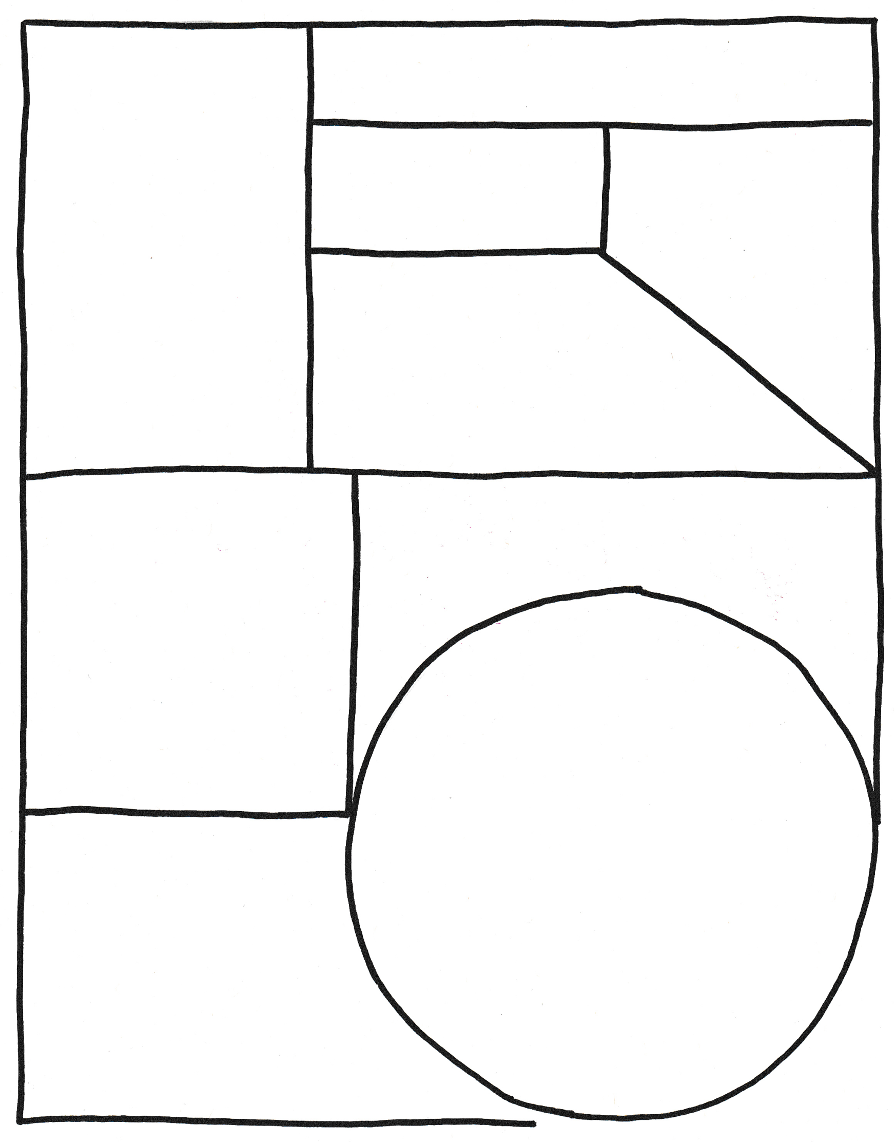
Biography – Australian Female Politician
My family
Full name
Portrait of me
The important contributions I have made to Australian politics/society

Born
My achievements
Interesting things about me…

BTN Transcript: Episode 4 – 5/3/19

Hey everyone. Amelia Moseley here and that means it's time for another week of BTN. Take a look at what's coming up in today's show. Should you be allowed to use smart phones at school? Martin investigates. I take a look back at Australia's pioneering female politicians and Jack busts a move with a group of young breakdancers.

That's all coming up in a minute, but first let's have a look at some of the big stories that have been in the news.

This Week in News

Some big bushfires have devastated parts of Victoria. Lightning started a fire in Bunyip State Park on Friday and over the weekend it grew, destroying homes, farms and businesses. There were also big fires near Yinnar South, and Dargo and Licola in Gippsland. Nearby schools were closed yesterday as fire crews fought to bring the fires under control.

Over in Vietnam there's been a disappointing end to a meeting between Donald Trump and Kim Jong un.
It was only the second time ever that the leaders of North Korea and the US have got together. Many were hoping the meeting would end in some sort of agreement which would involve North Korea getting rid of its nuclear weapons. But that didn't happen. The leaders left early without signing anything.

The ABC has a new chairperson. Ita Butrose is a bit of a media legend. She's run magazines and was the first female editor of a major city newspaper in Australia. The PM, Scott Morrison said she was the perfect pick. He was also asked to name a wonderful story about the ABC. Nawww. Thanks for the shout out.

And one of Australia's biggest parties went off with a bang on the weekend. The Sydney Gay and Lesbian Mardi Gras brought together hundreds of thousands of people of all ages, from all over the world and a famous face or two. The Mardi Gras started in the 70s as a gay rights protest but over the years it's become one of the world's biggest celebrations of its kind.

Phone Ban in Schools
Reporter: Martin Dougan

INTRO: Now to the big mobile phone debate. Over the past few months there's been a lot of talk about whether primary school kids should be allowed to use smartphones at school. They’re already banned at state schools in New South Wales as well as many other schools around the country. But not everyone thinks a ban is the best solution. Here's Martin.

Lots of us rely on our smartphones and tablets every day. Chatting, messaging, emails, games and, of course, social media are just some of the things we can access on them.
MARTIN DOUGAN, REPORTER: It's all good fun isn't it? But what about school time? Should you guys be allowed to use your mobile phone during school hours? Well some of you may know this but the government in NSW has banned mobile phones in primary schools, which gives other schools across the country an option to opt in.

TEACHER: Martin I need your phone.
Some schools might take away phones at the start of the day or give students lockers for their devices. The government says it doesn't mind how schools do it, as long as phones don't come out during school hours.

REPORTER: I get the feeling that resisting temptation could be a little bit tricky.

So why ban mobiles? Firstly, it’s to stop you guys getting distracted in class isn't it? We all know you like messaging and playing games but of course class isn't the time or place. Then there's online bullying. Taking away phones means there's less chance of that kind of behaviour happening during school hours.

While many people support the ban, not everyone thinks it's the right call. Some principals spoke out against the ban. They say mobile phones can be a good educational tool and are sometimes part of classroom activities. Plus, we all know mobile phones become an even bigger part of life when we get older. So, some experts reckon it's good to learn to use them responsibly when we’re young. Some parents are concerned about the safety side of things. In some circumstances a student may need to contact their parent or guardian during school if there's an emergency.
So, what do you guys think?
KID 1: I don't think they should be banned completely, after school if you have to go somewhere. Like finish off homework at a friend's house, you can tell parents where you're going.
KID 2: I honestly wouldn't really care because I don't have a phone, but I think it would be better so people won't be distracted and stuff.
KID 3: Let's say that you had a phone in class and you're looking on Instagram and you saw something that was mean, or something that could impact your mood for the rest of the day and might not do as well with your work.
Over in the UK some schools have come up with an interesting solution. They've banned smartphones in class. Instead kids are given these. Sometimes known as dumb or brick phone. The kind that dinosaurs like me had when we were kids. These devices don't have access to the internet, so there’s no social media and less chance of distraction. But it does still let kids make calls and send texts if they need to.

MARTIN: I’ve brought one here with today. Believe it or not, this was the very first phone that my parents bought me when I was younger, and I thought it was the bee's knees. Honestly, I thought this thing was the best thing since sliced bread. I thought I’d bring it along with me today to see if the kids here think that it could be an option, but mainly, to have a bit of fun.
KID: How do you turn this on? It’s not working.

KID: Can you even message on here? Does it have apps?

KID: It’s something from another planet. I would never, ever accept this.

KID: I think it’s a good because I don’t think this has fortnite on it.

Did You Know?

Did you know, 100,000 mobile phones are dropped down the toilet in the UK every year and surveys show about 8% of Australians have done the same thing.

Palm Oil Ban

Reporter: Jack Evans

INTRO: Hope they gave it a good wash afterwards. Now to a very different type of ban that's just been announced by Zoos Victoria. Last week it said it would stop selling any products made by companies that use non animal friendly palm oil. Let's find out what that is and why it might hurt these guys. Take a look.

Alright it's time to play everyone's favourite game - what do these things have in common?
JACK: Oh, I know this one. it's on the tip of my tongue. Yes, they're all delicious, oh except the fuel and soap. Oh, how about they're all things I buy sometimes?
Oh, I'm afraid the answer we were looking for was, they all use palm oil.
JACK: Ooooh I wouldn't have got that. No.
Palm oil is a type of oil that comes from the fruit that grows on, you guessed it, palm trees. And as we just saw it's used in a whole bunch of different products from chocolate to soap. In fact, chances are you've used something with palm oil in it without even realising it, that's because it can sometimes be tricky to spot, or it can appear on the label as vegetable oil.
While palm oil itself isn't necessarily bad, the way it's sometimes sourced is a real issue. Huge areas of rainforests are bulldozed every year to make room for palm oil plantations particularly in Indonesia and Malaysia. That destroys the habitat of endangered animals like tigers, elephants and these guys - orangutans.
PHIL: So today we are here with Cluet. Today's a bit warm so he's hiding behind one of the palm trees.
JACK: Yep he's a bit shy today.
PHIL: He is, so maybe he'll pop out a bit later on.
JACK: So, can you tell me Phil, why is palm oil such a big problem for orangutans like Cluet?
PHIL: So Sumatran Orangutans come from the rainforests in Sumatra and unfortunately one of their biggest threats is the clearance of the forests in which they live. Palm oil production is responsible in part for that.
JACK: And so, what is Zoos SA doing to help that?
PHIL: We do a couple of things so we're part of the responsible palm oil network in Austral-Asia. So, we encourage people to select products when they're out at the shops to choose products that use certified sustainable palm oil and also products that are clearly labelled in doing that.
In the last few years a lot of big companies have worked to either get rid of Palm oil in their products or make sure it's sourced from "animal friendly" plantations which means that the orangutan habitats weren't destroyed to make room for palms. But many still use it and don't make it clear on their labelling where the palm oil comes from.
Now Zoos Victoria has announced that they won't be selling any products from companies unless they can prove that the palm oil they use is animal friendly or that it soon will be. It means the zoo won't be selling products made by Mondelez, which owns Cadbury and the Natural Confectionary Company. Not all of their products contain palm oil in fact Cadbury says all the chocolate it makes in Australia is palm oil free. But it does use it in some fillings and Zoos Victoria says the companies aren't measuring up to their wild-life friendly standards. They want laws which would force companies to show on their label where palm oil comes from.
DR JENNY GRAY, Zoo's Victoria CEO: When we have labelling and we can tell what is inside a product we’re happy to promote it and to sell it. But when we can't tell, we will not be part of that.
Zoo's Victoria hope that by talking about the issue it will encourage people to look closer at the ingredients on their favourite products and do what they can to keep these amazing animals safe.

Ask a Reporter

Do you have a question about palm oil? Ask me live on Friday during Ask a Reporter. Head to our website for all the details.

Australian Women in Politics

Reporter: Amelia Moseley

INTRO: This Friday the 8th March is International Women’s Day which is all about celebrating the achievements of women. Yay. Of course, here in Australia there are heaps of women doing all sorts of important work in some really important places including in parliament. But women haven’t' always had a place in politics. Let's find out more.

JOAN CHILD, FORMER SPEAKER OF THE AUSTRALIAN HOUSE OF REPS: Fifty percent of the electorate are women and their point of view should be represented.
DOROTHY TANGNEY, FORMER POLITICIAN & AUSTRALIAN SENATOR: It is not as woman that I have been elected to this chamber, but as a citizen of the Commonwealth.
MARGARET GUILFOYLE, FORMER VICTORIAN SENATOR: I would like to see more women in parliament to take part in the decision making.
They're strong words spoken by strong women who were pioneers in Australian politics. But you don't have to go back that far to find a time when women had no say at all in the way our country was run. Around 130 years ago, no Australian woman, in fact no woman in the world had the right to vote, let alone stand for Parliament.

REPORTER: But it was right here in this very room that things changed. In 1894, South Australia's government became only the second in the world to give women the right to vote but it also became the first in the world to give women the right to run for election.
In 1897, South Australian Catherine Helen Spence became the first female political candidate. While she didn't win, she paved the way for more women to step up in the early days of federation. But while most Australian women had the right to be elected to federal parliament from 1902. It took 41 years for a woman to actually win a seat. In fact, it was two women.
In 1943, Dame Dorothy Tangney was elected to the senate and Dame Enid Lyons was elected to the House of Representatives and they walked into parliament side-by-side.
DAME ENID LYONS: This is the first occasion upon which a woman has addressed this house. For that reason, it's an occasion which for every woman in the Commonwealth marks in some degree, a turning point in history.
You could tell a lot of people weren't expecting that turning point, there weren't even any designated female toilets at Parliament House. All the way up to the 1980s, only a handful of women were elected to our federal government. But over the next few decades, that changed a lot. We had female Premiers, a female Governor General and in 2010 a female Prime Minister.
It took three more years for the first Indigenous woman to sit in parliament. Now we're used to seeing women in some of Australia's most powerful jobs and some argue that women now have exactly the same opportunities as men. But others say women are still being treated differently and that might be discouraging women from getting into politics or staying there. That said, most people agree we've come a long way.
KID 1: When I grow up, I probably would like to be a politician, because I have quite strong views on things. When I see high profile women in government, it makes me feel good and that you know that's a potential thing that I could pursue.
KID 2: Being a boy, I think it is important because sometimes women have a better idea than men.
KID 3: Whenever I see politicians around that are doing good for the community and for Australia, I feel very satisfied and I feel that Australia is becoming a bit more equal.

Quiz

Which country had the world's first female prime minister? Was it:
New Zealand
The United Kingdom or
Sri Lanka?

It was Sri Lanka. Sirimavo Bandaranaike was chosen to lead her country in 1960.

Rat Island

Reporter: Carl Smith

INTRO: Now let's go somewhere a bit different. To a tiny island in the pacific called Reiono where a team of researchers are on a mission to completely get rid of rats. Carl went with them to find more about the project and why little rodents are causing some big problems.
CARL SMITH, REPORTER: There's no denying this is an island paradise. And I've travelled thousands of kilometres to get here. To this tiny, uninhabited island called Reiono about 60 kays away from Tahiti in the middle of the Pacific Ocean.
And hey, it's definitely not a bad place for a reporter to be. It's also not bad place to hang out if you're a giant crab or a seabird.
REPORTER: It wasn't the beautiful sunrise that woke me up this morning, it was the squawking and squeaking of all the native seabirds here on the island.

Reiono is a haven for wildlife. And that's because there are no humans here. Well, except for us. But there's one type of critter living here that's definitely not welcome.
The Polynesian rat is found on most islands in the Pacific Ocean. So much so that early Europeans thought they were probably native. But eventually they realised they'd actually come on boats with Polynesian people as they travelled across the Pacific. Now the little creatures are wreaking havoc on Reiono. You see rodents are notoriously tough to get rid of. They eat almost anything and in warmer climates they can breed all year round. They're gobbling up entire plant species, attacking seabird nests and competing with crabs in the undergrowth. But scientists have an ambitious plan.
REPORTER: I'll be spending some time with the rat eradication experts and some volunteers as they prepare to get rid of every rat on this island atoll.
That's a big job. I mean, we're talking thousands of rats. The first step is knowing your enemy and that means catching these little pests and fitting them with trackers. So, scientists know the best places to put down rat poison. Then it's a case of baiting and waiting. Unfortunately, kinda like the rats, my time on this island is up.
REPORTER: So, today's my last day here on Reiono. The team is still working hard to chase down rats on this island but they’re confident they are going to get the job done.

A few weeks later I checked in to see how the experiment went.

RESEARCHER: I'm very excited to report to you that we are 99% confident we are rat free.

REPORTER: Congratulations. How does that feel?

RESEARCHER: Great.

It's a big win for this tiny island and all the native creatures living on it. But there's a lot more work for intrepid rat catchers ahead, as they try to protect pristine paradises like this from the problem of pests.
Sport
It was a day to remember for Aussie tennis fans. Nick Kyrios arguably produced the best tennis of his career to win the Mexican Open on Saturday. He defeated Alexander Zverev, in straight sets, 6-3, 6-4.
New Matildas captain, Sam Kerr has led the Aussies to a huge 4-1 win over South Korea in the cup of Nations scoring two goals. Lisa De Vanna got on the score sheet too. But the moment of the match belongs to Emily Gielnik, with this piece of magic.

And finally, back to tennis because the Brazil Open has replaced its ball kids with ball dogs. No, not Bull dogs, ball dogs. They're doing it to help encourage pet adoption. Although I don’t think the organisers have thought this one through. That dog doesn't seem to want to give the ball back.

Breakdancing Olympic Sport

Reporter: Jack Evans

INTRO: Right, let’s take a bit of a break and have a dance because our next story is about break dancing.
See what I did there? The International Olympic Committee is considering whether breakdancing should be included in the 2024 Olympic Games. So, we sent Jack to a dance class to break it down for us.
JACK: Ok Jack you got this. So, you might not be the most flexible and you might not be able to do that or any of that really. Uh oh I think I need to hip-pity hop outta here.
LAURENCE: Hey, where are you going?
JACK: Oh, um I realised I've got to go because I'm afraid I'll break something.
LAURENCE: We can make it easy.
As you can tell, I'm not exactly gifted when it comes to the art of break dancing. But for these guys it's a piece of cake.
JYE: I love it, I started dancing ages ago and I've always just enjoyed to dance in general, so I just really love the movement of it.
BEN: I feel like really free, I feel I can do whatever I want, groove however I want, and nobody will judge me for that.
MAX: I love that you can kind of like escape like you don't have any worries like you can get away from school and it’s just a really fun thing to do.
Breakdancing or breaking or b-boying or b-girling first became popular during the 70s and 80s on the streets of New York and in popular music videos like this one. In the beginning break dancers took inspiration from Kung Fu movies as well as This guy, James Brown the OG funk master.
Break dancing is now really popular right around the world and for a lot of B-Boys and B-Girls it's a serious sport. In fact, there are some very serious comps where dance crews show off their stuff for some big prizes. Last year break dancing was even included in the Youth Olympics in Argentina. With Russia's Sergei Chernyshev and Japan's Ramu Kawai both taking home gold. Now the organisers of the 2024 Olympic Games in France say they want break dancing to be included for the very first time. The IOC hasn't given it the final go ahead yet, but they seem pretty keen which is great news for these guys.
JYE: I think it will be really cool cause there's so many good break dancers out there it's going to give people an opportunity to see what they can do.
BEN: That's like a whole new level, that's just amazing how like dance break dancing especially. Because it’s pretty under cover not many people know about it and it’s amazing how it can be in the Olympics which is a major industry of many athletes who have done amazing things.
MAX: It's a big step for break dancing because it's a very physically demanding sport and it means people can show off their fitness and their skills.
JACK: Alright, am I ready for gold?
DANCERS: Ummm, maybe?
JACK: Maybe I'll try my luck at disco.

Closer

Jack maybe don't give up your day job just yet. Well, that brings us to the end of the show. But don't worry you don't have to go a whole week without us. You can head to our website for heaps of fun stuff or check out our YouTube channel where there's a new BTN Newsbreak every weekday. Have an awesome week and I'll see you soon.

