EPISODE 16
8th June 2021

KEY LEARNING
Students will view a range of BTN stories and use comprehension skills to respond to a series of focus questions.

CURRICULUM
English – Year 4
Use comprehension strategies to build literal and inferred meaning to expand content knowledge, integrating and linking ideas and analysing and evaluating texts.

English – Year 5
Use comprehension strategies to analyse information, integrating and linking ideas from a variety of print and digital sources.

English – Year 6
Use comprehension strategies to interpret and analyse information and ideas, comparing content from a variety of textual sources including media and digital texts.

English – Year 7
Use comprehension strategies to interpret, analyse and synthesise ideas and information, critiquing ideas and issues from a variety of textual sources.
  - Teacher Resource

Focus Questions
As a class, discuss the stories featured in the episode of BTN Classroom and record the main points of the discussion. Students will then respond to the following focus questions.

Athlete Pressures
- Discuss the BTN Athlete Pressures story as a class.
- What words would you use to describe elite athletes?
- What tennis tournament did Naomi Osaka recently withdraw from?
- Why didn’t Naomi Osaka want to attend a press conference at the tournament?
- The tournament rules say that all players must hold press conferences after each match. True or false?
- How much was Naomi Osaka fined for not attending?
- Complete the following sentence. A survey by the AIS found that athletes were significantly more likely to report high levels of _____________ stress.
- How many elite athletes report experiencing symptoms of anxiety and depression?
  - 1 in 2
  - 1 in 3
  - 1 in 4
- Do you think elite athletes should have to be in the media? Why or why not?
- What do you understand more clearly since watching the BTN story?

China Population
- Discuss the BTN story as a class and record the main points of the discussion.
- Do you have siblings? How many do you have and what do you like about them?
- When did China start the one-child policy?
- The one-child policy meant it was illegal for most people to have more than one child. True or false?
- Why did China start the one-child policy?
- What happened if people had more than one child? Give an example.
- What problems did the one-child policy cause?
- What is the population of China?
- How many children are couples currently allowed to have in China?
- What questions do you have about the story?

Check out the China Population resource on the Teachers page.

Volcanic Activity
- What do you know about volcanoes? Discuss in pairs before watching the BTN story.
- What ingredients does Jack use in the volcano experiment in the BTN story?
- What are the layers of a volcano from inside to outside?
  - Core, mantle, crust
  - Crust, mantle, core
  - Mantle, core, crust
- What is another name for magma?
- There are no active volcanoes in Australia. True or false?
- In which ocean can you find the Ring of Fire?
- What is the Ring of Fire? Describe using your own words.
- What affect did the eruption of Mount Nyiragongo have on the environment and people?
- Name three facts you learnt watching this story.
- Illustrate an aspect of the Volcanic Activity story.

Check out the Volcanic Activity resource on the Teachers page.

COVID Sniffer Dog
- Retell the COVID Sniffer Dog story using your own words.
- Complete the following sentence. Dogs have got many more _______in their nose than humans to detect scent.
- Where in Australia are they training dogs to detect COVID?
- What part of the human body are they collecting the sample from?
- What does a sniffer dog do if it smells a positive COVID sample?
  - Barks
  - Sits
  - Stands
- How accurate are the dogs at detecting COVID? Give a percentage.
- The dogs can detect COVID even if someone does not have symptoms. True or false?
- Where will the sniffer dogs be used to detect COVID?
- What breed of dog are they using to detect COVID?
- What did you like about this story?

Skate Park Kid
- Briefly summarise the BTN Skate Park Kid story.
- What town does Harley live in? Find on a map.
- Why did Harley want to update his local skate park?
- What design did he come up with for the BMX tracks?
- What features does Harley want to include in the new skate park?
- How much money did he get for the upgrade?
- What process did he go through to get the money?
- How does Harley feel about what he has achieved?
- What advice does Harley give to other kids?
- Illustrate an aspect of the story.

  - Teacher Resource
EPISODE 16
8th June 2021

KEY LEARNING
Students will learn more about population control and the challenges of an increasing population.

CURRICULUM
Geography – Year 6
Differences in the economic, demographic and social characteristics of countries across the world.

Geography – Year 7
Factors that influence the decisions people make about where to live and their perceptions of the liveability of places.

The influence of accessibility to services and facilities on the liveability of places.

China Population

Focus Questions
- Discuss the BTN story as a class and record the main points of the discussion.
- Do you have siblings? How many do you have and what do you like about them?
- When did China start the one-child policy?
- The one-child policy meant it was illegal for most people to have more than one child. True or false?
- Why did China start the one-child policy?
- What happened if people had more than one child? Give an example.
- What problems did the one-child policy cause?
- What is the population of China?
- How many children are couples currently allowed to have in China?
- What questions do you have about the story?

Activity: Class Discussion
After watching the BTN story students will reflect on the story and then respond to the following:
- What do you THINK about what you saw in the BTN story?
- What did you find surprising or interesting about the story?
- Think of three questions you have about the BTN China Population story.
- Why do you think BTN covered this story?
- What are the positives and challenges of an increasing population? Create a T-chart.

Activity: Glossary
Students will brainstorm a list of key words that relate to the BTN China Population story. Below are some words to get them started.

POPULATION | CONTROL | POLICY
AGING POPULATION | GROWTH | CONTROVERSIAL

Activity: Six Hat Thinking
Working in pairs, students use Six Hat Thinking to explore the issues raised in the BTN China Population story. Ask students to respond to the following questions:

How did the China Population story make you feel?

What do you know about population control?
What have you learnt from the story?
Were there any positives from the story? If so, what were they?
What are some of the negatives or challenges that you learnt from the story?
Why is it important to find out more about the topic?
What questions were raised during this activity?
What do you want to learn further about this topic?

Activity: Population Research
After watching and discussing the BTN China Population story, what questions do students have and what are the gaps in their knowledge? The following KWLH organiser provides students with a framework to explore their knowledge on this topic and consider what they would like to know and learn.

What do I know? | What do I want to know? | What have I learnt? | How will I find out?

Students will develop their own question/s to research, collecting and recording information from a wide variety of sources. Students may develop their own question to investigate or select one of the questions below.
- What factors affect a growing population?
- What is population control and what are some examples?
- The world’s population is expected to reach 9 billion by 2050. Investigate some of the challenges facing Australia and the world with an increasing population.
- What are some solutions to a growing population in Australia?

Activity: Population Control
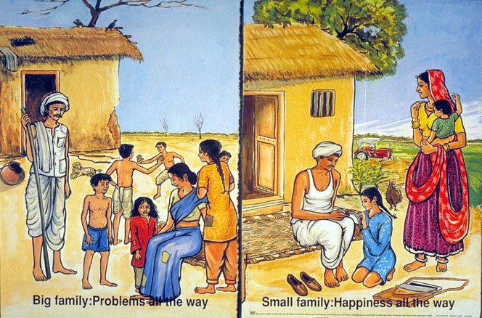
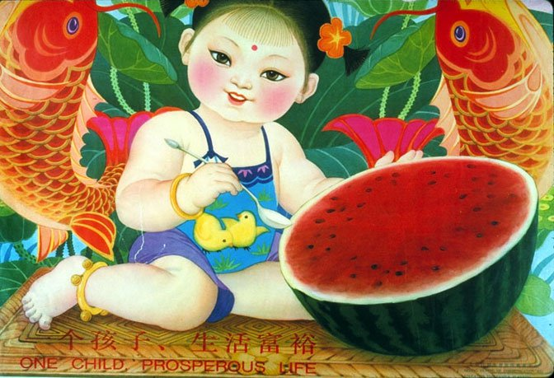
Countries such as China and India have run campaigns to control population growth. Below are examples of these campaigns. Do you think the number of children people have should be controlled? Outline the pros and cons of trying to curb population growth.
One child prosperous life Big family: Problems all the way Small family: Happiness all the way

Watch the BTN One Child Policy story and respond to the following questions:
- When did China introduce the `one child policy’?
- Why was it introduced?
- Why did many people think the one child policy was controversial?
- Some people say the policy has caused some problems. Give one example.

Activity: BTN Population stories
Students watch the following BTN population stories and answer the questions.

BTN Population Debate story

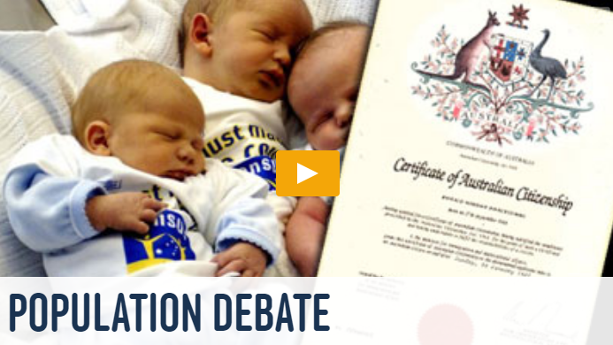
- How much has Australia’s population grown in the last 50 years?
- If the population keeps growing at its current rate, it will be______ by 2050.
- What factors affect a growing population?
- Why were people encouraged to move to Australia?
- What sort of incentives were offered?
- Describe the different groups wanting to migrate to Australia now?
- What are the benefits of a growing population?
- What are some disadvantages?
BTN World Population story

- How much does the population grow each day?
- Why has there been a huge growth in population in a short space of time?
- What has happened to Australia’s population in the last 50 years?
- What is Australia’s population expected to be by 2050?
- What challenges does Australia face with a growing population?
- Which countries are likely to be most affected by increased population?
- What do scientists say we need to do to cope with more people in the world?
- Do you think the population of the world should be controlled? Explain your answer.

BTN 24 Million Australians story

- Why is Australia’s population growing?
- Why were people encouraged to move to Australia in the past?
- People are living longer than they did in the past. True or false?
- What are the benefits of a growing population?
- Why do some people worry about our population getting bigger?
- By 2043 our Australia’s population is expected to reach….
- What do you think about Australia’s population growing? Explain your answer.

Activity: An increasing population
Students watch the ABC Catalyst video How to deal with increasing population then answer the following questions:
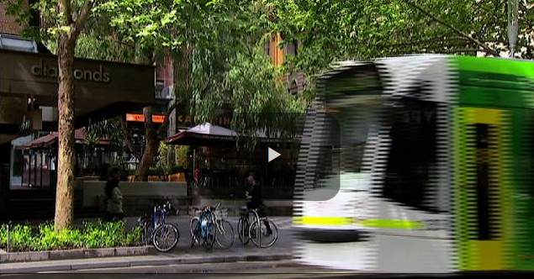
- What do you think is meant by the term `liveability’?
- Rob Adams says the secret to managing Melbourne’s increasing population without losing liveability is building on the existing ____________________.
- Give an example of building on existing infrastructure.
- What is medium density housing?
- Where does Rob Adams suggest that medium density housing should be built?
- What did you learn watching the video?

Useful Websites
- China introduces three-child policy to alleviate problem of ageing population – ABC News
- China releases once-in-decade census data showing falling population growth – ABC News
- One Child Policy – BTN

EPISODE 16
8th June 2021

KEY LEARNING
Students will locate active volcanoes around the world and identify the hazards caused by volcanoes. Students will investigate the different layers of volcanoes and describe their features.

CURRICULUM
Science – Year 6
Sudden geological changes and extreme weather events can affect Earth’s surface.

Science involves testing predictions by gathering data and using evidence to develop explanations of events and phenomena and reflects historical and cultural contributions.

Scientific understandings, discoveries and inventions are used to solve problems that directly affect peoples’ lives.

Scientific knowledge is used to solve problems and inform personal and community decisions.

Science – Years 5 & 6
With guidance, pose clarifying questions and make predictions about scientific investigations.

Science – Year 7
Identify questions and problems that can be investigated scientifically and make predictions based on scientific knowledge.

Collaboratively and individually plan and conduct a range of investigation types, including fieldwork and experiments, ensuring safety and ethical guidelines are followed.
  - Teacher Resource

Volcanic Activity

Focus Questions
Discuss the BTN story as a class and record the main points of the discussion. Students will then respond to the following:
- What do you know about volcanoes? Discuss in pairs before watching the BTN story.
- What ingredients does Jack use in the volcano experiment in the BTN story?
- What are the 3 main layers of a volcano from inside to outside?
- What is another name for magma?
- There are no active volcanoes in Australia. True or false?
- In which ocean can you find the Ring of Fire?
- What is the Ring of Fire? Describe using your own words.
- What affect did the eruption of Mount Nyiragongo have on the environment and people?
- Name three facts you learnt watching this story.
- Illustrate an aspect of the Volcanic Activity story.

Activity: Class Discussion
Before watching the BTN Volcanic Activity story, facilitate a class discussion, using the following questions to get the discussion started...
- How would you describe volcanoes? Use a mind map to record your responses.
- What does a volcano look like?
- Where can you find volcanoes?
- What else do you know about volcanoes? Brainstorm and record your thoughts as a class.
- What do you want to learn about volcanoes?

After watching the BTN story hold a class discussion. Use a mind map to record your student’s responses.

What hazards do volcanoes cause?

Where can you find volcanoes?
?

Activity: Glossary
Students will brainstorm a list of key words that relate to the BTN Volcanic Activity story. Below are some words to get them started. Students will create their own class glossary of scientific keywords and terms. Consider creating a photographic glossary and students can use photos and/or diagrams to help explain each keyword.

MAGMA | VOLCANOLOGY | TREMOR
DORMANT | ERUPTION | LAVA FLOW

Further investigation: Tricky words
Students will choose additional keywords and terms to add to their class glossary that are tricky. For example, fissure, geothermal, igneous rock, Ring of Fire, pyroclastic flow or plate boundary. Students will find a definition and explain to their classmates what the keywords mean.

Activity: Research project
After watching and discussing the BTN Volcanic Activity story, what questions do students have and what are the gaps in their knowledge? The following KWLH organiser provides students with a framework to explore their knowledge on this topic and consider what they would like to know and learn.

What do I know? | What do I want to know? | What have I learnt? | How will I find out?

Act like a scientist
Students will start to think like scientists and develop their own question/s for inquiry, collecting and recording information from a wide variety of sources. Students may develop their own question for inquiry or select one or more of the questions below.
- How many active volcanoes are there worldwide? Locate some of Earth’s active volcanoes on a map and describe their proximity to Australia. Draw the Ring of Fire on your world map.
- Are there any volcanoes in Australia? Locate these volcanoes on a map of Australia. Choose one to research in more detail.
- How can you tell if a volcano is active or dormant? Explore and describe the features of an active and dormant volcano.
- Can we predict when a volcano will erupt? Explore further.
- What impact can volcanic eruptions have on people and the environment? Consider the negative and positive effects.
- What are the different layers of a volcano? Draw a cross section of a volcano showing the following features: crust, mantle, crater, magma chamber, magma, ash, cloud, vent. Explain some of the features of each layer.
- What is the biggest volcano on Earth? Investigate how it was formed.

Activity: Geography
On a map of the world students will locate and highlight the major active and dormant volcanoes (including the volcanoes mentioned in the BTN Volcanic Activity story). Students will then respond to the following:
- Circle nearby cities and towns to each of the volcanoes you mark.
- Highlight the Ring of Fire on your map.
- What do you notice about the location of the volcanoes in relation to the Ring of Fire?

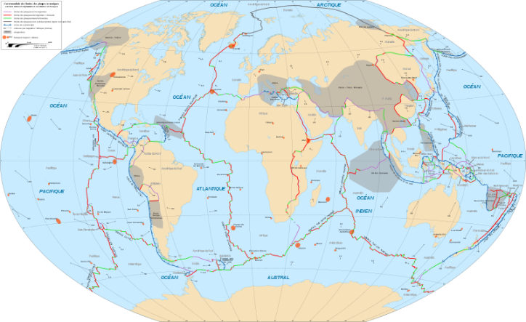
Hands on activity – Tectonic plates
Most of the world's volcanoes are found around the edges of tectonic plates, both on land and in the oceans.

As a class explore the 15 major tectonic plates on Earth and draw and label them on a world map. Using an enlarged version of the tectonic plates map, create a class jigsaw puzzle of tectonic plates. Paste your map onto foam or thick card and cut along the tectonic plate lines. Sit the pieces in a small inflatable pool or trough of water and observe how they move.

Students will then respond to the following questions about tectonic plates:
- How do the pieces interact with one another? Are they still or constantly moving?
- What direction and speed are they moving?
- Investigate how your jigsaw puzzle experiment reflects how tectonic plates move.

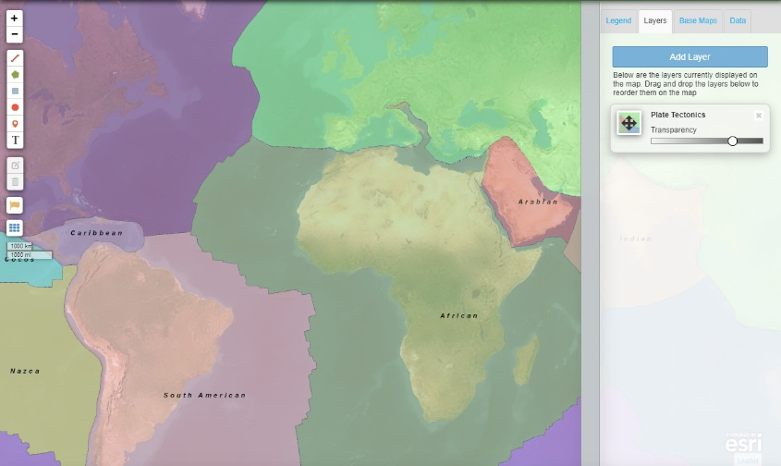
Alternatively, students can use this Interactive Map Maker (National Geographic) to explore the connections between tectonic plates and volcanoes.

Using the interactive map students will add and label the following:
- Major tectonic plates
- 5 or more active volcanoes
- 5 or more dormant volcanoes
- The Ring of Fire
National Geographic – Interactive MapMaker

Activity: Science experiment
Provide students with the opportunity to think and behave like volcanologists. In pairs or small groups, students will build a volcano, by using these step-by-step instructions or watching this instructional video on how to make a volcano. Students will use the following investigation framework before, during and after their investigation.

Before starting this activity, introduce students to what a science investigation is and why we do them. Think of words that relate to “science investigation” and then find and explain their meanings. Here are some concepts to get you started: variable, observation, diagram, fair test and prediction.

Before the investigation | Before starting this experiment, respond to the following:  - What am I going to investigate?  - What do I think will happen? Make a prediction. Why do I think this will happen?  - What steps do I need to follow to investigate my prediction?  - What materials and equipment will I need? Make a list or draw and label each item.  - What variables am I going to keep the same? For example, think about using different materials to change the shape of the volcano or adding more bi-carb soda.  - What things may affect what you are investigating?  - Draw a labelled diagram to illustrate the investigation setup.  - Describe what you will be doing in each stage of the investigation.
Investigation | - Use these step-by-step instructions (Questacon) or watch this instructional video (National History Museum) to make your own bi-carb soda volcano. You may want to film your experiment.  - Record your observations. How high did the eruption go? How far did the mixture spread?  - Try using different amounts of bi-carb soda, water or vinegar. How does it change the eruption?
After the investigation | - Write a sentence that summarises what happened.  - Draw a labelled diagram of your observations to show what happened.  - Draw a labelled diagram of a volcano including Earth’s layers (crust, mantle, outer core and inner core). Explain some of the features of each layer.  - Was this what I expected to happen? Yes or no.  - Why do I think this happened? Use science ideas to explain. What gas is produced when bicarb is mixed with vinegar. Is this the same gas that is produced when a volcano erupts?  - What problems did I experience when I was doing the investigation?  - One important fact I learned when doing this investigation was…  - What I found surprising was…  - What I would do differently next time is…
Activity: Choose a project
Individually or in small groups, students will choose one of the following projects to work on and then present their findings to the class.
Model
Create a 3D model of a volcano. Make the model using materials found around your school or home. Label the features of a volcano on your model. Display your model in the classroom.

Famous volcanoes
What are some of the world’s most famous volcanoes? Create a “Who Am I” quiz about the top 3 most famous volcanoes and test your classmates.

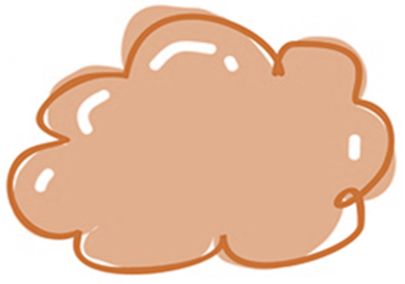
Habitat
What animals and plants call volcanoes home? Choose one animal or plant and explore how it has adapted to survive in such a dangerous environment.

True or false?
Find out as much as you can about volcanoes. Create a true or false quiz and test your classmates. Alternatively, create a word find or crossword about volcanoes.

Useful Websites
- Volcano Warning – BTN
- Volcanoes Explained – BTN
- Hawaii Volcano – BTN
- Everything you need to know about volcanoes – Newsround
- Volcano – Geoscience Australia
- What makes volcanoes erupt? – TedEd
- Volcano Facts – National Geographic Kids
- Curious Kids: Why do volcanoes erupt? – The Conversation

  - Teacher Resource

BTN Transcript: Episode 16 - 8/6/2021

Hey. I'm Amelia Moseley and you're watching BTN. Here's what's coming up. Why China's trying to give its population a boost, pups put their noses to good use in the fight against COVID and meet Harley who's helping to create a skate park for kids in his community.
Athlete Pressures

Reporter: Joseph Baronio

INTRO: All that soon, but first here's a question for you. Do you think pro athletes face too much pressure from fans and the media? It's something a lot of people are asking after star tennis player Naomi Osaka pulled out of the French Open because she said talking to the press was bad for her mental health. Joe takes a closer look at the issue and what it's really like being a sporting superstar. Check it out.

What does it take to be a world class athlete?
KID 1: To be an elite athlete you need to have a lot of you need to be determined.
KID 2: It also takes a lot of courage.
KID 3: A lot of training, a lot of courage, really.
Yep, as much as we may dream of being the best and enjoying all the rewards and glory that comes with it, we also know that it's hard work. But for every hour an elite athlete spends playing or training, they're also spending way more time doing other stuff you might not even think about.

Whether it's travelling to events, making sure they eat, drink and rest properly, promoting brands and products or attending press conferences and talking to the media. It's that last one that’s got a lot of people talking right now because for some athletes it's not just another responsibility. It can be a really difficult and sometimes upsetting part of the job. At least tennis star, Naomi Osaka, thinks so because it recently led to her pulling out of the French Open.

See, before the event started, she flagged that she wouldn't attend press conferences, explaining in a tweet that people don't often think about the mental health of athletes and that some questions from journalists can make athletes doubt themselves, saying it can be like kicking a person while they're down. And, after a loss or a bad game, it's easy to see where she's coming from. Hey, I wasn't even ready yet.
The rules say that all players must hold press conferences after each match, no matter if they win or lose. And when Osaka skipped the press conference after winning her first round match, event officials didn't like it. They fined her almost $20,000 and threatened to kick her out of the competition.

But why should she have to talk to journalists if she doesn't want to? Well, a lot of money from professional sports comes from things like sponsors, TV deals and, of course, fans who pay to come to see the action happen. And covering the personalities in those sports is a big way to attract interest in them and the organisations they play for; and in this case, the tournament Naomi Osaka was playing at, the French Open. It all comes back to money and exposure, and while it's something that can benefit athletes, recently many have spoken out about the negative effects press coverage can have on their mental wellbeing.

MO FARAH, OLYMPICS LONG DISTANCE RUNNER: Well, you have 40 journalists, you’ve got the camera right in front of you, and it’s nerve wracking.

A survey by the AIS last year found that athletes were significantly more likely to report high to very high levels of psychological stress and roughly one-in-three athletes report experiencing symptoms of anxiety and depression. Eventually, Osaka pulled out of the tournament on her own and while a few people have criticised the move.

TONY ESTANGUET, PARIS OLYMPICS COMMITTEE PRESIDENT: When you are an athlete, you have some rights, but you also have some duties, and you have to accept to speak to the media.

Many others, including celebrities and other athletes, have spoken out in support of her decision. What do you guys think about it?
KID 2: I think they should be able to do what they feel.
KID 4: I feel like they should sort of be in the media, but like not too much.
KID 1: The media, they're always like right in their faces like press conferences a lot of the time and if they could, if the player wants them to just ease up on it a bit then they should ease up on it.
News Quiz

The Houston family lives in Gippsland, Victoria. They love their footy, but they couldn't play in their local league over the weekend while a lot of their friends could.

KID 1: It’s upsetting, and I wish I could play but, I’m still happy that my friends can play and enjoy it.

KID 2: I feel like it’s a little unfair because I like footy a lot and not being able to play it annoys me.

So why not? It's because their home is on the boundary between Greater Melbourne which is in lockdown and regional Victoria where lots of activities are now going ahead after COVID restrictions relaxed over the past week. Regional Victorians can now travel freely, shop and go back to school.
NASA has announced that it's launching two new missions later this decade to study a nearby planet. But which planet are they heading to? Mercury, Venus or Mars. It's Venus. The missions will hopefully help us learn more about the planet's atmosphere and surface.
Meghan, Duchess of Sussex, has given birth to her second child, a baby girl. She and husband, Prince Harry, have named her Lilibet Diana Mountbatten-Windsor in honour of two royals. Who are they? It's Queen Elizabeth whose family nickname is Lilibet and Diana after Harry's mum, Princess Diana.
China Population

Reporter: Amelia Moseley
INTRO: Next up, let's take a trip to China where the governments just made a big change to one of its laws. It had a policy which limited couples to having two kids but now it's letting them have three. Let's find out why China put limits on having babies in the first place and why it's had to change.
Families come in all different sizes.

KID 1: I have two siblings and they’re both brothers.

KID 2: I have three siblings.

KID 3: It’s just the two of us.

KID 4: I have no siblings, I’m an only child.

But imagine if the number of brothers and sisters you had wasn't really up to your parents; it was up to the government. Well, over in China, that's how it's been for decades, and it all started with a plan known as the one-child policy. In the 1980s, China's government made it illegal for most people to have more than one kid. It was worried about its fast-growing population that was close to hitting a billion people and whether there'd be enough food, resources and jobs for everyone in the future. People that did have more than one kid were slapped with really big fines or other punishments if they couldn't pay up.
CHINESE WOMAN: They'd have their house pulled down. If they didn’t pull down your house, they’d take away all your timbers and horse carts.
While the one-child policy did help to slow down population growth, it was a pretty controversial move, because choosing how many kids you want is generally considered a basic human right. It also contributed to some other problems. Most people in China wanted to have a boy, because culturally they were seen as more valuable to the family and to this day there are more men than women in China.
But another problem started to grow from the plan. While the People's Republic of China is far from short on people, it is short on young people. While that might mean more lovely afternoon games of croquet, it's not so lovely for a country's economy. For example, you need young people to get jobs, earn money, spend money and have kids that can eventually do all those things too and young people can also help to look after older people.

That's why in 2016 China's government scrapped the one-child policy in favour of two children. At first there was a jump in births, but then a year later, it dropped again. Now, with China’s ageing population at a whopping 1.4 billion people, the government's decided to up the number of kids per couple again, to three. But the big question is, will people take up the offer?
CHINESE WOMAN: I think only super-rich families might have the aspiration, because they have more money to raise children.
CHINESE GIRL: Now, I am the only child in my family, and I really hope my parents can give birth to a younger brother or younger sister.
That’s why China's government says it's going to help by cutting the cost of education and housing and educating young people on marriage and love. Whatever that means. But only time will tell if it's enough to convince families to add another sibling to their gang. Something these kids say can come with its own set of problems.

KID 1: When your parents aren’t home you have to look after them and keep them accountable.

KIDS: We might get into fights every now and then. Yeah definitely.

KID 3: I never really get my own time but sometimes I can like when I’m sleeping at least they’re not jumping on me.

KID 4: But it’s really fun because like there’s always someone to hang out with and it’s like you’re never alone or you never get bored in the house.

Kids Talk

How worried are you about COVID-19? How do you feel about school, family, friendships? Here at BTN, we want to know, so we're launching Kids Talk. It's a survey all about you and how your world's changed since the COVID-19 pandemic began. We also want your opinions on some big topics. And we'd like school kids all around Australia to get involved so we can learn more about you. Just head to our website for all the details.

Volcanic Activity

Reporter: Jack Evans

INTRO: We've seen some incredible footage this year of volcanic eruptions in places like Iceland, Italy, and the Democratic Republic of Congo. But while volcanoes are often amazing to look at sometimes they can cause serious damage. Jack finds out more about volcanoes and what's really going on beneath the surface. Take a look.
For billions of years these fiery peaks have been belching up molten rock, hot ash and gas. Which makes for some pretty cool drone shots, a perfect place to cook a hot dog, I mean I wouldn't try that. Oh, and apparently a nice spot to play volleyball. Wait a minute, that can't be right.? Oh no, those people are playing volleyball right near an active volcano. Anyway, where was I? Ah yes, volcanoes. They're epic, spectacular and well sometimes kinda bizarre. So how do they work?
JACK: Well according to this science experiment it’s a combination of vinegar, baking soda, dish washing liquid and a little bit of water. That doesn't seem right. I think we have to do a bit more digging. You see the Earth is made up of layers. The part I'm standing on and, well all of you are standing on is the crust. Volcanoes start their journey deep down underground.
Further, further, ooh there's that wig I lost. Keep going, a little further and stop. Right, here we are at the core. Which is hot, like as hot as the surface of the sun hot. That heat sends a lot of pressure out through the next layer, the mantle. At some points molten rock or magma builds up at the surface of the mantle and breaks through weak points in the crust as a, yeah, a volcano. As the lava cools it turns into rock and over time we get great big volcanoes like this one or this one or this one. Yeah, there are hundreds of them around the world and some of them can be really dangerous. While there are no active ones here in Australia, our neighbours across the ditch are pretty familiar with them.

JACK: I promise I won’t try to eat you. Well, that’s what you said last time, you did try to eat me. They're part of a big chain of volcanos known as the Ring of Fire, which go all the way along the Pacific Plate, in the Pacific, specifically.

What's that I hear you ask? Well, it's just one of the tectonic plates that make up the Earth's outer layer. They're constantly and very slowly moving. Where the sort of jigsaw pieces meet volcanoes can form. Which is why this plate gets the name, Ring of Fire.
Most of the time volcanoes are pretty manageable and countries have plans in place for when one erupts. But they can be disastrous. This is Mount Nyiragongo in the Eastern Democratic Republic of Congo, near the city of Goma. It's one of the world’s most active and dangerous volcanoes and it erupted back in May. The lava, ash and smoke tore through 17 villages, destroying hundreds of homes, schools, health centres and killing at least 32 people. Now that the lava has stopped people have been able to return to their homes. But this volcano isn't going anywhere and it's something people here just have to live with. And it is a reminder of just how powerful and dangerous these amazing natural wonders can be.

Did You Know?

Did you know that Australia's actually home to hundreds of volcanoes? But none of them have erupted in nearly 5000 years. The most recent known eruptions were in South Australia at Mt Gambier and Mt Schank.

Ask a Reporter

Do you have a question about volcanoes? Well, you can ask me live on Friday during Ask A Reporter. Just head to our website for all the details.
COVID Sniffer Dogs

Reporter: Amelia Moseley

INTRO: Now, it's no secret that dogs have great noses and for years those noses have been put to use sniffing out illegal goods, or even helping to rescue people. But now a new trial's underway in Adelaide to see if they can also detect COVID-19 in people. So, I went along to put our four legged friends to the test.

Let's talk about noses.
Amelia, Reporter: No, not my nose. His nose.
This is Quake, and he has an amazing schnozz. In fact, it's up to 100 times more sensitive than mine or yours.
DR ANNE-LISE CHABER, COVID DOG DETECTOR PROGRAM: So, dogs are very good because they've got much more cells in their nose to detect scent. You have to understand that we see the world with our eyes and the dogs see the world with their nose.
That's why dogs here at the Adelaide Uni Animal Sciences School are being trained to do a very important job, sniffing out COVID. See it turns out people with certain diseases produce a certain scent and luckily Rona is one of them, and these cuties are the first dogs in Australia learning to pick up on it.
DR ANNE-LISE CHABER: There are 27 countries now in the world that are training dogs to detect COVID and we are collaborating with all of them.
So how does a doggy COVID test work exactly? Let me demonstrate. First you need a nice, smelly sample.
DR ANNE-LISE CHABER: We just take the gauze and take them, and you just put them under your armpit, on bare skin. Just leave it there for two minutes.
Amelia: So that will collect enough of my scent that the dogs will be able to do my COVID test?
DR ANNE-LISE CHABER: Exactly.
Amelia: Awesome.
ALEX, COVID DOG DETECTOR PROGRAM: So, what I'm going to get you to do. I’m going to get you to take your samples out and we'll put them into this specimen jar.
Amelia: Nice sweaty armpit samples, that’s not too bad.
ALEX, COVID DEOG DETECTOR PROGRAM: I can't smell anything. Okay Amelia, as I said your scent sample's now going to be put into our lineup. So, I'll just introduce it here into number 4.
Enter detector doggo, Bonnie. She knows to sit if she smells a positive test. Her reward for getting it right? Play time. And luckily it wasn't my sample.
ALEX, COVID DOG DETECTOR PROGRAM: So you’re all good, you're in the clear.
Amelia: Good to know.
Of course, there are no actual COVID samples here today or we wouldn't wanna be here. But the dogs have been fully trained with real samples from people with and without COVID, and researchers say they're around 97 percent accurate at sniffing it out, even if someone doesn't have symptoms yet.
DR ANNE-LISE CHABER: The dogs actually able to detect people, when they're in the incubation phase of the disease, that when you just caught the disease, you're not sick yet, and you are just at the beginning of producing the viruses.
Amelia: So, Dr Anne-Lise, I guess it's better having a dog like Quake do the test for you rather than sticking a swab up your nose? Much more fun I think?
DR ANNE-LISE CHABER: I think so.
Researchers reckon dogs' noses won't replace the nose swab test, but they could help to screen big groups of people quickly like at airports or sports games or even in developing countries where people don't have access to labs for testing results.
DR ANNE-LISE CHABER: So, you can actually use a Labrador and not a laboratory.
Quake and the other doggos are now moving into the next phase of training. They're learning to detect the virus on people's bodies using volunteers, like me. But not every dog can do this job, or not every dog wants to.
DR ANNE-LISE CHABER: So, all dogs can do it. But some dogs don't really like to work. So, Labradors are really happy to work. And every day when they come to work, they are overjoyed.
And you know what they say, work hard, play hard.
DR ANNE-LISE CHABER: At night he comes back to my place. He's very playful, really likes to be with kids and a bit cheeky sometimes.
And if they keep up their good work who ‘nose’ how helpful these talented pooches can be.
Sport

It's been a disappointing week for some of tennis' biggest stars at the French Open starting with none other than Aussie and world number one Ash Barty. She had to retire in her second round match because of a hip injury.

ASH BARTY: It’s heartbreaking I think but it won’t take away the brilliant three months that we’ve had, as much as it hurts right now.
Serena Williams lost in straight sets to Elena Rybakina in the fourth round. And after a tough third round win against Dominik Koepfer, Roger Federer announced he would be pulling out of the tournament to rest a knee injury.
Aussie Richie Porte has won the Criterium du Dauphine by just 17 seconds. The race is a week-long slog through the French Alps and after finishing runner up twice, Richie was pretty happy with the win.
Shelly Ann Fraser Pryce is fast, like really fast. The Jamaican sprinter just became the second fastest woman ever running a blistering 10.63 seconds in an Olympic warm up event. Imagine when it’s the real deal.
Skate Park Kid

Rookie Reporter: Harley

INTRO: Finally, today, you're about to meet 12 year old Harley from Meredith in Victoria. He was so keen to get his friends off the couch and playing outside that he spent a year campaigning to improve his local skatepark Now, it's paying off in a big way. Check it out.

HARLEY: G'day BTN, my name is Harley. I live in Meredith, Australia. This is my brother Max. Our favourite thing to do in Meredith is come down to the skatepark and ride our BMXs, skateboards and scooters.
JOE: How long have you been going to the skate park?
HARLEY: Well, I've been going to the skatepark for years with my friends and my brother and yeah, I've always like, it's a good skate park but it's not the best so I thought we needed a new update.
This is our current skatepark. It's not in the best condition and it's really rusty. It's the only place for children to chill and hang out. We did heaps of research, took photos of other BMX tracks and skate parks, and we put it all on a piece of paper and sent it to the council. The design we came up with is to use the land around the oval for two BMX tracks. One with bigger jumps for the older kids and one with smaller jumps for the little kids.

The next part of the project is to create a fantastic new skate park, using concrete jumps such as concrete table top, half pipe and it'd be great to see a concrete bowl. We're hoping it'll be done in the next 12 months, so it will be ready for the school holidays.
JOE: How much money did you manage to get to get it upgraded?
HARLEY: Well, we got $420,000 for the upgrade.
JOE: How hard was it to get that?
HARLEY: It took us roughly about two years to get the money. We talked to my old principal about it and then we made a proposal, we just got some like feedback and notes from people that wanted it. We talked to the local policeman and then we handed in the proposal to the council and then it was a waiting game; and then I got the phone call from my principal saying that it had been approved and we had got the money for it.

JOE: Fantastic.

HARLEY: I'm really proud of it and so is my best mate, like, it's just a really good feeling that we've got something good for the community.
JOE: What would you say the moral of the story is here?
HARLEY: If you want something not to give up because I nearly gave up about it, because I thought it's been so long that I was just gonna give up, but I've learnt not to give up and just keep trying and then yeah, it'll come true. Thanks BTN see you around.
Closer

Good work, Harley. Well, that's it for now but we'll be back with more news for you next week. Until then, you can check out our website for more stories, teacher resources and specials and don't forget to have your say in our Kids Talk survey. We want to find out how you're going and get your opinion on lots of big issues. Have an awesome week. And I’ll see you soon. Bye.

