Episode 25
1st September 2020



Border Restrictions
- Discuss the BTN Border Restrictions story as a class and record the main points of the discussion.
- Why have many states and territories put border restrictions in place?
- How have the border restrictions affected the kids in the BTN story?
- Complete the following sentence. Many experts say that closing the borders is one of the best ways to keep the _______________ contained.
- What does Alan Joyce, the boss of Qantas think about the border closures?
- Why has businessman Clive Palmer taken Western Australia’s government to court?
- What does Australia’s Constitution say about goods and services moving freely around the country?
- What are some exceptions to that law?
- What border restrictions are there in the state where you live?
- Do you think the border restrictions are a good idea? Give reasons for your answer.

Check out the Border Restrictions resource on the Teachers page.

Hay Fever Problem
- What did the BTN Hay Fever Problem story explain?
- Complete the following sentence. Hay fever affects one in ______ Australians.
- What triggers hay fever?
- What are allergens? Give an example.
- How does a person’s body react if they have hay fever?
- What are the symptoms of hay fever?
- Why is spring usually the worst time of year for hay fever?
- Why is this year’s hay fever system different to previous years?
- What can people do to control their hay fever?
- What do you understand more clearly since watching this story?

Check out the Hay Fever Problem resource on the Teachers page.

Going Cashless
- Discuss the BTN Going Cashless story in pairs. Record the main points of the discussion.
- The Reserve Bank says fewer people are using cash to pay for things. True or false?
- How are people choosing to pay for things? Give at least one example.
- What have some banks closed in response to fewer people using cash?
- Why are fewer people using cash since the COVID-19 pandemic?
- How have businesses preferred people pay for things since COVID?
- What are some advantages of going cashless?
- What are the disadvantages?
- Do you think a cashless society is a good idea? Give reasons for your answer.
- How does a cashless society impact on you?

Science of Taste
- What is the main point of the BTN Science of Taste story?
- Complete the following sentence. Studies show only _______% of kids are eating enough vegetables.
- Which science agency has started a program to teach kids about taste and healthy foods?
- How many servings of vegetables should primary school aged kids be eating every day?
- As part of evolution, why were humans born with a liking for sweet tasting food?
- Why do humans have a dislike for bitter tasting food?
- What is the problem with eating too much sweet food?
- How do people’s preferences for different tastes develop?
- How can people retrain their taste buds to like different food?
- What was surprising about this story?

COVID Catch-Up Newspaper
- Briefly summarise the BTN story.
- How old is Suzy?
- Why did she start the COVID Catch-Up Newspaper?
- What equipment does she use to write the newspaper?
- What sorts of stories does Suzy have in the COVID Catch-up?
- How have people responded to it?
- How do people get a copy of Suzy’s newspaper?
- Complete the following sentence. Money donated to the newspaper goes to ___________________.
- What would you like to ask Suzy about her newspaper?
- Write a message of support to Suzy and post it in the comments section on the story page.

Teacher Resource
Episode 25
1st September 2020

Border Restrictions

Students will learn more about Australia’s Federation and the three levels of government and responsibilities of each.


Civics and Citizenship – Year 6
The roles and responsibilities of Australia’s three levels of government.
Develop appropriate questions to guide an inquiry about people, events, developments, places, systems and challenges.
History – Year 6
Key figures, events and ideas that led to Australia’s Federation and Constitution.

English
Plan, draft and publish imaginative, informative and persuasive print and multimodal texts, choosing text structures, language features, images and sound appropriate to purpose and audience.


- Discuss the BTN Border Restrictions story as a class and record the main points of the discussion.
- Why have many states and territories put border restrictions in place?
- How have the border restrictions affected the kids in the BTN story?
- Complete the following sentence. Many experts say that closing the borders is one of the best ways to keep the _______________ contained.
- What does Alan Joyce, the boss of Qantas think about the border closures?
- Why has businessman Clive Palmer taken Western Australia’s government to court?
- What does Australia’s Constitution say about goods and services moving freely around the country?
- What are some exceptions to that law?
- What border restrictions are there in the state where you live?
- Do you think the border restrictions are a good idea? Give reasons for your answer.


Personal response
After watching the BTN Border Restrictions story, ask students to finish one or more of the following incomplete sentences:
- This story made me wonder why…
- It was interesting to learn that…
- This story made me feel…
- BTN covered this story because…

Class Discussion
As a class discuss the BTN Border Restrictions story using the following questions as a guide. Record the main points of discussion.

- Why have the borders been shut between states and territories in Australia?
- Who decides whether the borders should be closed?
- How have border restrictions impacted people?
- How have you been affected by the border restrictions?
- Do you think the border restrictions are a good idea? Give reasons for your answer.

Federation and Australia’s Constitution
To gain a deeper understanding of how Australia came to have states and territories, students will watch the following BTN stories Federation and Constitution and answer the questions below.
- 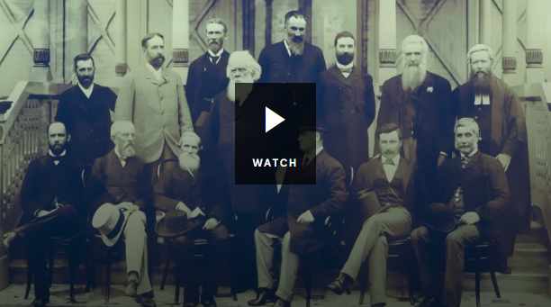Before Federation, Australia was divided into six separate ______________.
- Which other country might have been part of Australia?
- Who was Henry Parkes?
- What was his famous speech about?
- Why were initial attempts to become a Federation rejected?
- What role did Alfred Deakin play in Australia becoming a Federation?
- In what year did Australia become a nation?
- Who was Australia’s first Prime Minister?

- 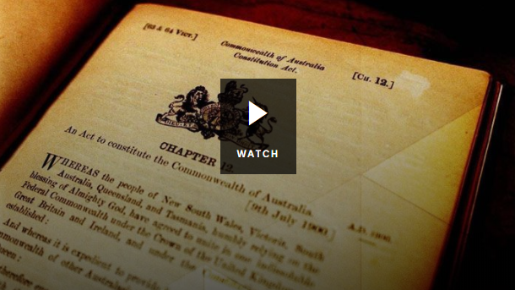What is a constitution?
- What sorts of things are set out in Australia’s Constitution?
- No other law can overrule the constitution. True or false?
- When was Australia’s Constitution drawn up?
- Which group of people were discriminated against in the original constitution?
- What is a referendum?
- What two changes to the Constitution happened as a result of the referendum in 1967?
- Why do you think the Constitution is described as the country’s birth certificate?
Three Levels of Government
Students will investigate the three levels of government in Australia and the responsibilities of each. Watch the Parliamentary Education Office Three Levels of Government video and the BTN Levels of Government story to learn more about how the levels of government in Australia work. Ask students to respond to the questions below.
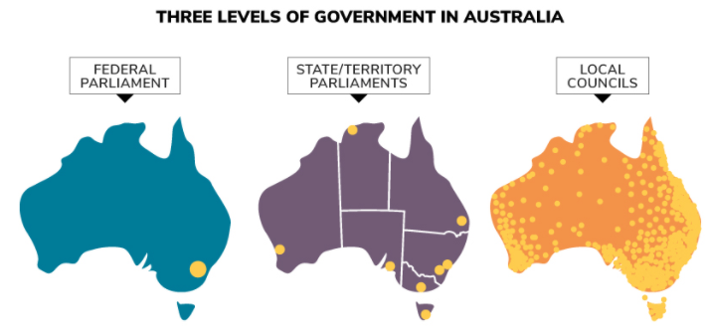
Parliamentary Education Office

Federal Government

- What is the decision-making body of federal government?
- What are the two houses of parliament?
- What is the leader of the federal government called?
- How often are elections held?
- What are the representatives of each houses of parliament called?
- Give three examples of federal government responsibilities.

State and Territory Government
- What is the decision-making body of state government?
- Are all states made up of two houses?
- What is the leader of the state government called?
- What is the leader of each territory government called?
- Give three examples of state government responsibilities.

Local Government

- What is the decision-making body of local government?
- What are the representatives called?
- What is the head of the council called?
- Give three examples of local government responsibilities.

Shared and separate responsibilities
Federal
State
Local
Working in pairs, students will investigate the shared and separate responsibilities of the three levels of government. They can display their information using a Venn diagram with three circles. Record shared responsibilities in the overlapping areas. Ask students to consider why there are some responsibilities that are shared between the different levels of government.

Challenge
Research an issue that state/territory and federal governments have disagreed on. How was the issue resolved?

Mini Debate or Persuasive text
Students will develop a mini debate or a persuasive text for or against the following statement: ‘State and territory borders should be closed to stop the spread of coronavirus.’ Students can use the information recorded on the mind map and their own research to help develop their argument.

Mini debate
- Working in pairs, students will prepare a 1-2-minute speech for a mini debate on the topic.
- One person will speak for the affirmative and the other will speak for the negative.
- Before students begin to construct their argument, ask them to record what they already know about the topic and what they would like to find out. Students then research the topic to gain a greater understanding of the issue.
- Ask students to list their arguments in point form on paper (without their partner seeing them). When they have done this, ask them to choose the five best points that will form the basis for their debate.
- Students will write in point form, their debate on cards that fit into the palm of their hand. Their debate needs to have an introduction (introducing the topic), middle (three main points) and a conclusion (restating their position). Students practise their speech and then present the mini debate to other students.

Structure
Introduction
- What is the point you are trying to argue? Construct an introductory paragraph which states the issue or topic.
- Introduce the arguments that will be developed in the body of the text.

Body
- Construct arguments that support your point of view.
- Each paragraph starts with a topic sentence which introduces each point.
- The rest of the paragraph gives more reasons.
- Arguments can be ordered from strongest to weakest.

Conclusion
- Restate your position on the argument.
- Construct a concluding paragraph that provides a summary of your arguments and a call to action.
Tips
- Who is your audience? For example, are you directing your argument at kids, teachers or politicians?
- Explore how language choices can have a big impact on persuading your audience.
- Which language devices give the report credibility and authority?
- Which are designed to create an emotional response in the listener?
- Provide facts and evidence to support your argument.
- Write in the present tense.
- Check your spelling and punctuation.

Use this Read Write Think persuasion map to plan your exposition text.

Quiz Questions | Your Answer
- How many levels of government are there in Australia?
  - One
  - Two
  - Three
- Before Federation, Australia was made up of 6 different colonies.
  - True
  - False
- Australia is made up of…
  - 6 states and 2 territories
  - 5 states and 3 territories
  - 7 states and 1 territory
- What is the leader of a state called?
  - Prime Minister
  - Premier
  - Chief Minister
- What is the name of the set of rules by which Australia is run?
  - Federation
  - Constitution
  - Referendum

Answers: 1c, 2a, 3a, 4b, 5b


Levels of Government – BTN
https://www.abc.net.au/btn/classroom/levels-of-government/10524692

Federation – BTN
https://www.abc.net.au/btn/classroom/federation/10528704

Constitution – BTN
https://www.abc.net.au/btn/classroom/constitution/10529046

Federal Court says hard border best at stopping coronavirus from entering WA in Clive Palmer case – ABC News
https://www.abc.net.au/news/2020-08-25/wa-loses-bid-for-fresh-trial-in-clive-palmer-hard-border-battle/12592524

How effective are border closures at stopping COVID-19? This is what scientists think – ABC News
https://www.abc.net.au/news/health/2020-07-10/coronavirus-victoria-border-closures-what-does-science-say/12438244

Teacher Resource
Episode 25
1st September 2020
Hay Fever Problem
Students will learn more about the causes, symptoms, treatment and prevention of hay fever.

Health and Physical Education – Year 3 and 4
Identify and practise strategies to promote health, safety and wellbeing.

Describe strategies to make the classroom and playground healthy, safe and active spaces.

Describe strategies to make the classroom and playground healthy, safe and active spaces.

Health and Physical Education – Year 5 and 6
Investigate community resources and ways to seek help about health, safety and wellbeing.

Plan and practise strategies to promote health, safety and wellbeing.

Investigate the role of preventive health in promoting and maintaining health, safety and wellbeing for individuals and their communities.

Health and Physical Education – Year 7 and 8
Practise and apply strategies to seek help for themselves or others.

Investigate and select strategies to promote health, safety and wellbeing.

Evaluate health information and communicate their own and others’ health concerns.

Plan and use health practices, behaviours and resources to enhance health, safety and wellbeing of their communities.
- What did the BTN Hay Fever Problem story explain?
- Complete the following sentence. Hay fever affects one in ______ Australians.
- What triggers hay fever?
- What are allergens? Give an example.
- How does a person’s body react if they have hay fever?
- What are the symptoms of hay fever?
- Why is spring usually the worst time of year for hay fever?
- Why is this year’s hay fever system different to previous years?
- What can people do to control their hay fever?
- What do you understand more clearly since watching this story?


Before watching
Before watching the BTN Hay Fever Problem story students will write down as much as they can about hay fever and other allergies.
What do you know about hay fever?

After watching
Students will respond to one or more of the following questions after watching the BTN story:
- 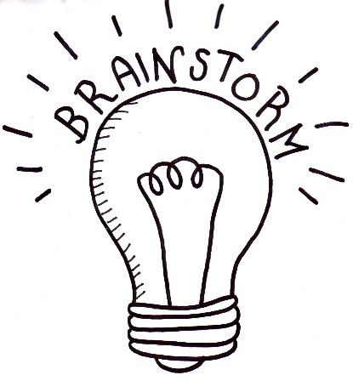What did you learn from the BTN story?
- What do you THINK about what you saw in the BTN Hay Fever Problem story?
- Have you experienced hay fever? Describe some of your symptoms.
- When do people experience hay fever?
- What do WONDER about hay fever?
- Think of three questions you have about the story.

Glossary
Students will brainstorm a list of key words that relate to the BTN Hay Fever Problem story. Students may want to use pictures and diagrams to illustrate the meaning and create their own glossary. Here are some words to get you started.
Symptoms | Hay fever | Immune system
Prevention | Allergen | Allergic reaction

KWLH
Hold a class discussion after watching the BTN Hay Fever Problem story. What questions were raised in the discussion (what are the gaps in their knowledge)? The following KWLH organiser provides students with a framework to explore their knowledge on this topic and consider what they would like to know and learn.

What do I know? | What do I want to know? | What have I learnt? | How will I find out?

Questions for inquiry
Students will develop their own question/s for inquiry, collecting and recording information from a wide variety of sources. Students may develop their own question for inquiry or select one or more of the questions below.

- Why is hay fever called ‘hay fever’? Investigate when hay fever was discovered.
- How does hay fever affect the body? Use the following scientific words in your description: symptom, allergens, immune system and antibodies.
- What is the difference between a food allergy and a food intolerance?
- What is the difference between an allergy and a cold?
- How do you find out what is causing allergies?
- What can I do if I see someone having an allergic reaction?
- Why does pollen cause hay fever? Look at pollen under a microscope and record your findings. Investigate the pollen count in your area.
- How can you tell the difference between hay fever and COVID-19? List the symptoms for each disease and compare and contrast.

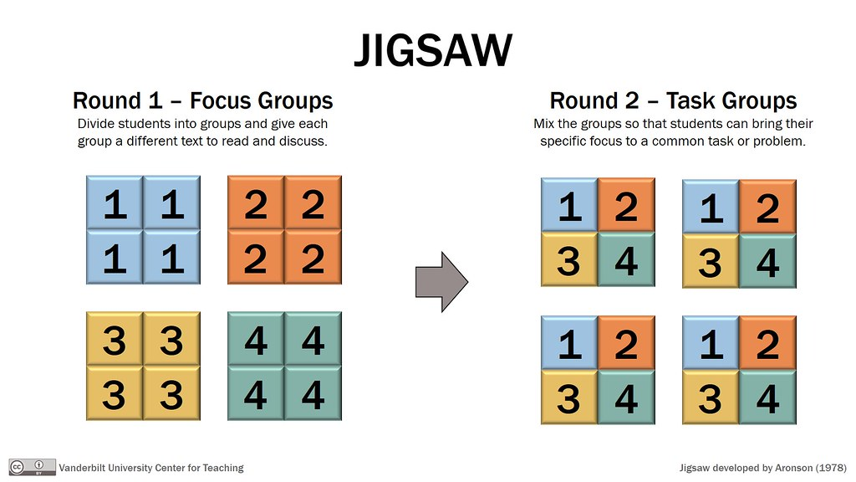Jigsaw learning activity
In this activity students will work cooperatively to learn more about allergies, how they affect people and how they can be prevented. Each group will become experts and then share what they have learnt with other students. Please note: If students are learning from home, they can choose one allergy/disease to research and become an expert.

Form groups | Divide the class into 6 x Focus Groups. Each Focus Group will be assigned a different allergy/disease (hay fever, food allergy, insect allergy, asthma, cold, flu) to investigate and become experts. Each group will need to decide how they will collect and communicate the information they find during their research.
Research | Each Focus Group will respond to the following questions to become experts:  - Describe the allergy/disease.  - How does it affect the body? Use scientific terms.  - What are the symptoms of the disease?  - What does it look like and what does it feel like?  - How do you get it?  - How can it be treated?  - How can it be prevented?
Share | Mix the Focus Groups to form Task Groups (Tasks Groups include one student from each of the Focus Groups) to share the information they have collected. Students will share the information they have collected and learn from one another.
Reflect | Students will reflect on the activity by responding to one or more of the following questions:  - What did you enjoy about this investigation?  - What did you find surprising?  - What would you do differently next time?

Campaign
Students will design a public education campaign to raise awareness about allergies and how they can be treated and prevented. Students will think about their campaign’s aim, target audience, and the value of raising awareness at their school. Students can use Canva to design a poster to put up around their school and the wider community.

Quiz
Students will create a quiz to test their classmates about a type of disease they have researched. Students will include quiz questions about the cause, symptoms and treatment of the disease.

Quiz Questions | Your Answer
- What is the scientific name for hay fever?
  - Rhinocerotidae
  - Allergic Rhinitis
  - Rhinovirus
- How many Australians will be affected by hay fever at some point in their life?
  - 1 in 2
  - 1 in 3
  - 1 in 5
- What can cause hay fever?
  - Pollen
  - Mould
  - Animal hair
  - All of the above
- What system in our body does hay fever mostly affect?
  - Digestive system
  - Immune system
  - Nervous system
- How can hay fever be prevented?
  - reduce exposure to allergens
  - increase exposure to allergens
  - eat a spoonful of honey every day
- Hay fever only occurs during spring and summer.
  - True
  - False
- Which of these isn’t a symptom of hay fever?
  - Sneezing
  - Watery eyes
  - Vomiting
- What is perennial hay fever?
  - Symptoms are only caused by flowers
  - Symptoms may occur at any time of the year
  - Symptoms will only last for two years
- Hay fever and asthma are caused by many of the same triggers.
  - True
  - False
- Hay fever can be cured.
  - True
  - False
Answers: 1b, 2c, 3d, 4b, 5a, 6b, 7c, 8b, 9a, 10b

Hay Fever – BTN
https://www.abc.net.au/btn/classroom/hay-fever/10524012

Hay Fever Season – BTN
https://www.abc.net.au/btn/classroom/hay-fever-season/10535476

Hay Fever and Asthma – Asthma Australia
https://asthma.org.au/about-asthma/triggers/hay-fever/

Hay Fever – Raising Children
https://raisingchildren.net.au/guides/a-z-health-reference/hay-fever

Kids Health – Child and Youth Health
http://www.cyh.com/subdefault.aspx?p=255

BTN Transcript: Episode 25 – 1/9/20

Hey, I’m Amelia Moseley and you’re watching BTN. Here’s what’s coming up. We find out why this year's hay fever season is nothing to sneeze at, learn about the pros and cons of going cashless and meet a young Victorian who's created a newspaper to help her neighbours in lockdown.

Border Restrictions

Reporter: Amelia Moseley

INTRO: But first today. You might've heard a bit of debate recently about Australia's borders and who's allowed to cross them. Some people have called on state leaders to relax their restrictions, but others say it’s not safe to do that yet. Let's find out more.

Over the past few months, people all across Australia have been separated, from friends, family, work and adventures just across the borders.
MADDIE, NSW: They've affected me school wise, because my school is in Albury, but my teacher's in Wodonga and she's unable to apply for a permit to cross the border because she's a bit out of the zone, so lately she has to zoom into class.
BEN, VICTORIA: Most of my Australian family live in Sydney, so I can't get to go see them and my nanna can't get to see her great, great grandchild who was just born.
Many states and territories have put rules in place, sometimes really strict rules, to try to stop the spread of coronavirus. Victorians have been shut right out from most places after the recent outbreak there. Don't worry, Victoria, we still love you. New South Wales residents are also being kept out of a few states, while Tasmania and Western Australia basically aren't letting anyone in at all. While not everyone agrees, many experts say closing borders is one of the best ways to keep the virus contained and a lot of state and territory leaders agree.
Mark McGowan, WA Premier: We've had no community spread now for 131 days and the borders have been a large part of achieving that outcome.
But some say the border restrictions have gone too far in some places.
Alan Joyce, Qantas CEO: So we have the situation where there are large numbers of states and territories that have had zero cases and they're not even open to each-other.
That was Alan Joyce, the boss of Qantas, and he's been joined by a bunch of other business leaders who say the border closures are too inconsistent and they're taking too high a toll on the economy. Meanwhile this businessman, Clive Palmer, is taking Western Australia's government to the High Court, because he says its border closure is unconstitutional.
Australia's constitution is kinda like a rule book for the whole country and it says that the states aren't allowed to stop people or goods from moving freely around the country. But there are a few exceptions like if something or someone might be a danger to citizens. That's why you can't take your dog to Tassie unless it's being treated for a certain kind of tapeworm, or your apple to South Australia because you might accidentally bring in fruit flies.
And many legal experts say that's kind of what's happening now with coronavirus. It's up to states and territories to make their own rules about how they manage the risk of COVID-19. But the Prime Minister says he'd like to see some restrictions eased and he wants Australia opened up by the Christmas holidays. So, what do you think?
ROSE, NSW: Keeping the borders closed is going to stop more spread of COVID and it’s going to stop the whole of Australia from getting flooded with COVID again.
ALICE, NSW: I also think that it's a good idea, because it can stop COVID from spreading, but I think it's annoying because we can't see family members.
BEN, VICTORIA: I think it's good that the borders are closed because without people moving the virus won't move and spread to more people, but I really hope they open to the end of the year because I really want to go see Hamilton and Frozen in Sydney, ahhh.

News Quiz

What was the name of the hurricane that slammed into the US state of Louisiana last week? Was it Laura, Lauren or Larry? It was hurricane Laura. With wind speeds of up to 214 kays an hour it was one of the most powerful storms ever to hit the US.
Meanwhile, wildfires are burning out of control in which US state? Texas, Utah or California? It’s California. There are hundreds of fires burning across the state and hundreds of thousands of people have been evacuated from their homes.

In the US, the President’s party put on a show last week. Do you know which party he belongs to? Democratic or Republican? It’s the Republican Party. The convention is where the party officially confirms its candidates, in this case, the President and the Vice President.
Do you know who this is? If you’re from the Top End you might. His name is Michael Gunner and he’s the Chief Minister of the Northern Territory. He’s managed to hold onto his job after the Territory’s recent election.
These fairy penguins are now being live streamed from Phillip Island. What state is that in? South Australia, Victoria or Tasmania? Phillip island is in Victoria and since tourists can’t visit at the moment the nature park decided to bring the penguin parade to the people.
Greta Thunberg is back at school after taking a gap year to campaign for climate action around the world. Which country does she live in? Norway, Sweden or Switzerland? Greta is from Sweden.
What’s being sent to Mauritius from around the world to help clean up a recent oil spill? Used clothing, wool or human hair? It’s human hair. It’s really good at soaking up oil and it’s more environmentally friendly than synthetic sponges so salons around the world, including here in Australia, are sending in their floor sweepings.

Hay Fever Problem

Reporter: Amelia Moseley

INTRO: Today is the first day of spring, which is good news if you like flowers and sunshine and also bad news if you have hay fever. Experts say this year could be particularly tricky for hay fever sufferers because of COVID-19. Check it out.
It's that beautiful time of year again when the sun's out, birds are chirping and all around you new things are growing. But for some people, that means a lot of this.
AMELIA, REPORTER: Yep. It's springtime. Also known as hay fever season.
Allergic rhinitis, otherwise known as hay fever, is pretty common. It affects around one in five Australians, including me. It's triggered by breathing in something you're allergic to, known as an 'allergen'. They're microscopic particles that come from things like grass, pollen, dust, mould, even pet fur. Your nose traps those particles in its tiny hairs and mucus to stop you from breathing them into your lungs. But, if your body decides those particles are dangerous, it starts an allergic reaction to get rid of them. That brings up some annoying symptoms like a blocked or runny nose, itchy, stinging or watery eyes, headaches and, of course, sneezing.
RANI: It's horrible. Because like when you first wake up in the morning all you feel is your itchy nose, itchy eyes, sore throat so when I inhale the pollen it like triggers my asthma off.
BRE: I think people who don't get it just think it's like just nothing, they think we're overexaggerating, or that it’s just nothing, it’s just there but it’s a lot more than they think.
CALINA: I've had to miss school some days especially on my favourite days and it’s quite annoying too cause of hay fever.
AMELIA, REPORTER: Aw, what are your favourite days?
CALINA: Tuesdays because we have PE.
AMELIA, REPORTER: Aw.
You can get allergies at any time of the year, no matter where you live, but, spring is usually the worst time for hay fever because lots of allergen-producing plants start popping up all over the place.
AMELIA, REPORTER: And this spring there's another thing to think about if you're a hay fever sufferer.
AMELIA, REPORTER: It's just hay fever. Yeah, these symptoms can be kind of similar to the symptoms of a cold, a mild flu or even the coronavirus.
At the moment, a lot of schools are being really strict about staying home if you're sick and that means that kids with hay fever could find themselves missing more school than they'd normally need to. Experts say it's important for people with hay fever to look out for anything unusual (like a fever or sore muscles) and to get tested if they're worried. It's also more important than ever to stay on top of hay fever symptoms.
RANI: I'll usually take some medicine like antihistamines.
CLAIRE: I also have a nasal gel to help stop my nose running.
BRE: I like eating white grapes cause they're a little bit more sour and they like unblock my nose or they'll help my eyes.
JACOB: I once had hay fever and I just ate the pineapple and it just went away the next day so that was good.
Huh. I'll have to try that one. You can also look up pollen counts so you can be prepared, stay inside on warm, windy days or when someone's mowing the lawn and maybe even put a little more space between you and your furry friend. Oh, and wearing a mask can help to. But it's always a good idea to chat to a doctor or pharmacist if you're unsure, because when this spring has sprung it'll be a bit different to any we've had before.
Did You Know?

Did you know that the term hay fever came about because, in the 1800s people noticed they had symptoms when they could smell hay, which is harvested in spring? Scientists eventually realised the real culprit was pollen, but pollen fever never really took off.
Ask A Reporter

Do you have more questions about hay fever? Well you can ask me live this Friday on Ask a Reporter. Just head to our website for all the details.

Going Cashless

Reporter: Jack Evans

INTRO: Now to something else that's changing because of COVID-19 and that's the way we spend money. Since the start of the pandemic there's been a move away from notes and coins and some say it won't be too much longer before cash is a thing of the past. Here's Jack.
$100: Ooh, come on everyone, someone's coming, try to look expensive.
JACK: Ha. Physical currency.
$20: Oh, it's useless. We're worthless.
JACK: What? Who said that?
$20: What happened to us? We used to be so valued. We were everywhere.
$50: Wallets, pockets, purses.
$5: Down the back of a dirty couch, actually that wasn't very nice.
JACK: Are you talking to me?
$100: And now's it's all, tap and go, mobile pay.
$10: The other day I saw someone pay with their watch.
JACK: Yeah, well that’s pretty common actually.
$20: Getting rid of cash is the worst thing that could have ever happened to us.
JACK: I'm sorry?
As sad as it may be for these guys, those in the know reckon a society where cold hard cash is no longer of value will almost definitely be in our future. For a while now the Reserve Bank of Australia has noticed that fewer Aussies are using the physical stuff and instead are swiping or tapping with cards or smart devices. It's led to a bunch of big banks shutting down branches and removing ATMs because people aren't using them as much as they used to and it's not just Australia. Many countries are on their way to becoming cash free. Now some reckon COVID-19 may be bringing us closer to a cashless society.
For starters, there's been a huge increase in online shopping, where famously you don't use physical currency. A recent report from Pay Pal found that since the pandemic started more than 2.5 million Aussies started shopping via the internet for the first time. Then there's the dirty debate.
$20: Dirty. How dare you.
JACK: Actually, you are a bit woofy.
$20: Rude.
JACK: When was the last time they cleaned you?
While experts aren't exactly sure if you can catch COVID via cash, we do know notes and coins can get pretty germy as they get passed around from person to person. In fact, in some parts of China they started sterilising their money when the virus broke out and around the world many businesses have been encouraging electronic payments over notes and coins.

There are other advantages to going cashless. Many say it'll will help reduce crime by letting authorities track where money's going and stop people avoiding tax. It also makes converting money to different currencies a lot easier.
But digital dollars also have their downside especially for people aren't as tech savvy or who live in areas where the internet isn't as reliable and there are people who rely on cash like buskers and charities. Oh, and kids, while there are services that let you get digital pocket money, many banks have a minimum age for debit cards. Plus, some experts worry moving to a cashless society could leave our money vulnerable to cyber criminals and that we will need to consider a backup so people can access their money if technology fails. So while this stuff might one day be worthless, for now, at least, cash is still very much of value.
JACK: Well at least you're in a museum, I mean that's pretty impressive.
$20: Yeah, your right. In fact, I'm probably worth more now than I ever was.
JACK: Well, I don't know about that.
Quiz

Which Australian coin features a picture of an echidna? Is it the 5c coin, the 10c coin or the 20c coin?
It's the 5-cent coin.

Science of Taste

Reporter: Ella Germein

INTRO: Now to a story about the science of taste. Australia's national science agency, the CSIRO, has launched a program designed to get more primary school kids eating vegetables, and no, not by reminding you again that they're healthy but by encouraging you to retrain your taste buds. Ella found out how it's done.
We all have foods that we love and foods that we're not so keen on.

SAMUEL & HENRY: We hate Brussel spirts.

SAM: I really do not like strawberries at all.
LAURA: I love strawberries.

ELLA: For me personally, I don't really like anything that jiggles or wobbles like jelly or yogurt. Urrggh. Does anyone want this?
But sometimes our tastes can lead us to eat too much of the foods that we shouldn't eat and not enough of the foods that we should. Studies show only 6% of kids are eating enough vegetables.
DR ASTRID POELMAN, CSIRO: So, kids in primary school should be eating four and a half to five servings of vegetables a day.
This is Astrid. She works for the CSIRO, and she says there's actually a good scientific explanation for the fact that we tend to prefer these to these.
DR ASTRID POELMAN, CSIRO: As part of the evolution we were born with a liking for sweet taste and a bit of a disliking for bitter taste. So, we needed sweet taste, in order to get the calories from the foods.
The trouble is, these days we are eating way more calories than we actually need and that's leading to some serious health problems.
DR ASTRID POELMAN, CSIRO: If we eat lots of sweet foods that don't have any other good nutrients in them, we don't really give our body what we what we need to grow. So therefore, it's really important to eat a lot of different variety of foods that our bodies need to grow up healthily.
So, is it possible to learn to like foods that we don’t usually like to eat? Well, Astrid says it is, especially when we're young. In fact, our taste preferences have a lot to do with what we eat when we're growing up. It's why if you look around the world you can see preferences for different kinds of food and some things that might be delicious to some people, seem a bit gross to others whether it’s century eggs or vegemite. But, if you're adventurous, you can learn to like all sorts of things.
DR ASTRID POELMAN, CSIRO: It's just by trying them, so every time we taste the food, we get a bit more familiar with how it tastes and how it feels in our mouth. And that's eventually how we come to like it.
The CSIRO has started a program called 'Food Adventurers' which helps primary school kids to retrain their taste buds towards healthy foods.
DR ASTRID POELMAN, CSIRO: It's really about exploring vegetables, exploring the different colours, the tastes and the and the textures, and having a bit of fun around them.
She says there is a lot to be gained by trying new flavours.
DR ASTRID POELMAN, CSIRO: There’s lots of different foods and plants available to us and lots of different cultures as well so we can get lots of different kinds of cuisines and dishes that we can learn to like.
So next time you're feeling hungry, why not be a little adventurous.

Sport

Major sports are back up and running in the US after one of the most tumultuous weeks ever. The NBA, WNBA, Major League Baseball and Major League Soccer all went on strike to protest racism and police violence. It started with the Milwaukee Bucks refusing to take the court after a police shooting in their state and it wasn't long before other teams, other sports and even sport commentators followed. After lots of discussions with players and other prominent Americans all of the leagues decided to start back up again on Saturday and finish off their seasons.

After 5 A-League championships, this is something Sydney FC's had a lot of practice doing. They took home the chocolates in Saturday's grand final with a 1-nil win over Melbourne City. But it wasn’t without a little bit of controversy. This 18th minute goal from Melbourne's Harrison Delbridge was called offside after a review. In the end Rhyan Grant was the hero and Sydney FC claimed back to back A-League titles.
Speeding things up a bit here, Lewis Hamilton has zoomed his way to victory in the Belgian Grand Prix. Aussie Daniel Riccardo ended up in fourth but managed to take home a bonus World Championship point for the fastest lap of the day. Nothing that the cameraman couldn't keep up with though. What a professional.
COVID Catch-Up Newspaper

Rookie Reporter: Suzy

INTRO: Finally, today, you're about to meet a 10-year-old from Melbourne who's been putting her time in lockdown to good use. Suzy has been using her mum's old-school typewriter to create a newspaper for kids called COVID Catch-Up. Take a look.
SUZY: Hi, my name is Suzy Pollard and I'm 10 years old and this is my cat Cloud, she's really cute. Come back, you weren't filming that were you? I started the COVID Catch-Up because my mum had a typewriter and I was having a lot of trouble keeping up with everything that was going on. So, I thought other kids might feel the same way and also because I was bored.
KATE: I'm Kate Howell, I'm Suzie's mum. I'm pretty proud of my 10-year-old girl.
SUZY: I just got an email from someone who must have read my newspaper and they sent in a really good article so now I'm typing it out to put in the newspaper.
KATE: What's the article about?
SUZY: Like, all the masks and stuff.
KATE: That's pretty exciting. People must be starting to read it. The COVID Catch-Up is coming out sometimes twice every week.
SUZY: Are you bored out of your mind? Here's a list of things to do when you're stuck at home, listen to a podcast, build some Lego, write a newspaper, or bake a cake or cookies.
SUZY: I'm writing my science section and I have written that if you mix baking powder and vinegar together, then it will make a fizzy thingy and if you do it on top of your cat's head, you'll get scratched.
KATE: She's up to issue six and it's been really exciting to see how people are supporting it and how excited her friends are when a new issue comes out, particularly if they have contributed something. Is that all of issue three, ready to go?
SUZY: No, I still have one more thing that I got sent in from my friend Alex and then it'll be finished. I'm putting the newspapers out.
KATE: Why do you put them out?
SUZY: 'Cause otherwise people won't find them because we live on the quietest street in the world.
SUZY: People can take a copy of the newspaper it’s on the corner of the street and then if they want to then they can donate. This is all the donations I've got. 100 per cent of proceeds go to healthcare workers.
KATE: There's not a lot of great news sometimes, this is a good news story. It seems to make people feel really good and I think she's seeing that now and it's giving her more confidence.
Closer

Well that's it for this week but we'll be back before you know it. And if you miss us in the meantime you can head online to check out more stories and specials and all sorts of other stuff. And don't forget you can watch BTN Newsbreak every weeknight and if you're 13 or over you can subscribe to our YouTube channel. I’ll catch you later. Bye.

