KEY LEARNING
Students will view a range of BTN stories and use comprehension skills to respond to a series of focus questions.

CURRICULUM
English – Year 4
Use comprehension strategies to build literal and inferred meaning to expand content knowledge, integrating and linking ideas and analysing and evaluating texts.

English – Year 5
Use comprehension strategies to analyse information, integrating and linking ideas from a variety of print and digital sources.

English – Year 6
Use comprehension strategies to interpret and analyse information and ideas, comparing content from a variety of textual sources including media and digital texts.

English – Year 7
Use comprehension strategies to interpret, analyse and synthesise ideas and information, critiquing ideas and issues from a variety of textual sources.

  - Teacher Resource

Focus Questions

Faith Bandler
- What inspired Faith Bandler to become a rights activist?
- What did Faith and her friend’s campaign to change?
- What impact did the 1967 Referendum have on Indigenous people’s lives?
- What will Faith Bandler be remembered for?
- If you could meet Faith Bandler and ask her a question, what would it be?

Edith Cowan
- Which Australian bank note does Edith Cowan feature on?
- Describe Edith Cowan’s life growing up.
- Complete the following sentence. Edith Cowan was the first Australian woman to serve as a member of ________________.
- What impact did Edith have on women’s lives today?
- What did you learn watching this story?

Dorothy Hill
- Where and when was Dorothy Hill born?
- Dorothy was the first person in her family to go to university. True or false?
- Dorothy Hill was a famous…
  - Anthropologist
  - Geologist
  - Meteorologist
- What type of work did Dorothy Hill do during WWII?
- Fill in the gaps. Dorothy Hill identified lots of new __________ species.

Nancy Bird Walton
- What sparked Nancy’s interest in flying?
- Which famous pilot gave Nancy flying lessons?
- At 19 years old Nancy made history. What happened?
- Why was Nancy Bird Walton known as the `angel of the sky’?
- What did Nancy do to encourage more women to get into aviation?

Evonne Goolagong Cawley
- Describe Evonne’s life growing up.
- How old was Evonne when she got her first tennis racquet?
- What was Evonne’s nickname?
- Which famous Aussie tennis star did she inspire?
- Think of a question you would like to ask Evonne Goolagong Cawley.

KEY LEARNING
Students will choose a significant Australian woman to investigate in depth and create a biography.

CURRICULUM
HASS – Year 3 and 4
Pose questions to investigate people, events, places and issues.

Locate and collect information and data from different sources, including observations.

HASS – Year 5 and 6
Develop appropriate questions to guide an inquiry about people, events, developments, places, systems and challenges.

Locate and collect relevant information and data from primary sources and secondary sources.

History – Year 6
The contribution of individuals and groups to the development of Australian society since Federation.

HASS – Year 7
Construct significant questions and propositions to guide investigations about people, events, developments, places, systems and challenges.

Aboriginal and Torres Strait Islander readers please note that this document contains images of deceased Indigenous people.

  - Teacher Resource

Australian Female Pioneers

Activity: Brainstorming
Before watching this story, students will brainstorm a list of significant Australian women. This activity can be done as a class or in smaller groups. The list can include famous Australian women or there might be an important woman in the students’ lives that has achieved something significant.

Activity: Personal Response
Discuss the BTN stories as a class. Students will then choose a woman featured in one of the stories and complete one or more of the following incomplete sentences:
- [insert name] was an important Australian because…
- It was interesting to learn…
- These are five words that I would use to describe…
- This story made me feel…
- It is important to remember [insert name] because …

Activity: Biography
Students will choose a well-known Australian woman to research and write a biography about. They can choose one of the women featured in the BTN stories (see images below) or another significant Australian woman else. Before students begin to construct their biographies, hold a class discussion to find out what they already know about biographical writing.

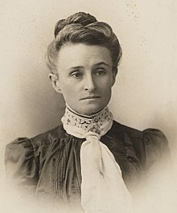  Edith Cowan, source of image | 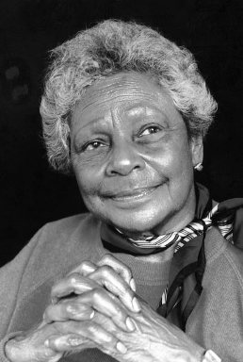  Faith Bandler, source of image

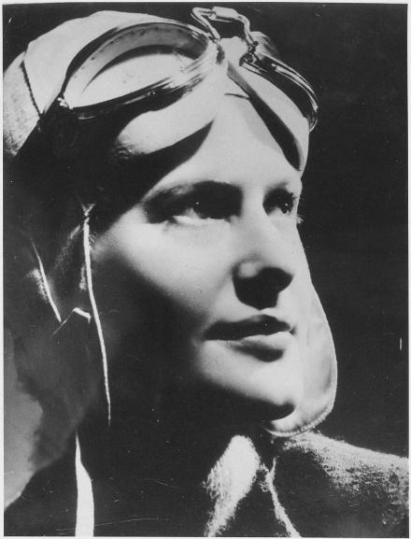
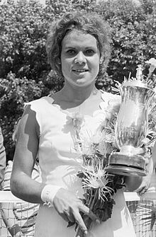
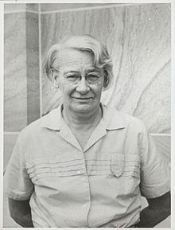
Dorothy Hill, source of image Nancy Bird Walton, source of image Evonne Goolagong Cawley,
source of image
Use the questions below to get a class discussion started with your students about biographical writing.
- What does a biography tell us about a person?
- Where can you look to find information for your biographical writing? It could include the internet, newspaper articles, magazine articles and interviews, other biographies, historical books or television interviews. Why is it important to use more than one source of information?
- What makes a biography interesting? For example, key information and facts, a timeline of events, photographs, illustrations and quotes.

Using the biography worksheet at the end of this activity, students will research and record information about one significant Australian woman. Some possible areas of research include:

- When and where were they born? Describe their family life growing up.
- What are some of their achievements? Choose one to explore in more detail.
- What inspired/motivated them?
- What were their challenges?
- How do we recognise their achievements?
- How have they made an impact on people’s lives?
- What do you admire about them?
Further investigation
- Create a timeline of significant events in their life.
- What are some of the key events in their life? Write a summary for one key event, which answers the 5 W’s – Who, What, Where, When and Why?
- How do primary sources (for example photos, letters, diaries, and official documents) help us understand what might have happened at a place in time? Find 1 or 2 primary sources that help you learn more about the person’s life.
- Imagine you could sit down and talk to them. What questions would you ask about their life and achievements?
- Write a letter thanking them for their achievements and how they have changed the world.
- Create a portrait.
- Make a Did You Know for other students.

Activity: International Women’s Day
International Women's Day is a global day celebrating the economic, political and social achievements of women past, present and future. How does your school honour and celebrate the achievements of women all around the world? Go to the UN International Women’s Day website for more information.

Useful Websites
- Women in History Special – BTN
- NAIDOC Indigenous Women – BTN
- Women’s History Month – BTN
- Australian Women in Politics – BTN
- Women’s History Month – Royal Australian Historical Society

