EPISODE 1
2nd February 2021

KEY LEARNING
Students will view a range of BTN stories and use comprehension skills to respond to a series of focus questions.

CURRICULUM
English – Year 4
Use comprehension strategies to build literal and inferred meaning to expand content knowledge, integrating and linking ideas and analysing and evaluating texts.

English – Year 5
Use comprehension strategies to analyse information, integrating and linking ideas from a variety of print and digital sources.

English – Year 6
Use comprehension strategies to interpret and analyse information and ideas, comparing content from a variety of textual sources including media and digital texts.

English – Year 7
Use comprehension strategies to interpret, analyse and synthesise ideas and information, critiquing ideas and issues from a variety of textual sources.
  - Teacher Resource

Focus Questions
As a class, discuss the stories featured in the episode of BTN Classroom and record the main points of the discussion. Students will then respond to the following focus questions.

COVID Wrap Up
- Discuss the BTN COVID Wrap Up story as a class.
- What impact did COVID lockdowns have on people over the holiday break?
- Which state has seen its first case of community transmission in 10 months?
  - Northern Territory
  - Tasmania
  - Western Australia
- Officials are worried about new strains of the virus from which countries?
- Players participating in which sporting event had to go into hotel quarantine before the tournament.
- Australia has approved the Pfizer vaccine. Why might we have to wait a while to get it?
- Which vaccine is awaiting approval and should be easier to get hold of?
- Who will be first in line to get the vaccine?
- How did the BTN story make you feel?
- How did COVID-19 restrictions affect you and your family over the holidays?

New US Government
- Who is the new President of the United States?
- Who is the Vice President?
- What problems has the President promised to tackle?
- What happened at the Capitol building over the holidays?
- Why were people protesting?
- Why were Donald Trump’s social media accounts banned?
- US politicians have impeached Donald Trump again. What does that mean?
- Donald Trump has become the first president in history to be impeached twice. True or false?
- What changes has the President already made?
- What questions do you have about the story?

National Anthem Change
- Discuss the BTN story with another student. Record the main points of your discussion.
- What is the name of Australia’s national anthem?
- Which words have been changed in the national anthem?
- Who made the decision to change some of the words in the anthem?
- Why have they been changed?
- Why is the change important to First Nations peoples?
- Complete the following sentence. The national anthem was written over ____________ years ago.
- What did you learn watching the story?
- Do you think we should have a new national anthem? Give reasons for your answer.
- Write your own verse to the Australian national anthem.

Swim and Survive Program
- What was the main point of the BTN story?
- About how many people drown in Australia every year?
- What are the kids in the BTN story learning to do in their swimming lessons?
- Why do they think it’s important to have swimming lessons?
- Complete the following sentence. At the moment, the government funds ______________ of swimming lessons for all primary school aged children.
- Explain the changes Royal Life Saving want to make to the water safety program.
- What does RLS say all 12-year-olds should be able to do in the water?
- Do you think kids should learn swimming at school or outside of school? Give reasons for your answer.
- Complete the following sentence. Learning to swim can be difficult for kids living in ______________ areas.
- What do you do to stay safe when swimming?

Check out the Swim and Survive Program resource on the Teachers page.

Ancient Egyptian Discovery
- Briefly summarise the Ancient Egyptian Discovery story.
- What did archaeologists discover recently?
- What is the Egyptian queen’s name?
- How long ago did she die?
- Complete the following sentence. Her husband was the first ____________of Egypt’s 6th dynasty.
- Why did ancient Egyptians build elaborate monuments for their dead royals and fill them with treasure?
- What is mummification?
- How did embalmers preserve the bodies?
- Describe the papyrus scroll that was discovered.
- What was surprising about this story?

Check out the Ancient Egyptian Discovery resource on the Teachers page.

EPISODE 1
2nd February 2021

KEY LEARNING
Students will develop a deeper understanding of water safety skills including staying safe at the beach and swimming pool.

CURRICULUM
Health and Physical Education – Year 3 & 4
Identify and practise strategies to promote health, safety and wellbeing.

Health and Physical Education – Year 5 & 6
Plan and practise strategies to promote health, safety and wellbeing.

Health and Physical Education – Year 7 & 8
Investigate and select strategies to promote health, safety and wellbeing.
  - Teacher Resource

Swim and Survive Program

Focus Questions
Discuss the BTN Swim and Survive Program story as a class and record the main points of the discussion. Students will then respond to the following:
- What was the main point of the BTN story?
- About how many people drown in Australia every year?
- What are the kids in the BTN story learning to do in their swimming lessons?
- Why do they think it’s important to have swimming lessons?
- Complete the following sentence. At the moment, the government funds ______________ of swimming lessons for all primary school aged children.
- Explain the changes Royal Life Saving want to make to the water safety program.
- What does RLS say all 12-year-olds should be able to do in the water?
- Do you think kids should learn swimming at school or outside of school? Give reasons for your answer.
- Complete the following sentence. Learning to swim can be difficult for kids living in ______________ areas.
- What do you do to stay safe when swimming?

Activity: Class Discussion
Before watching the BTN Swim and Survive Program story students, as a class, will respond to the following...
- What activities do you participate in that involve water?
- What do you do to be safe in and around water?
What do you know about water safety?
- How can kids learn to be more water safe?
- What are some hazards when swimming at the beach?
- What are some hazards when swimming at a pool?
- What water safety skills do you know? Make a list.
- Why is water safety important?

Activity: KWLH
After watching and discussing the BTN Swim and Survive Program story, what questions do students have and what are the gaps in their knowledge? The following KWLH organiser provides students with a framework to explore their knowledge on this topic and consider what they would like to know and learn.

What do I know? | What do I want to know? | What have I learnt? | How will I find out?

Students will develop their own question/s for inquiry, collecting and recording information from a wide variety of sources. Students may develop their own question for inquiry or select one of the questions below.
- Why is it important for kids to learn water safety skills? Write a persuasive piece of writing explaining your reasons. What persuasive techniques can you use to promote the message about water safety?
- What are some safety devices that can be used in the water? They may be safety devices used at the beach, inland waterways or a swimming pool. Include a photograph or your own illustration of the device and label/describe its safety features.
- When did surf life saving start in Australia? Research the history of surf life saving in Australia and record your findings on a timeline.
- Why is it important to swim between the red and yellow flags at the beach? Investigate the different flags and signs which help us to be water safe. Think of a creative way to teach kids in your class about what the flags and signs mean and why they are important.
- What dangerous marine animals can be found in Australia? Plot the most common dangerous marine animals on a map of Australia. Research where each animal can be found, why it is dangerous, how people can stay safe and avoid the animal, what the symptoms are if someone is attacked and what the first aid treatment if someone is attacked.

Activity: Water safety poster
Students will pick a place, it could be the beach, a river, dam, lake or a swimming pool. Students will respond to the following questions to guide their research and then make a poster promoting water safety (including highlighting the top 5 safety risks and water safety skills).

- What are some of the water safety risks (at the beach, river or swimming pool)? What are some obvious dangers and what are some of the are hidden dangers?
- Are there any dangerous marine animals in the area? If so…
  - Where can the animal be found?
  - How deadly is the animal (rating & description)?
  - How can you stay safe and avoid the animal?
  - Symptoms if someone has been attacked.
  - First aid treatment
- Is the area patrolled? If so, give a description.
- How can people be water safe in and around the area? Give some safety tips.
- Are there any safety devices that people can use to stay safe in the water?
- What can we do if we are in danger? How can we help others that are in danger?

Activity: Understanding rips
Students will watch the How to Survive a Rip Current video and answer the following questions:
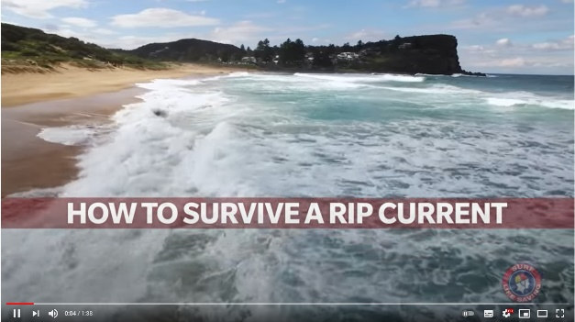
- What is the best way to avoid swimming in a rip current?
- Why is it important to stay calm if you get caught in a rip current?
- What should you do if you get caught in a rip?
- Never try to swim _______________ a rip.
- What else did you learn watching this video?

Activity: Oral presentation
Students will prepare an oral presentation to teach kids about the dangers of rips, how to spot rips and how to avoid them. Students will include the following in their presentation:
- How will you present the information to your audience? Think of a creative way to present your information, for example it could be a PowerPoint presentation or a play to get your message across.
- Allow time for students discuss the topic and then ask questions.
- Reflect on the activity. What was difficult about teaching other kids and what was successful?

Activity: Mini debate or persuasive text
Students will develop a mini debate or a persuasive text for or against the following statement: “All primary school students need to learn water safety skills for swimming in pools and at the beach”.

Mini debate
- Working in pairs, students will prepare a 1-2-minute speech for a mini debate on the topic.
- One person will speak for the affirmative and the other will speak for the negative.
- Before students begin to construct their argument, ask them to record what they already know about the topic and what they would like to find out. Students then research the topic to gain a greater understanding of the issue.
- Ask students to list their arguments in point form on paper (without their partner seeing them). When they have done this, ask them to choose the five best points that will form the basis for their debate.
- Students will write in point form, their debate on cards that fit into the palm of their hand. Their debate needs to have an introduction (introducing the topic), middle (three main points) and a conclusion (restating their position). Students practise their speech and then present the mini debate to other students.

Tips for persuasive writing
- Who is your audience? For example, are you directing your argument at kids, teachers or politicians?
- Explore how language choices can have a big impact on persuading your audience.
- Which language devices give the report credibility and authority?
- Which are designed to create an emotional response in the listener?
- Provide facts and evidence to support your argument.
- Write in the present tense.
- Check your spelling and punctuation.

Students can use this Read Write Think persuasion map to organise the information they find.

Activity: BTN Stories
As a class watch one or more of the following BTN stories to learn about water safety. After watching any one of the BTN videos ask students to respond to the discussion questions (to find the discussion questions and teacher resources go to the related BTN Classroom Episode and download the Episode Package).

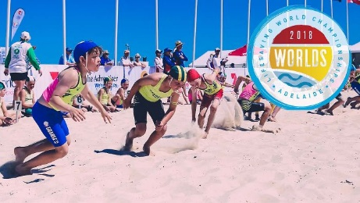  Lifesaving Championships 2018 | 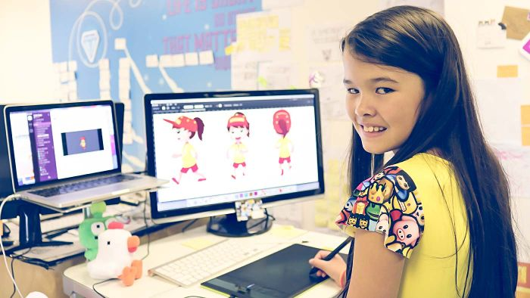  Beach Safety App | 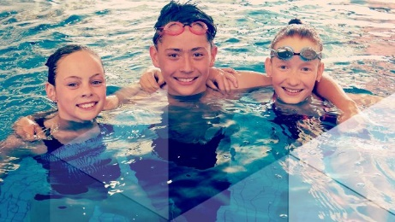  Compulsory Swimming

Useful Websites
- Rip Currents – Surf Living Saving Australia
- Flags and Signs – Surf Living Saving Australia
- Dangerous Marine Life – QLD Government
- Hazardous Animals – Northern Beaches Council
- The Birth of Surf Lifesaving – National Museum Australia
- Respect the River – Royal Life Saving Australia
- Royal Life Saving Australia

EPISODE 1
2nd February 2021

KEY LEARNING
Students will develop their historical knowledge and understanding of ancient Egypt. Students will identify a range of questions about the past to inform a historical inquiry on ancient Egypt.

CURRICULUM
History – Year 7
How historians and archaeologists investigate history, including excavation and archival research.
Significant beliefs, values and practices of the ancient Egyptians, with a particular emphasis on ONE of the following areas: everyday life, warfare, or death and funerary customs.
The importance of conserving the remains of the ancient past, including the heritage of Aboriginal and Torres Strait Islander Peoples.

  - Teacher Resource

Ancient Egyptian Discovery

Focus Questions
Discuss the BTN Ancient Egyptian Discovery story as a class and record the main points of the discussion. Students will then respond to the following:
- Briefly summarise the Ancient Egyptian Discovery story.
- What did archaeologists discover recently?
- What is the Egyptian queen’s name?
- How long ago did she die?
- Complete the following sentence. Her husband was the first ____________of Egypt’s 6th dynasty.
- Why did ancient Egyptians build elaborate monuments for their dead royals and fill them with treasure?
- What is mummification?
- How did embalmers preserve the bodies?
- Describe the papyrus scroll that was discovered.
- What was surprising about this story?

Activity: Class Discussion
Discuss the BTN Ancient Egyptian Discovery story in small groups or as a class. Ask students to record what they know about ancient Egypt. What questions do they have? Use the following questions to help guide discussion:
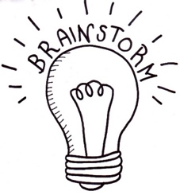
- What words do you associate with ancient Egypt? Make a list.
- What was discovered in Egypt recently?
- Archaeologists and historians are saying it will ‘rewrite history’. What do you think that means?
Using the Ancient Egyptian Timeline, ask students to identify the 6th dynasty when Queen Neit and her husband King Teti lived.

Activity: Glossary
Students will brainstorm a list of key words that relate to the BTN Ancient Egyptian Discovery story. Here are some words to get them started.
SARCOPHAGUS | ARCHAEOLOGIST | ANCIENT
ARTEFACTS | PHARAOH | FUNERARY

Activity: Investigating the Ancient Past
Finding out about the ancient past can be difficult. Some ancient peoples and civilisations have left behind evidence of the past which help us learn about how they lived. Working in pairs or small groups, ask students to consider the following questions:
- Why do you think people investigate the ancient past?
- How do we know about the ancient past? For example, archaeologists make discoveries, looking at artefacts in museums.
- What are some examples of evidence or places which help us understand the ancient past? For example, Aboriginal rock art in Australia, Mungo Man at Lake Mungo, Stonehenge in England.
- Why is it important to conserve the remains of the ancient past?
- What are some characteristics of Egypt’s ancient societies?
- What can the recent discoveries of mummies, wooden coffins and the temple of Queen Neit tell us?
Students will explore the work done by archaeologists to discover and preserve ancient artefacts. Ask students to record what they know about the work archaeologists do.
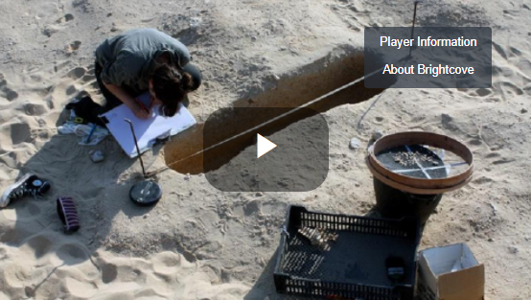
Go to chapter 5 - Archaeology in Egypt in the Investigating ancient Egypt digibook. Watch the video to learn more about what it’s like to be an archaeologist working on a dig in Egypt. Students can then respond to the following questions:
- How do archaeologists record their findings?
- What is photogrammetry and how is it used to document findings?
- What did you learn about the work of an archaeologist in this video?
Further investigation
Students will create a flow chart that shows the process an archaeologist undergoes from finding the artefact, preserving it and using it to interpret the past.

Activity: Funerary Customs & Mummification
Go to chapter 1 - Beliefs and funerary customs in the Investigating ancient Egypt digibook. Watch the video to learn more about funerary customs and mummification.

- Why is our understanding of ancient Egyptian religion, funerary customs and beliefs mostly based on the burials of the elite (wealthy people)?
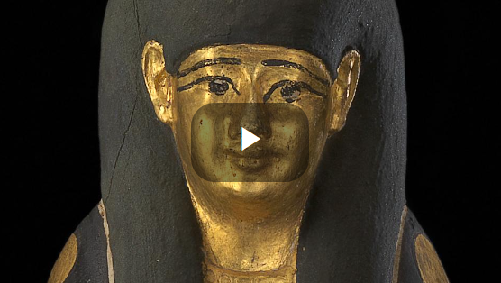
- What did ancient Egyptians believe about death and the afterlife?
- Why did ancient Egyptians place objects in the tomb? Give examples of these objects. (Canopic jars, lucky amulets, food and papyrus scrolls)
- What information in this video was surprising?

The Australian Museum has more information about funerals in Ancient Egypt.

The preservation of the body was an essential part of ancient Egyptian funerary belief and practice. In order to have a life after death, the Egyptians believed their bodies had to be preserved. The mummification process involved removing the internal organs, drying out the body and wrapping it in bandages. Students will research the significance of the afterlife to ancient Egyptians by investigating mummification. Here are some questions to help guide students’ research:
- Who was mummified in ancient Egypt?
- Why were they mummified?
- Why was the mummification process important?
Did You Know animals were also mummified in ancient Egypt? Animal mummies were created in recognition of the animal’s religious importance
- How were ancient Egyptians mummified?
- Why were mummies and sarcophagi’s important to ancient Egyptians?

Resources to help students with their research:
Egyptian Cat Mummies - BTN
Mummification explains the embalming of the body and then the wrapping and burial of the body.
How were mummies made in ancient Egypt - Metkids
Click on the coffin, the mummy and the objects to learn more about them.
How were ancient Egyptians mummified? – Australian Museum
What do you know about hay fever?

Activity: Egyptian Papyrus
Papyrus was used for everyday writing in ancient Egypt but also for documents that were put into the tomb with the dead. Archaeologists and historians use clues from papyrus to help them interpret the past. To learn more about papyrus, students will respond to the following:

- What is papyrus and how was it used in ancient Egypt?
- What is the Book of the Dead? How was it used as part of funerary customs?
- What are hieroglyphs and where would you see them in ancient Egypt?

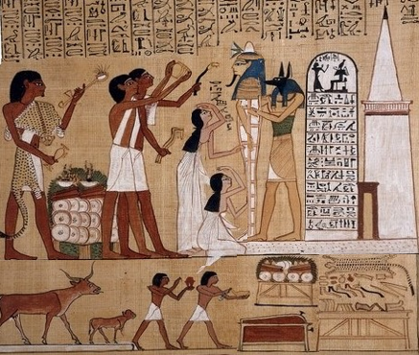
Students look at the scene from the Book of the Dead of Hunefer showing a funeral, and then identify the following:

- The mummy
- The tomb
- Hieroglyphics
- The mourners
- The priests
- Ceremonial objects on a table
Scene from the Book of the Dead of Hunefer

Activity: Investigate Ancient Egypt
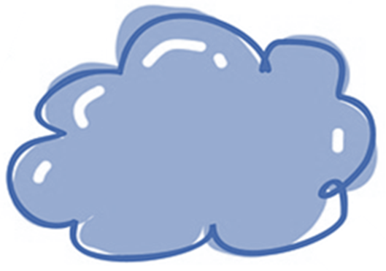
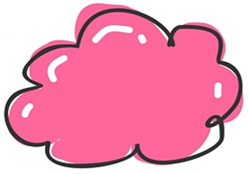

What was the role of sacred animals in ancient Egypt? Which animals were associated with which gods and goddesses? What were the connections between the role of a deity and their associated animal?
What were the roles of key people in ancient Egyptian society, such as the nobility, bureaucracy, women, and slaves?

Investigate an important person such as Tutankhamen or Nefertiti in ancient Egypt.
Why were the pyramids built? Consider the significant beliefs, values, and practices of the ancient Egyptians.

BTN Ancient Egypt stories

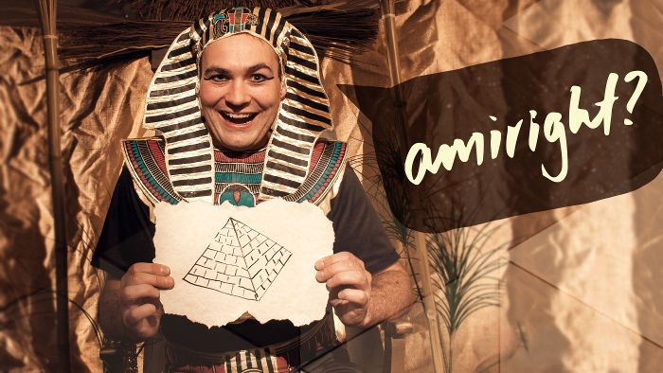Egypt Exploration | 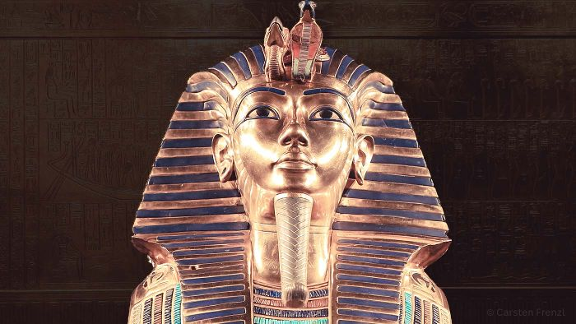Tutankhamun Exhibition
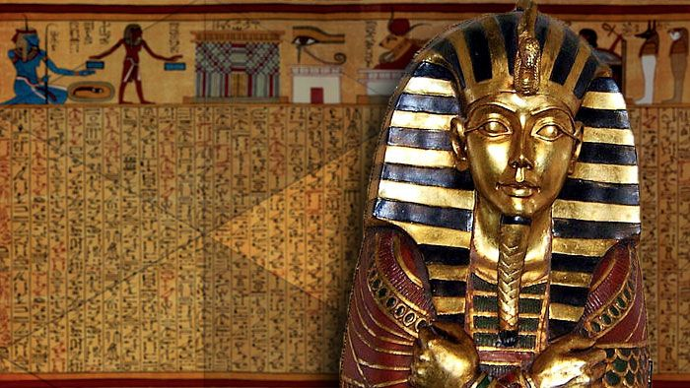Mummies | 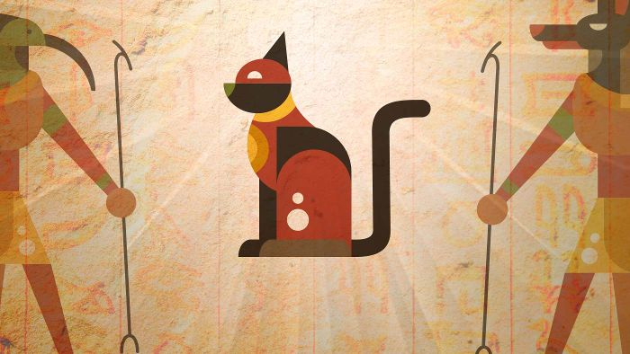Egyptian Cat Mummies

Useful Websites
- Investigating Ancient Egypt – ABC Education
- How were ancient Egyptians mummified? – Australian Museum
- Egypt: Discoveries will ‘rewrite history’ - Newsround
- Egypt unveils 3,000-year old coffins in latest discovery at Saqqara necropolis south of Cairo – ABC News
- Ancient Egyptian Timeline – Australian Museum
- How were mummies made in ancient Egypt - Metkids

  - Teacher Resource

BTN Transcript: Episode 1 - 2/2/2021

Hey there. Amelia Moseley here. Welcome back to another year of BTN. Hope you had a great holiday. Let's see what's coming up today. We're going to find out why our national anthem got a makeover during the holidays, ask whether kids should be swimming more at school and learn more about mummies.

COVID Wrap Up

Reporter: Nat Kelly

INTRO: But first up to that story that, unfortunately, just keeps on going. I'm talking about COVID-19. The virus has been busy over the holidays keeping families apart and keeping us from doing the things we want to do and now, it’s sparked a lockdown in Western Australia. Here's Nat with more.
OFFICIAL: G'day mate can I see your border form please?
COVID: Oh, I don't think I need one.
OFFICIAL: That's funny, but, yes you do.
COVID: What? But I'm the guy in the photo. That’s literally me.
OFFICIAL: That's cute. Now why don't you start by telling me where you've been over the last 14 days.
COVID: Lots of places.
OFFICIAL: Have you been overseas?
COVID: Maybe.
OFFICIAL: Well, in that case. SECURITY.
While we've been taking a break for the past few months, unfortunately the virus that made 2020 one of the worst years in living memory hasn't slowed down. A few outbreaks here in Australia saw parts of the country go into lockdown and kept some families apart during the holiday break. And now, for the first time in 10 months, WA has seen its first case of community transmission.
MARK MCGOWAN, WA PREMIER: I know for many Western Australians this is going to come as a shock.
People living in Perth, Peel, and the Southwest region have been ordered to stay home after a hotel quarantine worker tested positive to the virus. And it's got officials particularly worried because it could be a new, more contagious strain of the virus. A couple of those have popped up recently, including one that put London into lockdown and another from South Africa.
OFFICIAL: What's that?
COVID: This? Nothing, I just thought I'd stop by at the Australian Open.
Yep, as you might have heard, COVID-19 has had a bit of an impact on the tennis. There was a lot of debate about whether or not the event should even take place, and the organisers had to prove that it could be done safely. But some players were less than impressed about being forced into hotel quarantine after some people on their plane tested positive, while others made the most of things.
But, hey, it's not all been bad news. Overseas, some countries have started rolling out vaccines. Australia has just approved one vaccine, made by Pfizer, but because it's made overseas and has to be carefully stored and transported, we might have to wait a while to get it. The other vaccine that's awaiting approval is the Oxford AstraZeneca vaccine, which will be made in Australia, so it should be easier to get a hold of.
SCOTT MORRISON, PRIME MINISTER: Our officials have been moving swiftly and safely to introduce the vaccine here in Australia as soon as is safely possible.
But while there's hope on the horizon, these things take time, and it could be a while before things are back to normal.
COVID: Speaking of waiting, is this gonna take much longer? I have places to be, people to see.
OFFICIAL: Oh no you don't.
COVID: Hey, you don’t know what you’re doing with that. I suggest you give them to me. No, don’t go anywhere with that. Please. No, you don’t know what you’re doing.

News Quiz

This huge cloud of smoke was caused by a bushfire near which Aussie city? Was it Perth, Brisbane or Adelaide? It was outside of Adelaide. The fire destroyed two homes and many people had to evacuate along with pets and residents of a local wildlife park.

Which one of these Aussies was named Australian of the Year? Sexual assault survivor and advocate Grace Tame, former Prime Minister Malcolm Turnbull or journalist Kerry O’Brien. It was Grace Tame. Young Australian of the Year went to Isobel Marshall who started a charity when she was 18 making ethically sourced pads and tampons and helping to fight period poverty.

Which Australian institution turned 40 last week? Was it the CSIRO, The Australian Institute of Sport or the National Gallery of Australia? It was the Australian Institute of Sport. The AIS came about Australia failed to win a single gold medal at the 1976 Olympic Games and the government decided to set up an elite training centre to whip our athletes into shape.

Speaking of athletes, which country is hosting the Olympic Games this year? Is it Japan, the US or China? It’s Japan. The games were supposed to be held last year but, you know, COVID. While that’s still a big problem, organisers say (at least for now) it’s all systems go. At least the mascots seem keen. You go guys.

And can you name this cozy US senator? It’s Bernie Sanders. He and his adorable mittens became a meme when he was snapped at President Joe Biden’s inauguration ceremony. They are actually made of recycled material and were sent to him as a gift. Naw.

New US Government

Reporter: Amelia Moseley

INTRO: Now US politics has been big in the news over the holidays. There's the new president, of course, and some pretty dramatic stuff that happened in the lead-up to Joe Biden's first day. Take a look.

A superstar singer, a sea of flags and some meme-worthy mittens; this is how America officially welcomed its new president, Joe Biden and its first female Vice President, Kamala Harris. But after a big day full of waving, more waving, and some serious fireworks, it was pretty much straight down to business. The President has promised to tackle some teeny tiny problems like fixing the economy, ending racism, fighting climate change and dealing with the world's biggest outbreak of COVID-19. Actually, they're pretty big.
US PRESIDENT JOE BIDEN: Four hundred thousand Americans have died. That's more than have died in all of World War Two.
But on top of all of that is the tough job of trying to unite a divided country. Over the holidays you might've seen some pretty dramatic pictures from the US capital. These were supporters of Donald Trump who had just spoken to a crowd in Washington.
FORMER US PRESIDENT, DONALD TRUMP: We fight like hell and if you don't fight like hell, you're not gonna have a country anymore.
Since the election, he's been saying that Joe Biden's win was unfair and that the Democrats cheated. And while there's no evidence of that a lot of his supporters believe him and thousands of them stormed the Capitol Building where the federal government sits.
DONALD TRUMP SUPPORTER: We want our country back. We are protesting for our freedom right now.
For something like this to happen in a democratic and mostly peaceful country like the US was a pretty big shock. Twitter and Facebook even banned the President's accounts at the time saying they were worried he'd encourage more violence, and now US politicians have decided to impeach Mr Trump again.
JAMIE RASKIN, US REPRESENTATIVE: Donald J Trump engaged in high crimes and misdemeanors by inciting violence against the government of the United States.
Impeachment is a process written into the US Constitution which allows the parliament to get rid of a president who's broken their oath of office. Donald Trump is only the third president ever to be impeached. But, as you might remember, the senate voted not to remove him. Now he's become the first president in history to be impeached twice and the only one to be impeached after their presidency has ended. If he's convicted that'll be another first and while he can't be kicked out because he's already out, he might be stopped from ever running for president again.
The impeachment trial starts next week, but back to the new POTUS (that's President of the United States, in case you didn't know). He's already made some big changes or changed some things back including stopping the building of a wall between the US and Mexico, adding America back onto the Paris Climate Agreement to fight global warming and making friends with the World Health Organisation again. He's also made wearing masks and social distancing compulsory across the country and says more Americans will be given free COVID-19 vaccinations. Whether or not it'll be enough to fix the many problems facing the world's most powerful country, well, we'll have to wait and see.

Ask a Reporter

Want to know more about what’s been happening in the US? Well, you can ask me live this Friday on Ask a Reporter. Just head to our website for all of the details.

Quiz

Which one of these is the US Capitol building. Is it A or B? It's A. The other one is the White House, where the US president lives and works.

National Anthem Change

Reporter: Jack Evans

INTRO: Back to Australia now, and last week, as many marked Australia Day, we got a chance to try out our brand-new anthem. Well, it's the same anthem but it did get a bit of an update over the holidays. Jack found out why.
Australians all let us rejoice. Ah, the national anthem, a song we all know pretty well. But now it's a little bit different. For we are one and free. Did you spot the change? I'll play it again in case you missed it. For we are one and free.
Yup over the holidays our Prime Minister, Scott Morrison, decided to change the line we are YOUNG and free to we are ONE and free. It might not sound like much. But it's a change people have been asking for, well, for a while now. Because while Australia the country is pretty young, the continent has a history that goes back more than 65,000 years and many people felt the lyric ignored Aboriginal and Torres Strait Islander people.
SCOTT MORRISON, PRIME MINISTER: We live in a timeless land of ancient First Nations peoples and we draw together the stories of more than 300 national ancestries and language groups. How good is Australia and our anthem should reflect that and the changes that we have made, and we have announced today I think achieve that goal.
A lot of Aussies welcomed the change. Including Yorta Yorta man and CEO of the First Nations Foundation, Ian Hamm.
IAN HAMM, CEO FIRST NATIONS FOUNDATION: This is an important indication to ourselves as a country as to what our expectations are going forward, and to recognise in our national anthem the continued human occupation of this continent from 60,000 years plus to 1 January 2021, and beyond, is an important change in the national anthem.
While our national anthem has plenty of fans, some would like to see more than one word changed. After all it was written more than 100 years ago and there are some words that we don't really use any more like girt by sea. It's why some people have even written their own verses. While others have translated the anthem into Indigenous languages and some people think we'd be better off with a completely new song. So, what do you think?
KID 1: Yeah, I think we should have a new one because it's actually not like, kind of not showing the culture of Aboriginal People.
KID 2: I think because if it is one and free it recognises all different like ages and sort of like people.
KID 3: I think we should change a little bit of it, I think we should also recognise also that Indigenous people as well so like all of us.
KID 4: We should change it completely because some of the stuff in there, I don't really agree with and not much people do.
KID 5: Well, I think it could include all different cultures and like a lot of new stuff and different point of views.

Swim and Survive Program

Reporter: Olivia Mason

INTRO: Do you do swimming lessons at school? Lots of kids do and others do lessons outside of school. But some say swimming and water safety need to be a bigger part of the curriculum to try and prevent drownings in Australia. Here's Liv.
When it's stinking hot there's nothing better than getting into the water.
LIFEGUARD: There are no tubes in the deep end thank you.
But as much as splashing around with your mates can be a whole lot of fun, the water can sometimes be a pretty dangerous place. Every year there's around 200 drowning deaths around the country. Royal Life Saving Australia wants to see that number go down.
MICHELLE WILLIAMS, ROYAL LIFE SAVING SOUTH AUSTRALIA: Every drowning death is one too many. So, until that number is zero, our job's not done.
It's why they say learning how to swim is really important.
MEHTAB: We are learning freestyle, backstroke, breaststroke and survival strokes.
LANA: I'm learning backstroke.
LIARA: It's a good way to learn how to save yourself if you're in a rip current and it's good exercise.
HUZEFA: Of course, you have to learn to swim because it's like part of life. And if you don't learn you can even die one day in the water.
These guys are taking swimming lessons after school, which is how a lot of kids learn to swim. Public schools in most states and territories also teach some swimming and water safety, although how much you learn at school differs from place to place.
MICHELLE WILLIAMS: So currently, government funds one week of swimming lessons for all primary school aged children. But we'd really like to see that expanded. So ideally, three weeks, one week would be water safety skills within the water, and the other one would be down at the beach doing beach safety as well, and then just some general educational skills that they can learn in the classroom as well.
They say every 12-year-old should know how to tread water for 2 minutes, swim at least 50m, and know how to get in and out of the water safely in different environments. They also want 12-year-olds to be able to help others who get into trouble in the water.
MICHELLE WILLIAMS: Learning about water safety is really, really important. So, the more we can do, the better.
Some reckon a national program like this could help save lives, but others say it should be up to parents to get kids swimming lessons, not schools, and that swimming lessons could take time away from other important things.
For some schools, especially those in remote areas, it can be tricky to get access to pools and swimming instructors. But that's something Royal Life Saving Australia wants to change.
MICHELLE WILLIAMS: We'd really love to expand our programs to have more instructors out in the areas and the infrastructure in the pools as well.
Meanwhile these guys say we all need to be aware of the risks when we go for a dip and do what we can to stay safe.
LIARA: If you get caught in a current swim to the side, not straight.
LANA: Putting your hands up and shouting for help.
HUZEFA: Swimming between the flags at the beach.
MEHTAB: Always have like an adult around you just in case you get into danger.

Did You Know?

Did you know the front crawl stroke, which we know as freestyle, has been used for thousands of years? It even appears in Ancient Egyptian Hieroglyphs dating back to 3000BC.

Sport

WA's lockdown is forcing a bit of a reshuffle in Aussie sport. The Perth Scorchers were hoping to host the BBL preliminary final against the Brisbane Heat but instead, they'll stay in Canberra where they'll fight for a spot in the final against the Sydney Sixers.
Meanwhile the Perth Wildcats' have flown to Sydney to keep the NBL season alive.
And Round 2 of the AFLW season will most likely be getting a bit of a change up too, with the two WA clubs in lockdown and the Adelaide Crows told to self-isolate for 14 days after playing in Perth over the weekend. The first round kicked off on Thursday night, with a 1 goal win for St Kilda in their match against the Western Bulldogs. Sunday's matches weren't quite so close with North Melbourne taking a 62-point lead over Geelong, while Fremantle won by 30 points against the GWS Giants.
Meanwhile, international tennis stars are pretty happy to be out of quarantine and back on the court. As you might've head, Australia's strict quarantine rules got mixed reviews. Meanwhile, Djokovic had fun with fans from his balcony and Serena Williams said it was all worth it. Warm-up matches will continue at the Adelaide International and Melbourne Summer Series ahead of the Australian Open next week.

Ancient Egyptian Discovery

Reporter: Jack Evans

INTRO: Finally, today we're going to take a trip to Egypt, where archaeologists have uncovered a treasure trove of, well, treasures and also mummies. Here's Jack with more.

AARU RECEPTIONIST: Next ploise.
QUEEN NEARIT: Uh hi?
AARU RECEPTIONIST: Name?
QUEEN NEARIT: Oh um, Queen Nearit.
AARU RECEPTIONIST: Oh sorry, I didn't realise we were amongst royalty. Oi Osiris, check this out. We've got a Queen. You might know him as Lord of the underworld and Judge of the Dead.
QUEEN NEARIT: Where am I?
AARU RECEPTIONIST: You're dead darl. And you've been mummified. Which is great news for you.
QUEEN NEARIT: It is?
AARU RECEPTIONIST: Yeah, I mean look you. All in one piece. Well except for your brains and your lungs and all your organs really. They're over there in a jar.
QUEEN NEARIT: Well, what do I do now?
AARU RECEPTIONIST: Well, you can start by filling out this papyrus work and then we're gonna have to weigh your heart against this feather of Maat. But as long as that checks out, you're good to go.
This is Queen Nearit, well it's Amelia playing Queen Nearit. We don't have vision of the real Queen Nearit because she died about 4,200 years ago. But now we know a lot more about her because of this discovery. It’s a funerary temple near the Queens Pyramid containing a bunch of treasures and ancient artefacts.
ZAHI HAWASS, EGYPTOLOGIST: In 2010 we found a pyramid of a queen, but we never knew the name of the queen. Only yesterday we found a temple for the pyramid and we found the name of the queen, her name was Nearit.
She was the 3rd wife of King Teti the first pharaoh of Egypt's 6th dynasty, who ruled from 2323 BC - 2291 BC. Which means she was a big deal in life and in death. You see Ancient Egyptians believed that when you died you took a lot of your wealth with you. They built elaborate monuments for their dead royals and stuffed them with treasure. They also went to a lot of effort to preserve their bodies through mummification.
That's when people known as embalmers do a bunch of things to try and preserve their bodies. Like removing any organs and placing them in jars. Including the brain which was pulled out with a hook straight up the nose, then covering the body in a special salt called natron for about 40 days until everything was nice and dry and then stuffing the body with spices, rags and plants. Before wrapping it in linen bandages and placing it in a beautifully decorated coffin. If it was done well it meant bodies could remain intact for thousands of years and it's one of the reasons why we now know so much about ancient Egyptians and their way of life or death. And they didn't just mummify people they also mummified their pets.
Meanwhile, here in Queen Nearit’s Funerary Temple there were also statues and figures, ancient games, masks and other artefacts and a 4 metre papyrus scroll containing a chapter from the book of the dead, which is a book of spells that direct the deceased through the underworld in Ancient Egypt. Archaeologists also found 22 other burial sites containing 54 colourfully decorated coffins complete with mummies and they reckon they've only scratched the surface of this area. So, who knows what other interesting ancient Egyptians we'll get to meet.
QUEEN NEARIT: Is there any chance I could get my belongings back oh and maybe my organs.
AARU RECEPTIONIST: Oh yeah of course, they just have to be cleared by our customs department first. You know, formalities and what not.
QUEEN NEARIT: Customs?

Closer

Well, that's it for this week. Thanks so much for watching. We'll be back with more next week, and in the meantime, you can jump online and check out a whole heap of stories and specials and teacher resources. There's also Newsbreak every weeknight and for you 13 and over-13-year-olds, we've got a YouTube channel full of extra content so make sure you check that out. I'll see you next time. Bye!

