
KEY LEARNING
Students will view a range of BTN stories and use comprehension skills to respond to a series of focus questions.

CURRICULUM
English – Year 4
Use comprehension strategies to build literal and inferred meaning to expand content knowledge, integrating and linking ideas and analysing and evaluating texts.

English – Year 5
Use comprehension strategies to analyse information, integrating and linking ideas from a variety of print and digital sources.

English – Year 6
Use comprehension strategies to interpret and analyse information and ideas, comparing content from a variety of textual sources including media and digital texts.

English – Year 7
Use comprehension strategies to interpret, analyse and synthesise ideas and information, critiquing ideas and issues from a variety of textual sources.
  - Teacher Resource

Artificial Intelligence Special
As a class, discuss the stories featured in the episode of BTN Classroom and record the main points of the discussion. Students will then respond to the following focus questions.

AI Laws
- What is artificial intelligence?
- Who has recently passed laws to regulate artificial intelligence?
  - European Union
  - UK
  - Australia
- What does Superhuman Persuasion mean?
- What are some advantages and disadvantages of AI?
- Name three facts you learnt watching this story.

Creative AI
- What did Sony Pictures announce recently?
- How is AI already being used in the filmmaking process?
- How do you feel about watching movies that are made with entirely AI generated visuals?
- What creative jobs could be impacted by AI?
- Do you think AI can be as creative as humans? Why or why not?

AI Videos
- What is Sora?
- What is an example of what Sora can do?
- Why are some people worried about Sora?
- What are digital watermarks?
- What questions do you have about this story?

KEY LEARNING
Students will learn more about the impact of artificial intelligence and what aspects of AI should be regulated.

CURRICULUM
Science – Year 4
Science Knowledge helps people to understand the effect of their actions.

Science – Year 5 & 6
Scientific knowledge is used to solve problems and inform personal and community decisions.
Design and Technologies – Years 5 & 6
Select appropriate materials, components, tools, equipment and techniques and apply safe procedures to make designed solutions.

Design and Technologies – Years 7 & 8
Select and justify choices of materials, components, tools, equipment and techniques to effectively and safely make designed solutions.

Teacher Resource
AI Laws

Activity: Class Discussion
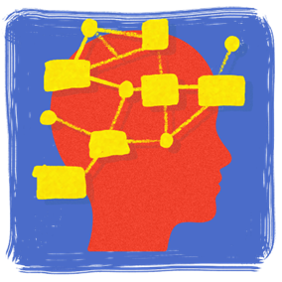
Discuss the BTN AI Laws story as a class and record the main points on a mind map with Artificial Intelligence in the centre. Students will respond to the following:
- What do you know about artificial intelligence?
- What are some examples of AI?
- What are some advantages or benefits of AI?
- What are some concerns or disadvantages?
- What did you learn from this story?
- What does this story make you wonder?
- Think of three questions you would like to ask about the story.


What questions do you have?
What surprised you about this story?

Activity: Glossary
Students will brainstorm a list of key words that relate to the BTN AI Laws story. Here are some words to get them started.

ARTIFICIAL INTELLIGENCE | SUPERHUMAN PERSUASION | CHATBOT
REGULATION | GENERATIVE AI | MACHINE LEARNING

Ask students to write what they think is the meaning of each word (including unfamiliar words). They will swap definitions with a partner and ask them to add to or change the definition. Check these against the dictionary definition.

Activity: AI Research
Discuss the information raised in the BTN AI Laws story. What questions were raised in the discussion and what are the gaps in students’ knowledge? The following KWLH organiser provides students with a framework to explore their knowledge on this topic.

What do I know? | What do I want to know? | What have I learnt? | How will I find out?

Students will develop their own question/s to research or choose one or more of the questions below. Encourage students to collect and record information from a wide variety of sources and present the information they find in an interesting way.

- When was AI first used? Investigate the history of AI and record your findings on a timeline.
- What is machine learning and what are some examples of it? Watch this video to learn more about it.
- Choose one type of AI technology and explain how it is used today. For example: chatbot, robotics, automation, augmented reality.
- What will artificial intelligence have an impact on in the future?
- How can we prepare for artificial intelligence?
- What are some concerns that people have about artificial intelligence?
- What is generative AI and what are some examples of it?
- What rules, laws or regulations should exist so that AI tools/technology can be used fairly in the future? For example, who is responsible if a self-driving car crashes or AI generated images should be labelled as such.

Activity: Persuasive Text
Students will explore the issues raised in the BTN AI Laws story and then develop a persuasive text for or against the following statement: `The benefits of artificial intelligence outweigh the risks’. Students need to weigh up the pros and cons of the issue then write a short persuasive argument using the following as a guide.

Introduction
- What is the point you are trying to argue? Construct an introductory paragraph which states the issue or topic.
- Introduce the arguments that will be developed in the body of the text.

Body
- Construct arguments that support your point of view.
- Each paragraph starts with a topic sentence which introduces each point.
- The rest of the paragraph gives more reasons.
- Arguments can be ordered from strongest to weakest.

Conclusion
- Restate your position on the argument.
- Construct a concluding paragraph that provides a summary of your arguments and a call to action.
Tips
- Who is your audience? For example, are you directing your argument at kids, teachers, or politicians?
- Explore how language choices can have a big impact on persuading your audience.
- Which language devices give the report credibility and authority?
- Which are designed to create an emotional response in the listener?
- Provide facts and evidence to support your argument.
- Write in the present tense.
- Check your spelling and punctuation.

Reflection
- How difficult was it to think of points to support one side of the argument?
- Do you think you would have done a better job supporting the other side of the argument?
- Was I able to convince others of my opinion?
- Did my opinion change?
- What did you learn from this activity?

Activity – Train AI to Clean the Ocean
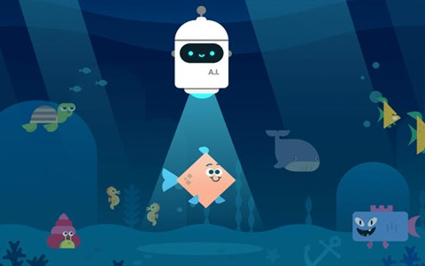
Learn about AI, machine learning and bias while exploring ethical issues and how AI can be used to solve world problems.
Play now

Activity – Choose an Activity
Working individually or in pairs, students can choose one or more of the following AI activities to try. Ask students what they learnt about AI doing the activity.

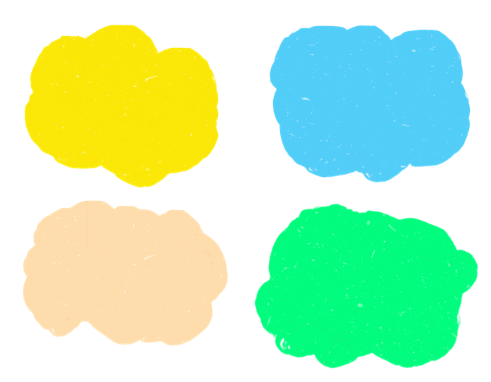
AI or Human?

Do this quiz to see if you can tell if the artworks were created by artificial intelligence or a human.

AI and Shadow Puppets
Learn how to make shadow puppets with the help of AI. Go to Shadow Art to start creating
AI Word Game
Play Semantris - a word association game powered by machine learning.
Quick Draw
Draw a picture of an object or idea and then see if AI can guess what your drawings represent.
Play Quick Draw

BTN Stories
As a class watch one or more of the following BTN stories to learn about the impact of artificial intelligence.

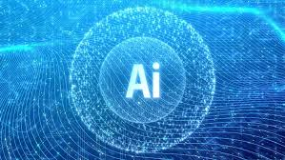AI Jobs | 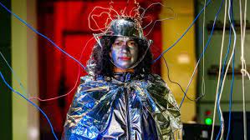Sentient AI | 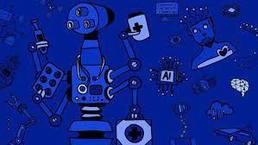Robot Revolution
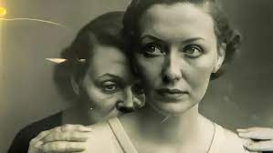  AI Art | 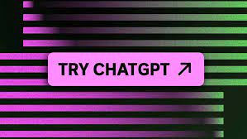  ChatGPT | 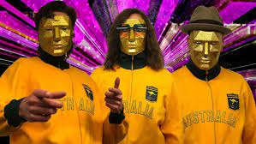  AI Song Contest
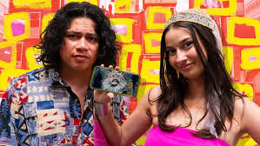
AI Videos

Useful Websites
- AI Jobs – BTN
- AI Videos – BTN
- What is artificial intelligence and why does it matter to you? – Newsround
- Australia’s artificial intelligence crackdown – Newsbreak
- ChatGPT – BTN
- Sentient AI – BTN

KEY LEARNING
Students will explore the impact of artificial intelligence on creative industries and look at how creative AI can be.

CURRICULUM
Science – Year 5 & 6
Scientific knowledge is used to solve problems and inform personal and community decisions.
Design and Technologies – Years 5 & 6
Examine how people in design and technologies occupations address competing considerations, including sustainability in the design of products, services, and environments for current and future use.

.

Teacher Resource
Creative AI

Activity: Class Discussion
Before Watching
Before watching the BTN Creative AI story students will discuss in small groups what they already know about AI and what they think this BTN story will be about.
- What do you know about AI?
- What words do you associate with AI?
What questions do you have about AI?
- What impact might AI have on jobs?
- What do you wonder about AI?

After Watching
Students will respond to one or more of the following questions after watching the BTN story:

- What did you learn watching the BTN Creative AI story?
- Have your thoughts or feelings about AI changed since watching the BTN story? Discuss.
- What impact do you think AI could have on some creative jobs?
- Do you think that AI can be as creative as humans? Give reasons for your answer.

Activity: Glossary
Students will brainstorm a list of key words that relate to the BTN Creative AI story. Here are some words to get them started.

ARTIFICIAL INTELLIGENCE | CREATIVE | GENERATIVE AI
ALGORITHM | MACHINE LEARNING | CREATIVE INDUSTRIES
Ask students to write what they think is the meaning of each word (including unfamiliar words). They will swap definitions with a partner and ask them to add to or change the definition. Check these against the dictionary definition.

Further activities for students:
- Students will add to their glossary by downloading the transcript for the BTN Creative AI story and highlight all the words that relate to the topic.
- Create a word cloud using key words from the Creative AI story. Create a word cloud using a free online word cloud creator such as Word It Out

Activity: AI Research
Discuss the information raised in the BTN Creative AI story. What questions were raised in the discussion and what are the gaps in students’ knowledge? Students will develop their own question/s to research or choose a question below.

- What are the advantages and disadvantages of artificial intelligence?
- How have jobs changed or been replaced by technology over time? Investigate and record your findings on a timeline. Include the following on your timeline: Industrial Revolution, digital revolution, and artificial intelligence.
- What creative jobs will artificial intelligence have an impact on in the future? Choose a job to research in depth explaining how AI will impact it.
- Are there any jobs that shouldn’t use AI? Why?
- Which jobs face the biggest risk of automation? Which face the lowest risk of automation?
- What do you think jobs will look like in 10 years or 50 years’ time? Make a prediction.
- How can artificial intelligence be used in creative jobs?
- How do artists use artificial intelligence as a tool to create art? Choose an artist to explore in detail.
- Can AI match humans for artistic creativity? Create an argument for or against.

Activity: AI or Human?
Can students tell if these artworks were created by artificial intelligence or a human? Take the quiz.
Students can respond to the following questions when they’ve completed the quiz:
- How difficult was it to tell whether the image was created by AI or a human?
- How can you tell if an image was created using AI? What are some things to look out for?
- What does AI mean for the future of art?
- Further investigation: How do AI image generators work?

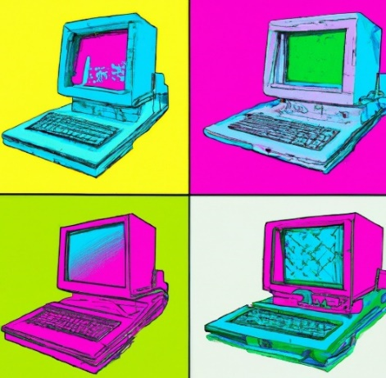
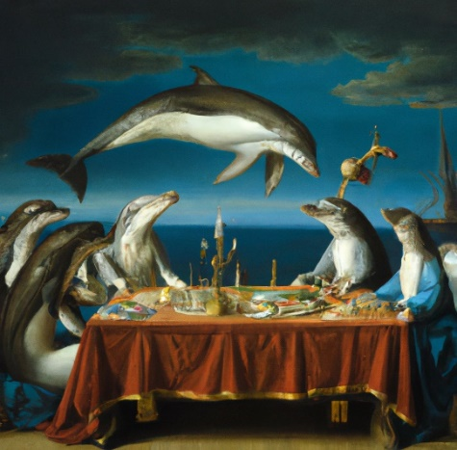

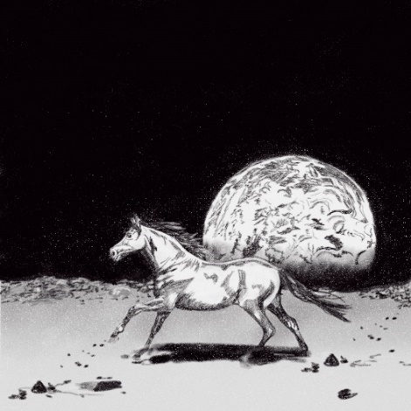
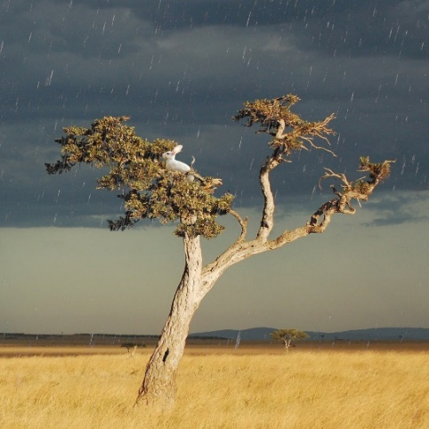

BTN AI Art story
The BTN AI Art story looks at the debate over an image created by artificial intelligence winning a prestigious photography prize. Students watch the story then respond to the following questions:
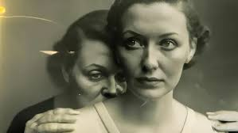
- What is AI art?
- Why did Boris Eldagsen refuse the photography award that he won?
- How do the AI programs create the art?
- What are the copyright issues with AI art?
- Do you think there is a place for AI in visual arts? Give reasons for your answer.

BTN AI Song Contest story
The BTN story looks at an online song contest where all of the songs were composed by computers and meets the programmers behind Australia’s entry. Students watch the story then respond to the following questions:
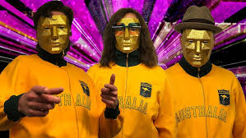
- Why was the AI Song Contest created?
- Explain how the song was created.
- Complete the following sentence. Computers find mathematical ________________ within music to create original songs.
- Who used computers to make music in 1961?
- What do you think the future of using AI in music is?

Useful Websites
- AI Art – BTN
- AI Jobs – BTN
- AI Videos – BTN
- Sentient AI - BTN
- AI Laws – BTN
- AI vs Human: The Creativity Experiment – ABC iView

