
EPISODE 31
5 November 2025

KEY LEARNING
Students will view a range of BTN stories and use comprehension skills to respond to a series of focus questions.

CURRICULUM
English – Year 4
Use comprehension strategies to build literal and inferred meaning to expand content knowledge, integrating and linking ideas and analysing and evaluating texts.

English – Year 5
Use comprehension strategies to analyse information, integrating and linking ideas from a variety of print and digital sources.

English – Year 6
Use comprehension strategies to interpret and analyse information and ideas, comparing content from a variety of textual sources including media and digital texts.

English – Year 7
Use comprehension strategies to interpret, analyse and synthesise ideas and information, critiquing ideas and issues from a variety of textual sources.
  - Teacher Resource

Focus Questions
As a class, discuss the stories featured in the episode of BTN Classroom and record the main points of the discussion. Students will then respond to the following focus questions.

Hurricane Melissa
- Which countries have been impacted by Hurricane Melissa?
- What category is Hurricane Melissa?
- What damage has Hurricane Melissa caused?
- What is another word for hurricane?
- Hurricanes usually affect people living near the equator. True or false?

White House Demolition
- Where is the White House? Find on a map.
- What changes is President Donald Trump making to the White House?
- Who is paying for the renovations?
- What other changes have been made to the White House throughout history? Give one example.
- What is the maximum number of terms an American president can serve?
  - 1
  - 2
  - 3

Pinjarra Massacre Apology
- What year did the Pinjarra Massacre happen?
- Where is Pinjarra located? Find on a map.
- What is the meaning of Frontier Wars?
- What questions do you have about the story?
- How did this story make you feel?

Check out the teacher resource on the Archives page.

Simulated Space Mission
- Summarise the BTN Simulated Space Missions story in three sentences.
- Describe the analogue habitat which featured in the BTN story.
- What is the purpose of analogue habitats?
- Why are simulated space missions important?
- What kinds of science experiments do people do during pretend space missions on Earth? Give one example.

Check out the teacher resource on the Archives page.

Mypolonga School Shop
- What do the students sell at the Mypolonga school shop?
- Who are their customers?
- What do the students spend their profits on?
- What skills have the students learned?
- How does running the school shop make the students feel?


We're inviting schools around the country to tell us what their passion project is. Amazing artistic achievements? Super sporting success? Terrific technological triumphs? Enthusiastic environmental education! It could be anything but make sure it's something your whole class or school is buzzing about. We'll choose the best pitches and help you turn them into BTN stories to share with other kids around Australia.

EPISODE 31
4 November 2025

KEY LEARNING
Students will learn about the Frontier Wars in Australia and why learning about them is an important part of truth-telling.

CURRICULUM
HASS – Year 5
The impact of the development of British colonies in Australia on the lives of First Nations Australians, the colonists and convicts, and on the natural environment.

HASS – Year 9
The causes and effects of European contact and extension of settlement, including their impact on the First Nations Peoples of Australia.

  - Teacher Resource

Pinjarra Massacre Apology

Focus Questions
Discuss the BTN story as a class and record the main points of the discussion. Students will then respond to the following:
- What year did the Pinjarra Massacre happen?
- Where is Pinjarra located? Find on a map.
- What is the meaning of Frontier Wars?
- What questions do you have about the story?
- How did this story make you feel?

This document may contain the names and images of Aboriginal and Torres Strait Islander people now deceased. It also contains links to sites that may use images of Aboriginal and Torres Strait Islander people now deceased.
It also contains some content that may be distressing.

Activity: Personal Response
After watching the BTN Pinjarra Massacre Apology story, ask students to finish one or more of the following incomplete sentences:
- It was interesting to learn that…
- Learning about the Frontiers Wars made me feel…

- It’s important to learn about the Frontier Wars because…


What questions do you have about the story?
What did you learn from the story?

Activity: Discuss
After watching the BTN Pinjarra Massacre Apology story students discuss the story in pairs, using the following questions to guide the discussion:
- Reflect on the apology by the Western Australian Governor. Why was it important? Watch the Governor’s apology.
- What were the Frontier Wars?
- What were the reasons for frontier violence?
- Why is truth-telling important?

Activity: Glossary
Students will brainstorm a list of key words that relate to the BTN Pinjarra Massacre Apology story. Here are some words to get them started.
MASSACRE | RESISTANCE | TRUTH-TELLING
COLONISATION | DISPOSSESED | RECONCILIATION

Activity: Researching Frontier Wars
Students will choose one or more of the questions below to explore in more detail or they can develop their own questions to research.

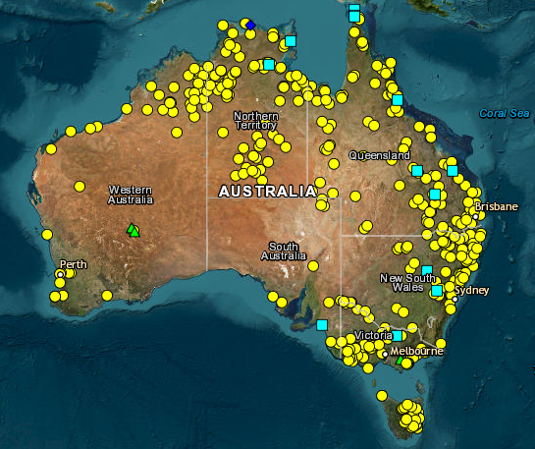
- What were the Frontier Wars and what was the cause of the violence?
- What happened in Myall Creek in 1838?
- What is truth-telling? Why is learning about the Frontier Wars an important part of truth-telling?
- How should these events be recognised or commemorated?
- Look at the map created for the Colonial Frontier Massacres Project. Why is it important to document these events? Use the interactive map to learn about sites that are near you.

Activity: Visual Literacy
Below are images that relate to the Frontier Wars. Students look at the image and then respond to the following questions:
- What do you see in this image?
- What does the image tell you about the Frontier Wars?
- How did the image make you feel?
- What question/s would you like to ask about the image?

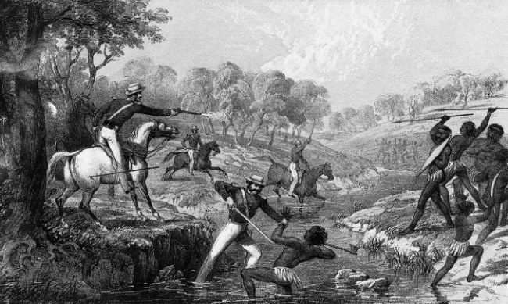  Waterloo Creek massacre | 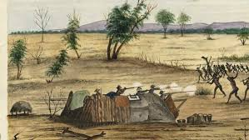  Bulla, Queensland 1861

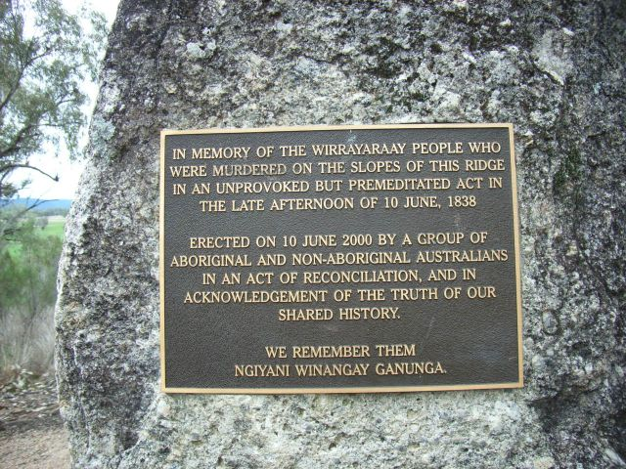  Myall Creek memorial plaque | Myall Creek Memorial  Working in pairs, students read the Myall Creek memorial plaque and respond to the following questions:  - Which groups worked together on the Myall Creek memorial?  - How is the Myall Creek remembered today?  - Why is the memorial important part of reconciliation?

Activity: BTN Stories
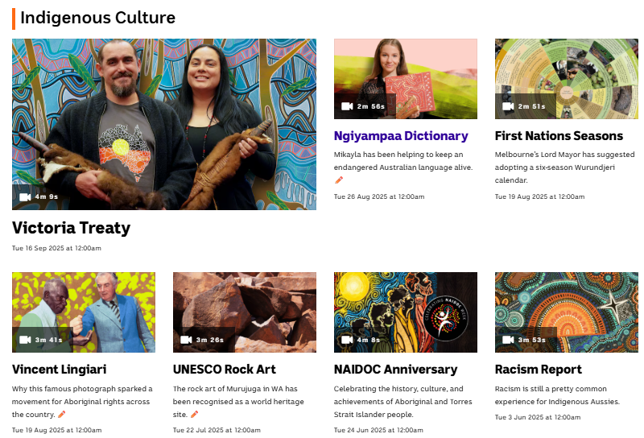
Visit BTN’s collection of stories which focus on Aboriginal and Torres Strait Islander peoples’ history, culture and issues.
After watching any one of the BTN videos ask students to respond to the discussion questions (to find the discussion questions and teacher resources go to the related BTN Classroom Episode and download the Episode Package).
Collection of BTN stories with a focus on Indigenous culture

Useful Websites
- WA Governor Chris Dawson apologises to descendants of Pinjarra Massacre, almost 200 years later – ABC News
- Myall Creek Memorial a symbol of reconciliation as descendants of victims and perpetrators gather – ABC News

EPISODE 31
4 November 2025

KEY LEARNING
Students will explore the purpose and importance of analogue space missions. Students will explore the features of an analogue space habitat and design and create a diorama of an analogue habitat.

CURRICULUM
Science – Year 5
The Earth is part of a system of planets orbiting around a star (the sun).

Scientific knowledge is used to solve problems and inform personal and community decisions.

Science – Years 5 & 6
With guidance, pose clarifying questions and make predictions about scientific investigations.

Science involves testing predictions by gathering data and using evidence to develop explanations of events and phenomena and reflects historical and cultural contributions.

Science – Year 7
Scientific knowledge has changed peoples’ understanding of the world and is refined as new evidence becomes available.
  - Teacher Resource

Simulated Space Mission

Focus Questions
Discuss the BTN story as a class and record the main points of the discussion. Students will then respond to the following:
- Summarise the BTN Simulated Space Missions story in three sentences.
- Describe the analogue habitat which featured in the BTN story.
- What is the purpose of analogue habitats?
- Why are simulated space missions important?
- What kinds of science experiments do people do during pretend space missions on Earth? Give one example.

Activity: Class Discussion
After watching the BTN Simulated Space Mission story, hold a class discussion using the following discussion starters.
- What is an analogue astronaut?

- Why do we have analogue astronauts?
- What are the key reasons for doing analogue missions? (to test technology, procedures, and human performance and psychology, training).
- Why are analogue missions important?
- What questions do you have about this topic?


What questions do you have about this topic?
What is an analogue astronaut?

Activity: Glossary
Students will brainstorm a list of key words that relate to the BTN Simulated Space Mission story. Here are some words to get them started.

ANALOGUE HABITAT | SPACE SIMULATION | ANALOGUE ASTRONAUT
EXPERIMENT | MOON HABITAT | ANALOGUE MISSION



Activity: Questions and Answers
Can you experience zero gravity on earth?
Are your students curious about analogue space missions? Students will make a list of questions they have about space exploration. For example:
- Why do astronauts need to prepare for isolation?
- Can you experience weightlessness on earth?
What questions do you have about analogue missions?
What happens to your body in space?
- What happens to the brain in zero gravity?

Students will use the internet to find answers to
their questions.

Activity: KWLH Research
The KWLH organiser provides students with a framework to explore their knowledge on a topic and consider what they would like to know and learn.

What do I know? | What do I want to know? | What have I learnt? | How will I find out?

Research Inquiry questions
Students will collect and record information from a wide variety of sources. Students may develop their own question for inquiry or select one of the questions below.
- What is an analogue space mission? Why are they conducted on Earth?
- What type of environments on Earth are used to simulate conditions in space or on other planets?
- How do analogue missions help astronauts prepare for living on the Moon or Mars?
- What challenges do astronauts face during analogue missions?
- What are some real-world examples of analogue missions? Write a summary for one analogue mission, which answers the 5 W’s – Who, What, Where, When and Why?

Activity: Explore an Analogue Habitat
Analogues have been used since the 1960s to simulate different aspects of space missions here on Earth. The missions have been integral to space exploration planning, research, hardware development, and astronaut training. In this activity student will explore the role and importance of analogue space missions and then act as engineers by making their own analogue habitat.

Class Exploration
As a class explore real-world locations on Earth that are used to simulate space environments. Identify some examples of analogue environments.
- Deserts (to simulate mars)
- Volcanic areas (that have terrain similar to the Moon)
- Underwater habitat (to practise spacewalk and isolation training)
- Polar stations (extreme cold, isolation and limited sunlight)

In small groups students will research one analogue mission or environment making as many notes as they can about its features. Record key information about the environment or mission including:
- Location
- Purpose
- Habitat design
- Challenges (temperature, oxygen, water, food, isolation)

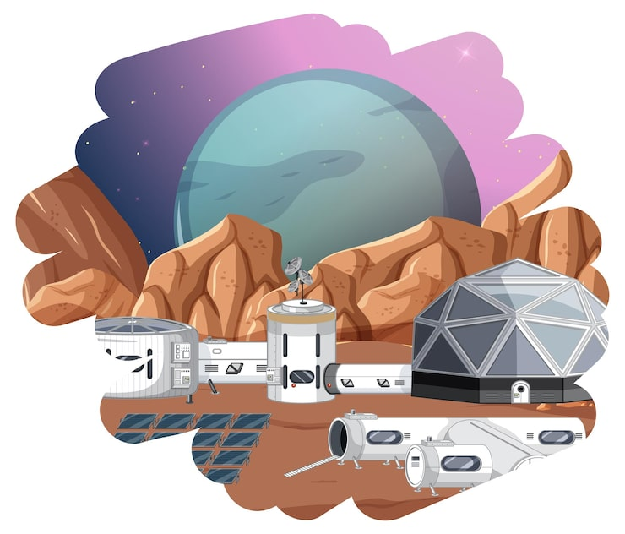
Research
Before creating their dioramas, students will investigate the role and importance of analogue astronaut missions.
- What is an analogue space mission?
- Why do astronauts and scientists use Earth environments to practise space exploration?
- Why are analogue space missions important?
- When was the first analogue space mission? Who ran the mission? Describe the mission.
- When was Australia’s first analogue astronaut mission?

Build an analogue space habitat
Students will design and build a diorama of an analogue space habitat to help scientists prepare for a space mission. It may be to prepare for living on Mars, the Moon or other planets. As part of their planning students will complete the following:
- Type of environment (desert, volcanic, underwater, or polar)
- What is the purpose of the missions?
- What materials will you need to build your diorama?
- What special features will you include in your diorama (for example, living quarters, a research labs, solar panels, communication systems, vehicles and water and oxygen supply)

To further extend your students, they can:
- Create a version of their habitat using Minecraft or with Lego
- Write a diary entry from an astronaut living in the analogue habitat

Activity: Launch with TEDEd

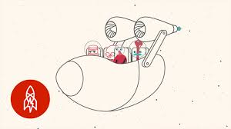 |  | 

What does outer space do to your body?
Watch this TEDEd video to learn more!
Are you more likely to explode or freeze in space?
Watch this TEDEd video to learn more!

BTN Space Science stories

Visit BTN’s collection of stories which focus on space science and space exploration. After watching any one of the BTN videos ask students to respond to the discussion questions

To find the discussion questions and teacher resources go to the related BTN Classroom Episode and download the Episode Package.

Link to collection of BTN Space Science stories

Useful Websites
- Australia’s first analogue space mission takes off – Australian Space Agency
- Why Do We Use Analogs? – NASA
- The Human Body in Space – NASA
- What outer space does to your body – TEDEd
- Simulated Space Missions – BTN High
- Analog Missions – NASA
- Design your own Mission to the Moon! (teacher’s guide) – Australian Space Agency
- What Hazards do Analog Missions Test? – NASA

  - Teacher Resource

BTN Transcript: Episode 31 – 4/11/2025

Yaama, I'm Jack Evans and you're watching BTN. Here's what's coming up. We'll get the lowdown on the big White House renos, find out the story behind this Governor's historic apology and learn what an analogue astronaut is.

Hurricane Melissa

Reporter: Wren Gillett

INTRO: But first today we're going to the Caribbean, which was hit by a devastating storm last week. Its name was Hurricane Melissa, and it was the strongest that's been seen in this part of the world. Here's Wren with more.

In the sky, a huge, powerful storm was growing. Below, people across the Caribbean prepared for what was coming.
PERSON: The people outside, they don't know the danger of this.
PERSON: Leave down here, because down here does not look safe.
NECEPHOR MGHENDI, IFRC: As we speak, today will be very difficult for tens of thousands, if not millions of people in Jamaica. Roofs will be tested. Flood water will rise.
PERSON: It’s coming, it’s coming.
Last week, Jamaica was hit by the strongest storm it's seen since records began. Its name? Hurricane Melissa.
JENS LAERKE, OCHA SPOKESPERSON: We are indeed looking at the storm of the century.
It made its way from the Atlantic Ocean into the Caribbean, and when it hit Jamaica, it was a category five hurricane, which is the strongest rating that exists. Wind speeds inside the spinning storm reached nearly 300 kays an hour, but it travelled super slowly, I'm talking slower than walking pace. This meant it stuck around for longer, causing more damage.
PERSON: It was terrifying for me and my child, the water level reached me to my waist.
As it moved through the Caribbean, it caused a lot of damage. It ripped trees from the ground, roofs off homes and flooded entire towns, leaving hundreds of thousands of homes without any electricity, and killing more than 50 people.
PERSON: The waves were very strong, we live on the second floor, and the waves reached all the way up.
WREN GILLETT, REPORTER: Now, hurricanes, typhoons or cyclones, as we call them here in Australia, don't happen everywhere. They usually affect people living near the equator, where the earth is closer to the sun and the weather is warmer and more humid. Why? Well, because hurricanes, like Melissa, use warm water to gain their power.
Cyclones only form over warm ocean water where the surface is above 26.5 degrees. That's when water evaporates and rises up into the sky, causing some big old storm clouds to form. As more warm, humid air gets sucked up, the clouds grow, and the movement of wind caused by the spinning of the Earth can make the storm whip around into a big spiral. The hotter the water, the more powerful they become, which is why experts are worried climate change is only going to make storms like this one more common.
CARINE JOCELYN, DIASPORA COMMUNITY SERVICES: Hurricane season happens every year, and unfortunately, they're getting worse. How do we really support these small islands so that there are ways to either prevent this or to have systems in place that can make it better.
Right now, people across the Caribbean and Central America are still cleaning up the mess that Hurricane Mellisa left behind. Lots of people are working together to send supplies and support to people who need it, from local volunteer groups to the United Nations.
STEPHANE DUJARRIC, UN SPOKESPERSON: Carrying supplies from the World Food Program, the international organization for migration, and UNICEF.
Meanwhile many are just happy to see the storm pass and to feel safe again.
PERSON: It's a bit scary, but you know, we got each other, so we're strong.

News Quiz

Hundreds of Ancient history students in Queensland found out last week that they’d learned the wrong topic for their year 12 exams. Do you know the name of the famous Roman leader they were supposed to be studying? It’s Julis Ceasar. Unfortunately, at least 8 schools have been teaching students about his nephew, Augustus instead.

STUDENT: Our teacher's kicking himself up over it, but honestly, it's not on him.

DONALD TRUMP, US PRESIDENT: We had a great meeting a week ago. You came all the way and now you came here. But this isn't quite as far.

Where did Australia’s Prime Minister have dinner with the US President last week? Was it in Korea, Malaysia or Japan? It was in Korea, which was hosting the APEC summit. Prime Minister Anthony Albanese also travelled to Malaysia, which was hosting a meeting of ASEAN, which stands for Association of Southeast Asian Nations.

There was a bit of storm last week over the redesigned website of which government agency? Was it Services Australia, the Australia Bureau of Statistics or the Bureau of Meteorology? It was the BoM and its redesign kinda bombed, with some saying it made important information harder to find.

DAVID CRISAFULLI, QUEENSLAND MP: Easy access to individual radars have been removed. The colour scheme we've become accustomed to has changed.

PERSON: I hate that change. What's going on there? That's, um... No, I'm not a fan.

The Bureau of Meteorology has apologised for confusion the change had caused and said they’ll make adjustments and help people get used to the change.

White House Demolition

Reporter: Wren Gillett

INTRO: Now you might have heard that the home of the US President is looking a bit different at the moment. The country's president surprised a lot of people by demolishing the East Wing of the White House. Wren found out what's going on and why it's causing a stir.
WREN GILLETT, REPORTER: Welcome to the White House, the symbol of America's democracy. Allow me to show you around. Here we have the Executive Residence, where US Presidents and their families live. To the West, there's the West Wing, which houses the Oval Office. It's where the president works. And then to the East you have, ahh. Well, normally this is where the East Wing is. Normally.
Yep, right now, one of America's most recognisable buildings is a little less recognisable, after part of it was demolished to make way for a brand-new ballroom.
DONALD TRUMP, US PRESIDENT: It's about 300 million dollars. It's set to do many, many things, including meetings of foreign leaders.
WREN GILLETT: Now, just so you're all aware, this isn't the first time the White House has been renovated.
For starters, the whole thing burned down during the war of Independence in 1814. It was rebuilt, and from there, US Presidents started adding their own touches. Theodore Roosevelt added the West Wing, then William Howard Taft expanded it, and added the Oval Office, which Franklin Roosevelt moved. He also added the East Wing, a pool, a bomb shelter, and a movie theatre, busy, busy. In 1949, Harry Truman gutted and rebuilt basically the whole interior and added a bowling alley. And in 1961, John F. Kennedy created the Situation Room, where national security meetings are still held today.
WREN GILLETT: So, yes, the White House has undergone many, many changes over the years.
But this one has certainly got people talking. Why? Well, for one, it's the biggest change the White House has seen in decades. Two, it came as a bit of a surprise. You see, President Trump originally said the ballroom wouldn't interfere with the East Wing, which was mainly used by the First Lady, that is the President's wife.
DONALD TRUMP: It won't interfere with the current building. It will be near it, but not touching it, and pays total respect to the existing building which I'm the biggest fan of.
Plus, the whole project is being funded by Donald Trump and private donors, which is pretty unusual. And no one else really got a say. That's not against the rules, but again, it's pretty unusual.
Yeah, you see this US President is operating a little differently to most. He's made a lot of big decisions quickly, sometimes without going through the usual processes, for example, those tariffs you're probably sick of us talking about. He's also sent the military into major cities against the wishes of local authorities.
DONALD TRUMP: To have a great country you can't have crime. And if the governor can't straighten it out, we'll straighten it out.
He's even floated the idea of serving as President for a third time, even though the constitution says ya can't. All of this has made a lot of Americans worried, and angry.
PERSON: The total disregard for the Constitution is incredible now, and it's increasing every day.
The country is also dealing with a national shutdown, which means Government workers aren't being paid, because the two main political parties won't agree to pass a national budget. So, yeah, there's a lot going on, and to some, seeing the White House looking like this was pretty upsetting.
PERSON: If there's ever a symbolism for this presidency, there it is.
Others see it as a builder doing what he knows best, taking charge and making things happen.
PERSON: This term versus the last term, he's just going forward, forward, forward, and he's not worrying about what people are saying about him. He's working for us.
Either way, it's a historic moment for The White House, and the country it represents.
WREN GILLETT: Ah, what a time to be a tour guide.

Quiz

What did President Barack Obama add to the White House in 2009? Was it a tennis court, a basketball court or a hot tub? It was a basketball court.

Pinjarra Massacre Apology

Reporter: Jack Evans

INTRO: Now we're going to Western Australia, where the state's Governor has made an important speech. He formally apologised to the descendants of those killed in one of the most brutal attacks in Australia's history, the Pinjarra Massacre of 1834. Let's find out more.
KARRIE-ANNE KEARING, BINDJAREB WOMAN: Every year on this date we gather here to remember the massacre in 1834. And this year I'm very honored to welcome the Governor Chris Dawson.
JACK EVANS, REPORTER: The Presence of Western Australia's Governor here in Pinjarra was a special moment. Because it was the first Governor 191 years ago who was responsible for one of the worst massacres in Australia's history.
CHRIS DAWSON, WA GOVERNOR: I come here on the invitation of the Bindjareb Noongar people. I come here on foot, unarmed, to walk softly on this country. I come with my heart, my koort, to say sorry. I come here today to say sorry for the dreadful wrongs perpetuated by the first Governor of Western Australia, Sir James Stirling.
KARRIE-ANNE KEARING: Before me, you know, my father and my aunties and my father fought for, you know, just to be recognised and for the governor to come down and actually do it is a big step for us as a community.
The Pinjarra Massacre took place on the 28th of October 1834. The then Western Australian Governor, James Stirling, led a group of armed men to ambush a group of Bindjareb Noongar people on the banks of the Murray River. While Governor Stirling reported killing 15 people, locals say that the number is actually closer to 80. You might not have heard of the Pinjarra Massacre before. It hasn't always been taught in schools and neither have many of the other violent conflicts between Australia's First Nations and European settlers that were part of what we sometimes call, The Frontier Wars.
As you probably know British people arrived in 1788 on a continent that had been home to Aboriginal people for tens of thousands of years. As they spread out many Indigenous people fought to defend their land. There were hundreds of massacres that killed tens of thousands of people. Like here in Victoria at a place known as the Convincing Ground where British whalers fought and killed many Gunditjmara people. And this water hole near Geraldton in WA called Wulong, or Binu Springs, was the site of a massacre in 1854.
THEONA COUNCILLOR, NAAGUJA WOMAN: They came from all sides that side that side and made like a killing ground, really.
The last recorded massacre took place less than 100 years ago in 1928 at the Coniston Cattle Station in the Northern Territory.

The exact details of these killings weren't always recorded, so it's hard to know exactly how many people died. But historians and traditional knowledge holders are working to find and tell the truth.
JACINTA ALLAN, VICTORIA PREMIER: I did not know of the massacres. I'm ashamed to say.
ELEANOR ANNE BOURKE, WERGAIA AND WAMBA WAMBA ELDER: By learning about the past from first people's perspective we can better understand how that past connects with now, the present.
For many it's not just a way of acknowledging conflicts that took place here, it's also an important step for healing and reconciliation.
KARRIE-ANNE KEARING: To me, it's a giant step. It's so significant that, you know I'm still trying to process it.
Analogue Astronauts

Reporter: Cale Matthews

INTRO: Recently a heap of scientists across the globe got locked in big dark rooms for two weeks. Why? To get a taste of what life would be like living on the Moon and Mars. It was part of a project called the World's Biggest Analog and Cale went to find out more.

ASTRONAUTS: So you see, this is where we spend most of the day.
CALE MATTHEWS, REPORTER: For two weeks, these guys have been living, working, eating...
ASTRONAUT: Then you add hot water.
..and sleeping on the moon. OK, maybe it's more like a tent in a shed. But this is some serious pretending that's helping the world get ready for a new era of space travel.
NEIL ARMSTRONG, ASTRONAUT: That’s one small step for man. One giant leap for mankind.
So, humans haven't set foot on the Moon in more than 50 years but, we're going back.
NEWS CLIP: Buckle up everybody, we're going for a ride to the Moon.
NASA, with the help of private space companies, has plans to set up bases on the Moon.
NEWS CLIP: The Moon, you guys.
NEWS CLIP: Back to the Moon and beyond.
Which could serve as a launch-pad to go to MARS. But to pull this off, there's lots of work that needs to be done on here earth. And that's why I've come out to the University of Adelaide. So, I've made it to the Moon bit says do not enter, luckily Mission Control is just over there.
Pretend missions like this, also called analogues have been used for ages. This is Buzz Aldrin and Neil Armstrong pretending to collect lunar samples just a few months before they actually went to the Moon. It's important to practice because real space is dangerous.
MARC HEEMSKERK: Because if you open the window, you're dead. You know, if if you mess up the rocket engine, you're dead. If you mess up your oxygen supply, you're dead. If you don't prepare your food for at least months in advance. You're dead… it's a bit more extreme than most places on Earth.
So, if you guys were on the actual Moon, would you still be alive right now?
ASTRONAUTS: Most likely not.
ASTRONAUTS: We keep track, we keep track of what we call the simulation death.
ASTRONAUTS: I think we all have one simulation depth, except Ilija. So, Ilija is still alive as far as the simulation is concerned.
Besides trying not to die Louis, Adrian, Ilija, and Kato have been doing experiments.
ASTRONAUT: We've been growing pants for the last eight days.
Testing out equipment and getting used to life as an astronaut.
ASTRONAUTS: I didn't realise that when you actually put the helmet on, you might get a little bit claustrophobic. So that was a little bit surprising to me. And then when the fog starts coming in, like I really fog up a lot on EVA. So what do I do? Do I rub the helmet with my nose? Do I lick it with my tongue, which I have done a couple times? You just gotta find a way to go to the next thing while being safe.
ASTRONAUTS: Our shower, which is wet wipes.
ASTRONAUTS: A lot of wet wipes, and a lot of wet wipes.
And at the same time, other scientists around the world have been doing something similar.
It was all part of the World's Biggest Analog, a project combining 16 different Moon and Mars habitats across the earth all working together at once.
JAS PUREWAL, COORDINATOR: This massive, massive global mission. Are we, in fact, then also mimicking, like, potentially a lunar colony, a lunar settlement, something like that, which is not that far off.
And while these analogue astronauts are still safe on earth, it can be easy to miss the little things.
ASTRONAUTS: I really like fresh fruit and it's not available here of course.
ASTRONAUTS: My baby boy, my son was born 5 months ago I didn't expect him to be growing up so fast.
ASTRONAUT: I miss my tools.
CALE: Whilst I feel for your tools, I feel like the audience is probably going connect more with you missing his son.

Quiz

Do you know the name of NASA's mission to return humans to the Moon? It's Artemis. Artemis was the Greek Goddess of the hunt, wild animals, and the Moon, and was also the twin sister of Apollo - the name given to NASA's first manned mission to the Moon.

Sport

Now, check this out…

COMMENTATOR: History in the making for Gemma Houghton!

With just 50 seconds left to go in the game, Port Adelaide's Gemma Houghton has become the first AFL player to reach 100 career goals. She reached the milestone after the siren at her team's clash against the GWS Giants over the weekend. Houghton first started her AFL career at Fremantle, kicking a total of 40 goals for the Dockers and then another 60 after moving to the Power in 2022. And speaking of history...

COMMENTATOR: 24 in a row.

North Melbourne have won more games in a row than any other major Aussie Rules team.
They haven't lost a game since the 2023 Grand final and head into the finals after a 49 point win over the Hawks and a perfect season.

Wow, what a moment! India has just clinched its first ever women's ODI Cricket World Cup. India started off strong, racking up 298 runs in their innings, with Shafali Verma smashing 87 of 78. South Africa looked up to the task, with opener Laura Wolvaardt making a century...

COMMENTATOR: 100, in a semi-final.

..but after Amanjot Kaur's incredible catch, it was all over, with India coming out on top by 52 runs.

Finally, the biggest marathon in the world, the New York City Marathon. This year, more than 55,000 people put their running shoes on to run 42-odd Ks through the city streets. And Kenya absolutely crushed it in the men's and women's, with Benson Kipruto clocking in at two hours, eight minutes and nine seconds and Hellen Obiri crossing the line in a course record of two hours, 19 minutes and 51 seconds.
Mypolonga School Shop

Rookie Reporters

INTRO: Finally, today we're going to share another BTN Passion Project, which is all about telling stories about things that are important to you. And this week we're getting a tour of Mypolonga's historic school shop.

STUDENTS: Welcome to our shop.
STUDENT: We're in Mypolonga.
STUDENT: It's like a country area, so it's a bit quiet and small.
STUDENT: The shops been running for 30 years.
STUDENT: We sell lemonade.
STUDENT: Postcards, key rings, magnets and bookmarks,
STUDENT: We also sell recipe books that students have made over the years.
STUDENT: The Proud Mary is like a riverboat that goes on the Murray River.
STUDENT: The river's just over there.
STUDENT: It's mainly elderly people that come here.
STUDENT: After they've been on the boat for a while, they come on the bus and they drive around to come over here.
STUDENT: There is tour leaders and they like show the people around the school.
STUDENT: And they just have a look at the shop and have opportunity to buy stuff.
STUDENT: And it's real money, not fake.
STUDENT: Fourteen dollars and fifteen dollars.
STUDENT: Every like, school shop we go around $600.00 and last week we ended up having $1294.00.
STUDENT: And anything sold at the outside counter will go into students' classroom profit for camps and excursions.
STUDENT: We also bought like school soccer balls and netballs and stuff.
STUDENT: People around Mypo make items and they go up into the inside counter.
STUDENT: Enjoy the rest of your day.
CUSTOMER: Thank you.
STUDENT: And we get 20% commission from each item.
STUDENT: We kind of have, like full control. Technically, the teachers just supervise us and help us with some monies.
STUDENT: They give us all the responsibilities of running a business and owning an actual shop.
STUDENT: When you're handling money, you have to balance how many you've sold and make sure that you've got all the right amounts of everything.
STUDENT: Little poems and pictures of around the area.
STUDENT: The first time I worked at the shop, I felt like really nervous.
STUDENT: It was pretty scary because there's lots of people that you don't know and it's bit overwhelming.
STUDENT: But then they always like complimented me and they like, smiled at me and it made me feel really nice about myself.
STUDENT: We're one of the only schools in Australia that do that run a program like this and it's very special for our community.
STUDENT: It's quite intriguing to just be able to have that leadership to step up and run our own business at like 11 or 12 years old.
STUDENTS: Bye. See you again. Thanks for coming.
Closer

Oh, nice one, guys! And remember, if you have a passion project you want to share, let us know on our website. Well, that's all we have for now, but we'll be back next week with more. And in the meantime, as always, you can keep up to date with Newsbreak or check out BTN High online. Have an awesome week and I'll see you next time. Bye!

