Episode 31
5th November 2019



Melbourne Cup Controversy
- Discuss the Melbourne Cup Controversy story as a class and record the main points of the discussion.
- About how many people watch the Melbourne Cup worldwide?
- The Melbourne Cup is the oldest horse race in Australia. True or false?
- What was the prize for the first Melbourne Cup in 1861?
- Who was Phar Lap and Makybe Diva?
- How can it be dangerous for horses racing in the Melbourne Cup?
- What happens to horses once their racing career is over?
- What story shocked many people including trainers, jockeys and racing officials?
- What is the Melbourne Cup doing to help retired horses?
- What questions do you have about the issues raised in the story?

Check out the Melbourne Cup Controversy resource on the Teachers page.

Berlin Wall
- What did the BTN Berlin Wall story explain?
- What happened on the 9th of November 1989?
- Name one of the countries that was part of the Allied powers?
- How many zones did the Allied powers divide Germany into?
- What is the capital city of Germany? Find using Google Maps.
- What was the Cold War?
- In what year was a wall built between East and West Berlin?
  - 1950
  - 1961
  - 1989
- How did the wall affect people’s lives?
- Describe what happened when the wall came down.
- What do you understand more clearly since watching the BTN story?

Check out the Berlin Wall resource on the Teachers page.

Reality TV Debate
- Before watching the BTN story, discuss what you know about reality TV.
- What do producers do to make reality TV more interesting? Give an example.
- What happened to one of the contestants on the show House Rules?
- Complete the following sentence. Channel 7 argued she was a contestant not an ____________.
- In Australia it’s illegal to bully employees. True or false?
- Why are contestants on reality TV shows put in high pressure situations?
- How can being on a reality TV show affect your real life?
- What advice does Matt give about being on a reality TV show?
- What are some of the differences between what you see on reality TV and real life?
- What was surprising about the BTN story?

Get your class involved in BTN’s Ask A Reporter. This week’s topic is reality TV.

Palawa Kani
- Briefly summarise the BTN Palawa Kani story.
- What is the name given to Tasmania’s traditional owners?
- What are some of the activities that Kobe is doing at the camp?
- What does palawa kani mean?
- How long has palawa kani been spoken?
- How did colonisation affect Indigenous people in Tasmania?
- How did Fanny Cochrane Smith help preserve Aboriginal language in Tasmania?
- How was palawa kani created?
- Why is it important to Kobe to speak palawa kani?
- What did you learn watching this story?

Esport Classes
- Retell the BTN Esport Classes story using your own words.
- What is esport?
- How much money did the 2019 Fortnite World Cup winner win?
- Some predict that by 2021 online gaming will be the biggest sport in the US. True or false?
- How can regular physical exercise help professional online gamers? Give an example.
- What is cognitive function?
  - Our endurance levels
  - Our ability to cope with stress
  - The way we solve problems and make decisions
- What does Dylan hope to achieve?
- How does esport help students’ learning?
- What did you like about the BTN story?
- What was surprising about the BTN story?

Teacher Resource
Episode 31
5th November 2019

Melbourne Cup Controversy

Students will explore the issues raised in the Melbourne Cup story and develop an argument for or against the issue.


English – Year 5
Plan, draft and publish imaginative, informative and persuasive print and multimodal texts, choosing text structures, language features, images and sound appropriate to purpose and audience

English – Year 6
Plan, draft and publish imaginative, informative and persuasive texts, choosing and experimenting with text structures, language features, images and digital resources appropriate to purpose and audience.

Plan, rehearse and deliver presentations, selecting and sequencing appropriate content and multimodal elements for defined audiences and purposes, making appropriate choices for modality and emphasis.

Use interaction skills, varying conventions of spoken interactions such as voice volume, tone, pitch and pace, according to group size, formality of interaction and needs and expertise of the audience.

English – Year 7
Use interaction skills when discussing and presenting ideas and information, selecting body language, voice qualities and other elements, (for example music and sound) to add interest and meaning.


- Discuss the Melbourne Cup Controversy story as a class and record the main points of the discussion.
- About how many people watch the Melbourne Cup worldwide?
- The Melbourne Cup is the oldest horse race in Australia. True or false?
- What was the prize for the first Melbourne Cup in 1861?
- Who was Phar Lap and Makybe Diva?
- How can it be dangerous for horses racing in the Melbourne Cup?
- What happens to horses once their racing career is over?
- What story shocked many people including trainers, jockeys and racing officials?
- What is the Melbourne Cup doing to help retired horses?
- What questions do you have about the issues raised in the story?


What do you see, think and wonder?
Discuss the BTN Melbourne Cup Controversy story as a class. Students will then write a personal response to the BTN story.

Students can finish one or more of the following incomplete sentences:
- It was interesting to learn that…
- Horses are special because…
- It’s surprising that...

Students will respond to the following questions. Students can then leave a comment on the BTN Melbourne Cup Controversy story page.


What did you learn from the story?

How do you feel about the issue?

Class Discussion

Six Hat Thinking
As a class, use Edward De Bono’s Six Hat Thinking to explore the issues raised in the BTN Melbourne Cup Controversy story. Make your own coloured hat cut-outs and place on the floor. Students will take it in turns answering questions in relation to what they already know about the issue, what they have learnt from the BTN Melbourne Cup Controversy story and what they want to learn further about the topic. Ask students to respond to the following questions:

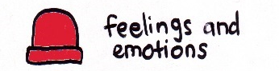 | How did the Melbourne Cup Controversy story make you feel?
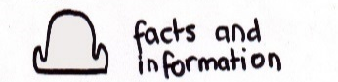 | What do you know about the Melbourne Cup?  What have you learnt from the story?
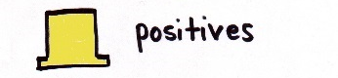 | Were there any positives from the story? If so, what were they?
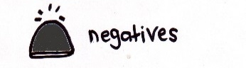 | What are some of the negatives or challenges that you learnt from the story?
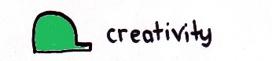 | Why is it important to find out more about the issue?
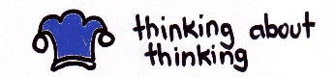 | What questions were raised during this activity?  What do you want to learn further about this topic?

Reflection
After this activity, ask students to reflect on what they have learnt. Students can include details about how their thinking on this issue has changed and why they think we should act.

History of the Melbourne Cup
As a class watch BTN’s Melbourne Cup History story. Find out how it all started by travelling back in time and discovering how a simple horse race became one of the most significant events on the Australian sporting calendar. Students will watch the story and answer the following questions:

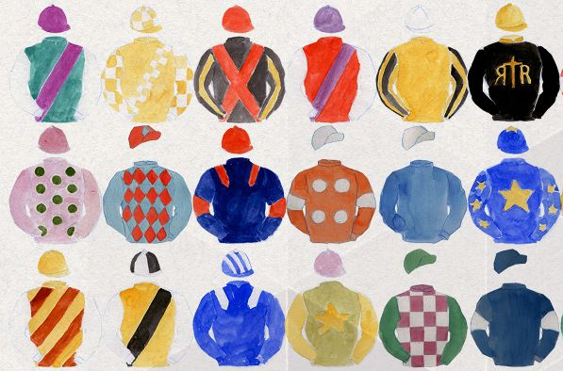
- In which year was the first Melbourne Cup held?
- Explain why horse racing became important in Australia.
- About how many people watched the first Melbourne Cup?
- Name two facts about the first winner of the Melbourne Cup.
- Who was Phar Lap?
- How much money does the winner of the Melbourne Cup get?
- At which racecourse is the Melbourne Cup run?
- About how many people watch the race worldwide?
- The Melbourne Cup is described as `the race that stops the nation’. Why do you think the race has become important to so many people?
Opinion Poll

Do you think horse racing has a future? Students will conduct their own opinion poll on the issue of horseracing. Working in groups, students will need to decide who their sample group will be and how many people will be polled. What method will they use to conduct the poll? (Face to face interviews or written responses).
- Ask students to graph the opinion poll results and display in the classroom.
- Students may want to film their interviews and then create a movie to present to other students.
- Students can compare their attitudes to that of their classmates and discuss their findings.
- Students can reflect on how reliable they think the results were and respond to the following: What would you do differently next time? Were your results surprising? Why or why not?

Mini Debate
Before preparing for the mini-debate, students will investigate the environmental, safety and moral/ethical issues related to horse racing in Australia. They may find it useful to record their information on the following chart.

What do I know? | What do I want to know? | What have I learnt? | How will I find out?

Preparing for your mini debate
- Working in pairs, students will prepare a 1-2-minute speech for a mini debate on the topic of horse racing.
- One person will speak for the affirmative and the other will speak for the negative.
- Before students begin to construct their argument, ask them to record what they already know about the topic and what they would like to find out. Students then research the topic to gain a greater understanding of the issue.
- Ask students to list their arguments in point form on paper (without their partner seeing them). When they have done this, ask them to choose the five best points that will form the basis for their debate.
- Students will write in point form, their debate on cards that fit into the palm of their hand. Their debate needs to have an introduction (introducing the topic), middle (three main points) and a conclusion (restating their position). Students practise their speech and then present the mini debate to other students.

Be a reporter for a day

Students will be a reporter for a day. Students will investigate the issues highlighted in the BTN Melbourne Cup Controversy story and write a newspaper article or online news report for kids. Things for students to think about:

- Who is your target audience? Use age appropriate language and themes.
- Write a headline that is short and to the point.
- Use words and pictures in your report.
- Find information from a variety of sources.
- Present the facts and/or opinions clearly and accurately.


Melbourne Cup History – BTN
https://www.abc.net.au/btn/classroom/melbourne-cup-history/10525606

Melbourne Cup 1866 – National Museum Australia
https://www.nma.gov.au/explore/collection/highlights/1866-melbourne-cup

Teacher Resource
Episode 31
5th November 2019

Berlin Wall
Students will learn more about the Berlin Wall, why it was built and the fall of the wall.

HASS – Yeas 5 & 6
Develop appropriate questions to guide an inquiry about people, events, developments, places, systems and challenges.

Locate and collect relevant information and data from primary sources and secondary sources.

Sequence information about people’s lives, events, developments and phenomena using a variety of methods including timelines.

HASS – Year 7
Construct significant questions and propositions to guide investigations about people, events, developments, places, systems and challenges.
- What did the BTN Berlin Wall story explain?
- What happened on the 9th of November 1989?
- Name one of the countries that was part of the Allied powers?
- How many zones did the Allied powers divide Germany into?
- What is the capital city of Germany? Find using Google Maps.
- What was the Cold War?
- In what year was a wall built between East and West Berlin?
  - 1950
  - 1961
  - 1989
- How did the wall affect people’s lives?
- Describe what happened when the wall came down.
- What do you understand more clearly since watching the BTN story?

What do you see, think and wonder?
After watching the BTN Berlin Wall story, students will respond to the following questions:
- What did you SEE in this video?
- What do you THINK about what you saw in this video?
- What did you LEARN from this story?
- What was SURPRISING about this story?
- What QUESTIONS do you have about this story?

Class Discussion
As a class discuss the BTN Berlin Wall story, using the following questions as a guide. Record the main points of the discussion.

- Where is Berlin? Locate on a map.
- What do you know about the Berlin Wall?
- When was the Berlin Wall built?
- Who built the wall?
- Why was the Berlin Wall built?
- How was it built?
- How big was it?
- Which countries ran West Germany?
- Which country ran East Germany?

Glossary
Students will brainstorm a list of key words that relate to the BTN Berlin Wall story. Here are some words to get them started.

Democracy | Communism | Cold War
Iron Curtain | Soviet Union | Allied powers

Berlin Wall research
Students will be exploring the Berlin Wall in more detail. They can develop their own key questions to investigate or respond to one or more of the questions below. Students can complete the following KWLH organiser to explore their knowledge and consider what they would like to know and learn.

What do I know? | What do I want to know? | What have I learnt? | How will I find out?
Here are some possible questions for students to research:
- How did the Berlin Wall affect the lives of people living in East Berlin? How did it affect the lives of West Berliners? Compare and contrast life on both sides of the wall.
- Why did the Berlin Wall become a symbol of the Iron Curtain during the Cold War?
- Why did the Berlin Wall come down in 1989? What were the events leading up to the fall of the Berlin Wall? How did people in Germany react? How did the rest of the world react?
- What is propaganda? How was it used by authorities in both East and West Berlin?

Students can present the information in one of the followng ways:
- A ‘Did You Know’ Facts sheet
- Prezi presentation
- Oral presentation
- An infographic using Canva


Visual literacy
Below are images of the Berlin Wall. Students look at the image and then respond to the following questions:
- What do you see in this image? Describe the setting and who is in the image.
- What do you think is happening?
- If there are people in the image who do you think they are? How do you think they might be feeling?
- What question/s would you like to ask the people in the image?
- Create a caption for each image.
Students will choose a photograph and write a short, fictional story based on the image. Students might want to tell the story of the photographer or a person in the photograph. Students will use their research to help them imagine what their characters were thinking and feeling.

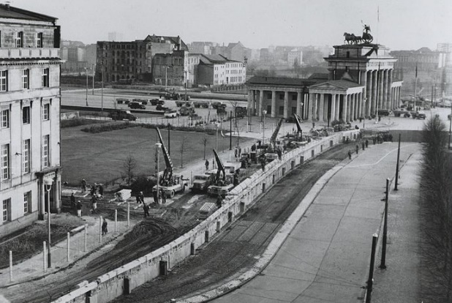  Link to image | 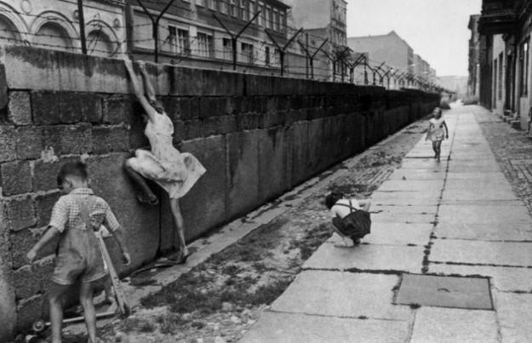  Link to image
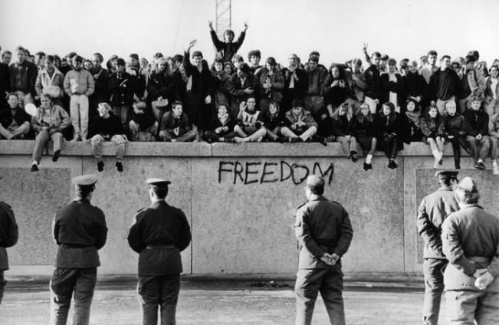  Link to image | 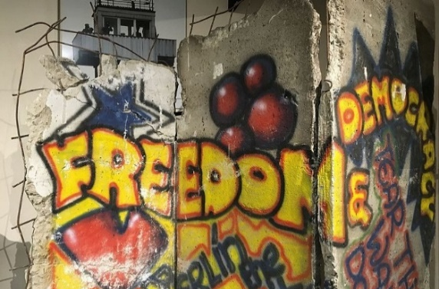  Link to image


Berlin Wall Quiz
Complete this quiz as a class or individually to test students on what they have learnt about the Berlin Wall.

- Berlin is the capital of which country?
  - Poland
  - Germany
  - France
  - Denmark

- What year was the Berlin Wall built?
  - 1945
  - 1951
  - 1961
  - 1989

- Which country had control over the government of East Germany?
  - Soviet Union
  - United States
  - China
  - Poland

- Who was in charge of West Germany?
  - United States
  - France
  - Britain
  - All of the above

- When was the Berlin Wall demolished?
  - 1961
  - 1989
  - 1999
  - 2009

- East Germany was controlled by a democratic government.
  - True
  - False

Answers: 1b, 2c, 3a, 4d, 5b, 6b

Guide: What was the Berlin Wall? – Newsround
https://www.bbc.co.uk/newsround/29913833

BTN Transcript: Episode 31 – 5/11/19

Hey. Amelia Moseley here and you're watching BTN. Let’s check out what’s coming up. The world marks 30 years since the fall of the Berlin Wall, we find out what happens behind the scenes of reality TV shows and meet some kids who are studying esports at school.

Melbourne Cup Controversy
Reporter: Nat Kelly

INTRO: We'll have all that and more soon. But first to the big story of the day, the Melbourne Cup. It's the country's most famous horse race but not everyone is a fan of racing and right now it's particularly controversial. Here's Nat.

It's Melbourne Cup day. A day of spring flowers, fascinators, chicken luncheons and of course, horses. It's often called the race that stops a nation, and for good reason. Hundreds of thousands of people come to Flemington to watch the race, while millions of Aussies watch it on TV. It's also pretty popular overseas, and all up around 600 million people tune in every year.
It's one of the oldest horse races in Australia. The first Melbourne Cup was in 1861, and back then, things were quite different. For starters, the prize for the first Melbourne Cup wasn't even a cup— it was a golden watch. It was only in 1865 that the first real cup was given to the winner. He thought it looked mega ugly, so he sold it. Wow. Much appreciation. They ended up redesigning the cup trophy in 1919, and it looks pretty much the same today.

For a long time, it's been one of the most sought-after prizes for trainers and jockeys alike. And it's turned a few horses into Australian legends. Ever heard of Phar Lap, or Makybe Diva?
But not everyone is a fan of The Cup, or horse racing in general. One issue is that it can be pretty dangerous for the horses and jockeys. It's not uncommon for a horse to get injured or even break a bone while racing, and unlike us humans, for horses, a broken leg is disastrous, and they usually have to be put down. In the past 6 years, 6 horses have died racing in the Melbourne Cup. And more than a hundred horses have died on Australian race tracks in the past year.
Then there's some more recent controversy, about what happens to horses once their racing career is over. The racing industry says that for most, it's a happy ending. Some horses get adopted and live out the rest of their lives on farms. Some are even recruited as police horses. Really successful horses can be valuable as breeding studs. That's how Makybe Diva is spending her days now; on a farm in the Hunter Valley.
But not every horse is that lucky. Recently, some pretty upsetting footage came out showing racehorses from NSW getting mistreated at abattoirs. That's a place where animals are killed for their meat. In NSW, ex-racehorses aren't supposed to be slaughtered, although that's not the case in every state. The story shocked many people, including trainers, jockeys and racing officials.

CHRIS WALLER, HORSE TRAINER: Personally, I couldn’t watch it. I had to look away.

AMANDA ELLIOT, VRC CHAIRWOMAN: I did not know this sort of treatment of horses was going on.

MARK FURNER: QLD AGRICULTURE MINISTER: As someone that’s been a previous owner of a retired horse, I’m appalled.

Many people in the racing industry say that they love their horses and want to make sure that they're looked after during their racing career and afterwards.
Investigations have started in a couple of states into the treatment of retired racehorses. And authorities are looking at ways to make sure animals are being well treated. Meanwhile, organisers of the Melbourne Cup say 10% of ticket sales this year will go towards a horse welfare fund. For some that's not enough; they'd like to see racing banned for good. But others are welcoming it as a positive first step to make sure all of these horses are treated the way they deserve.

Did You Know?

Did you know Michelle Payne is, so far, the only female jockey to have won the Melbourne Cup? She rode Prince of Penzance to victory in 2015. There's even a new film about it.

This Week in News

Violent protests are still going on in Chile. They started last month because lots of people were unhappy with the government and inequality in the South American country. Since then, at least 20 people have been killed. Chile was meant to host the UN climate conference in December, but it's now been moved to Spain. It's left Greta Thunberg, who'd already travelled to Chile, looking for an environmentally-friendly lift to the other side of the world.

Authorities in India say air pollution in the country's capital has become unbearable. On Sunday, the smog in New Delhi was so bad it couldn't be measured properly by pollution monitors. One app that measures air quality said breathing it was like smoking 33 cigarettes a day. Schools closed, and flights were diverted, and people were told to stay inside. While New Delhi has ongoing problems with air pollution, it's particularly bad at the moment because farmers have been burning leftover crops.

Meanwhile in Australia, people in New South Wales have celebrated some much-needed rain. It's been months since it's rained in this part of the country which explains why this guy was so thirsty. Rain has also poured down in southern Tasmania, helping to put out four major bushfires.

Berlin Wall
Reporter: Jack Evans

INTRO: Now to Germany which will be marking a really important anniversary this week, the fall of the Berlin Wall. 30 years ago, the wall split the city in two and to many it was a symbol of a bigger world conflict. Here's Jack.
On the 9th of November 1989 there was a massive party on top of a wall. There were hoses, a guy in a light up jacket named David Hasselhoff, your parents might know who he is. But mostly, there was hope as a country that was divided in two was finally united. To find out why the wall was there in the first place, we have to go back to the end of the Second World War.
After one of the deadliest conflicts the world had ever seen, Germany was finally defeated by the Allied powers, which included Britain, France, the United States and the Soviet Union. They split the country up into four zones, each one controlled by a different country. Germany’s capital Berlin was also split. The intention was always that eventually the country would be united again. But soon after the war the relationship between some the Allies turned sour.
The Soviet Union or USSR had a very different system of government to the other countries and was becoming more powerful. Things got really tense between it and the USA, as both countries started building weapons and making threats. It was known as the Cold War because there was never any direct fighting and it had a big effect on Germany. The eastern part, controlled by the Soviet Union, split from the western parts and became a communist country. While West Germany became a democratic republic. Germany's capital, Berlin, was also split in two, with the western half of the city controlled by democratic Germany and the East by the Soviet Union.
Living conditions in West Germany and East Germany started to look very different. While the West's economy grew, the East suffered. By the late 1950s a lot of people living in the East decided to leave for the West. Things were particularly bad in Berlin and the USSR wanted to stop its citizens from leaving.
So, with no warning, just after midnight on the 13th of August 1961, the East German government sent trucks, soldiers and construction workers into the city. They dug holes, put up concrete posts and strung barbed wire all the way across the border between East and West Berlin. Whichever side of the border people had gone to sleep on, they were now stuck on. People weren't even allowed to leave to see family and friends in the West or even cross the wall to work.
The wall which stretched 155 kilometres was eventually made sturdier, stronger and was heavily guarded. Despite this a lot of people tried to escape. While many were caught or killed during their attempt, it's thought around 5,000 people made it out successfully. Around the world the Berlin Wall became a symbol of the Cold War and there were protests and demands for change.
RONALD REAGAN, FORMER US PRESIDENT: Mr. Gorbachev, tear down this wall.
Meanwhile the Soviet Union had started to weaken. Then finally on November 9th, 1989 the East German government announced that people were finally allowed to cross the border freely and just as quickly as the wall went up, it came down. People started chipping away with hammers and chisels. There were massive celebrations with families and friends reuniting for the first time in decades. In less than a year Germany officially became a single country again. The economy recovered and today it's one of the most successful countries in Europe and while most of the wall has been removed, there are still some bits standing as a reminder of the past.

Did You Know?

Did you know there's a segment of the Berlin Wall in Australia? It sits outside of the Harmonie German club in Canberra. It's one of hundreds of slabs that were auctioned off and can now be found around the world.

Reality TV Debate
Reporter: Jack Evans

INTRO: Recently a popular reality TV show made headlines for not such a great reason. One of its contestants was given workers compensation after she claimed she was bullied while making the show. It’s the first time that's happened in Australia and some reckon it's a big reality check for reality TV. Jack went behind the scenes to find out more.

On tonight's episode of The Real House People of My Amazing BTN Carrot Race, Amelia has prepared a dinner for Jack to judge.
AMELIA: Tonight, I'm serving a salad with carrot.
JACK: Looks great. How dare you. You call that chicken.
AMELIA: I said carrot.
JACK: It's disgusting.
AMELIA: How dare you.
PRODUCER: Alright cut. Great work guys, that was brilliant.
Ok, so this is a bit extreme. But it might surprise you to learn that a lot of your favourite reality shows aren't as real as they might seem. One of the reasons these shows are so entertaining to watch is because they tell a story full of drama, twists and turns and great characters. And as we all know real life often isn't that interesting, which is why the producers of these shows often use some tricks to makes things a little more entertaining. For example, editing what people say.
JACK: Wow the carrots were amazing, when I make them at home the carrots are really dry and disgusting.
JACK EDIT: The carrots are really dry and disgusting.
Or even asking them to act a certain way.
PRODUCER: Can you say that again, but like sadder this time.
AMELIA: Oh, ok alright, I just really love carrots.
But there's been some debate about how far reality TV makers should be allowed to go to get a good story. Recently a former contestant of the Channel 7 show House Rules was awarded compensation after she complained about the way she was treated. She said she was bullied behind the scenes and made to look really bad on screen. In Australia there are laws about how employees can treat their workers and while Channel 7 argued she was a contestant and not an employee they lost the case. Some people reckon it could have an impact on the way reality TV shows are made in the future. You see it's not uncommon for shows like these to have a clear hero and a villain.
MATT TARRANT, REALITY TV CONTESTANT: With reality TV when you go through the casting process I think you're pretty aware of what character they're putting you in as. I wasn't really a hero but I also wasn't a villain.
If Matt looks familiar, that's because he was a contestant on Australian Survivor in 2016. He's also a magician and a mentalist, which is pretty cool. He said it's definitely true that editors use clever editing to get what they want and put contestants in high pressure situations to create drama. But he also reckons that when you sign up to be on a show like this, you kinda know what you're getting yourself into.
MATT TARRANT, REALITY TV CONTESTANT: What I saw on screen and what happened out there was definitely a little different at times. But I mean I also signed up for a reality TV show as well and they're going to only show what they want to show.
A lot of TV shows have psychologists to help people during and after the show and Matt says he felt supported. But while he says overall his experience was positive, he reckons other people thinking of going on one of these shows need to realise that the way you come across on screen can have an impact on your life after the show.
MATT TARRANT, REALITY TV CONTESTANT: I went to this dinner party once and this friend came up to me and said oh I've got a friend who wants to meet you. Like oh cool that would be nice, they love Survivor. This girl sat down and went Matt I think you're an idiot and she just had this representation of who I was based off the TV show.
As for us viewers, it's important to remember that TV, even reality TV, isn't real life.
JACK: You know I never realised how important carrots were to our friendship.
AMELIA: Well I never realised how much you hated my carrots.
JACK: What? I never said that, or did I?
Ask a Reporter

Do you have a question about reality TV? Well, we'll be around to answer them live on Ask a Reporter this Friday. Just head to our website for all the details.

Palawa Kani
Reporter: Emma Davis

INTRO: Now to Tasmania where some kids have been learning a second language. Now that's always a pretty cool thing to do, but for these guys it's extra special. Let's find out why.
For Kobe, spending time on the land that belonged to his ancestors is pretty special.
KOBE: It makes me feel special and it makes me feel like I really deserve to be on this land. And it makes me go wow every time I look at the ground.
Kobe is Palawa. That's the name of Tasmania's traditional owners and he's taking part in a camp that's designed to help kids connect to their culture.
KOBE: I've been making spears, we've been doing walks and we went fishing at little Swanport River.
Kobe's also been spending time here learning to speak palawa kani.
KOBE: Wulara tampura wula - We are going hunting.
Palawa kani is particularly special, not just because it contains words that have been spoken here for tens of thousands of years, but because it's allowing many Aboriginal people here to speak in their own language for the first time. Translated, palawa kani means Tasmanian Aboriginal people speak and it's actually only been around for about 30 years. It's made up of words from the many Aboriginal languages that existed in Tasmania before European settlers came here.
Colonisation was a terrible time for Indigenous people in Tasmania. The Europeans brought diseases with them that killed many people. Others died as they fought the invaders and hundreds were murdered. By the late 1870s Aboriginal cultures and languages had almost been wiped out in Tasmania but they weren't lost completely. Aboriginal people like Fanny Cochrane Smith helped to preserve them. 120 years ago, she recorded songs in her own language. There were also written records taken down by Europeans of words they heard Aboriginal people say and memories of Aboriginal people themselves. All of those things eventually helped researchers to create palawa kani.
TESSA ATTO, TASMANIAN ABORIGINAL CENTRE: So, a few little sentences and a few words that were known and a few songs that were sung. And then after that we started looking in written documents about us so over the years we probably had about 20 or so recorders that recorded everything about the language.
Tessa's spent the past 20 years learning palawa kani and she says the language is still changing as more words are discovered.
TESSA ATTO, TASMANIAN ABORIGINAL CENTRE: I wouldn't actually say that they're new words, they're just words that were recorded over the whole time that anything was written about us, so it is language that was always there, but language that is being looked at now and being reintroduced back to community.
She says that when kids like Kobe speak palawa kani it encourages other Tasmanian Aboriginal people to speak it too.
KOBE: I am a part of the palawa kani tribe. And I think it feels special, especially knowing that there's people around me who know where I'm from I hope that one day I can wow people with just how strong the language can be.

Sport
Ash Barty has capped off an incredible year by winning the WTA finals. She beat Elina Svitolina 6-4 6-3 to take home the amazing 6.4-million-dollar prize money. That's more than any other player has won from a single tournament. Ash is keeping grounded though, saying she's not a fan of expensive living. Instead, she says she'll be spoiling her niece and nephew with a new trampoline. This win brings her total prize money for the year to over 16 million dollars. That's a lot of trampolines.

South Africa has smashed England in the Rugby World Cup finals. The Springboks scored a monstrous 32 to 12, leaving England fans a little bit disappointed, however, that didn't bother South Africa. Fans from all over the country came together to celebrate their massive achievement. It's the third time South Africa has won the World Cup.

Lewis Hamilton has taken home his sixth Formula 1 driver's championship at this year's US Grand Prix. Lewis only had to place 8th in the final race to qualify, but he managed to place 2nd, blowing away fans and, it seems, himself. He is now only one championship away from matching Michael Schumacher’s record of 7 championship wins. Aussie racer Daniel Ricciardo also raced, narrowly beating Lando Norris and finishing sixth.

Esport Classes
Reporter: Jack Evans

INTRO: Speaking of sport, you're about to meet some school students who've been hard at work training to be athletes. But the sport they've chosen isn't the sort you usually get to do at school. It's gaming. Check it out.

Training to be an elite world class athlete is no walk in the park. Although walking is good exercise, but that's not the point. The point is that in order to become the best, you must train like the best and that means hitting the gym hard. Putting your athletic abilities to the test to get your game on or in this case your video game on.
Ok, so video games might not seem like the most athletic sport around, but the gym stuff will make sense a little later on. These guys are taking part in a competitive online gaming subject. They go to one of the growing number of schools around the country that are getting on board with esports.
DAMIAN BOTTACCIO, PRINCIPAL: We didn't want to just provide an arena for gaming to happen we wanted to approach it as a genuine sport.
Unless you've been living under a rock or been too busy playing video games, you probably know that the esports industry is a big deal. There are massive competitions with some equally massive prizes. Like the Fortnite World Cup, where earlier this year the winner Bugha won 4.3 million dollars. And experts say the industry is only going to get bigger.
JACK: In fact some predict that by 2021 online gaming will be the second biggest sport in the US, which means I better get practicing.
SARAH: Jack are you playing Fortnite at work?
JACK: I'm researching.
And while these guys are probably much better than I am, they've still got a bit of training to go before they're at a professional level and part of that includes hitting the gym. Why? Well it's not to make their fingers fitter, although that probably would be helpful. Experts reckon regular exercise can actually help with endurance, increase your ability to cope with stress and improved cognitive function, which is basically the way we solve problems and make decisions.
AIDEN: It really does help with the concentration, just being able to breathe, slow things down and have that mental resilience as well to push through because some games can go for an hour long.
So gaming is getting these guys fit and their teachers say it's also teaching them other stuff. Like problem solving and storytelling and for some it could lead to a career in computing. Because just like any sport only a lucky few get to make a career out of competitive gaming.
DYLAN: I've been considering entering esports as a professional player, but obviously I've been putting my somewhat realistic goals first before I try and make that big leap for esports.
But you never know, we could be looking at some of the future esports champions.
Closer

Good luck guys! Well that's it for today but we'll be back next week with more news and other fun stuff for you. In the meantime, you can jump on our website whenever you like. Plus, there're new episodes of Newsbreak every day and if you're 13 or over, you can subscribe to our YouTube channel so you never miss a thing. Have a great week. See you next time.

