
EPISODE 35
2nd December 2024

KEY LEARNING
Students will view a range of BTN stories and use comprehension skills to respond to a series of focus questions.

CURRICULUM
English – Year 4
Use comprehension strategies to build literal and inferred meaning to expand content knowledge, integrating and linking ideas and analysing and evaluating texts.

English – Year 5
Use comprehension strategies to analyse information, integrating and linking ideas from a variety of print and digital sources.

English – Year 6
Use comprehension strategies to interpret and analyse information and ideas, comparing content from a variety of textual sources including media and digital texts.

English – Year 7
Use comprehension strategies to interpret, analyse and synthesise ideas and information, critiquing ideas and issues from a variety of textual sources.
  - Teacher Resource

Focus Questions
As a class, discuss the stories featured in the episode of BTN Classroom and record the main points of the discussion. Students will then respond to the following focus questions.

Aussie News 2024
- What were the mysterious balls found on Coogee Beach?
- Which airline went into administration this year?
- What big decision was made by the Government about social media?
- How do you feel about the decision?
- What environmental challenges did Australia face this year?

Check out the End of Year resource on the Archives page.

World News 2024
- With around 3.7 billion people voting, 2024 has been called the biggest year ever for _______________.
- What was the result of the US election?
- 2024 is on track to be the…
  - Hottest year on record
  - Coldest year on record
- Where were the 2024 Olympics and Paralympics held?
- What was a big moment in space exploration?

Rookie Reporters 2024
- BTN featured some creative kids in 2024. Give an example of one.
- Name a young athlete that appeared on BTN this year.
- Which aspiring journalists featured on BTN?
- Which story featuring kid/s had the most impact on you this year? Explain why.
- If you could make a news report, what would it be about?

BTN Bloopers 2024
- What do you think was the funniest moment on BTN this year?
- Choose your top 3 stories from BTN this year. Briefly explain why you chose the stories.
- What topics or issues would you like to see reported on BTN next year?
- What changes would you make to BTN?
- Choose your favourite story on BTN this year and write a summary of the story.

EPISODE 35
3rd December 2024

KEY LEARNING
Students will choose their favourite stories from BTN in 2024. Students will explore what news values are and why they are important.

CURRICULUM
English – Year 6
Use comprehension strategies to interpret and analyse information and ideas, comparing content from a variety of textual sources including media and digital texts.

Compare texts including media texts that represent ideas and events in different ways, explaining the effects of the different approaches.

English – Year 7
Analyse and explain the ways text structures and language features shape meaning and vary according to audience and purpose.

Compare the text structures and language features of multimodal texts, explaining how they combine to influence audiences.

Media Arts – Years 5 & 6
Plan, produce and present media artworks for specific audiences and purposes using responsible media practice.

  - Teacher Resource

2024 Year in Review

Activity: The News in 2024

Which news stories from 2024 were important to you? Students will choose their top 10 news stories for 2024 and create their own quiz to test their classmates. Students’ quizzes should cover a range of categories, for example: Environment, Arts, Health, Science, Technology, Sport, Politics, Entertainment.

Students can visit the BTN subjects page for a range of news topics to browse through. News stories can be a mix of local, national and world news. Students will give reasons why they think these are the top ten news stories for 2024 (1-2 sentences for each news story).

Activity: What makes something ‘news’?
Have you ever wondered what makes news, news? Students will investigate what makes an event newsworthy. Before starting this activity, brainstorm some ideas as a class.

Watch BTN’s News Values video, which explores what makes news, news. This video looks at the news values that determine which stories we see and hear about and which ones we don't and how those news values can shape the way we see the world.

Students will choose a range of current news stories (up to 5 news stories) and evaluate why the story is in the news and what makes it newsworthy? Students can use a T-chart to organise their information.

News Story | Why is it news?  What makes it newsworthy?

Activity: Make your own news report
Have you ever dreamt of being a news reporter? Students will produce a short video about someone who’s doing something great, doing something interesting or helping others in their community. It could be a friend, family member, schoolteacher, or themselves. Alternatively, you could encourage students to research an issue that affects their local community. Use this checklist to decide on a story to cover.

- Choose someone in your community that you want to feature in your news report. Watch some of BTN’s Rookie Reports for inspiration.
- Write your story – Find out what makes a good feature story here. Celebrate the persons’ strengths in your writing. Share your story with the class.
- Plan your report – Story board your news report on paper.
- Make your news report – Check out the videos below for a range of tips on how to make a news report.

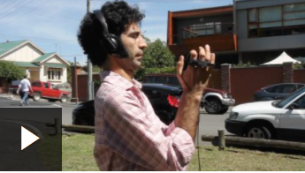  Recording great audio | 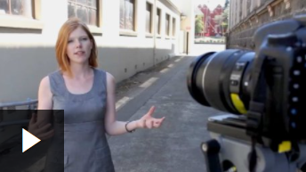  Shooting the story | 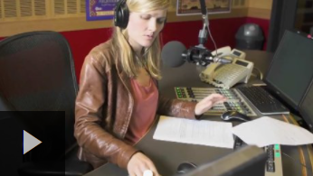  Conducting interviews

Activity: Kids on BTN
Many BTN stories this year featured young people, whether it was reporting on a news event affecting them or telling us about an issue or interest they were passionate about. Students can choose one of their favourite stories below or visit BTN’s website and respond to the following questions:
- What is the story about? Summarise it.
- Why did you choose this story?
- Describe the main issue/message in the story.
- What makes this story interesting?
- Why do you think BTN covered this story?
- What questions do you have about the story?

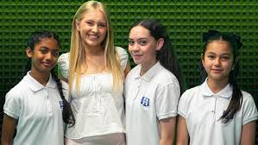  Podcast Kids | 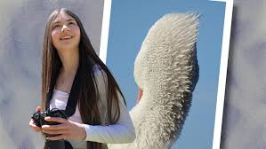  Photography Prize
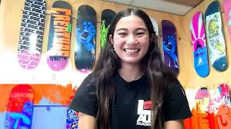  Arisa Trew | 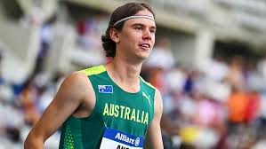  Young Paralympian
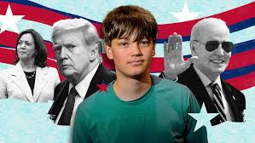  US Politics Interview | 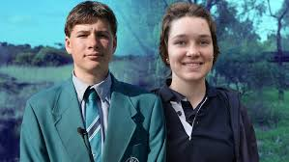  Young Conservationists
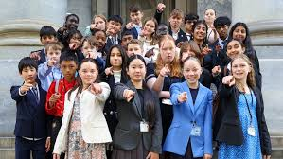  Junior Parliament | 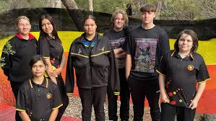  Reconciliation Week 2024

Activity: Women’s History Month
To celebrate Women’s History Month, BTN asked some Rookie Reporters to help tell the stories of some famous and influential Australian women. Discussion questions for each profile can be found in the Teacher’s Package for that episode of BTN.

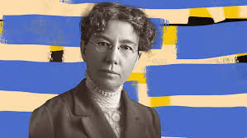  Mary Gilmore  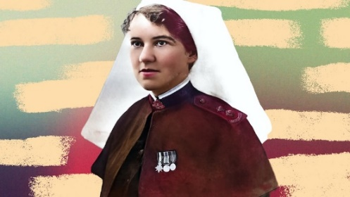  Elizabeth Kenny | 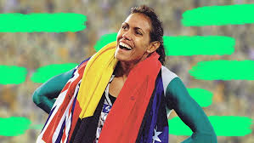  Cathy Freeman  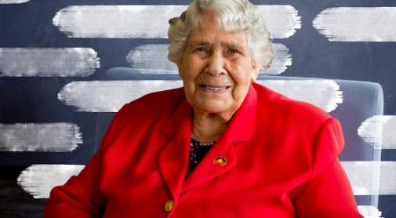  Dr Lowitja O’Donoghue

Activity: BTN Science Week Special
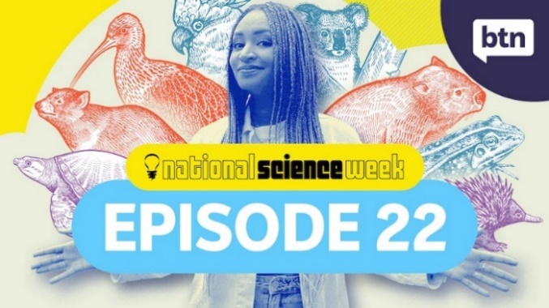
In this BTN Science Week special, we explore the 2024 theme `Species Survival’. Here are the topics covered in the special.
Evolution and Biodiversity
Mass Extinction
Zoos and Conservation
Young Conservationist
Naturalist Profiles Charles Darwin, Mary Anning, Jane Goodall and Sir David Attenborough.
Video | Teacher Resource

Activity: Media Literacy Special
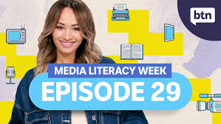
This BTN Media Literacy Week special takes a look at the following topics.
What is Media Literacy?
History of Media Literacy
AI and the News
Podcast Kids

Video | Teacher Resource

Activity: Create your own Super Quiz
After completing the BTN 2024 Super Quiz, students will create their own news quiz. Students can use the following as a guide.
- Make a list of news stories from 2024 that were important to you.
- Write a structure for your quiz. Include a quiz title, target audience, time frame in which quiz needs to be completed and news themes.
- Write and design your quiz. Consider including multiple choice, true or false and picture quiz. It is important that your questions are based on news stories from 2024. Make it fun, engaging and educational.
- Give your quiz to a classmate to complete. Provide your classmate with a score and correct answers.

Activity: Learning Areas
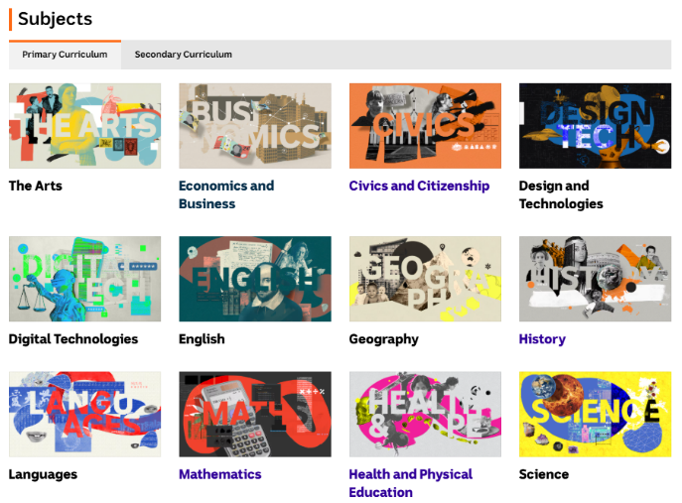
Visit BTN’s website to explore our Subjects page which sorts BTN stories into Learning Areas correlating to the Australian Curriculum.

These collections of BTN stories are useful for teachers planning a unit of work or for students to help them with a research inquiry.

After watching any one of the BTN videos ask students to respond to the discussion questions (to find the discussion questions and teacher resources go to the related BTN Classroom Episode
and download the Episode Package).

Activity: Get Your News Daily
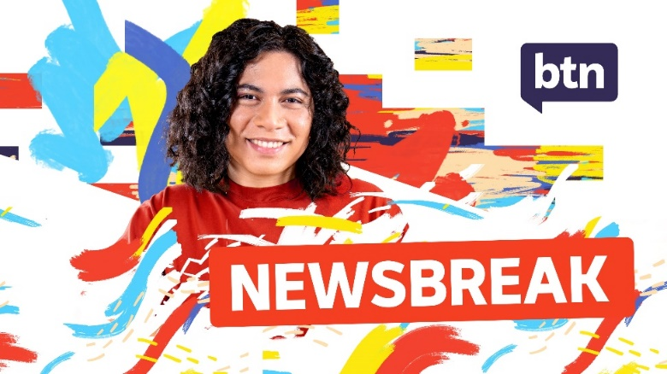
Watch BTN every day! BTN Newsbreak is a great way to kick off the morning routine. You can watch Newsbreak anytime on the BTN website or by subscribing to the BTN YouTube channel. Head to the BTN website for all the details.

Useful Websites
- BTN Classroom Stories – BTN
- Newsbreak Stories – BTN
- BTN Specials – BTN iView
- BTN Subjects – BTN

  - Teacher Resource

Super Quiz Questions

These quiz questions are to be used in conjunction with viewing BTN’s Year in Review 2024 program. Pause the video after each question to allow time for students to answer.

QUESTIONS | Your answers
- Keir Starmer is the new Prime Minister of which country?
A. Canada
B. UK
C. France

- What was future US Vice President JD Vance known for before entering politics?
A. Writing a book
B. Directing a movie
C. Composing a song

- Whose portrait was pasted over by these protesters?
- Queen Mary and her husband, Frederick, were crowned King and Queen of which country?
- Which of these adorable dogs won Best in Show at this year’s Westminster Dog Show?
A. Sage the Miniature Poodle
B. Mercedes the German Shepherd
C. Comet the Shitzu

- Australia’s Prime Minister became the first leader of the country to do what this year?
A. Climb to Mount Everest basecamp
B. Walk part of the Kokoda Track
C. Climb the Sydney Harbour Bridge

- WA senator Fatima Payman made an unusual speech in parliament that ended with what word or phrase?
A. Fatima Out
B. Like and subscribe
C. Skibidi

- What was Matthew Flinders famous for?
A. Circumnavigating Australia
B. Mapping the Murray River
C. Going to Antarctica

- What special material went into the medals awarded at this year’s Olympic Games in Paris?
A. Iron from a meteor
B. Metal from the Eiffel Tower
C. Metal from a spacecraft

- What did Aussie skateboarder Arisa Trew ask her parents for if she won a medal at the games?
- Who took out this year’s Women’s State of Origin?
A. New South Wales
B. Queensland

- James Earl Jones provided the voice to which of these animated characters?
- Moo Deng, the Pygmy Hippo became one of the world’s most famous animals this year. As well as becoming a viral internet star, Moo Deng scored what?
A. A role in the TV show
B. A line of clothing
C. An official theme song

TOTAL SCORE:
Answers

- UK
- Writing a book
- King Charles
- Denmark
- Sage the Miniature Poodle
- Walk part of the Kokoda Track
- Skibidi
- Circumnavigating Australia
- Metal from the Eiffel Tower
- A duck
- Queensland
- Mufasa from the Lion King
- Official theme song

  - Teacher Resource

BTN Transcript: Episode 35 - 3/12/2024

AMELIA: Oh, hey, there you are. We're just putting up the finishing touches because it's our last show of the year. And you know what that means.
NAT: Uh, Presents.
JACK: Holidays.
AMELIA: Uh, yeah, all of those things. But also, it's a BTN End Of Year Special. We're going to take a journey back through 2024 to remember all of the stories that made us laugh and cry and go, "Hmm," or, "Aww". And revisit the young people who did amazing things in 2024.
NAT: We'll also have our Superquiz to test your memory of the news in 2024.
JACK: And I'll show you some bloopers if you stick around.
AMELIA: Wait, I'm not in that, am I?
JACK: Well, we'll just have to wait and see.

World Wrap

Reporter: Wren Gillett

AMELIA: Well, in the meantime, here's Wren to take us on a journey around the world in 2024.

WREN GILLETT, REPORTER: Hey, Earth, good to see you. (SIGHS) 2024 - what a year! Leap year, in fact. So much has happened.
PERSON: Brat Summer was epic.
PERSON: Glasgow, like, Willy Wonka Experience.
PERSON: Brisbane won the AFL Grand Final, good year.
Yeah, all those things, plus a whole lot more. For starters, there was a lot of voting. Around 3.7 billion people cast their ballot in what's been called the biggest year ever for democracy. There was voting in some of the world's smallest democracies, as well as the world's biggest. But the election that attracted the most attention was...
PERSON: The US election.
PERSON: The US election
PERSON: The US election.
PERSON: The US election was definitely a major one.
The US election campaign had more twists and turns than a Hollywood movie. There were court room dramas, an assassination attempt…
DONALD TRUMP, US PRESIDENT I said to myself wow what was that?
…a last minute change of candidate…
KAMALA HARRIS, US PRESIDENTIAL CANDIDTATE 2024: And it is my great honour to have Joe's endorsement in this race.
And a comeback for the ages.
DONALD TRUMP: There has never been anything like this in this country and maybe beyond.
And while many people celebrated, some worried about the effect it could have on America, and the world.
PERSON: I'm pretty happy to be honest.
PERSON: I am devastated.
PERSON: I don't understand how he won?
PERSON: Big thing for Australia and America and a lot of other countries.
Right now, politics are particularly important because of the state of our planet.

ANTÓNIO GUTERRES, UN SECRETARY-GENERAL: There is no time to lose.
2024 is on track to be the hottest year on record. And according to scientists, that extra heat contributed to some big disasters, like Spain's historic floods, and the two major hurricanes in the US.
Weather reporter: Um, I apologise, this is just horrific.
Earth is facing other disasters too. There are more wars and conflicts happening now than there have been since World War II.
PERSON: Every one of us is suffering and has lost a couple of his family.
Ukraine's fight against Russia entered its second year.
PERSON: I'd really love our people to stay alive, and everything to be alright.
And as Israel marked a year since the October 7 terrorist attack by Hamas, the death toll in Gaza grew to more than 40,000.
PERSON: We ran away from bombardment and death, and we lost everything, our homes collapsed on us.
The fighting spread into Lebanon, until a ceasefire was called.
PENNY WONG, FOREIGN MINISTER: We hope that this is a catalyst for a broader ceasefire in the region.
But planet Earth, we had some good times too didn't we.
WREN GILLETT: Did you guys remember the Olympics happened this year?
STUDENT: Oh, my God, it did, too. How did none of us...?
PERSON: The Olympics? (LAUGHS) Yeah.
WREN: That happened.
PERSON: That happened. That's right. That was in France.
Despite a hiccup with a stinky river.
PERSON: How they were gonna like poop in the river? That was really funny to be honest.
The 2024 Olympics and Paralympics were pretty awesome. And Taylor Swift was so awesome she caused an Earthquake.
SEISMOLOGIST: It's evident on the seismic data for all three nights of the concert.
Although in 2024, it also got a little harder to tell when we were really looking at our fav celebs. Why? AI.
PERSON: Like I see things and I'm like is that real? And I have to and Google it.
AI raised some big questions for us this year.
PERSON: I think there are some people that do think AI is being creative, and then a lot who don't.
But science also helped us discover more about the real world. And, well, other worlds.
PERSON: This is the first time that we have evidence for liquid on mars.
Although we also learnt that rocket science is actually pretty difficult. And that life for astronauts doesn't always go as planned.
SUNITA WILLIAMS, BOEING STARLINER CREW: This is a test flight we were expecting to find some things.
And tech didn't always work on Earth either. Oh, not again.
PERSON: My grandma was, like, blowing up my mum's phone, being like, "The blue screen of death happened." And I was just like, "What do you mean?"
PERSON: So much has happened, it's been terrifying.
PERSON: It's been really quick honestly, like, I feel like, I can't believe it's already over.
Can't wait to see what our next journey round the sun brings. Weeeeeeee.
Super Quiz

Keir Starmer is the new Prime Minister of which country? Canada, the UK or France? It’s the UK.

KEIR STARMER, UK PRIME MINISTER: Change Begins Now.

What was future US Vice President JD Vance known for before entering politics? Writing a book, directing a movie or composing a song? He wrote a best-selling book which was later turned into a film called Hillbilly Elegy about his life growing up in a poor rural community.

Whose portrait was pasted over by these protesters? It was King Charles. Animal rights activists attacked his newly released portrait with a sticky picture of Wallace, although no permanent damage was done.

Meanwhile, the world got its first Australian Queen. Queen Mary and her Husband, Frederick, were crowned King and Queen of which country? It’s Denmark.

And which of these adorable dogs won Best in Show at this year’s Westminster Dog Show? Sage the Miniature Poodle, Mercedes the German Shepherd or Comet the Shitzu? It was Sage. Who’s a good girl?

OWNER: No words. I'm so happy. Exciting.

Aussie News

Reporter: Saskia Mortarotti

JACK: Do you know who's cuter than Sage the poodle?
AMELIA: Who?
JACK: Winnie.
AMELIA: Oh, Winnie! Hello, Winnie. Oh, you are cute.
NAT: Now we're going to take a look at some of the biggest news stories that happened here in Australia.
JACK: Yeah, like me getting Winnie. That was pretty big news.
Nat: Sure.
AMELIA: Oh, well, guys, I'm also having a baby!
NAT: Yeah, well, those are pretty big stories, too. But I think there were a few other things floating around, right? Sas, can you help fill us in? Sas?

CALE, BTN REPORTER: No way. I do the best ray gun.

SASKIA, BTN REPORTER: Oh! Oh! Sorry, guys. We're just having a barbecue and a chat about what happened in Australia this year.

MICHELLE, BTN REPORTER: How about those mysterious balls that shut down Coogee Beach?
CALE: Turns out they were made of poo and cooking oil.
MICHELLE: How can you still be hungry after talking about balls of poo?
CALE: We've got to eat. Food's expensive.
JOSH, BTN REPORTER: 'Cozzie livs', mate.
SAS: Yeah. This year, everyone was talking about the price of everything from food to petrol and housing.

JO MASTERS, BARRENJOEY CHIEF ECONOMIST: We know that Australians are hurting at the moment...

SAS: And while there were lots of reasons behind our rising 'cozzie livs' or cost of living, there was also a fair bit of anger directed at...

JOSH: 'Colesworth', mate.
CALE: Coleslaw?
JOSH: No, no, no, not coleslaw. 'Colesworth', Coles and Woolworths.

NAOMI SHARP SC, BARRISTER: There is very much a situation where there are two dominant retailers.
But supermarkets weren't the only Aussie businesses in hot water this year.

ALEX, BTN EDITOR: Bonza!
SAM, MOTION GRAPHICS DESIGNER: No, that was bad news.
ALEX: No. The airline!

SAS: Yep. Australia's newest airline, Bonza, went bust. And regional airline Rex went into voluntary administration.

CUSTOMER: If I can't use Rex, it would make our life really hard, actually.

SAS: Rex pulled through with help from the government. But Australia's aviation industry is still facing some turbulence.

PETER DUTTON, OPPOSITION LEADER: Less competition means higher prices.

SAS: Speaking of turbulence, there was plenty of that in this place.

FATIMA PAYMAN, SENATOR: Here's the advice, Senator Hanson.
LIDIA THORPE, SENATOR: You are not my King!
MAX CHANDLER-MATHER, MP FOR GRIFFITH: How is it that Senator Payman was having, had the courage to cross the floor?

SAS: Our politicians debated some big issues, like where our power should come from.

PETER DUTTON: If you don't have nuclear in the mix, you're not going to achieve your net zero by 2050.

SAS: The opposition announced its plan to build seven nuclear power stations if it wins the election next year. But the government says...

CHRIS BOWEN, MINISTER FOR CLIMATE CHANGE AND ENERGY: Tell him he's dreamin'.
MATT KEAN, CHAIR OF THE CLIMATE CHANGE AUTHORITY: It would take far too long and would be far too expensive.

SAS: But both the government and opposition agreed on this.

ANTHONY ALBANESE, PRIME MINISTER: Social media is doing social harm to our young Australians.

SAS: Australia became the first country in the world to ban social media for kids under 16. While some people say that's a good thing...

STUDENT: If you spend hours and hours and hours on it a day, you're missing out on real life.
SAS: ..others disagree.
PERSON: Yeah, I don't think it's going to work at all.
PERSON: It's sad for younger people as well.
SAS: Speaking of social media...
CALE: This one is actually grouse.
SAS: ..lots of people used it this year to share their snaps of the Aurora australis.
CALE: That one. Look at that.
SASKIA: But some beautiful sites in Australia faced hard times.
RICHARD LECK, WWF'S HEAD OF OCEANS: We've had a mass coral bleaching event declared on the Great Barrier Reef.
SAS: And we had a fight on our hands against some unwelcome pests.
JACK GOUGH, INVASIVE SPECIES ADVOCACY DIRECTOR: We have one shot left to stop fire ants.
KEEGAN BLIGNAUT, DUXTON BEES: Learning how varroa mites will spread and impact beekeepers is a huge unknown.
SASKIA: Ugh mozzie.
MICHELLE: How about the weather this year?
CALE: Yeah, it was great.
MICHELLE: No, it wasn't.
SAS: Yep as usual, the weather kept us on our toes.
KID: I'd never seen wind that strong in my life.
KID: I woke up really early to, like, a crush on my window.

SAS: We dealt with our share of disasters.
CALLUM SPURGE, WESTERN HONEY SUPPLIES: We've lost our crop for the next 5 to 10 years.
JOSH MURRAY, JOSH'S RAINBOW EGGS: There's a lot of really good people out there who have lost their livelihoods.
SAS: And we went through some hard times.
ANTHONY ALBANESE, PRIME MINISTER OF AUSTRALIA: We keep this vigil for the six souls we have lost.
PERSON: Some people may be sad because of what happened, and they might get all the memories of what happened to these people.
But there was also plenty to celebrate.
ARISA TREW, OLYMPIC SKATEBOARDER: I wasn't expecting them to all be here.
Whether it was sporting glory, Or pride in who we are. We welcomed back stolen treasures.
NOELEEN TIMBERY, LA PEROUSE LOCAL ABORIGINAL COUNCIL: After 254 years it was time for the spears to come home.
And handed land back to its original owners.
LESLEY TURNER, CEO CENTRAL LAND COUNCIL: Congratulations to all the native title holders.
We said g'day to some special visitors, and we said goodbye special friends.
PERSON: Just love seeing the pandas, come to say goodbye.
SASKIA: Well guys that's Australia for you, we'll save you a snag.

Super Quiz

Australia’s Prime Minister became the first leader of the country to do what this year? Climb to Mount Everest basecamp, walk part of the Kokoda Track or climb the Sydney Harbour Bridge? He marked ANZAC Day by walking part of the Kokoda track alongside PNG Prime Minister James Marape.

PNG SINGERS: Your presence here today...

FATIMA PAYMAN, SENATOR: ...this time will be between a mid government...

WA senator Fatima Payman made an unusual speech in parliament that ended with what word or phrase? Fatima Out, like and subscribe or Skibidi?

...Australia for a government with more aura. Skibidi.

Yep, that’s the one. In fact, the whole speech was delivered in internet slang, or brain rot in an effort to appeal to younger voters.

To the sigmas of Australia, I say that this goofy ahh government have been capping...

The remains of Matthew Flinders were reburied in the UK after his grave was lost and then rediscovered. Do you know what Flinders was famous for? Circumnavigating Australia, mapping the Murray River or going to Antarctica? Flinders was the first person to circumnavigate Australia, which means sailing all the way around, along with Kuringgai man Bungaree and a cat named Trim.

Rookie Reporters

Reporter: Jack Evans

AMELIA: Naww, Thanks guys. Of course, BTN would be nothing without you guys and in 2024 we've met some amazing kids doing some amazing things.
JACK: Let's take a look.
JACK EVANS, REPORTER: For starters you guys showed us just how creative you can be, from award winning photography to amazing silk paintings.
STUDENT: My silk painting that I created is about my Nan's connection with her community and how she tells her story.
And out of this world costumes.
MOLLY: Right now, I'm in the middle of making a costume for my new character Sylvester.
Oh, these guys even created their own card game.
SAM: Back in July of 2022, the teacher gave us some cards to play with. We started creating own rules for the game.
Speaking of games, we caught up with some young Olympians.
WREN: What was going to the Olympics actually like?
ARISA: Going to the Olympics was pretty cool, and, like, pretty fun, and we got to go to the village, like, every day.
ANGUS: My name is Angus Hincksman. I'm a T38 Para athlete running in the 1500 metres at the Paris Paralympic Games.
And some rising sport stars.
KUSHI: What's been the highlight of your career so far?
EMERSON: Probably yeah, Wimbledon Juniors, that was pretty big.
LANA: I wanna be the first female to win a championship.
MALACHI: My ancestors have been throwing spears for thousands of years. It comes naturally to me.
We also met some aspiring farmers.
SCARLETT: My whole life ever since I was like little, I've loved goats. They've been my favourite animal.
EMILY: There's something about cows that intrigues me. I like how they're quiet and shy. A bit like me.
As well as some aspiring journalists.
BUDDHIMA: Welcome to the PNTV studio, come on in
SAS: Thank you.
And even some aspiring bird callers.
KID: [Squarks]
PERSON: Wow!

When we needed help understanding the world around us, you answered the call.
QUINN: I'm a 15 year old political enthusiast from New Hampshire. It's one of the 50 states in the United States.
JUSTINA: Can you explain how politics work in the US?
QUINN: Big question. All right.
HADIA: I think Refugee Week is important because people who leaves their country, they get sad, and we try to acknowledge them.
ALI: We can remember our past lives and what we've gone through, and everyone can know.
We also heard from kids who have been in tough situations.
ABOUL: How am I to enjoy this freedom, when I am surrounded by violence and poverty.
ANTONINA: If only we could turn back time, to life before this terrifying war.
MAX: I hope the war will end as soon as possible.
ANDRII: My life has changed a lot. Because we flew to this country.
And some of you showed us what you've been doing to make the world a better place.
DJANGO: My project is to create and restore habitat for Fleurieu birds.
JOSEPH: I made Joseph's Recycling so we can turn something negative into something positive.
LEILA: The headstone project is a group of volunteers who dedicate their time to giving headstones to unrecognised nurses and soldiers that fought in the war.
Oh and some of you just showed us what it's like to be, well, you.
LEXIE: When I run, the world goes quiet. That's why I run.
DANNIELLA: When I was 12, my parents brought me and my four brothers back to Baryulgil to teach us about our culture.
ROSE: When we performed on a stage in front of the school, I finally felt like me.
Thanks everyone, we couldn't have done 2024 without you.

Super Quiz
What special material went into the medals awarded at this year’s Olympic Games in Paris? Was it iron from a meteor, metal from the Eiffel Tower or metal from a spacecraft? It was scrap metal that’d been taken from the Eiffel Tower during past renovations.

What did Aussie skateboarder Arisa Trew ask her parents for if she won a medal at the games?

ARISA TREW: The gift I asked from my parents if I, like, won was if I could get a pet duck because ducks are really cute and I really wanted a pet duck.

Yep, it was a duck.

Who took out this year’s Women’s State of Origin? Was it New South Wales or Queensland? It was the Maroons. New South Wales won the men’s series.

The world said goodbye to American actor James Earl Jones who died this year at the age of 93. He played roles on stage and screen but was probably best known as the voice of Darth Vader. He also provided the voice to which of these animated characters? James Earl Jones was the voice of Mufasa from the Lion King.

MUFASA, VOICED BY JAMES EARL JONES: We are all connected in the great circle of life.

And Moo Deng, the Pygmy Hippo became one of the world’s most famous animals this year. As well as becoming a viral internet star, Moo Deng scored what? A role in the TV show, a line of clothing or an official theme song? It’s a song. The um, catchy tune was released by Thailand Zoo which has been cashing in on the very cute little critter.

Bloopers

Reporter: Jack Evans

NAT: Aw! What about Winnie? Does Winnie need a theme song?
JACK: She already has one, it goes like this, Who is this puppy? So cute and fluffy?...
AMELIA: Alright, well, that's about all we have time for…
JACK: Oh what about the bloopers?
AMELIA: Oh, the bloopers.
JACK: Roll the tapes. Or as Winnie would say, "Ro-ro, ro-ro, ro-ro, ro-ro, ro." Yeah. There we go.
AMELIA: She's a good girl.

JUSTINA: And action.
JACK EVANS, REPORTER: Hmm, do you know what no one talks about enough?
KUSHI: Fully grown arthropo... fully grown arthropo...
Ah no, I was going to say no one talks about how hard it is being a BTN Reporter.
CALE: Oi.
MICHELLE: Great, that was chaos.
JUSTINA: Whaaaaaaaa
JOSH: Influenced by media. Sorry, sorry, sorry.
For starters we have to learn a lot of lines.
JOSH: Accounted for, sorry. 2023. 76% of... ughhhhh
JUSTINA: Ooh it's never been a great. Oh sorry, shh.
JUSTINA: Welcome to Jolly. I was going to say welcome to crown of thorns.
JACK: Where are those roads, and what is a road? That's not the line, but it's something like that.
WREN: Yep.
KUSHI: The African daisy, a native flowering plant. I'm so sorry.
JUSTINA: Go to your Tiffany trailer, oh wait
JACK: Sorry. That was not a... Sorry. Let's do that again.
It isn't enough to just say the line either, sometimes we have to really get into character.
LINCOLN: Can you give me a big over the top smile.
JOSH: How does the sound, sound? If I'm speaking at that level.
NAT: What does your week look like?
CALE: Is that how I sounded?
JACK: How did you even get here? Get here, what is this now? Well, Potter?
JUSTINA: Monsieur, monsieur.
WREN & JACK: Oh huh huh...
JACK: I'm going to do one more, I don't feel like my eyes were in it.
NAT: End scene.
And even if we do get it right, something always seems to go wrong.
WREN: My favourite kind of mistake.
AMELIA: I'm losing track of time.
JACK: Hang on everyone, I've got to go and…. Scary, that was scary.
SOPH: You're totally entangled. You're a part of the set now.
TATENDA: Guys?
AMELIA: Oh, is she going to go? Not go? Yeah. OK.
JACK: Lucky I've got ink here, and all of these pens.
JOE: Sorry I don't know when I'm reacting.
But who am I kidding, the truth is we wouldn't change this job for anything.
WREN: Yeah.
JUSTINA: Who said that?
THOMAS: I looked at the camera.
WREN: Take over France and, well, our living room.
JOE: Sorry, I-I...
MICHELLE: Josh, do you know how to do the Nutbush? This Australian phenomenon...
JOSH: So, thanks for joining us and we'll see you next year.
JOE, JUSTINA, WREN: [Wailing]
JUSTINA: CUT.
Closer
NAT: Well, that's it.
JACK: 2024 is over.
AMELIA: I'm a little bit sad.
JACK: Don't worry, we'll be back next year.
NAT: And we'll keep bringing you stories from Australia and around the world.
AMELIA: Have the best holidays! We'll miss you. Bye.
NAT: See ya.
JACK: Say bye, Winnie! Bye! Say bye.
AMELIA: Oh, this is for you, by the way Nat.
NAT: Oh, thanks. This is for you.

MICHELLE: Happy holidays.
JUSTINA: See you next year.
CALE: Have the best holidays of your life.
TATENDA: And have an awesome new year.
TASH: Bye!
DANIEL: See you next year.
CHARLOTTE: Happy holidays.
SAS: Happy holidays. See you next year.
SARAH: Happy holidays.
WREN: Can't wait to do it all again.
JOSH: Happy holidays, everybody. Hope you have a fantastic break.
JOE: Yeah. Happy holidays.

