EPISODE 20
26th July 2022

KEY LEARNING
Students will view a range of BTN stories and use comprehension skills to respond to a series of focus questions.

CURRICULUM
English – Year 4
Use comprehension strategies to build literal and inferred meaning to expand content knowledge, integrating and linking ideas and analysing and evaluating texts.

English – Year 5
Use comprehension strategies to analyse information, integrating and linking ideas from a variety of print and digital sources.

English – Year 6
Use comprehension strategies to interpret and analyse information and ideas, comparing content from a variety of textual sources including media and digital texts.

English – Year 7
Use comprehension strategies to interpret, analyse and synthesise ideas and information, critiquing ideas and issues from a variety of textual sources.
  - Teacher Resource

Focus Questions
As a class, discuss the stories featured in the episode of BTN Classroom and record the main points of the discussion. Students will then respond to the following focus questions.

State of the Environment Report
- In pairs, discuss the main points of the BTN story.
- How often is a the State of the Environment Report released in Australia?
- How would you describe Australia’s most recent report?
- How many Australian species are now listed as either extinct or extinct in the wild?
  - 10
  - 100
  - 1000
- What questions do you have after having watched the BTN story?

Europe Heatwave
- What temperature did it reach in the United Kingdom during the heatwave?
- How is the heatwave in the United Kingdom affecting people?
- What other countries in the have been affected by extreme temperatures and wildfires?
- What is causing heatwaves to become more common and extreme?
- How did this story make you feel?

Petrol Car Ban
- Which State or Territory announced they would ban the sale of all new petrol cars by 2035?
- Petrol is a fossil fuel. True or false?
- What is an EV?
- How far can an electric car travel before it needs recharging?
  - 5 km
  - 50 km
  - 500 km
- Electric cars are more expensive than their petrol powered equivalents. True or false?

Check out the teacher resource on the Teachers page.

Opera House Renovations
- How did they choose the architect for the Sydney Opera House?
- What year was the Sydney Opera House officially opened?
- How much did it cost to build the Opera House?
- Why did the Opera House recently undergo major renovations?
  - To improve the acoustics
  - To replace all the roof tiles
  - To repaint the interior
- How would you describe the Sydney Opera house?

Check out the teacher resource on the Teachers page.

Blackball Champions
- What is another name for blackball?
- What coloured ball is potted last to win blackball?
  - Red
  - Yellow
  - Black
- How old was Charlotte when she first started playing blackball?
- Where are the World Blackball Championships being held this year?
- What message of support would you give the kids in the BTN story?

EPISODE 20
26th July 2022

KEY LEARNING
Students will investigate the pros and cons of electric vehicles and other energy sources used to power cars.

CURRICULUM
Science – Years 5 & 6
Scientific knowledge is used to solve problems and inform personal and community decisions.

Science – Year 7
Solutions to contemporary issues that are found using science and technology, may impact on other areas of society and may involve ethical considerations.

Design and Technologies – Years 3 & 4
Recognise the role of people in design and technologies occupations and explore factors, including sustainability that impact on the design of products, services and environments to meet community needs.

Design and Technologies – Years 5 & 6
Examine how people in design and technologies occupations address competing considerations, including sustainability in the design of products, services, and environments for current and future use.

  - Teacher Resource

Petrol Car Ban

Focus Questions
Discuss the BTN story as a class and record the main points of the discussion. Students will then respond to the following:
- Which State or Territory announced they would ban the sale of all new petrol cars by 2035?
- Petrol is a fossil fuel. True or false?
- What is an EV?
- How far can an electric car travel before it needs recharging?
  - 5 km
  - 50 km
  - 500 km
- Electric cars are more expensive than their petrol powered equivalents. True or false?

Activity: Note taking
Students will practise their note-taking skills while watching the BTN Petrol Car Ban story. After watching the story, ask students to reflect on and organise the information into three categories. What information in the story was...?
- Positive
- Negative or
- Interesting

Activity: Class Discussion
Discuss the BTN Petrol Car Ban story as a class and record the main points on a mind map with ELECTRIC CARS in the centre. Students will then respond to the following and share their ideas as a class.
- What did you learn from this story?
- What does this story make you wonder?
- Think of three questions you would like to ask about the story.
- Do you agree with the ACT’s proposed ban on electric vehicles by 2035? Why or why not?
- What do you think could be done to encourage electric vehicle use in Australia?

Activity: Glossary
Students will brainstorm a list of key words that relate to the BTN Petrol Car Ban story. Here are some words to get them started.
ELECTRIC VEHICLE | EMISSIONS | BATTERY
HYBRID VEHICLE | INTERNAL COMBUSTION ENGINE | AIR POLLUTION

Activity: Electric Car Research
Discuss the information raised in the BTN Petrol Car Ban story. What questions were raised in the discussion and what are the gaps in students’ knowledge? The following KWLH organiser provides students with a framework to explore their knowledge on this topic.

What do I know? | What do I want to know? | What have I learnt? | How will I find out?

Students will develop their own question/s to research or choose one or more of the questions below. Encourage students to collect and record information from a wide variety of sources and present the information they find in an interesting way.

- How are electric cars different to cars fuelled by petrol, diesel or gas?
- How far can an electric car go on a single charge and how long do they take to recharge?
- How will the batteries in electric cars be recycled?
- Why are alternatives to petrol or diesel cars being explored?
- What emissions do petrol/diesel cars produce and why are they a problem?
- Are electric vehicles affordable? How do they compare to petrol cars?
- What are the pros and cons of electric cars?
- What is the availability of electric vehicles in Australia?
- Investigate the use of electric vehicles in other countries. Which countries have a high number of EV’s on the road?
- What do you think the future of electric cars is? Explain your answer.

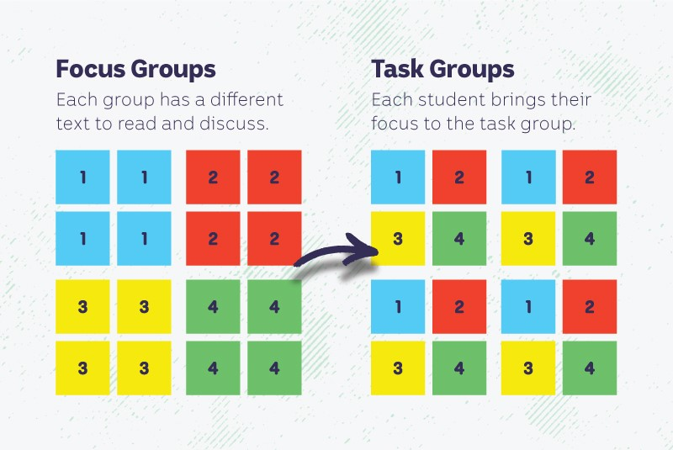
Activity: Jigsaw learning activity
In this activity students will work cooperatively to learn more about alternative energy sources used to power cars. Each group will become experts and then share what they have learnt with other students.

Form groups | Divide the class into 4 x Focus Groups. Each Focus Group will be assigned a different type of energy source to power cars (electric, hydrogen, biofuel, hybrid) to investigate and become experts. Each group will need to decide how they will collect and communicate the information they find during their research.
Research | Each Focus Group will respond to the following questions to become experts:  - How does the car work? (include a diagram)  - What is the environmental impact of the energy source?  - What are the advantages and disadvantages of the energy source?  - What are the challenges of using the energy source to power cars?
Share | Mix the Focus Groups to form Task Groups (Tasks Groups include one student from each of the Focus Groups) to share the information they have collected. Students will share the information they have collected and learn from one another.
Reflect | Students will reflect on the activity by responding to one or more of the following questions:  - What did you enjoy about this investigation?  - What did you find surprising?

Activity: Persuasive Text
Students will explore the use of new technologies and/or alternative fuels for our cars and then develop a persuasive text for or against the following statement: `Petrol powered cars should be banned in all states and territories in Australia’. Students need to weigh up the pros and cons of the issue then write a short persuasive argument stating why petrol-powered cars should or should not be banned in Australia.

Some issues to consider are:
- What is the environmental impact of petrol powered cars?
- What are some of the pros and cons of adopting new technologies to replace petrol-powered cars?

Tips
- Who is your audience? For example, are you directing your argument at kids, teachers, or politicians?
- Explore how language choices can have a big impact on persuading your audience.
- Which language devices give the report credibility and authority?
- Which are designed to create an emotional response in the listener?
- Provide facts and evidence to support your argument.
- Write in the present tense.
- Check your spelling and punctuation.

Use this Read Write Think persuasion map to plan your exposition text.

Introduction
- What is the point you are trying to argue? Construct an introductory paragraph which states the issue or topic.
- Introduce the arguments that will be developed in the body of the text.

Body
- Construct arguments that support your point of view.
- Each paragraph starts with a topic sentence which introduces each point.
- The rest of the paragraph gives more reasons.
- Arguments can be ordered from strongest to weakest.

Conclusion
- Restate your position on the argument.
- Construct a concluding paragraph that provides a summary of your arguments and a call to action.

Reflection
- How difficult was it to think of points to support one side of the argument?
- Do you think you would have done a better job supporting the other side of the argument?
- Was I able to convince others of my opinion?
- Did my opinion change?
- What did you learn from this activity?

Activity: Choose a project
Students choose one of the following projects to work on and then present their work to a partner, small group or the class.

Car of the Future
What sort of car do you think you’ll be driving in 50 years’ time? Design an environmentally friendly car of the future.
Electric Car Class
Check out BTN’s story about a class of car lovers and why they think electric car technology is so important. Retell the main points of the story to a group of students.
True or false?
Create a true or false quiz about electric vehicles or alternative energy sources used to power cars and test your classmates. Alternatively, create a word find or crossword.

Design a Poster
Design a poster or infographic which illustrates one or more of the benefits of electric vehicles. Think about the key message you want to get across.

Useful Websites
- Concerns electric vehicles still won’t be affordable for many by 2035 when ACT bans sale of new petrol cars – ABC News
- Electric car sales are rising in Australia, but the uptake is behind other markets. When will they be more affordable? – ABC News
- Electric Cars – BTN
- Hybrid Cars – BTN
- Solar Cars - BTN

EPISODE 20
26th July 2022

KEY LEARNING
Students will explore the history of the Sydney Opera House. Students will investigate the building, its functions, and its importance to people.

CURRICULUM
HASS – Year 4
Pose questions to investigate people, events, places and issues.

HASS – Year 5 & 6
Develop appropriate questions to guide an inquiry about people, events, developments, places, systems and challenges.

Locate and collect relevant information and data from primary sources and secondary sources.

HASS – Year 7
Construct significant questions and propositions to guide investigations about people, events, developments, places, systems and challenges.

Apply a methodology to locate and collect relevant information and data from a range of primary sources and secondary sources.
  - Teacher Resource

Opera House Renovation

Focus Questions
Discuss the BTN story as a class and record the main points of the discussion. Students will then respond to the following:
- How did they choose the architect for the Sydney Opera House?
- What year was the Sydney Opera House officially opened?
- How much did it cost to build the Opera House?
- Why did the Opera House recently undergo major renovations?
  - To improve the acoustics
  - To replace all the roof tiles
  - To repaint the interior
- How would you describe the Sydney Opera house?

Activity: Class Discussion
Discuss the BTN Opera House Renovation story in small groups or as a class. Ask students to record what they know about the Sydney Opera House. What questions do they have? Use the following questions to help guide discussion:
- Where is the Sydney Opera House? Find on a map.
- Why was the Sydney Opera House built?
- What sort of events take place in the Sydney Opera House?
- Why is the Sydney Opera House being renovated?
- Why is it important to conserve the Sydney Opera House?
- What words do you associate with the Sydney Opera House? Make a list.

What questions do you have about the story?
What did you learn from the story?

Activity: KWLH research
The KWLH organiser provides students with a framework to explore their knowledge on the topic of the Sydney Opera House and consider what they would like to know and learn.

What do I know? | What do I want to know? | What have I learnt? | How will I find out?

Questions to research
Students will collect and record information from a wide variety of sources. Students may develop their own question for inquiry or select one of the questions below.

- When and why was the Sydney Opera House built?
- Who designed the Sydney Opera House? Learn more about the competition to design a National Opera House for Sydney. What was the inspiration behind the winner’s design?
- What events take place at the Sydney Opera House?
- What materials were used to build the Sydney Opera House? Find some fun and interesting facts about the Sydney Opera House and how it was built. Include one or more of the following words in your summary: engineering, design, construction, innovation, architecture.
- What is the history of the Sydney Opera House? Create a timeline to show significant events that have taken place in and around the Sydney Opera House.
- What is an historical site and a heritage site? Find a definition. Make a list of heritage sites you know about around the world.
- Who are the traditional custodians of the land on which the Sydney Opera House was built? Explore this interactive to learn more about the significance of the area for First Nations people. What did you learn from this interactive? Who is Woollarawarre Bennelong? Research his story.

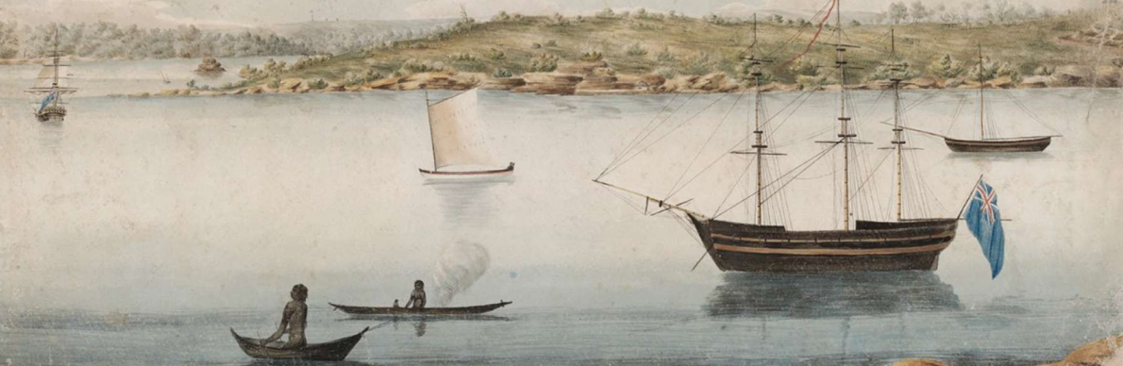

Sydney Opera House website - Tubowgule

Activity: Heritage Investigation
Students will choose one heritage building in their local area to investigate and become experts. Students will collect and record information from a wide variety of primary and secondary sources and present the information they find in an interesting way. Below are some examples of heritage buildings around Australia.

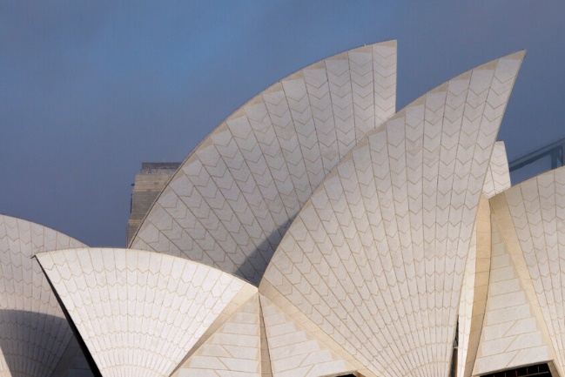  Sydney Opera House - UNESCO | 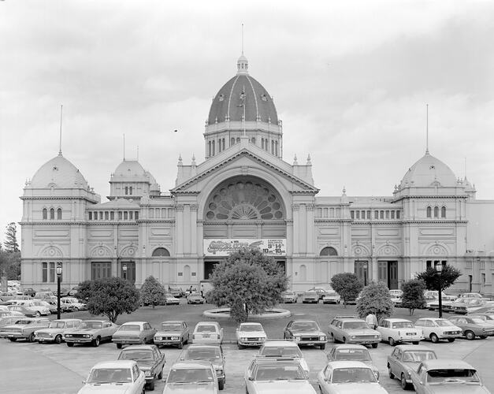  Royal Exhibition Building  Museum Victoria
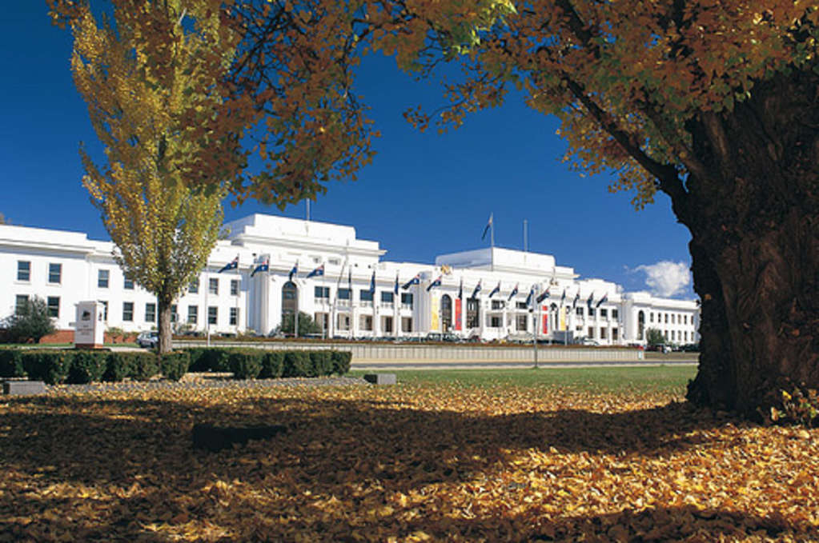  Old Parliament House Canberra - MOAD | 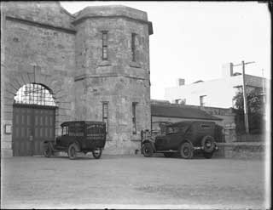  Fremantle Prison – State Library WA

Students will respond to the following questions:
- Where is it? Locate on a map.
- When was it built or created? How old is it?
- Who designed and built it?
- What does it look like? Draw a picture. Write a brief description.
- Why was it built or created? What is its function and who used it? Why is it important?
- What are some interesting facts about the heritage site? Include a brief history on the site.
- What does the site tell us about previous societies?

Provide students with the opportunity to visit the heritage site they have researched. Students will take photos, sketch drawings and record their observations. Challenge your students to make a 3D model of the structure using recycled materials.

Activity: Maths with Eddie Woo
Investigate the maths of the Sydney Opera House with superstar maths teacher Eddie Woo. Visit the Sydney Opera House website, choose any one of the videos to watch as a class and download the teacher worksheets.

Sydney Opera House: Teacher Resources
Join award-winning maths teacher, author and Wootube star Eddie Woo on a marvellous adventure around the Opera House uncovering the mathematical concepts behind the construction and design solutions of building the Sydney Opera House.

Learn about geometry, infinite numbers, and the importance of creativity in STEM. Each episode features special guests who have consulted on the design of the Opera House and includes a worksheet to support continued learning.

Recommended for ages 11+

Topics
- Nature Inspiring Design
- Calculating an Impossible Number
- The Purity of Geometry
- Acoustics – Mathematics to Make your Ears Ring
Presentation & Reflection
- Share and compare your findings with your classmates.
- Present your research in an interesting way.
- What did you enjoy about this activity? What was challenging?

Activity – Choose a project
Individually or in small groups, students will choose one of the following projects to work on and then present their findings to the class.

Make the Opera House
Design and create an artistic representation of the Opera House. How will you build it? Consider using Minecraft or use recycled objects to build a 3D model. You could make a collage or use papier Mache.
The Sails
Check out “Badu Gili: Wonder Women”. Design your own projection to go on the sails of the Opera House. What is your design? Why did you choose it? Why is it important?

Useful Websites
- Opera House Advertising – BTN
- Sydney Opera House completes major renovations – ABC News
- Sydney Opera House
- House History – Sydney Opera House
- Sydney Opera House – UNESCO

  - Teacher Resource

BTN Transcript: Episode 20 - 26/7/2022

Yaama I'm Jack and you're watching BTN. Here's what's coming up. We find out about Europe's record-breaking heatwave, take a peek at the newly renovated Sydney Opera House and meet some young cue ball champions.

State of the Environment Report

Reporter: Joe Baronio

INTRO: But first today to some bad news for Australia's environment. Last week the government released a big report looking at the health of all sorts of areas form air and water quality to biodiversity and the results weren't good. Here's Joe with more.

Teacher: Good afternoon. Thank you for coming to this meeting.
Student: Yeah, no worries, what’s the problem?
Teacher: We need to have a chat about your report. It's well, to put it lightly, it's not very good. It’s quite bad. Terrible even.
There's no hiding from a bad report and the new State of the Environment report is a doozy. It comes out once every five years and involves experts monitoring and surveying every aspect of the environment. But in the five years since the last report in 2016, a lot of things have gone downhill. Badly.
Environment Minister, Tanya Plibersek: Well, this report is indeed very disturbing reading, it says that our environment is in a poor state and it's getting worse.
Teacher: Let's take a look at some of your subjects. Umm, climate. You're in the top 20.
Student: Top 20? I mean that's good.
Teacher: Highest C02 emitters on Earth.
Student: Oh.
Teacher: And it says there's been a lot of extreme weather events?
Yeah, we've had more than our fair share of devasting floods, droughts, and bushfires. And while natural disasters have always been a part of life in Australia, experts say they're getting more serious and frequent because of climate change. Disasters like these have killed or displaced between 1 and three billion animals, and while we're talking about animals, more than 100 Australian species are now listed as either extinct or extinct in the wild. We've lost more mammal species than any other continent and the rate of disappearing species is higher than anywhere in the developed world.
In Australia, you're now more likely to come across a foreign or invasive plant species than a native one, even though billions of dollars has been spent over the past 50 years to try and manage them. And more than 6.1 million hectares of primary, natural forest has now been cleared, which is about six times the size of suburban Melbourne.
Teacher: And then we get to water.
Student: Oh, well, I'm sure I did alright in that subject.
Teacher: No.
While we've seen record rainfall and floods this year, the complete opposite, droughts, has also been a problem. The Murray-Darling Basin has recorded some of its lowest water levels ever, and a big decline in native fish populations too. Meanwhile the ocean in areas like the Great Barrier Reef has been getting warmer which has caused several mass coral bleaching events and deteriorated reefs around the country. All in all, at least 19 different ecosystems are on the verge of collapse and even all that is just scraping the surface.
Student: Oh no, this is the worst report ever. My parents are going to kill me.
Teacher: Look. We can help you turn this around. But it's going to take a lot of homework.
Experts say this could get better if state and federal governments act now and work together to boost funding for biodiversity conservation and improve environment laws.
Environment Minister, Tanya Plibersek: The task of restoring our environment actually is too big for government alone.
So, they say it's important for industries and communities to work together too, and that we should listen to Indigenous perspectives because, well they've been looking after the environment for thousands of years. So, hopefully by the next report in another 5-years' time, we'll bring our environmental grades up.
Teacher: Alright then. Any questions?
Student: Um, no, I don't think so.
Teacher: Ah, I've got one for you though. Why'd your parents name you 'Environment'?

Student: I don’t know?

News Quiz

Travellers returning from Indonesia are being told to wash or even throw out their shoes because of an outbreak of a disease that affects livestock. Do you know what it’s called? Hand and foot disease, foot and mouth disease or hand and mouth disease? It’s called foot and mouth disease and while it’s not dangerous for humans, it can spread easily on our clothes or our shoes. If it got into Australia, it could be disastrous to farmers, so authorities are trying to keep it out.

MURRAY WATT, AGRICULTURE MINISTER: But I cannot emphasise enough how important it is for people to take responsibility themselves, clean their shoes and as I say if they really don’t need them to come back, then leave them behind.

Which planet is this? It’s Jupiter and that’s one of its moons, Europa. The image was snapped by the James Webb Space Telescope, proving that it can take pretty good pics of planets close to us, as well as mind-boggling images of far-off space phenomena.

Can you name the other soccer superstar on the cover of FIFA 23? It’s Sam Kerr. The Aussie champ who now plays for Chelsea, is the first woman to feature on the cover of a FIFA video game and appears alongside Paris St Germain striker, Kylian Mbappé.

Europe Heatwave

Reporter: Jack Evans

INTRO: Now we're off to the UK and Europe for some sun. A lot of sun. The area's been going through a massive heatwave with temperatures in England reaching over 40 degrees which is pretty weird. Check it out.

If you live in the UK or Europe and you were asked this question recently (how's the weather?), then your answer would probably be.
VOXIE: It's uh, it's very hot.
VOXIE: It's gonna be super-hot.
VOXIE: It's going to be quite hot tomorrow as well isn't it.
Yep, you don't need a newspaper to tell you that temperatures have been scorching over in parts of the Northern Hemisphere. In fact, it reached a record breaking 40.2 degrees in some parts of the UK. Which for us here in Australia we're like, yeah cool whatever. But over there it's little more concerning. England has never recorded a temperature above 40 degrees before. To put things into perspective, average temperatures during summer in the UK are usually around 20 to 25 degrees. Which means a lot of houses and schools and most buildings in general really, haven't been designed to withstand such high temperatures.
VOXIE: A lot of our houses are not really set up for hot weather, I think I know one person who has air-conditioning in their house.
VOXIE: There's no AC anywhere so I think people are really struggling.
The dramatic increase in temperature is causing all sorts of problems. Some schools closed, while others stayed open but just for a few hours and people were told to try and avoid travelling with train services cancelled because the heat caused the metal tracks to expand and buckle. Oh, and at this airport the runway even melted.
VOXIE: This is pretty extreme; we weren't expecting this from London.
ISLA: I play hockey so it's meant that it's very, obviously tiring and hot when you play and our shin pads get really sticky in the heat.
Meanwhile people have been doing whatever they could to stay cool turning fountains into pools, taking part in a massive friendly water fight and of course eating stacks of ice blocks. Something even our furry friends could get onboard with.
ISLA: We've been drinking a lot of watered down orange juice, putting on a lot of sun cream that kind of thing, going in the paddling pool, that's been nice.
VOXIE: Stayed cool yesterday by drinking lots of water all day.
VOXIE: Wearing a cap and putting sun cream on and yeah just staying hydrated.
The extreme temps have also caused wild fires here in the UK and right across Europe. With thousands of people having to evacuate their homes. Meanwhile across the Atlantic, the US is also seeing record temperatures and wild fires. So why is it so hot? Well, for starters it's summer over there, so yeah there's that. And while heatwaves are common during summer, experts say they're getting more common and more extreme because of, well yeah, you guessed it, climate change.
ISLA: Well, obviously it's a sign of climate change so yeah, it's a bit worrying.
VOXIE: You obviously enjoy it when you have it, but it's definitely a mark of climate change.
SADIQ KHAN, MAYOR OF LONDON: This consequence of climate change, this excessive heat approaching 40 degrees and exceeding it, these sort of fires we are seeing today could become the norm rather than the exception.
PRINCE CHARLES: These commitments around net zero have never been more vitally important as we all swelter.
Experts reckon that heatwaves like this one will only continue to become more frequent and more severe and that these countries need to be able to adapt to the extreme heat in order to stay cool.
Quiz

Which country holds the record for the highest temperature ever recorded on Earth? Is it Australia, Jordan or the US? It's the US. A temperature of 56.7 degrees was recorded in Death Valley on the 10th of July 1913.

Petrol Car Ban

Reporter: Joe Baronio

INTRO: Traffic in Australia's Capital Territory is set to see some changes. Last week the ACT Government announced it was going to ban petrol cars by 2035. It's the first time an Aussie state or territory has started down the road to a fully electric future. Here's Joe.

Joe: Oh. there's one. Come on. That there is the petrol-powered car, also known as the internal combustion engine car. This species comes in all shapes and sizes and they're a common sight all around the country. But soon, they might not be.
See, the ACT has recently announced it will ban the sale of all new petrol and diesel powered cars by 2035. It's part of a plan to bring the territory's fossil fuel emissions down in line with a COP26 deal they signed last year.
ACT Emissions Reduction Minister, Shane Rattenbury: We've set a goal of being zero net-emissions by 2045 and so, we need to be serious about starting to give our community a clear sense of what's coming.
Joe: Ha ha, get a load of this. Now, the name of this species, internal combustion engine car, actually refers to its feeding habits. See, technically this beast is a carnivore because it needs juice made from dinosaurs to work.
Ah, well, that's a bit dramatic. Basically, internal combustion engines use fossil fuel, like petrol or diesel, or dinosaur juice, I suppose, which is ignited inside the engine. The energy from that combustion pushes pistons in the cylinders up and down, turning a crank shaft and making forward movement. But that combustion creates carbon dioxide and with nearly one and half billion cars on the roads, yeah, that's a lot of emissions. Which is why many countries, including most of Europe, have already decided to make the switch to…
JOE: That there. Now, this species looks almost exactly the same but, like many creatures in our world, it's evolved to suit the environment it lives in. So, this isn't a carnivorous, dinosaur munching beast anymore, it's an electric-nivor. Is that a word?
No, that's not a word. Electric vehicle, or EV, is the name you're looking for. These cars are being hailed as the future, even though they've actually been around for more than a hundred years. Of course, EV technology has come a long way. Nowadays, the cars are easier to make, faster, more reliable, more comfortable, cheaper to run, and safer. But, most importantly, they don't create pollution as you drive them around.
JOE: So, it might seem like these electric-nivors.
Cameraman: EVs.
JOE: EVs, are the dominant species, and the age of the petrol-powered beast is at an end. But this species still has a lot of adapting to do to really fit in to the harsh Australian environment.
Here in Australia, there are a lot of wide open, empty spaces and at the moment not so many places to charge your car, and then there's the price. EVs often cost around $10,000 more than their fossil fuel counterparts. Some worry that they'll still be too expensive for many by 2035. But the government says that should change as more EV models become available.
The ACT ban won't affect second-hand cars, only brand-new ones. And we're yet to see if other states will bring in their own bans.
JOE: So, while this species isn't facing total extinction any time soon, their days may be numbered.
Did You Know?
Did you know the first car ever to reach more than 100 kilometres an hour was electric? A Belgian man named Camille Jenatzy broke the record on the 29th of April 1899 in his rocket shaped vehicle, "le jamais content".

Opera House Renovations
Reporter: Jack Evans

INTRO: If you think of famous Aussie buildings you might think of this the Sydney Opera House. It's one of our most iconic pieces of architecture and while it looks great on the outside it had a few sound issues on the inside until recently. Check it out.
As an aspiring famous opera singer.

JACK: Can I get a tea? Honey?

Naturally, I need an equally famous venue for my debut and what's more famous than…

JACK: The Sydney Opera House.

Yep, located on Gadigal country on the banks of Sydney Harbour, this iconic Aussie landmark has long been regarded as one of the world’s most famous and recognisable buildings. With about 10.9 million people visiting every year to see all sorts of shows. Whether it's inside in one of its two performance spaces or outside. Oh, so pretty.
It's even won awards for its iconic design, which is mostly thanks to the roof which resembles shells or sails or tacos? Pizza? I don't know. Whatever you think they look like, the mastermind behind them was this guy, Danish architect Jørn Utzon. His design was chosen out of 233 others that were submitted back in 1954 as part of a competition to create a venue big enough to house multiple performances halls. Where orchestras, ballet, theatre and of course opera could all be performed.
It took 14 years, $102 million dollars and more than 10,000 workers to build. Oh, and if you're wondering, there are more than 1 million tiles covering it. The Sydney Opera House was officially opened in 1973 by none other than Queen Elizabeth II, herself. Ah, look, there she is.

JACK: But this famous building has also famously had challenges when it comes to acoustics.

Acoustics is the science of how sound travels. You see, sound waves travel directly out from their source. If they hit something soft, they get absorbed. But if they hit something solid, they bounce back. Concert halls are designed with that movement in mind, so the sound waves envelop the listener. Something the Sydney Opera House hasn't been very good at.
LOU ROSICKY, SYDNEY OPERA HOUSE: So, the space that the concert hall went into, wasn't initially conceived as being a concert hall. So, the concert hall was far too big for acoustic symphonic music to be played in. And so, you end up with a lot of dead spots in the room.
This is Lou, he's been working on making the sound better and he says that over the years there have been a few tweaks here and there to try and help. But now the Opera House has undergone its biggest renovation since it opened fixing the acoustic situation.
LOU ROSICKY, SYDNEY OPERA HOUSE: It sounds incredible, actually, it sounds really, really good. So, now the whole ceiling that sits over the stage can be tilted, tipped and angled in a way that can depending on who's performing on stage, and how big the stage is.
Lou says that they also made changes to make sure it was accessible for everyone. And while there are some people who think that the Sydney Opera House shouldn't be touched, given that it's heritage listed and all. There are many who are singing their praises and have welcomed the improvements.
Sport

Collingwood fans were left in awe when Jamie Elliot did this after the siren on Sunday. It was a close game against Essendon, all the way to the last minute where the Bombers had a chance but hit the post. Seconds later Elliot sealed the deal for the pies, who now sit at a comfy fourth place on the AFL ladder.
In the NRL the Wests Tigers have lodged an official complaint after a controversial end to their game against the Cowboys. The Tigers thought they had it in the bag after Starford To’a’s try in the final minute of the game. But the referee cut the party short when he awarded the Cowboys a late penalty. Valentine Holmes used it to give the Cowboys a one point win. And for the Tigers…
WESTS TIGERS COACH: It was a moment of elation and a moment of deflation.
And from Australia to the World, Athletics Championships that is. The big event wrapped up over the weekend, with some great news for Aussie Kelsey-Lee Barber who did this. She’s now the first woman to win back to back javelin world titles. Eleanor Patterson also brought home gold. They’ll be amongst the 435 athletes who will be hoping to nab some more gold at the Commonwealth Games which start this week in Birmingham in the UK.

Blackball Champions

Rookie Reporters

INTRO: Finally, today we're going to meet some young people who are at the top of their game in cue sports. Charlotte and Trent have been chosen to represent Australia at the World Blackball Championships in France in October and they've gone to their club rooms with some friends to tell us all about their favourite sport.

CHARLOTTE: When I tell someone I play eight ball, they think that's a pub sport. Why is a young girl playing a pub sport? But when I tell them I play snooker and billiards, that gives me a little bit more credit. Like it's a very noble sport, because it's a gentleman's game. I'm Charlotte Roseline Hatton. And I'm 15. Blackball is more of an attacking game where you pot all the colours that you're on so whether red or yellow, and then you put the black and then you win. I was 11 when I began playing cue sports. When I saw my mom and her friend playing, I decided, yeah, that's what I want to do cause it just looks like so much fun? They were laughing and having fun, so I was like "I want to do that too."
CHARLOTTE: We're on the drive home. And I heard mum got a text message. And mum was like "Oh can you read it for me? And I said, Yeah, of course I can. And I read it and I was like, mum, they've just asked me if I wanted to become, you know, part of the under 23 state team. She's like, no, you're not supposed to read that. Then I found out and I got really excited. And then I called dad, and he was like, really? He was supportive. But then it was like a whole shock of "oh my god, it's France." you know.
TRENT: We were playing over in Ipswich, Queensland for blackpool. And they were hosting the Nationals. And I didn't do very well on the singles. But I did well on the teams. I had a shot a high percentage. They announced the Australian team, they'll be going over to France and my name was on there. And it's like, wow. So, I was able to go to France because of that. It was very overwhelming. I wasn't expecting it.
TRENT: When I started playing, I was about 11. My uncle, he kept nagging me to play it. I didn't want to play initially. But I eventually started playing because of him and started entering comps and the rest is history.
CONNOR: I got into eight ball by coming out to a knockout with my cousin. And ever since then I just decided to play, had fun.
JASON: When I was living in my apartment, and we found that there were two pool tables inside it. We were bored so we just played on it every day. And that's how I got into it.
TRENT: It's taught me about like, mental aspects, and how nerves and stuff can play a massive factor into the frames. I try to breathe and just regulate my breathing. The community has been great like financially as well with assisting me. A lot of people give me advice. And it's very welcoming.
CHARLOTTE: You know, it's like a family once you get in there, and you meet everyone. I've made so many friends, close friends that I think I'll have for a lifetime.
JASON: There's this world snooker championship next year, in January. Hopefully I can meet a lot of top players. And try it out and play with them.
TRENT: My pool hero is probably Chris Melling. He's a fantastic player, and he is an excellent shot maker. So, he has incredible vision for the game. He can pull off most shots other players can't.
CHARLOTTE: Anna Lynch, and Jessica Woods. I've met them at Snooker. Anna Lynch, she's coached me a bit. And so has Jessica Woods. They're amazing women. Very inspirational. I would really like to be an advocate, and try and entice people, young people, girls, boys to play cue sports, because it's really fun.

Closer

Congrats guys and good luck over there. Well, that's it for BTN for this week, I hope you've enjoyed it. We'll be back next week of course and in the meantime there's plenty to see and do online and Newsbreak will be here every weeknight to keep you up to date. Have a great week. Yaluu.

