EPISODE 4
27th February 2024

KEY LEARNING
Students will view a range of BTN stories and use comprehension skills to respond to a series of focus questions.

CURRICULUM
English – Year 4
Use comprehension strategies to build literal and inferred meaning to expand content knowledge, integrating and linking ideas and analysing and evaluating texts.

English – Year 5
Use comprehension strategies to analyse information, integrating and linking ideas from a variety of print and digital sources.

English – Year 6
Use comprehension strategies to interpret and analyse information and ideas, comparing content from a variety of textual sources including media and digital texts.

English – Year 7
Use comprehension strategies to interpret, analyse and synthesise ideas and information, critiquing ideas and issues from a variety of textual sources.
  - Teacher Resource

Focus Questions
As a class, discuss the stories featured in the episode of BTN Classroom and record the main points of the discussion. Students will then respond to the following focus questions.

Julian Assange
- What was the internet like in the mid-2000s?
- Why did Julian Assange create WikiLeaks?
- What type of documents were published on WikiLeaks?
- Why was the US Government concerned about the documents published on WikiLeaks?
- What does extradite mean?

AI Videos
- What is Sora?
- What is an example of what Sora can do?
- Why are some people worried about Sora?
- What are digital watermarks?
- What questions do you have about this story?

Sun Safety Guidelines
- What were the main points of the BTN story?
- What does melanin do?
- The more melanin you have, the less likely you are to get burned. True or false?
- Why do people with darker skin need more exposure to sunlight?
- Name three things you learnt watching the BTN story.

Check out the teacher resource on the Archives page.

Black Hole Discovery
- Why can’t we see black holes?
- How do black holes usually form?
- What is the centre of a black hole called?
  - Accretion disk
  - Event Horizon
  - The Singularity
- What is the name of the black hole at the centre of the Milky Way galaxy?
- What did you learn about the newly discovered black hole called J0529?

Check out the teacher resource on the Archives page.

Takeover Melbourne
- Briefly summarise the BTN story.
- What type of instrument is a yidaki?
- What helped Malakai with his asthma and learning to play the yidaki?
- What animal does Malakai like to mimic while playing the yidaki?
- What did you like about the BTN story?

EPISODE 4
27th February 2024

KEY LEARNING
Students will learn more about the new sun safety guidelines that reflect different skin types.

CURRICULUM
HASS – Year 4
Reflect on learning to propose actions in response to an issue or challenge and consider possible effects of proposed actions.

Health and PE – Years 3 & 4
Identify and practise strategies to promote health, safety and wellbeing.
Health and PE – Years 5 & 6
Plan and practise strategies to promote health, safety and wellbeing.
Investigate the role of preventive health in promoting and maintaining health, safety and wellbeing for individuals and their communities.
Investigate community resources and ways to seek help about health, safety and wellbeing.

  - Teacher Resource

Sun Safety Guidelines

Focus Questions
Discuss the BTN story as a class and record the main points of the discussion. Students will then respond to the following:
- What were the main points of the BTN story?
- What does melanin do?
- The more melanin you have, the less likely you are to get burned. True or false?
- Why do people with darker skin need more exposure to sunlight?
- Name three things you learnt watching the BTN story.

Activity: Word Cloud
Students will create a word cloud poster about sun safety. A word cloud is a visual made up of important/key words relating to a topic. Ask students to think of words they associate with sun safety. Create a word cloud using a free online word cloud creator such as MonkeyLearn or Word It Out
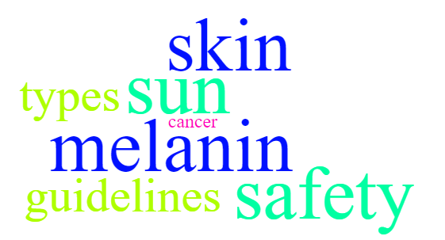

Activity: Class Discussion
After watching the BTN story, hold a class discussion using the following discussion starters.
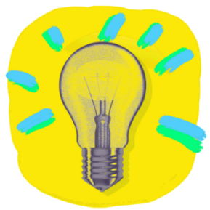
- What are the beneficial and harmful effects of the sun?
- Why do we need to protect our skin?
- What do you do to protect your skin from the sun? Make a list.
- What questions do you have about the story?

Activity: Glossary
Students will brainstorm a list of key words that relate to the BTN Sun Safety Guidelines story. Below are some words to get students started.

SUN PROTECTION | ULTRA VIOLET RADIATION | VITAMIN D
MELANIN | PIGMENT | SKIN TYPES

Activity: Research
Discuss the information raised in the BTN Sun Safety Guidelines story. What questions were raised in the discussion and what are the gaps in students’ knowledge?
What do I know? | What do I want to know? | What have I learnt? | How will I find out?

Students will develop their own question/s to research or choose one or more of the questions below.
- Why is the sun damaging to humans? What are UVA and UVB rays, and how do they affect humans?
- What is melanin? How does it protect the skin from UV radiation from the sun?
- Why is vitamin D important to the human body?
- What factors affect the amount of vitamin D your body makes? How does skin type, the time of day and year and clothing affect this?
- What are the warning signs of skin cancer? What should people do to check for these signs?
- How does sunscreen work to protect our skin?

Activity: The Science of Skin Colour
Students watch this video to learn more about the science of skin colour. Students respond to the following:
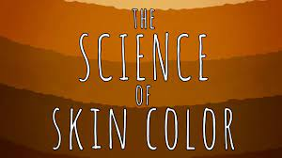
- Briefly summarise the information in the video
- Name three facts you learnt.
- What surprised you about the information in the video?

Activity: UV Radiation
Understanding ultraviolet radiation and the health effects of too much radiation is important as the sun’s UV radiation is the major cause of skin cancer. Students can use the following questions to guide their research:
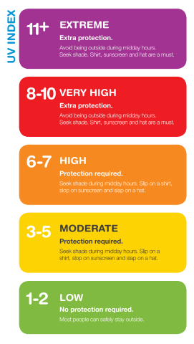
- What is UV radiation?
- Levels of UV radiation depend on a number of factors. What are they?

- Between what times of the day is UV radiation most intense?
- What is the UV index?
- What are the health effects of too much UV radiation?
- What can you do to reduce exposure to UV radiation but still spend time outdoors?

Sun Protection Times
The sun protection times can tell you whenever UV levels are forecast to be 3 or higher. These times are forecast each day by the Bureau of Meteorology website.
- What sun protection measures are recommended?
- Monitor the UV index and temperature in your area for a week and graph the results. Explain the connection between UV and temperature.

- Consider checking the UV index as a class at the beginning of each day to ensure that students are protecting themselves from the sun. Your school could give a daily UV alert and sun protection reminders to all students.
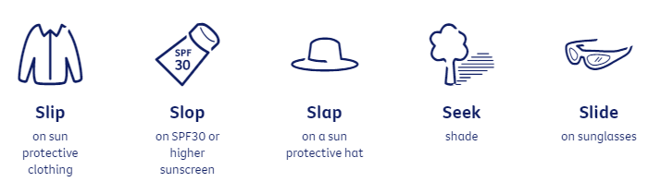
The free SunSmart App tells you when the UV is 3 and above with sun protection recommended for your location. The MyUv website also gives information about the UV forecast in your area.

Activity – Choose a Project
Individually or in small groups, students will choose one of the following projects to work on and then present their findings to the class.

Create a diagram
Create a labelled diagram of the skin showing the different parts of skin and what each part does.
Summary
Write a summary of the story. What was the story about? Why did BTN cover this story?

Public Education Campaign
Design a public education campaign to raise awareness about sun safety.
Quiz
Create a true or false quiz to test your classmate’s knowledge about sun safety.

Activity: Sun Safety Quiz

- Skin is the largest organ in the body.  A. True  B. False  - What does SPF stand for?  A. Sun protection focus  B. Sun protection factor  C. Sun proof formula  - UV radiation is the best source of vitamin D.  A. True  B. False | - You can’t get sunburnt on a cloudy day.  A. True  B. False  - What UV level requires sun protection?  A. 3 or above  B. 4 or above  C. 5 or above  - What is the name of the substance that gives skin its colour?  A. Melatonin  B. Melanin  C. Vitamin D

Useful Websites
- Experts have developed new sun safety advice for diverse skin types. Here’s what it says – ABC News
- Sun Safety Campaign – BTN
- Sun Safety – Cancer Council

EPISODE 4
27th February 2024

KEY LEARNING
Students will investigate the characteristics of black holes.

CURRICULUM
Science – Year 5 & 6
Science involves testing predictions by gathering data and using evidence to develop explanations of events and phenomena and reflects historical and cultural contributions.

With guidance, pose clarifying questions and make predictions about scientific investigations.

Compare data with predictions and use as evidence in developing explanations.

Science – Year 7
Predictable phenomena on Earth, including seasons and eclipses, are caused by the relative positions of the sun, Earth and the moon.

Scientific knowledge has changed peoples’ understanding of the world and is refined as new evidence becomes available.

  - Teacher Resource

Black Hole Discovery

Focus Questions
Discuss the BTN story as a class and record the main points of the discussion. Students will then respond to the following:
- Why can’t we see black holes?
- How do black holes usually form?
- What is the centre of a black hole called?
  - Accretion disk
  - Event Horizon
  - The Singularity
- What is the name of the black hole at the centre of the Milky Way galaxy?
- What did you learn about the newly discovered black hole called J0529?

Activity: Are you Curious about black holes?
Are your students curious about black holes? Black holes are among the most mysterious cosmic objects. They have been widely studied but are difficult to understand and prove they exist.

Students will make a list of questions they have about the BTN Black Holes Discovery story. For example:
- What does a black hole look like?
- Why is a black hole ‘black’?
- Why is a black hole a ‘hole’?
- If a black hole is invisible, then how do you see one?

Ask your students how they will find answers to their questions. NASA has answered 10 Questions You Might Have About Black Holes. Students will use the internet to find answers to their questions and share their findings with the class.
What is at the centre of black holes?

How do black holes form?

Activity: Vocabulary
Students will brainstorm a list of key words that relate to the BTN Black Hole Discovery story. Here are some words to get them started.

Light Years
Gravity
Mass
Astrophysicist
Supermassive
Black Hole
Quasar
Galaxy

Ask students to write what they think is the meaning of each word (including unfamiliar words). They will swap definitions with a partner and ask them to add to or change the definition. Check these against the dictionary definition.

Further activities for students:
- Students will add to their glossary by downloading the transcript for the BTN Black Hole Discovery story and highlight all the words that relate to the topic. For example, accretion disk, event horizon, the singularity, supernova and spaghettification.
- Who explores the universe? Learn more about the jobs involved with space exploration. Choose one job and investigate what the job involves and what you need to study to become one.
- Astronomers generally divide black holes into three categories. There are stellar mass black holes, supermassive black holes, and intermediate mass black holes. Do some research and then write a definition for each using your own words. Visit the NASA website to learn more.

Activity: Guide to Black Holes
NASA – Guide to Black Holes  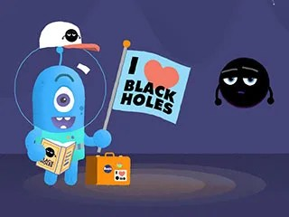 | Thinking about doing some black hole watching the next time you’re on an intergalactic vacation, but you’re not quite sure where to start? Well, look no further!  This series of animated NASA videos shows you everything you need to know. With topics ranging from basic black holes, to fancy black holes, to giant black holes and their companions. Watch this NASA animation to learn more about black holes.
NASA – Inside a Black Hole  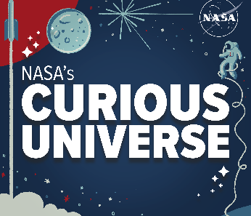 | Don’t let the name fool you: a black hole is anything but empty space. Black holes are some of the most extreme, bizarre and fascinating objects in the universe. Regina Caputo and Jeremy Schnittman describe what it might be like to go hunting for one.  NASA - Link to podcast

Activity: Life Cycle of a Star
Most black holes form from the remnants of a large star that dies in a supernova explosion. To help explain how black holes form it is useful to understand the life cycle of a star.

Class Discussion
Begin with a brief discussion to find out what your students know about stars. Encourage them to share their ideas. Explain the following concepts to your students. You may want to refer to NASA’s Star Basics, which looks at the birth, life, and death of stars. As you explain new concepts to your students identify new words to add to your class glossary.

Facts about stars:
- Stars are the most basic building blocks of galaxies.
- Stars are giant balls of hot gas – mostly hydrogen, with some helium and small amounts of other elements.
- Stars are non-living, but they have a life cycle, similar to plants and animals.
- Stars can have different masses.
- Depending on the mass of the star, there are two possible outcomes.
  - Low and medium mass stars burn cool and last for billions of years.
  - For stars much larger and hotter than our Sun, high-mass stars, the ending will be a spectacular explosion called a supernova.
- After a high-mass star explodes, a black hole is formed.
- The 2 most common types of black holes are called stellar-mass and supermassive.
- It is likely that our Milky Way Galaxy contains around 10 million black holes, but we will probably only ever 'see' about 1,000 of these.

Create
- Students will use neon paints to create their impression of a black hole. Display in your classroom or a room that can be darkened to highlight student’s artworks.
- Students will find images of the different stages in the life cycle of a star. Use these images to display the life cycle of stars as a concept map. Students will include the following in their life cycle: massive star, red supergiant star, supernova, and a black hole.

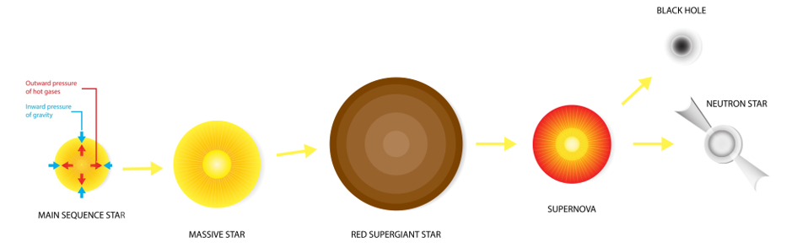

Activity: Science Investigation
Modelling the formation of a black hole
This 'Science in School’ activity will demonstrate to students how a black hole is formed through the collapse of a massive star, once the core of the star is unable to support the weight of the outer layers of gas surrounding it. The materials required for this activity include a balloon, aluminium foil, and a pin.

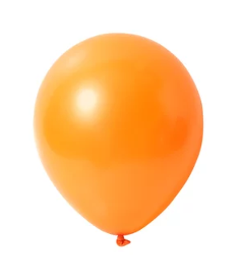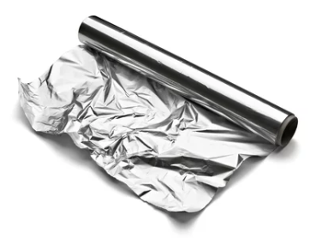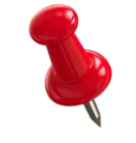

Activity: Black Hole Facts
In small groups, students will find out as much as they can about black holes and compile the information they find into a list of facts. Provide students with a list of suggested questions and/or topics to guide their research, for example:
- What is a black hole?
- How do black holes form?
- Characteristics of black holes
- Significant black holes in the universe

Facilitate a class discussion by asking each group to share one interesting fact they learned during their exploration. Record students’ responses on the white board to create a collective list of facts about black holes.

Students will use the facts they have discovered about black holes to create a quiz and then test their classmates. Students will include a range of quiz styles, for example:
- Multiple choice
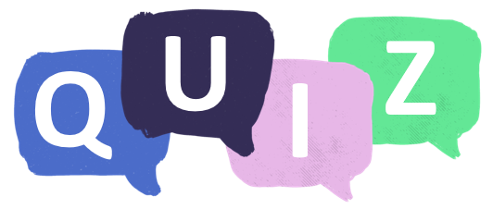
- True or false
- Fill in the blank
- Use photos or pictures
- When an answer is revealed, provide extra information to explain the answer.

Students can make their quizzes in Kahoot or Quizizz. Make it fun, engaging, and educational!

Useful Websites
- Researchers discover fastest-growing black hole that consumes the mass of 'the Sun and all the planets' combined — every day – ABC News
- Black Hole Basics – NASA
- Black Hole Photo – BTN
- Black Holes – National Geographic
- Space and our Solar System – ABC Education
- What is a black hole? (Grades 5-8) – NASA
- A Field Guide to Black Holes – NASA

  - Teacher Resource

BTN Transcript: Episode 4 - 27/2/2024

Hey. I'm Amelia Moseley and you're watching BTN. Welcome back, lets see what’s coming up on today’s show. We'll take a look at why videos like this are causing such a stir, learn more about black holes and meet Malakai who's learning to master the yidaki.

Julian Assange

Reporter: Michelle Wakim

INTRO: But, first today to a name you might have heard before, Julian Assange. He's an Australian who founded a website called WikiLeaks and right now he's in a legal fight to stay out of the US, where he could face some serious charges. So, what's going on? Michelle found out.

MICHELLE WAKIM, REPORTER: To understand the story of Julian Assange, we have to take a little trip into online history to see what the internet was like in the mid-noughties. 2006, in particular, was a huge year. Twitter had just launched; Facebook introduced 'News Feed'; And Elf Yourself was one of the biggest trends.
On top of this, a little website known as WikiLeaks was created by an Australian named Julian Assange. It was set up to help people expose secrets and classified information. Fast forward to 2010, and WikiLeaks became one of the most talked-about websites in the world.
NEWSREADER: WikiLeaks has published more than 90,000 US military documents.
NEWSREADER: At the centre of it all, of course, the mysterious, defiant editor in chief Julian Assange.
NEWSREADER: Julian Assange, the founder of WikiLeaks, has been put on Interpol’s most wanted list.
MICHELLE WAKIM, REPORTER: It published a video leaked by a US military worker, showing US soldiers killing unarmed civilians in Iraq. And followed that up with a huge amount of secret documents from the wars in Iraq and Afghanistan.
JULIAN ASSANGE, WIKILEAKS FOUNDER: It really is the most extraordinary compendium of war that has ever been released.
MICHELLE WAKIM, REPORTER: Publishing secrets is nothing new. In fact, it's a really important part of journalism and there are lots of examples of the media exposing governments doing the wrong thing. But what WikiLeaks did was different. The newspapers that also ran these stories chose what information the public needed to know and what information should be left out to keep people safe. But Assange published everything, in a big information dump. And the leaks kept coming, including hundreds of thousands of messages between US diplomats that made a lot of people furious.
HILLARY CLINTON, FORMER US SECRETARY OF STATE: There is nothing brave about sabotaging the peaceful relations between nations on which our common security depends.
JOHN BELLINGER III, US GOVERNMENT LEGAL ADVISOR: It's really almost apocalyptic to have 250,000 cables lost. It affects our relations with every country in the world and puts sources of information, not only government sources, but human rights activists and dissidents and others at great risk.
MICHELLE WAKIM, REPORTER: Plenty of people agreed with them, and saw Assange as a hacker who only cared about himself. But others saw him as a hero, who'd exposed information that the public deserved to know.
JEREMY CORBYN, UK POLITICIAN: What I think he's done is spoken truth to power.
MICHELLE WAKIM, REPORTER: This all came to head at the end of 2010. Assange was in the UK, when he was accused of an unrelated crime in Sweden. He was arrested and Sweden tried to have him extradited, which means sent to another country for legal reasons.
JULIAN ASSANGE, WIKILEAKS FOUNDER: The extradition proceeding to Sweden which is occurring in a very strange and unusual way is actually an attempt to get me into a jurisdiction which will then make it easier to extradite me to the US.
MICHELLE WAKIM, REPORTER: He took refuge in an unusual place: the Ecuadorian embassy in London. It meant local police weren't allowed to arrest him, as long as the Ecuadorian government agreed to keep him there. And they did, for 7 years. In that time Julian Assange got married, had kids, and kept the leaks coming, including some emails that were stolen from the Democratic party in the lead up to the 2016 election.

DONALD TRUMP, FORMER US PRESIDENT: WikiLeaks! I love WikiLeaks.
MICHELLE WAKIM, REPORTER: In 2019, Ecuador kicked him out and Assange was sent to jail in the UK for breaching bail, and he's been there ever since. He's no longer wanted in Sweden, but the US is trying to have him extradited and that's what last week's hearing was all about.
We won't know the outcome of the trial until next month, but a lot of people are watching this closely. For some, this about freedom of the press.
TIM DAWSON, INTERNATIONAL FEDERATION OF JOURNALISTS: If Julian Assange could be extradited to the United States and jailed for the rest of his life, then any journalist could face a similar fate.
MICHELLE WAKIM, REPORTER: Others say the US shouldn't have the right to charge someone who's not an American citizen, and didn't commit a crime while in the US.
ANTHONY ALBANESE, AUSTRALIAN PRIME MINISTER: Enough is enough. There is nothing to be served by his ongoing incarceration and I am concerned about Mr Assange’s mental health.
ANDREW WILKIE, AUSTRALIAN POLITICIAN: We call on the US, we call on the UK, to let him out of prison, drop the charges, let him be rejoined with his family, let him come home.
News Quiz

The government has announced an 11-billion-dollar boost for which branch of the Aussie military? Is it the Army, the Air Force or the Navy? It’s the Navy. That’ll pay for a bunch of warships including some that are able to be operated without a crew.

RICHARD MARLES: The largest fleet that we will have since the end of the second world war.

A US space company named Intuitive Machines has just become the first commercial business to do what? Orbit Mars, land on the moon or send humans to the ISS? It’s the first to land on the moon. The Odysseus robot touched down near the lunar south pole on Friday. Becoming the first piece of US hardware to make it to the moon since the 70s.

BILL NELSON: What a triumph! This feat is a giant leap forward for all of humanity.

And which famous artist has made the news by topping the US country charts? It’s Beyonce. While it’s not her usual musical style Queen B has made history as the first black female performer to boot scoot her way to number one.

Open AI

Reporter: Wren Gillett

INTRO: Now you might have seen a few videos like this floating around the internet recently. They’ve got a lot of people talking because they were generated by AI. Wren found out why that’s a big deal.

GENIE: Why hello there, Nat. Thanks for waking me up. What's going on.
NAT: You’re a genie.
GENIE: Yes, and this is your moment to make any dream of yours come true.
NAT: That’s a lot of pressure. No, you know what? I've always wanted to visit a cathedral that is filled with cats. Like, completely filled with cats. And in the corner, could there be a giant cat king sitting on a throne? Can you do that?
GENIE: Sure
WREN GILLETT BTN REPORTER: Yep, to many people this Sora thing seems preeeeety magical. Only the real Sora looks a lot less like this, and a lot more like this. It's the latest addition to the OpenAI family, the company behind DALL•E which can create images from text, and of course ChatGPT, which can write basically anything you ask it to. Well, Sora is their newest sibling, and she creates...
NAT: Videos?
GENIE: Yes. Any video your heart desires.
NAT: But I wanted to see a real cat cathedral.
According to OpenAI, in just a few seconds, Sora can create a 60 second clip, that's scarily specific and detailed. For example, A litter of golden retriever puppies playing the snow, or a petri dish with a bamboo forest growing within it that has tiny red pandas running around. Sora is even able to animate a still image, and even alter an existing video.
Now, Sora isn't the first program to do this sort of thing. But it is the most realistic, and it's certainly caused a stir.
TIKTOK GRAB: The internet just changed forever.
TIKTOK GRAB: Hopefully it's not that catastrophic to the world.
Experts say it could revolutionise the film and TV industry, and it could be a great tool for young creative people.
HANY FARID: Kids now at home can become the next Steven Spielberg, because they have an amazing imagination. And now they don't need cameras and actors in the studio, and 10s of hundreds of millions of dollars to create a movie, they just need their imagination.
WREN GILLETT BTN REPORTER: But there are also worries it could take the jobs of a lot of people working in creative industries.
GENIE: I could even do your job, Nat. Here's virtual Nat.
NAT: Um... Pff! no. Um, no, I'm alright. Thanks.
WREN GILLETT BTN REPORTER: But the major concern is a potential rise in mis and disinformation.
HANY FARID: I think we should be excited about the technology. But at the same time, we are seeing harm from the technology, we are seeing people use this for bad things.
WREN GILLETT BTN REPORTER: We've already seen AI used to make fake videos and voice recordings of politicians. And some are worried that as AI gets better, we won't be able to sort fact from fiction.
GENIE: Hey! Hey, Nat! Do you want to see a video of you presenting a really important speech
in front of a whole bunch of people?
NAT: Yeah, sure.
GENIE: With no clothes on?
NAT: No. What? No! That's it. I've had enough of this. How do I put you back in here?
GENIE: There's no putting this Genie back in the bottle.
NAT: Lamp. It's a lamp.
WREN GILLETT BTN REPORTER: Yeah, for better or for worse, experts say this kind of tech is here to stay. Which is why governments and experts around the world are working on ways to make AI safer.
TOBY WALSH: The good news is the technology is going to come in the next 10 or so years that's going to help protect us. There is going to be what's called Digital watermarks, and little stamps of authenticity, that will be added to all media, whether it be audio or video that we look at will vouch for the integrity that it hasn't been edited in any suspicious way.
WREN GILLETT BTN REPORTER: At the moment, Sora is still in the testing stage, and it will be a little while before it's available to the general public. But in the meantime, experts say we all need to think critically about what we see and read online.
HANY FARID: You know, there's a great adage, if it sounds too good to be true. It is. That's not bad words of advice when you're on the internet.
NAT: Hey, can I see that cat video again? Whoa! You made this? It's really good. Whoa.
Quiz

Do you know where the name Sora comes from? Is it Japanese for sky, does it stand for sentient operational robotic artist or is it the name if the lead developer? It's Japanese for sky, which according to OpenAI, is the limit.

Sun Safety Guidelines

Reporter: Michelle Wakim

INTRO: Now to the sun which, as we Aussies know, can be pretty dangerous if you don't slip, slop, slap, seek and slide. But while that advice still stands, Australian researchers recently updated their sun safety guidelines for people with darker skin who are at risk of not getting enough vitamin D. Here's Michelle.
AD CAMPAIGN: The sun’s shining down, so desperate to brown, but skin cancer isn't so hot.
MICHELLE WAKIM, REPORTER: It's a message that we Aussies have taken to heart: when you're in the sun, look after your skin.
AD CAMPAIGN: Slip, Slop, Slap.
MICHELLE: But not everyone has the same reaction to the sun. While some of us burn easily, others, not so much. There's good reason for that. It's all because of something called melanin.

Melanin is a pigment in our body that's responsible for our hair, eye, and skin colour. The more melanin you have, the darker your skin and it plays a big role in how we absorb ultraviolet or UV radiation. Melanin is produced here, in the top layer of your skin. It absorbs UV rays that hit your skin, giving you a natural layer of protection from the sun. The UV that isn't absorbed, is what can go on damage to our skin.

So, the more melanin you have, the less likely you are to get burned. That means that people with dark skin don't need quite as much sun protection. But experts are concerned that people with darker skin aren’t getting enough time in the sun, and it could be causing some other health problems.
DR POOJA SHARMA, DERMATOLOGIST: Melanin obstructs the manufacturing of Vitamin D in the skin.
You see, we actually need to absorb a little bit on UV radiation because that's what creates Vitamin D. Vitamin D helps our bodies absorb calcium, strengthens our bones, and can reduce the risk of some diseases. For light skinned people, getting enough Vitamin D is easy. But for people with more melanin, it takes more time in the sun to absorb enough UV.
DR POOJA SHARMA, DERMATOLOGIST: Darker skin coloured people need to be educated regarding their exposure to sunlight.
And that's why researchers have tweaked Australia's sun safety guidelines, to better reflect the diversity of skin colours in Australia.
PROFESSOR RACHEL NEALE, QMIR BERGHOFER: The new guidelines are really about recognising that the sun has benefits as well as harms, but the balance of those is not the same for all Australians.
Now, that doesn't mean throw this stuff out. Researchers say, for everyone, putting on sunscreen should be part of the daily routine. It's also important to wear a hat and stay in the shade. Yeah: slip, slop, slap, seek, and slide as usual. The difference is that people with really dark skin should try to spend a little bit of time outdoors everyday with their skin uncovered, to make sure they are getting enough Vitamin D. Not too much sun though; that thing is still dangerous.
STUDENT: I think it's important that you listen to these rules.
STUDENT: We need to wear sunscreen; wear hats and we need to stay in the shade.
STUDENT: Sometimes I wear like a long sleeve, or I wear a hat, or I just play in the shade.
Black Hole Discovery

Reporter: Thomas Midena

INTRO: Well, if you thought the sun was scorching hot, you ain't seen nothin' yet. Aussie astronomers have discovered what may be the brightest object in the entire universe. It's a supermassive black hole that eats the equivalent of a sun every single day. And if you were wondering how can a black hole be bright? Well, hopefully Thomas can explain.

THOMAS MIDENA, REPORTER: Oh, hi, I'm just trying to wrap my head around this.
Black holes. Weird things in space that suck things in.
DOCTOR WHO: That's a black hole. But that's impossible.
It's no wonder they've inspired so much science fiction.
TREASURE PLANET: a black hole.
So, what is a black hole?
CHRISTIAN WOLF, AUSTRALIAN NATIONAL UNIVERSITY: Black holes are really just a lump of mass, like the sun, like the Earth, like my body or a rock in the garden. But what makes them black is that the gravity is so strong that not even light can escape.
Black holes usually form when a massive star reaches the end of its life. Having burned all of its energy, it implodes, collapsing in on itself to an infinitely small point known as a singularity, which sucks in everything around it, including light.
CHRISTIAN: Everything that's inside of it, we cannot see. And the border of the black hole we call the event horizon. That's the place once you go beyond not even light can leave.
Outside of the event horizon is something called the accretion disc.
CHRISTIAN: An accretion disk is a giant storm around a black hole. It's all the material that gets laid out for the meal that black hole is going to have over the next weeks and months.
From a distance, glowing accretion discs can look just like stars. But, in 2019 we got our first up close look at an actual black hole. Followed by this photo which was taken in 2022.
CHRISTIAN: That's Sagittarius A star, the black hole at the centre of our Milky Way.
It's about 26 million kilometres in diameter. So, if this was the Earth, then in comparison, the Sagittarius black hole would be about the size of this entire oval. But if you think that's big, check out the latest black hole that's been discovered by researchers at the ANU. The J0529-435.
CHRISTIAN: Internally, we just call it J0529. So finding these fast growing black holes is like finding a needle in the haystack, because they're really rare. You look at the sky, you see lots of stars. Maybe one of them is a fast growing black hole, but you don't know unless you study them in detail.
It was Christian's job to choose which stars study. And it turns out he chose well, because this black hole they’ve discovered is a whopper, it's accretion disc is seven light years in diameter. It's bright enough that it's possible to see it from Earth with a backyard telescope. When the stars are out. At night. With a telescope a bit bigger than that one.

Oh.
CHRISTIAN: But this object is so far away, the light has been traveling for 12 billion years.
12 billion years?
CHRISTIAN: 12 billion? Not million. Indeed.
Scientists like Christian are pretty excited about what black holes like this one could teach us about the universe.
CHRISTIAN: So, black holes are really mysterious things. We don't know why they are as massive as they are. How have they been born? We don't even know whether these black holes formed among the stars, or whether they were made through a mysterious way in the Big Bang itself. We also don't know what happens to material after it falls into the black hole.
Sounds like there's plenty more to learn about these mysterious wonders.

Quiz

Black holes come in all different sizes. What do we call the biggest ones? Super humongous black holes, super huge black holes or supermassive black holes? It's supermassive black holes.

Sport

Yep, Australia cleaned up in the T20 international series against the Black Caps in Auckland. In the third and final match of the series, the Aussies secured a 27-run victory to take the series three-nil. The teams will meet again on Thursday for the first of two test matches to battle it out for Trans-Tasman glory.
Now, to the Matildas. Who are now one step closer to a spot at the Paris Olympics. Over the weekend they faced Uzbekistan in the first leg of their Olympic qualifying campaign and won 3-nil. With star skipper Sam Kerr still out, retired veteran Michelle Heyman stepped in and scored this header in the 72nd minute.
MICHELLE HEYMAN: It’s so nice to be back with the girls, back playing for my country and to come on and score a goal, it’s a dream come true.
And now, down to Tasmania where this crowd of 5,000 was pretty revved up for the world's toughest downhill mountain bike race, Hardline. With plenty of high-adrenaline jumps, drops and, uh, different kinds of drops. And a special shoutout to Gracey Hemstreet and Louise-Anna Ferguson for becoming the first ever female riders to make it into the Hardline final.

COMMENTATOR: Gracie stands it! Gracie makes it!

Takeover Melbourne
Rookie Reporter: Malakai

INTRO: Finally, today we're going to meet another winner of the Takeover Melbourne competition which asks young people to share their stories. Malakai is going to tell us how learning to play the Yidaki helped him in more ways than one. Take a look.

I've always loved listening to the yidaki, the didgeridoo. It mimics animals, country, and stories. Asthma meant I couldn't play.

In year 7 I got into Melbourne Indigenous Transition School and moved to Naarm. There were so many, something I hadn't experienced before, and it was really cold.

I met a very special teacher, Jayden. I'd never had an Aboriginal teacher before and it was so deadly. He started to teach me more about the yidaki. He taught me about colonisation, historical blak events, blak excellence, and circular breathing. I was told circular breathing could help me with my asthma. So, every day I would sit down, grab a glass of water and a straw, and practice.

I finally started to make sounds, sounds turned into beats, and beats turned into our native animals. I became obsessed with mimicking the kangaroo. When I'd almost run out of air, I would release a mighty howl and let the dingo in me run wild. After a few months of practice, I no longer needed my inhaler, my asthma had disappeared.

I built up enough courage to share my new skills with the mob. I felt so proud teaching and sharing my love of the yidaki. The yidaki has brought me closer to culture, it's made me even prouder to be a Gunai Kunai man.

Closer

Ahh, great work Malakai, keep it up. Well, that's all we have for today, but I'll be back with more next week. And in the meantime, you can jump online whenever you like and check out more stories and specials and resources for your teachers. And of course, Newsbreak will be right here in the studio every weekday, keeping you up-to-date. Have the best week and I'll see you soon. Bye!

