
KEY LEARNING
Students will view a range of BTN stories and use comprehension skills to respond to a series of focus questions.

CURRICULUM
English – Year 4
Use comprehension strategies to build literal and inferred meaning to expand content knowledge, integrating and linking ideas and analysing and evaluating texts.

English – Year 5
Use comprehension strategies to analyse information, integrating and linking ideas from a variety of print and digital sources.

English – Year 6
Use comprehension strategies to interpret and analyse information and ideas, comparing content from a variety of textual sources including media and digital texts.

English – Year 7
Use comprehension strategies to interpret, analyse and synthesise ideas and information, critiquing ideas and issues from a variety of textual sources.

Talking about natural disasters may be upsetting for some children and may cause some discomfort, distress and/or anxiety. BTN has a short video about the Important Things to Remember about Upsetting News.


  - Teacher Resource

Natural Disasters Special
As a class, discuss the stories featured in the episode of BTN Classroom and record the main points of the discussion. Students will then respond to the following focus questions.

Volcanoes Explained
- The word volcano comes from the word Vulcan, the Roman god of ___________.
- Where is the Popocatépetl volcano?
- What is another word for molten rock?
- Explain what a pyroclastic flow is and why are they dangerous?
- There are no active volcanoes in Australia. True or false?

Bushfire Science
- What are the three ingredients of a bushfire?
- How do bushfires start? Give one example.
- How does the slope of the land affect bushfires?
- Strong winds increase the intensity of a bushfire. True or false?
- What questions do you have about the story?

Aussie Earthquakes
- Where in Australia was there recently an earthquake? Find on a map.
- What are tectonic plates?
- How do tectonic plates cause earthquakes?
- Australia is right on the edge of a tectonic plate. True or false?
- How many centimetres does the Australian Continental plate move each year?

KEY LEARNING
Students will investigate the characteristics of volcanoes and what causes volcanoes to erupt.

CURRICULUM
Science – Year 6
Sudden geological changes and extreme weather events can affect Earth’s surface.

Science involves testing predictions by gathering data and using evidence to develop explanations of events and phenomena and reflects historical and cultural contributions.

Scientific understandings, discoveries and inventions are used to solve problems that directly affect peoples’ lives.

Scientific knowledge is used to solve problems and inform personal and community decisions.

Science – Years 5 & 6
With guidance, pose clarifying questions and make predictions about scientific investigations.

Science – Year 7
Identify questions and problems that can be investigated scientifically and make predictions based on scientific knowledge.

Collaboratively and individually plan and conduct a range of investigation types, including fieldwork and experiments, ensuring safety and ethical guidelines are followed.
  - Teacher Resource

Volcanoes Explained

Activity: Class Discussion
Discuss the BTN Volcanoes Explained story as a class. Ask students to record what they know about volcanoes. What questions do they have? Use the following questions to help guide discussion:

- What are volcanoes?
- What words would you use to describe volcanoes?
- What causes a volcano to erupt?
- Who studies volcanoes and why is it important to study volcanoes?

Activity: Questions and Answers
Are you curious about volcanoes? Students will make a list of questions they have about volcanoes and learn why it’s important to understand volcanoes. Students will use the internet to find answers to their questions.

Who studies volcanoes?
What are volcanoes?

Activity: Research project
After watching and discussing the BTN Volcanoes Explained story, what questions do students have and what are the gaps in their knowledge? The following KWLH organiser provides students with a framework to explore their knowledge on this topic and consider what they would like to know and learn.

What do I know? | What do I want to know? | What have I learnt? | How will I find out?

Act like a volcanologist
Students will start to think like scientists and develop their own question/s for inquiry, collecting and recording information from a wide variety of sources. Students may develop their own question for inquiry or select one or more of the questions below.
- What is a volcano? Why do they happen?
- What is the tallest volcano? Create a profile on the volcano.
- How do you know a volcano is going to erupt? Explain using your own words.
- What is the connection between volcanoes and tectonic plates?
- What impact can volcanic eruptions have on people and the environment? Consider the negative and positive effects.
- What are some of the main risks during a volcanic eruption? What is the most dangerous aspect of a volcano?
- What are the different layers of a volcano? Draw a cross section of a volcano showing the following features: crust, mantle, crater, magma chamber, magma, ash, cloud, vent.

Activity: Map Maker
MapMaker is an interactive mapping tool for exploring the world through a variety of data layers. Students will use National Geographic’s MapMaker to interpret geographic information about the world’s volcanoes.

Students will investigate the world’s volcanoes using MapMaker.
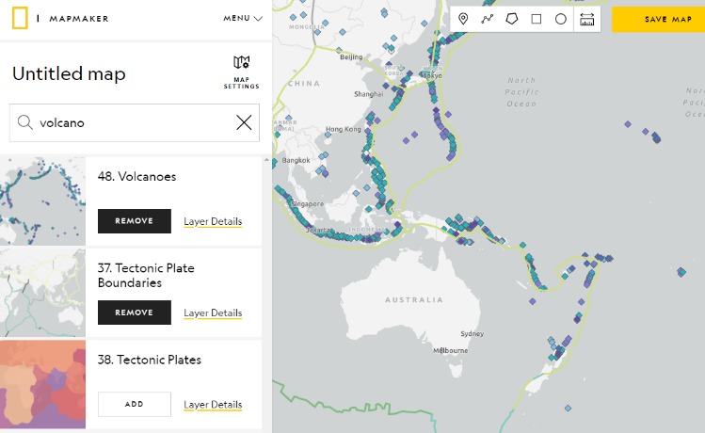
- Open MapMaker.
- Search for ‘Volcanoes’ in Layers.
- Add the Volcanoes Layer.
- Experiment with adding and removing different layers, including Volcanoes, Tectonic Plate Boundaries & Tectonic Plates.
- Show the legend. Explore the different types of volcanoes, tectonic plates & tectonic plate boundaries. Adjust the opacity level for each layer.

Further Investigation using MapMaker
- What are the different types of volcanoes?
- Where are the majority of the world’s volcanoes located?
- What do you notice about the location of the world’s volcanoes and tectonic plates?
- What is the name of the tectonic plate which covers Australia?
- Find the Ring of Fire on the map.
Activity: Ring of Fire
Students will investigate the geography of the Ring of Fire. Students will gather geographical data and make connections between the location of volcanoes and tectonic plates. Students can use the world map at the end of this activity to record their findings.

On a map of the world students will locate and highlight the following geographical data:
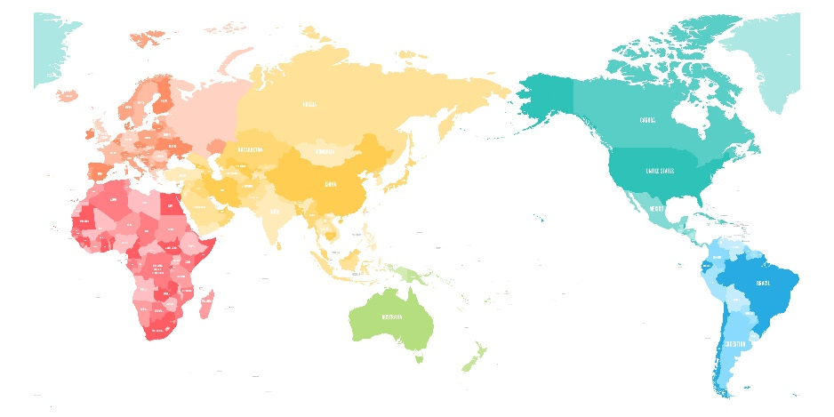
- Draw the Ring of Fire on your map.
- There are many active volcanoes along the Ring of Fire. Identify some well-known volcanoes and mark on the map (for example, Mauna Loa, Popocatépetl, Mount Fuji, Mount Tambora, Mount Pinatubo & Krakatoa).
- Circle nearby cities and towns to each of the volcanoes you mark.
- Draw the major tectonic plate boundaries.
- What ocean is in the path of the Ring of Fire? Label on your map.
- Locate and label Marianas Trench.

Further investigation
Students will respond to one or more of the following:
- What shape is the Ring of Fire?
- How long is the Ring of Fire?
- What tectonic plates sit on the Ring of Fire?
- What percent of the Earth’s active volcanoes are located on the Ring of Fire?
- What countries are located near or on the Ring of Fire?
- What is an ocean trench? Why are there so many trenches in the Ring of Fire?

Activity – Jigsaw learning
In this activity students will work cooperatively to learn more about Earth’s volcanoes. Each group will become experts and then share what they have learnt with other students.

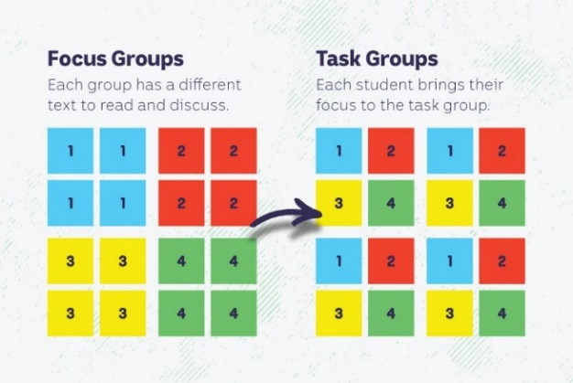
Form Groups
Divide the class into 4 x Focus Groups. Each Focus Group will be assigned a different volcano to study. Below is a list of volcanoes to choose from:
- Mount Vesuvius (BTN story)
- Popocatépetl
- Hunga Tonga-Hunga Ha'apai (BTN story)
- La Palma (BTN story)
Each group will need to decide how they will collect and communicate the information they find during their research.

Research
Each Focus Group will respond to one or more of the following questions to become experts:
- Where is the volcano? Find on a map.
- What type of volcano is it?
- What is the history of the volcano?
- Think of an interesting way to teach other students about this volcano. You could draw a cross-section of the volcano or create a diorama.

Share
Mix the Focus Groups to form Task Groups (Tasks Groups include one student from each of the Focus Groups) to share the information they have collected. Students will share the information they have collected and learn from one another.

Reflect
Students will reflect on the activity by responding to one or more of the following questions:
- What did you enjoy about this investigation?
- What did you find surprising?


Activity: Reading rocks
Provide your students with opportunities to examine rocks and make observations about them. Students may want to bring rocks in from home or you can explore the environment around your school and collect a small sample of rocks. Challenge your students by asking them to bring in a piece of volcanic rock to school (e.g., obsidian, pumice or granite).

Spark a discussion about rocks in your classroom by using one or more of the following questions. Record your students’ responses on a mind map, with the word ROCKS in the centre.
Discussion questions:
- Have you ever looked at rocks or collected them?
- Where would you look to find rocks?
- What do rocks feel and look like? Describe the characteristics of rocks. Are they heavy or light? What colour are rocks? Do they have texture?
- How are rocks the same and how are they different?
- What can you use rocks for?
- What is the relationship between rocks and volcanoes?

Encourage students to discuss what they already know about rocks and prompt them to ask questions they might have about rocks. Record your students’ responses on a KWLH chart.

Activity: BTN Stories
These BTN stories look at the impact that volcanoes have on people and the environment. After watching any one of the BTN videos ask students to respond to the discussion questions (to find the teacher resources go to the related BTN Classroom Episode and download the Episode Package).

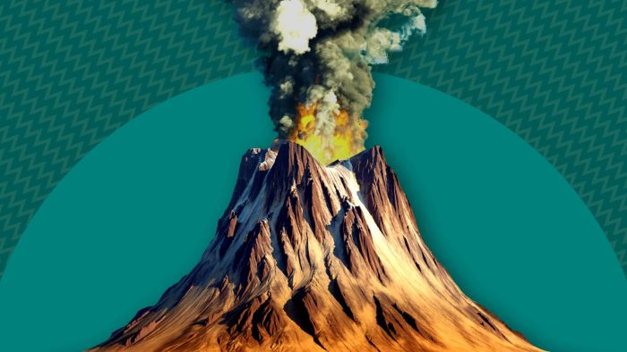  Volcanic Activity | 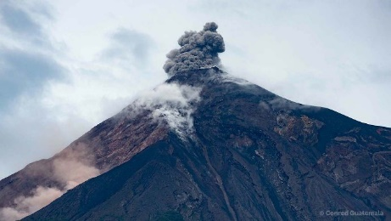  Volcanoes Explained | 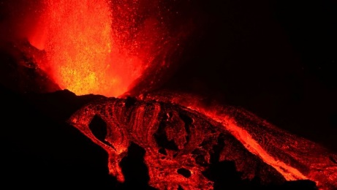  La Palma Volcano
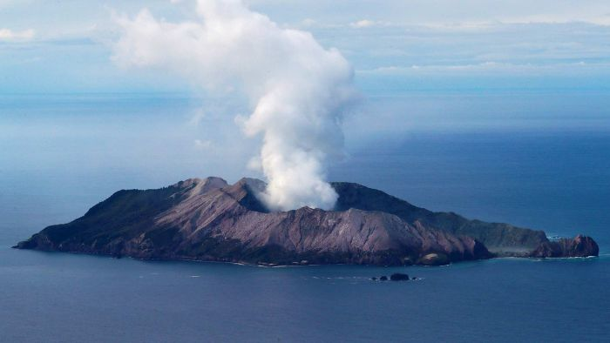  Volcano Warning | 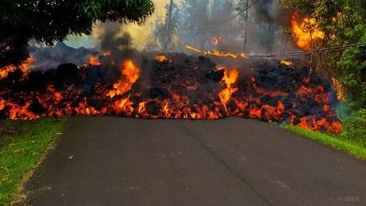  Hawaii Vaolcano | 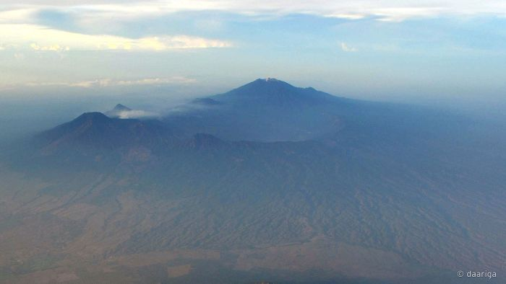  Volcano Safety

Useful Websites
- Popocatépetl volcano rumbles near Mexico City, coating towns with ash and disrupting flights – ABC News
- Tonga Volcano – BTN
- Volcanoes Explained – BTN
- Everything you need to know about volcanoes – Newsround
- What is a volcano? – Geoscience Australia
- Volcano Facts – National Geographic
- Structure of Volcanos – Australian Museum
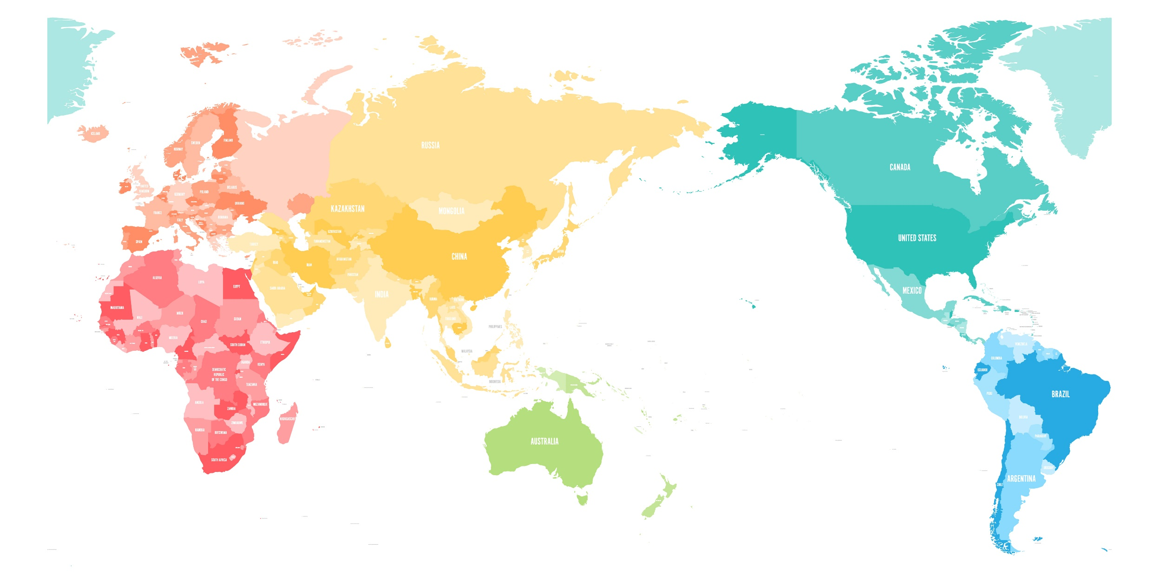

KEY LEARNING
Students will learn about the science of bushfires and Indigenous fire management.

CURRICULUM
HASS – Year 5
The impact of bushfires or floods on environments and communities, and how people can respond.

HASS – Years 5 and 6
Work in groups to generate responses to issues and challenges.

Science – Year 5 & 6
Scientific knowledge is used to solve problems and inform personal and community decisions.

Science – Year 6
Scientific knowledge is used to solve problems and inform personal and community decisions.

  - Teacher Resource

Bushfire Science

Activity: Note taking

Students will practise their note-taking skills while watching the BTN Bushfire Science story. After watching the story, ask students to reflect on and organise the information into three categories. What information in the story was...?
- Positive
- Negative or
- Interesting

Activity: Class Discussion
Discuss the BTN story as a class. Ask students what they know about bushfires. Use the following questions as a guide:

- Fire relies on which three elements?
- How do bushfires start? (human and natural causes)
- What factors affect the spread of bushfires? (fuel load, weather conditions, terrain, wind)
- What questions do you have about the story?

Activity: Glossary
Students will brainstorm a list of key words that relate to the BTN Bushfire Science story. Here are some words to get them started.

FUEL | TERRAIN | IGNITION
COOL BURN | OXYGEN | FIRE TRIANGLE

Activity: The Fire Triangle
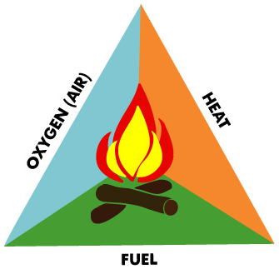
Students will investigate the three things a fire needs to burn:
- Fuel
- Air
- Heat

Ask students to predict what these three elements might be. Watch this short CFA Fire Triangle video then ask students to draw and label the fire triangle and explain how fuel, oxygen and heat might affect a fire. Explain to students that if you removed any side of the fire triangle, the fire would go out.
Working in pairs, ask student to discuss:
- Explain the role of fuel in the fire triangle. What are some examples of fuels that can be involved in fires? What would happen if fuel was removed?
- How does heat contribute to the fire triangle? Why is it crucial to ignition? What would happen if heat was removed?
- Why is oxygen necessary for fires to burn? How does it interact with the other elements of the fire triangle? What would happen if oxygen was removed?

Activity: Research
Discuss the information raised in the BTN Bushfire Science story. What questions were raised in the discussion and what are the gaps in students’ knowledge? The following KWLH organiser provides students with a framework to explore their knowledge on this topic.

What do I know? | What do I want to know? | What have I learnt? | How will I find out?

Students will develop their own question/s to research or choose one or more of the questions below.
- Investigate the factors that create bushfire risk.
- How can people prepare for the bushfire season?
- How does terrain (topography) affect the way a fire behaves? Fill in the missing word: For every 10˚ slope, the fire will ______________ its speed.
- What is radiant heat and how is it dangerous in a bushfire? What steps can be taken to reduce the risks of radiant heat?
- What is the fire danger rating system? How is the fire danger rating determined? Why is it important to have a fire danger rating?
- What is a bushfire survival plan?

Activity: Cultural Burning
Students will learn more about First Nations fire practices. As a class, watch the Big Weather: Benefits of Indigenous fire practices video. Students can then respond to the following questions:

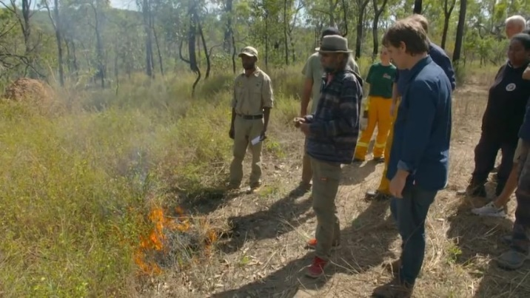
- What is a controlled burn?
- How are they used to reduce the risk of bushfire?
- What is cultural burning? Where in Australia are cultural burning practices common?
- What are the three main parts of Aboriginal burning?
- Fire management is part of how Aboriginal people look after country. What does this mean?
- How does cultural burning differ from modern firefighting techniques?
- How can we learn from First Nations Peoples about looking after Country?

To learn more about cultural burning, go to the Firesticks website. This Traditional burning video explores bushfire management practices in more detail.

Further investigation
Invite a First Nations speaker or expert on cultural burning to share their experiences and knowledge with students.

Useful Websites
- Curious Kids: how do bushfires start? – The Conversation
- Bushfire Survival Plan - BTN
- Fire Season Warning – BTN
- Burn off Season - BTN
- Big Weather: Benefits of Indigenous fire practices – ABC Education
- How Fire Behaves – CFA

KEY LEARNING
Students will learn more about the history and the cause of earthquakes in Australia.

CURRICULUM
Science – Year 5 & 6
Scientific knowledge is used to solve problems and inform personal and community decisions.

Science – Year 6
Sudden geological changes and extreme weather events can affect Earth’s surface.

Scientific knowledge is used to solve problems and inform personal and community decisions.

Science – Year 7
Scientific knowledge has changed peoples’ understanding of the world and is refined as new evidence becomes available.

Geography – Year 7
Causes, impacts and responses to an atmospheric or hydrological hazard.

  - Teacher Resource

Aussie Earthquakes

Activity: What do you see, think and wonder?
After watching the Aussie Earthquakes story students will respond to the following:
- What did you SEE in this story?
- What did this story make you WONDER?
- How did this story make you FEEL?
- Think of three questions you have about the BTN story.

Activity: Class Discussion
After watching the BTN Aussie Earthquakes story, hold a class discussion using the following discussion starters.

- What is an earthquake?
- What causes earthquakes?
- What words would you use to describe earthquakes?
- Who studies earthquakes and why is it important to study them?
- What questions would you like to ask a scientist about earthquakes?

Activity: Glossary
Students will brainstorm a list of key words that relate to the BTN Aussie Earthquakes story. Below are some words to get students started.

SEISMIC | FAULT LINE | TECTONIC PLATES
EPICENTRE | MAGNITUDE | EARTH’S CRUST

Ask students to write what they think is the meaning of each word (including unfamiliar words). They will swap definitions with a partner and ask them to add to or change the definition. Check these against the dictionary definition.

Further activities for students:
- Students will add to their glossary by downloading the transcript for the BTN Aussie Earthquakes story and highlight all the words that relate to earthquakes. Add the following words to the glossary to expand students’ knowledge on the topic: aftershock, Richter scale, seismologist, seismograph, subduction zone.
- What is the difference between an earthquake and an aftershock?
- How did this story make you feel? Make a list of words that describe how you felt after watching the BTN story.

Activity: Research Project
After watching and discussing the BTN story, what questions do students have and what are the gaps in their knowledge? The following KWLH organiser provides students with a framework to explore their knowledge on this topic and consider what they would like to know and learn.

What do I know? | What do I want to know? | What have I learnt? | How will I find out?

Act like a seismologist
Students will start to think like scientists and develop their own question/s for inquiry, collecting and recording information from a wide variety of sources. Students may develop their own question for inquiry or select one or more of the questions below.
- What is an earthquake? Why do they happen?
- Why do we get earthquakes in Australia?
- What are Australia’s worst earthquakes? Use a timeline to highlight your findings. Choose one to explore in more detail.
- How do tectonic plates cause earthquakes? How many tectonic plates make up Australia?
- How do we measure earthquakes? Investigate who invented the seismograph and when.
- What are the impacts of earthquakes?

Activity: Cause and Effect
This cause and effect diagram (also known as a fishbone diagram) is a useful tool which can help students identify causes for an effect or problem. The tool can be used during brainstorming sessions to record student’s ideas. The tool also helps to sort student’s ideas into useful categories.

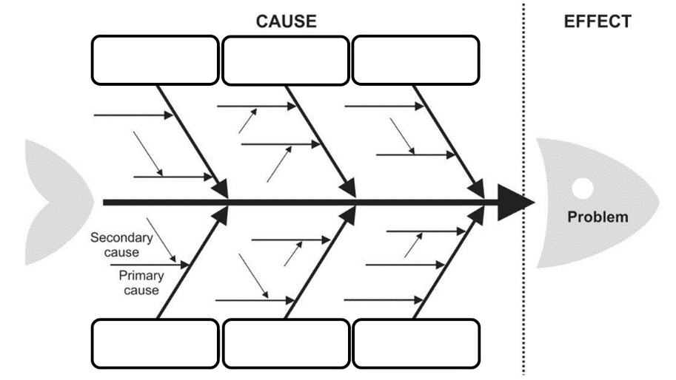
Materials: Flipchart and marker or whiteboard.
Categories: As a class brainstorm the major categories of causes of the problem. Useful categories for a Fishbone diagram about ‘Earthquakes’ could include:
- People
- Environment/Earth
- Infrastructure
- Roads
- Businesses
- Animals

Effects: In small groups, students will then brainstorm the effects that earthquakes can have on these categories. Students can search for news articles and other publications to help with their research.

Solutions:
How can we protect our community from earthquakes? Visit the Victoria State Emergency Service website to learn more about what communities can do to stay safe during an earthquake. Research what some of the design features are of an earthquake-proof building.

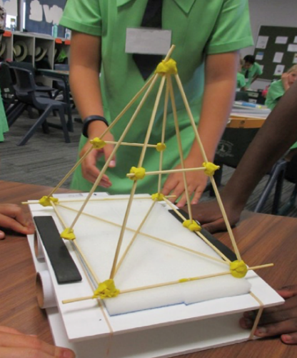
Activity: Design and Create
Visit the Queensland University of Technology (QUT) for a hands-on Earthquake Activity for your students. Students will apply their previous knowledge about earthquakes to construct a building that can withstand damage from earthquakes. Students will use the engineering design process to build their own structures with toothpicks and plasticine.

Source: QUT Earthquake Activity
Activity: Write a feature story
Students will imagine they are a reporter at the scene of the recent earthquake in Melbourne. Students will give a factual account of what happened and write a report on the news story which answers the 5 W’s – Who, What, Where, When and Why? Alternatively, students will write a report about the 1989 Newcastle Earthquake.
  Rookie Reporter Training |   Becoming a journalist

Visit BTN’s Rookie Reporter Training and Becoming a Journalist to learn more about how to make a news story.

Useful Websites
- Melbourne’s biggest earthquake in 120 years – BTN Newsbreak
- The Science of Earthquakes – BTN High
- Earthquakes: what are they and what causes them? – Newsround
- Why are earthquakes so hard to predict? – TedED
- Recent Earthquakes – Geoscience Australia
- Earthquake– Geoscience Australia (Education)

