EPISODE 3
20th February 2024

KEY LEARNING
Students will view a range of BTN stories and use comprehension skills to respond to a series of focus questions.

CURRICULUM
English – Year 4
Use comprehension strategies to build literal and inferred meaning to expand content knowledge, integrating and linking ideas and analysing and evaluating texts.

English – Year 5
Use comprehension strategies to analyse information, integrating and linking ideas from a variety of print and digital sources.

English – Year 6
Use comprehension strategies to interpret and analyse information and ideas, comparing content from a variety of textual sources including media and digital texts.

English – Year 7
Use comprehension strategies to interpret, analyse and synthesise ideas and information, critiquing ideas and issues from a variety of textual sources.
  - Teacher Resource

Focus Questions
As a class, discuss the stories featured in the episode of BTN Classroom and record the main points of the discussion. Students will then respond to the following focus questions.

Ukraine Anniversary
- How long has the conflict between Russia and Ukraine been going on for?
- Why has the Ukrainian school been important for the kids in the BTN story?
- How have their lives changed since moving to Australia?
- What message of support would you send to the people of Ukraine?
- How did this story make you feel?

Asbestos History
- Why was asbestos in the news recently?
- Asbestos is a...
  - Plant
  - Mineral
  - Gas
- Why was asbestos a popular building product?
- What health problems can it cause?
- When did the Australian government ban the use of asbestos?

School Lunch Rules
- What is the main point of the BTN story?
- What are the different categories in the traffic light healthy eating system?
- Give an example of a food from each category.
- What are the healthy eating guidelines in your school? Give some examples.
- Name three things you learnt watching the BTN story.

Check out the teacher resource on the Archives page.

Platypus Protection
- What are some unique features of the platypus?
- Platypuses are monotremes. What does that mean?
- Where in Australia can you find platypuses?
- What are some threats to platypuses?
- What is being done to protect them?

Check out the teacher resource on the Archives page.

Takeover Melbourne - Shriya
- Briefly summarise the BTN story.
- How does Shriya prepare for a dance performance?
- Bharatanatyam is an ancient Indian ________________ dance.
- How did Shriya overcome stage fright?
- What did you like about the BTN story?

EPISODE 3
20th February 2024

KEY LEARNING
Students will investigate the Australian Guide to Healthy Eating. Students will promote healthy eating habits in their school.

CURRICULUM
Health and PE – Years 3 & 4
Identify and practise strategies to promote health, safety and wellbeing.

Health and PE – Years 5 & 6
Plan and practise strategies to promote health, safety and wellbeing.

Health and PE – Years 7/8
Investigate and select strategies to promote health, safety and wellbeing.

Plan and use health practices, behaviours and resources to enhance health, safety and wellbeing of their communities.

Evaluate health information and communicate their own and others’ health concern.

  - Teacher Resource

School Lunch Rules

Focus Questions
Discuss the BTN story as a class and record the main points of the discussion. Students will then respond to the following:
- What is the main point of the BTN story?
- What are the different categories in the traffic light healthy eating system?
- Give an example of a food from each category.
- What are the healthy eating guidelines in your school? Give some examples.
- Name three things you learnt watching the BTN story.

Activity: Pre-viewing questions
Before watching the BTN School Lunch Rules story hold a class discussion using the following questions as a guide:
- What do you know about the ‘traffic light’ healthy eating guidelines in schools?
- List some foods you think are in each of the categories: red, amber, and green.
- Why do you think we have this system?
Green – always on the canteen menu
Amber – select carefully
Red – not recommended on the canteen menu

Activity: Class Discussion
After watching the BTN story students will reflect on the story and then respond to the following:

- What do you THINK about what you saw in this video?
- What did you find surprising or interesting about the story?
- Think of three questions you have about the BTN story.
- Why do you think BTN covered this story?

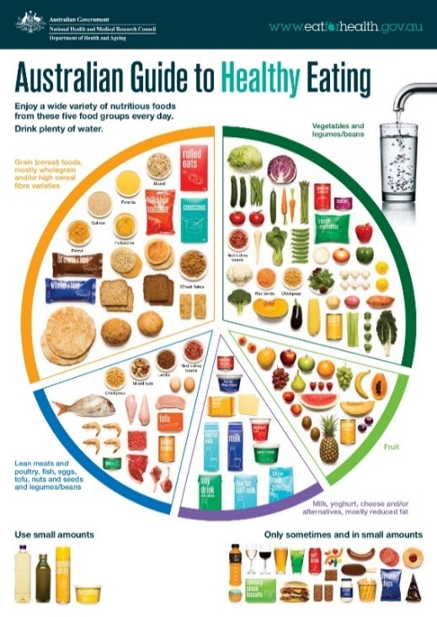
Activity: Guide to Healthy Eating
Ask your students if they have heard of the Australian Guide to Healthy Eating. Show them a picture of the guide on your classroom whiteboard, and facilitate a class discussion using the following questions:
- What are the five food groups?
- Identify some of the foods in each group.
- How many serves do children need from each of the food groups per day?
- Why do we have the Australian Guide to Healthy Eating?
- What sort of food choices do you make?
- What healthier food choices could you make? Identify which foods you should eat more of or cut down on.

Activity: What Am I?
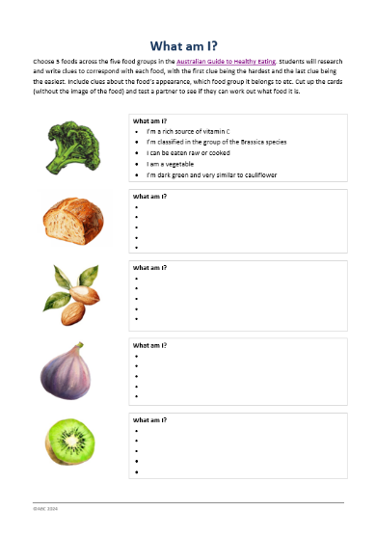
Students will make their own What am I? game to learn more about foods in the Australian Guide to Healthy Eating. There is an example at the end of this activity.
- Choose 5 foods across the five food groups in the Australian Guide to Healthy Eating.
- Research and write clues to correspond with each food, with the first clue being the hardest and the last clue being the easiest. Include clues about the food’s appearance, which food group it belongs to etc.
- Cut up the cards (without the image of the food) and test a partner to see if they can work out what food it is.

Activity: Heads Up!
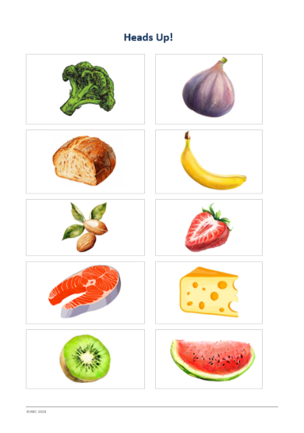
Students will make their own Heads Up! game to learn more about foods in the Australian Guide to Healthy Eating. There is an example at the end of this activity. This game can be played in groups or as a whole class.
- Choose a range of nutritious foods from the five food groups in the Australian Guide to Healthy Eating.
- Write or sketch an illustration of each food on pieces of card, post-it notes or sticker labels.
- Each player will choose one card and attach it to their headband without looking at what’s on the card. Headbands can be made from a strip of card wrapped around each player’s head.
- Players will take it in turns asking yes or no questions of the other players to try and guess which food is on their card.

Activity: Cooking from Scratch
Students will develop and prepare their own nutritious, delicious, and simple recipe, using fresh ingredients and then share with classmates. Working in small groups, students can use the following as a guide:
- Brainstorm some recipes (use cookbooks, magazines, or the internet to find a recipe or use your favourite recipe from home). Your recipe needs to be nutritious, delicious, simple, and fun to make. Try to choose a recipe that includes seasonal ingredients.
- Decide on one recipe that you will prepare and share with the class. Ensure that your recipe is different to other groups and the recipes complement each other. Your class might decide to have an outdoor picnic!
- Plan - What ingredients will you need and where will you get them from? Write a shopping list and budget for your recipe. What tools and equipment will you need?
- Collect your ingredients either from the supermarket, local green grocer, farmers’ market or your school kitchen garden.
- Prepare your meal and document the process by photographing each step.
- Share your meal with your class.
- Reflect on the process - What did you enjoy about this activity? What worked well and what was challenging? What would you do differently next time? What new skills did you learn?

Activity – Choose a project
Individually or in small groups, students will choose one of the following projects to work on and then present their findings to the class.

Design a Poster
Design and create a poster to encourage healthy eating habits in your school. Include in your poster the benefits of healthy eating.
Food Profile
Research one fruit or vegetable that you love! Find out as much as you can about this food and create a profile. Include a recipe that stars your chosen food.
Lunch Box Audit
Conduct an audit on your school lunch box. Identify which foods in your lunch box are categorised as green, amber, and red foods.
Meal Plan
Create a kid’s meal plan (for a day) which includes healthy food/drink options from the 5 food groups. Include recommended serving sizes in your meal plan.

Useful Websites
- Fairy Bread Guidelines – BTN Newsbreak
- Right Bite – Government of SA
- Australian Guide to Healthy Eating – Australian Government ‘Eat For Health’

What am I?
Choose 5 foods across the five food groups in the Australian Guide to Healthy Eating. Research and write clues to correspond with each food, with the first clue being the hardest and the last clue being the easiest. Include clues about the food’s appearance, which food group it belongs to etc. Cut up the cards (without the image of the food) and test a partner to see if they can work out what food it is.

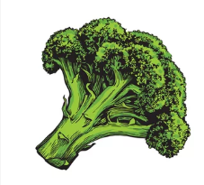 |  | What am I?  - I’m a rich source of vitamin C  - I’m classified in the group of the Brassica species  - I can be eaten raw or cooked  - I am a vegetable  - I’m dark green and very similar to cauliflower
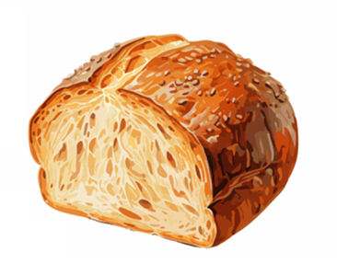 |  | What am I?
 |  | What am I?
 |  | What am I?
 |  | What am I?

Heads Up!

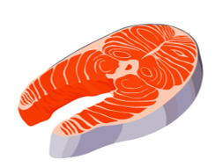
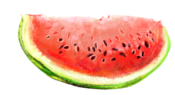

EPISODE 3
20th February 2024

KEY LEARNING
Students will develop a deeper understanding of platypuses and create a profile.

CURRICULUM
Science – Year 4
Living things depend on each other and the environment to survive.

Science knowledge helps people to understand the effect of their actions.

Science – Year 5
Living things have structural features and adaptations that help them to survive in their environment.

Science – Year 5 & 6
Scientific knowledge is used to solve problems and inform personal and community decisions.

Science – Year 6
The growth and survival of living things are affected by physical conditions of their environment.

  - Teacher Resource

Platypus Protection

Focus Questions
Discuss the BTN story as a class and record the main points of the discussion. Students will then respond to the following:
- What are some unique features of the platypus?
- Platypuses are monotremes. What does that mean?
- Where in Australia can you find platypuses?
- What are some threats to platypuses?
- What is being done to protect them?

Activity: See, Think and Wonder
After watching the BTN Platypus Protection story, students will respond to the following questions:
- What did you SEE in this video?
- What did you LEARN from this story?
- What do you WONDER about this story?
- What QUESTIONS do you have about this story?

Activity: Class Discussion
After watching the BTN story, hold a class discussion using the following discussion starters.
- Describe a platypus. What are some of their physical features?
- Platypuses are monotremes. What does that mean?
- Why are platypuses important to river ecosystems?
- Why is it important to protect platypuses?

Activity: Glossary
Students will brainstorm a list of key words that relate to the BTN Platypus Protection story. Below are some words to get students started.
PROTECTION | MONOTREME | MAMMAL
ECOSYSTEM | HABITAT | THREATENED

Activity: Platypus Research
Discuss the information raised in the BTN Platypus Protection story. What questions were raised in the discussion and what are the gaps in students’ knowledge? Students will develop their own question/s to research or choose one or more of the questions below.
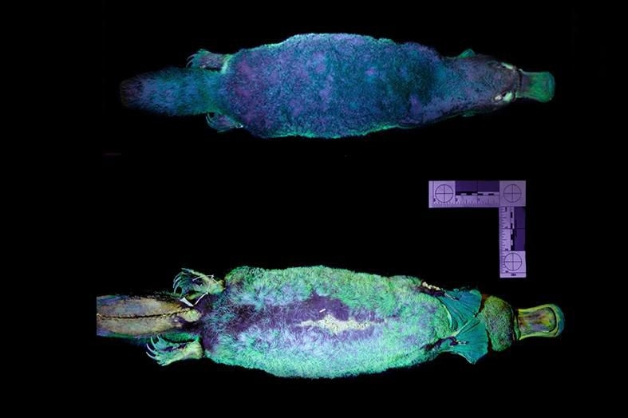
- How does the platypus use its unique features like its webbed feet and bill, to survive?
- What are the biggest threats to the platypus population?
- Why is the platypus well adapted to a semi-aquatic lifestyle?
- What are electroreceptors and how do platypuses use electroreception to find prey in the water?
- Platypuses fur glows green and blue under ultra violet light. What is biofluorescence and what do we know about why platypuses glow?

Activity: Platypus profile
Students will investigate the platypus and create a profile.

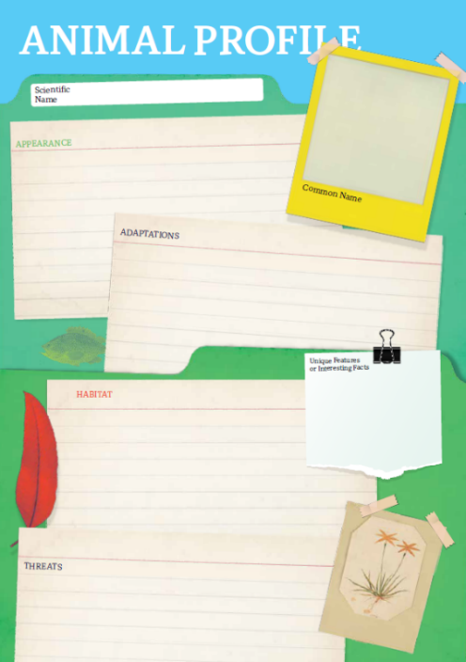
Research
Students will research the following and then share their research findings with the class or create a display in the classroom. Students can use the Animal Profile at the end of this activity.
- Illustration or photo
- Name (common and scientific name)
- Conservation
- Appearance
- Adaptations
- Habitat – where would you find platypuses?
- Threats
- Unique features

Activity: Features of a platypus
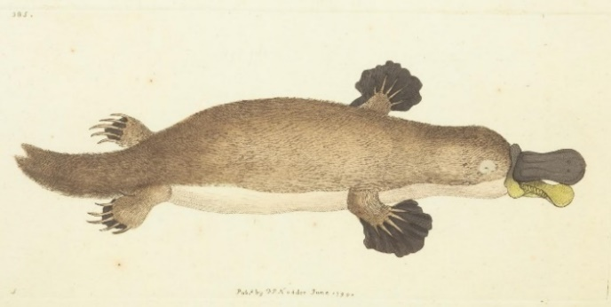
Students will create a labelled diagram of a platypus including the following information:
- A title
- An accurate drawing
- A scale to show size
- Labels to show features – webbed feet, flat tail, venomous spur (male only), bill, waterproof fur.

Activity – Platypus Dreaming Story
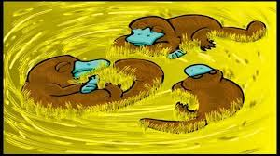
Students will explore Indigenous people’s connection to the platypus through Dreaming Stories. Listen to Biladurang - the Dreaming Story of how First Nations people believe the platypus got its features. Ask students to retell the story in their own words.

Activity – Choose a Project
Individually or in small groups, students will choose one of the following projects to work on and then present their findings to the class.

Platypuses and the ecosystem
Research the important role platypuses play in river ecosystems. Present your research in an interesting way.
Did you know?
Using the information in the BTN story and your own research, create a Did You Know fact sheet about platypuses. Publish using Canva.
Life cycle of a platypus
Create a diagram that shows the life cycle of the platypus from birth to adulthood.

Quiz
Create a true or false quiz to test your classmate’s knowledge about platypuses.

Activity: Platypus Quiz
- Platypuses are an introduced species.  A. True  B. False  2. Platypuses are…  A. Reptiles  B. Amphibians  C. Monotremes  3. What is the conservation status of the platypus?  A. Least concern  B. Near threatened  C. Extinct in the wild  Quiz Answers: 1 A, 2 C, 3 B, 4 B, 5 B, 6 A | 4. How do platypuses detect prey?  A. Magnetoreception  B. Electroreception  C. Echolocation  5. A baby platypus is called a…  A. Pup  B. Puggle  C. Cub  6. The platypus is on which Australian coin?  A. Twenty cent coin  B. Fifty cent coin  C. One dollar coin

Useful Websites
- Our animals: Lives of platypuses – ABC Education
- Platypus – Australian Museum
- What is a monotreme? – Australian Museum
- Platypus Return – BTN
- Platypus Census – BTN

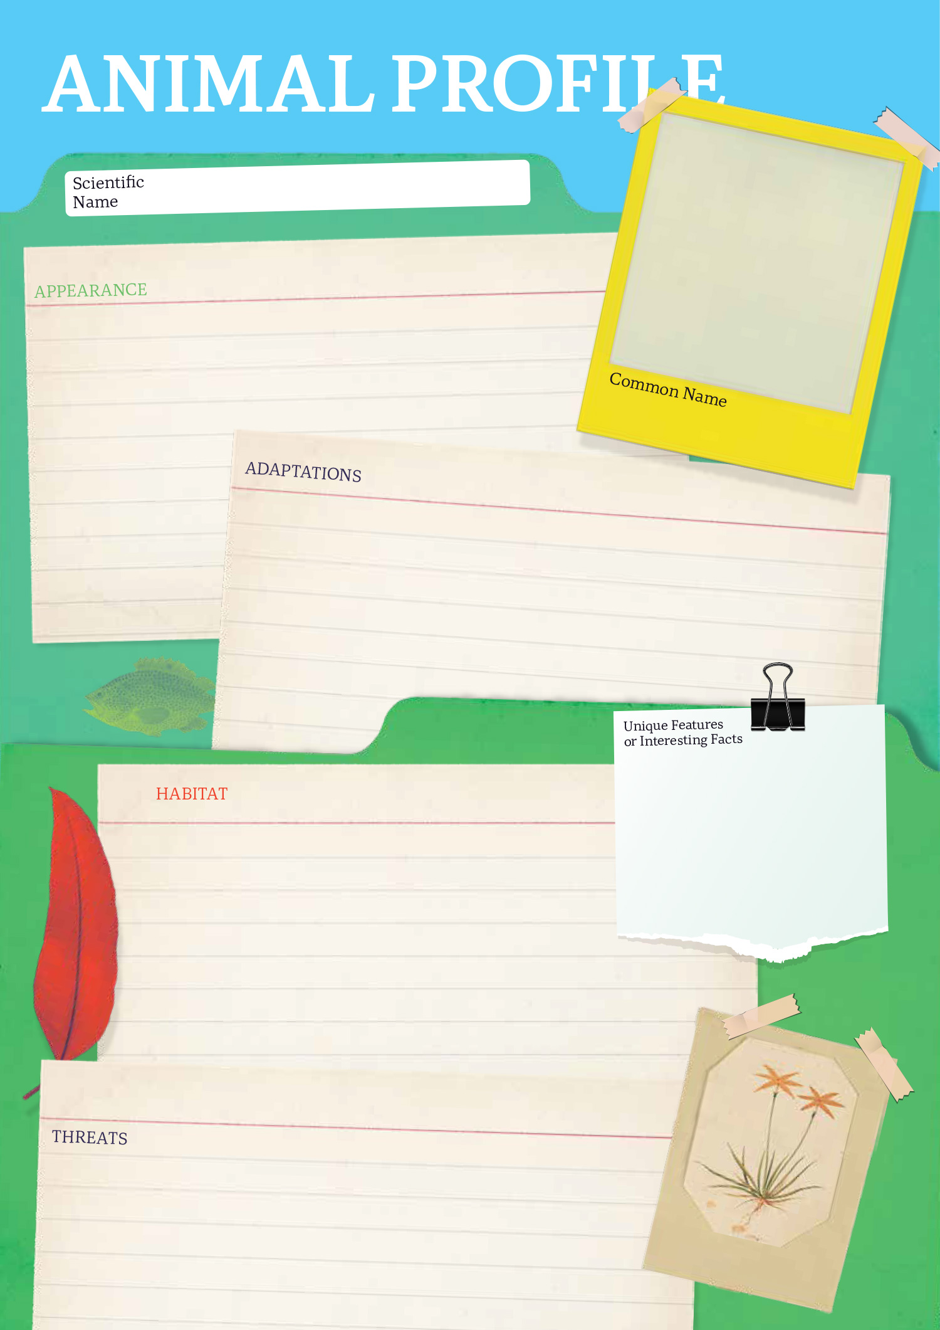

  - Teacher Resource

BTN Transcript: Episode 3- 20/2/2024

Hey. I'm Amelia Moseley and you're watching BTN. Thanks for hanging out with us again, lets see what’s coming up on today’s show. We find out about the mineral that's closed schools in Sydney, look at why this this classic snack might not be for sale at your school canteen and learn more about this mysterious monotreme.

Ukraine Anniversary

Reporter: Justina Ward

INTRO: All that soon but first today, to Ukraine. This Saturday marks two years since Russia invaded the country upending the lives of millions of people. Justina went to meet some young Ukrainians who have come to Australia to escape the war to find out how their lives have changed. Take a look.

Mariia: I came here to keep learning Ukrainian because I never want to forget my own language. Because language is culture.
For these kids, classes at the Ukrainian Community Centre are all about learning and celebrating their culture.
MAX: I'm doing stage two, language and culture.
SOFIA: We analyse like films; we write in Ukrainian.
For the past two years it's also been a great way to support each other.
Mariia: This school is so important to me because only here I met most of my friends.
LIZA: Here is Ukrainians that same as me have same story.
This Saturday will mark 2 years since their lives and the lives of millions of other people were changed when Russia invaded Ukraine.
Reporter: There are big explosions taking place in Kiev right now.
Andrii: When the war started, it was 24 or February 2022.
SofiIa: It was scary, I couldn't believe my ears eyes.
MAX: Mum said, that the war started. And then I was like having my breakfast. And like, we kind of didn't know what to do.
Mariia: When my mum said that war started. I asked, Do I need to go to school? Yeah, and she said, obviously no.
In the weeks leading up towards the invasion, Russian troops had been gathering around the border between Russia and Ukraine.
(PROTESTERS CHANT)
There'd been tension between the countries for many years and back in 2014, Russia invaded and took control of the Crimean Peninsula. But to many, what happened on the 24th of February was a huge shock.
Mariia: I even remember how on February 23, I was discussing with my friends at school, that it's like, really stupid to believe this and war will never happen.
MAX: I think it was kind of expected. But I, like just didn't believe it would happen.
Most people thought Russia with it's much bigger army would quickly win the war. But that didn't happen.

SOLDIER: We are going to win! I feel very good, very great.

Ukraine defended itself and the war become a long and brutal struggle.
ROSEMARY DICARLO, UNDER-SECRETARY-GENERAL FOR POLITICAL AND PEACEBUILDING AFFAIRS: Another year has passed, and we are no longer closer to the end of this illegal and unjustified war.
Hundreds of thousands of people have died in the conflict, and more than 6 million people have become refugees with some people making Australia their new home.
Andrii: My life has changed a lot. Because we flew to this country. We haven't done this before.
Mariia: I get to like change myself to fit into social norms. Like everything is different.
SOFIIA: It was really scary. We thought it would be for three days but now it's two years and yeah.
Of course a lot has changed in two years, not just for these guys, but for the world. And some are worried that the war in Ukraine is being forgotten.
MAX: I work at a swimming pool, and sometimes little kids even ask me if the war is still going.
SOFIA: I think there was a lot more attention towards the war. When it like initially happened. But it's like, now forgotten, and there's like more war going on, like in other places.
Ukraine has been relying on financial help from other countries, like the US. But lately, some politicians have been questioning whether support should continue.
Mike Johnson, U.S. Speaker of the House: The Republican-led House will not be jammed or forced into passing a foreign aid bill.
But other countries are still helping out.
Ursula von der Leyen, European Commission President: I think this €50 billion for four years also send a very strong message to Putin.
Volodymyr Zelenskiy, Ukrainian President: This is a clear signal that Ukraine will withstand, and that Europe will withstand.
But what most people want is an end to the war...
SOFIA: It's not going to be an easy escape. I don't know how long it will go for.
MAX: I hope the war will end as soon as possible.
SOFIIA: I’d really love for our people to stay alive and everything to be alright.
News Quiz

Which state was hit by a combination of destructive storms and bushfires last week? It was Victoria. More than 40 homes were destroyed in the Grampians by fires which were fanned by heat and high winds. Storms also knocked out powerlines and left thousands of people without electricity.

PM, ANTHONY ALBANESE: The Commonwealth is ready to do whatever we can to help Victorians through these hard days.

The world’s biggest single-day election has just taken place in Indonesia. Approximately how many people are thought to have voted? 50 million, 100 million or 200 million? It was around 200 million. That’s more than 20 times the number of Aussie voters. And this is the man who won the top job. 72-year-old Prabowo Subianto is a former military general with a controversial political history. He ran alongside the son of the outgoing president, Joko Widodo who has been really popular with Indonesian people.

What did Australia’s Prime Minister do on Valentines Day? He sent flowers to the opposition leader, he got engaged or he read out a poem in parliament? He got engaged. Anthony Albanese used the special day to pop the question to his girlfriend, Jodie Haydon.

PM, ANTHONY ALBANESE: I asked on the balcony, or one of the balconies…

Taylor Swift has played to the biggest crowd of her career at the MCG. How many people packed into the cricket ground to see her perform? Was it 76,000, 96,000 or 106,000? It was 96,000 which is the biggest crowd that’s ever come to see a female performer.

CONCERT GOER: Taylor Swift is my life.
CONCERT GOER: Literally the best.

Asbestos History

Reporter: Jack Evans

INTRO: Now, if you live in Sydney you might have seen some signs like this around. A whole bunch of sites around the city, including some schools, have been closed after asbestos was found in garden mulch. Jack looked into the history of asbestos and why it's causing so much trouble.
ADVERTISEMENT: Untouched by time’s dark captains, rust, rot and decay. Asbestos possesses rare qualities for which it stands alone.
It was once hailed as the magic mineral, so what is it? Asbestos is a naturally occurring and has long, thin fibres. It's both fire and water resistant which is what makes it magic or at least very hard to destroy.
The Greeks had a name for it. They called it the unquenchable, indestructible stone.
The Ancient Greeks and Romans wove asbestos into a material to make clothing and blankets. But it was around the time of the industrial revolution that it really took off. Because it doesn't conduct heat or electricity, asbestos was perfect for insulating things like steam pipes, turbines and ovens.
REPORTER: A most important use for Asbestos is in the form of winter coats for aero oil engines to keep them at an even temperate.
By the 20th Century it was commonly used as a building material in fire protective wear and well in all sorts of things actually.
REPORTER: The practical uses of asbestos are very numerous, at least 18,000 articles are made of it.
Several films including the Wizard of Oz and It's A Wonderful Life used asbestos to recreate snow. Because, well a, I guess it kinda really looks like snow.
COWARDLY LION IN WIZARD OF OZ: Unusual weather we're having ain't it.
But over time, we started to learn that perhaps asbestos wasn't as magical as we'd once thought. People working with asbestos in factories and mines began getting really sick. You see the almost invisible tiny fibres that make up asbestos can get stuck in our lungs if we breath them in and cause cancers and other diseases. But asbestos mining continued for a long time. Here in Australia entire towns were built around asbestos mines which provide jobs for thousands of people and for a long time we were the biggest users of Asbestos in the world.
But as more and more people got sick and the public learnt more about the dangers of asbestos, attitudes towards it began to change. During the 70's and 80's there were big meetings between countries to address the asbestos health crisis, mines closed, and companies stopped using it in their products.
VOICE ACTOR: You might not know it but homes built or renovated before 1987 may contain asbestos.
In 2003 the Australian Government completely banned the use of asbestos and there have been huge efforts to safely remove it when it's found. But there are many buildings that still contain asbestos materials, which is why the signs are a thing. It's also why it was such big news, when particles of asbestos were found in mulch across Sydney.
PRUE CAR, NSW DEPUTY PREMIER: We acted as soon as we were aware of this.
CHRIS MINNS, NSW PREMIER: That kind of asbestos being found in a park in Sydney is deeply worrying.
A lot of the contaminated areas have since been closed off including schools, parts of a hospital and several parks. There are more tests going on to try and find out how the asbestos got there and where else it might have ended up.
While it might seem a little scary, most of the asbestos that has been found is what's known as bonded asbestos which means it's mixed with something to make it solid like cement or resin so there's a lower risk of someone breathing it in. Still, authorities are taking it all very seriously, the government's set up a special task force to look into what happened and clean-up is underway to get rid of the mulch and keep everyone safe from this, not so, magical mineral.

Did You Know?

Did you know the town of Wittenoom in Western Australia has been completely closed because of asbestos contamination. It was the site of an asbestos mine and once home to more than 800 people but now it's completely empty and the government is bulldozing the remaining buildings.

School Lunch Rules

Reporter: Josh Langman

INTRO: Now to the school canteen, and what you can and can't buy there. Recently there was a bit of controversy when a couple of states updated their guidelines on what should be served in schools and recommended that a couple of classics be kept off the menu. Josh found out more.

HIRING MANAGER: Michael Ferr- uh Ferr Michael Ferry?
MICHAEL FERRY: It's pronounced "Fairy".
HIRING MANAGER: Um come on in. So, can you tell me a little bit about your previous experience?
MICHAEL FERRY: Yeah, I'm the fairy bread fairy. I used to make all the fairy bread.
HIRING MANAGER: Oooh, yes. I remember eating heaps of that stuff. So, um why do you need a job here?
MICHAEL FERRY: 'Cause I got fired.
JOSH LANGMAN, REPORTER: Yeah, the fairy bread fairy might not have as much to do anymore. At least in South Australia.
MICHAEL FERRY: Sorry, what was the question?

NEWSREADER: Is fairy bread biting the dust?
NEWSREADER: Fairy bread has been removed from the approved canteen menu.
NEWSREADER: South Australian public schools will cull Aussie staples like fairy bread.
You see, the state's education department recently announced it had made some tweaks to the guidelines they give schools on what sort food should be sold at canteens, and handed out at after-hours care, excursions, and class parties. They use a system of traffic lights to categorise different foods depending on how healthy they are.
MATTEA PALOMBO, DIETITIAN: It's a guideline to help people to understand, like, what to provide, and what's going to be most beneficial for children to be eating most of the time.
According to the system, green foods, you can have whenever you want. Amber foods, you should be more careful with. Red level 1 foods should only be served up to twice a term, and then there's red level 2 foods, which they say shouldn't be served at all, which now includes fairy bread. Probably because of those sugary hundreds and thousands. Some other states have a similar system, and WA's also made the news recently by adding ham and cheese toasties to the no-go list.
MATTEA PALOMBO, DIETITIAN: So, Ham is a processed meat. And I believe that would be the reasoning behind that. So we want to be limiting our intake of processed meat because it increases our risk of bowel cancer.
And while toasties and fairy bread got all the attention, the states also added a whole bunch of other types of food to the red list, like energy drinks and caffeinated food.
MATTEA PALOMBO, DIETITIAN: There is so much more variety now of food, and we just need to keep up to date with what we're putting on that guideline.
But while Mattea says there are really good reasons for having the guidelines and keeping them updated, it's also controversial. And it's not just because of people's fondness for fairy bread, but also because some reckon it's important for kids to have choice, and that we shouldn't be labelling foods as "never foods".
MATTEA PALOMBO, DIETITIAN: Some kids might have a balanced diet at home and going to the canteen is their sometimes food where they get the lollies, or they get the fairy bread. They might not give us nutrition, but they give us joy, and happiness, and they give us childhood memories.
And it looks like kids in South Australia have mixed feelings.
KID 1: It's more of a family related thing to stop their children from eating those unhealthy snacks.
KID 2: It’s a sometimes food and it should be not eaten very often.
KID 3: I mean, it's fair, but people should have more freedom to what they eat.
KID 4: They might be a little disappointed that someone else controls how they eat or what they eat.
In any case, none of this means your favourite foods are getting banned. The recommendations don't apply to what you bring to school in your lunchbox, and, at the end of the day, they are just recommendations.
BLAIR BOYER, SA MINISTER FOR EDUCATION, TRAINING AND SKILLS: The guidelines only apply to canteens, and they are guidelines. Parents are certainly still free to include fairy bread in their kid's lunchboxes if they wish.
HIRING MANAGER: You hear that? Fairy bread can still go in the lunchbox.
MICHAEL FERRY: So, you're saying I'm, I'm not out of a job? Yes. I can still make fairy bread; I can still make fairy bread. I can still make fairy bread. I can still make fairy bread.

Platypus Protection

Reporter: Josh Langman

INTRO: Now, have you ever seen a platypus? If you have - you're lucky. They're pretty hard to spot in the wild. But they can be seen at a new refuge at Taronga zoo that's been designed to help protect them. Josh found out more about it and why these little duck billed mammals are so special.

SCIENTIST JOSH: It's alive, it's alive.
JOSH LANGMAN, REPORTER: Yeah okay, so if you haven't figured it out already, that is not at all how the platypus came to be. But it's actually not that far from what people thought happened.
See, when British scientists first came across this little guy way back in the late 1700s, they were convinced it wasn't a real animal. And who could blame them? With webbed feet and the bill of a duck, mixed with the tail of a beaver, and the body of an otter - it does kind of seem like somebody just glued a bunch of random animal parts together. But that doesn't make platypuses any less cool.
Evidence of the platypus’ existence, or at least a member of its family, dates back over 60 million years. And that was back when Australia, Antarctica and South America were all the same continent. Fast forward in time, and now, these little mammals are only found down under.
Other very cool facts about the platypus include: like sharks, they use electrical impulses to detect objects and find food underwater, they're one of the only two mammals in existence that can lay eggs and when you put them under UV light, they glow. Seems pretty cool if you ask me.
So it's no surprise this unique animal has such a big place in Aussie hearts. Oh - and on our coins, too. If you know where to look - and you're lucky - you can find them on the Eastern side of Australia, in fresh-water creeks, and slow moving rivers. But even though they've been legally protected since 1912, they're far from safe.
DR PHOEBE MEAGHER, WILDLIFE CONSERVATION OFFICER: Platypus are on the decline, their population is steadily declining, unfortunately. Because they have a semi aquatic and semi terrestrial lifestyle, they get impacted by both drought, flood, but then also bushfire.
It's those things, along with land clearing, pollution, and other man made hazards that have caused platypus numbers to drop, to what experts think could be as low as 30,000. Which is why conservationists around the country have been hard at work getting them back on their webbed feet, including the ones here at Taronga Western Plains Zoo in Dubbo.
They've just opened a $12.1 million dollar Platypus conservation centre that's the largest of its kind in the world. And its home to not only a specially designed platypus exhibit, but also research facilities so that scientists can learn more about our little billed buddies. There are also 75 water tanks to house platypuses in crisis, along with special areas where they can recover and get ready to go back in the wild, where they belong.
Quiz

What's the name of a mammal that can lay eggs. Is it a marsupial, a monotreme or a placental? It's a monotreme. Platypus and echidnas are the only existing monotremes in the world.

Sport

The best of the NBA have come together to show off their skills at the Allstars Weekend in Indianapolis. Thre was the traditional dunk contest and in the All Star Game which the East All-Stars took out, 211 to 186.
Now to the pool where Australia's cleaned up at the World Aquatics Championships Isaac Cooper soared up the side of his lane in the 50m backstroke beating the world record holder from the USA by point two seconds.

ISAAC COOPER: I’ve been waiting a very long time to be able to stand on a long-horse podium.

The women's relay team also pulled ahead right at the end of a very tight race.

SPORTS COMMENTATOR: That came down to the absolute last stroke there.

Adding another gold to the 24 medals Australia collected over the championships.
And finally to the Desert X Prix in the Saudi Arabian desert. Where these electric SUVs have been tearing through sand, sand and more sand. It's a race that aims to bring global attention to areas impacted by climate change through fast cars, epic jumps and again -- a whole lot of sand.

Takeover Melbourne - Shriya
Rookie Reporter: Shriya

INTRO: Finally, today we're going to meet another winner of the Takeover Melbourne competition. It asks young Melburnians to share stories about their lives and the things that are important to them and for Shriya that's a type of classical Indian dance.

SHRIYA: Even though I love performing, I've always struggled with the nerves. I practise the steps in my head over and over again.

It takes about three hours to prepare for a concert. Appa does my makeup, while Amma dresses me. The red dye draws attention to our movements. The bells on our ankles intensifies the rhythm. The make-up around our eyes adds to the expressions.

Today, I am performing Bharatanatyam at the Sri Vakratunda Vinayagar temple. Bharatanatyam is an ancient Indian classical dance used to express emotions with melodies and rhythms. It is also used to express Hindu stories and devotion. Every hand gesture has a meaning. This move represents Lord Shiva, my favourite of the Hindu gods.

I find myself immersed in a world where I am not me, but a character in the story I'm telling. I started learning from my guru when I was 5.

I love to dance, but performing was tough. At times, it was debilitating. At one of my first concerts in front of 500 people, I forgot the moves, and a wave of fear overcame me. Suddenly, I froze. There was an invisible barrier that stood between me and my passion: stage fright. It is a performer's worst nightmare. The fear of messing up.

But as the years unfolded, I grew stronger in confidence with each performance. Through rigorous practice and discipline, I gained a profound respect for the artform, and I was able to truly embrace my talent. And instead of letting the fear control me, I was able to control it. Now when I'm on stage, I stand with confidence, unintimidated by the crowd. I am not afraid anymore. I embrace the warmth of the spotlight.

Closer

Wow, Shriya you're so good, keep it up. Well, that's it for today but we'll have more stories for you next week, and in the meantime, you can jump online and keep up to date with Newsbreak and BTN High. Have a great week and I’ll see you soon. Bye!

