Teacher Resource

Episode 19

23rd July 2019

**Moon Landing Special**



Students will investigate the relative sizes and movement of Earth, the Moon and the Sun. Students will explore Australia’s contribution in the Moon landing.

Students will investigate what it would be like to live on the Moon and what would be needed to sustain human life.



**Science – Year 3**

Earth’s rotation on its axis causes regular changes, including night and day.

**Science – Years 5 & 6**

Scientific knowledge is used to solve problems and inform personal and community decisions.

**Science – Year 7**

Predictable phenomena on Earth, including seasons and eclipses, are caused by the relative positions of the sun, Earth and the moon.

Scientific knowledge has changed peoples’ understanding of the world and is refined as new evidence becomes available.



**Space Race**

1. Discuss the BTN *Space Race* story as a class and record the main points of the discussion.
2. What was the name of the war between the United States and the Soviet Union in which they never directly fought each other?
3. What was the name of Earth’s first artificial satellite?
4. Which country was the first to launch an artificial satellite into Earth’s orbit?
5. Why was NASA created?
6. How did the US and Soviet Union test technology before sending humans into space?
7. Who was the first human to be launched into space?
   1. Yuri Gagarin
   2. Alan Shepard
   3. Neil Armstrong
8. What challenges did the US and Soviet Union face in their race to get to the Moon?
9. What did the crew of Apollo 8 do during their orbit of the Moon?
10. What questions do you have after watching the BTN story?

**Apollo 11**

1. Briefly summarise the BTN *Apollo 11* story.
2. How many astronauts were on Apollo 11?
3. How far is the Moon from Earth?
4. What was the name of the rocket that Apollo 11 took off from?
5. What was the name of the Apollo 11 Command Module?
   1. Snowcone
   2. Columbia
   3. Eagle
6. What words would you use to describe the landing of the Eagle on the Moon?
7. Complete the following sentence. “It’s one small step for man, one giant leap for ___________”.
8. What did Neil Armstrong and Buzz Aldrin collect while on the Moon?
9. Why did the crew have to be quarantined for 3 weeks once they returned to Earth?
10. Illustrate an aspect of the Apollo 11 story.

**Apollo 11 and Parkes**

1. Retell the BTN *Apollo 11 and Parkes* story using your own words.
2. What date did Aussies get to watch the Moon landing on TV?
3. Where are the 3 Australian stations that played a role in the Apollo 11 mission? Find using Google Maps.
4. What did scientists at Honeysuckle and Tidbinbilla stations do during the mission?
   1. Monitor the ship’s status
   2. Monitor the astronauts’ heart rate
   3. Monitor data inside the astronauts’ suits
   4. All of the above
5. What station relayed to the world the first images of Neil Armstrong setting foot on the Moon?
6. How big is the Parkes radio telescope dish?
7. What happened to the Parkes radio telescope just before it broadcast the Moon landing?
8. What is the name of the film that tells the story of the Parkes Observatory’s role in the Moon landing?
9. NASA stayed on the vision from Parkes for the rest of the 2 and a half-hour broadcast. True or false?
10. What did you learn watching the BTN story?

**Space Future**

1. What did the BTN *Space Future* story explain?
2. Explain what the students in the *Space Future* story are doing.
3. What do the kids in the story hope to do in the future?
4. When do experts think humans will make it to Mars?
   1. 5 years
   2. 25 years
   3. 50 years
5. What year does NASA hope to return astronauts to the surface of the Moon?
6. Complete the following sentence. NASA is building a spacecraft that will orbit around the ________.
7. Give an example of what space programs around the world have achieved recently.
8. Australia has its own space agency. True or false?
9. Illustrate an aspect of the *Space Future* story.
10. What did you like about the BTN story?



**Class discussion**

Before watching the BTN *Moon Landing Special* students will brainstorm a list of questions they have about the Moon. For example:

* How big is the Moon compared to Earth?
* How far is the Moon from the Sun and Earth?
* How long does it take for the Moon to orbit Earth?
* Why does the Moon appear to change shape each night?
* What is a lunar eclipse?
* Why can I sometimes see the Moon during the day?



**What do you see, think and wonder?**

After watching the BTN *Moon Landing Special* ask students to respond to the following:

* What did you SEE in this video?
* What do you THINK about what you saw in this video?
* What did you LEARN from this video?
* What was SURPRISING about this video?

Hold a class discussion about the information raised in the BTN special. Which of your students’ questions (from the class discussion) were answered? What questions weren’t answered that your students want to explore in more detail? Students will use the KWLH organiser below to help organise the questions raised in your class discussion and find out the gaps in their knowledge.



**KWLH**

The KWLH organiser provides students with a framework to explore their knowledge on the topic of Apollo 11 and space exploration and consider what they would like to know and learn.

|  |  |  |  |
| --- | --- | --- | --- |
| ***What do I know?*** | ***What do I want to know?*** | ***What have I learnt?*** | ***How will I find out?*** |
|  |  |  |  |

**Research questions for inquiry**

Students will determine a focus for their inquiry and develop a key question to guide their inquiry (below are some examples). Students will collect and record information from a wide variety of sources (internet, books, newspaper and magazines).

* Research and prepare a profile on Earth’s Moon. Include the following information: distance from Earth, how long it takes to orbit Earth, the minimum/maximum temperatures of the Moon and geographical features of the Moon. Include any other interesting facts you find.
* What are the relationships between Earth, the Moon and the Sun? Draw a diagram showing the relative sizes and movement of Earth, the Moon and the Sun. In your description include words like orbit, revolution and axis.
* How does gravity affect the Moon? Investigate Earth’s gravitational pull on the Moon and explain why we only ever see one side of the Moon.
* How can we see the Moon? Explain why we can sometimes see the Moon during the day.
* Why does the Moon appear to change shape each night? Explore the phases of the Moon using illustrations to help explain the different phases. Consider observing the Moon at night over a month. Record the date and time of your observations, draw what you see and describe the Moon’s shape and appearance.
* How will space exploration change in the future? Make a prediction about how space exploration will change in the future. Illustrate your prediction/s and provide an explanation.



**Timeline – History of space exploration**

Students will investigate the history of space exploration and present the information they find on a timeline. Below are some key events in the history of space exploration:

* 1957 – Sputnik, first artificial satellite launched into space
* 1961 – Yuri Gagarin, first person to enter space
* 1969 – Apollo 11, Moon landing
* 1990 – Launch of Hubble Space Telescope
* 1998 – Launch of International Space Station
* 2011 – Curiosity launches to Mars
* 2019 – First image of black hole released



Students will present their information on a timeline and respond to one or more of the following research questions:

* Find 1-3 interesting facts about each significant event on your timeline. Why are they significant?
* How has technology used in space exploration changed over time?
* Imagine if you were the first person to land on the Moon. Write a journal describing your experience including the challenges you face on the mission.
* How have advancements in space technology helped us on Earth? Research an invention which has come from the Apollo 11 mission, for example microchips, insulation, cordless tools, satellite television and water filters. Research why the technology was needed for the Apollo 11 mission and how the invention helps us in our day-to-day living on Earth now.
* Which dates on the timeline do you think are especially significant? Why?
* Look back on major events of 1969, the year of the Moon landing, to learn more about what was happening during that time. Choose one significant event from 1969 and create your own BTN style news story. Use the internet or search for newspaper articles in a library to help with your research.



**Research project – Apollo 11**

Students will explore the Apollo 11 space mission in detail and use the following questions to guide their research.

* Briefly summarise the mission.
* When did the mission take place?
* What was the purpose of the mission?
* Who was the crew? What were their roles?
* What did the mission discover?
* Which countries were involved in the mission?
* How has the mission helped us understand the Solar System and beyond?
* What were some challenges of the mission?
* Include photographs and diagrams in your research project.

**Further investigation**

Students will choose one of the following to investigate further:

* Imagine you are a reporter on Behind the News in 1969. Write a news article reporting on the Apollo 11 mission.
* Imagine you are one of the astronauts on the Apollo 11 mission. Write a journal entry in your diary about your experiences before, during or after the mission.
* How has space exploration changed since the first landing on the Moon. Make comparisons between now and then. Make predictions about future space missions and exploration. Include illustrations with your prediction.



**Interview – Memories of the Moon landing**

Students will interview someone who remembers the Moon landing and ask them to share their memories about the event. Students will prepare a list of questions, conduct the interview and then share their interview findings with the class. Below are some example questions.

* How old were you when man first landed on the Moon?
* Do you remember where you were?
* Did you watch it on TV or listen to it live on the radio?
* What are your strongest memories of the event?
* How did the event make you feel?
* Why do you think it was such a significant event?

Alternatively, students will imagine they are a reporter from 1969 and they have been given the opportunity to interview an astronaut from the Apollo 11 space mission. Students will need to think about the questions they would like to ask the astronaut. Students will write a list of questions and then try to find answers to their questions. Below are some example questions.

* How were you chosen to be a part of the Apollo 11 mission?
* How did you prepare for the mission?
* How long was the mission? What happened on each day?
* What were some of the challenges you faced during the mission?
* Describe your feelings before, during and after the mission.



**Research – Australia’s involvement in Apollo 11**

Students can choose one or more of the following research questions or come up with their own:

* How did Australia help show the world the Moon landing?
* Why was the Parkes telescope used to receive and send transmissions from the Moon to NASA?
* How has the film ‘The Dish’ helped Australians learn about Parkes and its role in the Moon landing?

**Create a Kahoot Quiz**

Use [*Kahoot!*](https://getkahoot.com/)to test students’ knowledge about Parkes and its role in the Moon landing. Quizzes can be created to recap learning or test personal knowledge. There is also the option to connect with classrooms around the world and play kahoot in real time.



**Class discussion – Space future**

Hold a class discussion about the information raised in the *Space Future* story. Create a class mind map about space exploration asking students to record what they know. Use the following questions to guide discussion:



* Why should we explore space?
* Is space exploration important? Why or why not?
* Is it important for Australia to be involved in space exploration? Why or why not?
* What are some of the benefits of space exploration?
* Are there any disadvantages? What are they?
* How has space exploration changed since the 1960s?
* What is the future of space exploration?
* Name an Australian astronaut that has gone into space. Create a profile.

**Further Investigation – Living on the Moon**

Students will investigate what it would be like to live on the Moon and what would be needed to sustain human life. Watch [The Living on the Moon video](http://splash.abc.net.au/home#!/media/1902269/living-on-the-moon) and the [BTN Moon Living video](http://www.abc.net.au/btn/story/s4071849.htm) to find out more.

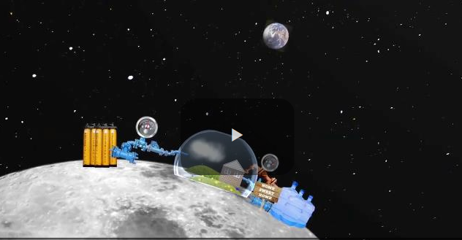 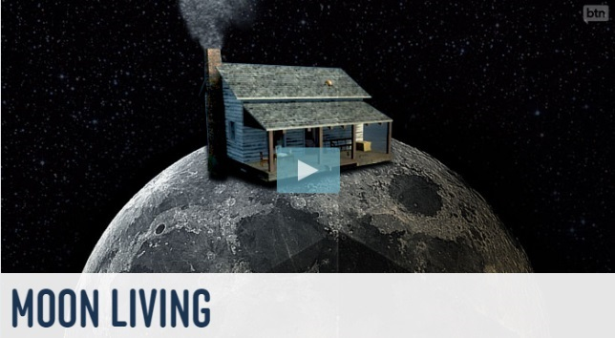

Begin with a class brainstorm using the following questions to guide discussion:

* What are the three basic things we need to survive?
* What do you think it would be like to live on the Moon?
* What are the challenges?
* What are the benefits of having a space settlement on the Moon?
* When planning for life on the Moon what are some important things to think about?

Students will then need to research conditions on the Moon, so they can plan and design a settlement on the Moon that will sustain human life.

* What are the conditions like on the Moon?
* What needs to be considered when planning a colony on the Moon? For example:
  + Water supply
  + Atmosphere (air supply)
  + Temperature
  + Food Production
  + Waste Management
  + Gravity
* What materials could be used to build a space settlement?

Students can create either a model or a labelled diagram of their `Moon settlement’. Display students’ work in a public space in the school.



[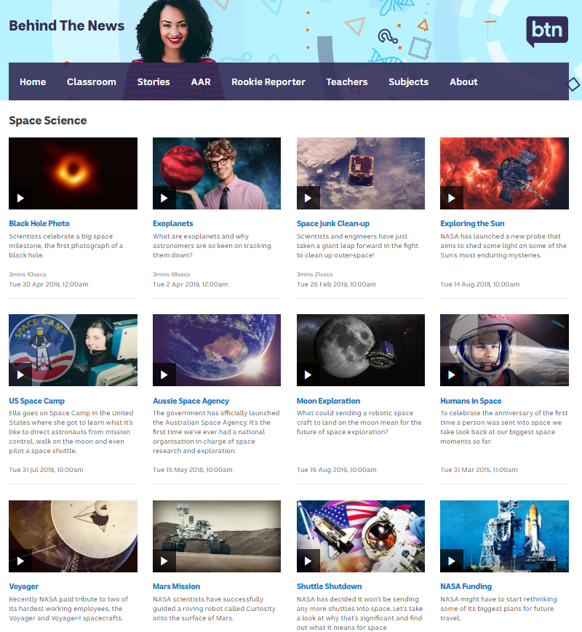](https://www.abc.net.au/btn/space-science/10614248)**BTN Space Science stories**

Visit BTN’s collection of stories which focus on space science and space exploration.

After watching any one of the BTN videos ask students to respond to the discussion questions (to find the discussion questions and teacher resources go to the related BTN Classroom Episode and download the Episode Package).

**Link to collection of BTN Space Science stories**

<https://www.abc.net.au/btn/space-science/10614248>



BTN – Moon Exploration  
<http://www.abc.net.au/btn/story/s4517911.htm>

ABC – The Moon and Beyond

<https://www.abc.net.au/news/science/>

BTN – Humans in Space

<https://www.abc.net.au/btn/classroom/humans-in-space/10526760>

National Geographic Kids – 10 facts about the Moon

<https://www.natgeokids.com/au/discover/science/space/facts-about-the-moon/>

ABC News – Pocket Guide to the Moon

<https://www.abc.net.au/news/2019-07-16/pocket-guide-to-the-moon/11260558>

NASA – Earth’s Moon

<https://solarsystem.nasa.gov/moons/earths-moon/overview/>

NASA – Apollo 11

<https://www.nasa.gov/mission_pages/apollo/apollo-11.html>

**BTN Transcript: Episode 19 – 23/7/19**

NEIL ARMSTRONG, ASTRONAUT: It’s one small step for man, one giant leap for mankind.

AMELIA MOSELEY, REPORTER: It was 50 years ago that the world first saw those pictures and heard those now very famous words as Neil Armstrong became the first person to set foot on the Moon. I'm Amelia Moseley and today we’re bringing you a very special episode of BTN from here at the CSIRO Parkes radio telescope in New South Wales. All to celebrate the 50th anniversary of the Moon landing. Let's see what’s in store. We'll find out what it took to get to the Moon. Learn more about Australia's role in that historic moment. And explore the future of space travel.

Space Race

Reporter: Emma Davis

*INTRO: But before we get to that let's go way back to the beginning, to a time before smartphones or the internet to find out why anyone had the crazy idea of going to the Moon in the first place. Let’s find out more about the scientists, the explorers, and the world events that played a part in what's known as the space race.*

EMMA DAVIS, REPORTER: Space travel has been dreamt about for a long time by artists and writers and scientists. But it wasn't until the 20th century that scientists made leaving Earth a real possibility.

World War 2 saw huge advancements in rocket science as both sides worked on missiles that could travel huge distances. Once that war ended, many of those same scientists played a part in the Cold War between the United States and the Soviet Union, a collection of communist states that included Russia. They were the world's most powerful countries at the time and while they'd fought together in the Second World War, they had very different political systems and were competing for power. While they never directly fought each other, they were working on powerful weapons including missiles that would be able to launch objects into space.  
  
On July 29, 1955, the US announced its plan to put an artificial satellite into Earth's orbit. Four days later, the Soviet Union made the same promise, and so began the space race. For scientists, especially in the USSR, it was a wonderful opportunity. They'd worked on space technology for decades and finally their leaders were spending money on their research.

On the 4th of October 1957, the Soviet Union launched Sputnik, Earth's first artificial satellite. It was only 58 centimetres in diameter and its batteries only lasted three weeks but Sputnik's journey taught experts all over the world a lot about Earth's atmosphere. It was a massive win for the Soviet Union. In response, US President Dwight Eisenhower signed the National Aeronautics and Space Act creating NASA which was set up to take care of all non-military space activity.  
  
The next step for both countries was human space travel. They tested the technology with dogs, monkeys and other small creatures and in 1961 the Soviets hit another milestone. On the 12th of April Yuri Gagarin became the first human launched into space. His capsule, Vostok 1, went around Earth once before he ejected from the capsule and landed with a parachute. One month later Alan Shepard became the first U-S astronaut to orbit Earth. The job of those early space explorers was incredibly dangerous. They were doing something that no-one had done before and testing technology that was still in its very early stages. But in 1962 the new US President announced an even bigger goal.  
  
JOHN F. KENNEDY, US PRESIDENT: We choose to go to the Moon in this decade and do the other things, not because they are easy, but because they are hard.  
NASA created Project Apollo and Project Gemini with the aim of developing the technology needed to put humans on the Moon. Of course, while the US was racing towards the Moon, the Soviet Union was doing all it could to get there first. Their haste led to problems on both sides and there were tragedies, like the death of cosmonaut Vladimir Komarov during a spaceflight and a fire that killed the crew of the first Apollo mission during a ground test. That was a huge blow for NASA, but Apollo kept going as scientists developed better and safer technology. In 1968 the crew of Apollo 8 became the first humans to orbit the Moon. They tested out communications, scouted for landing sites and took the most amazing photos anyone had ever seen of our home. Finally, the US was leading the space race and was almost ready to take on the next challenge, man's first steps on the Moon.

Apollo 11

Reporter: Matt Holbrook

*INTRO: Less than a year later NASA was finally ready for the main event. A manned trip to the Moon. The mission was called Apollo 11 and it was crewed by Michael Collins, Buzz Aldrin and Neil Armstrong. Let's find out more about their amazing journey.*

MATT HOLBROOK, REPORTER: July 16th, 1969 was definitely not a normal day. Especially if you were one of these three guys. After years of training, planning and preparation, Neil Armstrong, Michael Collins, and Buzz Aldrin were about to go the Moon. Yeah. The actual Moon, just a lazy 384,400 kays from Earth.  
  
BUZZ ALDRIN, ASTRONAUT: It was such a unique opportunity that was presented to a group of us who came along as pilots, to be given the opportunity to go into space and to go and maybe land on the Moon. What a wonderful thing that I’m here. What a magnificent achievement it is for humanity.  
   
NASA CONTROL: Ten, nine, ignition sequence start, six.  
  
Apollo 11 took off on a Saturn Five rocket, still the tallest, heaviest and most powerful rocket ever built. It was built in stages, designed to break off and fall to Earth once the fuel had been burnt up. At the very top was a small command module, where the crew spent three days eating and sleeping and exercising and going to the toilet. Apparently, the crew wanted to call it Snowcone, but NASA thought Columbia was more appropriate. It was attached to the lunar module, named Eagle, designed to take Buzz and Neil to the surface, while Michael waited in Columbia. But landing Eagle was tricky.  
  
NEIL ARMSTRONG, ASTRONAUT: Four forward, drifting to the right a little.   
  
NASA control, and the world, held its breath and then.  
  
NEIL ARMSTRONG, ASTRONAUT: Tranquillity base here, the Eagle has landed.  
  
NASA CONTROL: Tranquility, we copy you on the ground, you got a bunch of guys about to turn blue, we're breathing again. Thanks a lot.  
  
Neil Armstrong was the first to step out of the lunar lander, becoming the first human to set foot on another world.   
  
NEIL ARMSTRONG, ASTRONAUT: It's one small step for man, one giant leap for mankind.  
  
I love this line, but apparently, he meant to say one small step for a man. Not for man. But it's still a great line. Then it was Buzz Aldrin's turn. Neil and Buzz collected nearly 22 kilograms of Moon rocks and dust, set up the American flag, and, of course, took these incredible photos.  
  
NEIL ARMSTRONG, ASTRONAUT: The important achievement of Apollo was a demonstration that humanity is not forever chained to this planet and our visions go rather further than that and our opportunities are unlimited.  
  
After an astronaut sleepover onboard Eagle, Neil and Buzz rejoined with Michael and made for home. They landed safely as heroes, but then had to spend 3 weeks quarantined in a caravan. Just in case they'd picked up any alien diseases. By the time they got out, they were famous faces. There were giant parades and celebrations around the world, including here in Australia. In the years that followed, NASA sent more people to the Moon. But it was the original journey that captured the imagination of people everywhere.  
  
BUZZ ALDRIN, ASTRONAUT: We learned quite a lot out of going to the Moon. And now to go to a much bigger, much grander objective, of another planet in our Solar System. Eventually humans will leave the Sun and the Solar System and go to other stars. Eventually. Not in my lifetime or yours, but we'll learn how to do that.

Quiz

What’s the name of the place on the Moon where the Eagle landed? Was it:

The Sea of Storms  
The Sea of Tranquility or

The Sea of Troubles  
  
It was the Sea of Tranquility. It's not actually a sea, it's a flat area of rock called a mare formed by an ancient lunar volcano.

Moon Landing Memories

Reporter: Emma Davis

*INTRO: Imagine what it would've been like to watch in real time as humans did something we once thought was impossible. Well there are plenty of people who remember the Moon landing, probably even some of your family members. We asked kids to ask their grandparents what that historic day was like.*

HOLLIE: How old were you two both when the landing of the Moon happened?

RHONDA: 27.

HOLLIE: And what about you?

LEN: 23.

JAMES: How old were you in 1969?

JOYCE: I was 40 wasn’t I.

MILLIE: Where were you guys when all of this happened?

KATE: That's the thing I remember best because we got the afternoon off school.

JENNY: We were living in Boston in the United States.

JOHAN: I'd been a teacher in Bloemfontein, it's in the middle of South Africa in the free state.

BERNHARD: I was at work. I worked for CSIRO, division of soils in those days.  
  
IAN: Yeah, I was still at school, and we all, the whole school stopped. And we all just looked at it on an old TV, a TV that you had to turn the channels, clunk, clunk, clunk. There was no remote control.   
  
JOHAN: We didn't have television in South Africa in those days, so we had to rely on the radio for news.

JENNY: And it was late evening after dinner and we stayed up and watched.   
  
ZENYA: How did the Moon landing make you feel?

BERNHARD: It was the culmination of waiting for about 10 years. I had been waiting for this with anticipation, following the Apollo series.  
  
RHONDA AND LEN: We all thought it was very exciting because it was something that we would never have thought would happen.

ANDREW: There was enormous coverage of it because it was good news at a time when there was actually rather a lot of bad news around. So, this was really good news. So, everybody was interested. And of course, it was a remarkable event. Totally astonishing.

JAMES: What was going through your mind while it was happening?

JOYCE: Astonishment really, you know, and relief that they'd landed.   
  
KATE AND IAN: And I do remember at night time looking up at the Moon and thinking wow, there's people up there - I did that too.

ZELLA: How did you feel when they came back to Earth after the mission?

JENNY: It was a huge achievement when you think about it. Cos it's one thing to blast a rocket off into space, another thing to get it back safely.

JAMES: How did you feel when they landed back on Earth?

JOYCE: Oh relief, absolutely, yeah.

BERNHARD: And also, the great feeling that I had actually seen a great part of history.

JOHAN: After that we know that it is possible if you are really dedicated and if you want to have success.

Did You Know?

Did you know when they landed on the Moon, the Apollo astronauts left behind a small disk inscribed with messages from 73 countries in tiny print.

Apollo 11 and Parkes

Reporter: Amelia Moseley

*INTRO: Six hundred million people around the world watched the Moon landing on TV. And did you know most of those images were picked up right here in Australia. In fact, Aussie scientists played a big part in the Apollo 11 mission and so did this big dish behind me. It's a pretty cool story. Let's find out more.*

AMELIA MOSELEY, REPORTER: On July 21st, 1969, these kids in Perth crowded around the TV to watch mankind’s giant leap, just like other kids did right around the world. Except Aussie kids got to see it just a fraction of a second earlier than anyone else. And that's because the vision was picked up right here. In fact, without Australian telescopes and Australian scientists, it might not have been broadcast at all.  
  
You see, because of the rotation of the Earth, NASA needed different tracking stations around the world which would see the Moon at different times. Three of those tracking stations were based right here in Australia. NASA's Honeysuckle Creek and Tidbinbilla, both near Canberra, and CSIRO's Parkes radio telescope in New South Wales.  
  
TOM MCKAY, ABC REPORTER: How important is the role of the Australian stations in this mission?  
  
WILLSON HUNTER, NASA: They're extremely important. In fact, Australia is vital to our role because the Honeysuckle Creek complex here in Canberra is one of three complexes in the world which are essential to the Apollo Lunar Operations. There are only these three stations and their backups.  
  
Honeysuckle and Tidbinbilla communicated with the craft, and made sure things were going OK. Their job was to monitor things like the ship's status, astronauts' heart rates, and data from inside their suits like oxygen levels and temperature. They also let astronauts communicate with Mission Control in Houston. Honeysuckle received and relayed to the world the first images of astronaut Neil Armstrong setting foot on the Moon. But minutes in, it was the Parkes radio telescope and its 64 metre dish that had the clearest and best picture and it was used by NASA for the rest of the broadcast. But it very nearly didn't happen at all.  
  
JOHN BOLTON, PARKES OBSERVATORY DIRECTOR: We have a number of 100 to 1 chances and a number of 1,000 to 1 chances. All these have been backed up. Perhaps our biggest weakness is the weather. If we get a very severe storm with very high winds, then we'll no longer be able to keep tracking.   
  
Parkes radio telescope was positioned, waiting for the Moon to rise, when yep, things went wrong. Huge winds hit at speeds of up to 110 kays per hour. It shook the control room and blew the dish around. But the wind slowed, and just as Buzz Aldrin activated the TV camera, the Moon rose into the telescope's field of view, and the rest is history. History immortalised in the movie, The Dish.

MOVIE SCENE ‘THE DISH’:

We’ve got the Moon walk.

The Moon walk.

Why did they pick us?

Turns out it’s the largest radio telescope in the southern hemisphere.

What’s it doing in the middle of a sheep paddock?

The weather was still bad, and the telescope operated well beyond its safety limits, but hey. We got the best pictures, and they were great. NASA stayed on the vision from Parkes for the rest of the 2 and a half-hour broadcast. But all three Aussie telescopes and the people that worked on them played huge roles in the mission. And 50 years on, the role of this famous big Aussie dish in humankind's big moment is still celebrated.

Parkes Telescope - Interview

Reporter: Amelia Moseley

AMELIA MOSELEY, REPORTER: I'm standing right inside the Parkes telescope in the control room and I'm here with John Sarkissian who is the CSIRO Operations Scientist here at Parkes. John, it's very noisy in here. Clearly the telescope is doing something. What's it working on right now?  
  
JOHN SARKISSIAN, OPERATIONS SCIENTIST CSIRO PARKES RADIO OBSERVATORY: That's right. We're actually observing with it and we have astronomers in California near San Francisco at Berkley University and they're scanning the sky looking for evidence of intelligent civilizations, so it's extremely exciting what we’re doing here. We also do much more. Some of the great discoveries of the telescope include the first discovery and identification of quasars. They're most distant known objects in the universe. We also study pulsars. Pulsars are the very dense compact remains of massive stars that have exploded. It's actually a major area of research at the telescope and we have discovered more pulsars than all the other radio telescopes in the world combined.   
  
AMELIA MOSELEY: So obviously the dish's story didn't end with Apollo 11 then.  
  
JOHN SARKISSIAN: No, it didn't. In fact, the Parkes telescope supported all the manned lunar landing missions. The most critical one was Apollo 13. When the oxygen tank exploded while they were en route to the Moon it crippled the spacecraft and NASA needed the Parkes telescope, its great sensitivity, to detect the very weak signals that were being transmitted form the spacecraft and they were able to use that and analyse the problem and help save the mission and ensure that the astronauts returned safely to the Earth. Other missions we've supported since then have been, for example, the Curiosity Rover when it landed on Mars a few years ago. That was really exciting. It only lasted seven minutes but everything worked beautifully and when it landed we were all very, very happy and celebrated. It was great. And, just a few months ago, we also tracked the Voyager 2 spacecraft as it was leaving the Solar System and moving into interstellar space.   
  
AMELIA MOSELEY: And, so, what are you hoping the telescope is going to be able to do for, say, the next 50 years?   
  
JOHN SARKISSIAN: Well, the telescope has a great history of discovery and of scientific achievement. We have great plans for the future also. We are commissioning new radio receivers that will make it even more efficient. We are trialling new types of receivers too that allow us to see more of the sky at the same time, so we can do surveys that'll hopefully discover new objects, things that we 're not even aware of at the moment. And that's the great excitement. That's why we love doing the radio astronomy.   
  
AMELIA MOSELEY: Amazing. Well, hey, I don't know about you, but I'm hanging out for that alien life to be discovered, so, you never know.  
  
JOHN SARKISSIAN: I promise if we find something you'll be one of the first to know (along with 7 billion other people).  
  
AMELIA MOSELEY: Oh, alright. Thanks John.   
  
JOHN SARKISSIAN: No worries.

Space Future

Reporter: Emma Davis

*INTRO: Of course, a lot has happened in the 50 years since Apollo 11. More people went to the Moon, there were space stations and spacecraft that went further than ever before and there's more to come. So, before we go today let’s take a look into the future of space exploration and some of the world-changing moments you might be able to look forward to.*

EMMA DAVIS, REPORTER: This is ground control. Its mission? Collect and analyse samples from the planet Mars. It might be just a simulation, but these students are hoping that one day they'll be involved in the real thing.  
  
RAMI: I would like to become an engineer because since I was a child I loved building stuff, solving my own stuff.

MATTHEW: I'd like to be an astronomer because of all the infinite space you can explore and all the new things you'd find, new technologies and new possibilities.

ZAHRA: I feel like a physicist would be really cool, the stuff you do on the surface seems quite interesting to me.  
  
It's not as far off as it sounds. Experts reckon that humans will make it to Mars in the next 50 years, so in your lifetime. But of course, there's a lot of work we need to do before we get there. Starting with a return to this place. NASA's currently working on the Artemis Program with a plan to return astronauts to the surface of the Moon by 2024. But Artemis is more than that. Its eventual goal is to set up an extended human presence on the Moon aka a moon base. NASA is building a spacecraft that'll orbit around the Moon, like the International Space Station orbits Earth, that astronauts can live in and launch from on missions to Mars.  
  
But this won't be space race 2.0. It's not just Russia and the US involved anymore. There are private space companies and countries all around the world have their own space programs which often work together, and they've achieved some amazing things. While Mars might be a few decades away we can look forward to some space milestones that are just around the corner, like a new space telescope and our closest ever look at the Sun.  
  
Australia's also got a lot to look forward to. We got our own space agency last year and while it'll focus on domestic stuff like satellites for the farming industry and communications, people are hoping it'll open the door to a journey like this for real one day.  
  
ZAHRA: It really makes me look forward to what's going to happen cos when they go back up to the Moon they'll learn new stuff and get new technologies to hopefully go to different planets like Mars.

MATTHEW: It's just amazing that soon we could possibly be living on moons, on Mars and even in space and travel further.

Closer

Well, that's it for this BTN Apollo 11 anniversary special. I hope you've enjoyed it. I've certainly had an awesome time here at Parkes. We'll be back next week with another episode of BTN. But in the meantime, you can always head to our website or check out BTN Newsbreak online and on ABC Me every weeknight. I’ll catch you next time. Bye.