EPISODE 13
17th May 2022

KEY LEARNING
Students will view a range of BTN stories and use comprehension skills to respond to a series of focus questions.

CURRICULUM
English – Year 4
Use comprehension strategies to build literal and inferred meaning to expand content knowledge, integrating and linking ideas and analysing and evaluating texts.

English – Year 5
Use comprehension strategies to analyse information, integrating and linking ideas from a variety of print and digital sources.

English – Year 6
Use comprehension strategies to interpret and analyse information and ideas, comparing content from a variety of textual sources including media and digital texts.

English – Year 7
Use comprehension strategies to interpret, analyse and synthesise ideas and information, critiquing ideas and issues from a variety of textual sources.
  - Teacher Resource

Focus Questions
As a class, discuss the stories featured in the episode of BTN Classroom and record the main points of the discussion. Students will then respond to the following focus questions.

Opinion Polls
- What does the BTN story explain?
- What is the purpose of an opinion poll?
- How do polling companies choose a random sample of people?
- Why has it become difficult for polling companies to get a random sample of people?
- What did you learn watching the BTN story?

Check out the teacher resource on the Teachers page.

Democracy Sausage
- When did selling sausages at elections first begin?
- Why were sausages used for fundraisers at elections?
- It is compulsory to vote in Australia. True or false?
- In what year did Democracy Sausage become the Australian National Dictionary's word or phrase of the year?
  - 2000
  - 2016
  - 2022
- What do you like about election day?

Check out the teacher resource on the Teachers page.

New Philippines President
- Briefly summarise the BTN story.
- Who is the new leader of the Philippines?
  - Ferdinand Marcos Jr
  - Ferdinand Marcos Senior
  - Imelda Marcos
- What reputation did Imelda Marcos have?
- What happened to the economy when Ferdinand Marcos Senior was president?
- What questions do you have about this story?

Uranus Mission
- Who wants to send a mission to Uranus?
- What spacecraft has got the closest to Uranus?
  - Voyager 1
  - Voyager 2
  - International Space Station
- Uranus was discovered before telescopes were invented. True or false?
- Why does Uranus appear blue?
- How many moons orbit Uranus?

Check out the teacher resource on the Teachers page.

St John Cadets
- What skills do St John cadets learn? Given an example.
- How many years has St John been operating in Australia?
- What percentage of Australians volunteer?
  - 1 quarter
  - 1 third
  - 1 half
- Describe an aspect of the training the cadets do at St John.
- Choose three adjectives to describe volunteers.

EPISODE 13
17th May 2022

KEY LEARNING
Students will conduct their own opinion poll based on an issue of interest to them.

CURRICULUM
Civics and Citizenship – Year 5
The key features of the electoral process in Australia.

Civics and Citizenship – Year 6
The responsibilities of electors and representatives in Australia’s democracy.

Civics and Citizenship – Year 7
Reflect on their role as a citizen in Australia’s democracy.

Mathematics – Year 8
Explore the practicalities and implications of obtaining data through sampling using a variety of investigative processes.

  - Teacher Resource

Opinion Polls

Focus Questions
Discuss the BTN story as a class and record the main points of the discussion. Students will then respond to the following:
- What does the BTN story explain?
- What is the purpose of an opinion poll?
- How do polling companies choose a random sample of people?
- Why has it become difficult for polling companies to get a random sample of people?
- What did you learn watching the BTN story?

Activity: Class Discussion
Before watching the BTN Opinion Polls story, hold a class discussion asking the following questions:
- What do you know about opinion polls?
- Have you participated in a poll before? Explain.

After watching the BTN story, discuss with students what they learnt about opinion polls. Use the following questions to guide discussion.
- What is an opinion poll? Write a definition.
- Why do we have opinion polls?
- Who uses opinion polls (media, political parties, market research companies)?
- How have opinion polls changed over time (look at the history of opinion polls)?
- What are the advantages and disadvantages of opinion polls?
- Are opinion polls reliable? Explain.
- Can opinion polls predict the future? Explain.
- How is an opinion poll different to a survey or a census?

Activity: Glossary
Students will brainstorm a list of key words that relate to the BTN Opinion Polls story. Here are some words to get them started.

STATISTICS | RANDOM SAMPLE | POPULATION SIZE
OPINION | POLL | SAMPLE SIZE

Activity: Understanding Opinion Polls
In this activity students will find examples of opinion polls, surveys, data and statistics that help us understand information in the world around us. Students will respond to the following:
- Look for news stories that include data and statistics. It may be an opinion poll, survey or census. Choose one example to focus on for this activity.
- How do you think the information was collected? Was the information collected face-to-face, on the telephone, online or through other traditional techniques?
- How is the information represented? For example, in a graph, diagram or percentage. Is it clear and simple to understand?
- Are there comparisons made about the data? Explain.
- How do these statistics help us understand the information?

Activity: Class Opinion Poll
Students will conduct their own opinion poll on an issue or topic that interests them. Working in groups, students will need to decide who their sample group will be and how many people will be polled. What method they will use to conduct the poll? (Face to face interviews or written responses).

Issue | Working in groups, decide on an issue that you want the public’s opinion on. Decide on the question you will ask respondents, making sure that it is clear and relevant. Below are some examples:  - Should homework be banned?  - Should the voting age be lowered to 16?  - Should kids under the age of 14 be allowed to have a mobile phone?  - Should junk food ads be banned on kids’ TV?
Sample size | Sample size is important for obtaining reliable data. The greater the number of people interviewed, the more likely the prediction will be accurate. As a group decide what you will need to achieve an adequate sample size. You will need to think about the following:  - What is your population size? E.g., whole school.  - How big a sample do you need?  - How diverse is your sample?  - Will it be random or targeted?  - How will you invite people to participate?
Polling | - What method will you use to conduct your opinion poll?  - How will you record the data?  - Conduct your opinion poll.  - Sort and enter the information you have collected into an excel spreadsheet.
Present | What is the best way to represent the data you have collected? Summarise the information you have gathered and represent the results as a percentage. Alternatively create a graph, draw a diagram or create an infographic to highlight the opinion poll results.
Analyse | Analyse your results  - What do the opinion poll results tell you? Write a short paragraph explaining the results.  - How reliable do you think your results were?  - If you conducted another opinion poll with a different sample group, do you think the results would differ? Explain.  - Did you have a big enough sample size? If you surveyed the whole school how would this improve the representation opinions?  - What would you do differently next time?  - What are the advantages and disadvantages of opinion polls?  - If other groups in your class have polled on the same issue compare your results.

Activity: BTN Election Stories
Check out these BTN Election stories to understand more about voting and the federal election.

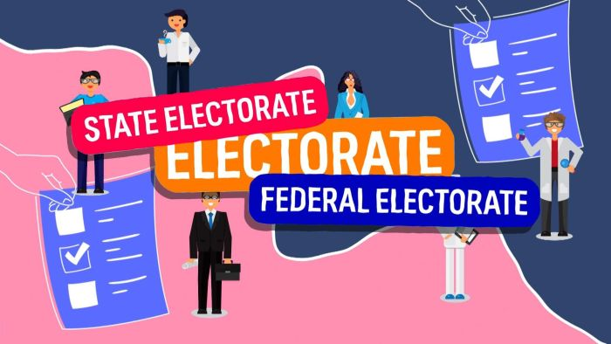

BTN Election Lingo - Electorates BTN Election Lingo - Parties
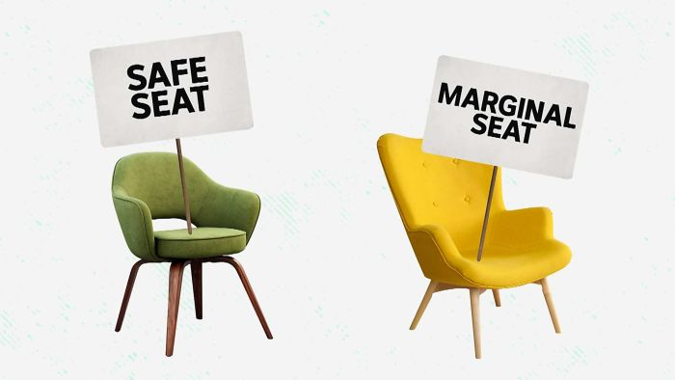
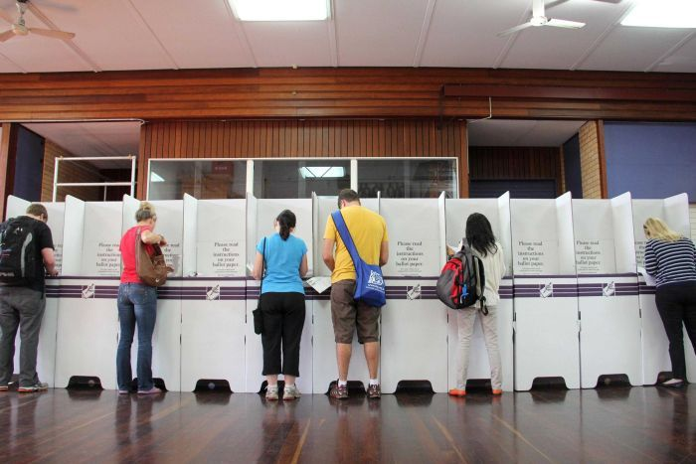

BTN Voting Age BTN – Election Lingo - Seats

Useful Websites
- Opinion Polls - BTN
- A brief history of opinion polls - Museum of Australian Democracy

EPISODE 13
17th May 2022

KEY LEARNING
Students will explore the meanings of key parliamentary terms, especially in relation to elections.

CURRICULUM
HASS – Year 4
Sequence information about people’s lives, events, developments and phenomena using a variety of methods including timelines.

HASS – Year 5
The key features of the electoral process in Australia.

Sequence information about people’s lives, events, developments and phenomena using a variety of methods including timelines.

HASS – Year 6
The responsibilities of electors and representatives in Australia’s democracy.

Civics and Citizenship – Year 7
Reflect on their role as a citizen in Australia’s democracy.
  - Teacher Resource

Election Lingo

Focus Questions
Discuss the BTN Democracy Sausage story as a class and record the main points of the discussion. Students will then respond to the following:
- When did selling sausages at elections first begin?
- Why were sausages used for fundraisers at elections?
- It is compulsory to vote in Australia. True or false?
- In what year did Democracy Sausage become the Australian National Dictionary's word or phrase of the year?
  - 2000
  - 2016
  - 2022
- What do you like about election day?

Activity: Explainers
Election reporting can be full of words and phrases that we don’t hear too often and can sound a little complicated. So, as part of BTN’s election coverage, we’ve asked some of our rookie reporters to explain some election terms.

Watch BTN’s Election Lingo videos to learn more about electorates, political parties, political seats and the democracy sausage!

Electorates | 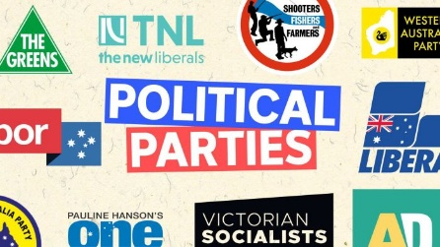  Political Parties
Safe and Marginal Seats | Democracy Sausage

Activity: Class Discussion
After watching any one of BTN’s Election lingo stories, using the following questions to guide a class discussion. Record responses on a mind map.
- What have you seen or heard to suggest there is an election? Discuss.
What questions do you have?
- Why do we have elections? What is the purpose of elections?
- Why are elections important?
- What is the role of the Australian Electoral Commission (AEC)?
- What questions do you have about this topic?

Activity: Glossary
Students will brainstorm a list of vocabulary that relates to elections. Students can find election related words in newspapers with election coverage or online articles. Here are some words to get students started.

ELECTION | MARGINAL SEAT | ELECTORATE
REPRESENTATIVE | POLITICAL PARTY | CANDIDATE

Additional glossary words
- Australian Electoral Commission (AEC)
- Ballot
- First-past-the-post
- Opinion poll
- Coalition
- Democracy
- Donkey vote
- Preferences
- Suffrage
- House of Representatives
- Senate
- Opposition
- House of Representatives / Senate
- Swing
- Safe, fairly safe and marginal seats

Further activity
- Create a word search using your glossary words
- Create your own quiz and test your classmates.
- In your own words, write a sentence for one or more of the terms in your glossary.

Activity: Electorates
We all know the street we live in, the suburb, the town or the city and the state. But do you know your electorate? Everyone lives in an electorate, a state electorate and a federal electorate. And each electorate is represented by a politician who has a seat in the House of Representatives or the lower house. What’s the difference between a state electorate and a federal electorate?

Watch
As a class, watch BTN’s Election Lingo explainer to learn more about electorates, and build on your student’s political awareness. Discuss the BTN story as a class and record the main points of the discussion. Students will then respond to the following discussion questions.

BTN video – Electorates

Discussion questions
Students will then respond to the following focus questions:
- What is an electorate?
- Each electorate is represented by a __________________.
- The House of Representatives is also known as what?
- How many federal electorates are there in Australia?
  - 51
  - 151
  - 251
- Which is the largest electorate in Australia? How many square kilometres does it cover?

Class Activity
Before starting this activity, investigate the following in small groups or as a class.
- What electorate is your school in? Locate on a map.
- Who is the current member for this federal electorate?
- What party do they represent?
- Can you find out who else is ‘running’ for this electorate?
- Is it a safe or marginal seat?
Get your students involved in a hands-on activity, where they will be creating their own electorate and naming it after themselves. Download the Parliamentary Education Office (PEO) Create your own Electorate lesson plan (Years 5-12) for step by step instructions and further resources.

Activity: Political Parties
During an election you hear a lot about parties, but they're not your typical balloons, presents and cake sort of party. They're political parties. A political party is a group of people who all share a similar view on how a country should be run and they all work together to try and achieve that.

Watch
As a class, watch BTN’s Political Parties explainer to learn more about Australia’s different political parties. Discuss the BTN story as a class and record the main points of the discussion. Students will then respond to the following discussion questions.

BTN video – Political Parties

Discussion questions
- What are the major political parties in Australia?
- To become Prime Minister your party has to win most of the seats in what house?
  - The lower house
  - The upper house
- Which party is part of the coalition with the Liberals?
- You have to be a politician to be a member of a party. True or false?
- How many members do you need to register a new political party?

Class Activity
Students will imagine they are given the opportunity to interview the leader of one of Australia’s political parties. Their task is to write a list of interview questions that they would like to ask the leader of the party. Students need to remember to write open-ended questions. Open-ended questions have no right or wrong answer and can’t be answered with a ‘yes’ or ‘no’.

Before writing their interview questions, students will need to think about the following:
- Who are the candidates for the main political parties in the 2022 Federal Election?
- What are the main political parties in Australia? How are they similar or different?
- What issues would you like to ask about in your interview?
- Choose a topic that is important to you and your school community. What do you want the leader of the party to do about it?

Test your students’ knowledge on political parties with this PEO Quiz!

Activity: Safe and Marginal Seats
There are all sorts of seats out there: Hard seats, soft seats, weird seats, fancy seats. But in an election the seats you hear most about are the safe seats and the marginal seats. So, what are they?

Watch
As a class, watch BTN’s Political Seats explainer to learn more about safe and marginal seats. Discuss the BTN story as a class and record the main points of the discussion. Students will then respond to the following discussion questions.

BTN video – Political Seats

Discussion questions
- To win an election, a party needs to get more than half of the seats in the…
  - House of Representatives
  - Senate
- What is a safe seat?
- In your own words, explain what a marginal seat is.
- How might a marginal seat affect the result of an election?
- Find out what electorate your school is in. Is it a safe seat or a marginal seat?

Class Activity
Before starting this activity, investigate the following or in small groups or as a class:
- How many seats in total are in Parliament House? How many seats are in the House of representatives and how many seats are in the Senate?
- Look at the seating plan of Parliament House, including the House of Representatives seating plan and Senate seating plan. Find where the candidate for your school electorate is seated.

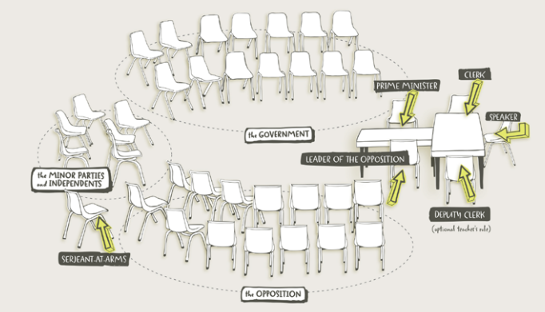
Turn your classroom into a parliament. Download the seating plan of the House of Representatives which can be found in the PEO toolkit.

Parliamentary Education Office - toolkit

Useful Websites
- History of Voting – BTN
- Voting Age Experiments – BTN
- Democracy Rules – AEC
- Practise Voting – AEC
- Why do we enrol to vote? – BTN Newsbreak
- Preferential Voting – BTN
- Parliamentary Education Office (PEO)
- Glossary – PEO

EPISODE 13
17th May 2022

KEY LEARNING
Students will learn more about Uranus and why astronomers want to explore it.

CURRICULUM
Science – Year 5
The Earth is part of a system of planets orbiting around a star (the sun).

Scientific knowledge is used to solve problems and inform personal and community decisions.

Science – Years 5 & 6
With guidance, pose clarifying questions and make predictions about scientific investigations.

Science involves testing predictions by gathering data and using evidence to develop explanations of events and phenomena and reflects historical and cultural contributions.

  - Teacher Resource

Uranus Mission

Focus Questions
Discuss the BTN story as a class and record the main points of the discussion. Students will then respond to the following:
- Who wants to send a mission to Uranus?
- What spacecraft has got the closest to Uranus?
  - Voyager 1
  - Voyager 2
  - International Space Station
- Uranus was discovered before telescopes were invented. True or false?
- Why does Uranus appear blue?
- How many moons orbit Uranus?

Activity: Quick Uranus Quiz
Begin the Uranus activity with a quick true or false quiz. Circle the correct answer.
Did You Know?
The radioactive element uranium was named after Uranus when it was discovered in 1789
- Uranus is the 7th planet from the sun. | True False
- Uranus is smaller than Earth. | True False
- The atmosphere of Uranus is made up mainly of hydrogen and helium. | True False
- Hydrogen gives Uranus its blue green colour. | True False
- Uranus rotates on its side. | True False
Answers: 1 True, 2 False, Uranus is about four times the diameter of Earth, 3 True, 4 False,
methane gives Uranus its blue green colour. 5 True

Activity: Glossary
Students will brainstorm a list of key words that relate to the BTN Uranus Mission story. Here are some words to get them started.

 | PLANET | SOLAR SYSTEM |  | ICE GIANT
 | ATMOSPHERE | ROTATE |  | ORBIT

Activity: Class Discussion
Discuss the BTN Uranus Mission story as a class. Ask students to record what they know about the planet. What questions do they have? Use the following questions to help guide discussion:
- Make a list of all the things you know about Uranus.
- How similar are Uranus and Earth?
- What are some differences between Uranus and Earth?
- Can humans survive on Uranus? Why or why not?
- Why does NASA want to send a probe to Uranus?
- What might be some of the challenges of exploring Uranus?
- Think of three unanswered questions you have about Uranus. Share them with the class.

Activity: Profile of Uranus
Create a profile of Uranus using a range of sources of information. The following questions will help guide students’ research:

- Who discovered Uranus and when was it discovered?
- How was it named? How long did it take to be named?
- Where is Uranus in the Solar System?
- Uranus is an ice giant planet. What does that mean?
- Describe Uranus’ atmosphere.
- How long is a day on Uranus?
- How long is a year on Uranus?
- Why does Uranus rotate on its side?
- Why does Uranus have extreme weather?
- List 10 interesting facts about Uranus.

Use a Venn diagram to compare and contrast Uranus with Earth. Compare and contrast the size of the planets, the distance from the sun and its physical features.

Uranus Earth

Activity: Create a Kahoot Quiz
Use Kahoot! to test students’ knowledge about Uranus. Quizzes can be created to recap learning or test personal knowledge. There is also the option to connect with classrooms around the world and play kahoot in real time.

BTN Space Science stories
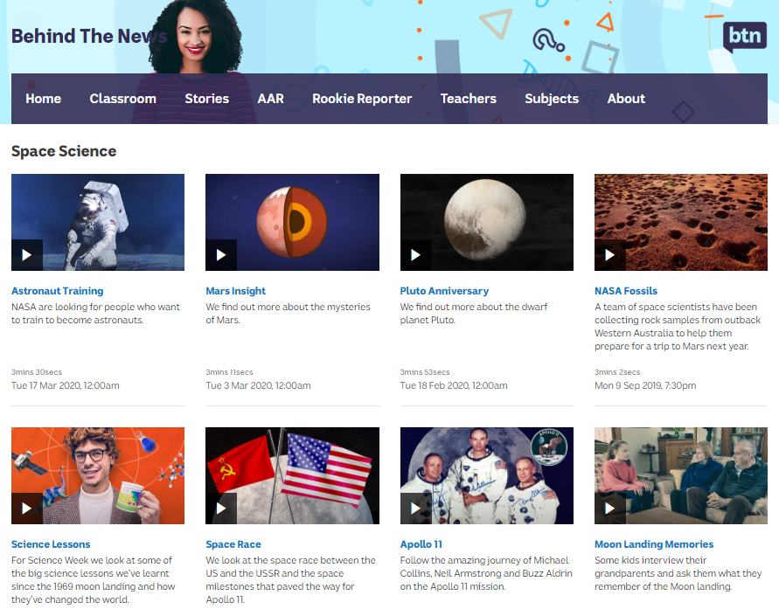
Visit BTN’s collection of stories which focus on space science and space exploration. After watching any one of the BTN videos ask students to respond to the discussion questions (to find the discussion questions and teacher resources go to the related BTN Classroom Episode and download the Episode Package).
Link to collection of BTN Space Science stories

Useful Websites
- Uranus – NASA Science
- Uranus is a very weird planet. Here’s why astronomers want to send a probe to it – ABC News
- By the Numbers: Uranus vs Earth – NASA Science
- All about Uranus – NASA Space Place

  - Teacher Resource

BTN Transcript: Episode 13 - 17/5/2022

Hey. I'm Amelia Moseley and you're watching BTN. Thanks for joining us, here's what's coming up.
We're going to take a trip to the seventh planet, find out about the origins of the democracy sausage and meet some kids who are learning to save lives.

Opinion Polls

Reporter: Jack Evans

INTRO: But first, to the election. Hopefully by Sunday we'll know who the next PM is going to be, and, in the meantime, you'll probably hear a lot of people guessing who is going to be looking at opinion polls. Jack had a look at what they are and how good they are at predicting the political future.
When it comes to predicting an election, there are a number of ways you could go about it. But if you want to be a little more scientific about it, you could go for opinion polls. You've probably heard the term being thrown around quite a bit recently. Opinion polls help to paint a picture of what people are thinking by asking people what they're thinking. I mean that seems pretty obvious. It is a little more complicated than that.
Asking every single registered voter how they are planning to vote would be, well, difficult. And that's where statistics comes in. If you were to get a big enough group of randomly chosen people and ask them for, well, their opinion, you'd start to get an idea of what the whole population thinks. Imagine the population is like this stew that I just so happen to be making. A random sample is like a spoonful. It'll give you a pretty good idea of the taste of the whole thing. Of course, if the sample's too small all you get is carrot. But if you use a big enough spoonful, you'll get a nice collection of delicious ingredients.
So, how do you scoop up a random sample of people? Well, in the old days it was done face-to-face. But as technology evolved polling companies started using phones. That was actually a pretty good way of getting a truly random sample because you don't really know who's on the other end of the line and area codes meant you could choose a sample from a certain electorate or for bigger surveys, make sure your sample came from across the country. These days they're continued to be done via phone calls and also through online surveys.
But today's tech has thrown up some problems for pollsters and some experts reckon it's getting harder to get a proper random sample. Unlike landlines, you can't tell where someone lives from their mobile number so you can't make sure you're reaching people in different areas. And unlike old days, mobile phones let you know who's calling and many people don't like answering calls from people they don't know. Then there are online polls which tend to only be filled out by people who like filling out online polls. So, you can start to see how a lot of opinions are being missed. The polling companies are trying to overcome this by using some clever statistical tricks to try to get around those problems, like weighting, which looks at who's answered a poll and adjusts the results if it looks like the sample isn't representative enough.
Still, not everyone has a high opinion of opinion polls. In fact, during the last election in 2019 the majority of opinion polls predicted that Labor would win easy. But that didn't happen. While some reckon opinion polls still have a really important role to play, others reckon maybe we shouldn't be relying on them to give us all the answers.
Election Lingo – Democracy Sausage

Rookie Reporter: Devon

When it comes to election day, there's a lot of talk about these tasty tubes of meat. But what does a sausage in a slice of white bread have to do with voting? Well, it's thought to have begun in the 1940s. During World War Two, butchers stuffed all the not-so-pretty bits of meat into sausages to avoid waste.
While they weren't fancy, they were cheap and tasty. Which made them a great option for fundraising. And where better way to fundraise than at the polling booth?
Australia's one of the few countries with compulsory voting. Which means nearly everyone turns up to have their say at schools, halls or churches. And so, the first election sausage sizzle was held. Over the years you'd spot leaders behind the barbie or chowing one down. There were even some sizzling scandals. From controversial eating styles. To accusations of sausage bribery. Turns out it takes a lot more than a free snag to snag votes.
In the 2016 Federal Election, the humble sausage truly became an Aussie hero. Australians on social media helped spread this hashtag around the world. And it became the Australian National Dictionary's word or phrase of the year. Now whether you're a meat eater, vegetarian or vegan there's a sausage for pretty much everyone. And no matter who Aussies vote for; most agree it wouldn't be a democratic election without the democracy sausage. Now who wants onions? Sauce?

News Quiz

This is Natasha Fyles, the new leader of which state or territory? She’s the new leader of the Northern Territory. She was chosen by her party for the top job after former Chief Minister Michael Gunner made the surprise decision to resign so he could spend more time with his family.

Do you know what organisation this symbol represents? Is it the European Union, the United Nations or NATO? It’s NATO, the North Atlantic Treaty Organisation. It’s a military alliance between North American and European countries around the Atlantic and now Finland’s leaders say they’re in favour of joining up as a response to Russia’s invasion of Ukraine. Russia is not impressed. It sees NATO as a threat and says it will punish Finland if it joins.

What is this a photo of? A black hole, the eye of a Tassie Tiger or an exploding star. It’s the black hole at the centre of our galaxy. Its name is Sagittarius A and its image has been taken for the first time by the Event Horizon telescope array.

Do you know the name of the famous Australian portrait competition that this painting won last week? The Bald Archie Prize, the Archibald Prize or the Archie Bell Prize? It’s the Archibald Prize. Blak Douglas is the second Indigenous artist to take out the prize thanks to his portrait of Wiradjuri artist Karla Dickins.

And do you know which country won Eurovision? Was it Ukraine, Italy or Australia? It was Ukraine. Kalush Orchestra’s song “Stephania” whomped it in, scoring the biggest public vote in the history of the song competition. It means Ukraine gets to host next year’s competition and the country’s president says they’ll do everything he can to make it happen.

New Philippines President

Reporter: Amal Wehbe

INTRO: Australia isn't the only country that's been election mode. The Philippines has just chosen its new leader, a man named Ferdinand Marcos Junior. That's a really familiar name to a lot of people in the Philippines and around the world and Amal found out why.

It's fair to say that people in the Philippines can get pretty passionate about politics. Meanwhile in Australia.
REPORTER: Do you know who these 2 people are?
PERSON 1: No.
PERSON 2: That's Scomo and I don't know him.
PERSON 3: Sorry not sure.
Hm, yeah, it's a bit different in Australia isn't it. But, back to the Philippines. They've just elected a man named Ferdinand Marcos Jr, affectionately known as Bongbong. But Marcos is a name that has a long and controversial history in the Philippines.
Back in 1965, Bongbong's dad Ferdinand Marcos Senior was elected President. He and his beauty queen wife Imelda Marcos were very popular. At first the economy boomed as they poured money into new roads and public buildings. While Imelda charmed world leaders and ordinary Filipinos. The couple also spent a lot of money on themselves. We're talking palaces, summer palaces, this. Imelda in particular had a reputation for loving luxury. She spent millions and millions on jewels, expensive clothes, designer bags, and most famously 3000 pairs of designer shoes.
BILL BIRTLES, JOURNALIST: They were just absolutely minted in terms of the amount of wealth they had, which is not what you're supposed to be when you're the president of a country.
So where did that money come? Well basically, they stole it. They used tax money and money meant for development projects. Marcos was also brutal to people who opposed him. In 1972 he imposed martial law on the Philippines.
REPORTER: Elections have been cancelled, criticisms of his regime have been outlawed, his political opponents have been jailed.
BILL BIRTLES, JOURNALIST: By the mid-1980s, there was growing opposition to this regime because the Marcos presidency didn't make the Philippines richer. It was in economic decay, millions and millions of people in poverty. And yet Marcos and his wife Imelda and their extended family were living it up.
In 1986 there was a revolution, and the Marcos family were driven out of power and out of the country. Ferdinand Marcos Senior died 2 years later, but his family still had influence in the Philippines.
BILL BIRTLES, JOURNALIST: The Marcos family has always had its loyalists. It's not like everybody in the Philippines agreed that they needed to be overthrown.
Bill's been in the Philippines covering the election and he says there are lots of reasons why people voted for the son of a dictator. Some still have good memories of life under Marcos Senior, and others are willing to overlook the family's reputation.
AMAL: And there's another thing that experts say had a big influence on Bongbong's success, this.
Bill says that the Marcos team have used social media to pretty much rewrite history, and paint life under the Marcos' as pretty good. And in a country where they spend twice the global average of time using social media, it's had a huge effect.
MICKO ELDAVE: President Marcos Senior was very brilliant.
FATHER RONALD BALASE: They would rather believe what they see on YouTube, TikTok especially.
So what does this mean for the Philippines? Well, some people are worried that history might repeat itself, and they say it's not a good sign for democracy. As for Bongbong he says people shouldn't judge him based on his family's history but on what he does for the Philippines, and it's future.

Quiz

Manny Pacquiao was one of the candidates up against Bongbong Marcos in the Philippines election. He's a politician and he's also famous for what sport? Football, basketball or boxing? Manny Pacquiao is a former world champion boxer. His rumble for the top job wasn't quite a knock out, but he congratulated Bongbong and said he hoped the new leader would help the poor.

Uranus Mission

Reporter: Jack Evans

INTRO: Okay, let's get away from politics now, in fact, let's get away from the Earth altogether and explore Uranus. The seventh planet in our solar system is one of the most mysterious because we've never managed to send a probe there, but scientists want to change that. Here's Jack.

ALIEN 1: Citizens of Uranus, I have some very exciting news.
ALIEN 3: Oh, are they finally going to change our planet’s name?
ALIEN 1: What? There's nothing wrong with the name of our planet.
ALIEN 3: Oh, c'mon we're the butt of every joke.
ALIEN 2: Yeah, literally.
ALIEN 1: Would you two stop being so immature. What I was going to say, is that the people of planet Earth are planning some sort of visit to us.
ALIEN 2: Oh, well that is actually pretty exciting news.
ALIEN 1: Yes, I know. Now I want everything perfect for their arrival alright. So, get the welcome banner ready. Yeah?
That's right us citizens of Earth, or rather a bunch of scientists in the US, are strongly urging NASA to send a mission to Uranus. They say for too long now the distant planet has been ignored. In fact, the only time we've gotten close to it was when a space probe, Voyager 2, did a fly by back in 1986. So, some reckon it's about time we sent another probe to Uranus to find out a bit more about it.
In the meantime, here's everything we do know. Let’s start with its discovery. Unlike the other planets, which you can see by just looking up, Uranus wasn't discovered until after telescopes had been invented. It was first spotted 241 years ago by the English astronomer and composer, William Herschel. Although at first, he thought it was a comet or a star. Mr Herschel actually wanted to call the planet Georgian Sidius, or George's Star, after King George III. About 70 years later astronomers eventually settled on Uranus, after the Greek God of the Sky. Although some prefer the pronunciation Uranus for obvious reasons.
Since then, we've managed to figure out a few things about our distant neighbour. Like the fact that Uranus is one of two ice Giants in our solar system. It's about 4 times bigger than Earth and has a small rocky core surrounded by hot dense fluids of icy materials such as methane, water and ammonia. And apparently, it's quite smelly.
ALIEN 2: Yeah, Uranus is full of stinky gas. Not a joke, just a fact.
That's because the atmosphere is thought to be made up of mostly hydrogen sulphide, which is the molecule that makes rotten eggs stinky.
ALIEN 2: See, I told you.
There is also some methane in the atmosphere which is why Uranus appears blue. There are some other cool things that we know about Uranus. Like there are 27 moons orbiting it; it has 13 rings; a day on Uranus is about 17 hours and 14 minutes and it takes 84 Earth years to rotate around the sun, which it does in its own unique way. You see, unlike the other planets in our solar system it rotates on its side, so it sort of looks like it's rolling rather than spinning.
As for getting there it would be nearly impossible for a spacecraft to land on the surface because it's mostly just swirling fluids. Add that to the extreme pressures and temperatures from the atmosphere and it's really no place for life to exist, soz guys. Which is why NASA is looking into sending a probe to study more of Uranus. Although being about 3 billion kilometres away from Earth it could take another 15 years before we actually get there.
ALIEN 2: 15 years.
ALIEN 3: Well, that's ages away. Ugh.
ALIEN 1: Wait, where are you going? I need you to help finish the welcome banner. I guess I could just do it myself then.

Quiz

How much would you weigh on Uranus? More, less or the same? You'd weigh less. Even though Uranus is bigger than Earth, it's less dense so it only has 89 percent of Earth's gravitational pull.

St John Cadets

Reporter: Michelle Wakim

INTRO: This week is National Volunteer Week, which celebrates all of the work done by volunteers of all ages in all different areas, all across Australia. Michelle went to meet with some young volunteers who spend their free time learning how to save lives. Check it out.

If you found yourself in an emergency with someone needing your help, would you know what to do? Well, these guys would.
INDIA: We are St John's Cadets, and tonight we're practising CPR and defibrillation.

These cadets are at their weekly training session, where they learn new skills and earn badges in different areas of first aid.

BELLE: Like a sprained ankle, or a snake bite and things like that.
OLIVIA: It was really interesting during the Emergency Management Badge, particularly at the start of the pandemic when we're learning about managing big medical events.

St John is a charity that has been in Australia for more than 130 years, providing ambulances and first aid around the country. And, like many important organisations in Australia, they rely mainly on volunteers. Almost one-third of Australians volunteer with organisations that do really important work in all sorts of areas. That's about 6 million people doing jobs that we rely on, for free. It's thought all that work is worth about $17 billion a year to the Aussie economy, that's a lot. That doesn't even count the unofficial volunteer work people do, whether it's cleaning up a beach, caring for a loved one, or brightening a stranger's day.
OLIVIA: It's really rewarding when someone comes to you for help and you're able to give them that help and they're able to go away and feel better.
When these guys are 16, they'll be able to use all the skills they’ve learnt to volunteer as first aid officers at festivals and other events.
OLIVIA: I used to go to the show and that was really an interesting way of getting experience in the community and helping people out.
And they say they've already put some of the skills they've learnt into practice.
INDIA: My brother fell off his skateboard and no one was home. It was just me and my brother, and he came home, and he was bleeding. He's like, ‘Help me, like, you're a cadet’. And I was like, ‘Okay.’ I bandaged him up, like did the job.
LACHLAN: My friend kneeled in broken glass.
RHIANNA: I've helped aid CPR, which was terrifying.
MICHELLE: Alright, I'm all gloved up.

This is all stuff that a lot of adults don't know how to do.

CADET: We’re just checking for response now, ‘can you hear me?’

I, for one am pretty impressed. While it's hard work, these guys say that being a cadet is really rewarding.
BELLE: It kind of gives me a lot more confidence.
INDIA: It really sets you up well for the future, like you can basically take these skills into any pathway.
LACHLAN: Everything that we do is for everyone's good. So, I feel like as a cadet, it's just really good to know that I can strive for my best and everyone else will do as well.
And whether it's saving lives, putting out fires, or any of the many, many jobs that volunteers do, they say there's a lot to be gained by giving back.
RHIANNA: I'm proud to be part of an organisation who's only giving. You’re giving skills to other people without anything in return. You're learning how to help society with, again, nothing in return.
LACHLAN: It benefits everyone really, including yourself. So why not give it a go?

Sport

Cricket fans, friends and teammates have all paid tribute to Andrew Symonds. The 46-year-old former Aussie all-rounder died in a car accident Saturday near Townsville. Symonds played 26 tests for Australia
and 198 one dayers, including helping to win 2 World cups.
Novak Djokovic has won the Italian Open beating Greek player Stefanos Tsitsipas. This is Djokovic's first title in more than six months. But it means he'll head into the French Open as top seed.
Sam Kerr has done it again, scoring not one but two goals at Wembley helping Chelsea take home the Women’s FA cup trophy. Over in the Men’s, Liverpool just keep winning. They won the Men’s FA cup, beating Chelsea 6-5 in penalties. It's the first time in 16 years they've won the trophy.
Hold tight because you're looking at the first Electric Scooter Championship. 30 riders battled it out in the streets of London over a 470 metre course reaching speeds of up 100 kays per hour.
Logan’s Fire Knife Dancing

Rookie Reporter: Logan

INTRO: Finally, today, we're going to meet another young Melburnian who’s told their story as part of the Take Over Melbourne competition. Logan wanted to share how he reconnected with his Samoan culture by learning fire knife dancing. Check it out.
I was born in Melbourne, but on my second birthday my mum took me to Samoa for a family reunion and we didn't leave for another nine years. I grew up with my cousins, speaking Samoan, going to the beach on the weekends and eating Samoan food. In 2014 mum and I moved back to Melbourne and my life changed. I began losing my Samoan language, eating junk food and playing PlayStation. I felt something was missing and I didn't know what. Mum took me to Samoan school so that I could continue to learn my language and culture. I tried Samoan dancing, but it wasn't for me. Then I signed up for a Siva Afi workshop.

Siva Afi is a Samoan ceremonial dance where you spin long blades lit with fire. It originated a long time ago when warriors would come back from war and would recreate battles for the village. During the workshop, memories of Samoa came flooding back. We used practise sticks, but mum promised if I practiced enough, one day I'd be able to try with fire. I saved my birthday and Christmas money and bought myself a Nifo Oti (the weapon used to perform Siva Afi).

Today I not only perform at events and celebrations but teach students around the world with my online workshops. I want this knowledge to be available to all Samoans and anyone wanting to build confidence, discipline, and feel a connection to Samoan culture. Learning about Siva Afi has strengthened my ties to my Samoan ancestors and made me confident in my identity as a Samoan-Australian. I no longer wonder who I am. I hope I can help others to be proud of who they are.

Closer

Awesome stuff Logan. Well, that's it for today's show. I hope enjoyed it - and maybe learned something. We'll be back with more next week and in the meantime, you can jump on our website to see more stories and quizzes and resources for your teachers. And, as usual, Newsbreak will be here every weeknight to keep you up to date. Have a good one. See you soon.

