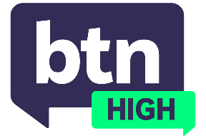
  EPISODE 6
  19th February 2025
  KEY LEARNING
  Students will discuss the risks involved in online gambling, and explore the skills and knowledge to make informed choices.
  CURRICULUM
  Health and PE – Years 7 and 8 (v8.4) – 1
  Health and PE – Years 7 and 8 (v8.4) – 2
  Economics and Business – Year 9 (v8.4)
  Economics and Business – Year 10 (v8.4)
  English – Year 10 (v9.0)
  - Teacher Resource

Gambling Influencers

Focus Questions
Discuss the BTN High story as a class and record the main points of discussion. Students will then respond to the following:
- Have you seen content from gambling influencers? Do you think it’s effective?
- What strategies are often used (online, TV, etc.) to encourage gambling?
- What are the risks of gambling?
- What do you think are some solutions to the problem?
- Where can people go to for help?

Activities
- In small groups, create a short film to raise awareness about the risks of gambling. Mention the kinds of strategies used by companies and influencers online, and where people can go for help.
- Design a poster warning students about the harmful effects of gambling on social media. Posters could be displayed in various parts of the school.
- Write a feature article about how some influencers are encouraging gambling online, and what could be done to combat the issue.

