KEY LEARNING
Students will explore the meanings of key parliamentary terms, especially in relation to elections.

CURRICULUM
HASS – Year 4
Sequence information about people’s lives, events, developments and phenomena using a variety of methods including timelines.

HASS – Year 5
The key features of the electoral process in Australia.

Sequence information about people’s lives, events, developments and phenomena using a variety of methods including timelines.

HASS – Year 6
The responsibilities of electors and representatives in Australia’s democracy.

Civics and Citizenship – Year 7
Reflect on their role as a citizen in Australia’s democracy.
  - Teacher Resource

Election Lingo

Focus Questions
Discuss the BTN Democracy Sausage story as a class and record the main points of the discussion. Students will then respond to the following:
- When did selling sausages at elections first begin?
- Why were sausages used for fundraisers at elections?
- It is compulsory to vote in Australia. True or false?
- In what year did Democracy Sausage become the Australian National Dictionary's word or phrase of the year?
  - 2000
  - 2016
  - 2022
- What do you like about election day?

Activity: Explainers
Election reporting can be full of words and phrases that we don’t hear too often and can sound a little complicated. So, as part of BTN’s election coverage, we’ve asked some of our rookie reporters to explain some election terms.

Watch BTN’s Election Lingo videos to learn more about electorates, political parties, political seats and the democracy sausage!

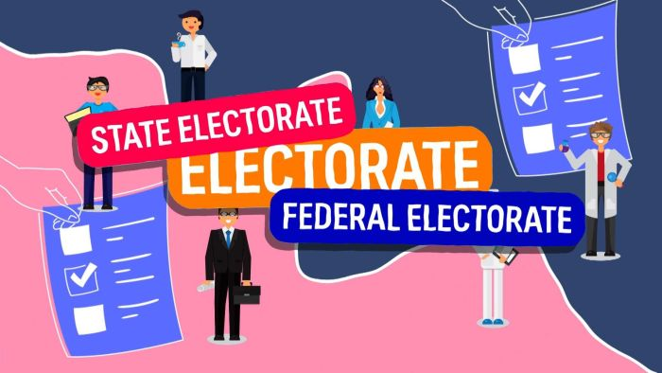  Electorates | Political Parties
Safe and Marginal Seats | Democracy Sausage

Activity: Class Discussion
After watching any one of BTN’s Election lingo stories, using the following questions to guide a class discussion. Record responses on a mind map.
- What have you seen or heard to suggest there is an election? Discuss.
What questions do you have?
- Why do we have elections? What is the purpose of elections?
- Why are elections important?
- What is the role of the Australian Electoral Commission (AEC)?
- What questions do you have about this topic?

Activity: Glossary
Students will brainstorm a list of vocabulary that relates to elections. Students can find election related words in newspapers with election coverage or online articles. Here are some words to get students started.

ELECTION | MARGINAL SEAT | ELECTORATE
REPRESENTATIVE | POLITICAL PARTY | CANDIDATE

Additional glossary words
- Australian Electoral Commission (AEC)
- Ballot
- First-past-the-post
- Opinion poll
- Coalition
- Democracy
- Donkey vote
- Preferences
- Suffrage
- House of Representatives
- Senate
- Opposition
- House of Representatives / Senate
- Swing
- Safe, fairly safe and marginal seats

Further activity
- Create a word search using your glossary words
- Create your own quiz and test your classmates.
- In your own words, write a sentence for one or more of the terms in your glossary.

Activity: Electorates
We all know the street we live in, the suburb, the town or the city and the state. But do you know your electorate? Everyone lives in an electorate, a state electorate and a federal electorate. And each electorate is represented by a politician who has a seat in the House of Representatives or the lower house. What’s the difference between a state electorate and a federal electorate?

Watch
As a class, watch BTN’s Election Lingo explainer to learn more about electorates, and build on your student’s political awareness. Discuss the BTN story as a class and record the main points of the discussion. Students will then respond to the following discussion questions.

BTN video – Electorates

Discussion questions
Students will then respond to the following focus questions:
- What is an electorate?
- Each electorate is represented by a __________________.
- The House of Representatives is also known as what?
- How many federal electorates are there in Australia?
  - 51
  - 151
  - 251
- Which is the largest electorate in Australia? How many square kilometres does it cover?

Class Activity
Before starting this activity, investigate the following in small groups or as a class.
- What electorate is your school in? Locate on a map.
- Who is the current member for this federal electorate?
- What party do they represent?
- Can you find out who else is ‘running’ for this electorate?
- Is it a safe or marginal seat?
Get your students involved in a hands-on activity, where they will be creating their own electorate and naming it after themselves. Download the Parliamentary Education Office (PEO) Create your own Electorate lesson plan (Years 5-12) for step by step instructions and further resources.

Activity: Political Parties
During an election you hear a lot about parties, but they're not your typical balloons, presents and cake sort of party. They're political parties. A political party is a group of people who all share a similar view on how a country should be run and they all work together to try and achieve that.

Watch
As a class, watch BTN’s Political Parties explainer to learn more about Australia’s different political parties. Discuss the BTN story as a class and record the main points of the discussion. Students will then respond to the following discussion questions.

BTN video – Political Parties

Discussion questions
- What are the major political parties in Australia?
- To become Prime Minister your party has to win most of the seats in what house?
  - The lower house
  - The upper house
- Which party is part of the coalition with the Liberals?
- You have to be a politician to be a member of a party. True or false?
- How many members do you need to register a new political party?

Class Activity
Students will imagine they are given the opportunity to interview the leader of one of Australia’s political parties. Their task is to write a list of interview questions that they would like to ask the leader of the party. Students need to remember to write open-ended questions. Open-ended questions have no right or wrong answer and can’t be answered with a ‘yes’ or ‘no’.

Before writing their interview questions, students will need to think about the following:
- Who are the candidates for the main political parties in the 2022 Federal Election?
- What are the main political parties in Australia? How are they similar or different?
- What issues would you like to ask about in your interview?
- Choose a topic that is important to you and your school community. What do you want the leader of the party to do about it?

Test your students’ knowledge on political parties with this PEO Quiz!

Activity: Safe and Marginal Seats
There are all sorts of seats out there: Hard seats, soft seats, weird seats, fancy seats. But in an election the seats you hear most about are the safe seats and the marginal seats. So, what are they?

Watch
As a class, watch BTN’s Political Seats explainer to learn more about safe and marginal seats. Discuss the BTN story as a class and record the main points of the discussion. Students will then respond to the following discussion questions.

BTN video – Political Seats

Discussion questions
- To win an election, a party needs to get more than half of the seats in the…
  - House of Representatives
  - Senate
- What is a safe seat?
- In your own words, explain what a marginal seat is.
- How might a marginal seat affect the result of an election?
- Find out what electorate your school is in. Is it a safe seat or a marginal seat?

Class Activity
Before starting this activity, investigate the following or in small groups or as a class:
- How many seats in total are in Parliament House? How many seats are in the House of representatives and how many seats are in the Senate?
- Look at the seating plan of Parliament House, including the House of Representatives seating plan and Senate seating plan. Find where the candidate for your school electorate is seated.

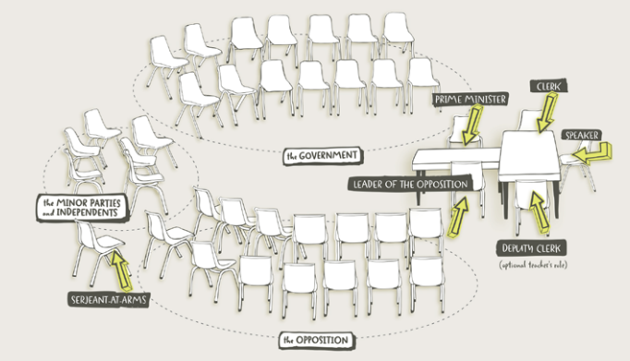
Turn your classroom into a parliament. Download the seating plan of the House of Representatives which can be found in the PEO toolkit.

Parliamentary Education Office - toolkit

Useful Websites
- History of Voting – BTN
- Voting Age Experiments – BTN
- Democracy Rules – AEC
- Practise Voting – AEC
- Why do we enrol to vote? – BTN Newsbreak
- Preferential Voting – BTN
- Parliamentary Education Office (PEO)
- Glossary – PEO

