EPISODE 30
25th October 2022

KEY LEARNING
Students will view a range of BTN stories and use comprehension skills to respond to a series of focus questions.

CURRICULUM
English – Year 4
Use comprehension strategies to build literal and inferred meaning to expand content knowledge, integrating and linking ideas and analysing and evaluating texts.

English – Year 5
Use comprehension strategies to analyse information, integrating and linking ideas from a variety of print and digital sources.

English – Year 6
Use comprehension strategies to interpret and analyse information and ideas, comparing content from a variety of textual sources including media and digital texts.

English – Year 7
Use comprehension strategies to interpret, analyse and synthesise ideas and information, critiquing ideas and issues from a variety of textual sources.
  - Teacher Resource

Focus Questions
As a class, discuss the stories featured in the episode of BTN Classroom and record the main points of the discussion. Students will then respond to the following focus questions.

Floods Update
- Which states have been affected by floods?
- What impact have the floods had on the farm kids in Forbes?
- How has the local community been helping out in Shepparton?
- What affect have the floods had on the kids in Tasmania?
- How did the kids in Forbes help out when their school was closed?

Weather Forecasts
- What is a meteorologist?
- Where do meteorologists collect information from to make predictions about the weather?
- We are in a __________________weather pattern at the moment which means an increased chance of __________.
- How can people stay safe during times of severe weather?
- What did you learn watching this story?

Check out the teacher resource on the Teachers page.

Federal Budget 2022
- In pairs, discuss the BTN story and come up with a definition of a federal budget.
- Who is the Federal Treasurer?
- This year will be the first budget handed down by the Labor Party in
  - 5 years
  - 10 years
  - 15 years
- Why is it a difficult time for Australia’s economy?
- Some people are worried that Australia could end up in a recession. What does that mean?

Diwali Festival
- Describe Diwali in one word.
- Diwali is the Festival of _____________.
- Who celebrates Diwali?
- Why are candles a big part of Diwali?
- What did you learn watching the Diwali story?

Check out the teacher resource on the Teachers page.

Glasses Emoji Campaign
- Why did Lowri write a letter to Disney?
- What impact did it have?
- Explain the #glasseson campaign that Lowri has started.
- How was BTN reporter Amal inspired by Lowri recently?
- What is Lowri’s message to the emoji creators?

EPISODE 30
25th October 2022

KEY LEARNING
Students will learn more about how meteorologists predict the weather. They will also learn more about the floods impacting on parts of Australia.

CURRICULUM
Science – Year 6
Sudden geological changes and extreme weather events can affect Earth’s surface.

Science involves testing predictions by gathering data and using evidence to develop explanations of events and phenomena and reflects historical and cultural contributions.

Scientific knowledge is used to solve problems and inform personal and community decisions.

Geography – Year 5
The impact of bushfires or floods on environments and communities, and how people can respond.

Geography – Year 7
Causes, impacts and responses to an atmospheric or hydrological hazard.

  - Teacher Resource

Weather Forecasts

Focus Questions
Discuss the BTN story as a class and record the main points of the discussion. Students will then respond to the following:
- What is a meteorologist?
- Where do meteorologists collect information from to make predictions about the weather?
- We are in a __________________weather pattern at the moment which means an increased chance of __________.
- How can people stay safe during times of severe weather?
- What did you learn watching this story?

Activity: Class Discussion
Discuss the BTN Weather Forecasts story as a class. Ask students to record what they know about weather forecasting. What questions do they have? Use the following questions to help guide discussion:
- Where does Simon work?
- What is a meteorologist?
- How do meteorologists predict the weather?
- Give some examples of where meteorologists collect information from.
- How far in advance can meteorologists predict the weather?
- Do you think the job of a meteorologist is an important one? Give reasons for your answer.
- How do people rely on weather forecasts? Give examples.
- What severe weather events has Australia experienced recently?
- Have you ever experienced a severe weather event? Explain your answer.
What questions do you have about the story?
What did you learn from the story?

Activity: Glossary
Students will brainstorm a list of key words that relate to the BTN Weather Forecasts story. Here are some words to get them started.

METEOROLOGIST | WEATHER | CLIMATE
FORECAST | FLOOD | DATA

Activity: Research
Discuss the information raised in the Weather Forecasts story. What questions were raised in the discussion and what are the gaps in students’ knowledge? The following KWLH organiser provides students with a framework to explore their knowledge on this topic.

What do I know? | What do I want to know? | What have I learnt? | How will I find out?

Students will develop their own question/s to research or choose one or more of the questions below. Encourage students to collect and record information from a wide variety of sources and present the information they find in an interesting way.

- How does the Bureau of Meteorology collect information to forecast weather? Create a poster using Canva.
Monitor the weather
As a class, monitor weather conditions in your local area. Consider what equipment will be needed and how you will present the data.
- How has weather forecasting changed over the years? Create a timeline.
- What is the difference between weather and climate?
- Investigate a major flood event that has occurred in Australia.
- Australia is in La Niña weather pattern at the moment. What is the difference between La Niña and El Niño?
- What impact has La Niña had on Australia recently?

Activity: A Day in the life of a meteorologist
Check out the ABC Education A day in the life of a meteorologist video and respond to the following questions:
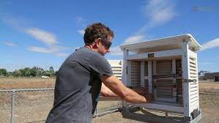
- What does a meteorologist do?
- How is information about the weather communicated with the public?
- Meteorological responsibilities are split into two parts? What are they?
- What equipment is used to gather information from the upper atmosphere? Who is the information particularly useful to?
- What was surprising about the information in the video?

Activity: Visual literacy
In this activity students will analyse a range of images which show the flooding which occurred in Victoria, NSW and Tasmania recently. Students will choose one or more of the images below and respond to the following:
- What is happening in the image? Create a caption for each image.
- How does the image make you feel?
- What does the image tell you about the impact floods have on a community?
- What questions do you have about what you see in the image?
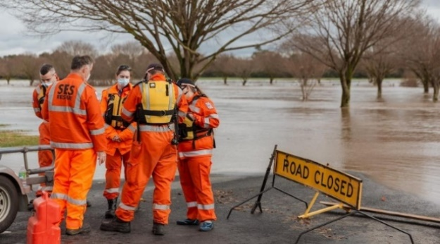  ABC News | 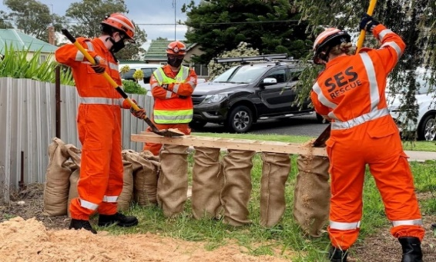  ABC News
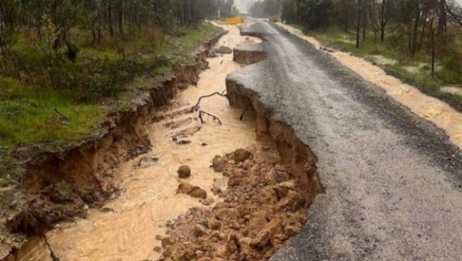  ABC News | 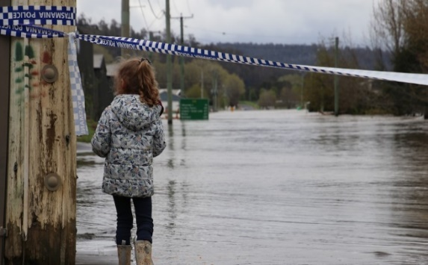  ABC News

BTN Ask a Reporter
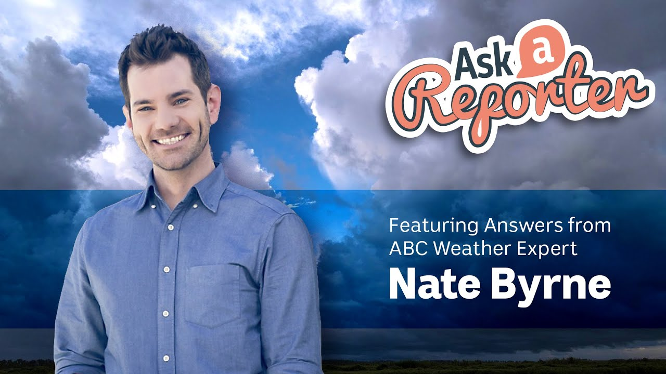
Watch the BTN Weather Science Ask a Reporter featuring ABC weather expert Nate Byrne.

Useful Websites
- Bureau of Meteorology severe weather outlook. What does it mean for each state and territory? – ABC News
- BOM’s severe weather outlook signals a summer of cyclones and floods – ABC News
- Explainer: how meteorologists forecast the weather – Bureau of Meteorology
- Weather Science – BTN
- Weather Forecasting - BTN
- Floods – Geoscience Australia
- Understanding Floods – Bureau of Meteorology
- Things you can do before a flood – NSW SES
- Big Weather: The impacts of floods on communities – ABC Education

EPISODE 30
25th October 2022

KEY LEARNING
Students will learn about Diwali, including customs, traditions and celebrations.

CURRICULUM
HASS – Year 3
Celebrations and commemorations in places around the world (for example, Chinese New Year in countries of the Asia region, Bastille Day in France, Independence Day in the USA), including those that are observed in Australia (for example, Christmas Day, Diwali, Easter, Hanukkah, the Moon Festival and Ramadan).

Civics & Citizenship – Year 3
Why people participate within communities and how students can actively participate and contribute.

HASS – Year 3
Pose questions to investigate people, events, places and issues.

Civics & Citizenship – Year 4
The different cultural, religious and/or social groups to which they and others in the community belong.

HASS – Year 5-6
Develop appropriate questions to guide an inquiry about people, events, developments, places, systems and challenges.

HASS – Year 6
The world’s cultural diversity, including that of its indigenous peoples.

HASS – Year 7
The significant beliefs, values and practices of Indian or Chinese society, with a particular emphasis on ONE of the following areas: everyday life, warfare, or death and funerary customs.
  - Teacher Resource

Diwali Festival

Focus Questions
Discuss the BTN story as a class and record the main points of the discussion. Students will then respond to the following:
- Describe Diwali in one word.
- Complete the following sentence. Diwali is the Festival of _____________.
- Who celebrates Diwali?
- Why are candles a big part of Diwali?
- What did you learn watching the Diwali story?

Activity: See, Think and Wonder
After watching the BTN Diwali Festival story, students will respond to the following questions:
- What did you SEE in this video?
- What did you LEARN from this story?
- What do you WONDER about this story?
- What QUESTIONS do you have about this story?

Activity: Class Discussion
Discuss the BTN Diwali Festival story as a class. Record what students know and would like to know on the KWHL chart below. Use the following questions to help guide discussion:

- What is Diwali?
- When is Diwali?
- Who celebrates Diwali?
- How is it celebrated?
- What Diwali celebrations do you know about? What might you see?
- Have you ever taken part in Diwali celebrations? Explain which ones.

Activity: KWLH
The following KWLH organiser provides students with a framework to explore their knowledge on this topic and consider what they would like to know and learn.

What do I know? | What do I want to know? | What have I learnt? | How will I find out?

Students will develop their own question/s to research or choose one or more of the questions below.
- How are the five days of Diwali celebrated? Create a schedule outlining the 5-day event.
- Why is Diwali on a different date each year? Investigate further and document your findings.
- Who observes Diwali?
- Where does the word Diwali come from and what does it mean? Explore the origins of the word Diwali and the history of the festival.
- What is a rangoli? What are other important symbols are used during Diwali?
- How can you wish your friend a happy Diwali? Visit this ABC article to learn more.

Activity – Choose a project
Individually or in small groups, students will choose one of the following projects to work on and then present their findings to the class.

Teach others
Make a brochure about Diwali that is informative and eye-catching. Include a list of celebrations that will be happening in your community. Alternatively, create a picture book that teaches children about Diwali.
Festival of light
What does Diwali mean? Discuss as a class. Design and make a paper lantern that you can light up with battery operated lights to display in your class.
Diwali rangoli patterns
Rangoli patterns are bright, geometric designs used during Diwali. They are thought to bring good luck and to welcome guests. Find a template and make your own rangoli.
Firework design
For Diwali, the lighting of fireworks celebrates the triumph of light over darkness. Design your own Diwali fireworks display and explain what your designs symbolise.

Activity: Celebrations around the world
Celebrate the diversity in your classroom. Students will share with the class which celebrations are important to them and research different celebrations around the world.

- Investigate how different countries around the world celebrate. How are their celebrations similar or different? Choose one country to research in depth and investigate the origin and significance of their celebrations. Design and make a poster, using symbols, words and images, to mark the celebration and display in the classroom.
- Learn about where students in your class come from and mark on a world map. Describe some of the special occasions that your family celebrate throughout the year, and mark on your classroom calendar. What do these special occasions have in common? How are they different? Use a Venn diagram to record your responses.
- Make a list of special days and weeks that are celebrated in Australia and around the world. For example, Lunar New Year, Diwali, Holi Festival, Yom Kippur, Vaisakhi, Lent, Vesak, and Eid al-Fitr. Mark on your classroom calendar.
- Choose one country to research in depth and investigate the origin and significance of their celebrations. Design and make a poster, using symbols, words and images, to mark the celebration and display in the classroom.

Activity – Jigsaw learning
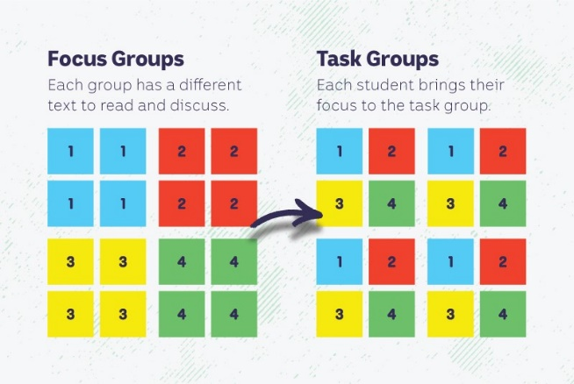
In this activity students will work cooperatively to learn more about cultural and religious celebrations observed in Australia and around the world. Each group will become experts and then share what they have learnt with other students.

Form Groups
Divide the class into 4 x Focus Groups. Each Focus Group will be assigned a different cultural celebration to investigate and become experts. Below is a list of celebrations to choose from:
- Diwali
- Eid al-Fitr
- Holi
- Lent
- Lunar New Year
- Vesak
Each group will need to decide how they will collect and communicate the information they find during their research.

Research
Each Focus Group will respond to the following questions to become experts:
- Write a summary on the celebration, which answers the 5 W’s – Who, What, Where, When and Why?
- What are the origins of the celebration?
- What are some of the customs and traditions of the celebration?
- Illustrate an aspect of the celebration.
- Think of an interesting way to teach other students about this celebration.

Share
Mix the Focus Groups to form Task Groups (Tasks Groups include one student from each of the Focus Groups) to share the information they have collected. Students will share the information they have collected and learn from one another.

Reflect
Students will reflect on the activity by responding to one or more of the following questions:
- What did you enjoy about this investigation?
- What did you find surprising?

Useful Websites
- What is Diwali? – BTN Newsbreak
- When is Diwali and how are the five days of the Festival of Lights celebrated? – ABC News
- Diwali Festival of Lights (YouTube) – National Geographic
- Diwali: What is it? – BBC Newsround
- Religious Celebrations Special – BTN

  - Teacher Resource

BTN Transcript: Episode 30- 25/10/2022

Hey, what’s up, Amelia Moseley here and you're watching BTN. Thanks for hanging out with us again. Let’s see what’s coming up on today's show. Jack investigates how Australia's federal budget works, we find out all about Diwali, the Festival of Lights and meet a teenager on a mission to get more glasses on emojis.

Floods Update

Rookie Reporters

INTRO: All that soon, but first up to the floods. Emergency warnings are in place across a lot of Australia and the East Coast saw more heavy rain over the weekend leaving even more homes and businesses underwater. We talked to kids in three states that have been hit the hardest to find out what it's been like and how they're getting help.

JONO, FORBES FARMER: Hi BTN, I'm Jono.
CAMERON, FORBES FARMER: And I'm Cameron and we're from Forbes.
JACKSON, FORBES PUBLIC SCHOOL: Hi, I'm Jackson.
RUTH, FORBES PUBLIC SCHOOL: And I'm Ruth and we're from Forbes Public School.
JACKSON, FORBES PUBLIC SCHOOL: Forbes is situated in the Central West part of New South Wales, about five hours away from Sydney.
JONO, FORBES FARMER: We've got 2300 acres on this farm and we grow crops, strip raw hay, and run sheep.
KID, FORBES PUBLIC SCHOOL: We've been swamped over the last few months with rain and have Wyangala Dam at its full capacity and has no other choice but to let the water out.
JONO, FORBES PUBLIC SCHOOL: It's been very wet and rainy and it's caused a flood that's gone through town. It's ended up to our place and through my barley crop that I sowed.
LOUISE, SHEPPARTON: Hi BTN, I’, Louise.
LACHLAN, SHEPPARTON: And I'm Lachlan. We live in a town called Shepparton on Yorta Yorta Country. We live in the north of Victoria.
LOUISE, SHEPPARTON: In Shepparton it has been wet and has been flooding. The river was really high and really close to land.
LACHLAN, SHEPPARTON: And it rained like every day.
LOUISE, SHEPPARTON: I felt pretty scared and worried when I found out about the floods.
LACHLAN, SHEPPARTON: I felt quite anxious and worried because I was scared of what was going to happen.
JAYDEN, DELORAINE: Hi my name is Jayden. I live in Deloraine.
LUKA, DELORAINE: I'm Luka and I live on the outskirts of Deloraine.
ANNA, DELORAINE: Hi my name's Anna and I live in Deloraine.
LUKA, DELORAINE: This is not a normal spring for us. There's been a lot of rain over 200 mls.
JAYDEN, DELORAINE: So, when we woke up, we realised our cousin's house was flooded with water. So, we needed to go help. They didn't know how much more water was going to go up, and they didn't know how to get everything out of their house.
ANNA, DELORAINE: The water level was like about this high in my house and I lost a quite a lot of things. I'm feeling a bit sad because of the stuff I lost but at the same time it's sort of a fresh start.
LOUISE, SHEPPARTON: We started sandbagging our house.

LACHLAN, SHEPPARTON: And chucking everything on tables and beds.
JONO, FORBES FARMER: We put some levee banks up and blocked some drains in the levee banks, but the flood water went over them so now it's all through the crops. In the past 11 years, there's been four floods, and it’s come all through our crops and wrecked them.
LACHLAN, SHEPPARTON: The floodwaters have eventually went down. We were able to get back to the house. It was very wet and it stinked in all sorts of places.
LUKA, DELORAINE: Now the floodwaters have gone down and left a massive mess. The community has been helping each other out to clean up.
JONO, FORBES FARMER: We've had to move sheep to higher ground and go and get groceries for people when we went into town.
LOUISE, SHEPPARTON: There have been a lot of emergency services around town, such as SES, State Emergency Services.
LACHLAN, SHEPPARTON: The Army, and other local communities.
LACHLAN, SHEPPARTON: The local community has been helping us out by giving us tips on what to do and food resources.
LOUISE, SHEPPARTON: Our community has made two relief centres where people can go where if they can't go anywhere else.
LACHLAN, SHEPPARTON: Helicopters have been lately coming with supplies such as bedding, and food for the relief centres.
FORBES PUBLIC SCHOOL KIDS: Last Friday due to flooding our school was closed so we went to the SES to fill up sandbags.
KID, FORBES PUBLIC SCHOOL: First we had to get the empty sandbags from storage. We had 2 areas; one which had two sandbag machines and one which was used for manual filling using shovels.
KID, FORBES PUBLIC SCHOOL: I enjoyed filling sandbags with my classmates because it felt good to help the community.
KID, FORBES PUBLIC SCHOOL: The SES were very grateful for our help. They told us that it would help out a lot of locals in protecting their properties and houses from the flood.
JONO, FORBES FARMER: Thanks for listening BTN, see ya next time.
News Quiz

This is Liz Truss. What country was she the leader of? Here are some clues. Liz Truss was the Prime Minister of the United Kingdom until this happened last week.

LIZ TRUSS, PRIME MINISTER UNITED KINGDOM: I am resigning as Leader of the Conservative Party.

Truss took the top job just six weeks ago but after weeks of political turmoil she’s decided to call it quits making her the shortest serving PM in UK history.

What does this acronym stand for? It’s the Bureau of Meteorology. The government organisation in charge of forecasting the weather. But last week it announced it’d prefer you and the rest of Australia didn’t actually call it BOM anymore but the more official sounding nickname, The Bureau. After quite a bit of backlash, it changed its mind. So BOM’s fine again.

Which of these famous singers has to take a break to report for military duty? It’s Jin from BTS. The eldest member of the biggest pop band in the world will be the first to report for mandatory military duty in Korea. Most Korean men have to serve at least 18 months in the armed forces by age 28.

Weather Forecasts

Reporter: Amelia Moseley

INTRO: Staying with the weather now, the Bureau of Meteorology has some not-so-great news for Aussies this summer, it's put out a severe weather outlook. Let's find out what that means and how weather experts at the BOM actually make these kinda predictions. Take a look.

MICHELLE: So, I’ve never done anything like this before, but I guess I want you to tell me my future?
Fortune Teller Amelia: Oh, I can do that. Oh, yes, I see a lot here, you’re in an office. It is your future tomorrow, and you’re at work.
Michelle: Okay, but tomorrow is Saturday. And I was kind of hoping to see further into the future than that.
Fortune Teller Amelia: Ah, you’re at a desk, and there’s a computer, and you’re about to have lunch.
MICHELLE: This just sounds like more work though.
FORTUNE TELLER AMELIA: Maybe you work too much? Anyway, time’s up. $5.
Yeah, as much as we'd like to see into the future, it's pretty tricky. Okay, impossible. That is unless you're the Bureau of Meteorology. Yep, meteorologists like Simon here study weather and his job is to find out what the future holds.
AMELIA, REPORTER: So, Simon, how do you predict the weather?
SIMON, SENIOR METEOROLOGIST, BUREAU OF METEOROLOGY: Well, it's a complicated process, but the first step is trying to get a good idea of what the weather is doing now. We get observations from people on the ground, from automatic weather stations, we use radar data, which tells us where it's raining, and what the winds are doing. We look at satellite pictures, as well, to see where the cloud is moving. We do actually get some weather data from planes as well. We get some data from floating buoys on the ocean, we still put up weather balloons too. And then we run some very complicated programs, which tells us what might happen over the next week or so.
AMELIA: But Simon, I did notice that there's a crystal ball out in the lobby, so, I was just wondering if that factored in?
SIMON TIMCKE, SENIOR METEOROLOGIST, BUREAU OF METEOROLOGY: Look, we just use that in emergencies, Amelia, not something we use every day.
AMELIA: I knew it. I knew there was some kind of magic to this.
SIMON TIMCKE, SENIOR METEOROLOGIST, BUREAU OF METEOROLOGY: No, really, I'm joking.
AMELIA: Oh.
SIMON TIMCKE, SENIOR METEOROLOGIST, BUREAU OF METEOROLOGY: What that is, is a sunshine recorder. And it works like when you hold a magnifying glass, the sun shines through it. And it burns a little line on a strip and that's how we measure the number of hours of sunshine on any day.
AMELIA: Oh, that's disappointing.
SIMON TIMCKE, SENIOR METEOROLOGIST, BUREAU OF METEOROLOGY: Sorry about that.

AMELIA: Oh, that’s okay.
Well, whether it's magic or science, having the power to predict the future of weather comes with a fair bit of responsibility. Meteorologists need to let people know when dangerous conditions are heading their way, like the recent rain and flooding in New South Wales, Victoria, and Tasmania.
KEVIN PARKIN, BUREAU OF METEOROLOGY: This event is probably the most significant rain event widespread across the state this year. Certainly, the most significant in recent months.
The Bureau also just had to deliver some bad news for a little further in the future, a severe weather outlook for the next couple of months.
SIMON TIMCKE, SENIOR METEOROLOGIST, BUREAU OF METEOROLOGY: At the moment we're in a La Nina phase. There's something similar to that called the Indian Ocean Dipole. That's in a negative phase at the moment. And when those two things combine it causes an increased chance of rainfall over some parts of Australia. It also increases the chance of an early start to the tropical cyclone season and an increased chance of more tropical cyclones than we would normally see.
It's likely to mean more widespread flooding in parts of eastern and northern Australia. And, in the south, longer heatwaves with hotter, muggier nights, but a slightly lower chance of fires in other parts of the country. And to top it off, more pollen plus stormy weather means people may find themselves with 'thunderstorm asthma' or hay fever.
AMELIA: So, how can people stay safe?
SIMON TIMCKE, SENIOR METEOROLOGIST, BUREAU OF METEOROLOGY: The best thing that people can do is keep an eye on the Bureau's website and the Bureau app and watch out for any warnings for any severe weather. And if there are warnings out then follow the advice of emergency services. They're the best place to tell us what to do under different sort of weather situations.
So, while it's not the best news, at least we know it's a real glimpse into our future so we can all be prepared.
MICHELLE: Can I at least have some change or something?
FORTUNE TELLER AMELIA: Ah, I'm sorry, I have to go.
MICHELLE: You know you’re still here, right?

Federal Budget 2022

Reporter: Jack Evans

INTRO: It's budget time again, when the Federal Government announces its plans for how it's going to spend Australia's money. This is the first Labor budget in nearly 10 years and it's a pretty weird time for the economy. Jack found out how it all works.

PIRATE CAPTAIN: Oh, alright Big Toe Terry and Liam Lobster Legs.

BIG TOE TERRY & LIAM LOBSTER LEGS: Aye aye, captain.

PIRATE CAPTAIN: Now, according to my calculations the treasure chest should be, oh, here it is.
BIG TOE TERRY & LIAM LOBSTER LEGS: Oh, the treasure.
PIRATE CAPTAIN: Look at all that gold.
LIAM LOBSTER LEGS: Arr, I'm going to buy myself a new peg leg, they're all the rage.
BIG TOE TERRY: I'm going to buy me self one of those parrots, all the pirates have on their shoulders.
PIRATE CAPTAIN: Hmm hmm, that's all well and good my fellow pirates, but perhaps we should be a bit more practical with our spending's. You know, it could be a while before we come across any more treasure. So, I think it best we.
LIAM LOBSTER LEGS: Don't say it.
BIG TOE TERRY: Not the B word.
PIRATE CAPTAIN: Budget.
LIAM LOBSTER LEGS: Oh, he said it.
BIG TOE TERRY: Budget, more like boring.
PIRATE CAPTAIN: Ah yes, I know it sounds boring, but a budget is one of the best ways to create financial stability. And isn't that what we want as pirates? Financial stability.
BIG TOE TERRY: Arr, he has a point.

LIAM LOBSTER LEGS: Arr.
He does have a point and just like these financially savvy pirates, Australia also has a budget. It's a big, long important document that outlines how the federal government plans to spend the country's money. That's hundreds of billions of dollars that comes mostly from taxes paid by people and businesses. This year will be the first budget handed down by the Labor Party in nearly 10 years and it's this guy's job to work out what to spend all the money on.
JIM CHALMERS, FEDERAL TREASURER: The job of this budget is to make sure that the budget and the economy is as resilient as it can be.
But budgeting is tricky, at the best of times.
PIRATE CAPTAIN: What do you think we need to buy, that we could spend our treasure on?
LIAM LOBSTER LEGS: Ore.
PIRATE CAPTAIN: Yes, go on.
LIAM LOBSTER LEGS: Ore.
PIRATE CAPTAIN: Yes, I’m listening.
LIAM LOBSTER LEGS: An Ore. I think we should spend it on, an Ore.
PIRATE CAPTAIN: Oh yes, well, we do need a new Ore. Put that down, Ore.
There are lots of different things Australia needs to pay for like health care, welfare, which helps people in need, education, defence, and transport just to name a few. But it's also not exactly the best time for the economy at the moment. You know the pandemic, high interest rates, the cost of living going up, natural disasters etcetera, etcetera. And that means the federal government and the government before them have racked up quite a bit more debt over the past couple years, while trying to keep the economy going.
PIRATE CAPTAIN: Oh, now we mustn't forget that we owe that other pirate crew a whole bunch of treasure.
BIG TOE TERRY: Arr, why?
PIRATE CAPTAIN: Well, don't you remember when we were too sea sick to loot, and so I had to take out a loan to keep us a float, literally.
This year’s budget is expected to address some of that debt, while finding ways to help out Aussies. But there are some worried that Australia could end up in a recession, which means the economy starts to slow and people don't have as much money to spend. But the treasurer says he's hoping we can avoid that, and that this year’s budget will help to get things back on track.
PIRATE CAPTAIN: Right, well we got our new Ore, we've paid off those other pirates. Oh, and looky here, we had enough money left over to get Big Toe Terry a pet parrot and Liam Lobster Legs a brand new peg leg.
LIAM LOBSTER LEGS: Shiver me timbers Captain, the 3000.
BIG TOE TERRY: I'm a real pirate.

LIAM LOBSTER LEGS: You sure are.
Diwali Festival

Reporter: Amal Wehbe

INTRO: More than a billion people around the world have just celebrated Diwali, the Festival of Lights. It's one of the most important events in the Hindu calendar. And Amal found out what it's all about and how its celebrated, with the help of some Aussie kids.

AMAL: Okay, describe Diwali in one word.
SEERAT: Light.
JEVI: Colours.
NAVROOP: Connections.
ANANYA: Sweets.
PALASH: Fireworks.
BHAVYA: Celebration.
Yep, that about sums up Diwali, which thousands of Aussies have been celebrating. But what exactly is it?
PALASH: Diwali is the Festival of Lights celebrated by millions of people around the world, mostly from the subcontinent of India. It consists of five days. The third day in particular being the main one where we eat sweets like firecrackers and make colourful artwork.
ANANYA: It's the victory of light over darkness.
JEVI: Diwali means like row of lights and lanterns.
NAVROOP: It's just like, a celebration that like bonds you with your family more and like brings more family time.
Diwali is one of the most important days in the Hindu calendar and marks the beginning of the Hindu new year. Hinduism by the way is the third largest religion in the world. But it's also celebrated by thousands of Sikhs and Jains and there are lots of different stories of royals or goddesses defeating demons and saving the day.
JEVI: Diwali started 1000s of years ago, when Rama a warrior God, he won a battle over Ravana who's like a devil God. And when he was coming home, his wife Lakshman, the goddess of beauty and peace, she used lanterns to light up her house, then Rahm could come home safely.
ANANYA: There is a Sikh one which is about the 6th guru coming back from prison.
That's actually where the whole light overcoming darkness thing comes from which is why during Diwali you'll see lots and lots of candles and lamps lit up.
PALASH: Candles symbolises good over evil, and they're a big part of Diwali.
SEERAT: We light traditional candles, called Diya’s to represent the defeat of darkness over light.
ANANYA: There are lots of candles at the house is at the doorstep. There's at the backyard in the living room, every room of the house.
And there are actually all sorts of traditions across the 5-day festival, so that there's lots of goodness coming into the new year.
BHAVYA: Diwali is important because people want good luck from Gods.
PALASH: We usually clean our houses on Diwali to welcome the Goddess Lakshmi. And also, to welcome our guests.
NAVROOP: Sometimes people make rangolis which are just coloured sand and like put it around the house so that it looks more clean and like prettier.
JEVI: I just buy new clothes. And I decorate the clay lanterns. And I play with the sparkles with my friends.
ANANYA: Mum makes lots of sweets during Diwali like gulab jamun, ladoo, jalebi, tons of sweets, which is the funnest day.
And all in all, it makes for a pretty exciting time of year.
KIDS: Happy Diwali.

Sport

What a comeback. The Diamonds went into their final match against The New Zealand Silver Ferns on the back foot having lost the last two of three games. But, after a slow start to the match, the Diamonds flipped a switch in the third quarter, eventually claiming a 57 to 53 win, giving them enough points to snag their tenth Constellation Cup.
The Men's T20 World Cup has kicked off and not in a good way for the Aussies. At the SCG, New Zealand trumped Australia by 89 runs which is the biggest loss the Aussies have faced in any T20 World Cups.

AUSTRALIAN CRICKETER: That’s a big loss in the context of the tournament, we were just totally outplayed.
In Melbourne, India took on Pakistan in front of one of the largest crowds for a cricket match ever at the MCG. And they were treated to some magic from India's Virat Kohli who hit 82 from 53 deliveries, helping to score a 4-wicket victory.

Glasses Emoji Campaign
Reporter: Amal Wehbe

INTRO: Have you ever used this emoji in a text? Well, 13-year-old Lowri from the UK says its "nerdy" meaning is giving people with glasses a bad rap. She's campaigning for new emoji options to be added to better represent the billions of glasses-wearing people out there, including Amal, who caught up with her for a chat.

AMAL: Hi.
LOWRI: Hi.
AMAL: So, can you tell me about you and your glasses?
LOWRI: Well, I've honestly been wearing them since I can remember, like, probably when I was zero and yeah, they're literally just a part of me, like, I can't see a thing without them. When I was about eight or nine, you know, like, I love watching Disney princesses. I used to take my glasses off to play like princesses or something with my sisters. I didn't really understand like why there weren't any you know, Princess that had glasses.
AMAL: And so, you then decided to do something about that, can you tell me what you did?
LOWRI: Well, I wrote a letter to Disney just asking for some, like a Disney princess or heroine who wore glasses. So that, like I said, other people wouldn't feel the way that I did.
AMAL: Did you ever hear back from Disney?
LOWRI: Recently, Encanto came out. And that is a pretty big response. And basically, the main characters Mirabel and she wears glasses and she's beautiful and so positive, and awesome.
AMAL: So, that was like your first big experience trying to advocate for glasses, but now you've moved on to a new one. Can you tell me a little bit about your campaign, #glasseson?
LOWRI: Yes. So, I've written another letter because the last one went so well. The president of the, what was it, oh no I forgot the name. Basically, I wrote a letter to Mr Mark Davis who basically like makes all the decisions about emojis. We're just asking just for the option to put glasses on, to even like already existing emojis. Because at the moment, there's only the nerd face, the glasses, the granny and the teacher.
AMAL: What's the issue now that there's only those three glasses emojis?
LOWRI: I think it makes a pretty big impact. Because all around the world, people have access to eye care, and they get their glasses, but they don't want to wear them for fear of being different or being called a nerd, because that's obviously what is portrayed in the media, and obviously has a negative connotation to it.
AMAL: And you know what, I actually have a confession to make. So, I've been wearing glasses since I was eight years old. So not zero, but for a long time. But then I started working as a reporter, and for some reason felt like I shouldn't wear my glasses when I was on TV. And then when I was reading stuff that you were saying, I'm like, you know what? She's right. And then I wore glasses for the first time ever on TV on Friday, because of you. So, I just want to say thank you, because you did inspire me.
LOWRI: Oh, that's lovely. Yay.
AMAL: If the emoji company was watching this right now, what's like your one pitch for why they should add these?
LOWRI: So, we’re just trying to break that like stereotype and barrier and allow people to be confident in my glasses because they're awesome. A small change can make honestly a huge difference. And if they just add those little like lines that makes glasses. Honestly it could impact so many people's lives.

LOWRI AND FAMILY: Hashtag glasses on.

AMAL: Hashtag glasses on.
Closer

Well, that's it for this week everyone. But don't worry we'll be back next week, and you can hang out with Newsbreak in the meantime. Have a lovely week, stay safe and I'll see you soon. Bye.

