
EPISODE 24
27th August 2024

KEY LEARNING
Students will view a range of BTN stories and use comprehension skills to respond to a series of focus questions.

CURRICULUM
English – Year 4
Use comprehension strategies to build literal and inferred meaning to expand content knowledge, integrating and linking ideas and analysing and evaluating texts.

English – Year 5
Use comprehension strategies to analyse information, integrating and linking ideas from a variety of print and digital sources.

English – Year 6
Use comprehension strategies to interpret and analyse information and ideas, comparing content from a variety of textual sources including media and digital texts.

English – Year 7
Use comprehension strategies to interpret, analyse and synthesise ideas and information, critiquing ideas and issues from a variety of textual sources.
  - Teacher Resource

Focus Questions
As a class, discuss the stories featured in the episode of BTN Classroom and record the main points of the discussion. Students will then respond to the following focus questions.

Paralympics History
- Working in pairs, discuss the Paralympics History story and record the main points of your discussion.
- What does the word Paralympics mean?
- Who started the first Paralympic Games and why were they created?
- When and where were the first official Paralympics Games held?
- What did you learn watching the BTN story?

Check out the teacher resource on the Archives page.

Arisa Trew
- What did Arisa win at the Olympic Games?
- Explain what pin swapping is.
- What gift did Arisa ask her parents for if she won at the Olympics?
- What advice does Arisa give?
- If you could send a message to Arisa, what would it be?

Nuclear Testing
- When was the first nuclear test?
- Nuclear fission is when ____________are split in a chain reaction and release a huge amount of energy.
- What is nuclear fallout and what impact can it have on people and the environment?
- When did many countries sign an agreement to reduce the number of nuclear weapons in the world?
- What questions do you have about the story?

Water on Mars
- Discuss the Water on Mars story in pairs or small groups. What were the main points of the discussion?
- Where on Mars do scientists think the liquid water is?
- How did scientists discover the water on Mars?
- Why is the discovery significant?
- What do Mars and Earth have in common? Use a Venn diagram to show similarities and differences.

Check out the teacher resource on the Archives page.

Rose’s Drama Class
- Where did Rose live before she moved to Lismore?
- Why was the move challenging for Rose?
- How did performing in the school play help her?
- What is Revolution 2024?
- How does Rose feel about living in Lismore now?

EPISODE 24
27th August 2024

KEY LEARNING
Students will learn more about the history of the Paralympic Games. They will also research an athlete competing in the Paris Paralympics and learn more about a Paralympic sport.

CURRICULUM
HASS – Year 3 and 4
Pose questions to investigate people, events, places and issues.

Locate and collect information and data from different sources, including observations.

HASS – Year 5 and 6
Develop appropriate questions to guide an inquiry about people, events, developments, places, systems and challenges.

Locate and collect relevant information and data from primary sources and secondary sources.

  - Teacher Resource

Paralympics History

Focus Questions
Discuss the BTN story as a class and record the main points of the discussion. Students will then respond to the following:
- Working in pairs, discuss the Paralympics History story and record the main points of your discussion.
- What does the word Paralympics mean?
- Who started the first Paralympic Games and why were they created?
- When and where were the first official Paralympics Games held?
- What did you learn watching the BTN story?

Activity: Personal Response
Write a personal response to the BTN Paralympics History story by completing the following sentences:
- It was interesting to learn…
- Five words that describe the Paralympic Games are…
- The Paralympic Games are important because…

Activity: Class Discussion
Discuss the BTN Paralympics History story as a class. Ask students what they know about the Paralympics. Use the following questions to guide discussion:

- What do you know about the Paralympic Games? Record students’ responses.
- What does the word Paralympics mean?
- Why were the Paralympics created?
- When and where did the first Paralympics take place?
- What words or symbols do you associate with the Paralympic Games?
- Do you think the Paralympic Games is an important event? Give reasons for your answer.

Activity: History of the Paralympic Games
Students will learn more about the history of the Paralympics and how the Games have evolved over time. Using the information in the BTN History of the Paralympics story, the History of the Paralympic Movement and the Evolution of the Paralympics videos and the history timeline, students respond to the following questions:
- Who started the first Paralympic Games? Why were they created?
- When and where were the first official Paralympic Games held?
- When did the Winter Paralympics begin and where were they held?
- How have the Paralympic Games changed over time?
- How many countries have hosted the Summer Paralympics? Plot each country on a world map.
- How do new sports get added to the Paralympic Games?

Activity: Paralympic Sports

Students will choose a Paralympic sport to learn more about. Here are the Paris 2024 Para Sports They will create a report about their chosen sport using the questions below as a guide:
- Which Para sport did you choose and why?
- Briefly summarise the sport.
How have technological advancements changed the way athletes compete in the Paralympic Games?
- Research the history of the sport at the Paralympic Games.
- Classification – Who is eligible and what are the classes? Find out more information here.
- What equipment is needed to play the sport?
- Number of Australians competing in the sport at the 2024 Paris Paralympic Games.

Activity: Australian Paralympic Biography
Students will choose an Australian Paralympic athlete and write a short biography about them. The Paris 2024 Australian Paralympics team can be found here. Before students begin to construct their biographies, hold a class discussion to find out what they already know about biographical writing. What does a biography tell us about a person?

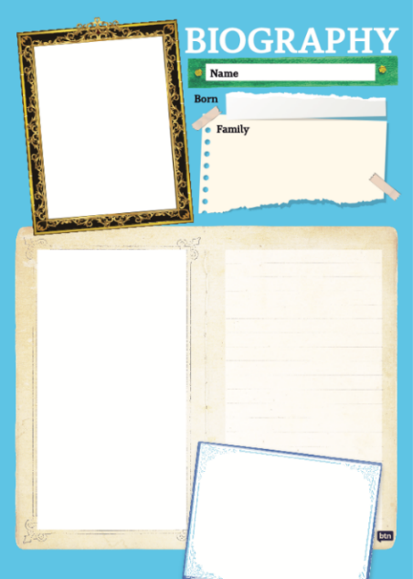
Create your Biography
Using the biography worksheet at the end of this activity, students will research and record information about their chosen athlete. Some possible areas of research include:
- When and where was the athlete born? Describe their family life growing up.
- Which sport do they compete in?
- What were some of their achievements? Choose one to explore in more detail.
- What were some challenges that they faced?

Activity – Choose a Project
Individually or in small groups, students will choose one of the following projects to work on and then present their findings to the class.

Paralympic Flag
What is the Agitos logo and what does it symbolise?
Create a poster to explain its meaning.
Profile of Paris
The 2024 Paralympic Games are being held in Paris, France. Students will research and create a profile of Paris.

Did you know?
Using the information in the BTN story and your own research, create a Did You Know fact sheet about the Paralympic Games. Publish using Canva.
Quiz
Create a true/ false or multiple-choice quiz to test your classmate’s knowledge about the Paralympics.

Activity – Fierce Girls: Paralympians
The ABC’s Fierce Girls podcast tells the stories of some of Australia's most extraordinary women, including many significant sportswomen. Listen to the stories of Paralympians Daphne Hilton and Louise Sauvage in the podcast.

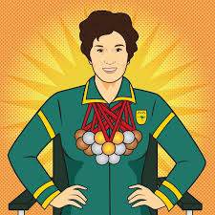  Daphne Hilton (Ceeney) | 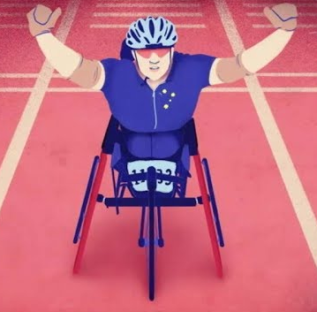  Louise Sauvage

Respond to the following questions after listening to the podcast.
- Summarise the story of Daphne and/or Louise.
- What challenges did they face?
- What inspired you about their story?
- If you could interview Daphne or Louise, what three questions would you ask them?

BTN Paralympics Stories
Watch these BTN videos to help students learn more about the Paralympic Games.

  Young Paralympian - Angus Hincksman |   Paralympics Champ Isis Holt |   Paralympic Dreams

Useful Websites
- Paralympians – Paralympics Australia
- Paris 2024 Para Sports – Paralympics Australia
- Young Paralympian – Angus Hincksman – BTN

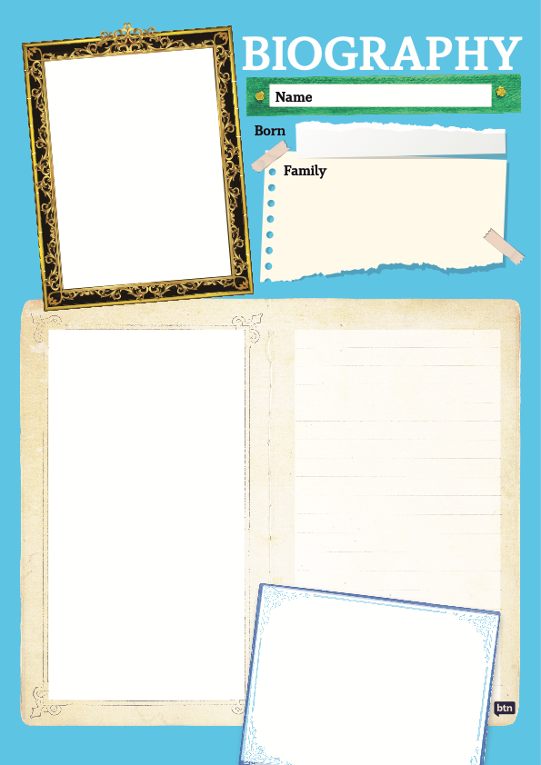

EPISODE 24
27th August 2024

KEY LEARNING
Students will explore the characteristics of the planet Mars.

CURRICULUM
Science – Year 5
Scientific understandings, discoveries and inventions are used to solve problems that directly affect peoples’ lives.

The Earth is part of a system of planets orbiting around a star (the sun).

Science – Years 5 & 6
Scientific knowledge is used to solve problems and inform personal and community decisions.
Science – Year 6
The growth and survival of living things are affected by the physical conditions of their environment.
Science – Year 7
Predictable phenomena on Earth, including seasons and eclipses, are caused by the relative positions of the sun, Earth and the moon.
Scientific knowledge has changed peoples’ understanding of the world and is refined as new evidence becomes available.
  - Teacher Resource

Water on Mars

Focus Questions
Discuss the BTN story as a class and record the main points of the discussion. Students will then respond to the following:
- Discuss the Water on Mars story in pairs or small groups. What were the main points of the discussion?
- Where on Mars do scientists think the liquid water is?
- How did scientists discover the water on Mars?
- Why is the discovery significant?
- What do Mars and Earth have in common? Use a Venn diagram to show similarities and differences.

Activity: Class Discussion
After watching the BTN Water on Mars story, hold a class discussion responding to the following questions:

- What do you know about Mars?
- What does Mars look like?
- How similar are Earth and Mars?
- Describe the location of Mars in relation to the Earth and the sun.
- Why do you think scientists want to explore Mars?
- What might be some challenges of exploring Mars?
- Think of 3 unanswered questions you have about Mars.

Activity: Q&A
Are you curious about Mars? Students will make a list of questions they have about the BTN story and space exploration. Students will use the internet to find answers to their questions and share their findings with the class.
Why do we study planets?
What do you know about Mars?

Activity: Glossary
Students will brainstorm a list of key words that relate to the BTN Water on Mars story. Here are some words to get them started.

MARS | PLANET | SOLAR SYSTEM
SOLAR SYSTEM | RESOURCES | EXPLORATION

Ask students to write what they think is the meaning of each word (including unfamiliar words). They will swap definitions with a partner and ask them to add to or change the definition. Check these against the dictionary definition.

Further activities for students:
- Where did Mars get its name? Explore its meaning. Why are most of the planets in the solar system named after Roman gods? Learn more by watching this video How Do Planets Get Their Names? We Asked a NASA Expert (Source: NASA).
- What is the difference between an icy giant, a gas giant and a terrestrial planet? Include an illustration or diagram with your explanation.
- Use as many of the following words to write a summary about Mars: Martian, Red Planet, terrestrial, space exploration, solar system, Phobos, Deimos, Perseverance rover and iron oxide.
- Who explores planets? Learn more about the jobs involved with space exploration. Choose one job and investigate what the job involves and what you need to study to become one. Explore job roles at the Australian Space Agency.

Activity: Jigsaw Learning
In this jigsaw learning activity students will work cooperatively to learn more about the 8 planets in our solar system. Each group will become experts on one of the planets and then share what they have learnt with other students.

Visit NASA’s website to learn all about the 8 planets in the solar system: Mercury, Venus, Earth, Mars, Jupiter, Saturn, Uranus, and Neptune.

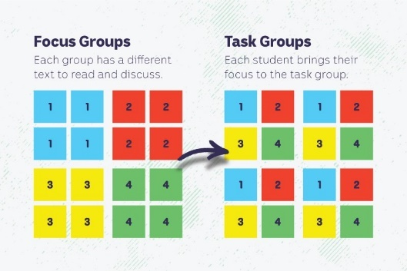
Form groups
Divide the class into 8 x Focus Groups. Each Focus Group will be assigned a different planet and become experts. Each group will need to decide how they will collect and communicate the information they find during their research.

Research
Each Focus Group will work as a team to learn as much as they can about their topic. They will use the following as a guide for their research.
- What is the name of the planet? Investigate the origins of the planet’s name.
- When was the planet discovered?
- How big is the planet?
- Where is the planet in the solar system in relation to Earth and the Sun? Draw a diagram.
- How far away is the planet from the Sun?
- What does it look like? Describe the surface of the planet and find pictures that illustrate these features. Use words from your class glossary when describing the planet.
- What important scientific discoveries have been made about the planet? List any missions.
- Optional: Write 1-3 scientific questions to research and answer.
- Include diagrams.
- Include a glossary of key words.
- Interesting facts!

Share
Mix the Focus Groups to form Task Groups (Tasks Groups include one student from each of the Focus Groups) to share the information they have collected. Students will share the information they have collected and learn from one another.

Reflect
Students will reflect on the activity by responding to one or more of the following questions:
- What did you enjoy about this investigation?
- What did you find surprising?

Activity: Scientific Investigation
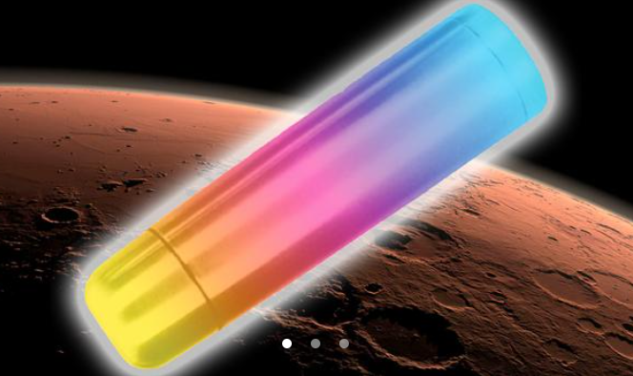
In this NASA classroom activity: Mars Thermos student teams use the engineering design process and everyday materials to design an insulator that will keep a small amount of water from rapidly changing temperature. The goal of this activity is to keep cold water cold and warm water warm.

Mars Thermos Classroom Activity (Source: NASA)

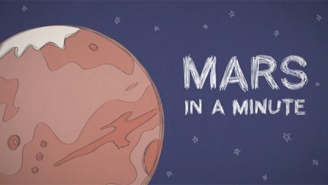
Begin this activity by watching this NASA video as a class Mars in a Minute: Is Mars Red Hot?

Link to NASA Classroom Activity
Mars Thermos

Activity: Graphic Organisers
Graphic organisers are a helpful learning tool for students to organise, clarify, or simplify complex information. Students will choose one type of graphic organiser to help them explore, understand and analyse our solar system and the importance of space exploration.

Venn Diagram  Purpose: To compare the similarities and differences between two or more things.  Procedure: Write the items being compared in the circles. Where the circles overlap, record similarities. Record the characteristics which are different in the areas that do not overlap.  Activity: Compare the similarities and differences between Earth and Mars.   | Mind Map  Purpose: To assist in activities that involve planning, brainstorming, making notes, organising or problem solving.  Procedure: An issue or topic is written in the centre. Related ideas are linked to the central issue and other ideas are developed from these.  Activity: Use a mind map to record what you know about Mars.   | KWL Chart  Purpose: To help organise your thoughts before, during, and after a learning exercise.  Procedure: Identify what you know about a topic. Then, think about what you want to research or learn. After the lesson, reflect on what you have learned.  Activity: Use a KWL chart to organise information about Mars.  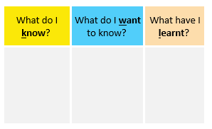

Activity: Mars Facts
In small groups, students will find out as much as they can about Mars and compile the information they find into a list of facts. Provide students with a list of suggested questions and/or topics to guide their research.

Facilitate a class discussion by asking each group to share one interesting fact they learned during their exploration. Record students’ responses on the white board to create a collective list of facts about Mars.


Students will use the facts they have discovered about Mars to create a quiz and then test their classmates. Students will include a range of quiz styles, for example multiple choice, true or false or fill in the blank. Students can make their quizzes in Kahoot or Quizizz. Make it fun, engaging, and educational!

Activity: Mars Quiz

- What is Mars?  A. Rocky planet  B. Gas giant  C. Ice giant  - Why is Mars called the ‘Red Planet’?  A. It is hotter than Earth  B. It is the closet planet to the Sun  C. There is rusty iron on the surface  - Scientists have found evidence of water on Mars.  A. True  B. False  - How many moons does Mars have?  A. 1  B. 2  C. 3  - What was Mars named after?  A. Roman god of the underworld  B. Roman god of love and beauty  C. Roman god of war | - Humans have not set foot on Mars before.  A. True  B. False  - What was the first spacecraft to land on Mars?  A. Curiosity  B. Perseverance  C. Viking 1  - What is the average temperature on Mars?  A. -60 degrees Celsius  B. 0 degrees Celsius  C. 60 degrees Celsius  - Where is Mars in the solar system?  A. 1st planet from the Sun  B. 4th planet from the Sun  C. 8th planet from the Sun  - Mars is the only planet that has been explored by rovers.  A. True  B. False

Quiz Answers: 1A, 2C, 3A, 4B, 5C, 6A, 7C, 8A, 9B, 10A

Useful Websites
- Water on Mars – Newsbreak
- Scientists find evidence of `oceans’ of underground water on Mars – Newsround
- Life on Mars – BTN
- Mars Class – BTN
- Space Food – BTN High
- Mars – NASA
- About the Planets – NASA
- Mars in a Minute: Is Mars Red Hot? – NASA Jet Propulsion (YouTube)

  - Teacher Resource

BTN Transcript: Episode 24 - 27/8/2024

Hey, I'm Amelia Moseley and you're watching BTN. Thanks for hanging out with us again. Let's see what's coming up on today's show. We learn more about the history of nuclear tests, discover the underground oceans of Mars, and meet Australia's youngest gold medallist. All that soon.

Paralympics History

Reporter: Wren Gillett

INTRO: But first today, if you're missing the Olympics, we've got some good news for you - it's not over yet, because, this week, the Paralympic Games begin in Paris. Wren found out more about the Paralympics and how it all began.
WREN GILLETT, REPORTER: It's the event that keeps us on the edge of our couches every four years, making us feel like running as fast as we can, swimming for as long as our lungs can withstand and leaping as high as gravity permits. Yep, that Olympic action isn't over yet, because the Paralympics are about to begin.
Para in Greek means beside or alongside, meaning the Paralympics are quite literally the parallel Games to the Olympics. And for the past 64 years, they've been bringing together the world's best athletes with physical, visual and intellectual impairments. Now, people with impairments have been playing all sorts of sports for a long time. But the story of the Paralympics dates back to World War II.

It was the deadliest conflict in history, and it also left millions of people with life changing injuries. At the time many weren't expected to live very long, and doctors would often give them sedatives and encourage them to lie still. But one doctor in Britain, Ludwig Guttmann, had a different idea.

DR LUDWIG GUTTMANN: You haven't got much hope?
PATIENT: No.
DR GUTTMANN: Now, look here, cut that out, will you?

He encouraged his patients to get up and move around, by taking part in craft and sporting activities, which eventually turned competitive.
DR GUTTMANN: And then I saw of course, how these men react, not only physically but psychologically.
On the opening day of the London Olympic games back in 1948, Guttman organsied a team to compete in an anarchy demonstration, which he called the Stoke Mandeville Games. The 14 men and two women who took part that day are now seen as the first Paralympians. In 1952, the first international version of the event was held when a small team from the Netherlands travelled to join in and compete as well. And in 1960, the first official Paralympic Games were held in Rome, featuring 400 athletes from 23 different countries. And then in 1976, the first Winter Games in Paralympics history were held in Sweden. Since then, the Paralympics have only gotten bigger. This year they'll be in Paris, and the competitors have a message for us.
Yep, these athletes are the best in the world.
And getting to the Paralympics takes years of training and dedication.
This year, 160 Aussies will be in Paris, competing in 17 of the 22 Paralympic sports.
TRISTAN KNOWLES: Hey, BTN! Tristan Knowles here, captain of the Rollers, the Australian men's wheelchair basketball team. I'll be competing at the Paris Paralympic Games.
SARAH WALSH: Hey, BTN. My name is Sarah Walsh and I'm competing in the long jump at this year's Paralympics in the classification T64 for below-knee amputees.
For these guys, and all the other Paralympic athletes, everything they have been working for will soon be coming down to one moment, one shot, one stretch in Paris.
WREN: So get ready, because we're about to watch another wave of world-class athletes take over France... and well our living rooms for the next little while anyway.
Quiz
Which of these sports is at the Paralympics but not the Olympics? Judo, Badminton or Boccia? It's Boccia. Boccia and Goalball are two sports that you'll only have the chance to see at the Paralympics.

Arisa Trew

Reporter: Wren Gillett

INTRO: While we're in the Olympic spirit, how would you like to meet Australia's youngest ever Olympic gold medallist? Well Wren caught up with Arisa Trew, fresh from her skateboarding win at the Paris games to find out what it was like and whether she has a pet duck yet. Take a look.

WREN: Welcome Arisa.
ARISA: Thank you.
WREN: Basically, you just went to the Olympics, and now you're back doing normal, normal life. What's that like?
ARISA: Yeah, I mean, like coming back from the Olympics, it's like a bit different. Because before, like, I could just be out in public and like, people wouldn't know who I am, but now there's, like, a lot more people that know who I am. Like, they come up pictures to say hi and stuff. So that's, like, really different.
WREN: What was going to the Olympics actually like?
ARISA: Going to the Olympics was pretty cool, and, like, pretty fun, because, like, the skate park was really, like fun to skate. And it was like, had a feature from all the other skate parks we had competed in to qualify it. So that was really cool. And we got to go to the village, like, every day. And it was really fun. Because when we were there, we were mainly just pin swapping with people. And we got so many pins.
WREN: Could you explain to me what pin swapping is?
ARISA: At the Olympics like, every country gets their own country's pin. So, I had Australian pins, and you go to other countries, and you ask to swap a pin, and like me and Ruby had a competition with the boys in the Australia team to see who could get the most.
WREN: Who won?
ARISA: I think me, and Ruby won, but, like, we never really counted them.
WREN: I reckon we'll just go with you and Ruby winning, I reckon.
ARISA: Yeah.
WREN: And you didn't just go to the Olympics. You won gold at the Olympics. What was that like?
ARISA: I was like, Oh my gosh. Like, it was like, actually, I'd won, and it was crazy.
WREN: Do you have your gold medal here?
ARISA: I don't have it, like with me right now, but I can go and get it.

[Twelve Seconds Later]
ARISA: It's like, a lot heavier than you'd think. It's, like, pretty heavy for a metal, I'd say, and like this, um, silver bit is a piece of the Eiffel Tower.
WREN: I now want to ask a question that I think has been on everyone's mind. Um, when you won, you said that your celebratory gift would be, hopefully, a duck.
ARISA INTERVIEW: The gift I asked for from my parents if I, like, won, was if I could get a pet duck because ducks are really cute and I really wanted a pet duck.
WREN: Have you got a pet duck?
ARISA: No, I haven't got a pet duck yet, but I'm getting two when I come back from, like...I'm pretty sure Brazil, because I'll be in Australia for longer. But I'm literally just about to leave Australia again to go to, like, three more competitions.
WREN: And what do you reckon you're going to name them?
ARISA: I'm not really sure. Because I, like, really wanted a duck when I was like, younger, like, I've wanted a duck for so long, and like, I planned it when I was younger. I was going to name it One cheese and the other one, quackers. Then also people now saying, like, oh, name a Goldie or Paris or like, Oly for Olympics that, I'm not really sure, but we'll just have to see.
WREN: I'm going to say I'm a big fan of cheese and quackers.
ARISA: Yeah, I like that one as well.
WREN: If there was one piece of advice that you could give all of the people watching this interview right now, what would it be?
ARISA: Advice like I give people who are watching this or just anyone, is that if you want to try something new, always give it a go, never give up, and just always have fun. And if you're skateboarding, it's sometimes challenging, but it really pushes you to just like become more confident, to believe in yourself, and it's just the funnest sport ever.

News Quiz
You probably know who this is, but do you know how to pronounce her name?

AMARA: First you say 'comma', like a comma in a sentence.
LEELA: Then you say 'la', like... # La la la la la la! #
KERRY WASHINGTON: Put it together and it's... One, two, three.
ALL: Kamala.

Yep, Kamala Harris’ nieces gave us a lesson on pronouncing her name last week at the Democratic National Convention.

ALL: Kamala.
KERRY WASHINGTON: For president!!

It was full of speeches for all sorts of people, politicians, former presidents, former talk show hosts, and of course, the Vice President herself who accepted the Democratic Party nomination to run for president.

KAMALA HARRIS: I see a nation that is ready to move forward.

Meanwhile in Australia Lia Finocchiaro has been elected as the new leader of where: Victoria, Western Australia or the Northern Territory. It’s Northern Territory. Her party, the Country Liberals won the territory’s election on Saturday.

LIA FINOCCHIARO: Tomorrow is a new chapter for the Territory.

Why were some schools in this Hunter Valley town evacuated last Friday? Was it because of flooding, a tornedo or an earthquake? It was a magnitude 4.8 earthquake. While no one was injured, thousands were left without power and there was a bit of damage to some buildings.

RESIDENT: Everything started shaking.
RESIDENT: I honestly felt terrified.
RESIDENT: It was awesome. (CHUCKLES)

Do you know where this volcano is erupting? Is it in Iceland, Italy or Hawaii? It’s on Iceland’s Reykjanes Peninsula, which has seen nine eruptions since 2021.

And the biggest diamond in a century has been found by a mining company in Botswana. It measures 2,492 what? Inches, carats or grams? It’s 2,492 carats, which is the measurement used for diamonds.

Nuclear Testing

Reporter: Joe Baronio

INTRO: The 29th of August is the International Day against Nuclear Testing. While that's something we don't really see happening anymore, a few decades ago nuclear tests were a big deal, and they had a lasting impact on the planet. Joe, can tell you more.

Joe Baronio, Reporter: On July 16th, 1945, this explosion in the desert of New Mexico changed the world forever. It was a test of the world's first nuclear bomb called Trinity, and it was the turning point for one of the most dangerous races in human history.
The nuclear story actually begins a few years earlier in 1938, when three German scientists discovered something called Nuclear Fission, which is when atoms are split in a chain reaction and release a huge amount of energy. And when World War II began in 1939, a race began to use this new discovery to build a super-bomb.

This famous physicist, Albert Einstein, actually wrote to the US president urging him to do it because he was worried the NAZIs would figure it out first and, in a top-secret project led by this guy, J. Robert Oppenheimer, the Americans developed and tested the world's first nuclear weapon.
Two weeks later, in August 1945, they dropped two bombs on Hiroshima and Nagasaki.

MAN: The bomb is dropped.

The cities were almost entirely destroyed and hundreds of thousands of people died. While Japan surrendered, many were horrified including the man who built the bomb.
J. ROBERT OPPENHEIMER: Now I am become death, the destroyer of worlds.
The threat of nuclear weapons didn't end with the war.

PUBLIC AWARENESS CAMPAIGN: Please duck and cover.

This is an actual video shown to kids in the US back in the 50s when many people were worried about a nuclear attack. America had a new enemy, the Soviet Union. They were developing and testing their own nuclear weapons, and the U.S. and its allies were racing to keep up, conducting tests in locations around the world. At the time, many people didn't realise that just testing these weapons could have catastrophic impacts. See, each blast creates massive amounts of tiny radioactive particles called fallout which can poison people and the environment. That happened to Bikini Atoll in the Marshall Islands when, on the first of March 1954 the U.S. set off its largest nuclear detonation ever: Castle Bravo.
Bikini Atoll Resident: The earth shook. Most of us were very afraid.
Joe Baronio: Lots of Marshallese people suffered radiation sickness and died, and the islands are still contaminated. In Australia, the United Kingdom detonated twelve bombs in The Montebello Islands, Emu Field, and Maralinga.
Maralinga Resident: We all got sick. Diarrhea, vomiting, and sore eyes, I couldn't open my eyes.
Joe Baronio: But the testing continued. In 1961, the Soviets dropped Tsar Bomba, the most powerful weapon the world has ever seen over the Arctic Ocean. France, China and India also tested nuclear weapons until the 1990s, but as time went on more and more people spoke out against them.
KID: We just want our world to live because it's a nice place.
Joe Baronio: In 1995 there were huge protests over French tests in the Pacific, and the following year many countries signed an agreement to ban nuclear weapons tests completely. These days, nuclear tests are basically unheard of, and the number of nuclear weapons is continuing to drop. And since 2009 the UN has marked August 29 as the International Day Against Nuclear Testing to remind us all of the devastating power of these super-weapons.

Water on Mars

Reporter: Justina Ward

INTRO: Now to some exciting news from space. Scientists in the US have found an oceans-worth of water on Mars and they say that where there's water, there could also be life. So, does this mean we can all live on Mars now? Let's find out.
Justina: Ever dreamt of a drink that's out of this world, like seriously out of this world. Introducing Mars Water. Straight from the newest discovery on the Red Planet.
Astronaut: Mm, I can taste the iron.
Justina: Mars Water, where the future is refreshing. Available 2060 at your nearest space station.
Yep. According to scientists, Mars water is a real thing. You see scientists from the University of California reckon they've discovered liquid water under the surface of Mars and say there's enough of it to cover the planet with an ocean at least a kilometre deep. Although.
Vashan Wright, University of California: The liquid water is roughly eleven to twenty kilometres beneath the subsurface and getting that liquid water would be quite challenging.
So, how did they figure all this out? Introducing NASA's Mars InSight Lander. It touched down on the planet in 2018…

ANNOUNCER: Touchdown confirmed.

…and until it shut down a few years ago it's been sitting quietly listening to the pulse of Mars measuring how fast seismic waves from Marsquakes travel through the planet. And because sound travels at different speeds through different materials, they could work out water was deep inside the planet.
Dr. Clare Kenyon, Astrophysicist: This is the first time that we have evidence for liquid water on Mars, which is why this is so exciting.
Vashan Wright, University of California: Water affects just about everything about our planet’s evolution. We know that water is a key ingredient for life as we know it. It means that it's potentially habitable in the mid crust of Mars.
While Mars is hundreds of degrees colder than Earth and hardly has any oxygen. Mars and Earth actually have a lot in common. Mars has got polar ice caps, volcanos and seasons. And some scientists reckon that billions of years ago Mars was a lot like Earth today.
Dr. Clare Kenyon, Astrophysicist: There's actually history that Mars had surface water a long time ago in the past. So, when we look at the rocks, we see evidence of, you know, dried out by ocean basins or lake basins, and we see streams; we see canyons that look like they were carved by water just like on Earth.
In fact, Scientists think it's one of the few places in our solar system, other than Earth, where life may have once existed. And may still exist… errr, probably not like this…
Alien: Oh.
…but in some tiny form. Some also think that Mars could one day support human life. And some big companies and organisations are spending a lot of time and money to try to get there, conducting all sorts of experiments to work out how they could make the journey and live on the surface. And while the discovery of liquid water is big news it may not be that helpful.
Dr. Clare Kenyon, Astrophysicist: Drilling 10 kilometres down is really hard, even on Earth, let alone on Mars.
And there are some other things to work out.
Dr. Clare Kenyon, Astrophysicist: So you've got to be able to land, you know, you've got to build a habitat, which we don't really know how to do yet, and then you've got to somehow have a ship to get you back in, you know, about a year. And that's a very long time to do all those things. And you'd want to get it right if you're going all that way.
But while it might be some time before we see humans living on the red, dusty planet, and taking a refreshing sip of cool, Martian water. It's still an exciting step in our understanding of life in our solar system.
Quiz

When did NASA land a rover on Mars? In 1979, 1997 or 2007? It was in 1997. Sojourner was the first of five NASA rovers to successfully explore Mars, two of which are still operational and in 2021 they were joined by the first Chinese rover, Zhurong.

Sport

The AFL's top eight teams have been locked in for this year's finals series. It will all kick off in a couple of weeks, with Port Adelaide, who finished second on the ladder, hosting third place Geelong in their qualifying final, and a Sydney showdown, with the top placed Swans taking on fourth place GWS.

Meanwhile, it'll be Brisbane versus Carlton and Western Bulldogs versus Hawthorn in do-or-die elimination finals. But it's not just the finals everyone's talking about...

COMMENTATOR: Oh, no!

...with a big investigation launched over this water bottle incident in the Carlton and Saint Kilda match on the weekend. Ouch! Now let's shift gears, 'cause we're heading to the Dutch Grand Prix where this guy has won for the second time this year.

COMMENTATOR: Lando Norris wins.

It was a rough set up for Norris after a quick start from Max Verstappen.

COMMENTATOR: And Max Verstappen takes the lead!

But a strong 18th lap saw him overtake Verstappen to take out the title.

And finally, to a sport that's not for the faint-hearted or, well, the wobbly footed. Uh...yeah. Over the weekend, 21 of the world's best slackliners took part in this high altitude slackline competition in China. They had to walk on ropes suspended more than 1,000m above the ground, and were judged by their speed, the distance they walked, and how many mistakes they made. Oh, my goodness, I feel sick just looking at them!

Rose’s Drama Class
Rookie Reporter: Rose

INTRO: Finally, today, let's hear from another winner of the ABC's Heywire competition which asks kids in regional areas to share their stories. Rose tells us how a school play changed her life in Lismore.

Seven months ago, I moved from a small rural town in Vietnam to Lismore in northern New South Wales.
Everything in my world changed. New country, new language, new school. I was filled with fear. I had to adapt fast.

Making friends was difficult as my English wasn't great, and people couldn't understand my accent. I kept to myself, stayed quiet and couldn't wait for school to end each day. I felt isolated and lonely.

But that all changed when I was asked to be in the school play. I couldn't believe it. Singing, dancing and acting was a huge part of my life in Vietnam. But I had become so shy and withdrawn. I wasn't sure if I could perform.

During rehearsals I realised how supportive and kind the other students were. We were in this together.
Over time, my confidence grew. When we performed on a stage in front of the school, I finally felt like me.

Now I'm on a mission. In my journal, I have written a list of all the things I want to achieve this year. I call it Revolution 2024.

I've joined the debating team to Chess Club, STEM workshop, band practice, choir, and the SRC. And I also put my hand up for the next school play. You might think it's a lot of extra activities, but that was my life in Vietnam.

It's only been seven months, but Lismore is now starting to feel like home to me. Now I embrace change.
Fear is just something for me to overcome.
Closer

Oh, well, that's all we have for you today. But don't you worry because we'll be back with more next week. Until then, you can check out our website for stories and specials and resources for your teachers up there too. Plus there's Newsbreak and BTN High for you high schoolers or nearly high schoolers. I'll catch you soon. Bye.

