Episode 32

10th November 2020



**US Election Result**

1. Discuss the BTN *US Election Result* story as a class.
2. It is compulsory to vote in the US. True or false?
3. Why did many Americans mail in their vote?
4. Donald Trump accused his opposition of…
   1. Not wearing a mask to the polling booth
   2. Playing golf instead of voting
   3. Rigging the election
5. Why were some of Donald Trump’s supporters protesting outside ballot-counting centres?
6. Who has been elected the President of the United States?
7. Which political party do they belong to?
8. Complete the following sentence. Donald Trump is demanding a recount of _______ in some states.
9. What words would you use to describe what you saw in this news story?
10. What questions do you have about this story?

**UK Lockdown**

1. Discuss the BTN *UK Lockdown* story with another student.
2. Where does Sam live in England? Find on a map.
3. Why is Sam’s mum more likely to catch the coronavirus?
4. What is Sam’s routine when he gets home from school?
5. What challenges has Sam been doing to raise money?
6. How has the second lockdown helped Sam and his mum?
7. Where in the UK has one of the highest rates of COVID-19?
8. At Mikey’s school they have bubbles for each year group. What does this mean?
9. How does Mikey make sure he is staying active during lockdown?
10. How did you feel watching the BTN *UK Lockdown* story?

**Conscription**

1. Discuss the BTN *Conscription* story as a class. Record the main points of the discussion.
2. What is conscription?
3. Which former Prime Minister tried to introduce conscription in World War One?
   1. Billy Hughes
   2. Gough Whitlam
   3. Alfred Deakin
4. Why did he try to introduce it?
5. What were the arguments for and against conscription?
6. What was held to decide whether conscription should be introduced and what was the result?
7. In 1964 conscription was introduced for the…
   1. Vietnam War
   2. Korean War
   3. War in Afghanistan
8. How were men chosen to go to the Vietnam War?
9. What year did Australia end conscription?
10. What did you learn watching this story?

Check out the [Conscription resource](https://www.abc.net.au/btn/teachers/) on the Teachers page.

**Ned Kelly**

1. Before watching the BTN story, record what you know about Ned Kelly.
2. Who was Ned Kelly?
3. What was Ned Kelly’s life like growing up? Describe his family.
4. What is a bushranger?
5. What did Ned Kelly wear to protect himself?
6. What happened at Glenrowan in 1880?
7. After Ned Kelly died, there was a Royal Commission into the conduct of police during the Kelly outbreak. What did it find?
8. Do you think Ned Kelly is a hero or a villain? Give reasons for your answer.
9. What three words would you use to describe Ned Kelly?
10. Create a timeline of Ned Kelly’s life.

Check out the [Ned Kelly resource](http://www.abc.net.au/btn/teachers.htm) on the Teachers page.

**Butterfly Migration**

1. Briefly summarise the BTN *Butterfly Migration* story.
2. Which butterfly was the BTN story about?
   1. Cabbage White
   2. Caper White
   3. Monarch
3. About how many species of butterflies does Australia have?
4. Using words or pictures, describe the life cycle of a butterfly.
5. In which state is the butterfly migration happening?
6. How often do the mass migrations happen?
7. What is the aim of the citizen science project, Brisbane's Big Butterfly Count?
8. Complete the following sentence. Butterflies can tell us how healthy the ________________ is.
9. What do butterflies need to survive and thrive?
10. Name three facts you learnt watching this story.

Teacher Resource

Episode 32

10th November 2020

**Conscription**



Students will explore the history of conscription in Australia.



**HASS – Year 3**

Days and weeks celebrated or commemorated in Australia (including Australia Day, Anzac Day, and National Sorry Day) and the importance of symbols and emblems.

**HASS – Year 5 & 6**

Develop appropriate questions to guide an inquiry about people, events, developments, places, systems and challenges.

Locate and collect relevant information and data from primary sources and secondary sources.

Sequence information about people’s lives, events, developments and phenomena using a variety of methods including timelines.

**HASS – Years 6 & 7**

Examine primary and secondary sources to determine their origin and purpose.

**HASS – Year 7**

Construct significant questions and propositions to guide investigations about people, events, developments, places, systems and challenges.



1. Discuss the BTN *Conscription* story as a class. Record the main points of the discussion.
2. What is conscription?
3. Which former Prime Minister tried to introduce conscription in World War One?
   1. Billy Hughes
   2. Gough Whitlam
   3. Alfred Deakin
4. Why did he try to introduce it?
5. What were the arguments for and against conscription?
6. What was held to decide whether conscription should be introduced and what was the result?
7. In 1964 conscription was introduced for the…
   1. Vietnam War
   2. Korean War
   3. War in Afghanistan
8. How were men chosen to go to the Vietnam War?
9. What year did Australia end conscription?
10. What did you learn watching this story?



**Personal response**

After watching the BTN *Conscription* story, ask students to finish one or more of the following incomplete sentences:

* This story made me wonder why…
* It was interesting to learn that…
* This story made me feel…
* BTN covered this story because…

**Discussion**

Discuss the information raised in the BTN *Conscription* story. Ask students to record what they know about conscription on a mind map. What questions do students have? Use the following questions to guide discussion:

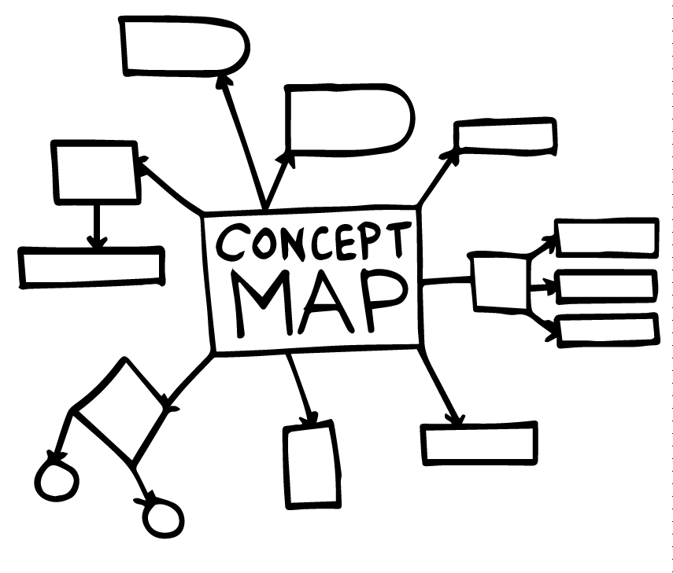

* What is conscription? Come up with a class definition.
* Which Prime Minister tried to introduce conscription?
* Why was it considered necessary?
* Why would people support conscription?
* Why would people be against it?



**Key Words**

Students will brainstorm a list of key words that relate to the BTN *Conscription* story. Here are some words to get you started.

|  |  |  |
| --- | --- | --- |
| **Conscription** | **Enlist** | **Controversial** |
| **Volunteer** | **Referendum** | **Propaganda** |



**Australia’s involvement in war**

**1939 – 1945**

Second World War

**1914 – 1918**

First World War

**1962 – 1975**

Vietnam War

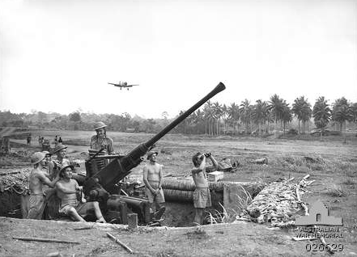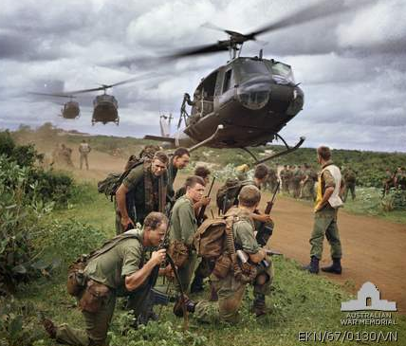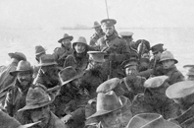

Ask students to create a timeline that highlights Australia’s involvement in war over the last 100 years. Students will work in small groups to work through the following questions, gathering basic information and understanding. Students will find and collect images, photographs, illustrations and video that represents Australia’s involvement in war.

* Why did Australia become involved in this war?
* What was Australia’s involvement?
* Were Australian citizens conscripted to serve in the war?



**Research**

Students will be investigating conscription in more detail. They can develop their own key questions to investigate or respond to one or more of the questions below.

* What reasons might soldiers have for voting for or against conscription?
* Many countries introduced conscription with some restrictions. Do you think the outcome of the referendum would have been different if Prime Minister Billy Hughes had been more specific about who could be conscripted? Give reasons for your answer.
* How did views about Australia’s involvement in the war change over time?
* How did people try to convince others of their point of view about conscription?

Students can present their research in a number of ways. These include:

* Podcast - [Audacity](https://sourceforge.net/projects/audacity/) or [GarageBand](https://www.apple.com/mac/garageband/) are both well suited to making podcasts. To publish they will need to use a free service like [PodOmatic](https://www.podomatic.com/), [Buzzsprout](https://www.buzzsprout.com/)
* News article
* [Prezi](https://prezi.com/index/) presentation



**Conscription posters**

Working in pairs, students will choose one or more of the following conscription posters or leaflets to analyse. Students can choose one or more of the examples below or find another conscription poster on the [Australian War memorial](https://www.awm.gov.au/learn/schools/resources/sources/conscription) website. Below are some questions students can respond to when analysing the texts.

* Describe the poster. What do you see?
* What is the key message of the poster?
* Why do you think the poster was created?
* Who was the intended audience?
* What persuasive techniques were used to promote the message?
* What question/s do you have about the poster?
* Are conscription posters a primary or secondary source of information?
* Further investigation: Why do you think women featured prominently in conscription posters?

|  |  |
| --- | --- |
| Source: [State Library NSW](https://digital.sl.nsw.gov.au/delivery/DeliveryManagerServlet?dps_pid=FL3140526&dps_func=stream) | Source[: Australian War Memorial](https://s3-ap-southeast-2.amazonaws.com/awm-media/collection/RC00320/screen/3778848.JPG) |
| Source: [State Library Victoria](https://blogs.slv.vic.gov.au/wp-content/uploads/2012/10/thedeathballot.jpg) | Source: [Australian War Memorial](https://s3-ap-southeast-2.amazonaws.com/awm-media/collection/RC00339/screen/3783334.JPG) |
| Source: [Australian War Memorial](https://s3-ap-southeast-2.amazonaws.com/awm-media/collection/RC00336/screen/3783331.JPG) | Source: [Australian War Memorial](https://s3-ap-southeast-2.amazonaws.com/awm-media/collection/RC00305/screen/3819946.JPG) |



**Conscription and the Vietnam War**

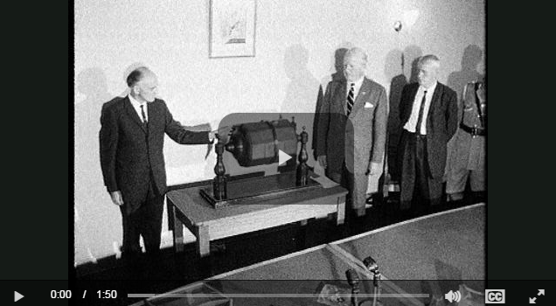

Watch the [Vietnam birthday ballot video](http://splash.abc.net.au/home#!/media/521089/luck-of-the-draw-the-vietnam-birthday-ballot-) and answer the following questions about conscription:

* How were men chosen to go to the Vietnam War?
* Why did Australia have to conscript men for military service?
* What reasons might people have to support or oppose the war in Vietnam?
* How do you feel about conscription? Write a personal response giving reasons for your answer.

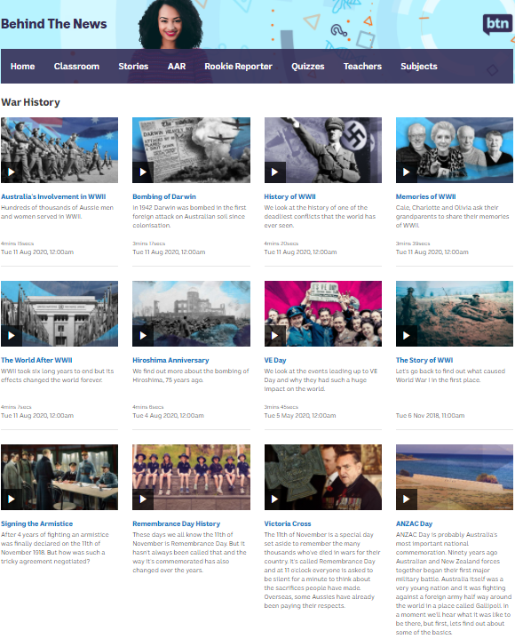

**BTN War History stories**

Visit BTN’s [collection of War History stories](https://www.abc.net.au/btn/war-history/10614234). After watching any one of the BTN videos ask students to respond to the discussion questions (to find the discussion questions and teacher resources go to the related BTN Classroom Episode and download the Episode Package).



Conscription Digibook – ABC Education

<https://education.abc.net.au/home#!/digibook/825363/conscription-in-20th-century-australia>

Vietnam War – BTN

<https://www.abc.net.au/btn/classroom/vietnam-war/10524226>

Sources: The conscription debate – Australian War Memorial

<https://www.awm.gov.au/learn/schools/resources/sources/conscription>

Teacher Resource

Episode 32

10th November 2020

**Ned Kelly**



Students will learn about the life of Ned Kelly using primary and secondary sources.



**HASS – Year 3 and 4**

Pose questions to investigate people, events, places and issues

Locate and collect information and data from different sources, including observations.

**HASS – Year 5 and 6**

Develop appropriate questions to guide an inquiry about people, events, developments, places, systems and challenges.

Locate and collect relevant information and data from primary sources and secondary sources.

Examine different viewpoints on actions, events, issues and phenomena in the past and present.

The role that a significant individual or group played in shaping a colony.

**HASS – Year 7**

Construct significant questions and propositions to guide investigations about people, events, developments, places, systems and challenges.

Apply a methodology to locate and collect relevant information and data from a range of primary sources and secondary sources.



1. Before watching for the BTN story, record what you know about Ned Kelly.
2. Who was Ned Kelly?
3. What was Ned Kelly’s life like growing up? Describe his family.
4. What is a bushranger?
5. What did Ned Kelly wear to protect himself?
6. What happened at Glenrowan in 1880?
7. After Ned Kelly died, there was a Royal Commission into the conduct of police during the Kelly outbreak. What did it find?
8. Do you think Ned Kelly is a hero or a villain? Give reasons for your answer.
9. What three words would you use to describe Ned Kelly?
10. Create a timeline of Ned Kelly’s life.



**What do you see, think and wonder?**

After watching the BTN *Ned Kelly* story, students will respond to the following questions:

* What did you SEE in this video?
* What do you THINK about what you saw in this video?
* What does this video make your WONDER?
* What did you LEARN from this story?
* How did this story make you FEEL?

**Personal response**



Write a personal response to the BTN *Ned Kelly* story. Ask students to finish one or more of the following incomplete sentences:

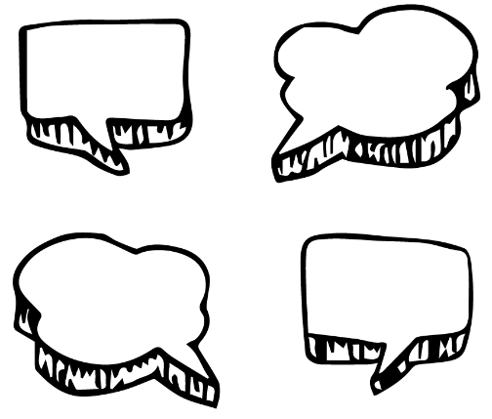

* Ned Kelly was a famous …
* It was interesting to learn…
* It was surprising to learn that...
* These are five words that I would use to describe Ned Kelly…



**Ned Kelly inquiry**

Discuss the story as a class and ask students to pose questions about Australia’s famous bushranger Ned Kelly. They can develop their own key questions to investigate or respond to one or more of the questions below. Students can complete the following KWLH organiser to explore their knowledge and consider what they would like to know and learn. Below are some possible questions for students to research.

|  |  |  |  |
| --- | --- | --- | --- |
| ***What do I know?*** | ***What do I want to know?*** | ***What have I learnt?*** | ***How will I find out?*** |
|  |  |  |  |

* Who is Ned Kelly? Use a timeline to record the significant events in Ned Kelly’s life.
* Why did Ned Kelly become a bushranger?
* Who were the Kelly Gang? Explore the members of the gang and their relationships to one another. Imagine a conversation between Ned Kelly and his brother Dan Kelly.
* Why is Ned Kelly remembered as a significant person?
* Why did some people consider Ned Kelly to be a hero? Do you think Ned Kelly was a hero or a villain? Give reasons to support your answer.
* What were some challenges that Ned Kelly faced? Imagine you are Ned Kelly and write a journal explaining some of the challenges he faced.
* Do you think it is important that we learn more about Ned Kelly? Why or why not?
* How do primary sources (for example photos, letters, diaries and official documents) help us understand what might have happened at a place in time? Find 1 or 2 primary sources that help you learn more about the life of Ned Kelly.
* How would you describe Ned Kelly? Make a list of his positive and negative characteristics.
* What are some of the key events in the life of Ned Kelly? Write a summary for one key event, which answers the 5 W’s – Who, What, Where, When and Why?
* How many bushrangers were there in Australia? Explore the history of Australia’s most notorious bushrangers.

**Primary and Secondary sources**

Students will collect and record information from a wide variety of primary and secondary sources and present the information they find in an interesting way.

* Primary sources – Through using primary sources, that is a document like a diary, paintings or a physical object such as stone tools, that was written or created at a particular time, we can gain an understanding of what might have happened at a place in time.
* Secondary sources – Secondary sources are documents written after an event has occurred, providing “second-hand” accounts of that event, person, or topic. Unlike primary sources, which provide first-hand accounts, secondary sources offer different perspectives, analysis, and conclusions of those accounts.

As part of their research, students will need to:

* Use appropriate terms and concepts in their presentation and refer to evidence and sources.
* Write down the name of the source of the information.
* Look for facts and opinions that answer their inquiry question/s.
* Write down using their own words facts and opinions from the source.



**Create a biography**

Students will research and write a biography on Ned Kelly. Before students begin to construct their biographies, hold a class discussion to find out what they already know about biographical writing. Discuss what type of information is included in a biography and what they tell us about a person. The [Civics and Citizenship website](http://www.civicsandcitizenship.edu.au/cce/contemporary_gallery,14538.html) has some examples of biographies for students to look at.

Below are some discussion starters:

* What does a biography tell us about a person?
* Where can you look to find information for your biographical writing? It could include the internet, newspaper articles, magazine articles and interviews, other biographies, historical books or television interviews. Why is it important to use more than one source of information?
* What makes a biography interesting? For example, key information and facts, a timeline of events, photographs, illustrations and quotes.

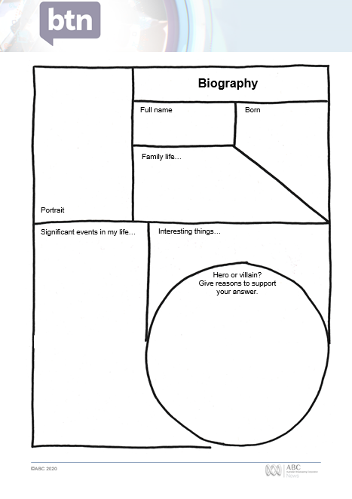

Using the biography organiser template at the end of this activity, students will find and record information about Ned Kelly.

Some possible areas of research include:

* Where and when was Ned Kelly born? Locate using Google Maps.
* Describe his family life growing up.
* What inspired/motivated him?
* What were some of the challenges he faced?
* What do you admire about him? Make a list of his positive and negative personality traits.
* Sketch a portrait of Ned Kelly. Explore and experiment with different techniques and media to produce a portrait. Exhibit your artworks in your school library. Include captions on your artworks.

Further investigation

* Imagine you could sit down and talk to Ned Kelly. What questions would you ask about his life?

Present your findings in an interesting way.

* Give a presentation on their achievements.
* Make a “Did you know?” for other students.
* Write a letter thanking them for their achievements.
* Create a timeline highlighting significant events.



Ned Kelly – BTN

<https://www.abc.net.au/btn/classroom/ned-kelly/10541218>

Ned Kelly fact sheet – State Library of Victoria

<https://www.slv.vic.gov.au/search-discover/explore-collections-theme/australian-history/ned-kelly/ned-kelly-fact-sheet>

Ned Kelly Collection – National Museum Australia

<https://www.nma.gov.au/explore/collection/highlights/ned-kelly>

The Hunt for Ned Kelly Clues – ABC Education

<https://education.abc.net.au/home#!/media/29502/archeologists-hunt-for-ned-kelly-clues>

Sidney Nolan and Ned Kelly Interactive Lesson – NGA

<https://nga.gov.au/education/resources/nedkelly/index.html>

Sidney Nolan’s Ned Kelly Series – Geelong Gallery

<https://www.geelonggallery.org.au/learn/k-12-resources/other-resources/sidney-nolan-s-ned-kelly-series-1111>

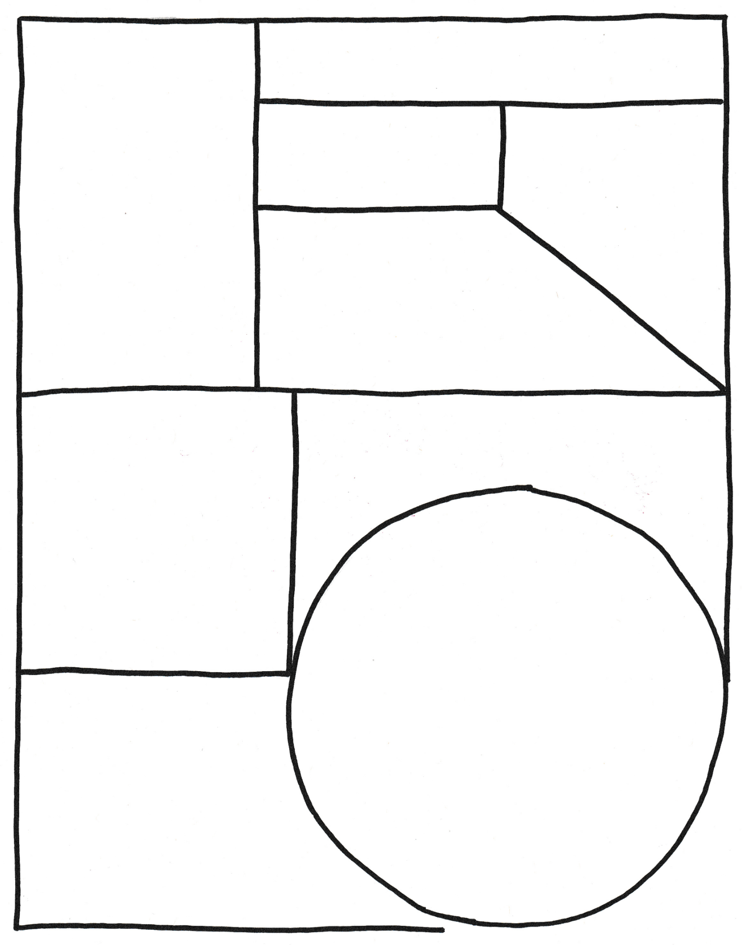

Family life…

Full name

Portrait

Significant events in my life…

Born

Hero or villain?

Give reasons to support your answer.

Interesting things…

**Biography**

**BTN Transcript: Episode 32 – 10/11/20**

Hey. I'm Amelia Moseley back with you for another episode of BTN. Did you miss me? Here's what's coming up. We meet some English kids who are heading into another lockdown, Leela learns why Queensland's skies are full of butterflies and Matt has a chat with a legendary bushranger. All that soon.

US Election Result

Reporter: Amelia Moseley

*INTRO: But first today to the US of A. As I'm sure you know, they just had an election and boy was it big news. Let’s find out what happened and what might happen next.*

People often compare US elections to a circus and look you can kinda see why. There are performances, costumes, tricks. Well, kind of, I mean the trick is catching the hat. And a whole lot of dancing. But this circus has a serious outcome and, once Election Day came along, the future of the country was in the hands of your average Joe or Joanne. Voting isn't compulsory in the US but hundreds of millions of Americans chose to have their say; the most voters the US has seen in more than a century. But while the end game for these two is, of course.

DONALD TRUMP, US PRESIDENT: Winning, winning, winning.

First there was a lot of counting, counting, counting to be done. The threat of coronavirus meant a lot of Americans mailed in their votes, so this was an even slower process than usual, and I'm not sure these guys really got enough of a...  
  
JOE BIDEN, US PRESIDENT-ELECT: Thank you, thank you, thank you.  
  
There you go. As the numbers rolled in, it was clear that this would be a grab your popcorn, edge of your seat, nail bitingly neck-and-neck kind of election. But there was confidence on both sides.  
  
JOE BIDEN, US PRESIDENT-ELECT: We believe we’re on track to win this election.

DONALD TRUMP, US PRESIDENT: We were getting ready to win this election. Frankly, we did win this election.  
  
Wait, what? No, he hadn't. But the controversy didn't end there. President Trump started accusing his opposition of rigging the election and called for counting to stop. But after several tense days of waiting, it finally became clear that one presidential candidate did have enough votes to win. Spoiler alert, it wasn't Trump.   
  
KAMALA HARRIS, US VICE PRESIDENT-ELECT: The president-elect of the United States of America, Joe Biden.   
  
JOE BIDEN, US PRESIDENT-ELECT: For all those of you, who voted for President Trump I understand the disappointment tonight. I've lost a couple of times myself. But now, let's give each other a chance.  
  
Biden supporters across America were literally dancing in the streets.  
  
US CITIZEN: It's one of the great days in American history. You know. We really proved that democracy wins.  
  
Is that a watermelon? Clever. Anyway. They also celebrated Biden's running mate, Kamala Harris, who became the first woman of colour to become Vice President of the United States.   
  
KAMALA HARRIS, US VICE PRESIDENT-ELECT: To the children of our country regardless of your gender, our country has sent you a clear message. Dream with ambition.  
  
US CITIZEN: It gives women of colour and minorities, you know, hope, like we can dream big, so I am excited to see that.  
  
So that's it. The election is finally over, right? Eh, not quite. President Trump isn't ready to admit defeat. He's demanding a recount of votes in some states and says he's going to challenge the election result in court. Many Trump supporters are backing that.  
  
US CITIZEN: So, we’re here to show support for our president and we know that there's absolutely no way they've counted all of our legal votes.   
  
Others say Joe Biden is the winner fair and square.  
  
US CITIZEN: America spoke, the people spoke. You gotta count every vote, ok.   
  
We won't have an official winner for a few weeks yet, and that winner won't be sworn into office until January, but no matter what happens this is an election that's made history and won't be forgotten anytime soon.

News Quiz

What’s Victoria’s premier, Daniel Andrews holding in this photo, which he tweeted to celebrate another COVID-free day. It’s a doughnut. The tasty zero-shaped treats have become an unofficial symbol of days when there are no new COVID-19 cases and no deaths and there’ve been a few of those now. The government’s now lifted the “Ring of Steel” around Melbourne and Victorians can freely move around the state.

What Australian state has announced it’ll be the first to open its borders up to everyone? Tasmania, South Australia or New South Wales? It’s New South Wales. It’s going to open its borders to Victoria on November 23rd. The other states and territories are also relaxing their border restrictions, and many are hoping by Christmas we might be one big Aussie family again.

3-year-old Elif lifted the spirits of her country when she was rescued from rubble three days after a deadly earthquake. What country was it in? Italy, Turkey or Iran. It was in Turkey.

A train driver in Rotterdam was saved last week by a statue of what? A whale, a duck or a bear? It was a sculpture of a whale’s tale which caught the train when it derailed from an elevated track.

Speaking of heroic animals. How did this parrot help his owner Anton last week? By warning him about a burglar, by warning him his house was on fire or by saving him from a snake? It’s b. Erik saved his owner from a fire by squawking his name until he woke up. Anton’s house was destroyed but firefighters say it could have been worse without Erik on the job.

England Lockdown

Rookie Reporters

*INTRO: Now to England in the UK, which is one of several places in Europe that's going into lockdown, again, to deal with another wave of COVID-19. We spoke to a couple of kids to find out more about what's going on and what it's been like for them. Take a look.*

Hi, my name is Sam, I'm 14 and I live in Sturbridge, England. I've been in lockdown with my mum, dad and sister. My mum has a blood cancer called myeloma which means she's more likely to catch coronavirus. We've been in lockdown for 9 months, but my mum has only left the house to go to hospital or to go to dog walks. During the first lockdown schools shut and we had to do home learning. Now we're in the second lockdown, schools are open, and me and my sister have very important exams.  
  
However since we're going to school it means we're putting our mum at risk so when we get home we have to do a routine. This routine is washing our hands when we get home, washing our phones then going upstairs having a showing and coming down and putting our clothes straight in the wash.  
  
Coronavirus has also affected my normal life restricting me from doing football and boxing because the more people I see the more likelihood I have of transmitting COVID. During the actual time I've had due to coronavirus I've been doing fundraising. I’ve done a head shave and 15 hours on the XBox as part of my 15 challenges. Our Prime Minister Boris Johnson has recently said that our hospitals are under a lot of pressure in second lockdown.

BORIS JOHNSON, UK PRIME MINISTER: I know how tough this is. For staff in the NHS and care homes who are facing a tough winter on the frontline. For families who can’t meet in the way that they would want to.

I’m quite happy the second lockdown has come around because it releases pressure on the NHS and the hospitals and also helps my mum.  
  
Hi, I'm Mikey, I'm 10 years old and I live in Liverpool in the Northwest of England with my mum, dad and my little brother and sister. Recently our government put Liverpool in tier 3 category because our COVID-19 rate was one of the highest in England. That meant we have had higher restrictions than some other places. It meant we couldn't socialise with anyone outside our household. In school we have bubbles for each year group so I can't play with my little brother.  
  
For a while we had a testing centre across the road. I spend most of my time at home playing video games so that I can speak to friends, and I play football, basketball and read a lot of books. I go for walks in our local park with my mum, but we can't meet anyone else here. I track my step every day to make sure I'm being active.  
  
The whole of England has now been put in lockdown and because Liverpool has high rates of infection, we have been chosen as a city to try mass testing. Up to half a million could be tested, including kids. Lots of people here don't agree about whether this is a great thing or a bad thing because people are confused about it. I hope it means that Liverpool might be more back to normal by Christmas so we can share this day with family.

Quiz

Which of these European countries has not announced a nation-wide lockdown? France, Germany or Sweden? It's Sweden. Although people there are being encouraged to wear masks and work from home. Heaps of other countries in Europe are going into lockdown or bringing in heavy restrictions.

Conscription

Reporter: Matthew Holbrook

*INTRO: The 11th day of the 11th month is Remembrance Day, which marks the end of the First World War. So, today we thought we'd find out more about an issue that divided Australians during that war and wars that came afterwards, and that’s conscription. Here's Matt to tell you all about it.*

BILLY HUGHES, FORMER PRIME MINISTER: We have come to a crisis in this war. The need for men has not lessened; the need for Australia to play her part as becomes a nation of free people is not affected by recent events.   
Prime Minister Billy Hughes was determined to convince the public that Australia needed conscription. It was 1917 the middle of the First World War and there was a shortage of men volunteering to fight. He wanted to be able to force people to fight for their country. That's known as conscription. And by this point, most other countries involved in the war were already doing it. But it was controversial and for years, it had divided Australia.  
  
The First World War had been going since mid-1914 and all of Europe was caught up in it and Australia, as a member of the British Empire, had to go along. Some young men wanted to join the army for adventure and excitement a few even lied about their age to do so and, while tens of thousands quickly enlisted so many in fact they were sometimes turned away. In a few short years it was a different story.  
  
Many had already been killed or wounded during the campaign at Gallipoli, Australia's first real involvement in the war. And thousands more were dying on the Western Front in France.

BILLY HUGHES, FORMER PRIME MINISTER: With more young soldiers like you we may be able to win this war.

Labor Prime Minister, Billy Hughes, believed making young men enlist to fight overseas was the only way. So, he took it to the people holding a plebiscite. Basically, a vote of the whole country. Some believed Australians had a duty to fight. There were campaigns and posters promoting the need for conscription to protect the country. Others were strongly opposed. Like the Women's Peace Army, led by Vida Goldstein.  
  
Vida Goldstein, WOMEN’S PEACE ARMY: You, who give life, cannot, if you think deeply and without bias, vote to send any mother's son to kill, against his will, some other mother's son.  
On October 28, 1916, it went to a vote. The nation answered no, but only just. Soon after, the Prime Minister was forced to leave the Labor Party because most of his party didn't support conscription. So, he went on to start the Nationalist Party instead. The Nationalist Party got into government and then there was a plebiscite for the second time.  
  
On 20th of December 1917, the vote was another failure. Conscription was never successfully brought in. But by the war's end in November 1918, a total of 416,809 men had voluntarily enlisted. Close to 40 per cent of the male population aged between 18 and 44. There were even Aboriginal men who volunteered despite racist laws that tried to stop them.  
  
But the conscription debate wasn't over. In the Second World War, people could be forced to fight in Australia and in some cases, overseas. Then in 1964 conscription was brought in for the Vietnam War. Every 20-year old man in the country was part of a nation-wide lottery. If their birthday was drawn out, they were forced to go and fight. So, there were big protests and many young men refused to go. Some Australians didn't believe the war in Vietnam was necessary, and that Australia shouldn't be fighting.   
In 1972, the conscription law was scrapped, three years before the war in Vietnam ended. It would be the last time Australians were sent to fight in a war against their will, and the policy of conscription would remain a controversial part of our country's history.

Quiz

In what year did World War One begin? Was it 1914, 1915 or 1918? It began in 1914 and finished on the 11th of November 1918.

Ned Kelly

Reporter: Matthew Holbrook

*INTRO: This Wednesday marks a very famous moment in Australian history. 140 years ago, one of Australia's most notorious bush rangers, Ned Kelly, was hanged at Melbourne Gaol. Matt was lucky enough to score an, um interview with him. Check it out.*

MATT HOLBROOK, REPORTER: Edward Kelly, Hi, how's it going? Mind your head. Oooh. Maybe just take if off for now. We’ll see how we go. Take a seat.   
  
NED KELLY: You’ve really made it hard for me to get in here, haven’t you?  
  
MATT: Is it alright if I call you Ned?  
  
NED: No.  
  
MATT: OK.  
  
NED: Nah just kidding. Mate, you can call me whatever you like, ahhh, people like to call me larrikin. Top bloke. Bushranger. Outlaw. Hero.  
  
MATT: Some people also call you police murderer? But we'll come back to that one. For now, I’d like to start with learning a bit more about your family.  
  
NED: It was a long time ago now. But I was born in Beveridge, in Victoria way back, in December?

MAN: Yeah it was in December.

NED: Yeah December 1854. I was one of 8 kids. Mum and dad had quite a few kids so that kept them busy. Look, I don’t think they had it easy. No. Dad had a few run ins with the police. He was an Irish Catholic ex-convict, so, they had it out for him.  
  
MATT: You once described the police as…  
  
NED: A parcel of big ugly fat-necked wombat headed, fat bellied, magpie legged, narrow hipped, splaw-footed sons of Irish bailiffs or English landlords.

MATT: You took on a lot of responsibility pretty early in life.

NED: When I was 12 my father died. Left just me the eldest to look after the family.  
  
MATT: You essentially became a bushranger, well as a teenager you were a known accomplice of a famous one, Harry Power. You were actually arrested a few times before one charge in particular stuck, and that sent you to jail for three years.   
  
NED: Yes. 3 years experience in Beechworth Pentridge’s dungeons for receiving a stolen horse. But here’s the kicker, I didn't even know it was stolen. I just got it from my mate, so there you go it wasn’t my fault.  
  
MATT: in April 1878, a police officer tried to arrest your brother, Dan, for stealing horses.  
  
NED: Don’t get me started this whole thing is a fabrication. This Fitzpatrick fella reckons that I shot him. I didn't.  
  
FLASHBACK OF FITZPATRICK: He shot me.  
  
FLASHBACK OF NED: Yeah, I shot him.  
  
NED: They locked up my mum, they locked up a few other people. I had nothing to do with it. It was really unfair. Really unfair and everyone knew it.   
  
MATT: So, then you, your brother, and some of your friends went into hiding and eventually became known as...  
  
NED: The Kelly Gang. The police they got a tip off we were up at Stringybark Creek, and well, the long and short of it is...  
  
NEWSPAPER REPORTER: Atrocious murder by bushrangers.   
  
NED: Yeah, we shot three cops. From that point on we were declared outlaws, and it meant that we could be taken "dead or alive". Shot on sight, pretty much. So ahh, yeah, months and months went on, but we escaped the old po po.  
  
MATT: You robbed banks. You took entire towns hostage.  
  
NED: Yeah, most of them actually enjoyed that one. You see we burned mortgages and shared the loot with them.   
  
MATT: At Glenrowan you had this with you.

NED: I did.   
  
MATT: Looks pretty strong. Useful, heavy. Is it easy to make?  
  
NED: Easy to make? This, easy to make. Mate this is made out of old ploughs. Iron, heavy iron. Do you think it’s easy to make? Yeah, I was just sittin’ there with my hammer going bang bang bang, my brother walks in going…  
  
DAN KELLY: Well, that looks pretty difficult.  
  
NED: Yeah Dan of course, it looks difficult, it's fifty kilos of solid iron. So, no it wasn’t easy.   
  
MATT: Could it withstand a bullet?  
  
NED: Yeah, as many as you like. Go on, get yourself a revolver, give it a go.  
  
MATT: Ahh Ned, we don't have any firearms here. This is a television studio.

NED: You gotta give me a warning first.

MATT: I appreciate the enthusiasm. It was at Glenrowan in June of 1880, that you made your last stand. The rest of your gang was killed in the fighting, but you were wounded, captured and later sentenced to death by hanging.  
  
NED: Yep. But you know what? People rallied in the streets for me, nobody wanted me dead. There was even a petition going around with like 32,000 signatures on it. They could see I was fighting for them, for the poor and against corruption.  
  
MATT: You were convicted of murder. Those things, by your own admission did happen.   
  
NED: Yes. And I paid the price, on the 11th of November 1880.  
  
MATT: After you died, there was a Royal Commission into the Victorian Police and their conduct during the Kelly Outbreak. It exposed corruption and problems in the police force and led to some big changes in the way it operated. After all this time, you're still really famous, both as a kind of underdog hero some people celebrate, and also as a killer and outlaw others despise. What do you say to that?  
  
NED: Well. Such is life.  
  
MATT: Thanks Ned.

NED: Nah, just kidding.

MATT: Appreciate your time.

NED: Likewise. Thanks for having me on.

Ask a Reporter

If you've got any questions about that you can ask us live on Friday. Check out our website for all the details.

Did You Know?

Did you know, when Ned Kelly was 11, he saved a boy from drowning? His parents were so grateful they bought young Ned a green silk sash which he was wearing under his armour during the shootout at Glenrowan.

Sport

Australia has finished off this year's Bledisloe Cup series with a bang winning the final match by 2 points in Brissie. The series is played between two of Rugby Unions biggest rivals, Australia and New Zealand. Even though the Aussies won the final match, New Zealand still took out the overall series 2-1 stretching their winning streak to a whopping 18 years.  
Moving over to Rugby League, the State of Origin has kicked off for the 40th time. This year was a little different though with Adelaide hosting a game for the first time ever. New South Wales started strong and finished half time 10 points up but a big comeback by Queensland saw the Maroons snatch the win 18 to 14. Sydney’s hosting game 2 on Wednesday with the Blues needing a win in the best of 3 series.   
  
Have you ever seen a Scorpion Kick Goal in soccer? Well check out this absolute screamer from Valentino Lazaro in Germany. The goal wasn't enough for his team to win the match, but it has gone viral. Let's watch it one more time. Wowsers.  
  
What sort of active wear is this? It's all part of Darwin's Variety Santa fun run.

KATRINA FONY LIM, VARIETY CHILDREN’S CHARITY: It’s actually raising money for Variety Starfish Program which is a free learn to swim program for kids with a disability.

500 people participated raising 9000 dollars. I wonder if everyone got milk and cookies after they crossed the finish line.

Butterfly Migration

Reporter: Leela Varghese

*INTRO: Now, if you live in South East Queensland you might have witnessed a fluttering or two recently. A fluttering, by the way, is a group of butterflies and literally millions of them filled the skies in a rare mass migration. Here's Leela to tell you more.*

KID ONE: I just saw thousands of little butterflies flying around me in the sky.

KID TWO: I reckon there were, ten thousand, hundred and seventy.  
  
LEELA, REPORTER: Yes. If you live in South East Queensland, you might have found it hard to miss these little thieves taking over the skies and stealing. Our hearts. I love butterflies and I'm not the only one.   
  
KID ONE: It made me feel happy like it was a sign something good was coming.

KID TWO: So excited because I thought one would come down to me.  
  
This is the butterfly in question, the Caper White. You might have seen them around. They're pretty common, and not just in Queensland, but a mass migration like this only happens every six to ten years. And experts say it's because there's been lots of good rain, which meant lots of plant growth, which meant lots of food for lots of Caper White caterpillars.  
  
LEELA: Quick refresher on the lifecycle of a butterfly. A butterfly lays eggs, caterpillars hatch from the eggs, caterpillars go into cocoons or chrysalis’ and eventually emerge as a beautiful butterfly. Fly butterfly.

More than 400 different types of butterfly call Australia home. Which is lucky for us and not just because they're pretty, they're actually really important for the environment.  
  
Jutta Godwin, Brisbane's Big Butterfly Count: They are brilliant pollinators. Not as efficient as bees, but they are visiting more flowers, so they pollinate a lot. They are an essential part of the food chain. Without caterpillars there will be a lot less birds and it will just flow on from there.  
  
This is Jutta. She's asking people to think more about butterflies. Actually, more specifically she wants people to count them in Brisbane's Big Butterfly Count.   
  
Jutta Godwin: This butterfly count is meant to assess all our butterfly populations. We go out into the field and we catch butterflies and identify them.  
  
She says people of all ages can get involved using an app or a brochure to identify butterflies they see.  
  
KID THREE: You can tick off the ones that you find.

KID FOUR: And then in the end we're going to count how many of each species we found so then we know exactly what type have more and what have less around in our area.  
  
Yep. The more we know about butterfly populations the more we can help them.  
  
KID FIVE: Depending on what butterflies there are and what they eat we would plant certain plants to help grow that population if they're endangered.

KID THREE: For butterflies to have more population they will need to lay their eggs and some butterflies can only lay their eggs on certain plants.  
  
These guys want to do their part to keep our skies full of butterflies and I am all about that too.  
  
LEELA: Sneaky butterflies stealing our hearts.

Quiz

How many wings does a butterfly have? 1, 2 or 4? Butterflies have four wings.

Closer

Well that's just about it for today, but before we go, just a reminder to have your say in this year's Happiness Survey. It's super easy and fun to fill out online and it'll help us to know how you're feeling after what's been a pretty unusual year. Have a great week and I'll see you next time. Bye.