

**EPISODE 4**  
25 February 2025

**KEY LEARNING**

Students will view a range of BTN stories and use comprehension skills to respond to a series of focus questions.

**CURRICULUM**

**English – Year 4**Use comprehension strategies to build literal and inferred meaning to expand content knowledge, integrating and linking ideas and analysing and evaluating texts.

**English – Year 5**

Use comprehension strategies to analyse information, integrating and linking ideas from a variety of print and digital sources.

**English – Year 6**

Use comprehension strategies to interpret and analyse information and ideas, comparing content from a variety of textual sources including media and digital texts.

**English – Year 7**

Use comprehension strategies to interpret, analyse and synthesise ideas and information, critiquing ideas and issues from a variety of textual sources.

Teacher Resource

**Focus Questions**

As a class, discuss the stories featured in the episode of BTN Classroom and record the main points of the discussion. Students will then respond to the following focus questions.

# Ukraine Update

1. Where is Ukraine? Find on a map.
2. Describe what life is like for Taisiia since the war began.
3. How long has the conflict between Russia and Ukraine been going on for?
4. Ukraine has been relying on help from other countries to fight the war, particularly the ___________.
5. How did this story make you feel? Discuss as a class.

# Interest Rate Cut

1. Summarise the BTN story in three sentences. Share your summary with another student.
2. Which bank decides whether to increase or decrease interest rates?
3. Who is affected by interest rate cuts?
4. What is inflation?
5. What questions do you have about this story?

# Snake Season

1. Which state has had an increase in snake bites recently?
2. Cassie says there are more snakes around this year because…
3. What should you do if you see a snake?
4. What are some common mistakes people make around snakes?
5. Name three facts you learnt watching the BTN story.

Check out the [teacher](https://www.abc.net.au/btn/weekly-teacher-resources/10746906) resource on the Archives page.

**Protecting the Moon**

1. What makes the Moon special? In pairs brainstorm a list.
2. In what year did humans first walk on the Moon?
   1. 1959
   2. 1969
   3. 1979
3. The Moon has been listed as a vulnerable site. True or false?
4. Give an example of an artefact found on the Moon.
5. Do you think the Moon should be protected? Give reasons for your answer.

Check out the [teacher](https://www.abc.net.au/btn/weekly-teacher-resources/10746906) resource on the Archives page.

**Cretaceous Find**

1. Briefly explain the BTN Cretaceous Find story.
2. Who studies dinosaurs?
   1. Palaeontologists
   2. Physicists
   3. Physiologists
3. What type of dinosaur fossils did scientists recently find in Victoria?
   1. Ornithischian
   2. Sauropod
   3. Therapod
4. What were some physical features of the giant therapod?
5. Illustrate an aspect of the BTN story.



**EPISODE 4**  
25 February 2025

**KEY LEARNING**

Students will learn about snakes and how to keep safe around them. Students will learn how snakes are represented in different cultures around the world.

**CURRICULUM**

**Science – Year 4**

Living things depend on each other and the environment to survive.

Living things have structural features and adaptations that help them to survive in their environment.

**Science – Year 5**

Living things have structural features and adaptations that help them to survive in their environment.

**Science – Year 6**

The growth and survival of living things are affected by physical conditions of their environment.

**Science – Year 6**

The growth and survival of living things are affected by the physical conditions of their environment.

**Science – Year 7**

Classification helps organise the diverse group of organisms.

**Geography – Year 5**

The influence of people, including Aboriginal and Torres Strait Islander Peoples, on the environmental characteristics of Australian places.

The environmental and human influences on the location and characteristics of a place and the management of spaces within them.

Teacher Resource

**Snake Season**

# Focus Questions

Discuss the BTN story as a class and record the main points of the discussion. Students will then respond to the following:

1. Which state has had an increase in snake bites recently?
2. Cassie says there are more snakes around this year because…
3. What should you do if you see a snake?
4. What are some common mistakes people make around snakes?
5. Name three facts you learnt watching the BTN story.

# Activity: Class Discussion

Students will discuss the BTN Snake Seasonstory in pairs and then share their thoughts with the class.

* A picture containing text, vector graphics

  Description automatically generatedWhat do you THINK about what you saw in this video?
* What does this video make you WONDER?
* What did you LEARN watching the the story?
* Think of three questions you would like to ask about snakes.

Discuss the BTN Snake Season story as a class using the following questions to guide discussion:

* When are you more likely to see snakes around, in warmer or cooler weather conditions?
* How many snake species are there in Australia?
* What should you do if you see a snake?
* What are the common mistakes people make around snakes?
* What should you do if you are bitten by a snake?

# Activity: Snake Profile

Students will research and write a profile about a snake species found in Australia. Students can use the animal profile worksheet at the end of this activity to record their findings. Encourage students to use a range of sources to find their information.

**Research**

Students will research the species and create a profile. Students can use the Animal Profile at the end of this activity.

* Illustration or photo
* Scientific and common name
* Classification (class, family, genus)
* Appearance
* Habitat
* Where is it found?
* Feeding and diet
* Behaviours and adaptations
* Predators
* Conservation status
* Interesting facts
* Safety – guidelines to stay safe around snakes and first aid treatment.

**Further Activity**

* **Model** – Create a 3D model of the species using recycled materials. Display your model in your school.
* 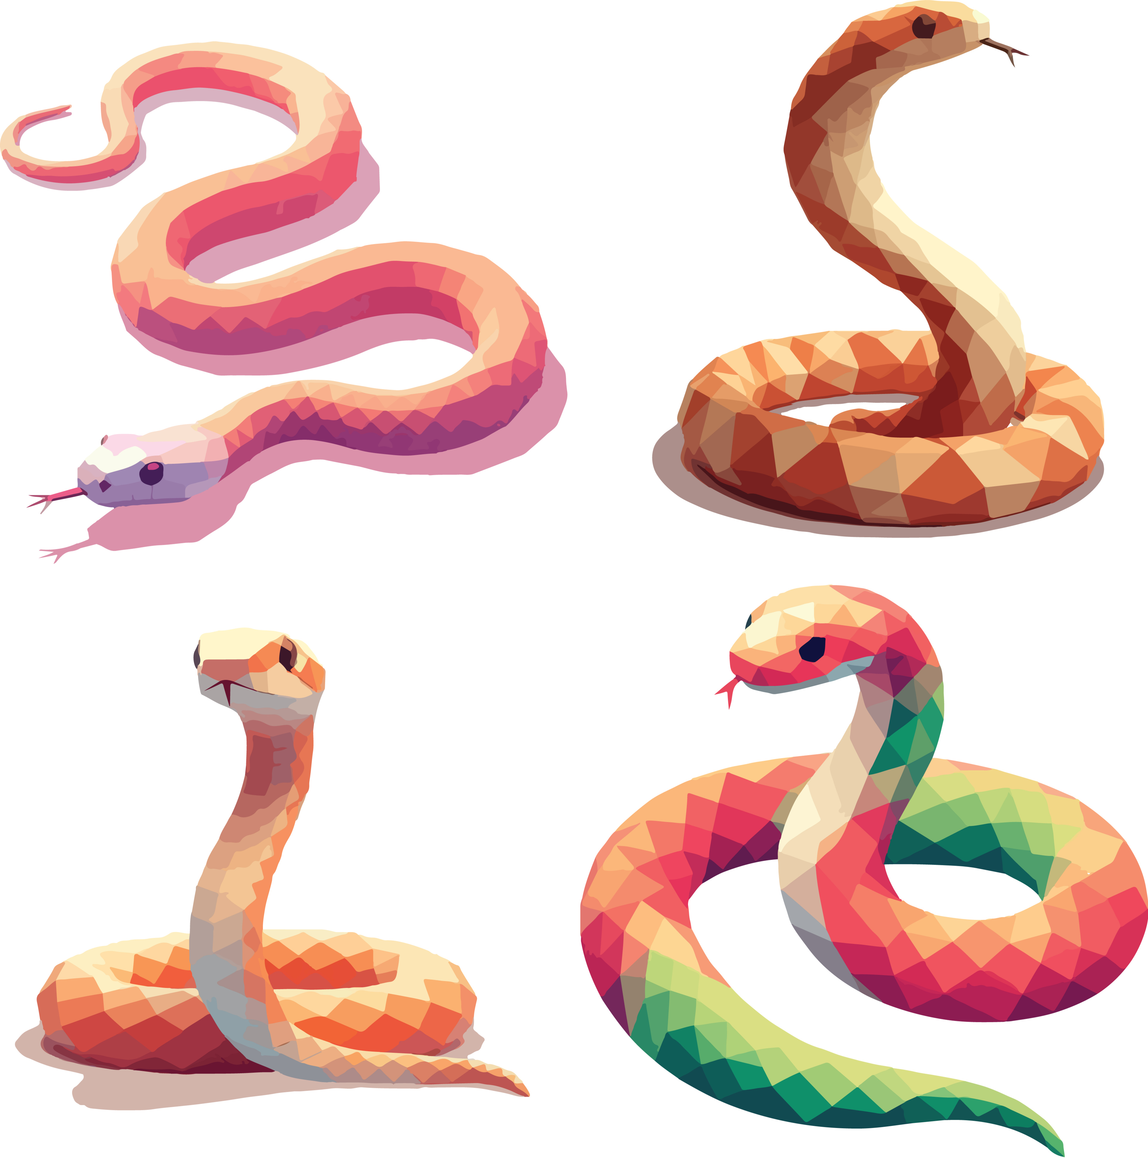**True or false?** – Investigate the classification of the species. Create a quiz (true or false, multiple choice, fill in the blank) and test your classmates.
* **Children’s book or comic** – Write and illustrate either a children’s book or comic which tells the story of the species. Include another species in your story which shares the same family or genus.
* **Geography** – Where in the world does the species live? Show the species distribution on a map using shading.
* **Citizen Science** – Are there any citizen science projects that helps us better understand the species? Investigate.
* **Art** – Create a drawing that represents a snake from a Dreaming story.
* **Guidelines** – Create an informative poster which educates others about how to stay safe around snakes.

# Activity: Different Cultures

Start this activity by asking your students “What do you know about snakes in different cultures around the world?”. Discuss as a whole class or in small group and then share and record your students’ ideas. Discuss how snakes are represented in different cultures (for example in Lunar New Year celebrations, Indigenous Dreaming stories or different religions).

Explain that in Indigenous Australian cultures, snakes have special significance and often appear in Dreaming stories, for example the Rainbow Serpent. Students will conduct their own research into the Rainbow Serpent and its importance in Indigenous cultures.

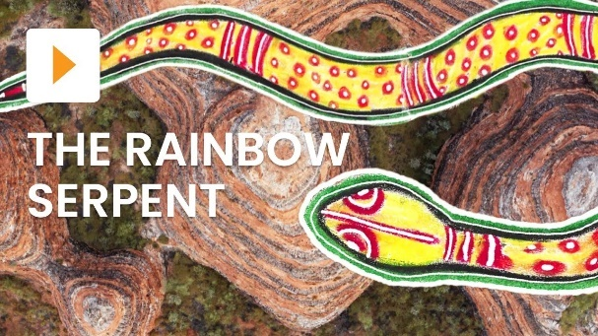Watch this [ClickView video](https://www.youtube.com/watch?v=vjTM-MJKccg) to learn more about the story of the Rainbow Serpent in Indigenous cultures.

* What features of the land is the Rainbow Serpent most commonly associated with?
* What else did the Rainbow Serpent create?
* There are many places in Australia that have Dreaming stories about the Rainbow Serpent related to their creation. Name one location.

First Nations Stories: The Rainbow Serpent (*Source:* [*ClickView*](https://www.youtube.com/watch?v=vjTM-MJKccg))

* What is the Indigenous name for Rainbow Serpent in this location?

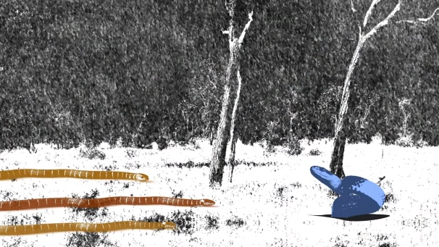

Watch this [ClickView video](https://www.youtube.com/watch?v=OLHGzT47-Ag) to learn about the story of Uluru’s markings.

* What landform does the Kuniya and Liru story take place on? Find on a map.
* What type of snake is a Kuniya and a Liru?
* How did the snake interact with the environment in the Dreaming story?

First Nations Spirituality: The Story of Uluru's Markings (*Source:* [*ClickView*](https://www.youtube.com/watch?v=OLHGzT47-Ag))

* What do the actions of the snake in the story symbolise? (e.g., creation, transformation, danger, wisdom)

**Indigenous language**

The Rainbow Serpent is known by different names in different Aboriginal cultures. Find the name for Rainbow Serpent in different Indigenous languages and record in the table below. Find the name for Rainbow Serpent in the Indigenous language where you live. Use a map of Australia to highlight the area.

|  |  |
| --- | --- |
| Indigenous language | Name for Rainbow Serpent |
| *Kuninjku language (Arnhem Land)* | *Ngalyod* |
| *Noongar language (Southwest corner of WA)* | *Wagyl* |
|  |  |
|  |  |

# Activity: Year of the Snake

This Lunar New Year celebrates the zodiac animal the snake. Students will respond to one or more of the following and then create a poster, or art/craft celebrating the Year of the Snake.

* Complete this sentence. In Chinese culture the snake symbolises….
* People born in the Year of the Snake are said to be…
* Name four traits that are associated with the zodiac animal the snake.
* Like all zodiac animals the snake has both positive and negative connotations. Use a T-chart to record your findings.
* What is the Chinese symbol for snake?
* How do you say snake in Chinese Mandarin?

How were the 12 animals chosen and why are they in a particular order? In the Chinese zodiac, the snake is the sixth animal in the cycle of 12 animals. Legend has it that the jade emperor had a race to determine the 12 zodiac animals and their order. Find out how the snake crossed the river. You can learn more about the Chinese Zodiac stories [here](https://www.lakesidearts.org.uk/news/chinese-zodiac-stories/).

Students will create and display a piece of art or craft celebrating the Year of The Snake in their classroom. They can create a poster to celebrate Lunar New Year 2025 with a focus on the snake, make an accordion snake or a make a model snake puppet.

|  |
| --- |
|  |
| Jumping paper snake : r/papercraft Make a DIY snake for Lunar New Year 2025 - CBBC  Make a DIY snake for Lunar New Year  (*Source:* [*YouTube BBC Blue Peter*](https://www.youtube.com/watch?v=vpGbdtpzF5Q)) |

# Useful Websites

* [What to do if you see a snake](https://www.abc.net.au/btn/newsbreak/btn-newsbreak-20250217/104947976) – BTN Newsbreak
* [Snake Season](https://www.abc.net.au/btn/classroom/snake-season/102964974) – BTN
* [Dangerous Animals](https://www.abc.net.au/btn/classroom/dangerous-animals/12827978) – BTN
* [The importance of snakes](https://environment.desi.qld.gov.au/wildlife/animals/living-with/snakes/importance) – QLD Government Environment
* [Awesome 8: Super Snakes](https://kids.nationalgeographic.com/nature/article/super-snakes) – National Geographic Kids
* [Bites and Stings: First Aid](https://www.betterhealth.vic.gov.au/health/healthyliving/bites-and-stings-first-aid) – Better Health
* [Snakes](https://www.environment.nsw.gov.au/topics/animals-and-plants/native-animals/native-animal-facts/snakes) – NSW Environment and Heritage
* [Reptiles](https://australian.museum/learn/animals/reptiles/) – Australian Museum
* [Wildlife Encounters](https://www.nationalparks.nsw.gov.au/safety/wildlife-encounters#watch-for-snakes-and-reptiles) – NSW National Parks and Wildlife Service
* [Lunar New Year 2025: Everything you need to know about the Year of the Snake](https://www.bbc.co.uk/bitesize/articles/zf74h4j#:~:text=In%20the%20Chinese%20zodiac%2C%20the%20snake%20is%20the%20sixth%20of,Year%20of%20the%20Wood%20Snake.) – BBC Bitesize



**EPISODE 4**  
25 February 2025

**KEY LEARNING**

Students will learn more about potential threats to the Moon and explore reasons for protecting it.

**CURRICULUM**

**Science – Year 5**

Scientific understandings, discoveries and inventions are used to solve problems that directly affect peoples’ lives.

The Earth is part of a system of planets orbiting around a star (the sun).

**Science – Years 5 & 6**Scientific knowledge is used to solve problems and inform personal and community decisions.

**Science – Year 6**The growth and survival of living things are affected by the physical conditions of their environment.

Teacher Resource

**Protecting the Moon**

# Focus Questions

Discuss the BTN story as a class and record the main points of the discussion. Students will then respond to the following:

1. What makes the Moon special? In pairs brainstorm a list.
2. In what year did humans first walk on the Moon?
   1. 1959
   2. 1969
   3. 1979
3. The Moon has been listed as a vulnerable site. True or false?
4. Give an example of an artefact found on the Moon.
5. Do you think the Moon should be protected? Give reasons for your answer.

# Activity: Note taking

Students will practise their note-taking skills while watching the BTN Protecting the Moon story. After watching the story, ask students to reflect on and organise the information into three categories. What information in the story was...?

* Positive
* Negative or
* Interesting

# Class Discussion

Discuss the information raised in the BTN Protecting the Moon story. Record the main points of the discussion on a mind map. Here are some questions to guide the discussion:

* A picture containing text, vector graphics

  Description automatically generatedWhat do you know about the Moon? Brainstorm a list.
* What makes the Moon special? Discuss as a class.
* What are some threats to the Moon?
* Do you think the Moon should be protected? Why or why not?
* Think of three questions you have about the BTN story.

# Activity: Key words

Students will brainstorm a list of key words that relate to the BTN Protecting the Moon story. Here are some words to get them started.

Vulnerable

Space tourism

Protect

Artefacts

Monument

Exploration

Lunar surface

Preserve

Ask students to write what they think is the meaning of each word (including unfamiliar words). They will swap definitions with a partner and ask them to add to or change the definition. Check these against the dictionary definition.

# Activity: Moon Research

Discuss the information raised in the BTN Protecting the Moon story. What questions were raised in the discussion and what are the gaps in students’ knowledge? Students will develop their own question/s to research or choose one or more of the questions below.

* What impact could future space exploration and commercial activities (mining, tourism) have on the Moon?
* **A picture containing plant

  Description automatically generated**What are some potential threats to the Moon?
* Should sites beyond Earth be protected like sites on Earth? Give reasons for your answer.

Create a profile of Earth’s Moon. Include information about the distance from Earth, how long it takes to orbit Earth, temperatures and geographical features. Include any other interesting facts you find.

* How can we continue to explore the Moon without damaging it?
* Should the Moon belong to everyone, or can some countries claim parts of it? Explain your answer.
* What resources are found on the Moon and why might people want to mine them?
* Should mining on the Moon be allowed? Give reasons for your answer. Who owns the Moon’s resources?

# Activity: Apollo 11 Mission

The Apollo 11 mission marked the first time that humans landed on the Moon. Students can watch the [BTN Apollo 11 story](https://www.abc.net.au/btn/classroom/apollo-11/11313696) to learn more about the mission and answer the following questions:

* Summarise the mission.
* What was the purpose of the mission?
* Who was the crew? What were their roles?
* What did the mission discover?
* How has the mission helped us understand the Solar System and beyond?
* What were some challenges of the mission?
* Do you think landing on the Moon is one of humanity’s greatest achievements? Give reasons for your answer.

# Activity: BTN Moon stories

As a class watch one or more of the following BTN stories to learn more about the Moon. After watching any one of the BTN videos ask students to respond to the discussion questions (to find the teacher resources go to the related BTN Classroom Episode and download the Episode Package).

|  |  |  |
| --- | --- | --- |
| 50th Moon Landing Anniversary Special (Ep 19), 2019 - Behind The News  [Moon Landing Special](https://www.abc.net.au/btn/classroom/20190723-ep19-btn/11313570) | Moon Water Discovery - Behind The News  [Moon Water Discovery](https://www.abc.net.au/btn/classroom/moon-water-discovery/12827578) | Moon Exploration - Behind The News  [Moon Exploration](https://www.abc.net.au/btn/classroom/moon-exploration/10524260) |
| Artemis Launch - Behind The News  [Artemis Launch](https://www.abc.net.au/btn/classroom/artemis-launch/14038538) | Moon Living - Behind The News  [Moon Living](https://www.abc.net.au/btn/classroom/moon-living/10527786) | SpaceX Launch - Behind The News  [SpaceX Launch](https://www.abc.net.au/btn/classroom/spacex-launch/12296458) |

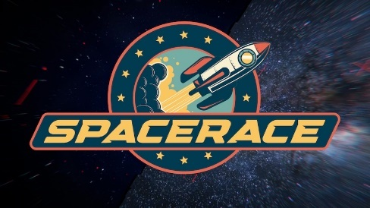

[New Moon Race](https://www.abc.net.au/btn/classroom/new-moon-race/102786290)

# Useful Websites

* [Moon placed on World Monument Fund list of heritage sites in need of protection](https://www.abc.net.au/news/science/2025-01-17/moon-cultural-heritage-world-monument-fund-watch-list/104828450) – ABC News
* [Who protects the Apollo sites when space law says no-one owns the Moon?](https://www.abc.net.au/news/science/2019-07-19/apollo-11-moon-landing-heritage-preservation-outer-space-treaty/11055458) – ABC News



Teacher Resource

**BTN Transcript: Episode 4 -25/2/2025**

Yama, I'm Jack and you're watching BTN. Here’s what’s coming up. We find out why there's so much interest in interest rates, learn how to stay safe around snakes and discover more about the historical significance of the Moon.

# Ukraine Update

Reporter: Wren Gillett

*INTRO: But first up today we're going to talk about Ukraine. It's just marked three years since Russia invaded the country and as the war drags on, world leaders are looking for solutions. But there's been a lot of controversy as Wren found out.*

WREN GILLETT, REPORTER: This is Taisiia. She lives in Sumy in Ukraine, where life is pretty different now than it was three years ago.  
  
TAISIIA, UKRAINE: Waking up to the sound of drones is terrifying. But in Sumy, that's just how everyday life is now.  
  
She can't go to school.  
  
TAISIIA: This is one of the buildings of Sumy vocational school, which can no longer provide education to its students.  
  
And at night the electricity goes off.  
  
TAISIIA: Learning to play the piano without electricity is really hard, but I turn on my little string lights and start playing.  
  
TOBY FRICKER, UNICEF: For any child at any age who wants to play be with their friends, and children like Taisiia are not able to do that day in day out, because there's that incessant fear.  
  
Life changed suddenly for people in Ukraine on the 24th of February 2022, when Russian soldiers entered the country.  
  
VLADIMIR PUTIN, PRESIDENT OF RUSSIA: Circumstances require firm and immediate action from us. I decided to conduct a special military operation.  
  
It was a huge shock for Ukraine and the world. Most people thought Russia, which had a much bigger army, would quickly take control of the country. But Ukraine fought back, and the war became a long and brutal battle, killing hundreds of thousands of people. Today, Russia occupies roughly 20 percent of Ukraine, while Ukraine holds a small section of Russian territory. Ukraine has been relying on help from other countries to fight the war, particularly the US, which has given billions of dollars in military aid and put sanctions on Russia, restricting trade and pulling out American business. Which is why the world was so shocked when this happened.  
  
NEWS: We turn now to president Trump speaking with Russian President Vladimir Putin.  
NEWS: US President says he plans to meet Vladimir Putin.  
  
NEWS: US and Russian officials say they'll begin working on a path to end the war in Ukraine.  
  
Last week President Donald Trump spoke by phone with Russian president Vladimir Putin and organised a meeting between American and Russian officials. It was the first official meeting between the two countries since the war in Ukraine began and they discussed working more closely together. Ukraine's leader wasn't included.  
  
VOLODYMYR ZELENSKYY, PRESIDENT OF UKRAINE: It is critical that any negotiations to end the war are not happening behind the backs of the key parties affected by the Russian aggression.  
  
After the meeting, Trump said some really controversial and untrue things about Ukraine and President, Volodymyr Zelenskyy.  
  
DONALD TRUMP, US PRESIDENT: We haven't had elections in Ukraine, we have essentially martial law in Ukraine, where the leader in Ukraine, I mean hate to say it, but he's down to a four percent approval rating.  
  
Last week, a group of European leaders held their own emergency meeting.   
  
VOLODYMYR ZELENSKYY: We must apply pressure together to make real peace.  
  
They said it was important to work towards a deal that was good for Ukraine and would send a message to Russia's President.  
  
KEIR STARMER, UK PRIME MINISTER: Only a lasting peace in Ukraine that safeguards its sovereignty will deter Putin from further aggression in the future.  
  
There's a lot of uncertainty right now, but world leaders say they'll continue to work towards an agreement that will end the war. And let people like Taisiia live their lives without fear.  
  
TAIISIA: One day, my generation will be the one rebuilding our country and my hometown.

**News Quiz**

The Prime Minister has announced a massive rescue package to save what sort of business based in Whyalla? Is it a car factory, a steelworks or a gold mine? It’s a steelworks. Whyalla’s Steelworks supplies 75 percent of the steel we use in Australia and provides more than a thousand jobs. But it’s future has been in doubt because of financial problems. TheSouth Australian government put the steelworks into public administration until a new buyer can be found and the Federal Government has promised 2.4 million dollars to make sure it stays open.

The Government and the opposition have also promised to spend more than 8 billion dollars to help Aussies do what? Go to the doctor, build a house or buy groceries? It’s go to the doctor. Last week the Prime Minister announced the government would spend 8.5 billion dollars to make sure nearly all doctor’s visits are bulk billed which means they’re paid for by Medicare. The opposition leader said if he’s elected, he’ll do the same thing.

Scientists a monitoring an asteroid that could get uncomfortably close to Earth in about 8 years. Its name is 2024 YR4 and its thought to be around the size of what? A car, an Olympic swimming pool or France? While they don’t know for sure, Scientists think it’s somewhere between 40 and 90 metres in diameter, so somewhere in the realm of a swimming pool. So, it’s not good, but they say the chances of it actually hitting Earth are still really low.

And the Australian War Memorial has given out the very first Distinguished Service Award for animals which recognises bravery and dedication from animals in the military or civilian live. What sort of animal received it? It was a dog.

# Interest Rate Cut

Reporter: Jack Evans

*INTRO: Last week Australia's Reserve Bank announced it was cutting interest rates for the first time in five years. It was big news and made a lot of people happy. But, as you're about to find out, balancing interest rates and inflation is a, ah, wicked problem. Check it out.*

MUNCHKIN: Look it's the RBA.  
  
RBA: Fellow Australians, let me set the record straight. Yes interest rates have been lowered.  
  
JACK EVANS, REPORTER: It's the announcement that people had been waiting for in the land of OZ-tralia.  
  
MICHELE BULLOCK, GOVERNOR OF THE RBA: Thank you all for coming as you know the board decided to cut the interest cash rate by 25 bases to 4.1 percent.  
  
JIM CHALMERS, TREASURER OF AUSTRALIA: This is the rate relief that Australians need and deserve.   
  
PERSON: It's a huge change for us, it's going to make a big difference.   
  
PERSON: It's pretty good for first time home buyers.  
  
MUNCHKIN: Come out Come out  
  
MUNCHKIN: Interest Rates have been lowered.   
  
RBA: Let us be gl…  
  
MUNCHKIN: Wait, what's an interest rate?   
  
RBA: Oh, Well, that's a good question. One that many find confusifying. Let's say you wanted to buy a house.  
  
MUNCHKIN: Like a Munchkin house?   
  
RBA: Yes, a Munchkin house. What other house would you buy? You are a Munchkin.   
  
Houses, Even Munchkin houses can be very expensive, and you'll probably need to borrow money from a bank. In exchange for letting you borrow its money the bank charges interest, an extra charge on top of your repayments. How much interest they charge is up to the bank to decide.

RBA: But usually, it's based on a national interest rate that is set by the Reserve Bank of Australia. Speaking of which I must be getting back there, so if there are no further questions.

MUNCHKIN: Wait, what is the Reserve Bank?   
  
RBA: Oh, well...  
  
The Reserve Bank is Australia's Central Bank. It's responsible for keeping the country’s financial system stable and part of that is fighting inflation. That's when…  
  
WIZARD OF OZ: A hot air balloon fills with hot air.  
  
Well yes, but in this case, inflation is when prices go up. Which is exactly what's been happening for the past few years. One way to fight off inflation is to make it more expensive for people to borrow money. That means they're less likely to do a lot of spending which reduces demand for goods and pushes prices down. Except there's an obvious downside.  
  
MUNCHKIN: We pay more for our Munchkin Mortgages.   
  
RBA: Yeah, that's right.  
  
In Australia interest rates have been steadily rising for the past few years, which has put extra pressure on homeowners.   
  
PERSON: Cost of living has gone up and interest rates are high.   
  
Now, Michelle Bullock says that they've managed to get inflation under control.  
  
MICHELE BULLOCK: It's clear that higher interest rates have been working as anticipated restricting economic activity and putting downward pressure on inflation.   
  
Which means...  
  
MUNCHKIN: Interest rates are going down.  
  
RBA: Yes, that’s what I said at the start. Remember I flew down in on the bubble. Yeah, it looked really good.   
  
But it's not all sunshine and rainbows. Lower interest rates can push up the price of houses, which are already very high. And there's always the risk that that pesky inflation could creep up. So, as you can see it's a delicate balancing act for the RBA. And while many welcomed the news, the interest rate cut wasn't as big as people were hoping for and the Reserve Bank says it's not likely there will be anymore in the near future.   
  
PERSON: It's not saving that much you know.   
  
PERSON: It's great but I wish it had been a lot more   
  
RBA: Ok, are we all good? Can I leave?  
  
MUNCHKIN: Wait.  
  
RBA: Nope, too late. The bubbles up, Sorry. See you later. Bye. Send me any email.

**Snake Season**

Reporter: Aiden McNamara

*INTRO: Now to snakes. They're a part of life here in Australia during summer but recently there's been an increase in bites up in Queensland. So, Aiden got some tips on how to stay safe around our slithery neighbours. Check it out.*

STUDENT: It was pretty scary. So, I was standing about here. Snake was over there.

STUDENT: It looked a bit silver in the sun, but when it came into the shade, it was brown with a bit of black all over it.  
  
SUDENT: And we got told what happened, and I was a bit in shock.  
  
STUDENT: There was a snake I was like whoa.  
  
STUDENT: It's not really that scary because I have had snakes at my house before.  
  
AIDEN MCNAMARA, REPORTER: As these kids, and probably many of you know, snakes are a part of life here in Australia. And not just in the bush either. Yikes.  
STUDENT: We see a few snakes.  
  
STUDENT: They like it when it's warm, especially if it's dry.  
  
Australia has around 140 species of snakes. Some of those are totally harmless. Around 100 are venomous. And 12 of those are potentially deadly. And sometimes it can be hard to tell the difference. For example, this is an Olive Python, totally harmless. But this is an Eastern Brown Snake, one is of the most venomous snakes in the world. So maybe don't take any chances.  
This is Cassie. She knows lots about snakes. And this is me. I don't know as much and placed a lot of trust in Cassie.  
CASSIE DELLA-FLORA, ADELAIDE SNAKE CATCHERS: Okay so these are my pets, you can't just pick up a snake like in the wild and it be like this.   
  
They're Murray-Darling Carpet Pythons.  
Cassie reckons the long summer this year has been perfect for snakes, which is why we're seeing more of them.  
CASSIE: They cannot digest or eat food in the cold times, as soon as the first sunny days come out. They are out and about, so they want to make most of the hot days.  
  
Wet weather in Australia's north has also made them more active, which led to new warnings to be on the lookout for snakes.  
What should we do if we see a snake?  
  
CASSIE: You stand completely still. They do not bother you at all. You're an inanimate object when you stand still, so definitely stand still and you can watch them all day.  
  
Should I be scared?  
CASSIE: No, definitely not. They're not out to harm or attack you. They can't hear, they go on vibration, so they will feel the ground rumbling when you're moving and so forth, and that's when they're gonna move.  
  
But if I see one, I can scream?  
CASSIE: Yes. Yeah, they can't hear you. If you stand still and scream as loud as you want, that's fine. It's not going to bother snakes.  
What are the common mistakes people make around snakes?  
CASSIE: Moving too fast, trying to grab the snake. It's not safe to grab the snake if you don't know what it is.  
Cassie says that while the chances you being bitten by a dangerous snake are low, it's good to know what to do if you are.  
  
CASSIE: Call triple zero, stay still. Get the help to come to you. So that's the most important. Stay still. Be calm. Help to come to you.  
And take a little bit of extra care when you're outside in the summer.  
STUDENT: When I play my backyard, I have to stomp around a lot so they don't come near me or my dogs.  
  
STUDENT: Make sure you're walking on paths, especially in the hot weather.  
  
STUDENT: Don't go in bushes.  
  
STUDENT: I would never touch a snake because they're dangerous and they could bite you and you don't know if they are poisonous or not.  
  
So with a bit of knowledge we can safely live alongside our slithery neighbours.   
STUDENT: They do keep down the rat and mice population, and they're also like, this is where they live, and we can't really stop that.

# Quiz

A person who studies snakes is known as what? A haematologist, a herpetologist or a herbologist? It's a herpetologist.

# Protecting the Moon

Reporter: Wren Gillett

*INTRO: Now we're going somewhere a little different, the Moon. Well, we're not going there, but quite a few businesses and governments are trying to. Which is why some say the Moon needs protection. Here's Wren*GRU: Now, I wasn't going to tell you about this yet, but I have been working on something very big, very special. Dave, listen up please. We are going to steal, pause for effect, the Moooon.  
  
WREN GILLETT, REPORTER: Yeah look, while minions and shrink rays might all seem a bit far-fetched, because well, they are, the truth is that a lot of people do have their eyes on.  
  
GRU: THE MOOOOOON.  
  
Right now, there are heaps of projects around the world aiming to get there. Whether it's to build lunar bases, take tourists on tours, or even mining the Moon.  
  
ALICE GORMAN, SPACE ARCHAEOLOGIST: There are a lot of particularly private industries interested in going to the Moon.   
  
This is Alice Gorman, she's a space archaeologist. Cool right?.  
  
GRU: Yeah, I mean, she's no supervillain, but ya know.  
  
I'm not talking to you. Anyway, her work involves looking at artefacts from space and using them to help study the past. And for people like Alice, the Moon is more than just a resource, it's a monument, a moon-ument if you will.  
   
ALICE GORMAN: If you think of a monument, not necessarily as you know, like a church or a temple or something like that, but as something of a large scale that's important to human culture. Then the entire Moon is kind of a monument.   
  
NEIL ARMSTRONG, APOLLO 11: That's one small step for man, one giant leap for mankind.   
  
Remember this, well ya probably don't cause it happened in 1969, but trust me it was a big deal.  
  
ALICE GORMAN: They left behind them their descent vehicle, a whole bunch of scientific experiments, the boot prints, places where they took cores and samples.  
  
Yep those early astronauts and those that came after them left a whole heap of artefacts, that people like Alice want to protect.   
  
ALICE GORMAN: Remember, there's, there's about 100 places where something has touched the lunar surface that humans have made. Even if we didn't think they were interesting and important places to keep for us to understand, we have a responsibility to those future generations who may have completely different ideas, completely different scientific techniques.  
  
It's why a US organisation recently added our favourite orbiting rock to the World Monuments Fund watch list. It's a list that draws attention to vulnerable historic sites that need protection. Places like the Longmen Grottoes in China, the Waru Waru Fields in Peru and Angola's spaceship cinema. Yeah, all pretty cool, but this is the first site that's literally out of this world.  
  
ALICE GORMAN: Being on that watch list brought it to the attention of so many people who'd never heard of lunar cultural heritage.  
  
You see, right now, there aren't any laws protecting the Moon. There is a famous treaty called the 'Outer Space Treaty', but no one owns the Moon, and technically everyone can do what they want with it.  
  
ALICE GORMAN: There isn't yet any system like we have on Earth.  
And that's something a lot of people want to change, so that people like this guy, can't just rock up to our space rock and steeeeeeal its resources.  
  
GRU: Whatever. I'll leave the Moon alone, okay? Stop laughing Dave.

# Quiz

How many people have walked on the Moon? 2, 4 or 12? It's 12. Of the 24 men went there between 1969 and 1972, 12 got to have a stroll on the surface.

# Sport

Yeah, things didn't start off great for the Matildas, when the USA got this goal in the opening minute of their second game of the SheBelieves Cup. Despite putting up a fight, the USA then went on to secure another goal in the 68th minute. And it wasn't until the last ten minutes of the game that the Tillies finally found themselves on the board thanks to this header from Michelle Heyman, but it wasn't enough with the Americans beating the Tillies 2-1.   
  
Over to tennis and 17-year-old Russian Mirra Andreeva has become the youngest WTA 1000 winner ever.  
  
Wow that trophy looks heavy. She defeated Clara Tauson 7-6, 6-1 at the Dubai Championships and has big plans for the year ahead.  
  
Now to cricket and India has claimed the Champions Trophy. They beat hosts, Pakistan, by six wickets. Indian superstar Virat Kohli made an unbeaten century and became the fastest man to reach 14,000 ODI runs in the process.  
  
Finally to Western Australia where Alexia Phillips has broken the female shearing world record for the most merino ewes shorn in eight hours. She whizzed through 367 sheep which is an average of about 80 seconds per sheep and beat her previous record of 358 sheep.   
  
**Cretaceous Find**

Reporter: Tatenda Chibika

*INTRO: Finally, today, to some terrifying therapods. Scientists from Museums Victoria have identified three different kinds of meat-eating dinosaurs that used to live here in Australia, including a species that's never been found here before and the world's oldest mega-raptor. Here's Tatenda.*

TATENDA CHIBIKA, REPORTER: You have a megaraptorid?  
  
JOE: Oh yeah, we've got megaraptorids.  
TATENDA: Should we leave?  
  
Yeah it turns out 120 million years ago or so Australia was home to some pretty interesting and slightly terrifying creatures.   
  
JAKE KOTEVSKI, MUSEUMS VICTORIA PHD STUDENT: They've got these large muscular forearms with these recurve claws that basically bring you in for a hug of death.

While, thankfully, they're not bringing them back to life, palaeontologists here in Boonwurrung country in Victoria have revealed evidence that a bunch of meat-eating dinosaurs once called this area home.  
  
TIM ZIEGLER, COLLECTION MANAGER, MUSEUMS VICTORIA RESEARCH INSTITUTE: This is the site where we've recently discovered the fossil remains of one of Australia's largest theropod dinosaurs to have ever lived.  
  
What Tim's talking about is a megaraptorid. A giant therapod that's only found in South America and Australia.   
  
TIM: This is a two-legged, fast-moving predator, six to seven meters long. What we have discovered are the fossil bones of its lower leg and some of its vertebrae.   
  
The bones were discovered on the beach a couple of years ago and since then, scientists have been working to identify them along with several other fossils found in the area that have been collected and stored by the Museum for years.   
  
And it wasn't the only exciting find.  
  
TIM: This specimen was collected over 35 years ago, and it's only now that we understand that it represents the first fossil of a Carcharodontosaurus a shark toothed dinosaur, ever found in Australia.  
  
The Carcharodontosaurus was another species of therapod that lived in the Cretaceous period. Overseas fossils have showed it could grow up to thirteen metres in length about the same size as a T-Rex. Except this Aussie one was quite a bit smaller.  
  
JAKE: It's just tiny. We don't see Carcharodontosaurus this small in the fossil record.  
  
It's kind of weird and really interesting because it means species that was King of the dinos in South America took second place here in Australia while Mega raptor’s reigned supreme.   
  
And according to researchers, it could provide a clue about how these dinosaurs evolved and spread through Gondwana, the ancient supercontinent that Australia and South America once belonged to.   
  
JAKE: Some previous research has proposed that mega rapids might have evolved here in Australia. First, we're finding the oldest evidence of them in this country, but they were confined to a certain size, and then would move on and disperse through Australia, through Antarctica, into South America and attain a larger size.   
  
It also paints a picture of what life was like here in Victoria in the Cretaceous period and the amazing, terrifying creatures that once called our country home.   
  
JAKE: That's just the beauty of paleontology. It's an ongoing science with just this long history, and everything we can describe just improves our understanding of what these animals looked like, what animals were present in Victoria, and how our continents on this planet once were merged together.

**Closer**

That's all we've got for this week, but we'll be back soon, and in the meantime, you can jump online to see more stories and quizzes and resources for your teachers. Plus, there's Newsbreak and BTN High for you highschoolers or nearly-highschoolers. Have a great week. I'll see you see soon. Bye.