

Threatened Flora
- Discuss the BTN Threatened Flora story in pairs. Record the main points of the discussion.
- Where in Australia can you find the Woods Well Spyridium? Find using Google Maps.
- What factors are threatening the survival of some Australian flora?
- How many different species of plants are there in Australia?
- What percent of plants are listed as threatened in Australia?
- What things depend on plant species? Give one example.
- How do botanic gardens help protect plants?
- What is a seed bank?
- How are the kids in the BTN story helping protect Australia’s plants?
- If we lose a plant species it is lost forever. True or false?

Koala Threat
- Before you watch the BTN Koala Threat story, record what you know about koalas
- Discuss the BTN Koala Threat story in pairs. Record the main points of the discussion.
- What happened to the koalas on Kangaroo Island this year?
- What did a recent World Wildlife Fund study find about koala populations?
- What do koalas do when they are feeling threatened?
- What happened to the koala’s food source during the bushfires?
- Even before the fires, habitat loss was a problem for koalas. What were the causes of habitat loss?
- Complete the following sentence. Some are worried that koalas could be extinct in some areas by ________.
- What did you learn watching the BTN story?
- How did this story make you feel?

Frog Spotting
- Retell the BTN Frog Spotting story to another student.
- How do frogs communicate?
- Why do male frogs call?
- Where do you measure a frog to find its length?
- What animals eat frogs?
- What do frogs eat?
- Complete the following sentence. Frogs are a critical part of the food _______.
- Why are a lot of Australia’s frog species under threat?
- What are frogs sensitive to?
  - Pollution
  - Sunlight
  - Water
- What is a citizen scientist?

Teacher Resource
Threatened Flora

Students will learn more about the importance of preserving native plants and research a threatened native plant in detail.


Science - Year 4
Living things have life cycles.

Living things, including plants and animals, depend on each other and the environment to survive.

Science – Year 5
Living things have structural features and adaptations that help them to survive in their environment.

Scientific knowledge is used to inform personal and community decisions.

Science – Year 6
The growth and survival of living things are affected by the physical conditions of their environment.


- Discuss the BTN Threatened Flora story in pairs. Record the main points of the discussion.
- Where in Australia can you find the Woods Well Spyridium? Find using Google Maps.
- What factors are threatening the survival of some Australian flora?
- How many different species of plants are there in Australia?
- What percent of plants are listed as threatened in Australia?
- What things depend on plant species? Give one example.
- How do botanic gardens help protect plants?
- What is a seed bank?
- How are the kids in the BTN story helping protect Australia’s plants?
- If we lose a plant species it is lost forever. True or false?


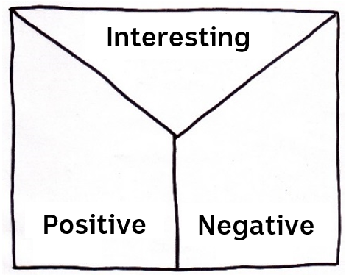
Note taking
Students will practise their note-taking skills while watching the BTN Threatened Flora story. After watching the story, ask students to reflect on and organise the information into three categories. What information in the story was...?
- Positive
- Negative or
- Interesting

Class Discussion
Discuss the BTN Threatened Flora story as a class, using the following questions to guide the discussion. Record responses on a mind map. Clarify students’ understanding of the following terms: Flora, introduced species, native, conservation and biodiversity.
- Why do we need plants?
- What native plants do you know? Make a list.
- What things are threatening our native plants?
- Name an animal or insect that relies on native plants.
- Why is it important that we protect and conserve living things?


Match these terms to their definitions

Term | Definition
Threatened species | This species is facing a high risk of extinction in the wild in the medium-term
Extinct | There is no immediate threat to the survival of this species
Least concern | This species is facing a very high risk of extinction in the wild in the near future
Vulnerable species | This species may be considered threatened in the near future
Endangered | This species is no longer in existence

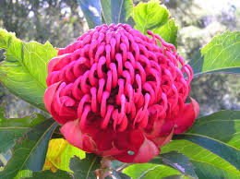
Get to know the plants in your area
Students choose a plant in their school grounds, backyard or local park. Then respond to the following:
- Describe the plant they have chosen using words and an illustration. Include the different parts of the plant and any interesting features.
- Identify what type of plant it is. Find its botanical name. Is it a native or introduced species?
- Describe any insects or wildlife on or near the plant.
- Find out the conservation status of the plant.

Further investigation
Does your local botanic garden have a program similar to the one in the BTN story? Students can investigate working with their local botanic garden to collect and propagate seeds from endangered plants.
Improve the biodiversity in your school yard
Students will work together to plant and care for native plants in their school yard. Ask them to consider the following:
- What kind of native plants will you plant and where will you plant them? Which plants are native to your area?
- Where will the plants get the sun or shade they need?
- Where will it be most appreciated?
- What materials and tools are needed?
- Predict and record the growth rate, for the first days/weeks/months, and see whose predictions are most accurate.
- Include an information label next to the plant for other students to learn more about it and the biodiversity of your school yard. Include the botanical name, when it was planted and some basic information.
- Make a map of your school yard which highlights important plants in your school yard.

Students will choose a threatened Australian plant to learn more about (they may want to choose one that is local to their area). The Threatened Australian Plants fact sheet may help students select a plant to investigate. Use the template below to help guide their research.

Research project – Threatened Australian Plant
Scientific and common name
Describe its appearance
What does it look like (shape, size, colour, special features)?

Locate where this species can be found using Google Maps

Conservation Status

Threats

Recovery Action (what is being done to protect the species)

Interesting facts
- What is your favourite thing about this species?
- What surprised you about your research?

Photograph or Illustration

BTN stories
These BTN stories explore different ways in which threatened plants are being protected.
Endangered Seeds
- How many plant species in WA are threatened with extinction?
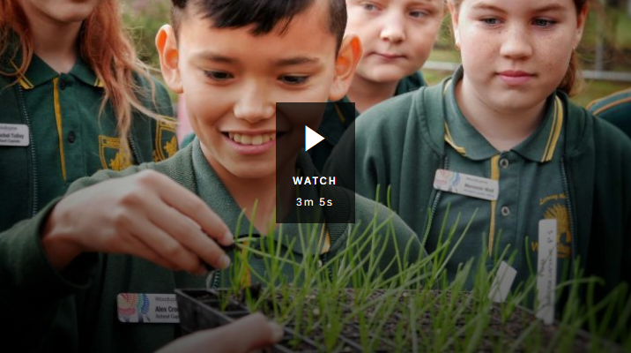
- What is a seed bank?
- Where is the biggest seed bank in the world located? Find using Google Maps.
- How many different types of seeds does it hold?
- What type of plants does the seed bank in WA focus on?
- What are the kids in the BTN story doing?
- What is the name of the plant they are looking after?
- How do the kids know when to harvest the seeds from the plant?
- Why is it important to collect seeds?

Plant Bank
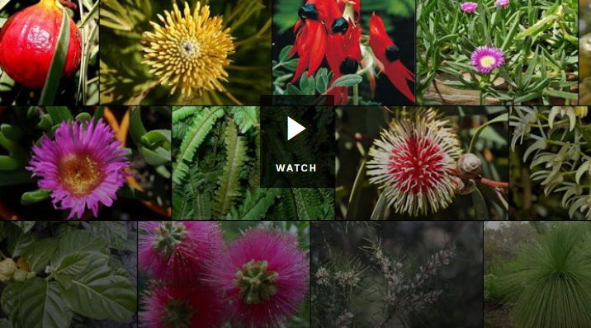
- What is another word for plants?
- How many species of plants can be found in Australia?
- Since European settlers arrived in Australia how many different types of plants have disappeared?
- Someone that studies plants is called a...
- The idea of seed banks is a completely new idea. True or false?
- List a reason why scientists store seeds?
- Where in the world is the ‘doomsday vault’? Locate using Google Maps.
- Why is it important that we look after our plants?
- How are seeds prepared for the seed bank? Illustrate using a flow chart.

Doomsday vault
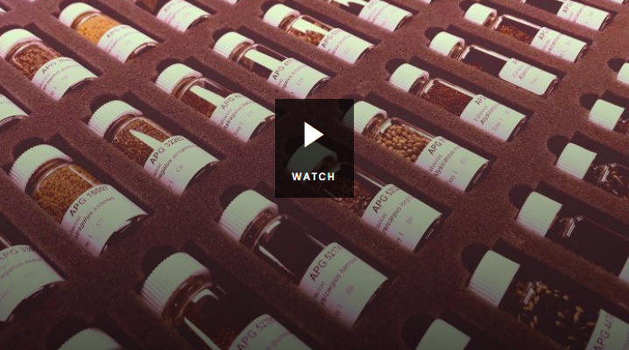
- Describe what the seed bank and its surroundings looks like.
- Why was the seed bank created?
- Why is the seed bank also called the Doomsday Seed Vault?
- How many different types of seeds are stored in the bank?
- List some of the types of seeds that are stored in the seed bank.
- Australia is about to make its biggest deposit to the seed bank. True or false?
- How old is the Doomsday Seed Vault?
- What did you learn while watching the BTN story?


Threatened Australian plants – Department of Environment and Heritage
https://www.environment.gov.au/system/files/resources/d947f8ec-dd8b-4e7f-bd3b-8246e0702547/files/plants.pdf
Plant Bank – BTN
https://www.abc.net.au/btn/classroom/plant-bank/10529572

Endangered Seeds - BTN
https://www.abc.net.au/btn/classroom/endangered-seeds/11229492

National Herbarium of New South Wales – The Royal Botanic Garden Sydney
https://www.rbgsyd.nsw.gov.au/Science/National-Herbarium-of-New-South-Wales

Teacher Resource
Koala Threat
Students will develop a deeper understanding of the issues facing koala populations in Australia.

Science – Year 5
Living things have structural features and adaptations that help them to survive in their environment.

Scientific knowledge is used to solve problems and inform personal and community decisions.

Science – Year 6
The growth and survival of living things are affected by physical conditions of their environment.

Scientific knowledge is used to solve problems and inform personal and community decisions.

Science – Year 7
Classification helps organise the diverse group of organisms.

Scientific knowledge has changed peoples’ understanding of the world and is refined as new evidence becomes available.

- Before you watch the BTN Koala Threat story, record what you know about koalas
- Discuss the BTN Koala Threat story in pairs. Record the main points of the discussion.
- What happened to the koalas on Kangaroo Island this year?
- What did a recent World Wildlife Fund study find about koala populations?
- What do koalas do when they are feeling threatened?
- What happened to the koala’s food source during the bushfires?
- Even before the fires, habitat loss was a problem for koalas. What were the causes of habitat loss?
- Complete the following sentence. Some are worried that koalas could be extinct in some areas by ________.
- What did you learn watching the BTN story?
- How did this story make you feel?

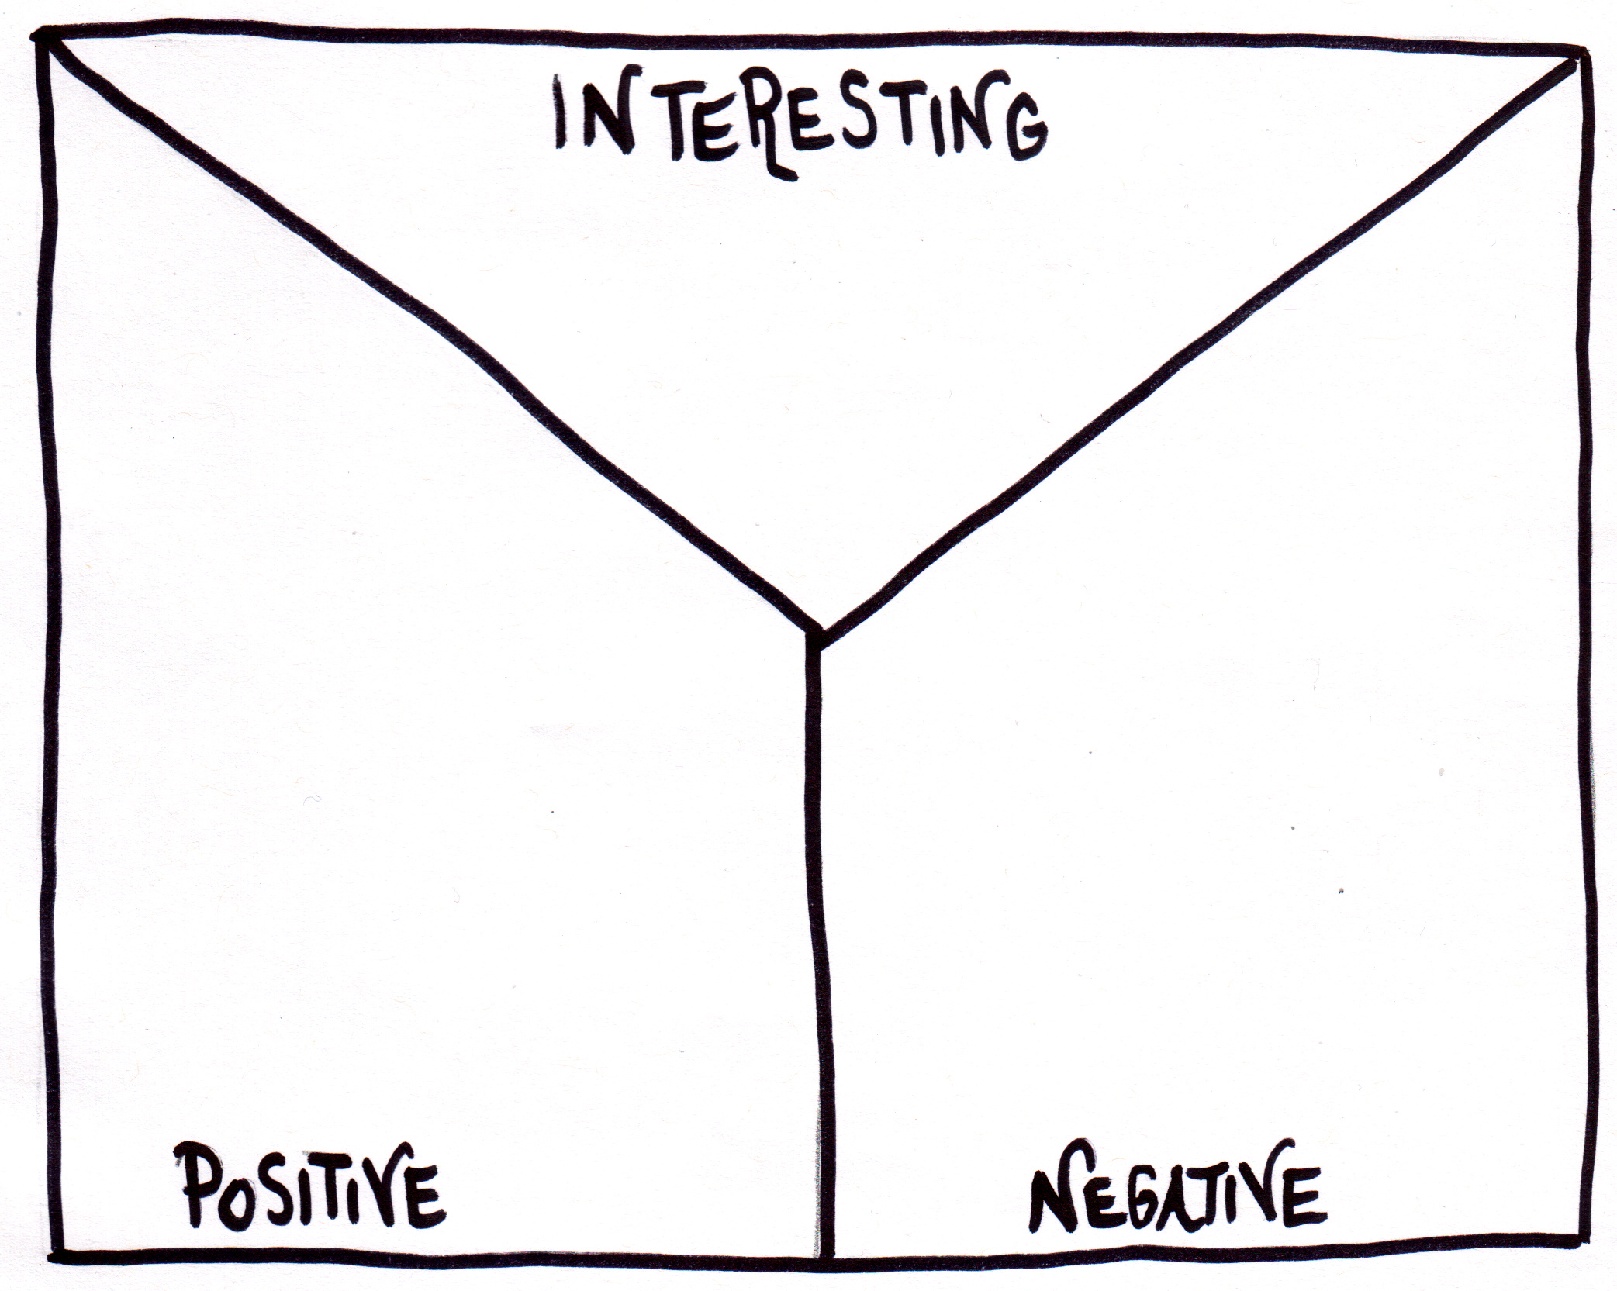
Note Taking
Students take notes while watching the BTN Koalas Threat story. After watching the story, students reflect on and organise the information into three categories.
What information about koalas was...?
- Positive
- Negative or
- Interesting

Glossary
Students will brainstorm a list of key words that relate to the BTN Koala Threat story. Students will then use the words to write their own sentences about the topic. Students may want to use pictures and diagrams to illustrate the meaning and create their own glossary. Here are some words to get you started.
Ecosystem | Habitat | Native
Species | Conservation | Population
Vulnerable | Threat | Marsupial
Inquiry Questions
After watching and discussing the BTN Koala Threat story, what questions do students have and what are the gaps in their knowledge? The following KWLH organiser provides students with a framework to explore their knowledge on this topic and consider what they would like to know and learn.

What do I know? | What do I want to know? | What have I learnt? | How will I find out?

Students will develop their own question/s for inquiry, collecting and recording information from a wide variety of sources. Students may develop their own question for inquiry or select one of the questions below.

- Where can koalas be found? Use a map of Australia to highlight where koalas live in the wild. Why don’t koalas live in Western Australia?
- Is there just one species of koala? Explore the physical features of koalas and how these vary depending on their environmental conditions.
- What is the difference between a vulnerable and an endangered species? Explore the status of koala populations around Australia.
- What threats do koala populations face?
- How are koala populations measured? Think of all the reasons why finding and counting koalas might be hard. Investigate what citizen science projects are happening to help count koalas.
- How many koalas are there left in the wild? Look at numbers of koalas before and after the 2019-2020 Australian bushfires. What would the numbers look like if we had another bushfire? Predict the numbers.

Literacy activity – Koala habitat
This literacy activity demonstrates students active listening and interpreting skills. Students will listen to a description of a koala’s habitat and create a simple black and white artwork illustrating its habitat. Teachers will use the following as a guide for this activity.

- Find a description of a koala habitat to read aloud to your students. Alternatively, choose another Australian native animal that is a vulnerable or endangered species. Visit the Australian Museum to explore a range of Australian animal habitats.
- Read the description of the koala habitat aloud to your class as a whole, reading the description 2 or 3 times.
- Students will take notes and write down key words as they listen.
- Students will illustrate the habitat using only a black felt—tip pen (0.4 or 0.6) on a piece of A4 art paper. Students will include as much detail as they can.
- Display the student’s artwork in a school exhibition.
- We would love to see your students’ artwork! Send your artwork to us at btn@abc.net.au
- Challenge students by asking them to recreate the habitat as a diorama or a virtual reality experience using Minecraft.
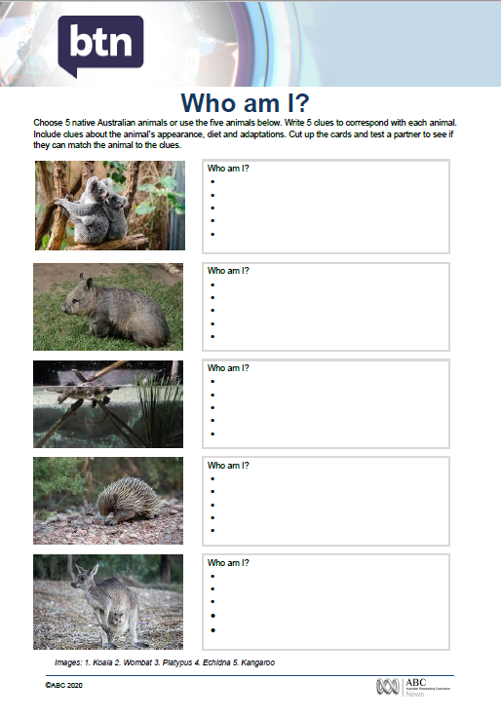
Who am I?
Students will make their own Who am I? game to learn more about native Australian animals.

- Students will research and write 5 clues to correspond with each animal in the Who am I? worksheet at the end of this activity, with the first clue being the hardest and the last clue being the easiest.
- Include clues about the animal’s special features, its predators and how it adapts to its environment.
- Students will test their game on a partner.

Quiz Questions | Your Answer
- Koalas are a type of…
  - Monotreme
  - Marsupial
  - Reptile
- What is the scientific name for a koala?
  - Macropus rufus
  - Tachyglossus aculeatus
  - Phascolarctos cinereus
- Koalas are herbivores
  - True
  - False
- Where do koalas get most of their water from?
  - Eucalyptus leaves
  - Digging underground
  - Lakes and ponds
- What is the status of koalas?
  - Endangered
  - Vulnerable
  - Critically endangered
- What is a baby koala called?
  - Joey
  - Puggle
  - Pup
- What is a threat to koalas?
  - Tree clearing
  - Global warming
  - Bushfires
  - All of the above
- Koalas need very little sleep
  - True
  - False
- How many digits do koalas have on each of their front paws?
  - 3
  - 4
  - 5
- What habitat do koalas live in?
  - Rainforest
  - Desert
  - Eucalypt forest
  - All of the above
Answers: 1b, 2c, 3a, 4a, 5b, 6a, 7d, 8b, 9c, 10c

WWF report finds 71pc decline in koala numbers across norther NSW bushfire-affected areas – ABC News
https://www.abc.net.au/news/2020-09-06/wwf-koala-loss-report-finds-71pc-decline-after-fires/12624938

Bushfires and Wildlife – BTN
https://www.abc.net.au/btn/classroom/bushfires-and-wildlife/11910468

Koala Carer – BTN
https://www.abc.net.au/btn/classroom/koala-carer/11391692

Koalas in Decline – BTN
https://www.abc.net.au/btn/classroom/koalas-in-decline/10522878

Koala – NSW Government
https://www.environment.nsw.gov.au/topics/animals-and-plants/native-animals/native-animal-facts/koala

Who am I?
Choose 5 unique native Australian animals or use the five animals below. Write 5 clues to correspond with each animal. Include clues about the animal’s appearance, diet and adaptations. Cut up the cards and test a partner to see if they can match the animal to the clues.

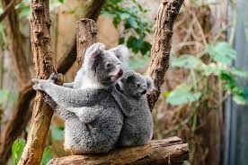 |  | Who am I?
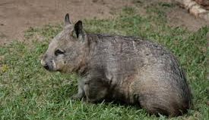 |  | Who am I?
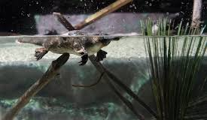 |  | Who am I?
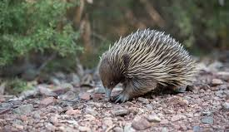 |  | Who am I?
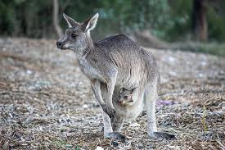 |  | Who am I?
Images: 1. Koala 2. Wombat 3. Platypus 4. Echidna 5. Kangaroo

Teacher Resource
Frog Spotting
Students will develop an understanding of the issues regarding declining frog populations and understand the importance of frogs in ecosystems.

Science – Year 4
Living things have life cycles.

Living things depend on each other and the environment to survive.

Science – Year 5
Living things have structural features and adaptations that help them to survive in their environment.

Science – Year 6
The growth and survival of living things are affected by physical conditions of their environment.

Science - Years 5 & 6
Scientific knowledge is used to solve problems and inform personal and community decisions.

- Retell the BTN Frog Spotting story to another student.
- How do frogs communicate?
- Why do male frogs call?
- Where do you measure a frog to find its length?
- What animals eat frogs?
- What do frogs eat?
- Complete the following sentence. Frogs are a critical part of the food _______.
- Why are a lot of Australia’s frog species under threat?
- What are frogs sensitive to?
  - Pollution
  - Sunlight
  - Water
- What is a citizen scientist?

What do you know about frogs?
Discuss the BTN Frog Spotting story using the questions below as a guide. Record the main points of discussion on a mind map.
- Why are frogs an important part of ecosystems?

- What are the main threats to Australian frogs?
- What do frogs need to survive?
- How do frogs communicate?
- Which species of Australian frogs have become extinct?
- Why is frog conservation important?

Key words
Students will brainstorm a list of key words that relate to the BTN Frog Spotting story. Students will then use the words to write their own sentences about the topic. Here are some words to get you started.
Habitat | Amphibian | Ecosystem
Predator | Prey | Semi permeable
Adaptations | Threatened | Tadpole
Profile of frog
Students choose an Australian frog (or a frog that lives near them) and find out about its habitat, distribution (where in Australia the frog is found), adaptations and whether it has any threats.

COMMON NAME:
SCIENTIFIC NAME:
APPEARANCE:
HABITAT:
SIZE:
DISTRIBUTION:

Illustration/photo
ADAPTATIONS:

THREATS:

INTERESTING FEATURES OR FACTS:


What are bio-indicators?
Do frogs make good bio-indicators?
Further Investigation
Frogs are one type of organism in an ecosystem. Students will draw a food chain to show what a frog eats and what feeds on frogs. Students will show the flow of energy between organisms in this food chain. How might other living things in the ecosystem be affected if the frog population is threatened?

Features of a frog
Students will learn more about the different parts of a frog by labelling the image below. They can then choose three features to explore in more depth and write a paragraph about each feature.

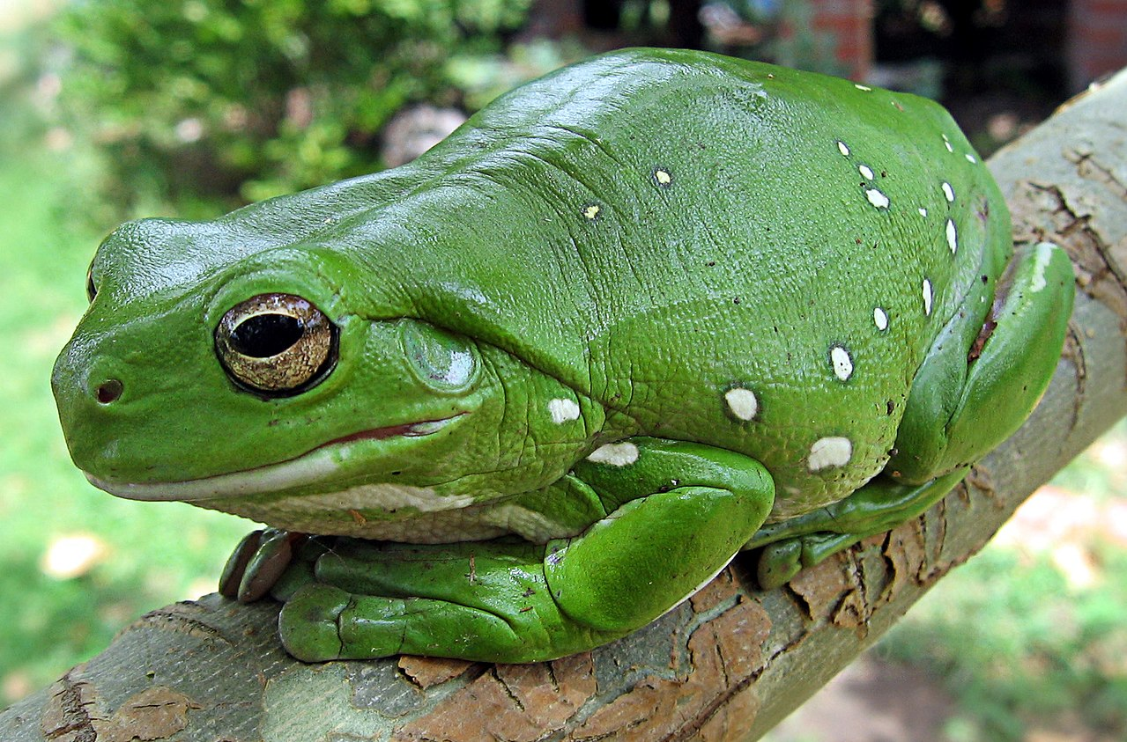
Protruding eyes

Sac-like lungs

Digits – fingers and toes

Soft, moist skin

Hind limb

Fore limb

Backbone and internal
External nares (nostril)

Tympanum (ear drum)
Australian Green Tree Frog

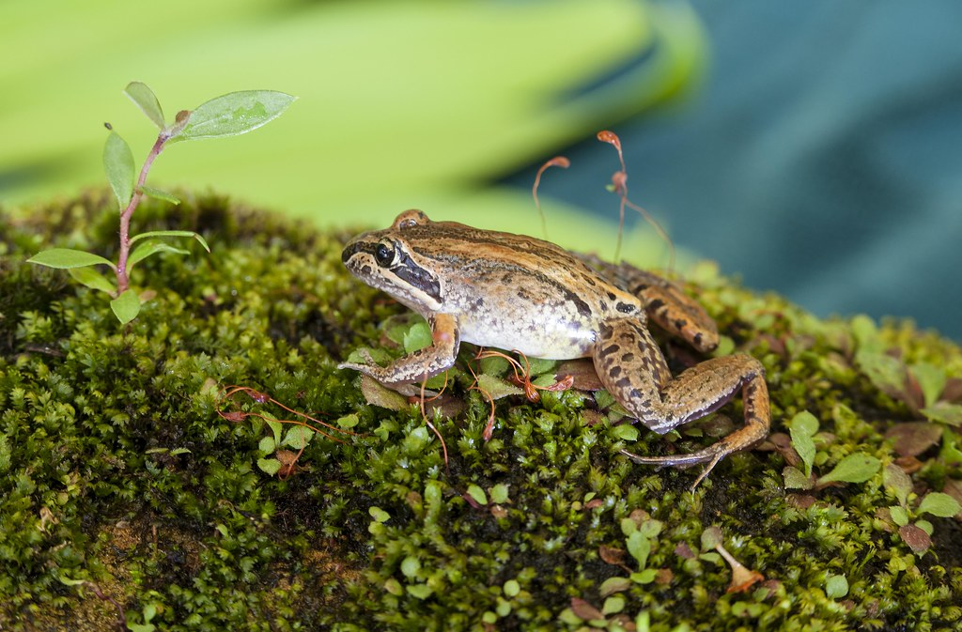
Create a frog friendly garden
Creating a frog-friendly habitat is a great way to help protect local frog populations from decline as well as maintaining the health of the environment.

Using Frog ID or the Atlas of Living Australia, students will find out about the frogs that live in their local area and what their needs are.

Here is some information about how to go about constructing a frog friendly habitat:
ABC Gardening Australia video - How to build a frog bog habitat
Gardening Australia Frog bog factsheet
Australian Museum – Create a frog habitat


FrogID Citizen Science
Scientists need your help to count Australia’s frogs! Students can get involved in the FrogID citizen science project which is helping people learn more about what is happening to Australia’s frogs. FrogID uses a mobile app to help identify frog species by their call and geotagging to map species distribution. Each species of frog has its own unique call. By using the FrogID app to record frog calls students can help identify frogs and their habitats. To find out more go to the FrogID website.

Quiz Questions | Your Answer
- A frog is a…
  - Mammal
  - Amphibian
  - Reptile
- Frogs are cold blooded.
  - True
  - False
- Frogs breathe using their…
  - Lungs
  - Gills
  - Lungs and skin
- Which part of their body do frogs use to help them swallow?
  - Eyes
  - Stomach
  - Tongue
- Frogs drink water through their…
  - Skin
  - Mouth
  - Gills
- About how many native frog species are there in Australia?
  - 40
  - 140
  - 240
- How many species of Australian frogs have become extinct?
  - 2
  - 3
  - 4
- Frogs are the only native amphibians in Australia.
  - True
  - False
- Frogs are found on every continent except…
  - Europe
  - Antarctica
  - North America
- What is a group of frogs called?
  - A school
  - A pod
  - An army

Answers: 1b, 2a, 3c, 4a, 5a, 6c, 7c, 8a, 9b, 10c
FrogID – Australian Museum
https://www.frogid.net.au/

Australia’s native frogs – Australian Museum
https://australian.museum/learn/animals/frogs/

Why Frogs Count Information sheet – Australian Museum
https://assets.ctfassets.net/7ngxgjlhb3jq/1rN9MtYOy2eOVjEQ8PXE1p/00c8e511aa1bbe00fb428933c04112ca/_MIAB_frogID_panels_Sml.pdf

Why do frogs call? – Australian Museum
https://australian.museum/blog/science/why-do-frogs-call/

Frog Future – BTN
https://www.abc.net.au/btn/classroom/frog-future/10541784

Frog Bog factsheet - Gardening Australia
https://www.abc.net.au/gardening/factsheets/frog-bog/9801490#:~:text=Frogs%20drink%20their%20skin%2C%20so,t%20too%20hot%20also%20help.&text=And%2C%20of%20course%2C%20a%20garden%20to%20give%20the%20frogs%20habitat.

Create a frog habitat – Australian Museum
https://assets.ctfassets.net/7ngxgjlhb3jq/7ni3XrvT0G7ngYJ1ldGvHo/9b70774b7c25e5e3a79cf0e6bfe6b046/J4921_FrogID_Habitat_poster_07.pdf

