EPISODE 2
8th February 2022

KEY LEARNING
Students will view a range of BTN stories and use comprehension skills to respond to a series of focus questions.

CURRICULUM
English – Year 4
Use comprehension strategies to build literal and inferred meaning to expand content knowledge, integrating and linking ideas and analysing and evaluating texts.

English – Year 5
Use comprehension strategies to analyse information, integrating and linking ideas from a variety of print and digital sources.

English – Year 6
Use comprehension strategies to interpret and analyse information and ideas, comparing content from a variety of textual sources including media and digital texts.

English – Year 7
Use comprehension strategies to interpret, analyse and synthesise ideas and information, critiquing ideas and issues from a variety of textual sources.
  - Teacher Resource

Focus Questions
As a class, discuss the stories featured in the episode of BTN Classroom and record the main points of the discussion. Students will then respond to the following focus questions.

Ukraine Tension
- Where are Ukraine and Russia located? Find on a map of the world.
- Why are some worried about Russia sending soldiers into Ukraine?
- What was Russia called between 1922 and 1991?
- Complete the following sentence. Today Ukraine is an independent ___________.
- What organisations does the president of Ukraine want to join?

Inland Floods
- How have people in north of South Australia been affected by the recent floods?
- What weather pattern is partly to blame for the floods?
- How have people in Coober Pedy been affected?
- What major highway connecting Adelaide to Darwin has been cut-off by the floods?
- How have people been helping and supporting those affected by the floods?

Check out the teacher resource on the Teachers page.

COVID Waste
- What are some items that we can use to help protect ourselves from COVID?
- How many disposable masks are put into landfill around the world each month?
  - 1 billion
  - 29 billion
  - 129 billion
- How long does it take for plastic to break down?
- What parts of a rapid antigen test (RAT) can be recycled?
- What are some other ways we can reduce our waste?

Safer Internet Day 2022
- Discuss the BTN story with another student. Record the main points of your discussion.
- What are some examples of cyberbullying or online abuse?
- What can you do if you experience cyberbullying or online abuse?
- What are some tips for staying safe online?
- What website has a tool that lets you report online abuse?

Check out the teacher resource on the Teachers page.

Frozen Iguanas
- Before watching this BTN story predict what you think it is going to be about.
- Why are iguanas freezing in some parts of the United States?
- What country are green iguana’s native to? Find on a map.
- Iguanas a warm blooded. True or false?
- Where do cold blooded animals get their energy from?

EPISODE 2
8th February 2022

KEY LEARNING
Students will investigate what floods are, what causes them and how they impact on people and places in Australia.

CURRICULUM
Geography – Year 5
The impact of bushfires or floods on environments and communities, and how people can respond.

Geography – Year 7
Causes, impacts and responses to an atmospheric or hydrological hazard.

  - Teacher Resource

Inland Floods

Focus Questions
Discuss the BTN Inland Floods story as a class and record the main points of the discussion. Students will then respond to the following:
- How have people in north of South Australia been affected by the recent floods?
- What weather pattern is partly to blame for the floods?
- How have people in Coober Pedy been affected?
- What major highway connecting Adelaide to Darwin has been cut-off by the floods?
- How have people been helping and supporting those affected by the floods?

Activity: Class Discussion
Discuss the BTN Inland Floods story as a class. Create a class mind map with FLOODS in the middle. Use the following questions to guide discussion: Ask students to record what they know about floods. What questions do they have? In small groups, ask students to brainstorm responses to the following questions:
- What do you know about floods?
- What causes flooding?
- What impact does flooding have on people and the environment?
- What is extreme weather?
- What questions do you have about flooding?

Activity: Glossary
Students will brainstorm a list of key words that relate to the BTN Inland Floods story. Here are some words to get them started.

RAINFALL | RECEDING | CLIMATE
WEATHER | FLOOD | LA NINA

Activity: Floods Research
Discuss the information raised in the BTN Inland Floods story. What questions were raised in the discussion and what are the gaps in students’ knowledge? The following KWLH organiser provides students with a framework to explore their knowledge on this topic.

What do I know? | What do I want to know? | What have I learnt? | How will I find out?

Students will develop their own question/s to research or choose one or more of the questions below. Encourage students to collect and record information from a wide variety of sources and present the information they find in an interesting way.
- Investigate a major flood event that has occurred in Australia. Include the following information in your response:
  - When and where did the flood occur?
  - What type of flood was it?
  - What impact did the flood have? Who and what was affected?
- What are the two types of flooding - riverine and flash? Write an explanation of both.
- How do experts predict where and when a flood is going to occur?
- What causes flooding?
- Why is flood water dangerous?
- How do floods affect people? What are the immediate and long-term needs of people?
- What can people do before a flood to stay safe? Create a public awareness campaign that targets people living in flood prone areas.

Watch these videos to help students understand more about weather, climate and floods.
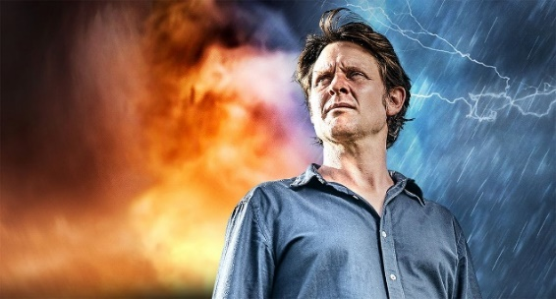
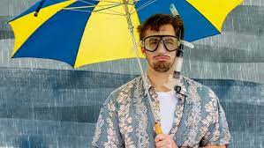

BTN La Nina Explained Big Weather: The Impact of Floods on Communities
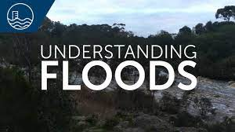
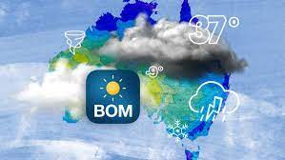

BTN Weather Science BOM – Understanding Floods

Activity: Visual literacy
In this activity students will analyse a range of images which show the flooding which occurred in South Australia recently. Students will choose one or more of the images below and respond to the following:
- What is happening in the image? Create a caption for each image.
- How does the image make you feel?
- What does the image tell you about the impact floods have on a community?
- What questions do you have about what you see in the image?

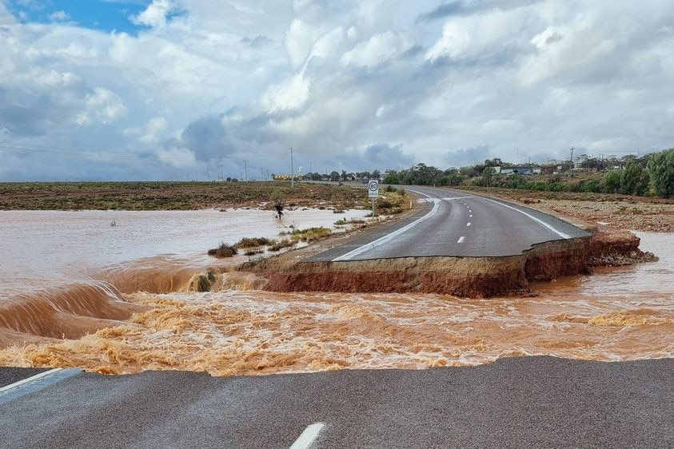  ABC News | 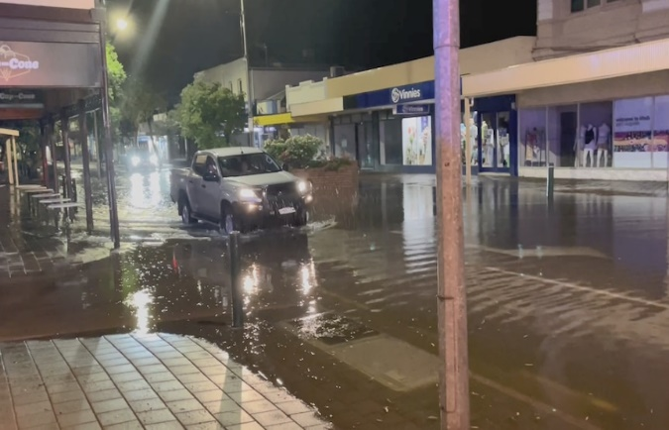  ABC News
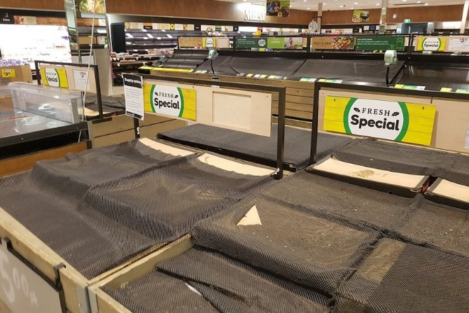  ABC News | 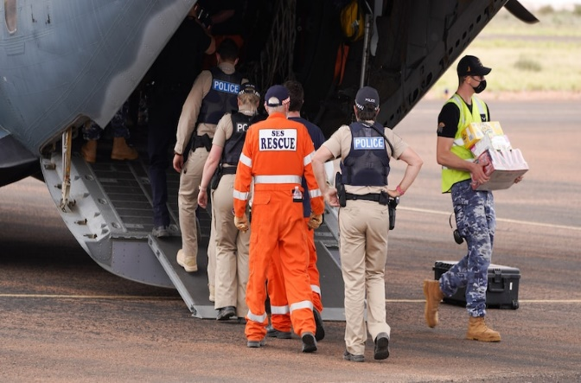  ABC News

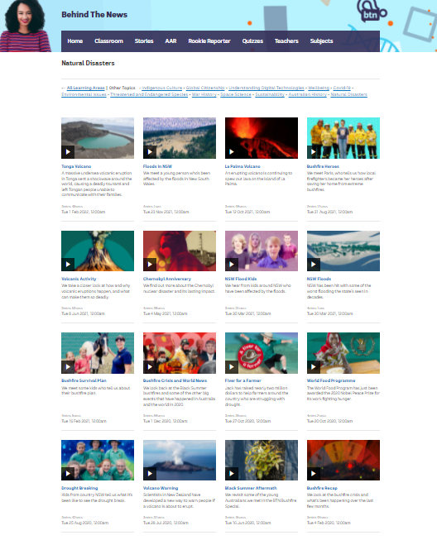
BTN Natural Disaster stories
Visit BTN’s collection of stories which focus on natural disasters.

After watching any one of the BTN videos ask students to respond to the discussion questions (to find the discussion questions and teacher resources go to the related BTN Classroom Episode and download the Episode Package).

Useful Websites
- Port Augusta hit by huge downpour, causing flooding on highway – ABC News
- Outback flooding splitting up families, with at least 12 more days until Stuart Highway reopens – ABC News
- Australian Defence Force prepares to drop food supplies into Coober Pedy isolated by floodwaters – ABC News
- South Australia makes major emergency declaration over storm damage and flooding – ABC News
- Floods – Geoscience Australia
- Understanding Floods – Bureau of Meteorology
- Things you can do before a flood – NSW SES
- Big Weather: The impacts of floods on communities – ABC Education
- Floods in NSW – BTN

EPISODE 2
8th February 2022

KEY LEARNING
Students will learn more about online safety issues and develop skills to stay safe online.

CURRICULUM
Digital Technologies – Years 5 & 6
Plan, create and communicate ideas and information, including collaboratively online, applying agreed ethical, social and technical protocols.

Digital Technologies – Years 7 & 8
Plan and manage projects that create and communicate ideas and information collaboratively online, taking safety and social contexts into account.

Health & Physical Education – Years 5 & 6
Practise skills to establish and maintain relationships.

Plan and practise strategies to promote health, safety and wellbeing.

  - Teacher Resource

Safer Internet Day 2022

Focus Questions
Discuss the BTN Safer Internet Day 2022 story as a class and record the main points of the discussion. Students will then respond to the following:
- Discuss the BTN story with another student. Record the main points of your discussion.
- What are some examples of cyberbullying or online abuse?
- What can you do if you experience cyberbullying or online abuse?
- What are some tips for staying safe online?
- What website has a tool that lets you report online abuse?

Activity: Class Discussion
Ask students to think about how they spend their time online. Students will take notes about what they do online, if their devices have controls or filters on and how they stay safe online. Ask students to bring this information to a class discussion.

Use the following questions to get the discussion started...
- List all the ways you use technology for communication.
- What does it mean to you to be safe online? Give examples.
- What are some examples of cyberbullying or online abuse?
- What can you do if you experience cyberbullying or online abuse?

Activity: Six Hat Thinking
As a class, use Edward De Bono’s Six Hat Thinking to explore the issues raised in the BTN Safer Internet Day 2022 story. Make your own coloured hat cut outs and place on the floor. Students will take it in turns answering questions in relation to what they already know about the issue, what they have learned from the story and what they want to learn further about the topic. Ask students to respond to the following questions:

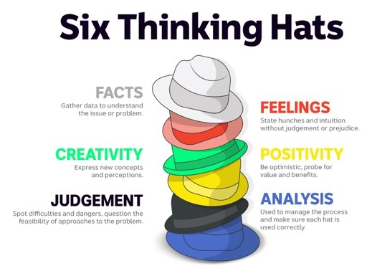
- How did the Safer Internet Day 2022 story make you feel?
- What do you know about staying safe online?
- What have you learnt from the story?
- Were there any positives from the story? If so, what were they?
- What are some of the negatives or challenges that you learnt from the story?
- Why is it important to find out more about the staying safe online?
- What questions were raised during this activity?
- What do you want to learn further about this topic?

Reflection
After this activity, ask students to reflect on what they have learnt. Students can include details about how their thinking on this issue has changed.

Activity: Cyber citizen
Students will explore the issue of cyber bullying and what it means to be a responsible cyber citizen. Ask students to brainstorm the positive and negative aspects of young people accessing information communication technologies and experiences they have using social networking.

Divide the class into groups of 4-5 students. Assign each group one of the following roles:
- The bully (consider the reasons they do it and the excuses they use)
- The victim (how it makes them feel and reasons why they might not tell an adult)
- The parents (what they can do)
- The bystander witnessing cyber bulling (their responsibilities)
- The school (what role do schools play in the issue)

Record students’ responses and discuss questions about the issue that they may have. These questions can be used to guide their research. Other possibilities include:
- What does it mean to be a responsible cyber citizen?
- What can be the consequences for people who bully online?
- What does it mean to be cyber smart?

Students will create and publish a guide on how to stay safe and be smart online. Students’ guides will educate and support other young people in their community.

Activity: #GameOn
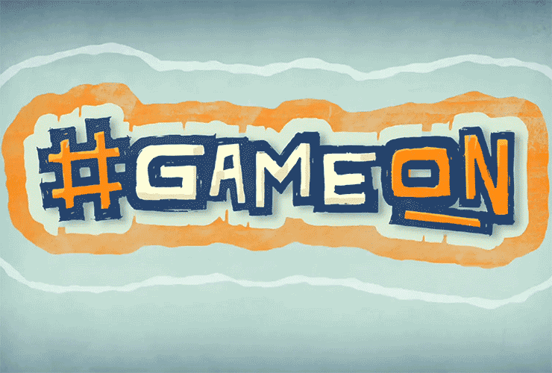
This eSafety resource uses videos to teach kids about the differences and similarities of online and face-to-face interactions and how they can protect their privacy and security online. The resource is based on a short online drama series.

Lesson plans based on the issues raised in the videos are provided in study guides for upper primary and lower secondary students. This resource has also been designed to support students learning from home.
#GameOn resource – eSafety Commissioner

The student activities in this resource cover some of the following topics:
- Your digital reflection
- Playing Safe
- Online Friendships
- Cybercitizenship
- Personal digital devices
- Do you live your life online?
- Screen Time vs Green Time

Activity: Be smart online – Take up the challenge
These teacher-led activities use animated videos to introduce students to key online safety issues including cyberbullying, protecting personal information and sharing images.
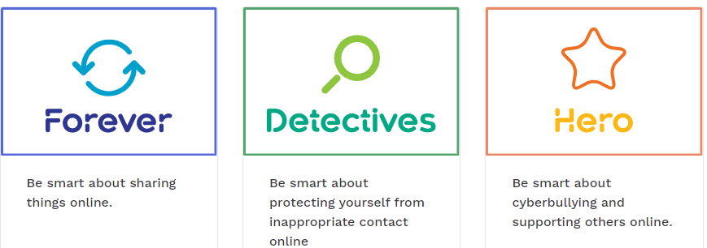

Useful Websites
- Safer Internet Day 2021 – BTN
- Digital Footprint – BTN
- Online Trolls – BTN
- Avoid these passwords – BTN Newsbreak
- Cyberbullying – Kids Helpline
- Cyberbullying – eSafety Commissioner
- Online safety videos for educators – eSafety Commissioner

  - Teacher Resource

BTN Transcript: Episode 2 - 8/2/2022

Hey, I'm Amelia Moseley and you're watching BTN. Thanks for joining us again, here's what's coming up. We find out about the floods which have cut off towns in inland Australia, learn just how much extra rubbish this pandemic is creating, and we solve the mystery of the frozen iguanas.

Ukraine Tension

Reporter: Amelia Moseley

INTRO: Don't worry, no iguanas were harmed in the making of that story. But before we get to all that, we're going to talk about a serious situation that's happening in Eastern Europe near Ukraine's border. Over the past few months more than a hundred thousand Russian soldiers have gathered there and it's got a lot of people worried. Let's find out what's going on.
Welcome to Ukraine. It's an Eastern European country with a population of 44 million people and plenty of visitors.
AUSTRALIAN: This is the view from our balcony.
But near the border of this snowy country are some people that not everyone’s welcoming. More than a hundred thousand soldiers. They've been sent by Ukraine's neighbour, Russia, over the past few months. And while Russia's president says this is just a military exercise, many are worried this could turn into an invasion and a war. One that would be much bigger than just these countries.
Volodymyr Zelensky, Ukraine President: I openly say that this will not be a war between Ukraine and Russia. This will be a full scale war in Europe.
But first you should know the tension between Russia and Ukraine isn't new. It's been going on for many years and that's partly because these countries have a long shared history. They were both a big part of the Soviet Union or USSR. By size, it grew to be bigger than any other country. And it became one of the world's superpowers and a major rival to the US.
But the Soviet Union didn't allow its people to have many freedoms, including the freedom to choose their leaders. Over the years it saw many controversies and disasters, including the world's worst ever nuclear accident at the Chernobyl power plant in Ukraine. In 1991 after nearly 70 years, the Soviet Union fell.
Today Ukraine is an independent democracy, but some people still think of it as a part of Russia, including Russia's President Vladimir Putin. And for many years there's been tension and conflict. There are also some people in Ukraine who feel close ties to Russia. Although many, especially in the west of the country, feel closer to Europe.
Recently, Ukraine's government even said it would like to join the European Union, and NATO. That stands for North Atlantic Treaty Organisation; a group that was formed during Soviet times by countries including the US, UK and France who've agreed to protect each other. But Mr Putin sees NATO as a threat to Russia, and he's demanded a promise never to let Ukraine join and that NATO stay away from Eastern Europe. Many people in Ukraine say they're feeling really worried.
UKRAINIAN RESIDENT 1: I'd say it's definitely increasing anxiety and stuff for sure.
UKRAINIAN RESIDENT 2: We are afraid that Russia will attack Ukraine in the coming months. And we are very worried about this because we all built this country. We love it. We believe in its future.
The US and UK have now sent more of their own troops into different parts of Europe but not Ukraine. And while things are pretty tense, both sides say they don't want to fight.
VLADIMIR PUTIN, PRESIDENT OF RUSSIA: We should find a way to ensure security of all participants of this process. Ukraine, European countries and Russia.
JEN PSAKI, WHITE HOUSE PRESS SECRETARY: Certainly, all of our preference is to deescalate and to prevent an invasion from happening. But that is up to President Putin to make that decision.
So, everyone's hoping the situation will cool down in this chilly part of the world.

News Quiz

How old do you have to be to get a COVID vaccine booster shot in Australia? 12, 16 or 18? You have to be 16. It used to be 18 but last week ATAGI, which advises on vaccines in Australia lowered the age.

Happy Lunar New Year. More than a billion people around the world have been celebrating the holiday and welcoming the new year which is represented by which animal of the Chinese zodiac? Is it the rat, the dog, or the tiger? It’s the year of the tiger. And some believe that people born this year will be extra brave and bold.

Here’s a history question. Can you name the ship that Captain Cook sailed to Australia in 1770? It was the Endeavour and last week the National Maritime Museum announced that its remains have finally been found. It was amongst a group of wrecks that were deliberately sunk off the coast of the US during the War of Independence.

KEVIN SUMPTION, NATIONAL MARITIME MUSEUM: It’s 22 years of work, and to be able to confirm that this is indeed the wreck site of Cook’s Endeavour it’s fantastic.

Except the people in charge of the exploration said that announcement was too early, and more research is needed. So, watch this space, I guess.

Inland Floods

Reporter: Jack Evans

INTRO: Now we're going to the centre of Australia, which is usually known for being dry but not so much at the moment. There've been serious floods in South Australia's north and they've cut off some outback towns and led to empty supermarket shelves. Here's Jack to explain.
This is what a once in a hundred year storm looks like.
COOPER: It was raining a lot and it flooded and there was a lot and a lot of wind.
RAPHAEL: Honestly when I looked at the rain and the flood. I was like, this isn't possible, this can't happen because like this is the first time, I've ever had a huge rain in my whole life.
These guys live in Port Augusta, which was hit by a pretty serious storm recently that flooded most of the area when it received more than a quarter of its annual average rainfall in just one night.
COOPER: Well, it flooded the shed and it had destroyed most of the carpet.
RAPHAEL: When I looked outside there was like, oh my gosh man, the whole city was flooded.
MARLIN: Our driveway got flooded so we couldn't go anywhere so I don't really know what the streets look like.
TEMPERANCE: We have a big hole in our driveway.
Port Augusta isn't the only town that was hit. Right across Central Australia there has been heavy rainfall, which the Weather Bureau says has been caused by a monsoonal weather system that has dragged tropical moisture across the land. Along with La Nina, a weather pattern that we're in at the moment, which is bringing wetter conditions than usual to Australia's east.
PAUL LAINIO, BUREAU OF METEOROLOGY: We rarely see this amount of rainfall across South Australia. So, 50 to over 200 millimetres recorded in a number of locations across the state and just across the border in the Northern Territory, similarly high falls, falls of over 100 millimetres in a day and that's on top of earlier rainfall from that late January period.
People have had to evacuate their homes, many buildings and properties have been damaged and some towns have been completely cut off. The floods have left people in Coober Pedy and surrounding towns stranded and supplies have had to be airlifted by the military.
JANICE ENGLISH, MARLA TRAVELLER'S REST: We're currently out of fresh produce, meat, milk, fruit and vegetables, water and probably the next couple of days we won't have any diesel.
Coober Pedy isn't the only town running out of supplies. The storms and flooding have caused damage to train lines and highways that connect South Australia with the Northern Territory and Western Australia. It's meant trucks can't get through with stock leaving some supermarkets in the Northern Territory looking like this.
SAM: Lately the shops have been very very empty. Last night we had food with no meat in it because there was no meant in the shops.
While flood waters have been receding, authorities say it could be a while before things are back to normal. But there is a silver or rather green lining. The rainfall has transformed usually dry and arid landscapes with an explosion of plants and wildlife. Including frogs, crabs and shrimp that emerged from deep in the mud.
DAVID WATSON, CHARLES STURT UNIVERSITY: This place has been transformed, the frogs are going bananas, the ducks are breeding it's a little tricky to go to bed at night cause it's so noisy.
In the meantime, people have been working together to clean up, after one of the biggest storms, they've ever seen and which they hope to never see again.
Quiz

Can you name La Nina's opposite: a weather pattern that brings hotter, drier weather to this part of the world? It's El Nino which is Spanish for the little boy.

COVID Waste

Reporter: Amelia Moseley

INTRO: Now, we all know that this pandemic we're living through isn't great. Huge understatement, right? And amongst the many negatives it's thrown our way is a big-old pile of rubbish. Let’s find out more.

Remember when you didn't know how to wear a face mask? You'd never smelt hand sanitiser? And shoving a swab up your nose and wiggling it around until your eyes watered was…
NAT: Wait, what?
AMELIA: It’s gonna be a thing in like a year. So, just trust me. Hold still.

NAT: Wait, ah, just give me a minute.
Yeah, things have definitely changed a lot since COVID. People all across the world have found themselves in need of things they probably didn't think they'd ever need, or need so much of, or even want, to be honest. Like disposable masks, face shields, nasal swabs, plastic gloves, bottles of hand sanitiser, takeaway food containers, and bubble wrap.
AMELIA: Oh, you know, for all the extra online shopping.
And while a lot of this extra stuff is being used to keep people safe and separated, it's making a tonne of extra waste. Well about 1.6 million tonnes actually. That's how much plastic waste has been made every day since the pandemic started. That's like 10,000 blue whales or 1.2 million teams of BTN reporters.

AMELIA: Umm, I'm not quite sure that put things in perspective, but you get the idea. It’s a lot.

In fact, when it comes to something like disposable masks around 129 billion are chucked into landfill every month. That's like…
AMELIA: Well, that's just like 129 billion masks.
And plastic takes a long time to break down; like, 450 years long. And when stuff isn't chucked out properly, it can end up where it shouldn't. Hospitals, in particular, are creating a huge amount of waste. The WHO says discarded syringes, test kits, old vaccine bottles and personal protective equipment are creating big problems, especially in developing countries where getting rid of waste is already tricky.
AMELIA: But if you're thinking can't we just make all of this COVID-y stuff recyclable? Well, unfortunately it’s not always that simple. For example, these. Rapid antigen tests.
DEAN WHITING, CEO Pathology Technology Australia: It's nice to think that the plastic parts could be recycled. The sad truth is that they will be contaminated with biological waste from your nose or your mouth so really in that sense they can't be. You should really put it into a zip lock bag, and you should put the waste into your household waste, not into the recycling bin. Just the cardboard packaging and the paper leaflet, for example, can be.
There's also the issue of reusable face masks. While they're fine in some situations (and definitely better than nothing) experts say N95 masks are best but, you guessed it, they're disposable. Environmental organisations say sadly, for now, we just have to put up with the extra waste to keep us safe.
Alejandra Laclette, PLANET ARK Recycling Campaign Manager: We have to make sure that we take care of our community and make sure that they're safe. So, this is something that importantly right now it just has to be, it has to happen.
Amelia: But wait. We can try to make up for our waste in other ways. Like…
We can snip the straps off our masks before putting them in the bin, so if they end up where they shouldn’t, they won't trap animals. Keep cutting down on plastic packaging and reducing our food waste. There are also companies working on more eco-friendly COVID essentials, like biodegradable masks. And hopefully in the not-too distant future these things that used to not be a thing will not be a thing again. And that'll be a good thing.

Safer Internet Day 2022

Reporter: Amal Wehbe

INTRO: Over the past few years we've all spent a fair amount of time online and while that can be a good thing, it's also important to be aware of potential online dangers. That's why today, Australians are marking Safer Internet Day. This year's theme is all about playing fair and preventing cyberbullying and abuse. Here's Amal.

NIC: Amal this is terrible, you've got to do it again.
AMAL, REPORTER: Yeah, sometimes life can get you down. And in those moments the online world can be a great way to take your mind off things.
AMAL: Yes. I killed today's Wordle.
But sometimes people can use the internet in a pretty bad way to make themselves feel more powerful or in control by hurting others. Yep, I'm talking about cyber bullying or online abuse. And unfortunately, it's something that young people know a lot about. In fact, on average 1 in 5 young Aussies have experienced being threatened, excluded or abused online. And 1 in 5 young Aussies have admitted to behaving negatively online, often after experiencing online abuse themselves. But what exactly is it?
KID 1: Cyber bullying and online abuse is using technology and social media platforms to harm other people.
That can happen in lots of different ways. It could be posting nasty comments about someone. Or spreading rumours or lies. It could also be embarrassing someone by spreading photos or videos they don't want people to see. Or pretending to be someone else online to trick or humiliate someone.
KID 2: Some examples of online abuse are stalking, blackmailing, revealing personal information.
And if you've ever been or know someone who's been bullied online, you'll know how harmful it can be.
KID 3: It can make someone feel isolated and unconfident. It can also make you feel very alone at the time.
JULIE INAM GRANT, AUSTRALIA'S eSAFETY COMMISSIONER: Cyber bullying can happen 24/7. It's, you know, we take it home with us on our phones in our pockets.
This is Julie who is Australia's eSafety Commissioner, a position set up by the government in 2015, to fight online abuse, cyberbullying and other online nasties. They do that by working with online companies, as well as individuals.
JULIE INAM GRANT: We can bring parents and other students and teachers together to get to the heart of that matter. And we can really stop that from happening in the future.
Thanks to a new set of Aussie laws the Commission has the power to force all sorts of online platforms to deal with harmful content.
JULIE INAM GRANT: We can even go to the search engines if there's really terrible information about you that's damaging that people can Google or Bing we can compel them if it's really serious material to take it down.
She says if you are facing cyberbullying or online abuse, it's important to tell someone about it. The eSafety Commission site even has a tool that lets you report it directly. But there are other things we can do to lookout for ourselves and our mates online.
KID 4: You can just take a screenshot and then show an adult. Then you can block them or delete the app.
KID 5: I think it's mostly just to stay calm and try not to get under the influence of what they're saying.
KID 1: If you're experiencing online abuse, you can talk to a trusted adult, ban them but make sure to take a screenshot first.
KID 2: If you're having a tough time online, just remember it's never your fault and you can always turn to a trusted adult or help service.

Sport

The Winter Olympics are off to a pretty cool start in Beijing. Get it? Pretty cool? Anyway. Aerial skier Laura Peel and figure skater Brendan Kerry got given the special honour of being Australia's flag bearers. And before too long, Tess Coady had claimed the first Aussie first medal, a bronze in the women's slopestyle snowboarding. And who got Australia's first gold? Freestyle skier Jakara Anthony. She needed a score of 80.28 to win over Jaelin Kauf from the US and smashed it with an 83.09. It's Australia sixth gold medal in Winter Olympic history.
Now, to some warmer weather in Hawaii where surf legend Kelly Slater has made history, claiming his eighth Pipeline win just days before his 50th birthday. He's the oldest person ever to win the world famous event, which he first took out 30 years ago. Local wildcard Moana Jones Wong also has a place in history after winning the first ever full women's event at the iconic North Shore break. Gnarly dude.

Frozen Iguanas

Reporter: Jack Evans

INTRO: Now, as promised, to those frozen iguanas. Florida in the US is experiencing a cold snap right now and it's led to the strange and disturbing sight of iguanas lying frozen stiff on the ground. But don't worry, they're not dead, they're just cold blooded. Jack can explain.
IGUANA: Ah, there you are Henchman. Now are all the iguanas free?
HENCHMAN: What?
IGUANA: I asked you to free all the iguanas.
HENCHMAN: Freeze all the iguanas
IGUANA: Free.
HENCHMAN: Freeze.
IGUANA: Free.
HENCHMAN: Uh oh.
IGUANA: Are you telling me you froze all the iguanas?
IGUANA: That wasn't the plan. I wanted you to free all the iguanas so that we could build an iguana army and take over the world. You're on thin ice henchman, pun not intended.
Yep, frozen iguanas are very much a thing over in the US at the moment. I just highly doubt it's because some henchman misheard an iguana and froze them all. So why are iguanas freezing? Well, to point out the obvious, it's really cold over there at the moment. Parts of the US have been walloped with a pretty harsh winter storm with temperatures in South Florida reaching as low as minus 3.8 degrees. That's unusually cold, especially for these guys.
You see green iguanas are not actually native to North America. They originate from Central and South America, as well as some islands in the Caribbean, where it's a lot warmer. Oh, and then there's the fact that like all other reptiles, iguanas are cold-blooded. You see, we humans, and other mammals and birds, are warm blooded which means our bodies control their own temperatures. So, for humans even when it's a bit chilly out here, it stays a toasty 37 degrees or so in here.
That's not the case for cold blooded creatures, like insects, arachnids, fish, amphibians and reptiles. Their temperatures depends on the environment they're in. They get energy from the warmth of the sun and if it cools down, they start to slow down, and eventually become immobile.
STACEY COHEN, ZOOLOGIST: Their bodies basically start to shut down where they can’t use their functions and so they are up in the trees on the branches sleeping and then because it gets so cold, they lose that ability to hang on and then they do fall out of trees a lot.
IGUANA: They're falling out of trees. Oh, this is a disaster.
HENCHMAN: Yeah, well maybe they shouldn't be falling asleep in trees.
IGUANA: Yes, well maybe you shouldn't have frozen them.
HENCHMAN: Yeah, well that’s true. Don't worry boss, I'm sure that as soon as the sun comes out and things start heating up again, eventually they'll thaw out. Yeah?
Yep, don't worry just because they're frozen and falling out of trees doesn't mean they're dead. See, being cold blooded has its advantages. It means you can survive much more extreme temperatures than we hot blooded creatures. This isn't the first time iguanas have frozen because of cold weather and experts reckon that eventually they'll thaw out and get moving again. So, hopefully when things start heating up, these guys will go back to doing what they do best.
IGUANA: Which, when they're finally thawed, they will be taking over the world.

HENCHMAN: Yes.

Closer

You gotta watch out for those iguanas. Well, that's it for today's show. But we'll be back next week with more and, in the meantime of course, there's Newsbreak every weeknight. Plus, there's heaps to see and do on our website including some resources for your hard-working teachers. Have a great week. Look after each other as always and I'll see you next time. Bye.

