EPISODE 25
5th September 2023

KEY LEARNING
Students will view a range of BTN stories and use comprehension skills to respond to a series of focus questions.

CURRICULUM
English – Year 4
Use comprehension strategies to build literal and inferred meaning to expand content knowledge, integrating and linking ideas and analysing and evaluating texts.

English – Year 5
Use comprehension strategies to analyse information, integrating and linking ideas from a variety of print and digital sources.

English – Year 6
Use comprehension strategies to interpret and analyse information and ideas, comparing content from a variety of textual sources including media and digital texts.

English – Year 7
Use comprehension strategies to interpret, analyse and synthesise ideas and information, critiquing ideas and issues from a variety of textual sources.
  - Teacher Resource

Focus Questions
As a class, discuss the stories featured in the episode of BTN Classroom and record the main points of the discussion. Students will then respond to the following focus questions.

Voice Referendum
- What date will the Indigenous Voice to Parliament referendum be held?
- What is a referendum?
- What will people be voting on at the referendum?
- What do you need to pass a referendum in Australia?
- What questions do you have about the story?

Varroa Mite Spread
- Discuss the BTN story in pairs or small groups.
- What is another name for a varroa mite?
  - Varroa demolisher
  - Varroa destroyer
  - Varroa destructor
- A varroa mite is a parasite. True or false?
- How do varroa mites affect honey bees?
- Where in Australia have varroa mites been found?

Female Scientists
- Before watching this story name some famous scientists. How many are women and how many are men?
- What did Rosalind Franklin discover?
- Why has science been a male-dominated field? Give one reason.
- What female scientist helped discover nuclear fission?
- Name an Australian female scientist.

Check out the teacher resource on the Archives page.

Protecting Native Wildlife
- Briefly summarise the BTN story.
- What is the meaning of endemic species?
- How many species are known to be threatened in Australia?
  - 170
  - 1,700
  - 17,000
- What are some threats to native animals in Australia?
- How can we help protect Australian animals? Give an example.

Check out the teacher resource on the Archives page.

Spiderman Animator
- How did Preston get involved in the “Spider-Man: Across The Spider-Verse” movie?
- Summarise the process that Preston uses to make animations.
- What was the most exciting part about working on the movie for Preston?
- How long has Preston been making Lego animations for?
- What are Preston’s future goals?

EPISODE 25
5th September 2023

KEY LEARNING
Students will investigate reasons why women are poorly represented in science. They will also create a biography of a female scientist of their choice.

CURRICULUM
HASS – Years 5 and 6
Work in groups to generate responses to issues and challenges.

Present ideas, findings, viewpoints, and conclusions in a range of texts and modes that incorporate source materials, digital and non-digital representations and discipline-specific terms and conventions.

Science – Year 7
Investigate how cultural perspectives and world views influence the development of scientific knowledge.
  - Teacher Resource

Female Scientists

Focus Questions
Discuss the BTN story as a class and record the main points of the discussion. Students will then respond to the following:
- Before watching this story name some famous scientists. How many are women and how many are men?
- What did Rosalind Franklin discover?
- Why has science been a male-dominated field? Give one reason.
- What female scientist helped discover nuclear fission?
- Name an Australian female scientist.

Activity: Brainstorming
Before watching this story, students will brainstorm a list of famous scientists. They will then go through their list and highlight all the women. This activity can be done as a class or in smaller groups. Discuss students’ responses.

Activity: Discussion
Working in pairs or small groups, students will discuss the BTN Female Scientists story using the following questions as a guide.
- What did a recent report find about representation of female scientists in the Australian curriculum?
- Why is it important to learn about female scientists?
- If you could meet any female scientist from history, who would it be? Give reasons for your answer.
- How can girls be encouraged to pursue careers in science?

What questions do you have about the story?
What did you learn from the story?

Activity: Female Scientist Biography
Students will choose a well-known female scientist to research and write a biography about. They can choose one of the female scientists featured in the BTN story or another one. Before students begin to construct their biographies, hold a class discussion to find out what they already know about biographical writing.

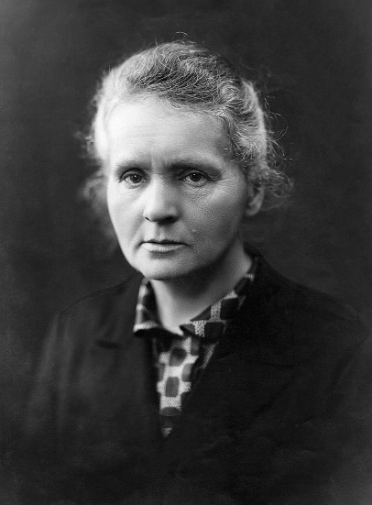
Use the questions below to get a class discussion started with your students about biographical writing.
- What does a biography tell us about a person?
- Where can you look to find information for your biographical writing?
- What makes a biography interesting? For example, key information and facts, a timeline of events, photographs, illustrations and quotes.

Using the biography worksheet at the end of this activity, students will research and record information about a female scientist. Some possible areas of research include:
Marie Curie

- When and where were they born? Describe their family life growing up.
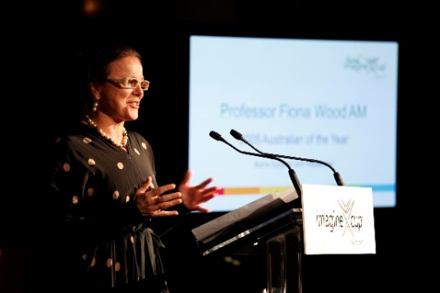
- What are some of their achievements? What area of science did they focus on?
- What inspired/motivated them? Who were their role models?
- What were their challenges?
- How do we recognise their achievements?
- How have they made an impact on people’s lives?
- What do you admire about them?
Fiona Wood

Further investigation
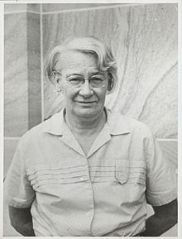
- Create a timeline of significant events in their life.
- What are some of the key events in their life? Write a summary for one key event, which answers the 5 W’s – Who, What, Where, When and Why?
- How do primary sources (for example photos, letters, diaries and official documents) help us understand what might have happened at a place in time? Find 1 or 2 primary sources that help you learn more about the person’s life.
- Imagine you could sit down and talk to them. What questions would you ask about their life and achievements?
- Write a letter thanking them for their achievements and how they have changed the world.
- Make a Did You Know for other students.
Dorothy Hill

Activity: BTN Female Astronaut story
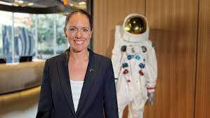
BTN caught up with Katherine Bennell-Pegg who is the first woman to be trained as an astronaut under the Australian flag.
What types of careers are there in space exploration? Learn more about the space sector and pathways for a career in space. Choose one to explore in more detail.

Activity: Fierce Girls podcast
Ruby Payne Scott – The Girl Who Listened to the Stars
In the 1940s when Ruby Payne Scott went to university, she was the only girl in her class. Back then, you could count the number of female physicists in the entire country on one hand.
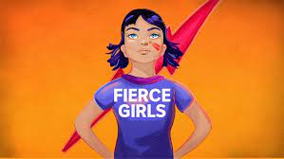
Listen to the Fierce Girls Podcast to learn more about her life and her contribution to space exploration. Students will listen to the podcast and then respond to the following questions:
- What were some of Ruby Payne Scott’s challenges? List some of the roadblocks she faced.
- What course did she graduate in at university?
- What top secret job did Ruby Payne Scott do during WWII? Illustrate an aspect of her job.
- What is radio astronomy?
- What were some of Ruby Payne Scott’s achievements?

Andrea Boyd — The Girl Who Became the Voice of Space
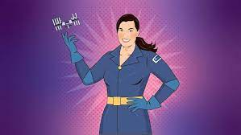
Andrea Boyd worked hard to become the International Space Station’s only Aussie flight controller, talking to the astronauts who lived in the space station as it orbited Earth. But Andrea didn't stop there — she wanted to bring space exploration to Australia. She convinced the country's leading academics, businesspeople, and the government to open the Australian Space Agency.

Listen to the Fierce Girls Podcast to learn more about her life and her contribution to space exploration. Students will listen to the podcast and then respond to the following questions:
- What is one of the best places for stargazing?
- What TV show inspired Andrea Boyd to reach to the stars?
- What is the International Space Station (ISS)? Describe.
- What is Andrea Boyd’s job for the ISS?
- What is a Soyuz?
- How would life be different without satellites?
- Summarise Andrea Boyd’s achievements in space exploration.
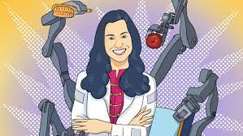
Marita Cheng – The Girl Who Built Robots
When Marita was little, she thought robots could change the world but not many other girls thought the same. So, Marita started Robogals, a club to show girls they could work in robotics when they grew up.
Listen to the Fierce Girls Podcast to learn more about her life and her contribution to robotics.

Activity: Interviews with female scientists
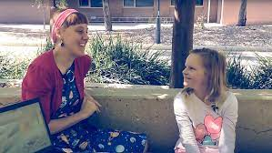
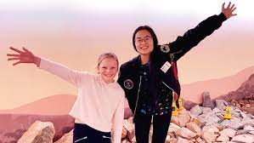
Rookie Reporter Lily loves all things science! She decided to interview female scientists about their lives and their jobs.
Vienna Tran is studying medicine and hopes to one Eriita Jones is a Planetary and Space scientist.
day be a space doctor. Watch Lily’s interview here Watch Lily’s interview here

Useful Websites
- Aussie Astronaut – BTN
- Dorothy Hill – BTN
- Nobel Prize awarded women – The Nobel Prize

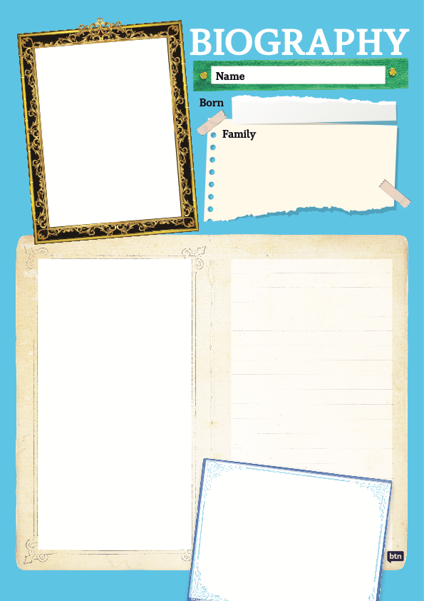

  - Teacher Resource

BTN Transcript: Episode 25 – 5/9/2023

Hey. I'm Amelia Moseley and you're watching BTN. Thanks for being here again, let’s see what’s coming up on today’s show. We find out why Aussie bees are in trouble, visit an animal hospital for Threatened Species Day and meet a young animator who's scored a spot in a famous film franchise.

Voice Referendum

Reporter: Josh Langman

INTRO: But first today to the big news of the week. Australia has been given a date for the referendum on the Voice. Josh went along to the announcement to find out what happens next.

We've been waiting, and waiting, and waiting. And finally, after lots of debates, marches, and, frankly, a lot of anticipation, last Wednesday, the Prime Minister decided to drop into South Australia to drop the date.
JOSH LANGMAN, REPORTER: He's right over there doing it here in my home town. Let's have a listen.
ANTHONY ALBANESE, AUSTRALIAN PRIME MINISTER: Today, I announce that referendum day will be the 14th of October.
There you have it. Mark your calendars, everybody. Because we have an official date for the referendum.
JOSH: Now in case you've forgotten what this is all about, here's a quick recap for ya.
Back in 2017, there's a big meeting at Uluru. First Nations delegates put together a plan to improve the lives of Indigenous people. It calls to enshrine a First Nations Voice in the Australian Constitution, to advise the government on issues that affect Indigenous people. But to change the constitution, we need a referendum: a big national vote. And here we are.
JOSH: So, you might be wondering, what happens now?
Well, on October 14, all Australians aged 18 and over will have to cast their vote. It'll be a bit like an election, and I'm personally hoping for some sausage sizzles. Voters will be given a slip of paper, with this question written on it. And they'll have to write either 'Yes' or 'No'.
You might have also seen this piece of paper pop up in your mailbox. It's been sent to all Australians to explain what they'll do on the day, and outline the arguments for both sides.
On the 'Yes' side, it's about: recognising and paying respect to First Nations history, listening to advice from Aboriginal and Torres Strait Islander people on matters that affect them and hopefully, improving their lives.
TANYA HOSCH, INDIGENOUS SOCIAL ACTIVIST: It's the fair thing to do, it's the just thing to do and it's the right thing to do. As for the 'No' side, the main arguments are: there's not enough detail about exactly what the Voice would look like and what powers it would have. It could be legally risky and divisive.
JACINTA NAMPIJINPA PRICE, AUSTRALIANS FOR UNITY: We will not allow for the Prime Minister and this referendum to divide our country along the lines of race within our constitution.
While we don't know exactly how people are gonna vote just yet, early surveys have shown the country is pretty split on the issue. At the moment, the 'No' vote seems to be ahead, but 'Yes' campaigners reckon they can turn that around. To do that, they'll need not only a majority of Australians, but also a majority of the states. So, they're focusing on states where things are really close, like South Australia. And that's one of the reasons the PM made the big announcement here.
NOEL PEARSON, LEADING 'YES' CAMPAIGNER: South Australia has led other states in Australia on so many issues in the past.
Of course, it also meant that this Adelaide-based BTN reporter could be there on the scene, ready to ask the hard-hitting questions that matter.
INTERVIEWER JOSH: What does the Voice mean for Aussie kids?
Ehh, maybe not.
INTERVIEWER JOSH: Agh, rats.
Oh, well, at least I got to be there.
JOSH: Well there you have it Australia. Right here, from my home town Adelaide. 6 weeks to go. Josh Langman, Behind the News.

News Quiz

Do you know the name of the hurricane that caused widespread damage in the South-East of the US last week? Was it Idalia Idaho Or Irina? It was Idalia. The storm was a category 3 when it slammed into Florida, causing some bad floods before moving inland.

A week after its successful moon landing, India has launched another big space mission. Where is this one headed? Venus, the Sun or an asteroid? It’s headed to the Sun. Aditya-L1 is carrying scientific instruments to observe the Sun’s outermost layers in a four-month journey.

And do you know what’s behind this blue glow in South Australia’s Port Lincoln? Is it a light festival, a glowing algae or radioactive water? It’s a glowing algae called Noctiluca scintillans, or sea sparkle.

When you pick it up, it's, I don't know, it dribbles through your fingers. And whenever it lands on something, it glows. Just little splatters of bright glue, I suppose.

The glowing happens because of a totally natural and very cool chemical process known as bioluminescence.

Varroa Mite Spread

Reporter: Joe Baronio

INTRO: Now to some bad news for Aussie bees. Authorities say the Varroa mite has now spread, and some reckon we may not be able to get rid of it. Here's Joe to tell you what that is and why it's a huge blow for Aussie agriculture.

Radio: Come in Officer.
Bee police officer: Go ahead.
RADIO: We have reports of killers on the loose in the hives.
OPERATOR: They're described as eight-legged, red-ish brown, crab-looking creatures, known in the hives as the Varroa mite.
BEE OFFICER: Oh, right, I'm on my way.
Joe Baronio, Reporter: It's a code red emergency for bees across the southeast of the country right now because these tiny critters, also known as Varroa destructors, are causing, well, destruction. They find their way into hives and hitch a ride on the back of honeybees, but these hitchhikers aren't just after a free ride. Instead, they're a parasite that can cause malformations and spread viruses, which can sometimes make bees unable to fly and eventually die. That's not just bad news for the bees but also for us.

See, bees are pollinators which means they're responsible for fertilising plants and making them produce fruit, seeds, nuts, and so on. A lot of foods we produce and eat here in Australia rely on honeybee pollination, including things like berries, apples, and almonds; and then of course there's honey which is a $14 billion per year industry.
Bee officer: Where was the suspect seen?
Operator: They were first spotted in the Port of Newcastle in June last year.
That's right. Up until then Australia was the only major honey-producing country in the world to be varroa mite free. So, when they were discovered, it was a major agricultural emergency.
Dugald Saunders, NSW MP: The decisions been made by the Department of Primary Industries to actually enforce a state-wide lockdown of movement of hives and bee products.
Since then, authorities have been working tirelessly to try and eradicate or get rid of all of the mites once and for all. To do that, the hives infected by Varroa mites have to be destroyed, and more than 25,000 have been in the last 12 months, which is devastating for apiarists, or beekeepers.
David Vial, Apiarist: Devastated. Lots of hard work, you know that's gone down the drain. We’ve basically, got to start again.
Operator: Ummm, bad news, they've also been spotted recently in Euroley New South Wales and Euston near the New South Wales-Victoria border. And 215 other areas of New South Wales too.
Bee officer: 215? I'm gonna need some more reinforcements.
So far, the mites are still contained in New South Wales, and some experts still hope to apprehend this varroa mite pest. But the bad news is right now it's pollination season for almonds, and farmers are desperately trying to round up bees from apiarists around the country to help pollinate their almond trees which means there's a risk of a widespread varroa mite outbreak. In fact, some experts reckon that it's been on the run too long and instead authorities should focus on managing it.
Stephen Targett, Australian Honeybee Industry Council Chair: I think this is going to change the way we look at it, I believe, I believe we'll go to transition to management.
Operator: Status update officer? Are we finally gonna catch this thing? Officer? Officer?
Well, that's a good question. Authorities aren't giving up and farmers are doing everything they can to help stop the spread of this menace, but only time will tell if we can arrest it for good.
Female Scientists

Reporter: Justina Ward

INTRO: Now when you get to high school, you'll likely learn about the achievements of some very famous and very clever scientists. But a recent report has found that not enough of them are women.
Justina found out why that matters.

If you were asked to think of a scientist, who would you pick?
Student: Ummm well, generally it’s the common ones like Albert Einstein and stuff.
Student: Probably Albert Einstein, but I've always also been a fan of Isac Newton as well.
Student: Ooh Albert Einstein, David Attenborough.
Student: Would be George Washington Carver.
Yep, all very impressive people. But did you notice what else they've got in common? They're all men. In fact, a recent study has found that female scientists don't get much of a mention in the Australian curriculum. Which could be why these guys had a bit trouble naming female scientists.
Student: There's one with Curie, Marie Curie, I think?
Student: Marie Curie
Student: Marie Curie
Student: Marie Curie
Student: Marie Curie.
JUSTINA: Can you think of any other female scientists?
Dr Kat Ross, Astrophysicist: Across Australia there are 145 scientists that are mentioned. And of those 145, only one was a woman.
Surprisingly, it's not Marie Curie, who by the way, discovered radioactivity.
Student: There was one that did DNA? Rosalind Franklin.
Yep. Rosalind Franklin. A British chemist who was a pioneer in understanding the molecular structure of DNA. And she's the only female scientist mentioned in the syllabus across Australia.
Dr Kat Ross, Astrophysicist: We're being taught of a lot of male scientists, but the incredible work of women and the incredible work of Australians is being left out.
So, why isn’t there more female scientists in our textbooks? Well, for centuries science has been a male-dominated field. In fact, for a long time women weren't allowed to work or study in scientific jobs. Although, many found a way and made contributions. But because the work of women was often undervalued, the men they worked with, sometimes got all the credit.
Dr Kat Ross, Astrophysicist: I think we've had a long history of undervaluing and under appreciating the work that women do, and the science that women do.
Despite that, history is full of amazing female scientists, not just Marie Curie. Take a look at Lise Meitner, she helped discover nuclear fission. Eunice Newton Foote discovered the effect of CO2 in the atmosphere. And Marie Tharp produced one the first scientific maps of the Atlantic Ocean floor. Not to mention our Aussie scientists. Like Ruby Payne Scott who helped identify types of solar bursts that come from the Sun. And Fiona Wood helped develop spray on skin to heal burns victims.
Dr Kat Ross, Astrophysicist: There's just almost too many women to mention and in fact our team at ‘Include Her’ is helping to create an encyclopedia and at the moment we have a list of over 300 women that can easily be included in school classrooms.
And researchers say learning about their achievements could have a big impact on students.
Student: I feel good because then you'd have like more role models to look up to. And like you could like, you know, what you could do when you're older. And it will probably like motivate you more to be a scientist.
Tegan Clark, PhD Researcher: I think it’s just important that boys and girls see both - everybody a diverse workforce and diverse people in STEM.
The good news is, some states and territories are already trying to get more female scientists into the curriculum. And as more amazing women do more amazing things. They'll be even more to inspire the next generation of scientists.

Quiz

Which of these scientific firsts is attributed to Augusta Ada King, Countess of Lovelace, who lived in the 19th century? The first computer algorithm, the first vaccine or the first combustion engine? It's the first computer algorithm. Ada Lovelace, as she was known, worked with Charles Babbage, who came up with the idea of a programmable digital machine. Lovelace was the one that realised it could be used for more than just calculations.
Protecting Native Wildlife

Reporter: Joe Baronio

INTRO: This Thursday is Threatened Species Day which is all about drawing attention to Aussie animals that are facing some big problems - many of them caused by us. Joe caught up with the keepers at Werribee Zoo in Victoria to find out what they're doing to help.

Joe Baronio, REPORTER: Australia is world-renowned for things like beaches, vegemite, BTN. I think. But also, of course, our wildlife. Yep, we've got more than our fair share of cool, quirky, and sometimes terrifying creatures. In fact, Australia is home to the second-largest number of endemic species. Which are plants and animals only found here and nowhere else. But something a lot of these critters have in common is that they're facing some big threats. Since colonisation in 1788, Australia has lost about 100 native plants and animals, and at the moment more than 1,700 species are known to be threatened in Australia. But that's where these folks step in.
Dr Jen O'Dwyer, Werribee Open Range Zoo Vet: Hi, I'm Jen. I'm one of the veterinarians here at the Werribee open range zoo as part of Zoos Victoria. Here at Zoos Victoria, we are lucky enough to have state-of-the-art facilities to help care for all of our wildlife.
It's not just animals that live at the zoo. These guys help care for native animals that are found sick or injured in the wild.
Dr Jen O'Dwyer, Werribee Open Range Zoo Vet: Between all of our facilities here at Zoos Victoria, we see well over 4,000 Wildlife cases a year, and that number is growing. Now, the species we see can be anything from a frog right through to a koala, kangaroo – we see all kinds of different cases.
Unfortunately, a lot of the things we humans do can lead to animals like these getting hurt, whether it be from a car, cat, or pollution.
Dr Jen O'Dwyer, Werribee Open Range Zoo Vet: Spring brings in our babies and our juveniles. So, we do tend to see a lot of orphans who might be possums we do see koala Joeys and other babies, baby birds in particular. So, this is why we do it. This is Wesley - and the whole experience of being able to care for these animals see them through the rehabilitation and then the eventual release, that's the best part of the job.

We've got a fighting extinction program and this program really homes in on 27 priority native threatened species. And this program allows on-the-ground conservation efforts, but it also gets the community involved. We have citizen science, we have breeding programs, all aimed at reversing those threatened species' status.
And this is where you, I, and everybody else can step in to help too. Things like keeping our plastic waste out of the environment, keeping pet cats inside, and keeping an eye out for animals on the road at dawn and dusk.
Dr Jen O'Dwyer, Werribee Open Range Zoo Vet: so, members of the public might be interested in how they can help an animal in distress or even recognize an animal in distress. So, we have some obvious times where we may see the animal being hit by a car or run into a window. Sometimes it's not as obvious but if you see something unusual, so a nocturnal animal that's out during the day, a koala on the ground perhaps.

Now if it's safe to do so both for yourself and for the animal, we want to make sure that that animal is collected calmly and quietly and taken to one of our facilities or contact one of your local Wildlife organizations. If you're not sure, the best thing you can do is keep your distance and get in contact with your local wildlife authority. We can all join together, and we can definitely help our wildlife out.
Quiz

Threatened species day marks the extinction of which Australian animal? It's the Thylacine or Tasmanian Tiger. The last known Tassie Tiger, named Benjamin, died at Beaumaris Zoo in Hobart on the 7th of September 1936.

Sport
Australian Rinky Hijikata’s US Open run has come to an end. In the fourth round, the 22-year-old went down to American Frances Tiafoe. But this career best performance means Hijikata will climb into the top 100 rankings. 13th seed Alex de Minaur is now the only Aussie left in the singles.
Australia has secured a 3-0 clean sweep in their Twenty20 games against South Africa after a five-wicket win in the series final in Durban. In reply to South Africa's 8-190, Travis Head, the Aussie opener, thumped a career best 91 off 48 balls.
The Boomers have beaten Georgia 100-84 ending their FIBA World Cup campaign on a high, even though they won't be taking home a medal. Patty Mills led the side with 19 points. The Boomers didn't win enough games to progress through to the next round, but we saw some great performances from young stars including Josh Giddey.
The race for the NRL premiership is heating up with the first weekend of finals football locked in. The make-up of the top-eight came down to the final game of the regular season, with Cronulla doing enough to secure a home final, beating the Canberra raiders 24 points to 6.
Spider-Man Animator

Reporter: Justina Ward

INTRO: Finally, today, let's meet Preston. He's not your average everyday Canadian teenager, because after making his own trailer for Spider-Man: Across the Spider-Verse using Lego, he was asked to animate a scene in the actual movie. Check it out.

JUSTINA WARD, REPORTER: So, tell me, how does it feel to have your animation in the Across the Spider-Verse movie?
PRESTON: Honestly, it feels super incredible to be to have my work finally noticed, and on the big screen for everyone else to enjoy. It's just it's super cool.
JUSTINA: So how did this all happen?
PRESTON: When the trailer came out, I was like, hey, why don't I recreate this in Lego? Because that'd be cool. What inspired me was the Lego movies, I used to watch that a lot, watch those a lot when I was younger. Two weeks later, I finished the trailer. And I've decided to upload it to YouTube and Twitter not expecting that much. But then it absolutely blew up. And then yeah, Sony contacted me like the saw it a day or two later. Sadly, though, I didn't see the email until like two months later because od ahhhh, it got sent to my junk. I was super excited but didn't really believe it was real afterwards, and neither did my dad too. He ended up contacting someone from Sony. Yeah, he confirmed that it was real, and that Sony actually wanted to work with me. It felt like a fever dream at the time, it was so surreal that they were actually asking me to do a part for like an just an absolutely incredible movie.
JUSTINA: So, let's check it out.
PETER PARKER: Oh no.
BOSS: Tomorrow morning Spiderman page one with a decent picture this time.
PETER PARKER: You're absolutely right boss.
BOSS: Shut up. Get out.
PETER PARKER: You got it boss. I'm on it. Eek I need a raise. Boop boop. Miguel, it's Peter.
MIGUEL: We got an anomaly. Thank you, Peter. You're one of our best.
PETER PARKER: Boop boop.
JUSTINA: So, talk us through the process of making animation.
PRESTON: I do all these from home. I use this free 3D software called Blender. I get the models I then I'll record like footage of the actual thing that I'm recreating and then once I'm done like animation and stuff, I'll light the animation and then I'll render it. All the time I do compositing, like you know, adding depth of field adding flares, adding colour grading that kind of stuff. Usually after that I upload.
JUSTINA: And what was the most exciting thing working on the movie?
PRESTON: Honestly. the most exciting thing was just getting to talk to my idols, like people I've been like looking up to for so long, I actually got to finally work with them.
JUSTINA: How long have you been making animations for?
PRESTON: I've been doing animations for around seven years. And what inspired me to do these animations was Pixar movies. My favourite thing about making animations is the creativity that comes along with it, like the first thing that comes to your mind. I bet you can make it in animation right now.
JUSTINA: So where do you see yourself going from here?
PRESTON: In the future, I want to be a director and animator, and pitch movie ideas to studios or maybe direct my own movies and stuff.
JUSTINA: Probably the two most important questions of them all, who's your favourite superhero?
PRESTON: My favourite superhero’s got to be Spider-Man. You know, like having him having to balance out personal life and having to balance being Spider-Man. It just makes him a really interesting character to watch.
JUSTINA: Do you have any tips for kids who want to start making their own animations?
PRESTON: Some advice I can give to people who want to start making animations is start slow and then work your way up to big things slowly over time as you learn new, new abilities and teach yourself new stuff. There's no limit to what you can do, your imagination's the limit really.
Closer
Oh amazing work! I’m sure that’s not the last we’ll see of Preston. Well, that's it for us today though and we'll be back with more next week. In the meantime, Newsbreak will be here in the studio every weeknight to keep you up to date and you can check out our website whenever you like. Have a great week. See you soon. Bye!

