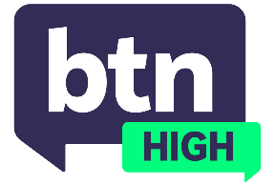
  EPISODE 35
  25th June 2025
  KEY LEARNING
  Students will discuss digital media and the rules around ownership.
  CURRICULUM
  Economics and Business – Year 8 (v8.4)
  Economics and Business – Year 8 (v9.0)
  Civics and Citizenship – Year 9 (v8.4)
  Digital Technologies, Years 7 and 8 (v9.0)
  Digital Technologies - Years 9 and 10 (v8.4) 1 Digital Technologies – Years 9 and 10 (v8.4) 2
  Digital Technologies – Years 9 and 10 (v9.0) 1
  Digital Technologies – Years 9 and 10 (v9.0) 2
  - Teacher Resource

Digital Media Ownership

Focus Questions
Discuss the BTN High story as a class and record the main points of discussion. Students will then respond to the following:
- List the advantages and disadvantages of digital media.
- List the advantages and disadvantages of physical media.
- What do you think should happen if access to the media we have paid for disappears or is taken down from a service/platform?
- Should companies have clearer rules for people who pay to access online media?

Activities
- Select a media source/brand such as a streaming service or platform. Research and analyse information about who owns it, and what rights consumers should be aware of. Present your information as either a magazine feature or short video.
- In groups, discuss the different types of digital media ownership, and who you think should own them. Present your discussion points to class.
- Vinyl records have surged in popularity in Australia and now make up around 70% of the music sold on physical media (2023). Do you predict there’ll be a rise in other physical media? Discuss in groups.

